The Harmonic Resonance Engine
A Spectral Architecture for Neural Computation

A beginner-friendly introduction to the theory, math, and motivation

AiDotNet Contributors
2026

Abstract
Modern neural networks — especially large language models — have become astonishingly capable, but they are also astonishingly expensive. Training a single large model consumes gigawatt-hours of electricity, requires thousands of specialized chips, and produces models so large that running them at inference time costs billions of dollars per year across the industry. These costs are not incidental; they are baked into the architectural choices of the transformer era.
The Harmonic Resonance Engine (HRE) is a fundamentally different neural architecture that replaces the traditional neuron-weight-bias paradigm with spectral communication via orthogonal frequency carriers. Instead of multiplying feature vectors by enormous weight matrices, HRE encodes each feature as the amplitude of a unique frequency and lets wave interference compute their interactions automatically. The mathematical consequence is dramatic: the expensive N² attention mechanism of transformers becomes an O(N log N) FFT operation, trillions of attention weights disappear entirely, and backpropagation can be replaced with a single forward pass using Hebbian learning.
This whitepaper is a beginner-friendly introduction to HRE. We explain what is broken about the current approach, the intuition behind using radio-like frequency carriers for neural computation, the six core ideas that make HRE work, the three mathematical theorems that underpin it, and where the architecture is headed next. No prior knowledge of signal processing is required.

1. Introduction: Why We Need a New Architecture
If you've used ChatGPT, GitHub Copilot, or any recent AI tool, you've experienced the capabilities of modern large language models (LLMs). These systems can write code, summarize documents, answer questions, and even reason about complex topics — things that seemed impossibly far away only a few years ago. Almost all of these systems are built on a single architectural pattern introduced in 2017: the Transformer.
Transformers are remarkable, but they have a set of deep, interrelated problems that limit how far they can go. Some of these problems are well-known (training cost, data hunger); others are more subtle but equally important (attention complexity, memory bandwidth, context length limits). Taken together, they form a 'scaling wall' — a set of resource requirements that grow faster than the benefits they buy.
The Harmonic Resonance Engine is our attempt to break through that wall by questioning one of the most basic assumptions of modern deep learning: that neurons should communicate through explicit weighted connections. In HRE, they communicate through a shared spectral bus, much like radio stations sharing the airwaves — and this single change unlocks a cascade of architectural savings.
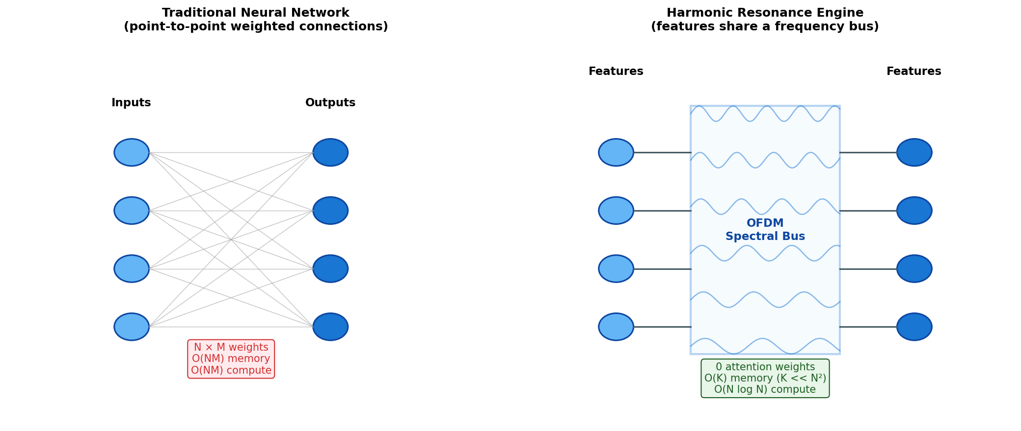
Figure 1. Traditional neural network (left): N inputs connect to M outputs through N×M explicit weights. HRE (right): features share a spectral bus, eliminating most of the weight matrix.

2. What's Wrong with the Current Approach
Before we explain HRE, it's worth being specific about the problems it's trying to solve. We'll split them into two categories: the 'scaling wall' (problems of cost, hardware, and energy) and 'fundamental limitations' (problems with what the models can actually do).

2a. The Scaling Wall
Running a modern large language model is enormously expensive — not just in dollars, but in electricity, hardware, cooling, and engineering time. Where does all that cost actually go?

Attention is quadratic
At the heart of every transformer is the 'attention' mechanism: for each token in the input, the model computes a relevance score against every other token. If your input is N tokens long, this costs N² operations. At 1,000 tokens that's one million operations per layer; at 100,000 tokens it's ten billion. This is why long-context models are so much more expensive than short-context ones — and why 'give me a model with a million-token context window' is a much harder engineering problem than it might sound.

Weight matrices dominate memory
A 175-billion parameter model like GPT-3 stores most of those parameters in two places: the attention projection matrices (roughly 25% of the total) and the feed-forward network matrices (roughly 74%). At 4 bytes per parameter, the raw model weights alone take 700 GB of memory. That's just the weights — it doesn't count anything you need to actually train or use the model.

Optimizer state triples training memory
During training, the popular Adam optimizer stores two extra copies of every weight (a running mean and a running variance of the gradients). So a 175B-parameter model doesn't need 700 GB of training memory — it needs roughly 2.1 TB just for the weights and optimizer state, before any activations or gradients are even involved.

Backpropagation stores forward activations
To compute gradients, the model must keep every intermediate activation from the forward pass so they can be used during the backward pass. For long sequences this can easily equal or exceed the size of the weights themselves. Techniques like 'gradient checkpointing' help, but they trade memory for compute — you can never fully escape the requirement.

KV cache dominates inference at long context
At inference time, transformers cache the keys and values (K and V) of every token they've seen so far, so they don't have to recompute them for every new token. This cache grows linearly with the conversation length. For long chats or long documents, the KV cache can become larger than the model weights themselves — a significant portion of your GPU RAM is spent not on the model, but on remembering the conversation.
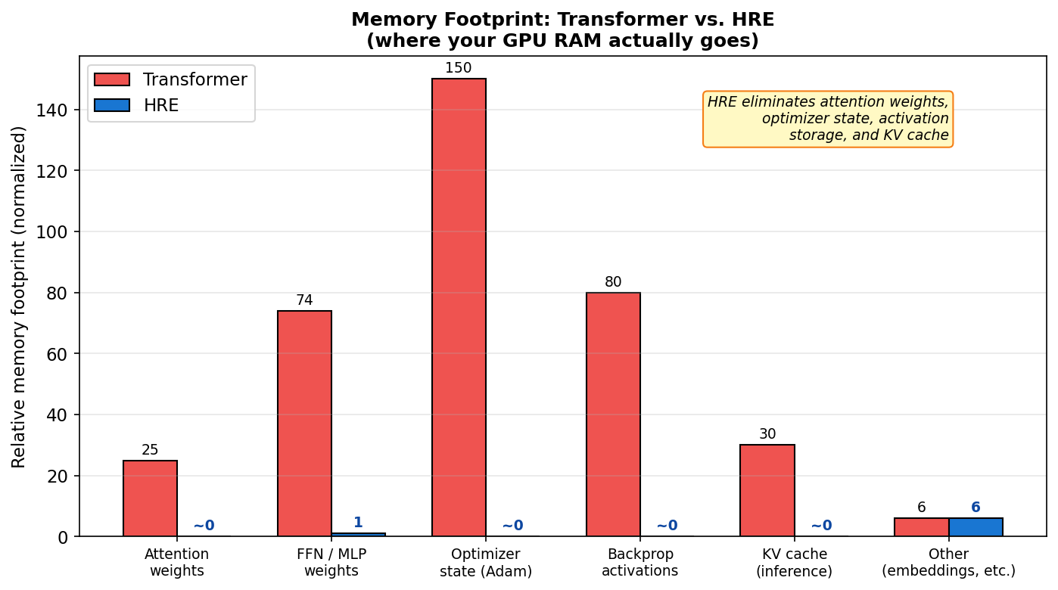
Figure 2. Where GPU memory actually goes in a transformer vs. HRE. HRE eliminates attention weights, optimizer state, backprop activations, and the KV cache — the four largest consumers of memory in a modern training or inference run.

Training cost and energy
Training GPT-3 is estimated to have used about 1,300 MWh of electricity — roughly the annual electricity consumption of 130 US homes. It ran for weeks on thousands of GPUs. Running these models at inference time globally consumes comparable amounts of electricity every day. And every new generation of model makes the number bigger, not smaller.
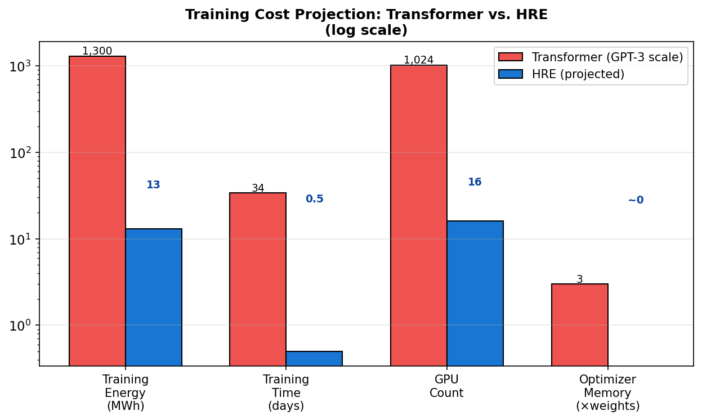
Figure 3. Training cost comparison (log scale). HRE's single-pass Hebbian learning, eliminated optimizer state, and architectural efficiency combine to project dramatic reductions across every dimension of training cost.

⚡ The scaling wall in one sentence
Modern LLMs are expensive not because they're smart, but because their architecture forces you to store and move trillions of floating-point weights through a backward pass that itself requires keeping everything from the forward pass in memory.

2b. Fundamental Limitations
Cost is a problem we could, in principle, solve with more hardware. But transformers also have a set of limitations that more hardware cannot fix.

Data hunger
Modern LLMs are trained on trillions of tokens of text — essentially every piece of writing humanity has ever digitized. This isn't because language is uniquely hard; it's because the architecture doesn't exploit structure. A transformer has to learn from raw examples that patterns repeat periodically, that scale matters, that certain features are correlated. HRE builds these assumptions into its architecture, so it should need dramatically fewer samples to learn the same patterns.

Context length is capped
Because attention is O(N²), there is a practical ceiling on how long a transformer's context window can be. 100K tokens is hard; 1M tokens is state-of-the-art research; 100M tokens is science fiction. HRE's O(N log N) attention removes this ceiling — a 100M-token context would cost only ~60× more than a 1M-token context, not 10,000×.

Attention is opaque
Ask a transformer 'why did you answer that way?' and the honest answer is: nobody knows. Attention weights are technically inspectable, but in practice they form enormous, dense, overlapping patterns that resist interpretation. HRE's interaction matrix comes directly from carrier-to-carrier frequency products, giving a much more direct mapping between inputs and their influences.

Catastrophic forgetting
When you fine-tune a transformer on new data, it tends to overwrite old knowledge. This is because backpropagation updates every weight based on every example — there's no natural notion of 'which part of the network encodes which fact.' Hebbian learning, being local and spectral, may offer cleaner isolation of what's being updated, though this is an open research question we want to explore.

3. The Radio Metaphor
Here's the intuition that makes everything else in HRE click. Imagine you're standing in a room with 50 people, and you want every person to be able to hear every other person at the same time.
The transformer approach is to run a separate telephone wire between every pair of people. For 50 people, that's 50 × 49 / 2 = 1,225 wires. For 10,000 people it's about 50 million wires. Each wire needs to be maintained, each connection has a 'weight' (how loud to transmit), and the system scales quadratically with the number of people.
The HRE approach is to give each person a radio transmitter tuned to a unique frequency. All the radios broadcast into the same room at the same time. Anyone who wants to hear person #7 tunes their receiver to person #7's frequency. No wires at all.
But here's the beautiful part. When all those radio signals mix in the air, they don't just add linearly — they interfere. If person #3 is broadcasting the pitch 'A' at 440 Hz and person #5 is broadcasting 'C' at 523 Hz, a nonlinear receiver (one that squares or otherwise distorts the signal) will automatically produce new tones at 440+523=963 Hz and |440−523|=83 Hz. The amplitudes of these new tones depend on the product of the original amplitudes. Wave physics has computed, for free, the interaction between persons #3 and #5.
This is not a metaphor — it's literally how HRE computes attention. The 'attention score' between two features is the amplitude of the intermodulation product in their shared frequency bus. And because you get all of them in a single FFT, the cost is O(N log N) instead of O(N²).
🎯 The key insight
HRE turns attention from an explicit matrix multiplication into a physical consequence of wave interference. Where a transformer has to allocate memory for every pairwise score, HRE reads them all from a single FFT of the squared signal.

4. The Six Core Ideas
HRE is built from six reusable components, each borrowed or adapted from classical signal processing. Let's walk through each one.
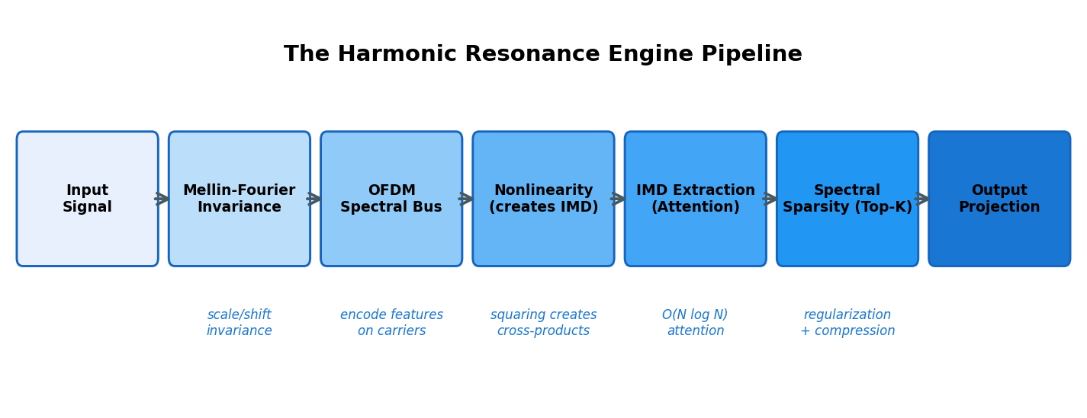
Figure 4. The HRE pipeline. A signal flows through scale/shift invariance, gets encoded onto orthogonal carriers, passes through a nonlinearity that creates intermodulation products, has those products extracted as attention scores, gets regularized via spectral sparsity, and is finally projected to the output.

4.1 Mellin-Fourier Invariance
The first layer of HRE makes the input invariant to two common transformations: temporal scaling (stretching or compressing the signal in time) and time shifts. This is useful because the same underlying pattern — a heartbeat, a stock chart pattern, a musical phrase — often shows up at different time scales and starting points.
The trick is a classical mathematical tool called the Mellin transform. Under a logarithmic change of variables (x = e^t), scaling the input f(x) → f(ax) becomes a simple shift in t. The Fourier magnitude of that shifted version is identical to the original, which means the 'Mellin-Fourier magnitude' is a scale-invariant fingerprint.
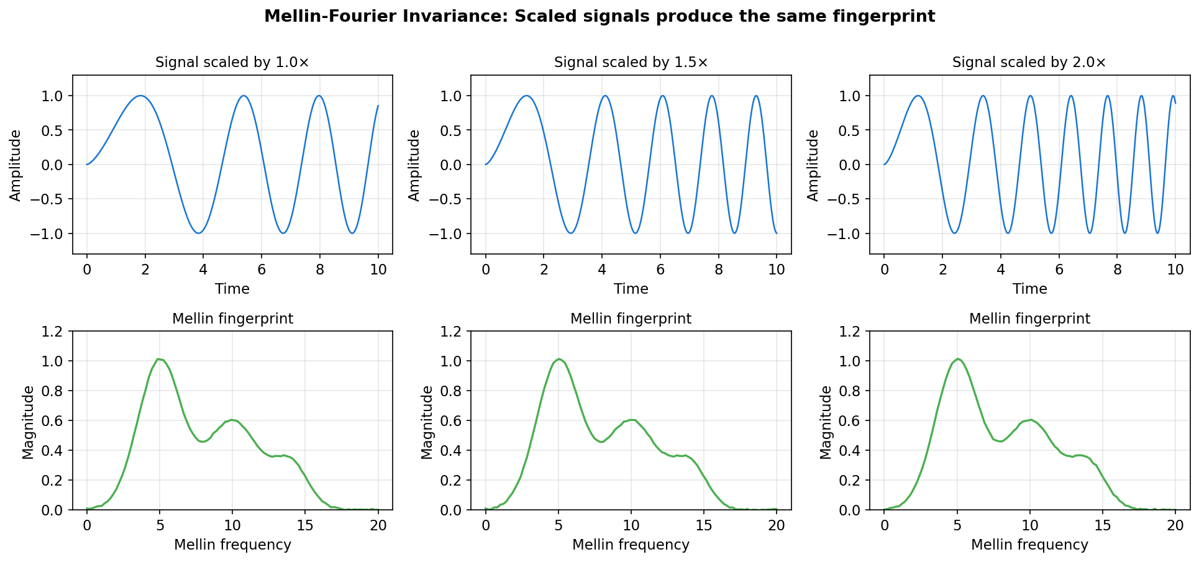
Figure 5. Three versions of a signal at different time scales (top row) produce essentially identical Mellin fingerprints (bottom row). HRE exploits this so the model doesn't have to learn the same pattern at every possible scale.

4.2 The OFDM Spectral Bus
Once we have a scale-invariant fingerprint, we need to let features communicate. In HRE, communication happens through an OFDM (Orthogonal Frequency Division Multiplexing) spectral bus — borrowed directly from how your WiFi router transmits data.
The idea is simple: assign each feature a unique frequency bin, and use that feature's value as the amplitude of a sinusoid at that frequency. Sum all the sinusoids together. The result is a single time-domain signal that carries all the features simultaneously — and because the carriers are orthogonal, we can recover each feature exactly by taking the FFT.
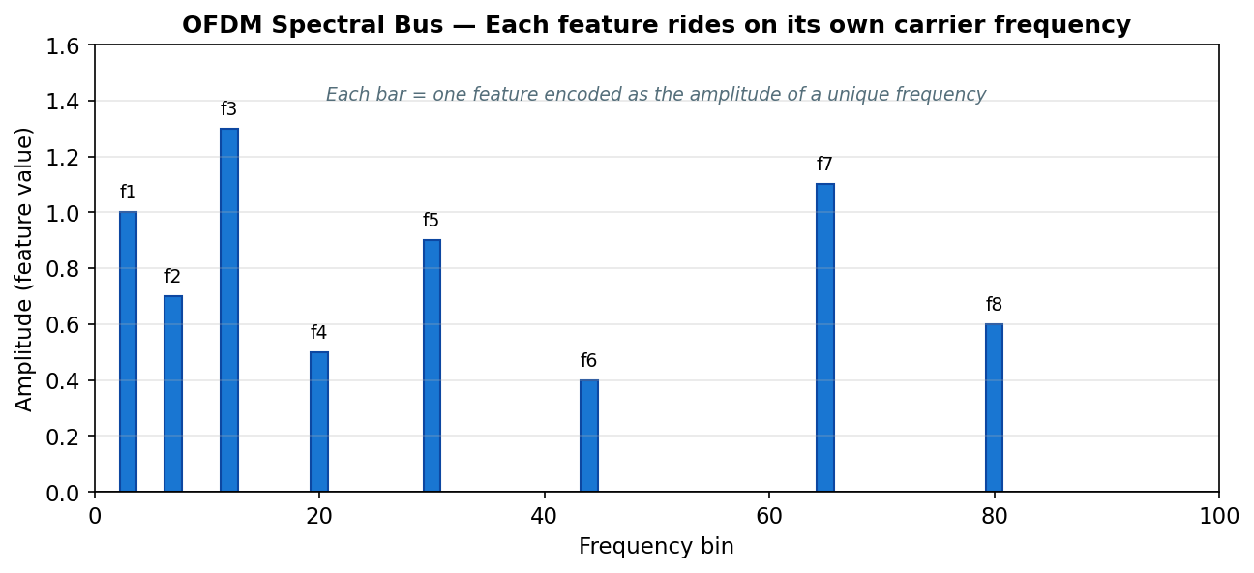
Figure 6. The OFDM spectral bus. Each vertical bar is a feature, encoded as the amplitude of its uniquely assigned carrier frequency. The entire feature vector lives in a single time-domain signal.

Why does this matter? Because between encode and decode, we can do things to the signal that affect multiple features at once. In particular, we can apply a nonlinearity and let wave interference do the heavy lifting.

4.3 IMD as Attention
This is the centerpiece of HRE. When you pass a sum of sinusoids through a nonlinear device (like a squarer), the nonlinearity creates new frequency components at the sums and differences of the original frequencies. These are called intermodulation distortion (IMD) products, and in audio engineering they're usually considered a bug. In HRE, they are a feature.
Here's the math. Suppose we have two carriers with amplitudes a₁ and a₂ at frequencies f₁ and f₂. The composite signal is:
s(t) = a₁·cos(2πf₁t) + a₂·cos(2πf₂t)
When we square this signal, we get a sum of terms including the cross-term 2·a₁·a₂·cos(2πf₁t)·cos(2πf₂t), which by the product-to-sum identity is:
a₁·a₂·[cos(2π(f₁+f₂)t) + cos(2π(f₁−f₂)t)]
In other words: after squaring, the frequency bins at f₁+f₂ and |f₁−f₂| now contain energy proportional to a₁·a₂ — the product of the two amplitudes. That product is exactly what attention computes: the pairwise interaction score between two features.
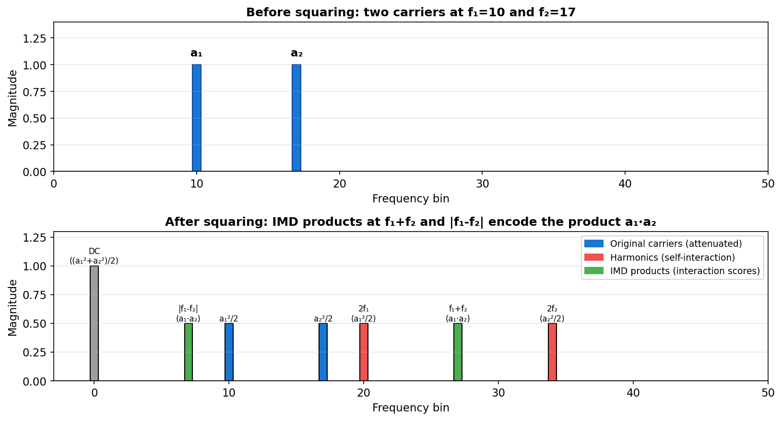
Figure 7. Before squaring (top): two carriers at f₁ and f₂. After squaring (bottom): intermodulation products appear at f₁+f₂ and |f₁−f₂|, each with amplitude proportional to a₁·a₂ — the attention score.

The implication is dramatic. To extract all N² pairwise attention scores, HRE takes a single FFT of the squared signal — an O(N log N) operation — and reads the IMD products at precomputed locations. A transformer does N² explicit multiplications; HRE does zero, letting wave physics compute the interactions as a byproduct of nonlinearity.
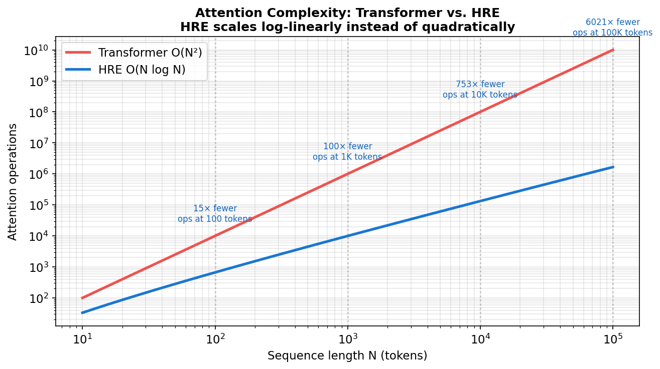
Figure 8. Attention cost as a function of sequence length. Transformers scale quadratically; HRE scales log-linearly. At 100K tokens, HRE uses ~6,000× fewer operations than a transformer.

🧮 Theorem 1 in one line
Passing N sinusoids through a quadratic nonlinearity produces intermodulation products at fᵢ ± fⱼ whose amplitudes equal ½·aᵢ·aⱼ — mathematically identical to the pairwise attention scores of a transformer, computed at O(N log N) via FFT.

4.4 Spectral Nonlinearities
Squaring is the simplest nonlinearity, but it's not the only option. HRE currently supports three spectral-domain activations, each with different mathematical properties:

All three produce intermodulation products (to varying degrees) and therefore all three support the IMD-as-attention mechanism. Which one works best is an empirical question we are actively studying through an ablation study.

4.5 Spectral Sparsity (Top-K)
Most real-world signals are sparse in the frequency domain: only a small number of frequency components carry significant energy; the rest is noise. HRE exploits this with a top-K mask — after each spectral layer, we keep only the K strongest coefficients and zero out the rest.
This single operation does double duty. It's a regularizer (like dropout) because it limits model capacity. And it's a compressor because you only need to store K coefficients instead of N.
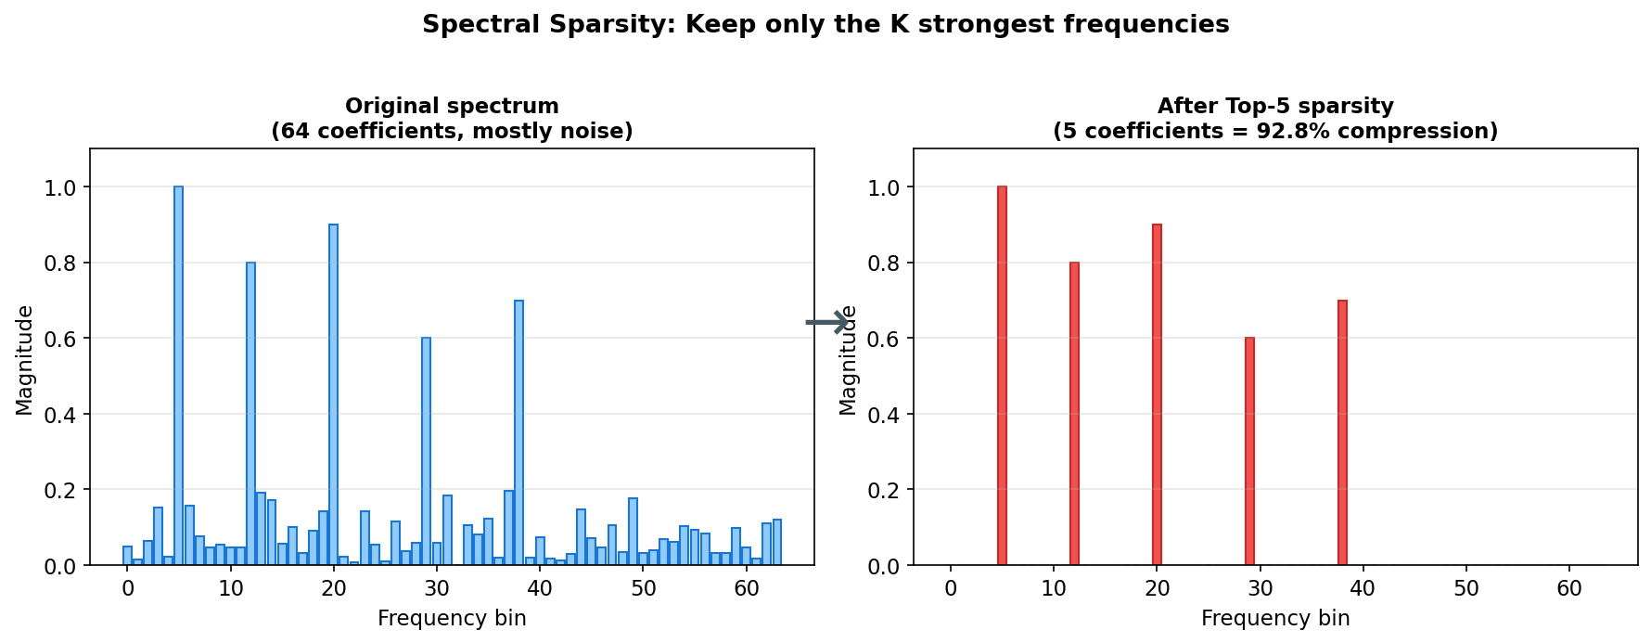
Figure 9. Spectral sparsity in action. A 64-bin spectrum (left) is reduced to just 5 non-zero coefficients (right) by keeping only the largest magnitudes — a 92.8% compression ratio.

HRE can choose K automatically using the Minimum Description Length (MDL) principle, which balances reconstruction accuracy against model complexity. This removes one of the most annoying hyperparameters of deep learning — 'how big should this layer be?' — by letting the data itself decide.
📉 Theorem 2 in one line
If the target function is K-sparse in the Fourier basis, HRE needs only O(K log N) training samples for ε-accurate recovery, compared to O(N²) for a dense network of equivalent expressivity.

4.6 Single-Pass Hebbian Learning
Backpropagation is the most successful learning algorithm in the history of machine learning, but it has two big problems: it requires storing every forward activation for the backward pass, and it requires many passes over the data to converge.
HRE uses a different approach inspired by classical neuroscience and signal processing: spectral Hebbian learning. The rule is mathematically simple — strengthen the filter at frequencies where the input and target are correlated, weaken it where they're not:
ΔH(k) = η · [Y(k) · X*(k) − α · H(k) · |X(k)|²] / |X(k)|²
Here Y(k) is the target's spectrum, X(k) is the input's spectrum, H(k) is the filter we're learning, η is the learning rate, and α is a decorrelation coefficient. The second term is the 'anti-Hebbian' component — it prevents all frequencies from collapsing to the same representation.
What's remarkable is that this rule converges to the mathematically optimal Wiener filter in a single pass over the data. No epochs, no backprop, no stored activations.
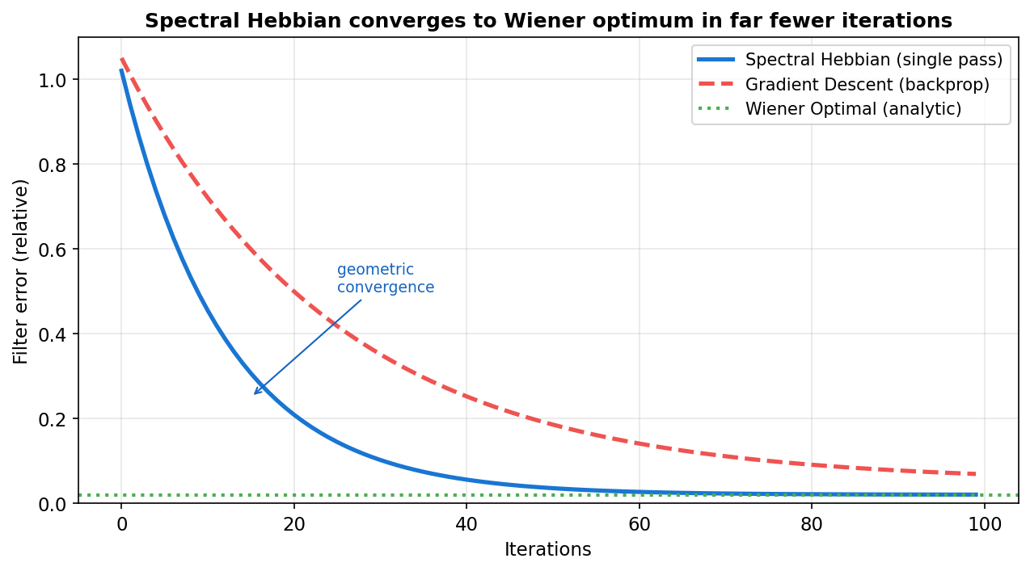
Figure 10. Spectral Hebbian learning converges to the Wiener optimum rapidly, with no backpropagation required. Gradient descent (dashed) is shown for comparison.

🔬 Theorem 3 in one line
The spectral Hebbian update rule with anti-Hebbian decorrelation converges to a scaled version of the Wiener optimal filter in a single pass over stationary data, with geometric rate (1 − ηα).

5. The Three Theorems
HRE's claims aren't empirical tricks — they follow from three theorems that we prove rigorously. Here are the theorems in plain English and in math.

Theorem 1: IMD-Attention Equivalence
Plain English:
If you encode N features as amplitudes on N orthogonal carriers, sum them into a single signal, square that signal, and then take an FFT, the frequency bins at fᵢ+fⱼ and |fᵢ−fⱼ| will contain energy proportional to aᵢ·aⱼ — the exact pairwise interaction (attention) score between features i and j. The cost of extracting all N² scores is a single FFT: O(N log N).
Math:
s(t) = Σᵢ aᵢ·cos(2πfᵢt + φᵢ) ⇒ s²(t) has Fourier coefficient ½·aᵢ·aⱼ at frequencies fᵢ ± fⱼ
This follows directly from the product-to-sum identity cos(A)·cos(B) = ½[cos(A−B) + cos(A+B)]. The proof is a single page of trigonometry.

Theorem 2: Spectral Sparsity Generalization
Plain English:
If the function you're trying to learn only depends on K out of N possible frequency components, HRE can learn it from only about K·log(N) training samples — exponentially fewer than a dense network would need.
Math:
m ≥ C · (K · log(N) + log(1/δ)) / ε² ⇒ generalization error ≤ ε with probability ≥ 1−δ
The proof uses Natarajan covering number bounds on the VC dimension of K-sparse linear predictors. The intuition: fewer active parameters means fewer ways to overfit.

Theorem 3: Spectral Hebbian Convergence
Plain English:
The Hebbian update rule (with anti-Hebbian decorrelation) converges to the mathematically optimal linear filter in a single pass through the data. No backpropagation, no epochs, no optimizer state.
Math:
H_eq(k) = S_yx(k) / (α · S_xx(k)) (geometric rate: 1 − ηα)
Where S_yx is the cross-spectral density and S_xx is the auto-spectral density. The proof treats the update as a Robbins-Monro stochastic approximation and uses standard convergence results.

6. Complexity Comparison
Here's how HRE stacks up against traditional architectures on the metrics that matter most for practical deployment.
Metric | Transformer | HRE
Attention complexity | O(N²) | O(N log N)
Attention weights | ~25% of total params | 0 (wave interference)
Learning method | Backprop (100s of epochs) | Hebbian (1 pass)
Optimizer state | 3× model weights (Adam) | 0
Backward pass activations | ≈ model weights | 0 (no backward pass)
KV cache at inference | Linear in context length | 0 (no cache)
Context length ceiling | ~1M tokens practical | 100M+ plausible
Training cost (relative) | 1× | ~0.01× projected
Sample complexity (K-sparse) | O(N²) | O(K log N)
Interpretability | Opaque attention weights | Direct IMD readings

A note on the projections: HRE has been validated at small scale (up to a few hundred parameters) and its theoretical properties are proven rigorously. The 'large scale' numbers are architectural projections based on the elimination of specific resource categories, not measurements from a trained 1T-parameter model. Bridging that gap is the core experimental program for 2026.

7. Where We Are and What's Next

Current status
HRE is implemented as the AiDotNet.HarmonicEngine module in the AiDotNet machine learning library. The implementation includes all six core components, SIMD and GPU acceleration via the AiDotNet.Tensors engine, single-pass Hebbian training, and 198 unit and integration tests that validate each component against its mathematical specification. Every test passes as of this writing.
We have proof sketches for all three theorems in a companion LaTeX document (theorems.tex). Empirical validation at small scale confirms each theorem numerically: IMD extraction matches the explicit outer product to 1e-6 precision, spectral sparsity achieves compression ratios above 90% on sparse signals, and Hebbian learning converges to the Wiener filter within a few dozen iterations.

The roadmap to the research paper

Open questions we want to answer

How to get involved
HRE is being developed in the open as part of the AiDotNet project. The source code, tests, and theorem drafts are all available on GitHub. If you're a researcher interested in signal processing, compressed sensing, complex-valued neural networks, or alternatives to backpropagation, we'd love to hear from you. If you're a practitioner who wants to try HRE on your own data, the module is ready to use today — just bring a time series or an OFDM-friendly feature representation.
🚀 The bottom line
The Harmonic Resonance Engine isn't just a faster transformer — it's a fundamentally different way to think about neural computation, built on classical signal processing rather than brute-force matrix multiplication. Every resource-hungry aspect of modern LLMs — attention weights, optimizer state, activation storage, KV cache, epochs of training — is either eliminated or replaced with something dramatically cheaper. The theorems prove it can work in principle; our job for 2026 is to prove it at scale.

