CS171 Final Project Report: Predicting Food-at-Home Monthly Prices
Nathan Montero, Arushi Nirmal, Suparn Posina
Department of Computer Science, San Jose State University
{nathan.montero, arushi.nirmal, suparn.posina}@sjsu.edu
Abstract—Food prices are an important economic indicator, and accurate short-term forecasting can benefit both consumers and retailers. The focus of this project was to predict the monthly weighted average unit price of food groups using the USDA Economic Research Service Food-at-Home Monthly Area Prices(F-MAP) dataset. We framed this task as a supervised regression problem and compare a mean baseline with Ridge Regression, Decision Tree, Random Forest, Multi-Layer Perceptron(MLP), and Long Short-Term Memory(LSTM) models using a chronological train-validation-test split. Experimental results on the held-out 2018 test set shows that all learned models substantially outperformed the mean baseline, with Random Forest achieving the lowest validation error at RMSE = 0.0301, MAE = 0.0161, R² = 0.9957. The most interesting insight is that recent price history dominates prediction, while contextual features such as geographic area, calendar month, and the number of reporting stores contribute relatively little at a one-month forecasting horizon.
Index Terms— Machine Learning, regression, food price forecasting, Random Forest, LSTM, USDA F-MAP

I. Introduction
Food prices are a central economic signal, and reliable short-horizon prediction has practical value for consumers planning budgets and for retailers managing pricing and inventory. We study whether the average monthly retail price of a food group can be predicted from its recent price history together with basic context (calendar month, geographic area, and the number of reporting stores). The task is supervised regression. The target is Unit_value_mean_wtd, the weighted average unit price of a food group in dollars per 100 grams. Each observation represents one (year, month, food group, geographic area) combination, and the model predicts that combination's price. To address this problem, we compare a mean baseline with five machine learning models: Ridge Regression, Decision Tree, Random Forest, Multi-Layer Perceptron (MLP), and a Long Short-Term Memory (LSTM) network. We evaluate each model using a chronological train-validation-test split and analyze feature importance, prediction errors, and neural network training behavior.
The remainder of this paper is organized as follows: Section II provides background information, Section III describes the dataset and preprocessing pipeline, Sections IV and V present the methodology and experimental setup, Section VI discusses the experimental results and error analysis, and Sections VII and VIII conclude with the discussion and future work.
II. Related Work / Background
Food price prediction is a supervised regression problem in which historical observations are used to estimate future prices. In this work, we compare a mean baseline with linear, tree-based, and neural network models under a common evaluation framework to determine which approach best predicts monthly food prices.
III. Dataset and Problem Formulation
A. Dataset
We use the F-MAP dataset. It contains 113,400 observations spanning January 2012 through December 2018 (84 months), covering 90 food groups across 15 geographic areas (metro regions plus a National aggregate). The dataset is publicly available from a trusted government source under USDA ERS public-use terms.
Each row contains 15 columns, including identifiers (Year, Month, food-group code/name, region code/name), purchase aggregates (weighted and unweighted purchase dollars and grams), Number_stores, and several price measures, including the target Unit_value_mean_wtd, its standard error, an unweighted mean, and a GEKS price index. The dataset is complete and clean: 0 missing cells and 0 duplicate (Year, Month, food group, area) keys.
Because this is a regression task, class imbalance is not applicable. Instead, we examine the distribution of the continuous target variable and note that it is right-skewed.
B. Preprocessing
For leakage control we exclude every column that mechanically encodes the price: the purchase-dollar and purchase-gram aggregates (price = dollars ÷ grams), the unweighted mean price, the target’s standard error, and the GEKS index. These would trivially reveal the answer. Engineered features. Because prices are highly autocorrelated, we add per-series (food group × area) lag and rolling features: price_lag_1, price_lag_3, price_lag_12 and rolling means price_roll_3, price_roll_12. The calendar month is encoded cyclically as month_sin and month_cos so December and January are treated as adjacent. Building a 12-month lag consumes the first year of every series, so 2012 becomes a warm-up year that supplies history but is not itself predicted. This reduces the usable set from 113,400 to 97,200 rows (23 columns after adding the 8 engineered ones). The final model inputs are 12 features: food group and area (categorical), Year, Month, month_sin, month_cos, Number_stores, and the five lag/rolling price features. All preprocessing is fit on the training split only.
C. Problem Statement
The prediction task is formulated as a supervised regression problem. Each training sample represents a single food group and geographic area for a given month, using temporal, geographic, and engineered historical price features to predict the corresponding Unit_value_mean_wtd, the weighted average unit price of a food group. The engineered feature set includes cyclical month encodings (month_sin and month_cos), lagged prices (price_lag_1, price_lag_3, and price_lag_12), and rolling average features (price_roll_3 and price_roll_12). Model performance is evaluated using RMSE, MAE, and R².
For the neural network models, training is performed by minimizing the mean squared error (MSE) between the predicted price $\check{y}$​ and the true price y:
Loss MSE​ =1/N $\sum_{i=1}^{n}{{(y_{i}-{\check{y}}_{i})}^{2}}$
IV. Methodology
A. Baseline
As a simple reference, we use a mean predictor that always predicts the average target value from the training set. This baseline provides a minimum performance level that every machine learning model should exceed. Comparing against a simple baseline helps determine whether the additional model complexity produces meaningful improvements.
B. Models
Ridge Regression serves as the linear baseline. Categorical features are one-hot encoded and numerical features are standardized before training. The model uses L2 regularization, and the regularization parameter is selected from {0.1, 1, 10, 100} based on validation RMSE.
A Decision Tree Regressor is trained using ordinal-encoded categorical variables and the engineered numerical features. Hyperparameter tuning evaluates maximum tree depths of 5, 10, 20, and unlimited depth together with minimum leaf sizes of 1, 5, and 20. The configuration with the lowest validation RMSE is selected.
A Random Forest Regressor is trained using multiple decision trees to improve generalization. Models are evaluated using 50 and 100 trees with maximum depths of 10, 20, and unlimited depth while fixing the minimum leaf size at two samples. The best-performing configuration is selected using the validation set.
The Multi-Layer Perceptron (MLP) is implemented using scikit-learn's MLPRegressor. Candidate architectures include one hidden layer with 64 neurons and two hidden layers with 64 and 32 neurons. The network uses ReLU activation, the Adam optimizer, a learning rate of 0.001, batch size 256, early stopping, and L2 regularization. Validation performance determines the final architecture.
The LSTM model is implemented in PyTorch. Each sample consists of a 12-month sequence containing standardized price, Number_stores, and cyclical month features. The network uses a single LSTM layer with a hidden size of 48, learned embeddings for food groups (12 dimensions) and geographic areas (4 dimensions), followed by a fully connected layer with 64 hidden units, ReLU activation, 0.15 dropout, and a final linear output layer for regression.
C. Training and Hyperparameters
All models were trained using the chronological split described in Section III, with data from 2013–2016 used for training and 2017 reserved for validation and hyperparameter selection. This approach prevents temporal data leakage while allowing model configurations to be compared consistently before evaluation on the held-out 2018 test set.
Hyperparameters were selected independently for each model family using validation RMSE as the primary selection criterion. Ridge Regression evaluated multiple values of the L2 regularization parameter (α). Decision Tree and Random Forest models explored different maximum tree depths and model complexities, while the MLP compared multiple hidden-layer architectures together with different L2 regularization strengths. The configuration achieving the lowest validation RMSE was selected for each model before final testing. This tuning process helps improve generalization while reducing overfitting.
The neural network models were trained using the Adam optimizer. The MLP used a learning rate of 0.001, a batch size of 256, and a maximum of 150 epochs with early stopping enabled after ten consecutive epochs without validation improvement. The LSTM also used the Adam optimizer with a learning rate of 0.001, MSE loss, a weight decay of 1x10⁻⁵, training and validation batch sizes of 512 and 1024, respectively, and early stopping with a patience of five epochs. During training, the model automatically restored the weights corresponding to the lowest validation loss.
V. Experimental Setup
The dataset was divided using a strictly chronological train/validation/test split to preserve temporal ordering and prevent future information from leaking into the training process. The year 2012 was used as a warm-up period to construct lag features and was therefore excluded from model evaluation. Data from 2013–2016 (64,800 observations) were used for training, 2017 (16,200 observations) was used for validation and hyperparameter selection, and 2018 (16,200 observations) was reserved as the held-out test set for the final evaluation.
Model performance was evaluated using root mean squared error (RMSE), mean absolute error (MAE), and the coefficient of determination (R²). RMSE penalizes larger prediction errors more heavily, MAE provides an interpretable measure of the average prediction error, and R² measures the proportion of variance explained by the model. Together, these metrics provide a comprehensive evaluation of regression performance.
All experiments were performed using a random seed of 42, which was applied to Python, NumPy, and PyTorch to ensure reproducibility. When CUDA was available, the seed was also applied to all CUDA devices. The MLP and LSTM models were trained using Google Colab, with the LSTM utilizing an NVIDIA Tesla T4 GPU, while the remaining models were trained using scikit-learn.
VI. Results and Analysis
A. Main Results
The performance of all models on the held-out 2018 test set is summarized in Table I. All machine learning models substantially outperform the mean baseline, demonstrating that the engineered temporal and contextual features provide meaningful predictive information. Among the evaluated models, Table 1 shows that Random Forest achieves the strongest overall performance, obtaining the lowest RMSE (0.0301) and MAE (0.0161) while achieving the highest R² (0.9957). The LSTM and MLP also perform competitively, while Ridge Regression and the Decision Tree provide similar predictive accuracy despite their simpler architectures.
TABLE I. Model Comparison on the 2018 Held-Out Test Set
Model | RMSE | MAE | R²
Mean Baseline | 0.4592 | 0.3444 | -0.0006
Ridge Regression | 0.0332 | 0.0174 | 0.9948
Decision Tree | 0.0333 | 0.0183 | 0.9947
Random Forest | 0.0301 | 0.0161 | 0.9957
MLP | 0.0331 | 0.0218 | 0.9948
LSTM | 0.0322 | 0.0175 | 0.9951

B. Error Analysis and Ablations
Although all models achieved strong predictive performance, errors were not distributed uniformly across all food categories. Figure 1 presents the Random Forest feature importance, showing that price_lag_1 is by far the most influential predictor. Rolling average and additional lag features provide smaller contributions, while contextual variables such as geographic area, calendar month, and the number of reporting stores contribute comparatively little. This indicates that recent price history is the primary driver of short-term food price prediction.
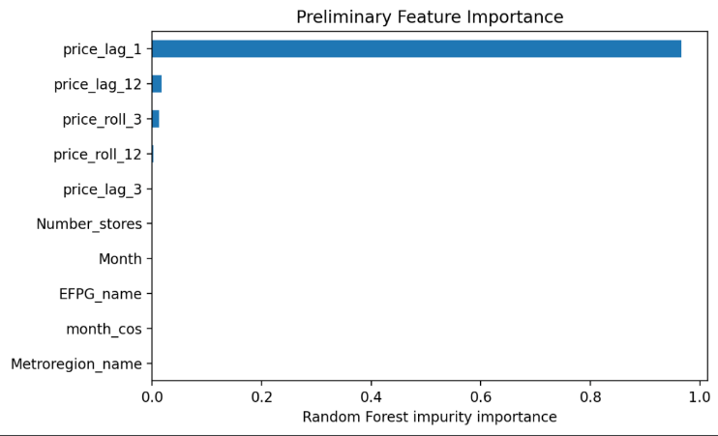
Fig. 1. Random Forest feature importance (price_lag_1 dominates).
Prediction errors are concentrated in more volatile or specialty food categories. As shown in Figure 2, vitamins and meal supplements, frozen seafood, infant formula, dry spices, and processed meats exhibit the highest mean absolute errors. These categories experience greater price volatility, promotional effects, and lower sampling frequency, making future prices less predictable using historical observations alone. In contrast, staple food categories have relatively stable prices and therefore produce substantially lower prediction errors.

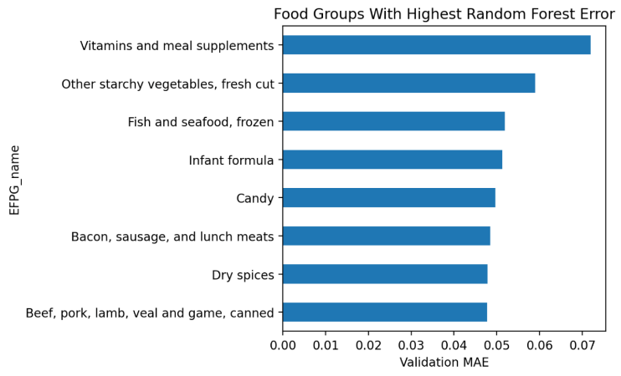
Fig. 2. Food groups with the highest validation MAE.
VII. Discussion
Interpret your results honestly: what worked, what did not, and why. State limitations (data size, label noise, generalization, compute). Connect back to concepts from the course (bias-variance, imbalance, metric choice).
VIII. Conclusion and Future Work
Summarize the problem, approach, and headline finding in a few sentences, then propose concrete next steps you would take with more time or data.
Author Contributions
Required for this course. One or two sentences stating who did what (e.g., 'A. built the data pipeline; B. trained the models; C. led the analysis and writing').
References
Use IEEE reference style, numbered in order of appearance. Examples:
[1] A. Author and B. Author, “Title of the paper,” in Proc. Conf. Name, City, Country, 2024, pp. 1–9.
[2] C. Author, Title of the Book, 2nd ed. City: Publisher, 2023.
[3] D. Owner, “Dataset name,” Repository/Source, Year. [Online]. Available: https://…

