Mateo Noring
4/28/2024
Week 3 Assignment

Browsers I tested on:
  - Chrome
  - Edge
  - Fire Fox
  - Chrome Mobile
Links:
https://github.com/oopsGRENADE/oopsGALLERIES/tree/main
https://oopsgrenade.github.io/oopsGALLERIES/
https://github.com/oopsGRENADE/oopsGALLERIES/blob/main/index.html
https://github.com/oopsGRENADE/oopsGALLERIES/blob/main/template.html
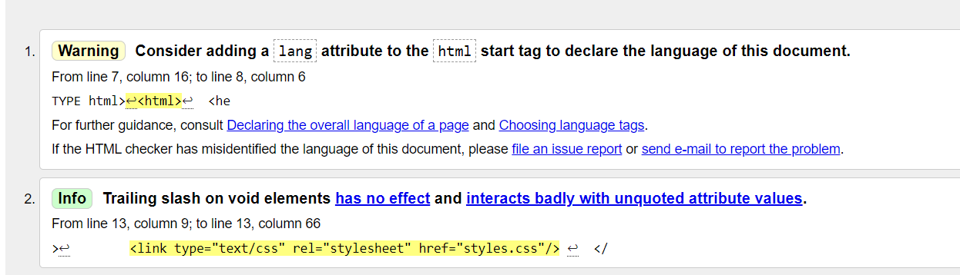

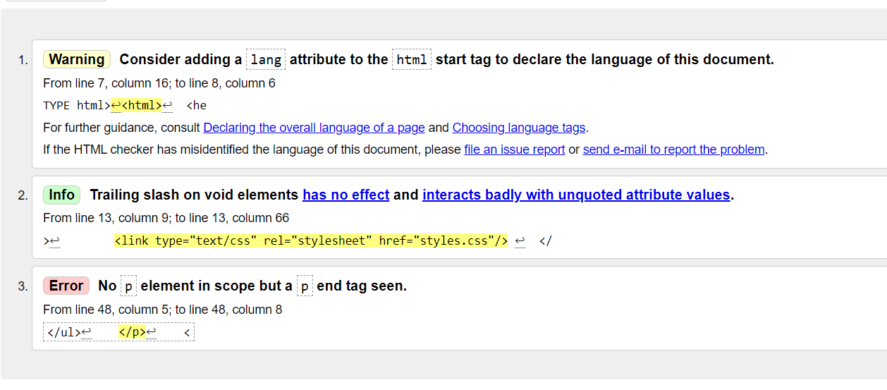
I don’t know why it gives me the error on myInterests.html, there is a <p> that connects to the end tag.

Graphics Included:
This is what I used for my logo. As well as, some images I made that I used in my Gallery: