

CAPSTONE PROJECT REPORT
Report 2 – Project Management Plan

– Hanoi, January 2026 –
Table of Contents
I. Record of Changes 3
II. Project Management Plan 4
1. Overview 4
1.1 Cost & Time Estimations 4
1.2 Project Objectives 5
1.3 Project Risks 6
2. Management Approach 7
2.1 Project Processes 7
2.2 Quality Management 8
2.3 Project Training Plan 9
3. Responsibility Assignments 10
4. Project Communications 11
5. Configuration Management 12
5.1 Document Management 12
5.2 Source Code Management 12
5.3 Tools & Infrastructures 12

I. Record of Changes
Date | A*  M, D | In charge | Change Description
10/01/2026 | A | NamPH | Create Report 2 Document
15/01/2026 | M | Team | Update Report 2 for GreenMarket (4-month iterative plan, WBS, RACI, communications, configuration).
18/01/2026 | A | NamPH | Add Management Approach
20/01/2026 | M | NamPH | Update Configuration Management
11/03/2026 | M | NamPH | Update Cost & Time Estimate, Project Processes and Tools & Infrastructures
*A - Added M - Modified D - Deleted

II. Project Management Plan

1. Overview

1.1 Cost & Time Estimations

No. | Work items / Deliverables | Effort (person-days) | Timeline
1 | Stage 1: Initiation & Planning (weeks 1–2) | 30
1.1 | Project kickoff, roles, communication plan | 5 | Week1
1.2 | Requirements elicitation (actors, scope, MVP vs optional) | 10 | Week1
1.3 | Jira/Git setup, conventions, Definition of Done | 10 | Week1
1.4 | Report 1: Project Introduction (final) | 5 | Week2
2 | Stage 2: Analysis & Requirement Baseline (weeks 1–2) | 25
2.1 | Define actors, high-level use cases, and scope baseline | 10 | Week2
2.2 | Screen flows & authorization matrix; baseline main flows | 10 | Week2
2.3 | Report 3: SRS v1.0 (baseline UC/actors/diagrams) | 5 | Week2
3 | Stage 3: Architecture & Design Baseline (weeks 1–2) | 25
3.1 | System architecture & technology stack definition | 10 | Week2
3.2 | Database design (PostgreSQL), ERD + entities | 10 | Week2
3.3 | Report 4: SDS v1.0 (baseline) | 5 | Week2
4 | Stage 4: Implementation (Iterative & Incremental) (weeks 3–14) | 240
4.1 | Implementation Iteration 1 (weeks 3–5) | 60
4.1.1 | Implement Auth: phone registration + OTP sandbox login/logout + RBAC base | 15 | Week3
4.1.2 | Implement News: browse/search/filter/sort posts + post detail | 15 | Week3
4.1.3 | Implement Shop: create/edit shop, view shop detail | 10 | Week4
4.1.4 | Implement Post MVP: create/edit draft post + image upload + my posts list | 15 | Week5
4.1.5 | Code Package & Unit Testing Report (Iteration 1) | 5 | Week5
4.1.6 | Software Package Version 1 | 0 | Week5
4.2 | Implementation Iteration 2 (weeks 6–8) | 60
4.2.1 | Implement Moderation (Manager): queue + review + approve/reject/hide + logs | 15 | Week6
4.2.2 | Implement Reports: report post/shop + evidence upload + view resolution | 15 | Week6
4.2.3 | Implement Favorites & Block/Unblock shop | 10 | Week7
4.2.4 | Implement Trash/Restore post (restore within 30 days rule) | 10 | Week7
4.2.5 | Update Report 3: SRS v1.1 (sync UC/flows after Iteration 2) | 5 | Week8
4.2.6 | Integration Test Cases (v1) | 5 | Week8
4.2.7 | Software Package Version 2 | 0 | Week8
4.3 | Implementation Iteration 3 (weeks 9–11) | 60
4.3.1 | Admin Web: Account management (roles, lock/unlock, audit logs) | 15 | Week9
4.3.2 | Admin Web: Category & Attribute + category-attribute config + preview | 15 | Week9
4.3.3 | Template management (report reasons & reject templates) + basic moderation config | 10 | Week10
4.3.4 | Export CSV + basic analytics aggregation (dashboard KPIs) | 9 | Week10
4.3.5 | Implement Rating & Review and Loyalty System API | 1 | Week10
4.3.6 | Update Report 4: SDS v1.2 (refine design after Iteration 3) | 5 | Week11
4.3.7 | Report 5: Integration Test Report | 5 | Week11
4.3.8 | Software Package Version 3 | 0 | Week11
4.4 | Implementation Iteration 4 (weeks 12–14) | 60
4.4.1 | UX/UI refinement + bug fixing | 13 | Week12
4.4.2 | Implement Web Client UI (News, Marketplace, User Profile, Seller Workspace) | 6 | Week12
4.4.3 | Security hardening (RBAC checks, rate limiting) + performance tuning | 13 | Week12
4.4.4 | System integration + regression testing | 13 | Week13
4.4.5 | Update Report 3: SRS v1.2 & Report 4: SDS v1.3 (final sync) | 10 | Week13
4.4.6 | Final demo rehearsal + Software Package Version 4 | 5 | Week14
5 | Stage 5: Verification & Validation (weeks 15–16) | 40
5.1 | Report 5: System Test Cases + System Test Report | 15 | Week15
5.2 | Report 6: User Guides (Installation Guide, User Manual) | 15 | Week15
5.3 | Acceptance Test and Support (bug fixing, stabilization) | 10 | Week16
6 | Stage 6: Closing (week 16) | 20
6.1 | Report 7: Final Project Report | 10 | Week16
6.2 | Presentation File (slides + demo script) | 10 | Week16
Total estimated time: 380 person-days (with 5h/day)

1.2 Project Objectives
# | Metric | Unit | Planned | Actual | Notes / References
1 | Effort Usage | Person-day | 380 pds | — | Tracked via Project Tracking / weekly timesheet
2 | Review Defects | No. of defects | ≤ 10 major | — | Design + code reviews checklist
3 | Unit Test Defects | No. of defects | ≤ 25 | — | Jest (backend) + basic component tests
4 | Integration Test Defects | No. of defects | ≤ 20 | — | API contract tests via Postman/Newman
5 | System Test Defects | No. of defects | ≤ 25 | — | E2E flows: Guest/Customer/Manager/Admin/Host/Collaborator/Staff
6 | Timeliness | % | ≥ 90% | — | On-time deliverables / total deliverables
7 | Requirement Completeness | % | ≥ 90% | — | Must-have requirements delivered; fail if ≤ 75%
8 | Demo Readiness | % | ≥ 95% | — | All demo scripts pass without critical bugs

1.3 Project Risks
# | Risk Description | Impact | Possibility | Response Plans
1 | Scope creep due to many roles (Manager/Host/Staff/Collaborator) and optional features | High | Medium | Mitigation: Freeze MVP at Week 7; mark Host/Staff/Collaborator as optional.  Contingency: Drop optional modules; focus on moderation + search/filter.
2 | Integration risk between Mobile App, Admin Web, and Backend APIs | High | Medium | Mitigation: Swagger contract + weekly integration checkpoint.  Contingency: Use feature flags and mock data to keep UI progressing.
3 | Performance issues for multi-criteria search/filter (PostgreSQL indexes) | High | Medium | Mitigation: Design indexes early and benchmark with seed data.  Contingency: Limit filter combinations in MVP; optimize queries.
4 | Content abuse (spam posts/ report spam from Guest) | Medium | High | Mitigation: Rule-based pre-check + rate limiting on posting/reporting.  Contingency: Tighten limits and prioritize manager moderation queue.
5 | Mobile instability (React Native build issues, device-specific bugs) | Medium | Medium | Mitigation: Use stable RN/Expo versions; test on 2–3 devices weekly.  Contingency: Reduce device-specific features; prioritize core flows.
6 | OTP/SMS and Payment integration complexity | Medium | Low | Mitigation: Use OTP sandbox (mock) and MoMo sandbox only.  Contingency: Switch to fully mocked flows while preserving interfaces.
7 | Team coordination and overlapping modules | Medium | Medium | Mitigation: Clear ownership per module + RACI + weekly review.  Contingency: Rebalance tasks; pair-programming for blockers.
8 | Developing additional songs for both the Web Client and Mobile App doubled the frontend workload. | High | Medium | Mitigation: Design a RESTful backend API (NodeJS) from the start so that the web and app can use the same API 100%, avoiding logic rewriting. Prioritize completing the API first.

2. Management Approach

2.1 Project Processes
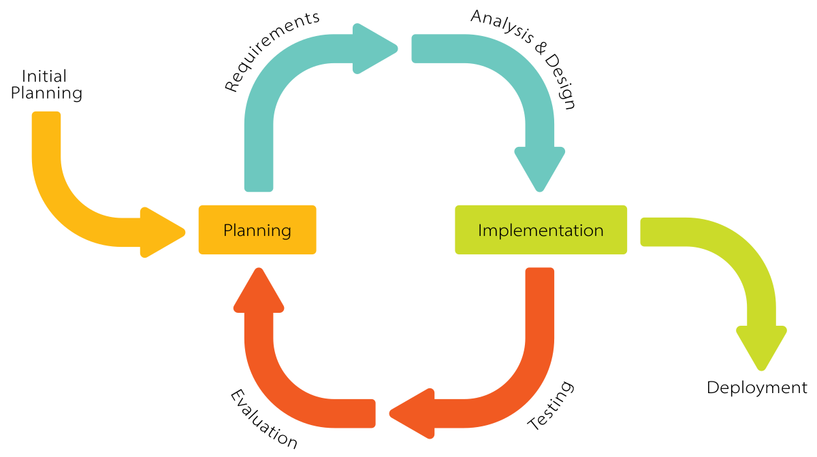
Figure 2.1 : Iterative & Incremental Software Development Process Model
The project follows an Iterative & Incremental development process across 4 months (16 weeks). Each iteration delivers a working increment of GreenMarket (Mobile App + Admin Web + Backend), including planning, implementation, integration, testing, and stakeholder review. This approach reduces integration risk and keeps the MVP demo-ready early.
Iteration 1 (Weeks 1–4): OTP sandbox login, storefront, posting listings, basic browse/search.
Iteration 2 (Weeks 5–8): Moderation (Manager), reporting (Guest/Customer), categories/attributes, templates.
Iteration 3 (Weeks 9–12): Favorites, analytics dashboard, export CSV, performance tuning, rating and loyalty system.
Iteration 4 (Weeks 13–16): Web Client portal for end-users, stabilization, system testing, demo rehearsal, final packaging.

2.2 Quality Management
- Defect Prevention
- Establish Coding Standards: Implement coding standards and best practices to promote consistent and high-quality code.
- Utilise Static Code Analysis: Employ static code analysis tools to detect potential defects early in the development process.
- Conduct Code Reviews: Facilitate regular code reviews to identify and address defects before they can propagate through the codebase.
- Reviewing
- Regular Reviews: Perform ongoing code, design, and documentation reviews to maintain high standards.
- Involve Diverse Perspectives: Engage multiple team members in the review process to gain fresh insights and perspectives.
- Provide Constructive Feedback: Offer actionable feedback and ensure issues are tracked until resolved.
- Unit Testing
- Thorough Situational Analysis: Analyze all possible scenarios, including the worst-case situations, to ensure comprehensive testing.
- Alignment with Design: Ensure test cases are well-aligned with the system and architectural design.
- Immediate Error Notification: Promptly notify the responsible party of any defects, documenting them in the Bug Tracking software with appropriate priority levels.
- Timely Resolutions: Ensure that individuals accountable for defects have solutions to address issues as quickly as possible.
- State Transition for Test Cases: All test cases should initially reflect a "failure" state, transitioning to "pass" after necessary modifications or no significant changes to the primary code.
- Integration Testing
- Design Test Scripts and Cases: Create comprehensive test scripts and cases that align with system and architectural design.
- Error Notification and Documentation: Similar to unit testing, promptly inform the responsible individual of any defects and record them in the Bug Tracking software.
- Timely Defect Resolution: Ensure that accountable team members are equipped to resolve defects swiftly.
- Initial Failure State: Start all test cases in a "failure" state, transitioning to "pass" after suitable adjustments.
- Smooth Internal Module Functionality: Verify that internal modules within the system operate seamlessly together.
- System Testing
- Alignment with Design Specifications: Ensure that test cases align closely with the system and architectural design.
- Prompt Defect Reporting: Similar procedures for defect reporting and prioritization as in previous testing stages.
- Effective Defect Management: Ensure responsible parties can quickly address and resolve defects.
- State Transition for Test Cases: Maintain the "failure" to "pass" state transition protocol for all test cases.
- User-Centric Evaluation: Clearly differentiate the user’s perspective from that of the developer, ensuring an objective evaluation process.

2.3 Project Training Plan
Training Area | Participants | When, Duration
GreenMarket domain & requirements (marketplace + moderation) | All members | Week 1 (2 sessions)
NodeJS/Express API + JWT/RBAC + OTP sandbox | BE Core, BE Support | Week 1–2 (3 sessions)
PostgreSQL schema & indexing for search/filter (B-tree/GIN, query plan basics) | BE Core, BE Support | Week 2 (2 sessions)
ReactJS Admin (tables, forms, role guards) | Web FE | Week 2–3 (3 sessions)
React Native/Expo (navigation, networking, image upload) | App Dev A, App Dev B | Week 2–3 (3 sessions)
Testing (unit/integration/system) + Postman/Newman | All members | Week 3 (2 sessions)
Git/GitHub flow (branching, PR review) | All members | Week 1 (1 session)
Project management tools (Trello/Jira, GitHub Issues) | All members | Week 1 (1 session)
MoMo sandbox payment flow (demo) | BE Support, App Dev B | Week 8 (1 session)

3. Responsibility Assignments
RACI Chart: R~Responsible, A~Accountable, C~Consulted, I~Informed
Work Package | NamNT (Leader/BE Core) | DungBD (BE Support) | NamPH (Web FE) | NghiaTT(App Dev A) | PhongDH(App Dev B)
Requirements Analysis | A | R | C | C | C
Architecture & DB Design | A | R | C | I | I
API Development (Backend) | A | R | I | C | C
Search/Filter & Indexing | C | A | R | C | C
Mobile App Development | I | C | I | R | R
Web Admin Development | I | C | R | I | I
Testing & Quality Control | A | R | C | C | C
Documentation (Reports/Guides) | A | C | R | C | C
Deployment/DevOps | A | R | C | I | I
Demo & Presentation | A | R | R | R | R

4. Project Communications
Communication Item | Who/ Target | Purpose | When, Frequency | Type, Tool, Method(s)
Weekly meeting with mentor | All team members & mentor | Report progress. Discuss and solve problems | 3:00 pm every Wednesday | Offline meeting
Weekly Team Meeting | All team members | Report tasks.  Discuss issues, resolve problems. Define the next task | 9:00 pm every Sunday | Online meeting through Google Meet
Unscheduled meeting | All team members | Discuss and solve important issues | When there are significant problems that need to be solved quickly | Online meeting through Google Meet
Daily update | All team members | Share daily progress and blockers | 9:00 am, Mon–Fri | Chat group

5. Configuration Management

5.1 Document Management
The development team uses Google Docs, Google Sheets, and Google Drive for project documentation.
These platforms allow multiple people to view, edit, comment, and share at the same time, and can customize permissions for each member to ensure proper roles. The platforms also support tracing changes made, who is responsible, and comparing different versions at the same time, which increases the efficiency of using and managing project documents.

5.2 Source Code Management
The development team uses GitHub for version control of our source code, which simplifies the processes of storing, uploading, and downloading code. GitHub allows us to manage changes quickly and accurately, facilitating efficient task distribution and collaboration. This streamlined approach enhances our ability to produce high-quality programming projects.

5.3 Tools & Infrastructures

Category | Tools / Infrastructure
Technology | NodeJS + Express (Back-end), ReactJS (Web), React Native/Expo (Mobile App)
Database | PostgreSQL
ORM | Prisma
OTP/SMS | OTP/SMS Sandbox (Mock)
Payment | MoMo Sandbox (Mock)
IDEs/Editors | Visual Studio Code, Android Studio (optional)
Diagramming | draw.io (diagrams.net), Figma (UI wireframe)
Documentation | Google Docs/Sheets/Drive
Version Control | GitHub (source code), GitHub Projects/Issues
Testing | Jest (backend), Postman/Newman (API), Manual E2E checklist
Deployment/Hosting | VPS/Render/Fly.io (demo), Cloudinary/S3 for images
Project Management | Trello/Jira, Google Meet, Zalo/Discord group

