

CAPSTONE PROJECT REPORT
Report 3 – Software Requirement Specification

– Hanoi, January 2026 –
Table of Contents
I. Record of Changes 9
II. Software Requirement Specification 10
1. Overall Requirements 10
1.1 Context Diagram 10
1.2 Main Workflows 10
1.2.1 WF-01 Customer Creates Store Flow 11
1.2.2 WF-02 Host Create Promotion Content Flow 12
1.2.3 WF-03 Collaborator Accept Task Flow 13
1.2.4 WF-04 Admin Manage Account Flow 14
1.2.5 WF-05 AI Recommendation Flow 15
1.3 User Requirements 15
1.3.1 Actors 15
1.3.2 Use Cases (UC) 16
1.3.3 Use Case Diagrams 22
1.4 System Functionalities 28
1.4.1 Screens Flow 28
1.4.2 Screen Authorization 29
1.4.3 Non-UI Functions 32
1.5 Entity Relationship Diagram 33
2. Use Case Specification 37
2.1 Authentication 37
2.1.1 Register phone number 37
2.1.2 Login 38
2.1.3 Logout 39
2.2 Profile Management 40
2.2.1 View profile 40
2.2.2 Edit profile 41
2.3 Shop Management 41
2.3.1 Create shop 41
2.3.2 View shop details 42
2.3.3 Edit shop 43
2.3.4 Manage shop status 44
2.3.5 Search shops 44
2.3.6 View shop statistics 45
2.4 Post Management 46
2.4.1 View news feed 46
2.4.2 Search, filter and sort posts 46
2.4.3 View post details 47
2.4.4 Share post 48
2.4.5 View my posts 48
2.4.6 Create post 49
2.4.7 Edit post 50
2.4.8 Move post to trash 51
2.4.9 Restore post from trash 51
2.4.10 Permanently delete post 52
2.4.11 Submit post for moderation 53
2.4.12 View rejection reason 53
2.4.13 Manage post images 54
2.5 Favorite Management 55
2.5.1 Add post to favorites 55
2.5.2 Remove post from favorites 56
2.5.3 View favorite posts 56
2.5.4 Clear favorite list 57
2.6 Reports Management 58
2.6.1 Create report 58
2.6.2 Attach report evidence 58
2.6.3 View my reports 59
2.6.4 Cancel report 60
2.6.5 View report result 60
2.7 Moderation Management 61
2.7.1 Block shop 61
2.7.2 Unblock shop 62
2.7.3 View moderation queue 63
2.7.4 Moderate post 63
2.7.5 Resolve report 64
2.7.6 Send moderation feedback 65
2.7.7 View moderation history 65
2.7.8 View moderation statistics 66
2.7.9 Escalate violation 67
2.8 Operations Staff Management 68
2.8.1 View assigned tasks 68
2.8.2 Handle customer support requests 68
2.8.3 Update task status 69
2.8.4 View daily operation workload 70
2.8.5 View system notifications 71
2.9 Collaborator Management 71
2.9.1 View available jobs 71
2.9.2 Accept or decline job 72
2.9.3 View collaborator earnings 73
2.9.4 Request payout 73
2.9.5 Submit job result 74
2.10 Host Management 75
2.10.1 View host dashboard 75
2.10.2 Create promotional content 75
2.10.3 View host earnings 76
2.10.4 Request host payout 77
2.11 Promotion & Placement Management 78
2.11.1 View promotion packages 78
2.11.2 Purchase promotion package (sandbox) 78
2.11.3 Assign package to post (boost) 79
2.11.4 View boosted post status 80
2.11.5 Cancel boost / unassign package 81
2.11.6 View my purchase history 82
2.12 Analytics Management 82
2.12.1 View post performance 82
2.12.2 View shop performance 83
2.12.3 View “best time to post” suggestion 84
2.13 AI-assisted Insights 84
2.13.1 View AI recommendations (optional) 84
2.13.2 View AI insight history (optional) 85
2.14 Category & Attribute Management 86
2.14.1 View category list 86
2.14.2 Create category 87
2.14.3 Edit or disable category 87
2.14.4 View attribute list 88
2.14.5 Create attribute 89
2.14.6 Edit or disable attribute 90
2.14.7 Configure category attributes 90
2.14.8 Preview post form configuration 91
2.15 System Settings Management 92
2.15.1 View system settings 92
2.15.2 Update system settings 93
2.15.3 Manage content rules (banned keywords) 93
2.15.4 Manage post lifecycle rules 94
2.16 Account Management 95
2.16.1 View user accounts 95
2.16.2 Assign or remove roles 95
2.16.3 Lock user account 96
2.16.4 Unlock user account 97
2.16.5 View user role assignments 98
2.16.6 View account activity log 98
2.17 Additional System Utilities 99
2.17.1 Receive system notifications 99
2.17.2 View system announcements 100
2.17.3 Manage notification settings 100
2.17.4 Submit feedback to system 101
2.18 System Dashboard & Export 102
2.18.1 View admin dashboard 102
2.18.2 Export data to CSV 103
2.19 Promotion & Placement Admin Management 103
2.19.1 Manage placement slots 103
2.19.2 Manage package plans 104
2.19.3 View promotions list 105
2.19.4 Enforce promotion rules 105
2.20 Analytics Dashboard 106
2.20.1 View placement analytics dashboard 106
2.20.2 View trend scoring report 107
2.21 AI-assisted Insights 108
2.21.1 Generate AI insight summary (optional) 108
2.21.2 Manage AI insight settings (optional) 108
2.22 Financial Analytics 109
2.22.1 View revenue summary 109
2.22.2 View customer spending report (sandbox) 110
2.22.3 Export financial report to CSV (sandbox) 111
3. Functional Requirements 111
3.1 Splash 111
3.2 Authentication Management 113
3.2.1 Login 113
3.2.2 Verify OTP 115
3.2.3 Register 117
3.3 Profile Management 120
3.3.1 View profile 120
3.3.2 Edit Profile 121
3.4 Collaborator 123
3.4.1 Earning 124
3.4.2 Manage jobs 125
3.4.3 My Jobs 127
3.4.4 Job Detail 129
3.4.5 Submit Job Result 131
3.4.6 Request payout 133
3.5 Favorite 135
3.5.1 Favorite screen 136
3.6 Host 138
3.6.1 Create Promotional Content 138
3.6.2 Host Dashboard 140
3.6.3 Host Earning 142
3.6.4 Request payout 144
3.7 Home 146
3.7.1 Home 147
3.7.2 Post Detail 149
3.7.3 Search & Filter 151
3.8 Moderation 153
3.8.1 Moderation Dashboard 154
3.8.2 Moderation History 156
3.8.3 Moderate Post Detail 158
3.8.4 Moderate Post Detail 160
3.8.5 Moderation Statistics 163
3.9 Operations 165
3.9.1 Daily Workload 166
3.9.2 Task Detail 167
3.9.3 Task Queue 169
3.10 Reports 171
3.10.1 My Reports 171
3.10.2 Edit shop 173
3.10.3 Create Report 176
3.10.4 Blocked Shops 178
3.11 Settings 180
3.11.1 Feedback 181
3.11.2 Notifications 182
3.12 Shop 186
3.12.1 Shop Detail 186
3.12.2 Shop Form 188
3.12.3 Shop Search 190
3.13 Promotions 192
3.13.1 Promotion Packages Screen 192
3.13.2 Purchase Package 194
3.13.3 Boost Post 197
3.13.4 My Boosts 199
3.13.5 Transaction History 201
3.14 Analytics 203
3.14.1 AI Recommendations 203
3.14.2 Post Analytics 206
3.15 Admin Web 208
3.15.1 System Analytics (Admin) 208
3.15.2 Attribute Management (Admin) 209
3.15.4 Admin Login 211
3.15.5 Category Management (List) 212
3.15.6 Category Create / Edit 213
3.15.7 Data Export 214
3.15.8 Category – Attribute Mapping 216
3.15.9 Template Management 217
3.15.10 Template Builder 218
3.15.11 User List 219
3.15.12 User Detail 220
3.15.13 Activity Log 222
3.15.14 Admin Dashboard 223
3.15.15 Placement Slot Management 225
3.15.16 Promotion Package Management 226
3.15.17 Boosted Posts Management 227
3.15.18 AI Insights & Recommendation Settings 229
3.15.19 System Settings 231
3.15.20 Bonsai Post Form Preview 232
3.15.21 Admin Analytics 234
4. Non-Functional Requirements 235
4.1 External Interfaces 235
4.1.1 User Interface (UI) 235
4.1.2 Hardware Interfaces 236
4.1.3 Software Integration Based on the secondary actors defined in the Use Case specifications, the system must integrate the following software interfaces: 236
4.2 Quality Attributes 236
4.2.1 Usability 236
4.2.2 Security 236
4.2.3 Performance 236
4.2.4 Reliability & Availability 237
5. Requirement Appendix 238
5.1 Business Rules 238
5.2 System Messages 240

I. Record of Changes
Date | A*  M, D | In charge | Change Description
12/01/2026 | A | NamPH | Create Report 3 Document
16/01/2026 | M | Team | Update SRS for GreenMarket (new actors, OTP sandbox, MoMo sandbox, 40 UCs, 4-month scope).
18/01/2026 | M | NamPH | Update User Requirements
11/03/2026 | A | NamPH | Add Uce Cases
*A - Added M - Modified D - Deleted

II. Software Requirement Specification

1. Overall Requirements

1.1 Context Diagram
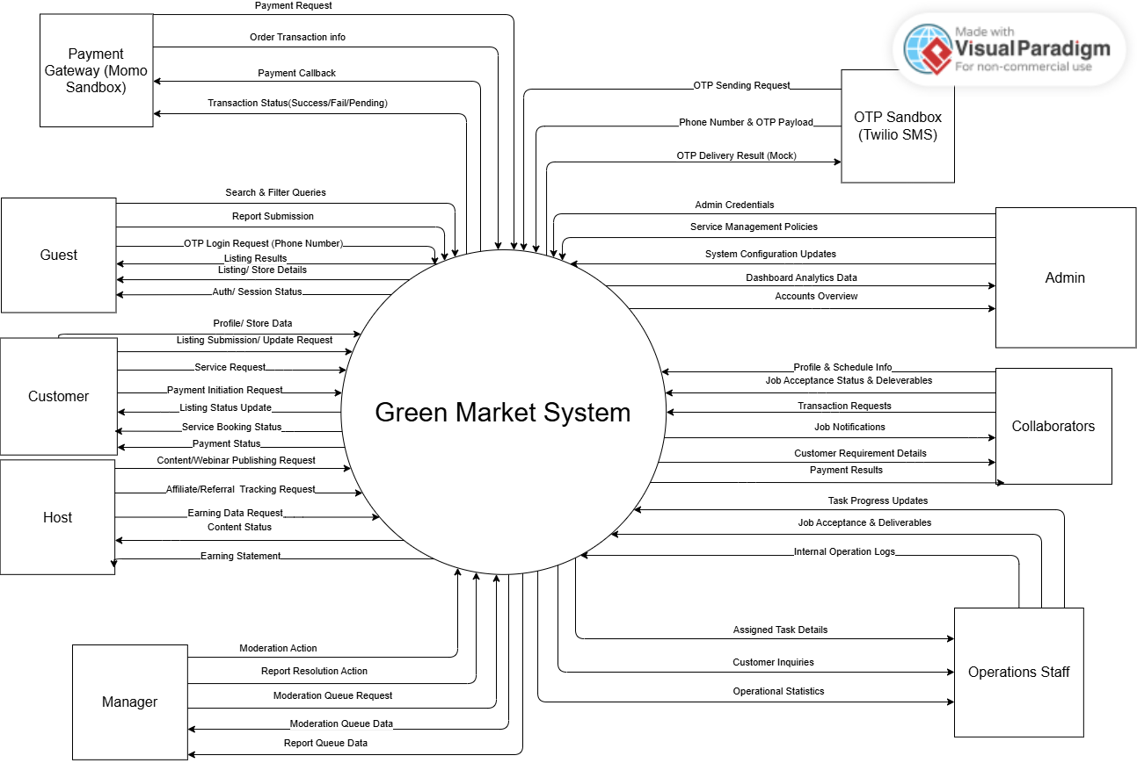
Figure 1.1: Context diagram for GreenMarket
Link diagram: https://online.visual-paradigm.com/share.jsp?id=343432353536352d36

1.2 Main Workflows

1.2.1 WF-01 Customer Creates Store Flow
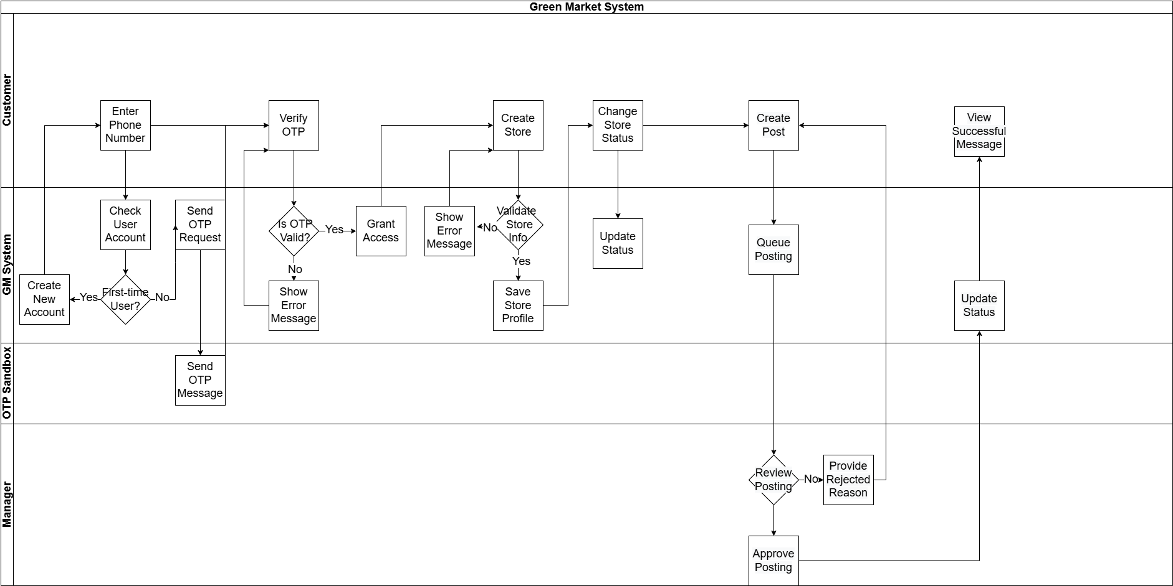

Figure 1.2.1: Customer Creates Store Flow

Link Diagram: Link Diagram

1.2.2 WF-02 Host Create Promotion Content Flow
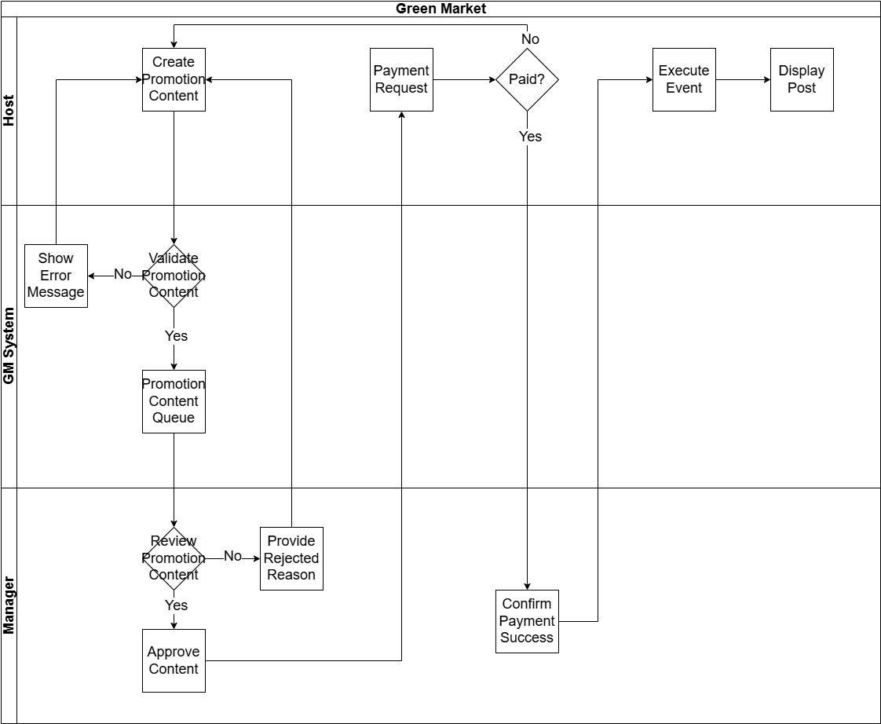
Figure 1.2.2: Host Create Promotion Content Flow
Link Diagram: link diagram

1.2.3 WF-03 Collaborator Accept Task Flow

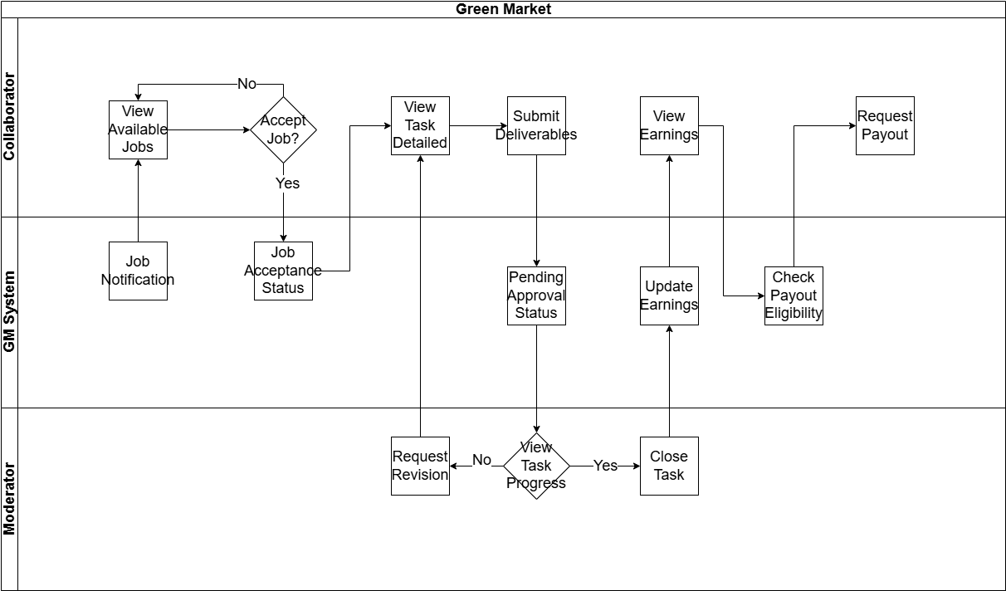
Figure 1.2.3: Collaborator Accept Task Flow
Link Diagram: link diagram

1.2.4 WF-04 Admin Manage Account Flow

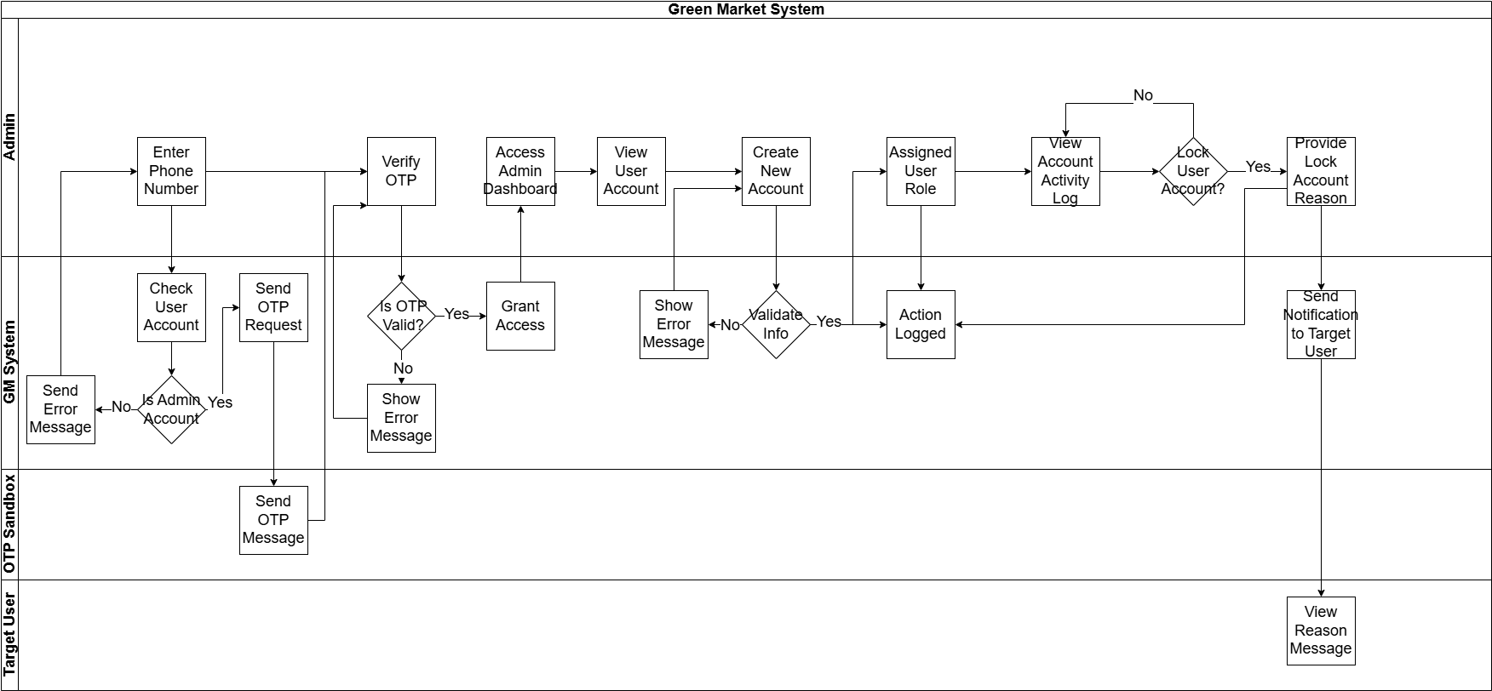
Figure 1.2.4: Admin Manage Account Flow
Link Diagram: link diagram

1.2.5 WF-05 AI Recommendation Flow

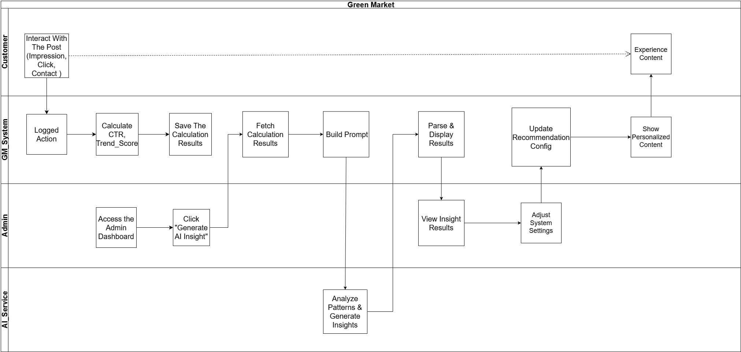
Figure 1.2.5: AI Recommendation Flow
Link Diagram: link diagram

1.3 User Requirements

1.3.1 Actors

# | Actor | Description
1 | Guest | Unauthenticated app user. Can browse/search/view listings and submit reports.
2 | Customer | Authenticated user (buyer/seller). Can create storefront, post listings, manage favorites, and report content.
3 | Manager | Operational moderator on the app. Reviews moderation queue, approves/rejects/hides listings, and resolves reports.
4 | Admin | System administrator (web only). Configures taxonomy/attributes, manages templates, provisions internal roles, analytics/export.
5 | Host | Content contributor/affiliate. Publishes content/webinar announcements and views earnings statement (mock).
6 | Collaborator | Freelance service provider. Maintains service profile and accepts customer jobs (photo/content assistance).
7 | Operations Staff | Internal staff supporting operations (tasks/tickets) in a minimal scope.
8 | Payment Gateway (Momo sandbox) | External payment sandbox used for demo of plans/featured listings.
9 | OTP/SMS Sandbox (Mock) | External OTP/SMS sandbox used to generate/verify OTP codes for phone-based login in demo mode (no real SMS cost).

1.3.2 Use Cases (UC)

ID | Use Case | Feature | Use Case Description
App-based
UC01 | Register phone number | Authentication | Register account using phone number.
UC02 | Login |  | Log in to the system.
UC03 | Logout |  | Log out from the system.
UC04 | View profile | Profile Management | Displays current user profile information and role details.
UC05 | Edit profile |  | Edit profile details.
UC06 | Create shop | Shop Management | The customer creates a shop profile (name, phone, location, description).
UC07 | View shop details |  | Displays shop profile and its published listings.
UC08 | Edit shop |  | Customer updates shop information and images.
UC09 | Manage shop status |  | Close or reopen the shop temporarily.
UC10 | Search shops |  | Search shops by keyword or location.
UC11 | View shop statistics |  | View shop performance statistics.
UC12 | View news feed | Post Management | Browse latest posts.
UC13 | Search, filter and sort posts |  | Search, filter, sort, and view trending or recommended posts.
UC14 | View post details |  | View detailed information of a post.
UC15 | Share post |  | Share post link.
UC16 | View my posts |  | View list of my own posts.
UC17 | Create post |  | Create a new post.
UC18 | Edit post |  | Edit post information (price, visibility, content).
UC19 | Move post to trash |  | Soft delete a post.
UC20 | Restore post from trash |  | Restore deleted posts within 30 days.
UC21 | Permanently delete post |  | Permanently delete posts after 30 days.
UC22 | Submit post for moderation |  | Submit post for approval.
UC23 | View rejection reason |  | View reason if post is rejected.
UC24 | Manage post images |  | Upload, remove, and reorder images.
UC25 | Add post to favorites | Favorite Management | Add a post to your favorite list.
UC26 | Remove post from favorites |  | Remove posts from favorites.
UC27 | View favorite posts |  | View list of favorite posts.
UC28 | Clear favorite list |  | Remove all favorite posts.
UC29 | Create report | Reports Management | Report a post or shop.
UC30 | Attach report evidence |  | Attach evidence to report.
UC31 | View my reports |  | View submitted reports.
UC32 | Cancel report |  | Cancel a report before processing.
UC33 | View report result |  | View report handling result.
UC34 | Block shop |  | Block a shop.
UC35 | Unblock shop |  | Unblock a previously blocked shop.
UC36 | View moderation queue | Moderation Management | View pending and reported posts.
UC37 | Moderate post |  | Approve, reject, hide, or unhide posts.
UC38 | Resolve report |  | Handle and close reports.
UC39 | Send moderation feedback |  | Send feedback to the post owner.
UC40 | View moderation history |  | View moderation actions history.
UC41 | View moderation statistics |  | View moderation workload statistics.
UC42 | Escalate violation |  | Escalate serious violation to admin.
UC43 | View assigned tasks | Operations Staff Management | View assigned tasks.
UC44 | Handle customer support requests |  | Handle user support tickets.
UC45 | Update task status |  | Update task progress.
UC46 | View daily operation workload |  | View daily workload.
UC47 | View system notifications |  | View system notifications.
UC48 | View available jobs | Collaborator Management | View available service jobs.
UC49 | Accept or decline job |  | Accept or decline a job.
UC50 | View collaborator earnings |  | View earnings.
UC51 | Request payout |  | Request payout.
UC52 | Submit job result |  | Submit completed work.
UC53 | View host dashboard | Host Management | View host dashboard.
UC54 | Create promotional content |  | Create promotional content.
UC55 | View host earnings |  | View earnings.
UC56 | Request host payout |  | Request payout.
UC57 | View promotion packages | Promotion & Placement Management | Customer views available promotion packages by slot (Home/Category/Search), duration, and price (sandbox).
UC58 | Purchase promotion package (sandbox) |  | Customer purchases a package via MoMo sandbox and receives purchase status.
UC59 | Assign package to post (boost) |  | Customer selects a post and assigns an active package to boost it in a chosen slot.
UC60 | View boosted post status |  | Customer views boost status (active/expired), slot, start/end date.
UC61 | Cancel boost / unassign package |  | Customer cancels a boost (if policy allows) and the post returns to normal ranking.
UC62 | View my purchase history |  | Customer views their purchased promotion packages and payment status (sandbox), including slot, duration, price, and effective time.
UC63 | View post performance | Analytics Management | Customer views post analytics (impressions/clicks/detail views/contact clicks) in last 7/30 days.
UC64 | View shop performance |  | Customer views shop-level analytics (views, top posts, engagement trend).
UC65 | View “best time to post” suggestion |  | Customer sees suggested peak hours/time windows derived from recent engagement stats (no AI required).
UC66 | View AI recommendations (optional) | AI-assisted Insights | Customer requests AI-written recommendations based on computed metrics (slot CTR, category hotness, peak hours).
UC67 | View AI insight history (optional) |  | Customer views previously generated AI insight summaries (stored text).
Web Admin -based
UC68 | View category list | Category & Attribute Management | View all categories.
UC69 | Create category |  | Create a new category.
UC70 | Edit or disable category |  | Edit or disable a category.
UC71 | View attribute list |  | View list of attributes.
UC72 | Create attribute |  | Create new attributes.
UC73 | Edit or disable attribute |  | Edit or disable attribute.
UC74 | Configure category attributes |  | Assign attributes to categories.
UC75 | Preview post form configuration |  | Preview post creation form.
UC76 | View system settings | System Settings Management | View current system configuration (OTP sandbox mode, post limits, report limits, etc.).
UC77 | Update system settings |  | Admin updates system configurations (e.g., max images per post, post expiry days, rate limits).
UC78 | Manage content rules (banned keywords) |  | Admin maintains banned keywords list to pre-check post content (basic anti-spam).
UC79 | Manage post lifecycle rules |  | Configure post status/lifecycle rules (e.g., auto-expire after N days; trash restore within 30 days).
UC80 | View user accounts | Account Management | View all user accounts.
UC81 | Assign or remove roles |  | Assign or remove system roles.
UC82 | Lock user account |  | Lock user account.
UC83 | Unlock user account |  | Unlock user account.
UC84 | View user role assignments |  | View role assignments of users.
UC85 | View account activity log |  | View account activity history.
UC86 | Receive system notifications | Additional System Utilities | Receive system notifications.
UC87 | View system announcements |  | View system announcements.
UC88 | Manage notification settings |  | Enable or disable notifications.
UC89 | Submit feedback to system |  | Submit feedback or suggestions.
UC90 | View admin dashboard | System Dashboard & Export | View high-level KPIs overview (total posts/shops, pending moderation, reports, basic traffic summary) for a selected time range.
UC91 | Export data to CSV |  | Export system data to CSV with filters (time range, category, shop, status), including posts, shops, reports/moderation, and placement analytics (slot CTR/click/contact conversion).
UC92 | Manage placement slots | Promotion & Placement Admin Management | Admin CRUD placement slots: create/list/update/disable slots (Home Top/Category Top/Search Boost) with scope, position, priority, and capacity. Slots control where boosted posts are displayed and enforce visibility limits/rules.
UC93 | Manage package plans |  | Admin creates/updates/disables package plans (slot, duration, price).
UC94 | View promotions list |  | Admin views all active/expired boosts by post/customer, slot, time window.
UC95 | Enforce promotion rules |  | Admin applies policy (limit per post, slot capacity, cooldown) and resolves conflicts.
UC96 | View placement analytics dashboard | Analytics Management | View detailed placement performance metrics by slot/category/time (impressions, clicks, CTR, contact conversion) for 7/30 days.
UC97 | View trend scoring report |  | View computed trend scores (slot score, hot categories, peak hours) using heuristic formula and moving average/smoothing over recent period.
UC99 | Generate AI insight summary (optional) | AI-assisted Insights | Admin requests AI-generated summary from aggregated metrics (no raw user data).
UC100 | Manage AI insight settings (optional) |  | Configure AI insights (enable/disable, prompt template, refresh frequency, output format) based on aggregated analytics only (no raw personal data).
UC101 | View revenue summary | Financial Analytics | Admin views total revenue from promotion packages by time range (7/30 days), slot, and package plan (sandbox payment records).
UC102 | View customer spending report (sandbox) |  | Admin views each customer’s total spending and purchase history for promotion packages (plan, slot, amount, status) within a selected time range.
UC103 | Export financial report to CSV (sandbox) |  | Admin exports promotion revenue/spending report to CSV with filters (date range, slot, plan, status) for reporting and analysis.
Web Client -based
UC104 | Rate and review a shop | Rating and Review Management | As a customer, I want to rate and review a shop so that I can share my buying experience with others.
UC105 | Reply to customer reviews |  | As a shop owner, I want to reply to customer reviews so that I can interact with buyers and resolve issues.
UC106 | View shop average rating and review list |  | As a user, I want to view a shop's average rating and reviews so that I can evaluate its reputation before buying.
UC107 | Report a fake/abusive review |  | As a user, I want to report a fake or abusive review so that the platform remains trustworthy.
UC108 | View reward points balance | Point & Loyalty System | As a user, I want to view my reward points balance so that I know how many points I currently have.
UC109 | Earn points via purchases or events |  | As a user, I want to earn points via purchases or events so that I can accumulate rewards for later use.
UC110 | Redeem points for promotion packages |  | As a shop owner, I want to redeem points for promotion packages so that I can boost my posts without spending money.
UC111 | View point transaction history |  | As a user, I want to view my point transaction history so that I can track my point earnings and usage.
UC112 | Browse and read news articles | News Hub | As a user, I want to browse and read news articles so that I can learn tips about plant care.
UC113 | Search news by keywords |  | As a user, I want to search news by keywords so that I can quickly find specific information.
UC114 | Share news to social platforms |  | As a user, I want to share news to social platforms so that I can spread useful knowledge to my friends.
UC115 | Login/Logout via Web Client | User Authentication & Profile | As a user, I want to log in and log out on the web so that I can access my account securely on a PC.
UC116 | View and update user profile on Web |  | As a user, I want to view and update my profile on the web so that my information is kept current.
UC117 | View news feed and categories on Web | Marketplace Discovery | As a user, I want to view the news feed and categories on the web so that I can browse available plants easily.
UC118 | Advanced search and filter posts on Web |  | As a user, I want to use advanced search and filters on the web so that I can find exactly the plant I need.
UC119 | View post details and seller contact info on Web |  | As a user, I want to view post details and seller contact info on the web so that I can contact them to make a purchase.
UC120 | Create and edit shop profile on Web | Seller Workspace | As a shop owner, I want to create and edit my shop profile on the web so that I can manage my brand effectively.
UC121 | Create and edit posts via Web dashboard |  | As a shop owner, I want to create and edit posts on the web so that I can manage my listings efficiently on a large screen.
UC122 | Bulk upload and manage post images |  | As a shop owner, I want to bulk upload images on the web so that I can save time when listing multiple plants.
UC123 | View and manage shop earnings on Web |  | As a shop owner, I want to view and manage my shop earnings on the web so that I can track my financial performance and request payouts from my PC.
UC124 | Manage favorite posts on Web | User Interactions | As a user, I want to manage favorite posts on the web so that I can save and organize items I want to buy later.
UC125 | Submit post/shop reports via Web |  | As a user, I want to submit reports on the web so that I can easily attach visual evidence of violations from my computer.
UC126 | Submit and view shop ratings on Web |  | As a user, I want to submit and view shop ratings on the web so that I can evaluate sellers conveniently.
UC127 | View and purchase promotion packages on Web | Promotion & Points Dashboard | As a shop owner, I want to purchase promotion packages on the web so that I can increase the visibility of my posts.
UC128 | Manage boosted posts on Web |  | As a shop owner, I want to manage boosted posts on the web so that I can track the status of my advertising campaigns.
UC129 | View point balance and loyalty history on Web |  | As a user, I want to view my point balance and loyalty history on the web so that I can manage my rewards from my PC.

1.3.3 Use Case Diagrams
1.3.3.1 : UCs for Guest

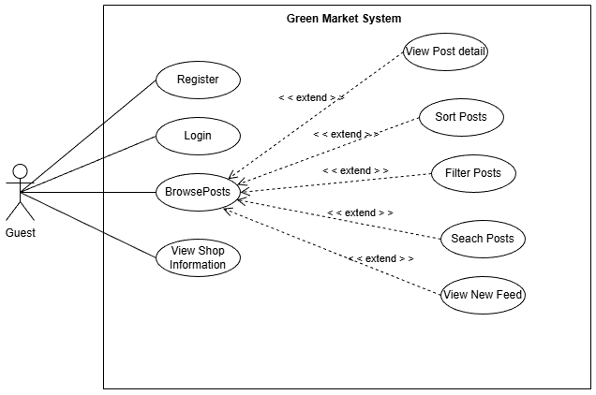
Figure 1.3.1: Use Case Diagram for Guest
Link diagram :GuestUseCase.drawio.png

1.3.3.2 : UCs for Customer
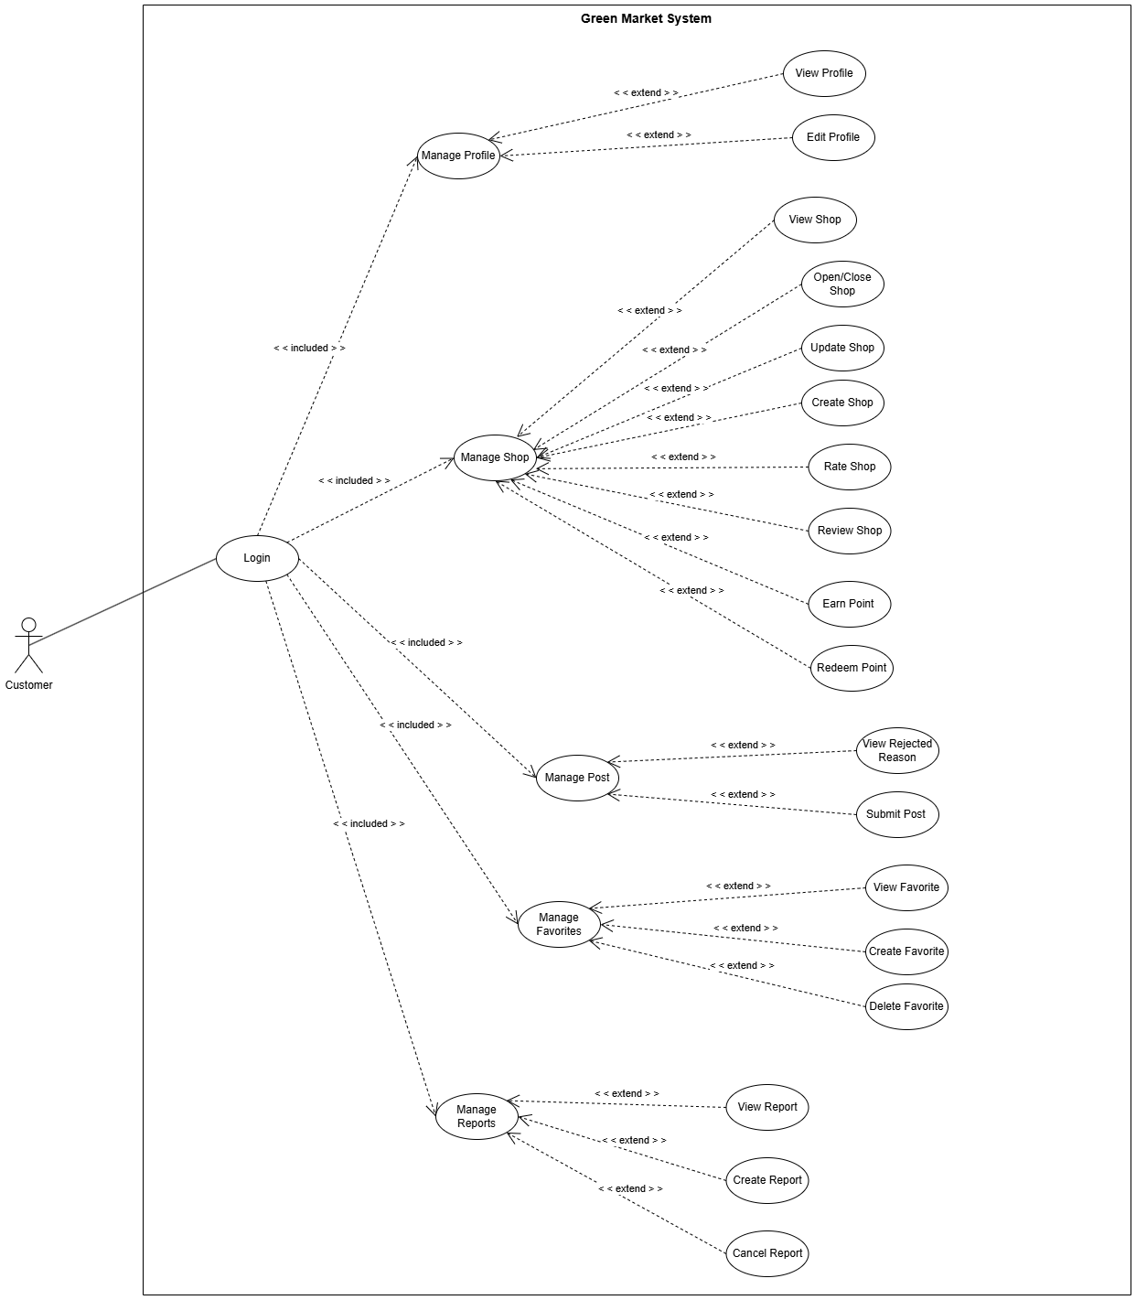
Figure 1.3.2: Use Case Diagram for Customer
Link diagram: -CustomerUseCase.drawio.png
1.3.3.3: UCs for Manager
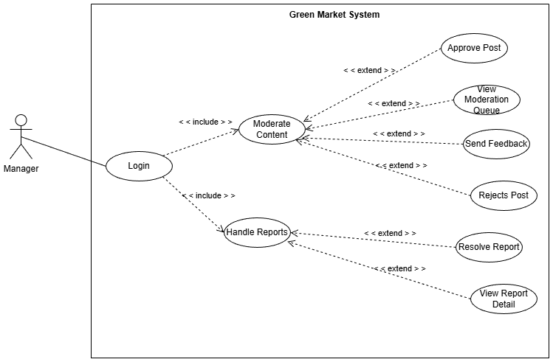
Figure 1.3.3: Use Case Diagram for Manager
Link diagram: -ManagerUseCase.drawio.png

1.3.3.4 : UCs for Admin
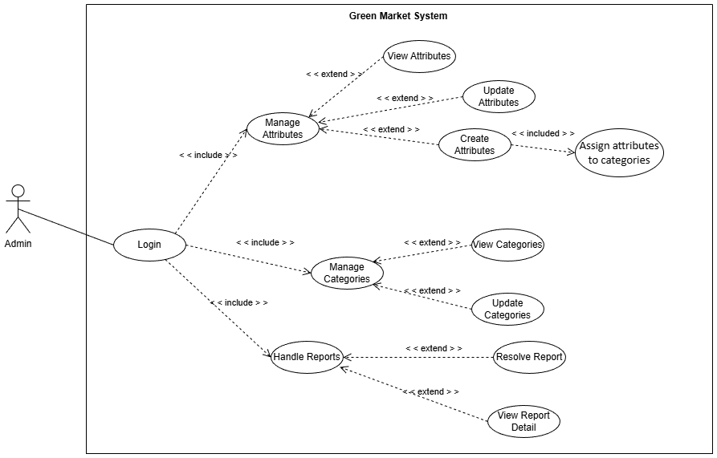
Figure 1.3.4: Use Case Diagram for Admin
Link diagram:-AdminUseCase.drawio.png

1.3.3.5 : UCs for Host
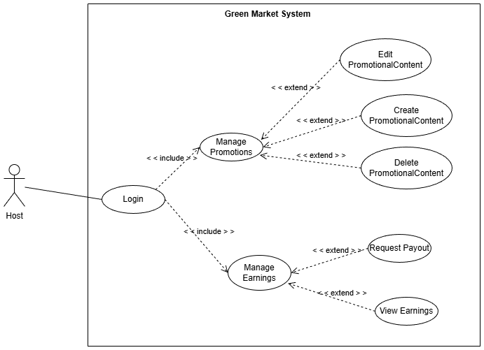
Figure 1.3.5: Use Case Diagram for Host
Link diagram:-HostUseCase.drawio.png

1.3.3.6 : UCs for Collaborator
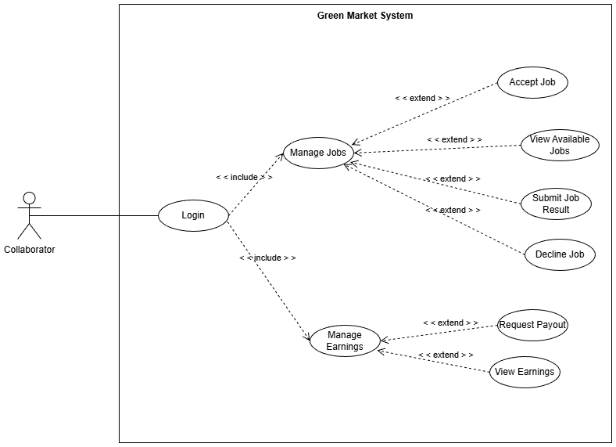
Figure 1.3.6: Use Case Diagram for Collaborator
Link diagram: -CollaboratorUseCase.drawio.png

1.3.3.7 : UCs for Operations Staff
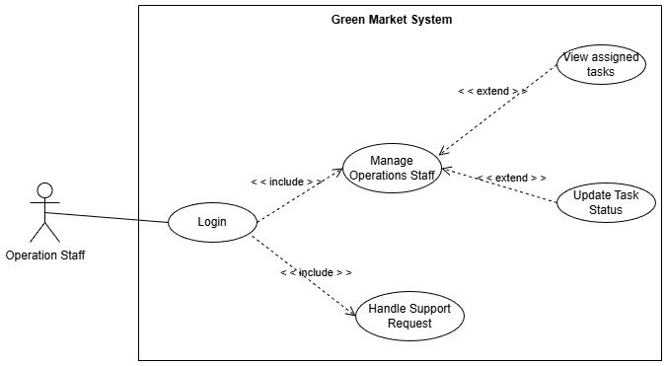
Figure 1.3.7: Use Case Diagram for Operations Staff
Link diagram:-OperationStaffUseCase.drawio.png

1.4 System Functionalities

1.4.1 Screens Flow

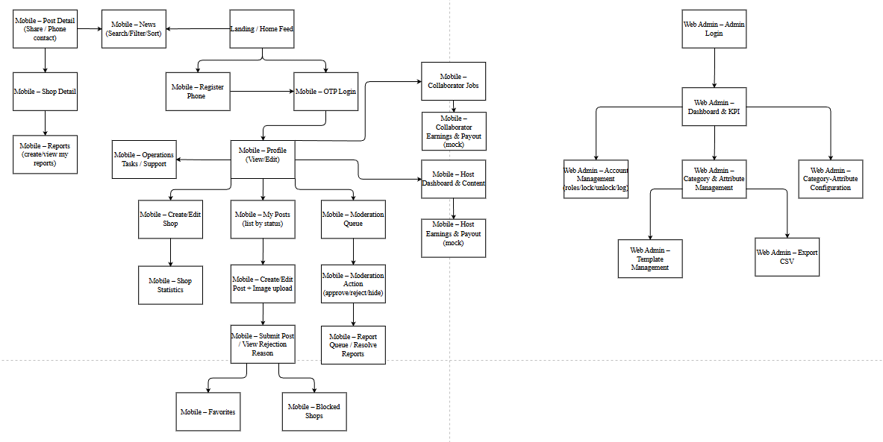
Figure 1.4.1: Mobile App - Screen Flow and Web Admin - Screen Flow of GM
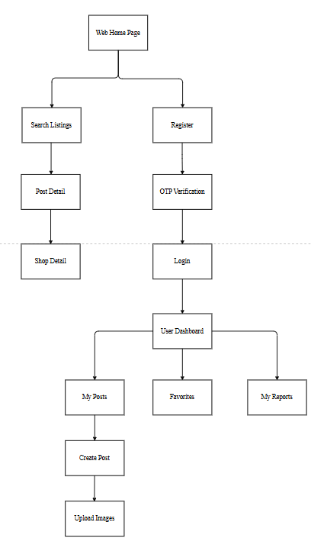
Figure 1.4.2: Web Client – Screen Flow of GM
Link diagram: https://online.visual-paradigm.com/share.jsp?id=333231303735362d32

1.4.2 Screen Authorization
Legend: 'X' means the role can access the screen/module. Admin functions are on Web Admin; other roles use Mobile App.
Screen / Module | Guest | Customer | Manager | Host | Collaborator | Operations Staff | Admin (Web)
Mobile + Web client – Landing / Home Feed | X | X | X | X | X | X
Mobile + Web client – Register Phone | X | X | X | X | X | X
Mobile + Web client – OTP Login | X | X | X | X | X | X
Mobile + Web client – Profile (View/Edit) |  | X | X | X | X | X
Mobile + Web client – News (Search/Filter/Sort) | X | X | X | X | X | X
Mobile + Web client – Post Detail (Share / Phone contact) | X | X | X | X | X | X
Mobile + Web client – Shop Detail | X | X | X | X | X | X
Mobile + Web client – Create/Edit Shop |  | X
Mobile + Web client – Shop Statistics |  | X
Mobile + Web client – My Posts (list by status) |  | X
Mobile + Web client – Create/Edit Post + Image upload |  | X
Mobile + Web client – Submit Post / View Rejection Reason |  | X
Mobile + Web client – Favorites |  | X
Mobile + Web client – Reports (create/view my reports) | X | X
Mobile + Web client – Blocked Shops |  | X
Mobile + Web client – Moderation Queue |  |  | X
Mobile – Moderation Action (approve/reject/hide) |  |  | X
Mobile + Web client – Report Queue / Resolve Reports |  |  | X
Mobile – Collaborator Jobs |  |  |  |  | X
Mobile – Collaborator Earnings & Payout (mock) |  |  |  |  | X
Mobile – Host Dashboard & Content |  |  |  | X
Mobile – Host Earnings & Payout (mock) |  |  |  | X
Mobile – Operations Tasks / Support |  |  |  |  |  | X
Web Admin – Admin Login |  |  |  |  |  |  | X
Web Admin – Dashboard & KPI |  |  |  |  |  |  | X
Web Admin – Account Management (roles/lock/unlock/log) |  |  |  |  |  |  | X
Web Admin – Category & Attribute Management |  |  |  |  |  |  | X
Web Admin – Category-Attribute Configuration |  |  |  |  |  |  | X
Web Admin – Template Management |  |  |  |  |  |  | X
Web Admin – Export CSV |  |  |  |  |  |  | X
Mobile + Web client – Shop Rating Screen |  | X
Mobile + Web client – Loyalty Points Screen |  | X
Note: Screens not available to Guest require an authenticated session (OTP login).

1.4.3 Non-UI Functions
# | Feature | System Function | Description
1 | OTP/SMS Sandbox (Mock) | Generate OTP code | Generate OTP for demo mode and return via response/log (no real SMS cost).
2 | Authentication | JWT token issuance/validation | Issue and validate JWT tokens after OTP verification; handle expiry and logout.
3 | Authorization (RBAC) | Role-based API guards | Enforce role permissions (Guest/Customer/Manager/Host/Collaborator/Operations Staff/Admin) on all APIs.
4 | Data Performance | PostgreSQL indexes | Apply compound/text indexes to support search/filter and queue queries (moderation/reports).
5 | ORM | Prisma | Data access via Prisma ORM (schema, migrations, query layer) for PostgreSQL

1.5 Entity Relationship Diagram

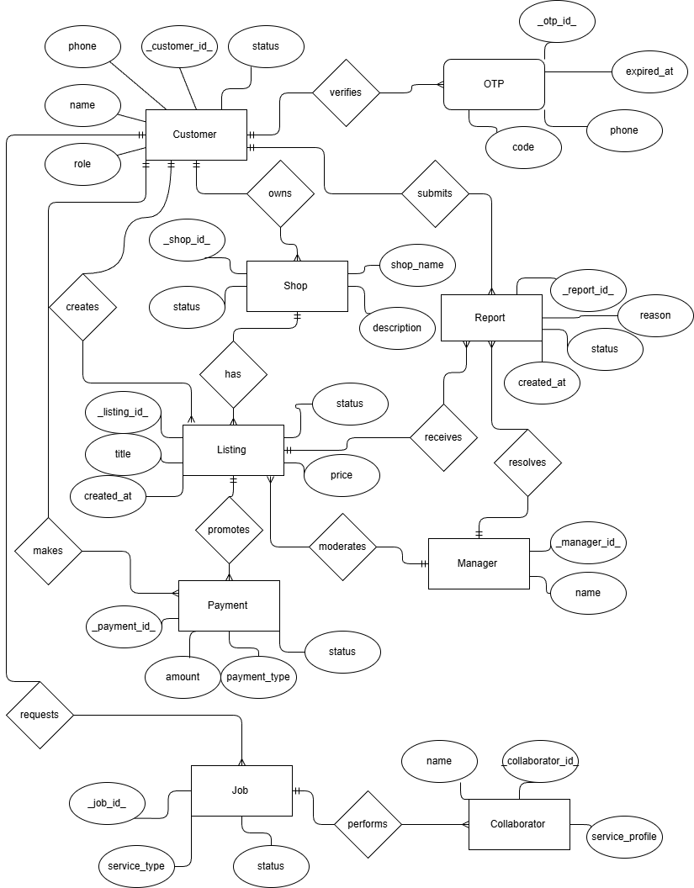
Figure 1.5.1: Logical ERD of GM
Link diagram: Logical ERD diagram

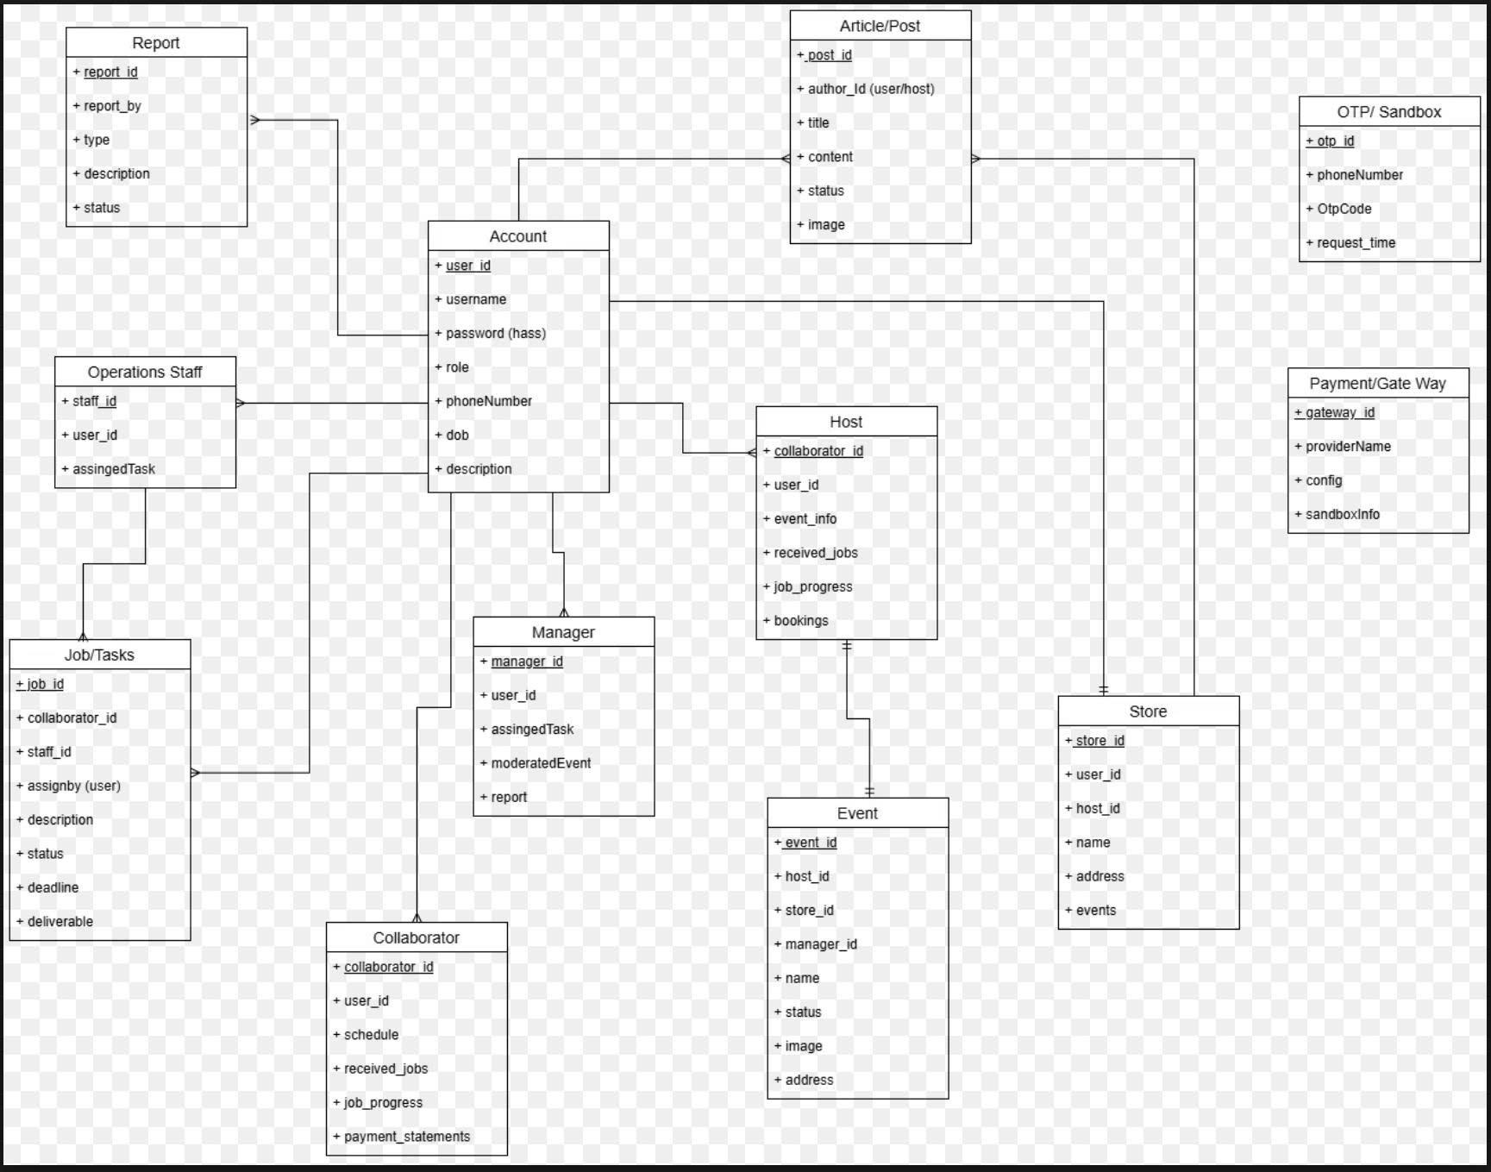
Figure 1.5.2: Physical ERD of GM
Link diagram:

Entities Description:
# | Entity | Description
1 | Account | User identity and authentication data (unique phone number, status, createdAt).
2 | Role | System role definition (Guest, Customer, Manager, Admin, OperationsStaff, Collaborator, Host).
3 | AccountRole | Many-to-many mapping between Account and Role.
4 | Shop | Customer shop profile (name, contact phone, location, description, status, ownerAccountId).
5 | Post | Plant post created by a shop (content, price, location, status: Draft/Pending/Approved/Rejected/Hidden/Trash).
6 | PostImage | Image metadata for a post (url, orderIndex, isCover, postId).
7 | Category | Plant category taxonomy (name, order, status).
8 | Attribute | Attribute field definition (type, options, status) used for structured post data.
9 | CategoryAttributeConfig | Config which attributes are used for each category (required/optional, order, inputType).
10 | PostAttributeValue | Stores attribute values for a post (postId, attributeId, value).
11 | Template | Post template content for quick posting and quality improvement.
12 | ModerationQueueItem | Represents a post queued for moderation (postId, reason, queuedAt).
13 | ModerationActionLog | Logs moderation decisions (approve/reject/hide/unhide) with actor, time, and note/template.
14 | RejectionReason | Predefined rejection reasons/templates used in moderation feedback.
15 | Report | Report submitted against Post/Shop (reasonCode, note, status).
16 | ReportEvidence | Evidence attached to a report (file/image URL).
17 | ReportResolution | Resolution result for a report (actionType, note, resolvedBy, resolvedAt).
18 | BlockedShop | Customer blocks a shop to hide its posts (customerAccountId, shopId).
19 | Favorite | Favorite relation between Customer and Post.
20 | Notification | In-app notification event (type, content, receiverId, readStatus).
21 | NotificationPreference | Per-user notification settings.
22 | Announcement | System announcements visible to Guest/Customer.
23 | Feedback | Customer feedback submissions for system improvement.
24 | OTPRequest | OTP request record (sandbox): phone, expiresAt, attempts, rateLimitWindow.
25 | OTPVerificationLog | Logs OTP verification attempts for audit and rate limiting.
26 | OperationTask | Internal task assigned to Operations Staff (status, priority, assignee).
27 | SupportTicket | Support request created by users and handled by Operations Staff.
28 | Job | Service job between Customer and Collaborator (jobType, requirements, status).
29 | JobDeliverable | Deliverables submitted by collaborator for a job (URLs, note).
30 | EarningStatement | Mock earnings statement for Host/Collaborator (period, totals, breakdown).
31 | PayoutRequest | Mock payout request for Host/Collaborator (amount, status).
32 | HostContent | Promotional content/webinar announcement created by Host.
33 | AdminActivityLog | Audit log for admin operations (role assignments, locks, config changes, exports).
34 | ExportRequest | Tracks CSV export requests (type, filters, requestedBy, generatedAt).
35 | PaymentTransaction (optional) | MoMo sandbox transaction attempts for plan/boost demo (no real settlement).

2. Use Case Specification

2.1 Authentication

2.1.1 Register phone number
Primary Actors | All | Secondary Actors | OTP/SMS Sandbox
Description | As a user, I want to register my phone number so that I can create an account for future OTP login.
Preconditions | • User is on registration screen.
Postconditions | • Account is created and linked to phone number; user can proceed to login.
Normal Sequence/Flow | 1. User enters phone number and taps 'Register'.  2. System validates phone format and checks duplicates.  3. System creates account with default role (Customer) and status Active.  4. System confirms registration success.
Alternative  Sequences/Flows | A1_Invalid phone format  1. System shows validation error and asks user to correct the phone number.  A2_Phone already registered  1. System shows 'Phone number already exists' and suggests logging in instead.

2.1.2 Login
Primary Actors | All | Secondary Actors | OTP/SMS Sandbox
Description | As a user, I want to log in using OTP so that I can access the system securely.
Preconditions | • User has a registered phone number.
Postconditions | • User is authenticated and redirected to home screen.
Normal  Sequence/Flow | 1. User enters phone number and requests OTP.  2. System sends OTP via sandbox and shows OTP input screen.  3. User enters OTP and submits.  4. System verifies OTP and creates a session/token.
Alternative  Sequences/Flows | A1_Invalid OTP  1. System rejects OTP and allows retry within limit.  A2_OTP expired  1. System asks user to request a new OTP.

2.1.3 Logout
Primary Actors | Authenticated Users | Secondary Actors | None
Description | As a user, I want to log out so that my session is closed on this device.
Preconditions | • User is logged in.
Postconditions | • User session is terminated and user returns to login screen.
Normal  Sequence/Flow | 1. User taps 'Logout'.  2. System clears session/token.  3. System redirects user to login screen.
Alternative  Sequences/Flows | A1_Session already expired  1. System redirects user to login screen and asks to login again.

2.2 Profile Management

2.2.1 View profile
Primary Actors | Authenticated Users | Secondary Actors | None
Description | As a user, I want to view my profile so that I can see my current account information and role.
Preconditions | • User is logged in.
Postconditions | • Profile information is displayed.
Normal  Sequence/Flow | 1. User opens Profile screen.  2. System loads profile details (name, phone, role, bio).  3. System displays profile details.
Alternative  Sequences/Flows | A1_Profile not found  1. System shows error and suggests re-login or contact support.

2.2.2 Edit profile
Primary Actors | Authenticated Users | Secondary Actors | None
Description | As a user, I want to edit my profile so that my contact information is up to date.
Preconditions | • User is logged in.
Postconditions | • Profile updates are saved.
Normal  Sequence/Flow | 1. User opens Edit Profile.  2. User updates editable fields (name, location, bio).  3. System validates inputs.  4. System saves changes and confirms success.
Alternative  Sequences/Flows | A1_Invalid input  1. System highlights invalid fields and asks user to correct and resubmit.

2.3 Shop Management

2.3.1 Create shop
Primary Actors | Customer | Secondary Actors | None
Description | As a customer, I want to create a shop profile so that I can sell and manage my listings.
Preconditions | • User is authenticated as Customer.  • User has not created a shop yet.
Postconditions | • Shop profile is created and visible to other users.
Normal  Sequence/Flow | 1. User opens Create Shop.  2. User enters shop details (name, phone, location, description).  3. System validates required fields.  4. System saves shop profile and confirms success.
Alternative  Sequences/Flows | A1_Missing required fields  1. System prompts user to complete required shop fields.  A2_Shop already exists  1. System redirects user to Edit Shop screen.

2.3.2 View shop details
Primary Actors | All | Secondary Actors | None
Description | As a user, I want to view a shop so that I can see its information and published listings.
Preconditions | • Shop exists.
Postconditions | • Shop details and listings are displayed.
Normal  Sequence/Flow | 1. User opens a shop from search/feed.  2. System loads shop profile and published listings.  3. System displays shop details and listing grid.
Alternative  Sequences/Flows | A1_Shop not found/disabled  1. System shows message that the shop is unavailable.

2.3.3 Edit shop
Primary Actors | Customer | Secondary Actors | None
Description | As a customer, I want to edit my shop so that my shop information and images stay accurate.
Preconditions | • User is authenticated as Customer.  • User owns the shop.
Postconditions | • Shop information is updated.
Normal  Sequence/Flow | 1. User opens Edit Shop.  2. User updates shop fields and images.  3. System validates inputs.  4. System saves changes and confirms success.
Alternative  Sequences/Flows | A1_Invalid input  1. System highlights invalid fields and asks user to fix.

2.3.4 Manage shop status
Primary Actors | Customer | Secondary Actors | None
Description | As a customer, I want to close or reopen my shop so that I can pause selling when needed.
Preconditions | • User is authenticated as Customer.  • User owns the shop.
Postconditions | • Shop status is updated (Open/Closed) and reflected to viewers.
Normal  Sequence/Flow | 1. User opens Shop Settings.  2. User toggles status to Close/Reopen.  3. System updates status and confirms.
Alternative  Sequences/Flows | A1_Shop has policy restriction  1. System blocks action and shows the reason (e.g., shop locked).

2.3.5 Search shops
Primary Actors | All | Secondary Actors | None
Description | As a user, I want to search shops so that I can find sellers by keyword or location.
Preconditions | • System has shop data.
Postconditions | • Search results are displayed.
Normal  Sequence/Flow | 1. User enters keyword/location in search box.  2. System returns matching shops.  3. User opens a shop from results.
Alternative  Sequences/Flows | A1_No results  1. System shows 'No shops found' and suggests changing keywords.

2.3.6 View shop statistics
Primary Actors | Customer | Secondary Actors | None
Description | As a customer, I want to view shop statistics so that I can understand my shop performance.
Preconditions | • User is authenticated as Customer.  • User owns the shop.
Postconditions | • Shop metrics are displayed (views, top posts, trends).
Normal  Sequence/Flow | 1. User opens Shop Statistics.  2. System aggregates shop metrics for selected period.  3. System displays charts/summary.
Alternative  Sequences/Flows | A1_No data  1. System shows empty state and guidance to publish listings.

2.4 Post Management

2.4.1 View news feed
Primary Actors | All | Secondary Actors | None
Description | As a user, I want to browse the news feed so that I can discover latest listings.
Preconditions | • System has published posts.
Postconditions | • Feed posts are displayed.
Normal  Sequence/Flow | 1. User opens Home/Feed.  2. System loads posts for ranking (boost + normal).  3. System displays feed with pagination.
Alternative  Sequences/Flows | A1_No posts  1. System shows empty feed and suggested actions.

2.4.2 Search, filter and sort posts
Primary Actors | All | Secondary Actors | None
Description | As a user, I want to search and filter posts so that I can find listings that match my needs.
Preconditions | • System has searchable post data.
Postconditions | • Filtered/sorted results are displayed.
Normal  Sequence/Flow | 1. User enters keywords or selects filters.  2. System applies filters/sort.  3. System displays results with pagination.
Alternative  Sequences/Flows | A1_No results  1. System shows 'No posts found' and suggests relaxing filters.

2.4.3 View post details
Primary Actors | All | Secondary Actors | None
Description | As a user, I want to view post details so that I can see full information before contacting seller.
Preconditions | • Post exists and is visible.
Postconditions | • Post detail page is displayed.
Normal  Sequence/Flow | 1. User opens a post from feed/search.  2. System loads post details.  3. System displays post detail page.
Alternative  Sequences/Flows | A1_Post removed/hidden  1. System shows message that the post is unavailable.

2.4.4 Share post
Primary Actors | All | Secondary Actors | None
Description | As a user, I want to share a post so that I can send the listing link to others.
Preconditions | • Post is visible.
Postconditions | • Share action is completed or share dialog is opened.
Normal  Sequence/Flow | 1. User taps Share on post.  2. System generates shareable link.  3. System opens native share options.
Alternative  Sequences/Flows | A1_Link generation failed  1. System shows error and allows retry.

2.4.5 View my posts
Primary Actors | Customer | Secondary Actors | None
Description | As a customer, I want to view my posts so that I can manage my listings.
Preconditions | • User is authenticated as Customer.
Postconditions | • User’s post list is displayed.
Normal  Sequence/Flow | 1. User opens My Posts.  2. System loads user's posts by status.  3. System displays list with filters.
Alternative  Sequences/Flows | A1_No posts  1. System shows empty state and 'Create post' CTA.

2.4.6 Create post
Primary Actors | Customer | Secondary Actors | None
Description | As a customer, I want to create a new post so that I can publish a listing.
Preconditions | • User is authenticated as Customer.  • User has a shop profile.
Postconditions | • Post is created (draft/pending) and saved.
Normal  Sequence/Flow | 1. User opens Create Post form.  2. User enters post info and images.  3. System validates required fields.  4. System saves post or submits for moderation.
Alternative  Sequences/Flows | A1_Missing required fields  1. System highlights missing fields and blocks submit.  A2_Image upload failed  1. System shows error and allows retry/remove image.

2.4.7 Edit post
Primary Actors | Customer | Secondary Actors | None
Description | As a customer, I want to edit my post so that the listing information stays accurate.
Preconditions | • User is authenticated as Customer.  • User owns the post.  • Post is editable (not locked).
Postconditions | • Post information is updated.
Normal  Sequence/Flow | 1. User opens Edit Post.  2. User changes fields.  3. System validates changes.  4. System saves updates and confirms.
Alternative  Sequences/Flows | A1_Post locked by moderation  1. System blocks edits and shows reason/status.

2.4.8 Move post to trash
Primary Actors | Customer | Secondary Actors | None
Description | As a customer, I want to move a post to trash so that I can hide it without deleting permanently.
Preconditions | • User is authenticated as Customer.  • User owns the post.
Postconditions | • Post status becomes Trashed and is hidden from public.
Normal  Sequence/Flow | 1. User taps 'Move to trash'.  2. System confirms action.  3. System updates post status to Trashed.
Alternative  Sequences/Flows | A1_User cancels  1. System keeps the post unchanged.

2.4.9 Restore post from trash
Primary Actors | Customer | Secondary Actors | None
Description | As a customer, I want to restore a trashed post so that it can be visible again.
Preconditions | • User is authenticated as Customer.  • Post is in trash and within restore window.
Postconditions | • Post is restored to previous status.
Normal  Sequence/Flow | 1. User opens Trash list.  2. User taps Restore.  3. System restores post and confirms.
Alternative  Sequences/Flows | A1_Restore window expired  1. System blocks restore and suggests permanent delete.

2.4.10 Permanently delete post
Primary Actors | Customer | Secondary Actors | None
Description | As a customer, I want to permanently delete a post so that it is removed from the system.
Preconditions | • User is authenticated as Customer.  • Post is in trash or eligible for delete.
Postconditions | • Post is permanently removed and cannot be restored.
Normal  Sequence/Flow | 1. User taps Delete permanently.  2. System asks for confirmation.  3. System deletes post and confirms.
Alternative  Sequences/Flows | A1_User cancels  1. System keeps the post in trash.

2.4.11 Submit post for moderation
Primary Actors | Customer | Secondary Actors | None
Description | As a customer, I want to submit my post for approval so that it can be published to the marketplace.
Preconditions | • User is authenticated as Customer.  • Post draft is complete.
Postconditions | • Post status becomes Pending and appears in moderation queue.
Normal  Sequence/Flow | 1. User taps Submit for moderation.  2. System validates post content.  3. System sets status to Pending and notifies user.
Alternative  Sequences/Flows | A1_Validation failed  1. System shows missing/invalid fields and blocks submit.

2.4.12 View rejection reason
Primary Actors | Customer | Secondary Actors | None
Description | As a customer, I want to view the rejection reason so that I can fix and resubmit my post.
Preconditions | • User is authenticated as Customer.  • Post is rejected.
Postconditions | • Rejection reason is displayed.
Normal  Sequence/Flow | 1. User opens rejected post detail.  2. System shows rejection reason.  3. User navigates to Edit Post to fix issues.
Alternative  Sequences/Flows | A1_No reason available  1. System shows generic message and suggests contacting support.

2.4.13 Manage post images
Primary Actors | Customer | Secondary Actors | None
Description | As a customer, I want to manage post images so that I can upload, remove, and reorder them.
Preconditions | • User is authenticated as Customer.  • User owns the post.
Postconditions | • Images are updated and saved.
Normal  Sequence/Flow | 1. User uploads/removes/reorders images.  2. System validates image count/size.  3. System saves image changes.
Alternative  Sequences/Flows | A1_Too many images  1. System blocks upload and shows max image limit.  A2_Invalid image format  1. System rejects file and shows supported formats.

2.5 Favorite Management

2.5.1 Add post to favorites
Primary Actors | Customer | Secondary Actors | None
Description | As a customer, I want to add a post to favorites so that I can revisit it later.
Preconditions | • User is authenticated as Customer.
Postconditions | • Post is added to favorites list.
Normal  Sequence/Flow | 1. User taps Favorite on a post.  2. System saves favorite record.  3. System shows confirmation.
Alternative  Sequences/Flows | A1_Already favorited  1. System shows 'Already in favorites'.

2.5.2 Remove post from favorites
Primary Actors | Customer | Secondary Actors | None
Description | As a customer, I want to remove a post from favorites so that my list stays relevant.
Preconditions | • User is authenticated as Customer.  • Post is in favorites.
Postconditions | • Favorite record is removed.
Normal  Sequence/Flow | 1. User opens Favorites list.  2. User taps Remove.  3. System removes favorite and updates list.
Alternative  Sequences/Flows | A1_Not found  1. System refreshes list and shows item was already removed.

2.5.3 View favorite posts
Primary Actors | Customer | Secondary Actors | None
Description | As a customer, I want to view my favorite posts so that I can compare saved listings.
Preconditions | • User is authenticated as Customer.
Postconditions | • Favorites list is displayed.
Normal  Sequence/Flow | 1. User opens Favorites.  2. System loads favorited posts.  3. System displays list with pagination.
Alternative  Sequences/Flows | A1_No favorites  1. System shows empty state.

2.5.4 Clear favorite list
Primary Actors | Customer | Secondary Actors | None
Description | As a customer, I want to clear my favorites so that I can start a new shortlist.
Preconditions | • User is authenticated as Customer.
Postconditions | • All favorites are removed.
Normal  Sequence/Flow | 1. User taps Clear all.  2. System asks for confirmation.  3. System clears favorites and updates UI.
Alternative  Sequences/Flows | A1_User cancels  1. System keeps favorites unchanged.

2.6 Reports Management

2.6.1 Create report
Primary Actors | Guest/Customer | Secondary Actors | None
Description | As a user, I want to report a post or shop so that I can flag inappropriate content.
Preconditions | • Target post/shop exists and is visible.
Postconditions | • Report is created with status Pending.
Normal  Sequence/Flow | 1. User taps Report.  2. User selects reason and optional description.  3. System creates report.  4. System confirms submission.
Alternative  Sequences/Flows | A1_Missing reason  1. System asks user to select a reason.

2.6.2 Attach report evidence
Primary Actors | Guest/Customer | Secondary Actors | None
Description | As a user, I want to attach evidence so that my report is clearer for reviewers.
Preconditions | • User is creating a report.
Postconditions | • Evidence file(s) are attached.
Normal  Sequence/Flow | 1. User selects Add Evidence.  2. User uploads file.  3. System validates size/type.  4. System attaches evidence.
Alternative  Sequences/Flows | A1_Invalid file  1. System rejects file and shows accepted formats/size limit.

2.6.3 View my reports
Primary Actors | Customer | Secondary Actors | None
Description | As a customer, I want to view my submitted reports so that I can track their processing status.
Preconditions | • User is authenticated as Customer.
Postconditions | • User report list is displayed.
Normal  Sequence/Flow | 1. User opens My Reports.  2. System loads reports created by user.  3. System displays status and submitted time.
Alternative  Sequences/Flows | A1_No reports  1. System shows empty state.

2.6.4 Cancel report
Primary Actors | Customer | Secondary Actors | None
Description | As a customer, I want to cancel a report so that I can retract it before processing.
Preconditions | • User is authenticated as Customer.  • Report is Pending and created by user.
Postconditions | • Report status becomes Cancelled.
Normal  Sequence/Flow | 1. User opens a pending report.  2. User taps Cancel.  3. System updates status and confirms.
Alternative  Sequences/Flows | A1_Report already processed  1. System blocks cancel and shows current status.

2.6.5 View report result
Primary Actors | Customer | Secondary Actors | None
Description | As a customer, I want to view the report result so that I know the final handling outcome.
Preconditions | • User is authenticated as Customer.  • Report is processed.
Postconditions | • Report resolution is displayed.
Normal  Sequence/Flow | 1. User opens report details.  2. System shows resolution and moderator note.  3. User can close the report.
Alternative  Sequences/Flows | A1_Result not available  1. System shows processing state and suggests checking later.

2.7 Moderation Management

2.7.1 Block shop
Primary Actors | Manager | Secondary Actors | None
Description | As a manager, I want to block a shop so that it cannot publish or be viewed due to violations.
Preconditions | • Manager is authenticated.  • Shop exists and is not blocked.
Postconditions | • Shop becomes Blocked; related posts are hidden; action is logged.
Normal  Sequence/Flow | 1. Manager opens shop action.  2. Manager selects Block and provides reason.  3. System blocks shop and hides posts.  4. System notifies shop owner.
Alternative  Sequences/Flows | A1_Insufficient permission  1. System denies action.

2.7.2 Unblock shop
Primary Actors | Manager | Secondary Actors | None
Description | As a manager, I want to unblock a shop so that it can operate again after review.
Preconditions | • Manager is authenticated.  • Shop is blocked.
Postconditions | • Shop becomes Active; action is logged.
Normal  Sequence/Flow | 1. Manager opens blocked shop.  2. Manager selects Unblock.  3. System updates status and logs action.
Alternative  Sequences/Flows | A1_Policy restriction  1. System blocks unblock and shows required conditions.

2.7.3 View moderation queue
Primary Actors | Manager | Secondary Actors | None
Description | As a manager, I want to view the moderation queue so that I can review pending or reported posts.
Preconditions | • Manager is authenticated.
Postconditions | • Queue list is displayed.
Normal  Sequence/Flow | 1. Manager opens Moderation Queue.  2. System loads pending and reported items.  3. Manager filters/sorts queue.
Alternative  Sequences/Flows | A1_No items  1. System shows empty queue.

2.7.4 Moderate post
Primary Actors | Manager | Secondary Actors | None
Description | As a manager, I want to approve/reject/hide a post so that marketplace content stays high quality.
Preconditions | • Manager is authenticated.  • Post is Pending/Reported.
Postconditions | • Post status is updated; action is logged; owner is notified.
Normal  Sequence/Flow | 1. Manager opens post from queue.  2. Manager reviews content.  3. Manager selects action and note.  4. System updates status and notifies owner.
Alternative  Sequences/Flows | A1_Already processed  1. System refreshes state and prevents duplicate action.

2.7.5 Resolve report
Primary Actors | Manager | Secondary Actors | None
Description | As a manager, I want to resolve a report so that reported content is handled and closed.
Preconditions | • Manager is authenticated.  • Report is Pending.
Postconditions | • Report becomes Resolved with outcome recorded.
Normal  Sequence/Flow | 1. Manager opens report.  2. Manager reviews evidence.  3. Manager chooses outcome and actions.  4. System closes report and logs decision.
Alternative  Sequences/Flows | A1_Report closed  1. System shows current status and prevents action.

2.7.6 Send moderation feedback
Primary Actors | Manager | Secondary Actors | None
Description | As a manager, I want to send feedback so that the post owner understands what to fix.
Preconditions | • Manager is authenticated.  • A moderation action exists.
Postconditions | • Feedback is sent and stored in history.
Normal  Sequence/Flow | 1. Manager selects template or writes note.  2. System sends notification.  3. System stores feedback with action log.
Alternative  Sequences/Flows | A1_Send failed  1. System retries or queues notification.

2.7.7 View moderation history
Primary Actors | Manager | Secondary Actors | None
Description | As a manager, I want to view moderation history so that I can audit past actions.
Preconditions | • Manager is authenticated.
Postconditions | • Moderation history is displayed.
Normal  Sequence/Flow | 1. Manager opens history.  2. System loads actions with filters.  3. Manager views action detail.
Alternative  Sequences/Flows | A1_No history  1. System shows empty state.

2.7.8 View moderation statistics
Primary Actors | Manager | Secondary Actors | None
Description | As a manager, I want to view moderation statistics so that I can monitor workload and trends.
Preconditions | • Manager is authenticated.
Postconditions | • Stats summary is displayed.
Normal  Sequence/Flow | 1. Manager opens statistics.  2. System aggregates metrics.  3. System displays charts/summary.
Alternative  Sequences/Flows | A1_No data  1. System shows empty state.

2.7.9 Escalate violation
Primary Actors | Manager | Secondary Actors | None
Description | As a manager, I want to escalate serious violations to admin so that higher-level action can be taken.
Preconditions | • Manager is authenticated.  • Violation is severe.
Postconditions | • Escalation ticket is created and admin is notified.
Normal  Sequence/Flow | 1. Manager selects Escalate.  2. Manager adds note/severity.  3. System creates escalation ticket.  4. System notifies admin.
Alternative  Sequences/Flows | A1_Admin unreachable  1. System queues escalation and confirms.

2.8 Operations Staff Management

2.8.1 View assigned tasks
Primary Actors | Operations Staff | Secondary Actors | None
Description | As operations staff, I want to view my assigned tasks so that I can handle work.
Preconditions | • Staff is authenticated.
Postconditions | • Assigned tasks are displayed.
Normal  Sequence/Flow | 1. Staff opens Assigned Tasks.  2. System loads tasks.  3. Staff views details/priority.
Alternative  Sequences/Flows | A1_No tasks  1. System shows empty state.

2.8.2 Handle customer support requests
Primary Actors | Operations Staff | Secondary Actors | None
Description | As operations staff, I want to handle support tickets so that user issues are resolved.
Preconditions | • Staff is authenticated.  • Ticket exists.
Postconditions | • Ticket is updated with resolution note.
Normal  Sequence/Flow | 1. Staff opens ticket.  2. Staff reviews info.  3. Staff updates status and resolution.  4. System logs update.
Alternative  Sequences/Flows | A1_Ticket closed  1. System prevents changes and shows status.

2.8.3 Update task status
Primary Actors | Operations Staff | Secondary Actors | None
Description | As operations staff, I want to update task status so that progress is tracked.
Preconditions | • Staff is authenticated.  • Task is assigned.
Postconditions | • Task status is updated.
Normal  Sequence/Flow | 1. Staff opens task.  2. Staff updates status and note.  3. System saves and logs timestamp.
Alternative  Sequences/Flows | A1_Invalid transition  1. System blocks and shows allowed statuses.

2.8.4 View daily operation workload
Primary Actors | Operations Staff | Secondary Actors | None
Description | As operations staff, I want to view daily workload so that I can plan work.
Preconditions | • Staff is authenticated.
Postconditions | • Workload summary is displayed.
Normal  Sequence/Flow | 1. Staff opens Daily Workload.  2. System aggregates tasks by status/due.  3. System displays summary.
Alternative  Sequences/Flows | A1_No data  1. System shows empty state.

2.8.5 View system notifications
Primary Actors | Operations Staff | Secondary Actors | None
Description | As operations staff, I want to view system notifications so that I can respond to events.
Preconditions | • Staff is authenticated.
Postconditions | • Notifications are displayed.
Normal  Sequence/Flow | 1. Staff opens Notifications.  2. System loads notifications.  3. Staff opens notification detail.
Alternative  Sequences/Flows | A1_No notifications  1. System shows empty state.

2.9 Collaborator Management

2.9.1 View available jobs
Primary Actors | Collaborator | Secondary Actors | None
Description | As a collaborator, I want to view available jobs so that I can accept suitable requests.
Preconditions | • Collaborator is authenticated.
Postconditions | • Available jobs list is displayed.
Normal  Sequence/Flow | 1. Collaborator opens Jobs board.  2. System lists jobs with filters.  3. Collaborator opens job detail.
Alternative  Sequences/Flows | A1_No jobs  1. System shows empty state.

2.9.2 Accept or decline job
Primary Actors | Collaborator | Secondary Actors | None
Description | As a collaborator, I want to accept/decline a job so that I can manage workload.
Preconditions | • Collaborator is authenticated.  • Job is open.
Postconditions | • Job status is updated and requester is notified.
Normal  Sequence/Flow | 1. Collaborator opens job.  2. Collaborator selects Accept/Decline.  3. System updates status.  4. System notifies requester.
Alternative  Sequences/Flows | A1_Job already taken  1. System blocks action and refreshes state.

2.9.3 View collaborator earnings
Primary Actors | Collaborator | Secondary Actors | None
Description | As a collaborator, I want to view my earnings so that I can track income (mock).
Preconditions | • Collaborator is authenticated.
Postconditions | • Earnings summary is displayed.
Normal  Sequence/Flow | 1. Collaborator opens Earnings.  2. System aggregates completed jobs.  3. System displays statement (mock).
Alternative  Sequences/Flows | A1_No earnings  1. System shows empty state.

2.9.4 Request payout
Primary Actors | Collaborator | Secondary Actors | None
Description | As a collaborator, I want to request payout so that I can withdraw earnings (mock).
Preconditions | • Collaborator is authenticated.  • Balance is available.
Postconditions | • Payout request is created (mock).
Normal  Sequence/Flow | 1. Collaborator taps Request payout.  2. Collaborator enters amount/method (mock).  3. System validates and creates request.
Alternative  Sequences/Flows | A1_Insufficient balance  1. System blocks request and shows available balance.

2.9.5 Submit job result
Primary Actors | Collaborator | Secondary Actors | None
Description | As a collaborator, I want to submit completed work so that the customer can confirm delivery.
Preconditions | • Collaborator is authenticated.  • Job is accepted.
Postconditions | • Job result is submitted and status updates.
Normal  Sequence/Flow | 1. Collaborator opens job.  2. Collaborator uploads result/note.  3. System saves result and updates status.
Alternative  Sequences/Flows | A1_Upload failed  1. System shows error and allows retry.

2.10 Host Management

2.10.1 View host dashboard
Primary Actors | Host | Secondary Actors | None
Description | As a host, I want to view my dashboard so that I can track content and earnings (mock).
Preconditions | • Host is authenticated.
Postconditions | • Dashboard is displayed.
Normal  Sequence/Flow | 1. Host opens dashboard.  2. System loads stats and summary.  3. System displays widgets.
Alternative  Sequences/Flows | A1_No data  1. System shows empty state.

2.10.2 Create promotional content
Primary Actors | Host | Secondary Actors | None
Description | As a host, I want to create promotional content so that I can publish information posts.
Preconditions | • Host is authenticated.
Postconditions | • Promotional content is created.
Normal  Sequence/Flow | 1. Host opens Create Content.  2. Host enters content and media.  3. System validates and saves content.
Alternative  Sequences/Flows | A1_Invalid content  1. System highlights missing fields.

2.10.3 View host earnings
Primary Actors | Host | Secondary Actors | None
Description | As a host, I want to view earnings so that I can track revenue (mock).
Preconditions | • Host is authenticated.
Postconditions | • Earnings statement is displayed (mock).
Normal  Sequence/Flow | 1. Host opens Earnings.  2. System aggregates transactions (mock).  3. System displays summary.
Alternative  Sequences/Flows | A1_No earnings  1. System shows empty state.

2.10.4 Request host payout
Primary Actors | Host | Secondary Actors | None
Description | As a host, I want to request payout so that I can withdraw earnings (mock).
Preconditions | • Host is authenticated.  • Balance is available.
Postconditions | • Payout request is created (mock).
Normal  Sequence/Flow | 1. Host requests payout.  2. Host confirms amount.  3. System validates and creates request.
Alternative  Sequences/Flows | A1_Insufficient balance  1. System blocks request.

2.11 Promotion & Placement Management

2.11.1 View promotion packages
Primary Actors | Customer | Secondary Actors | None
Description | As a customer, I want to view promotion packages so that I can choose a slot to boost visibility.
Preconditions | • User is authenticated as Customer.  • Packages are configured by Admin.
Postconditions | • Package list is displayed.
Normal  Sequence/Flow | 1. User opens Promotions.  2. System shows packages by slot/duration/price.  3. User views package details/rules.
Alternative  Sequences/Flows | A1_No packages  1. System shows empty state.

2.11.2 Purchase promotion package (sandbox)
Primary Actors | Customer | Secondary Actors | MoMo Sandbox
Description | As a customer, I want to purchase a promotion package so that I can boost my post.
Preconditions | • User is authenticated as Customer.  • Package exists.
Postconditions | • Payment status recorded (sandbox) and package activated if success.
Normal  Sequence/Flow | 1. User selects package and taps Purchase.  2. System initiates MoMo sandbox payment.  3. MoMo returns result.  4. System records transaction and activates package.
Alternative  Sequences/Flows | A1_Payment failed/cancelled  1. System shows failed status and keeps package inactive.

2.11.3 Assign package to post (boost)
Primary Actors | Customer | Secondary Actors | None
Description | As a customer, I want to assign an active package to a post so that it is boosted in a slot.
Preconditions | • User is authenticated as Customer.  • User owns post.  • User has active package.
Postconditions | • Boost is created with slot and effective time.
Normal  Sequence/Flow | 1. User selects post and package.  2. System validates slot capacity/policy.  3. System activates boost.  4. System confirms.
Alternative  Sequences/Flows | A1_No active package  1. System asks user to purchase first.  A2_Slot capacity full  1. System suggests another slot/time window.

2.11.4 View boosted post status
Primary Actors | Customer | Secondary Actors | None
Description | As a customer, I want to view boost status so that I know whether my post is currently boosted.
Preconditions | • User is authenticated as Customer.
Postconditions | • Boost status list is displayed.
Normal  Sequence/Flow | 1. User opens Boost Status.  2. System loads boosts.  3. System displays active/expired boosts.
Alternative  Sequences/Flows | A1_No boosts  1. System shows empty state.

2.11.5 Cancel boost / unassign package
Primary Actors | Customer | Secondary Actors | None
Description | As a customer, I want to cancel a boost so that my post returns to normal ranking.
Preconditions | • User is authenticated as Customer.  • Boost is active and cancellable by policy.
Postconditions | • Boost is cancelled and slot is released.
Normal  Sequence/Flow | 1. User selects boost.  2. User confirms cancel.  3. System cancels boost and updates ranking.
Alternative  Sequences/Flows | A1_Cancel not allowed  1. System blocks and shows policy reason.

2.11.6 View my purchase history
Primary Actors | Customer | Secondary Actors | None
Description | As a customer, I want to view my purchase history so that I can track purchased packages and payment status.
Preconditions | • User is authenticated as Customer.
Postconditions | • Purchase history is displayed.
Normal  Sequence/Flow | 1. User opens Purchase History.  2. System loads purchases/payments (sandbox).  3. System shows history with filters.
Alternative  Sequences/Flows | A1_No purchases  1. System shows empty state.

2.12 Analytics Management

2.12.1 View post performance
Primary Actors | Customer | Secondary Actors | None
Description | As a customer, I want to view post analytics so that I can understand impressions/clicks.
Preconditions | • User is authenticated as Customer.  • User owns the post.
Postconditions | • Post performance metrics are displayed.
Normal  Sequence/Flow | 1. User opens Post Performance.  2. System aggregates metrics (7/30 days).  3. System displays summary.
Alternative  Sequences/Flows | A1_No data  1. System shows empty state.

2.12.2 View shop performance
Primary Actors | Customer | Secondary Actors | None
Description | As a customer, I want to view shop analytics so that I can understand engagement.
Preconditions | • User is authenticated as Customer.  • User owns the shop.
Postconditions | • Shop performance metrics are displayed.
Normal  Sequence/Flow | 1. User opens Shop Performance.  2. System aggregates shop metrics.  3. System displays summary.
Alternative  Sequences/Flows | A1_No data  1. System shows empty state.

2.12.3 View “best time to post” suggestion
Primary Actors | Customer | Secondary Actors | None
Description | As a customer, I want to see best time to post so that I can publish when users are active.
Preconditions | • User is authenticated as Customer.
Postconditions | • Suggested peak time windows are displayed.
Normal  Sequence/Flow | 1. User opens Best Time to Post.  2. System computes peak hours from engagement.  3. System displays suggested windows.
Alternative  Sequences/Flows | A1_Insufficient data  1. System shows generic suggestion and notes limitation.

2.13 AI-assisted Insights

2.13.1 View AI recommendations (optional)
Primary Actors | Customer | Secondary Actors | LLM API (Gemini/OpenAI)
Description | As a customer, I want AI recommendations so that I can decide what to boost based on analytics.
Preconditions | • User is authenticated as Customer.  • Aggregated metrics are available.
Postconditions | • AI recommendation text is generated and displayed.
Normal  Sequence/Flow | 1. User taps Generate AI recommendation.  2. System prepares aggregated metrics.  3. System calls LLM and receives summary.  4. System displays recommendations.
Alternative  Sequences/Flows | A1_AI unavailable  1. System shows fallback message and suggests trying later.

2.13.2 View AI insight history (optional)
Primary Actors | Customer | Secondary Actors | None
Description | As a customer, I want to view AI insight history so that I can revisit previous summaries.
Preconditions | • User is authenticated as Customer.
Postconditions | • Saved AI summaries are displayed.
Normal  Sequence/Flow | 1. User opens AI Insight History.  2. System loads saved summaries.  3. User opens a summary to view details.
Alternative  Sequences/Flows | A1_No history  1. System shows empty state.

2.14 Category & Attribute Management

2.14.1 View category list
Primary Actors | Admin | Secondary Actors | None
Description | As an admin, I want to view all categories so that I can manage the taxonomy.
Preconditions | • Admin is authenticated.
Postconditions | • Category list is displayed.
Normal  Sequence/Flow | 1. Admin opens Categories.  2. System loads categories.  3. Admin searches/sorts list.
Alternative  Sequences/Flows | A1_No categories  1. System shows empty state.

2.14.2 Create category
Primary Actors | Admin | Secondary Actors | None
Description | As an admin, I want to create a category so that users can classify posts correctly.
Preconditions | • Admin is authenticated.
Postconditions | • Category is created.
Normal  Sequence/Flow | 1. Admin clicks Create Category.  2. Admin enters name/parent.  3. System validates and saves category.
Alternative  Sequences/Flows | A1_Duplicate name  1. System shows error and asks for a different name.

2.14.3 Edit or disable category
Primary Actors | Admin | Secondary Actors | None
Description | As an admin, I want to edit/disable a category so that taxonomy remains accurate.
Preconditions | • Admin is authenticated.  • Category exists.
Postconditions | • Category is updated or disabled.
Normal  Sequence/Flow | 1. Admin opens category detail.  2. Admin edits fields or disables category.  3. System validates and saves changes.
Alternative  Sequences/Flows | A1_Category in use  1. System warns or prevents disabling based on policy.

2.14.4 View attribute list
Primary Actors | Admin | Secondary Actors | None
Description | As an admin, I want to view attributes so that I can manage structured fields for posts.
Preconditions | • Admin is authenticated.
Postconditions | • Attribute list is displayed.
Normal  Sequence/Flow | 1. Admin opens Attributes.  2. System loads attributes.  3. Admin searches/sorts list.
Alternative  Sequences/Flows | A1_No attributes  1. System shows empty state.

2.14.5 Create attribute
Primary Actors | Admin | Secondary Actors | None
Description | As an admin, I want to create an attribute so that categories capture the right details.
Preconditions | • Admin is authenticated.
Postconditions | • Attribute is created.
Normal  Sequence/Flow | 1. Admin clicks Create Attribute.  2. Admin sets name/type/options.  3. System validates and saves attribute.
Alternative  Sequences/Flows | A1_Invalid config  1. System shows validation errors and blocks save.

2.14.6 Edit or disable attribute
Primary Actors | Admin | Secondary Actors | None
Description | As an admin, I want to edit/disable an attribute so that the schema stays correct.
Preconditions | • Admin is authenticated.  • Attribute exists.
Postconditions | • Attribute is updated or disabled.
Normal  Sequence/Flow | 1. Admin opens attribute detail.  2. Admin edits settings or disables attribute.  3. System validates and saves.
Alternative  Sequences/Flows | A1_Attribute in use  1. System warns about impact and applies policy.

2.14.7 Configure category attributes
Primary Actors | Admin | Secondary Actors | None
Description | As an admin, I want to assign attributes to categories so that post forms are standardized.
Preconditions | • Admin is authenticated.  • Category and attributes exist.
Postconditions | • Mappings are saved.
Normal  Sequence/Flow | 1. Admin selects category.  2. Admin selects attributes and required/order.  3. System saves configuration.
Alternative  Sequences/Flows | A1_Invalid mapping  1. System blocks save and shows constraint errors.

2.14.8 Preview post form configuration
Primary Actors | Admin | Secondary Actors | None
Description | As an admin, I want to preview post form configuration so that I can verify the form.
Preconditions | • Admin is authenticated.  • Category configuration exists.
Postconditions | • Preview is displayed.
Normal  Sequence/Flow | 1. Admin opens Preview Form.  2. System renders form for the category.  3. Admin reviews layout and required fields.
Alternative  Sequences/Flows | A1_Config missing  1. System asks admin to configure attributes first.

2.15 System Settings Management

2.15.1 View system settings
Primary Actors | Admin | Secondary Actors | None
Description | As an admin, I want to view system settings so that I know current configuration values.
Preconditions | • Admin is authenticated.
Postconditions | • System settings are displayed.
Normal  Sequence/Flow | 1. Admin opens System Settings.  2. System loads current configuration.  3. Admin reviews settings.
Alternative  Sequences/Flows | A1_Load failed  1. System shows error and suggests retry.

2.15.2 Update system settings
Primary Actors | Admin | Secondary Actors | None
Description | As an admin, I want to update system settings so that platform rules and limits can be adjusted.
Preconditions | • Admin is authenticated.
Postconditions | • Settings are updated and applied.
Normal  Sequence/Flow | 1. Admin edits a setting value.  2. System validates allowed ranges.  3. System saves changes and confirms.
Alternative  Sequences/Flows | A1_Invalid value  1. System rejects value and shows allowed range.

2.15.3 Manage content rules (banned keywords)
Primary Actors | Admin | Secondary Actors | None
Description | As an admin, I want to manage banned keywords so that basic anti-spam checks can run.
Preconditions | • Admin is authenticated.
Postconditions | • Banned keyword rules are updated.
Normal  Sequence/Flow | 1. Admin opens Content Rules.  2. Admin adds/edits/removes keywords.  3. System saves rules and applies checks.
Alternative  Sequences/Flows | A1_Duplicate keyword  1. System prevents duplicates and highlights existing item.

2.15.4 Manage post lifecycle rules
Primary Actors | Admin | Secondary Actors | None
Description | As an admin, I want to configure post lifecycle rules so that posts can auto-expire and be restored correctly.
Preconditions | • Admin is authenticated.
Postconditions | • Lifecycle rules are updated.
Normal  Sequence/Flow | 1. Admin opens Lifecycle Rules.  2. Admin sets expiry/restore windows.  3. System validates and saves rules.
Alternative  Sequences/Flows | A1_Invalid rule  1. System rejects invalid values and shows constraints.

2.16 Account Management

2.16.1 View user accounts
Primary Actors | Admin | Secondary Actors | None
Description | As an admin, I want to view user accounts so that I can manage access and status.
Preconditions | • Admin is authenticated.
Postconditions | • User accounts list is displayed.
Normal  Sequence/Flow | 1. Admin opens User Accounts.  2. System loads users with filters.  3. Admin views user detail.
Alternative  Sequences/Flows | A1_No users  1. System shows empty state.

2.16.2 Assign or remove roles
Primary Actors | Admin | Secondary Actors | None
Description | As an admin, I want to assign/remove roles so that user permissions are correct.
Preconditions | • Admin is authenticated.  • User exists.
Postconditions | • User roles are updated.
Normal  Sequence/Flow | 1. Admin opens user account.  2. Admin selects roles to add/remove.  3. System validates and saves roles.
Alternative  Sequences/Flows | A1_Invalid role  1. System blocks and shows allowed roles.

2.16.3 Lock user account
Primary Actors | Admin | Secondary Actors | None
Description | As an admin, I want to lock a user account so that access is blocked when necessary.
Preconditions | • Admin is authenticated.  • User is active.
Postconditions | • User status becomes Locked.
Normal  Sequence/Flow | 1. Admin selects Lock account.  2. Admin confirms and optional reason.  3. System locks account and logs action.
Alternative  Sequences/Flows | A1_Already locked  1. System shows status and does nothing.

2.16.4 Unlock user account
Primary Actors | Admin | Secondary Actors | None
Description | As an admin, I want to unlock a user account so that the user can access again.
Preconditions | • Admin is authenticated.  • User is locked.
Postconditions | • User status becomes Active.
Normal  Sequence/Flow | 1. Admin selects Unlock account.  2. Admin confirms.  3. System unlocks and logs action.
Alternative  Sequences/Flows | A1_Not locked  1. System shows status and does nothing.

2.16.5 View user role assignments
Primary Actors | Admin | Secondary Actors | None
Description | As an admin, I want to view role assignments so that I can audit permissions.
Preconditions | • Admin is authenticated.
Postconditions | • Role assignments are displayed.
Normal  Sequence/Flow | 1. Admin opens Role Assignments.  2. System lists users and roles.  3. Admin filters by role.
Alternative  Sequences/Flows | A1_No assignments  1. System shows empty state.

2.16.6 View account activity log
Primary Actors | Admin | Secondary Actors | None
Description | As an admin, I want to view account activity so that I can audit logins and key actions.
Preconditions | • Admin is authenticated.
Postconditions | • Activity logs are displayed.
Normal  Sequence/Flow | 1. Admin opens Activity Log.  2. System loads logs by date/user.  3. Admin views log detail.
Alternative  Sequences/Flows | A1_No logs  1. System shows empty state.

2.17 Additional System Utilities

2.17.1 Receive system notifications
Primary Actors | Admin/Manager/Staff | Secondary Actors | None
Description | As a user, I want to receive system notifications so that I can be informed of important events.
Preconditions | • User is authenticated.
Postconditions | • Notifications are delivered and stored in inbox.
Normal  Sequence/Flow | 1. System creates notification events.  2. System delivers to user inbox.  3. User can open notification details.
Alternative  Sequences/Flows | A1_Delivery failed  1. System retries delivery and logs failure.

2.17.2 View system announcements
Primary Actors | All | Secondary Actors | None
Description | As a user, I want to view announcements so that I can see system-wide updates.
Preconditions | • Announcements exist.
Postconditions | • Announcement list is displayed.
Normal  Sequence/Flow | 1. User opens Announcements.  2. System loads announcements.  3. User opens an announcement to view details.
Alternative  Sequences/Flows | A1_No announcements  1. System shows empty state.

2.17.3 Manage notification settings
Primary Actors | Authenticated Users | Secondary Actors | None
Description | As a user, I want to manage notification settings so that I can control what I receive.
Preconditions | • User is authenticated.
Postconditions | • Notification preferences are updated.
Normal  Sequence/Flow | 1. User opens Notification Settings.  2. User enables/disables types.  3. System saves preferences.
Alternative  Sequences/Flows | A1_Save failed  1. System shows error and allows retry.

2.17.4 Submit feedback to system
Primary Actors | Authenticated Users | Secondary Actors | None
Description | As a user, I want to submit feedback so that I can suggest improvements or report issues.
Preconditions | • The user is authenticated.
Postconditions | • Feedback is submitted and stored.
Normal  Sequence/Flow | 1. User opens Feedback form.  2. The user enters a message and optional screenshot.  3. System validates and submits feedback.
Alternative  Sequences/Flows | A1_Missing message  1. The system asks users to enter feedback content.

2.18 System Dashboard & Export

2.18.1 View admin dashboard
Primary Actors | Admin | Secondary Actors | None
Description | As an admin, I want to view dashboard KPIs so that I can monitor system health and activity.
Preconditions | • Admin is authenticated.
Postconditions | • Dashboard KPIs are displayed.
Normal  Sequence/Flow | 1. Admin opens Dashboard.  2. The system loads KPIs and summaries.  3. Admin filters by time range.
Alternative  Sequences/Flows | A1_No data  1. The system shows an empty state for the selected range.

2.18.2 Export data to CSV
Primary Actors | Admin | Secondary Actors | None
Description | As an admin, I want to export data to CSV so that I can do offline reporting and analysis.
Preconditions | • Admin is authenticated.
Postconditions | • CSV file is generated and downloadable.
Normal  Sequence/Flow | 1. Admin selects export filters.  2. The system generates an export dataset.  3. The system provides a CSV download link.
Alternative  Sequences/Flows | A1_Export too large  1. The system suggests narrower filters.

2.19 Promotion & Placement Admin Management

2.19.1 Manage placement slots
Primary Actors | Admin | Secondary Actors | None
Description | As an admin, I want to CRUD placement slots so that I can control where boosted posts appear and slot capacity.
Preconditions | • Admin is authenticated.
Postconditions | • Slot configuration is saved and applied.
Normal  Sequence/Flow | 1. Admin opens Placement Slots.  2. Admin creates/edits/disables slots.  3. System validates conflicts and saves rules.
Alternative  Sequences/Flows | A1_Slot conflict  1. System blocks save and shows conflict details.

2.19.2 Manage package plans
Primary Actors | Admin | Secondary Actors | None
Description | As an admin, I want to CRUD package plans so that customers can purchase boosts by slot, duration, and price.
Preconditions | • Admin is authenticated.  • Placement slots exist.
Postconditions | • Package plans are saved and available to customers.
Normal  Sequence/Flow | 1. Admin opens Package Plans.  2. Admin creates/edits/disables plans.  3. System validates and saves.
Alternative  Sequences/Flows | A1_Invalid price/duration  1. System blocks save and shows constraints.

2.19.3 View promotions list
Primary Actors | Admin | Secondary Actors | None
Description | As an admin, I want to view all promotions so that I can track active and expired boosts.
Preconditions | • Admin is authenticated.
Postconditions | • Promotion list is displayed.
Normal  Sequence/Flow | 1. Admin opens Promotions list.  2. System lists boosts by post/customer, slot, time.  3. Admin filters by status/date.
Alternative  Sequences/Flows | A1_No promotions  1. System shows empty state.

2.19.4 Enforce promotion rules
Primary Actors | Admin | Secondary Actors | None
Description | As an admin, I want to enforce promotion policies so that slot capacity, cooldown, and limits are respected.
Preconditions | • Admin is authenticated.
Postconditions | • Rule enforcement is applied and conflicts are resolved.
Normal  Sequence/Flow | 1. System detects conflicts/violations.  2. Admin reviews and applies actions.  3. System updates boosts/slots and logs changes.
Alternative  Sequences/Flows | A1_Auto-resolve suggestion  1. System proposes auto-resolution and admin confirms.

2.20 Analytics Dashboard

2.20.1 View placement analytics dashboard
Primary Actors | Admin | Secondary Actors | None
Description | As an admin, I want to view placement analytics so that I can compare slot performance by CTR and conversion.
Preconditions | • Admin is authenticated.  • Tracking data exists.
Postconditions | • Analytics dashboard is displayed.
Normal  Sequence/Flow | 1. Admin opens Placement Analytics.  2. System aggregates metrics by slot/category/time (7/30 days).  3. System displays charts/tables.
Alternative  Sequences/Flows | A1_No data  1. System shows empty state.

2.20.2 View trend scoring report
Primary Actors | Admin | Secondary Actors | None
Description | As an admin, I want to view trend scores so that I know which slots/categories/time windows are most effective.
Preconditions | • Admin is authenticated.
Postconditions | • Trend scores report is displayed.
Normal  Sequence/Flow | 1. System computes heuristic scores with smoothing.  2. Admin opens Trend Scoring report.  3. System displays slot score, hot categories, peak hours.
Alternative  Sequences/Flows | A1_Insufficient data  1. System shows partial scores and notes limitation.

2.21 AI-assisted Insights

2.21.1 Generate AI insight summary (optional)
Primary Actors | Admin | Secondary Actors | LLM API (Gemini/OpenAI)
Description | As an admin, I want AI-generated insight summaries so that I can quickly understand analytics and actions.
Preconditions | • Admin is authenticated.  • Aggregated analytics metrics are available.
Postconditions | • AI insight summary is generated and displayed.
Normal  Sequence/Flow | 1. Admin clicks Generate AI summary.  2. System prepares aggregated metrics (no raw personal data).  3. System calls LLM and receives summary.  4. System displays and stores summary (optional).
Alternative  Sequences/Flows | A1_AI unavailable  1. System shows fallback message and suggests trying later.

2.21.2 Manage AI insight settings (optional)
Primary Actors | Admin | Secondary Actors | None
Description | As an admin, I want to configure AI insights so that I can control prompts, refresh rules, and outputs.
Preconditions | • Admin is authenticated.
Postconditions | • AI insight settings are saved and applied.
Normal  Sequence/Flow | 1. Admin opens AI Insight Settings.  2. Admin enables/disables AI and edits template/frequency.  3. System validates and saves settings.
Alternative  Sequences/Flows | A1_Invalid template  1. System blocks save and highlights invalid fields.

2.22 Financial Analytics

2.22.1 View revenue summary
Primary Actors | Admin | Secondary Actors | None
Description | As an admin, I want to view revenue summary so that I can understand total income from promotion packages.
Preconditions | • Admin is authenticated.  • Payment records exist (sandbox).
Postconditions | • Revenue summary is displayed.
Normal  Sequence/Flow | 1. Admin opens Revenue Summary.  2. System aggregates revenue by date/slot/plan.  3. System displays totals and breakdown.
Alternative  Sequences/Flows | A1_No payments  1. System shows empty state.

2.22.2 View customer spending report (sandbox)
Primary Actors | Admin | Secondary Actors | None
Description | As an admin, I want to view customer spending so that I can analyze purchase behavior and top spenders.
Preconditions | • Admin is authenticated.  • Payment records exist (sandbox).
Postconditions | • Customer spending report is displayed.
Normal  Sequence/Flow | 1. Admin opens Customer Spending report.  2. System aggregates spending per customer.  3. Admin views totals and purchase list.
Alternative  Sequences/Flows | A1_No data  1. System shows empty state.

2.22.3 Export financial report to CSV (sandbox)
Primary Actors | Admin | Secondary Actors | None
Description | As an admin, I want to export financial reports so that I can do external accounting and analysis.
Preconditions | • Admin is authenticated.  • Financial data exists (sandbox).
Postconditions | • CSV financial report is generated and downloadable.
Normal  Sequence/Flow | 1. Admin selects export filters.  2. System generates CSV report.  3. System provides download link.
Alternative  Sequences/Flows | A1_Export too large  1. System suggests narrower filters.

2.23 Rating and Review Management

2.23.1 Rate and review a shop
Primary Actors | Customer | Secondary Actors | None
Description | As a customer, I want to rate and review a shop so that I can share my buying experience with others.
Preconditions | • Customer must be logged into the system.
Postconditions | • The review and star rating are saved and displayed on the shop's profile.
Normal  Sequence/Flow | - Customer navigates to the target shop's profile.  - Customer clicks on the "Write a Review" button.  - Customer selects a star rating (from 1 to 5) and enters text feedback in the comment box.  - Customer clicks "Submit".  - System validates the input and saves the review to the database.  - System displays a success message.
Alternative  Sequences/Flows | A1_Missing star rating  1. If the Customer clicks "Submit" without selecting a star rating, the system displays an error message requiring a rating.  2. The flow returns to step 3 of the Normal Flow.

2.23.2 Reply to customer reviews
Primary Actors | Customer | Secondary Actors | None
Description | As a shop owner, I want to reply to customer reviews so that I can interact with buyers and resolve issues.
Preconditions | • Customer is logged in and the shop has at least one customer review.
Postconditions | • The owner's reply is saved and displayed directly below the customer's review.
Normal  Sequence/Flow | - Shop Owner navigates to their shop's review management section.  - Shop Owner selects a specific customer review and clicks "Reply".  - Shop Owner enters their response in the text field.  - Shop Owner clicks "Post Reply".  - System saves the reply and makes it visible to the public.
Alternative  Sequences/Flows | A1_Empty reply text  - If the text field is empty upon submission, the system displays an error message.  - The flow returns to step 3 of the Normal Flow.

2.23.3 View shop average rating and review list
Primary Actors | Customer | Secondary Actors | None
Description | As a user, I want to view a shop's average rating and reviews so that I can evaluate its reputation before buying.
Preconditions | None
Postconditions | • The user views the calculated average star rating and the list of individual reviews.
Normal  Sequence/Flow | - User opens a shop's profile page.  - System calculates the average star rating and total number of reviews.  - System displays the average rating at the top of the profile.  - User scrolls down to the "Reviews" section to see the detailed list of customer feedbacks.
Alternative  Sequences/Flows | A1_ No reviews available  - If the shop has no reviews, the system displays "No reviews yet" and hides the average rating calculation.

2.23.4 Report a fake/abusive review
Primary Actors | Customer | Secondary Actors | None
Description | As a customer, I want to report a fake or abusive review so that the platform remains trustworthy.
Preconditions | • Customer must be logged into the system.
Postconditions | • The report is submitted to the Admin/Moderator for review.
Normal  Sequence/Flow | - User views the review list on a shop's profile.  - User clicks the "Report" icon next to a suspicious or offensive review.  - System displays a dialog prompting the user to select a reason for reporting.  - User selects a reason and clicks "Submit Report".  - System saves the report flag and displays a confirmation message.
Alternative  Sequences/Flows | A1_Cancel report  - At step 3, if the User clicks "Cancel", the dialog closes, and no action is taken.

2.24 Point & Loyalty System

2.24.1 View reward points balance
Primary Actors | Customer | Secondary Actors | None
Description | As a user, I want to view my reward points balance so that I know how many points I currently have.
Preconditions | • Customer must be logged into the system.
Postconditions | • The user's current point balance is displayed.
Normal  Sequence/Flow | - User navigates to the "My Profile" or "Loyalty" tab.  - System retrieves the user's current point balance from the database.  - System displays the total points clearly on the screen.
Alternative  Sequences/Flows | - None

2.24.2 Earn points via purchases or events
Primary Actors | Customer | Secondary Actors | None
Description | As a user, I want to earn points via purchases or events so that I can accumulate rewards for later use.
Preconditions | • Customer must be logged into the system.
Postconditions | • Points are added to the user's balance based on the transaction value or event participation.
Normal  Sequence/Flow | - User completes a valid purchase on the platform or participates in an eligible event.  - System verifies the successful transaction or event participation.  - System calculates the corresponding reward points based on the conversion rate.  - System adds the calculated points to the user's point balance.  - System displays a success message and sends a notification to the user about the points earned.
Alternative  Sequences/Flows | A1_Refunded purchase  - If the user cancels the order or the purchase is refunded, the system automatically deducts the previously awarded points from the balance.

2.24.3 Redeem points for promotion packages
Primary Actors | Customer | Secondary Actors | None
Description | As a shop owner, I want to redeem points for promotion packages so that I can boost my posts without spending money.
Preconditions | • Shop Owner is logged in and has a sufficient point balance.
Postconditions | • Points are deducted, and the selected promotion package is added to the shop's account.
Normal  Sequence/Flow | - Shop Owner navigates to the "Promotion Packages" store.  - Shop Owner selects a package and chooses "Pay with Points" as the payment method.  - System prompts for confirmation, showing the point cost and remaining balance.  - Shop Owner clicks "Confirm Redeem".  - System deducts the points and provisions the promotion package.  - System displays a successful redemption message.
Alternative  Sequences/Flows | A1_Insufficient points  - If the Shop Owner's balance is lower than the package cost, the system disables the "Pay with Points" option and displays an "Insufficient points" warning.

2.24.4 View point transaction history
Primary Actors | Customer | Secondary Actors | None
Description | As a customer, I want to view my point transaction history so that I can track my point earnings and usage.
Preconditions | • Customer must be logged into the system.
Postconditions | • A chronological list of point transactions is displayed.
Normal  Sequence/Flow | - User navigates to the "Loyalty" section and clicks on "History".  - System retrieves the transaction records (points earned, points spent, date, description) from the database.  - System displays the records in a paginated list, sorted from newest to oldest.
Alternative  Sequences/Flows | A1_Empty history  - If the user has never earned or spent points, the system displays an empty state message ("No transactions yet").

3. Functional Requirements

3.1 Splash

Figure 3.1: Splash of GreenMarket

3.2 Authentication Management

3.2.1 Login
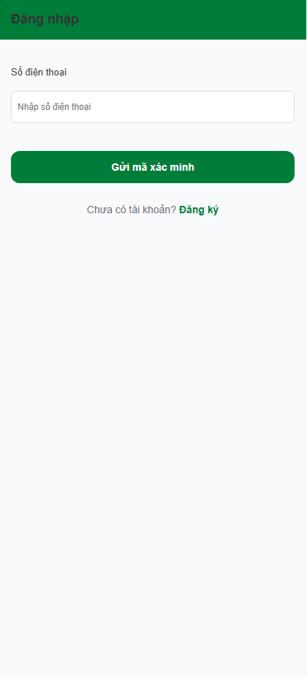
Figure 3.2.1: Login screen of GreenMarket
This screen allows the User, all actors of system to:
- Login: log into the system using their credentials
Field Name | Description
Số điện thoại | Data type: Number  Format: must be a valid phone format (e.g., 0987654321)  Initial: empty  Required: Yes
“Gửi mã xác minh” button | Action button: send OTP.

3.2.2 Verify OTP

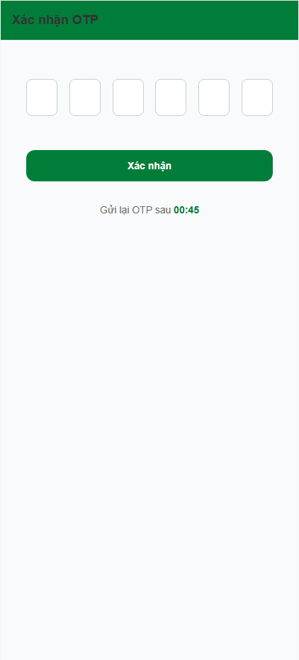

Figure 3.2.2: verify OTP screen of GreenMarket
This screen allows the User to:
- Type OTP and verify & login account
Field Name | Description
OTP | String, masked, required.
“Xác minh và đăng nhập” button | Action: verify OTP and login

3.2.3 Register

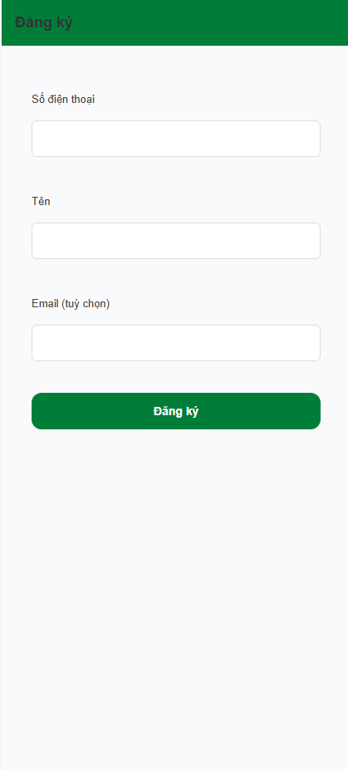
Figure 3.2.3: Register screen of GreenMarket
This screen allows the User to:
- Create a new account by providing basic personal information.
Field Name | Description
Số điện thoại | String, required.
Tên | String, required.
Email (tuỳ chọn) | String, optional.
“Đăng ký” button | Action: register new account and proceed to OTP verification.

3.3 Profile Management

3.3.1 View profile
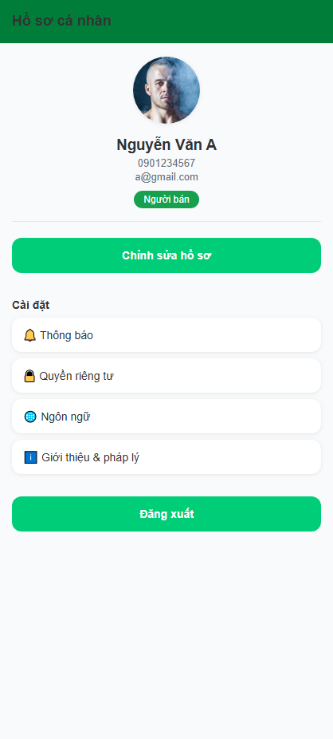
Figure 3.3.1: Profile screen of GreenMarket
This screen allows the User to:
- View profile information: view personal information including avatar, name, phone number, email, and role.
- Edit profile: navigate to edit profile screen.
- Access settings: access notification, privacy, language, and legal information settings.
- Logout: log out from the current account.
Field Name | Description
Ảnh đại diện | Image. Display user avatar.
Tên | String. Display user name.
Số điện thoại | String. Display user phone number.
Email | String. Display user email.
Vai trò | String. Display user role.
“Chỉnh sửa hồ sơ” button | Action. Navigate to edit profile screen.
Thông báo | Action. Navigate to notification settings.
Quyền riêng tư | Action. Navigate to privacy settings.
Ngôn ngữ | Action. Navigate to language settings.
Giới thiệu & pháp lý | Action. Navigate to about and legal information.
“Đăng xuất” button | Action. Log out from the current account.

3.3.2 Edit Profile

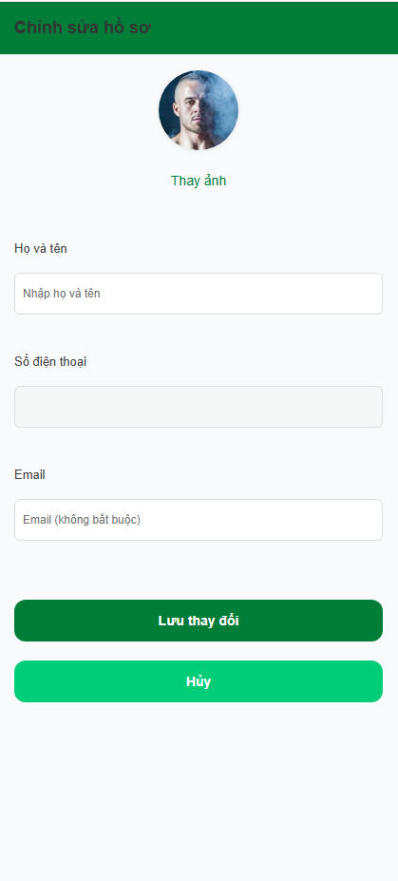
Figure 3.3.2: Edit profile screen of GreenMarket
This screen allows the User to:
- View current profile information: view existing personal information.
- Update profile information: update name, email, and avatar.
- Save changes: save updated profile information.
- Cancel editing: discard changes and return to profile screen.
Field Name | Description
Ảnh đại diện | Image. Display user avatar.
“Thay ảnh” button | Action. Select and update user avatar.
Họ và tên | String, required. Editable user full name.
Số điện thoại | String, read-only. Display user phone number.
Email | String. Display user role.
“Chỉnh sửa hồ sơ” button | String, optional. Editable user email.
“Lưu thay đổi” button | Action. Save updated profile information.
“Hủy” button | Action. Cancel editing and return to profile screen.

3.4 Collaborator

3.4.1 Earning
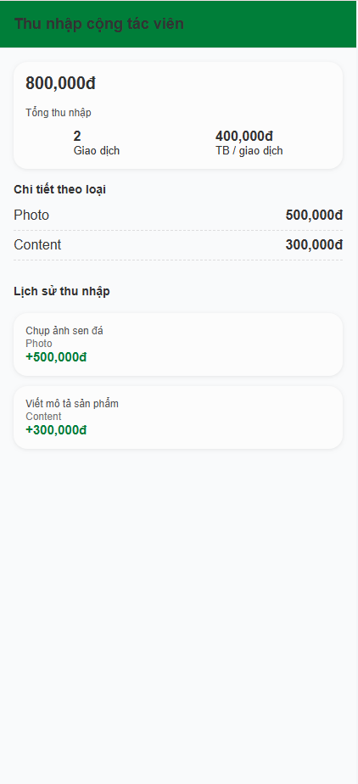
Figure 3.4.1: Collaborator earnings screen of GreenMarket
This screen allows the User to:
- View total earnings: view total income earned as a collaborator.
- View earning summary: view number of transactions and average income per transaction.
- View earnings by type: view earnings grouped by earning type.
- View earning history: view detailed earning transaction history.
Field Name | Description
Tổng thu nhập | Number, calculated. Display total collaborator earnings.
Giao dịch | Number. Display total number of earning transactions.
TB / giao dịch | Number, calculated. Display average earning per transaction.
Chi tiết theo loại | List. Display earnings grouped by earning type.
Lịch sử thu nhập | List. Display earning transaction history.
Mục thu nhập | Item. Display earning title, type, and amount.

3.4.2 Manage jobs
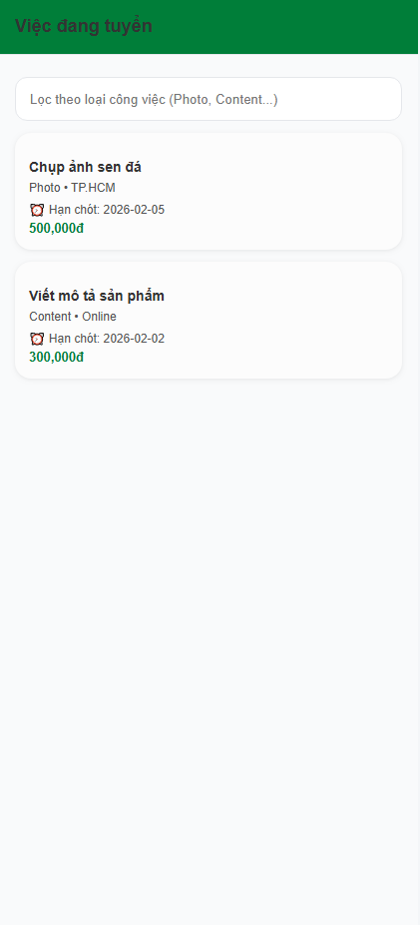
Figure 3.4.2: Available jobs screen of GreenMarket
This screen allows the User to:
- View available jobs: view and browse available collaborator jobs.
- Filter jobs: filter jobs by job category or keyword.
- View job information: view job title, category, location, deadline, and price.
Field Name | Description
Ô lọc công việc | String, optional. Used to filter jobs by category or keyword.
Danh sách công việc | List. Display available jobs.
Tiêu đề công việc | String. Display job title.
Danh mục công việc | String. Display job category.
Khu vực | String. Display job location.
Hạn chót | Date/Time. Display job application deadline.
Giá công việc | Number. Display job payment amount.
Thẻ công việc | Action. Select to view job details.

3.4.3 My Jobs

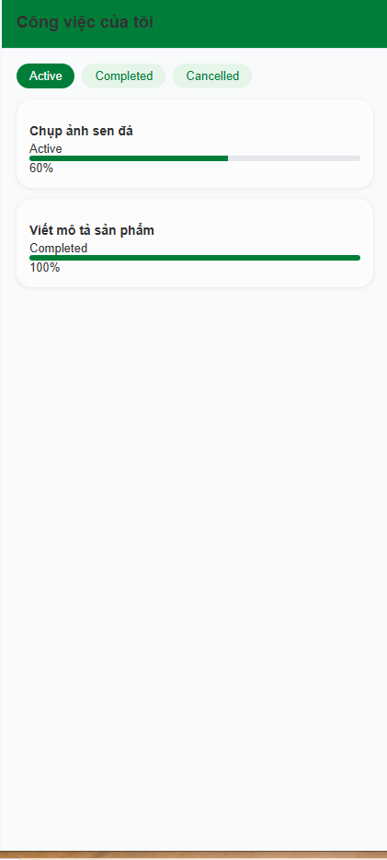

Figure 3.4.3: My jobs screen of GreenMarket
This screen allows the User to:
- View assigned jobs: view jobs assigned to the collaborator.
- Filter jobs by status: switch between Active, Completed, and Cancelled jobs.
- Track job progress: view progress status of each job.
Field Name | Description
Tab Active | Action. Display active jobs.
Tab Completed | Action. Display completed jobs.
Tab Cancelled | Action. Display cancelled jobs.
Danh sách công việc | List. Display collaborator jobs.
Tiêu đề công việc | String. Display job title.
Trạng thái công việc | Status. Display current job status.
Thanh tiến độ | Progress, percentage. Display job completion progress.
Thẻ công việc | Action. Select to view job details.

3.4.4 Job Detail

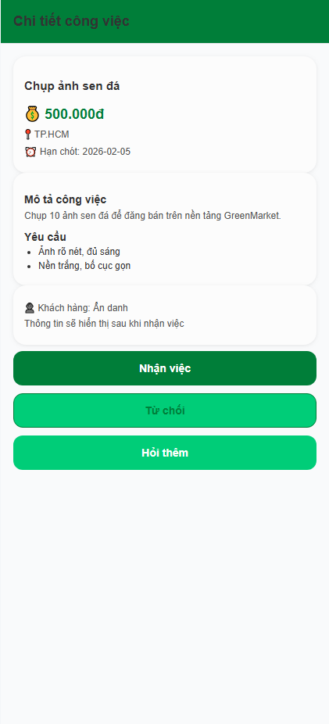
Figure 3.4.4: Job detail screen of GreenMarket
This screen allows the User to:
- View job details: view full information of a job including title, price, location, deadline, description, and requirements.
- View client information: view limited client information before accepting the job.
- Accept job: accept and start the selected job.
- Decline job: decline the selected job.
- Contact client: request more information about the job.

Field Name | Description
Tiêu đề công việc | String. Display job title.
Giá công việc | Number. Display job payment amount.
Khu vực | String. Display job location.
Hạn chót | Date. Display job deadline.
Mô tả công việc | Text. Display job description.
Yêu cầu | List. Display job requirements.
Thông tin khách hàng | Text, limited. Display limited client information before job acceptance.
“Nhận việc” button | Action. Accept the job.
“Từ chối” button | Action. Decline the job.
“Hỏi thêm” button | Action. Contact client for more information.

3.4.5 Submit Job Result

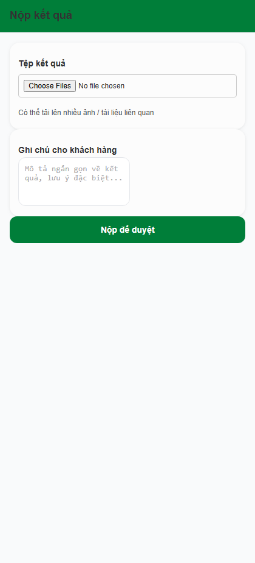
Figure 3.4.5: Submit job result screen of GreenMarket
This screen allows the User to:
- Upload job results: upload files related to the completed job.
- Add notes: provide additional notes or explanations for the client.
- Submit results: submit job results for client review and approval.
Field Name | Description
Tệp kết quả | File, multiple. Upload job result files.
Ghi chú cho khách hàng | Text, optional. Add notes for the client.
“Nộp để duyệt” button | Action. Submit job results for review.

3.4.6 Request payout

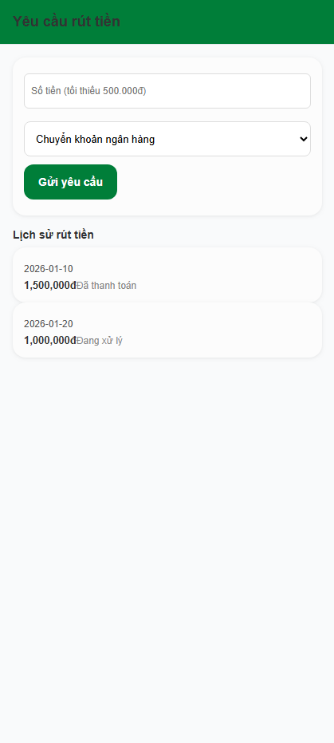
Figure 3.4.6: Request payout screen of GreenMarket
This screen allows the User to:
- Request payout: submit a payout request with selected amount and method.
- Select payout method: choose a payout method.
- View payout history: view previous payout requests and their statuses.
Field Name | Description
Số tiền | Number, required. Payout amount (minimum 500,000đ).
Phương thức rút tiền | Option. Select payout method.
“Gửi yêu cầu” button | Action. Submit payout request.
Lịch sử rút tiền | List. Display payout history.
Ngày rút tiền | Date. Display payout request date.
Số tiền rút | Number. Display payout amount.
Trạng thái | Status. Display payout request status.

3.5 Favorite

3.5.1 Favorite screen
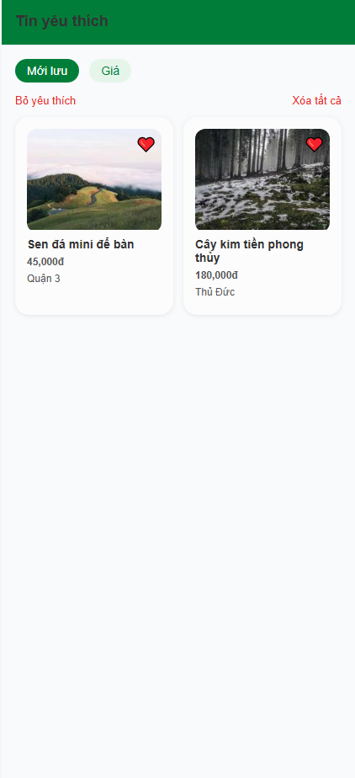
Figure 3.5.1: Favorites screen of GreenMarket
This screen allows the User to:
- View favorite listings: view and browse saved listings.
- Sort favorites: sort favorite listings by saved time or price.
- Remove favorites: remove selected listings from favorites.
- Clear favorites: remove all favorite listings.
- View empty state: view empty state when no favorite listings exist.
- View listing detail: navigate to listing detail screen.
Field Name | Description
Mới lưu | Sort option. Sort favorites by latest saved time.
Giá | Sort option. Sort favorites by price.
Bỏ yêu thích | Action. Remove selected listings from favorites.
Xóa tất cả | Action. Remove all favorite listings.
Danh sách tin yêu thích | List. Display saved listings.
Tin yêu thích | Item. Display listing image, title, price, and location.
Trạng thái rỗng | State. Display empty favorites message.
Thẻ tin | Action. Navigate to listing detail screen.

3.6 Host

3.6.1 Create Promotional Content

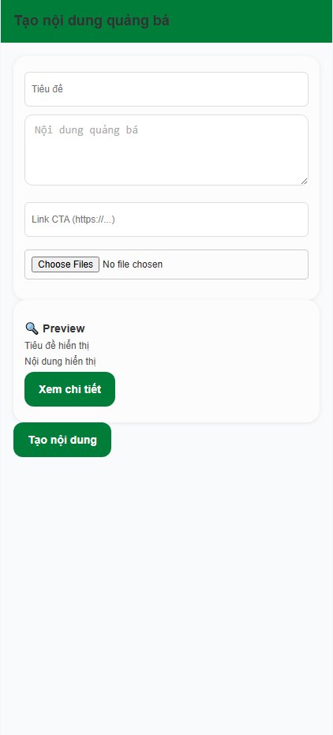
Figure 3.6.1: Create promotional content screen of GreenMarket
This screen allows the User to:
- Create promotional content: create promotional content with title, description, CTA link, and media.
- Preview content: preview promotional content before publishing.
- Publish content: submit and create promotional content.

Field Name | Description
Tiêu đề | String, required. Promotional content title.
Nội dung quảng bá | Text, required. Promotional content description.
Link CTA | URL, optional. Call-to-action link.
Tệp đính kèm | File, multiple, optional. Upload promotional media files.
Preview | View. Display promotional content preview.

3.6.2 Host Dashboard

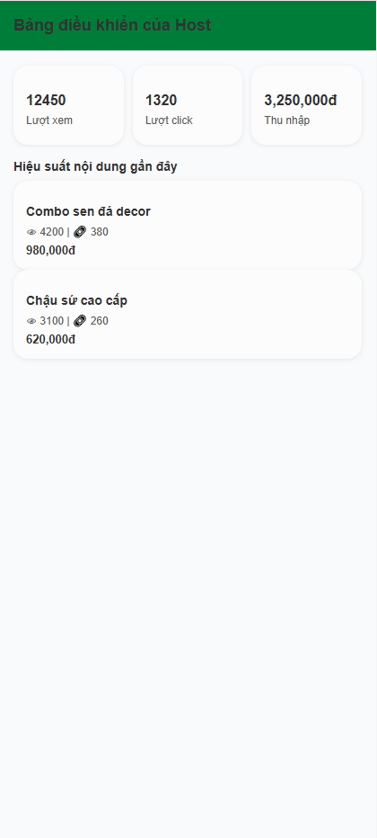
Figure 3.6.2: Create medical record screen of GreenMarket
This screen allows the User to:
- View performance statistics: view total views, clicks, and earnings.
- Monitor content performance: view performance of recent promotional contents.
Field Name | Description
Lượt xem | Number. Display total content views.
Lượt click | Number. Display total content clicks.
Thu nhập | Number. Display total earnings.
Hiệu suất nội dung gần đây | List. Display recent promotional content performance.
Tiêu đề nội dung | String. Display content title.
Lượt xem nội dung | Number. Display views per content.

3.6.3 Host Earning

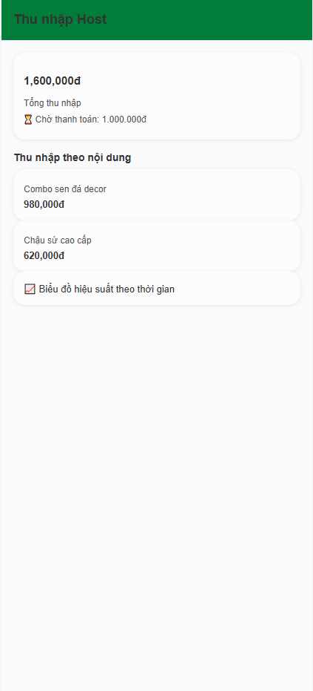

Figure 3.6.3: Host earnings screen of GreenMarket
This screen allows the User to:
- View total earnings: view total earnings as a host.
- View pending earnings: view earnings waiting for payment.
- View earnings by content: view earnings breakdown by promotional content.
- View performance over time: view earnings performance over time.
Field Name | Description
Tổng thu nhập | Number, calculated. Display total host earnings.
Chờ thanh toán | Number. Display pending earnings awaiting payment.
Thu nhập theo nội dung | List. Display earnings grouped by content.
Tiêu đề nội dung | String. Display promotional content title.
Thu nhập nội dung | Number. Display earnings per content.

3.6.4 Request payout


Figure 3.6.4: Request payout screen of GreenMarket
This screen allows the User to:
- Request payout: submit a payout request with selected amount and method.
- Select payout method: choose a payout method.
- View payout history: view previous payout requests and their statuses.
Field Name | Description
Số tiền | Number, required. Payout amount (minimum 500,000đ).
Phương thức rút tiền | Option. Select payout method.
“Gửi yêu cầu” button | Action. Submit payout request.
Lịch sử rút tiền | List. Display payout history.
Ngày rút tiền | Date. Display payout request date.
Số tiền rút | Number. Display payout amount.
Trạng thái | Status. Display payout request status.

3.7 Home

3.7.1 Home
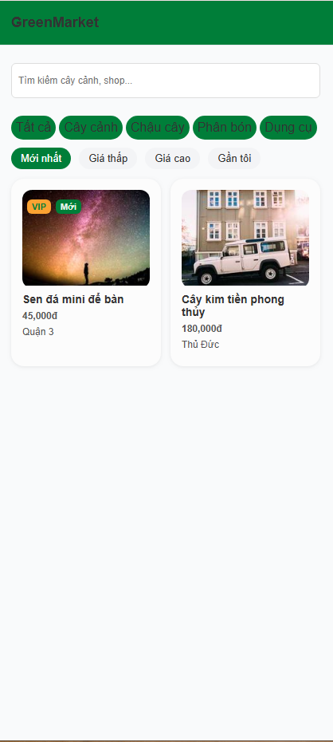
Figure 3.7.1: Home feed screen of GreenMarket
This screen allows the User to:
- View listings: view and browse available plant listings.
- Search listings: search listings by keyword (plants or shops).
- Filter listings: filter listings by selected categories.
- Sort listings: sort listings by latest, price (low to high / high to low), or nearest location.
- View listing detail: select a listing to navigate to the listing detail screen.
Field Name | Description
Tìm kiếm cây cảnh, shop… | String, optional. Used to search listings by keyword.
Danh mục | List, selectable. Used to filter listings by category.
Mới nhất | Sort option. Sort listings by latest time.
Giá thấp | Sort option. Sort listings by ascending price.
Giá cao | Sort option. Sort listings by descending price.
Gần tôi | Sort option. Sort listings by nearest location.
Bài đăng | List. Display available listings.
Nhãn VIP | Badge, conditional. Displayed for VIP listings.
Nhãn Mới | Badge, conditional. Displayed for new listings.
Thẻ bài đăng | Action. Navigate to listing detail screen.

3.7.2 Post Detail
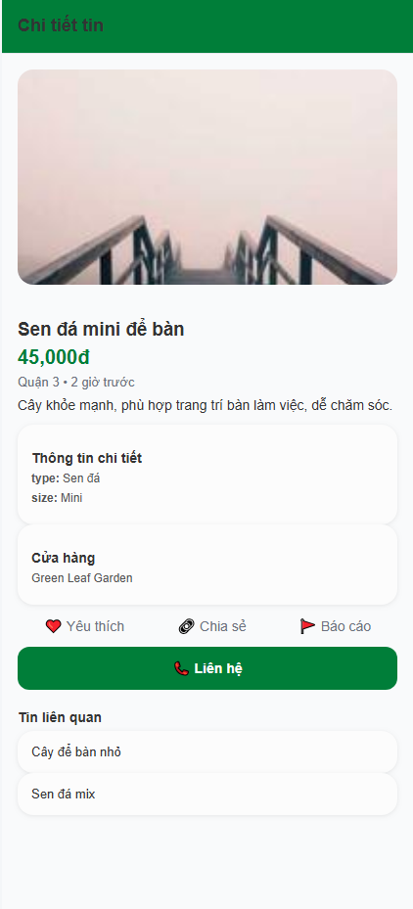
Figure 3.7.2: Post detail screen of GreenMarket
This screen allows the User to:
- View post details: view full listing information including images, title, price, location, time, description, and attributes.
- View seller information: view basic shop information of the listing.
- Interact with post: add post to favorites, share post, or report post.
- Contact seller: contact the seller directly.
- View related listings: view other related listings.
Field Name | Description
Hình ảnh tin | Image. Display listing images.
Tiêu đề tin | String. Display listing title.
Giá | Number. Display listing price.
Vị trí & thời gian | String. Display listing location and creation time.
Thông tin chi tiết | List. Display listing attributes.
Cửa hàng | Text. Display shop information.
Yêu thích | Action. Add or remove listing from favorites.
Chia sẻ | Action. Share listing.
Báo cáo | Action. Report listing.
“Liên hệ” button | Action. Contact the seller.
Tin liên quan | List. Display related listings.
Thẻ tin liên quan | Action. Navigate to related listing detail.

3.7.3 Search & Filter

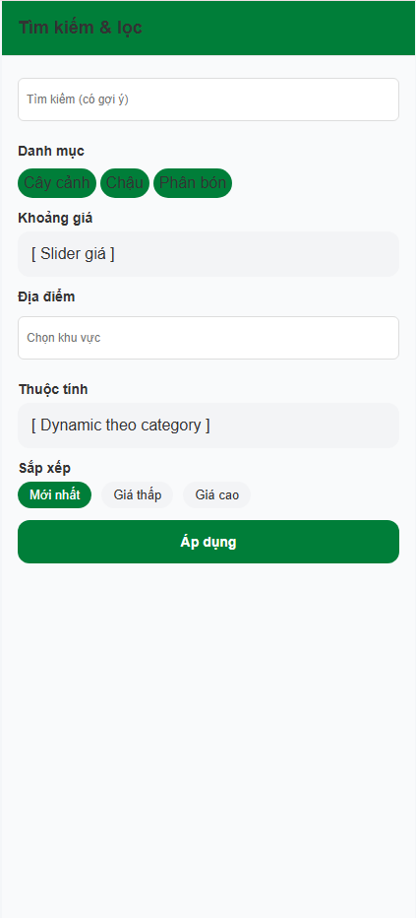
Figure 3.7.3: Search and filter screen of GreenMarket
This screen allows the User to:
- Search listings: search listings by keyword with suggestions.
- Filter listings: filter listings by category, price range, location, and attributes.
- Sort listings: sort listings by selected criteria.
- Apply filters: apply selected search and filter conditions.
Field Name | Description
Ô tìm kiếm | String, optional. Search listings by keyword.
Danh mục | List, selectable. Filter listings by category.
Khoảng giá | Range. Filter listings by price range.
Địa điểm | String, optional. Filter listings by location.
Thuộc tính | Dynamic list. Filter listings by category-specific attributes.
Mới nhất | Sort option. Sort listings by latest.
Giá thấp | Sort option. Sort listings by ascending price.
Giá cao | Sort option. Sort listings by descending price.
“Áp dụng” button | Action. Apply selected filters and return to listing results.

3.8 Moderation

3.8.1 Moderation Dashboard
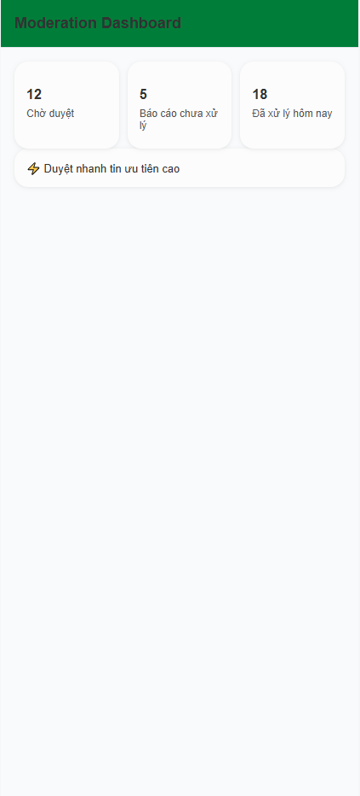
Figure 3.8.1: Moderation dashboard screen of GreenMarket
This screen allows the User to:
- View moderation statistics: view numbers of pending posts, pending reports, and resolved cases.
- Access priority moderation: quickly access high-priority items for moderation.
Field Name | Description
Chờ duyệt | Number. Display number of pending posts.
Báo cáo chưa xử lý | Number. Display number of unresolved reports.
Đã xử lý hôm nay | Number. Display number of cases resolved today.
Duyệt nhanh | Action. Navigate to high-priority moderation tasks.

3.8.2 Moderation History

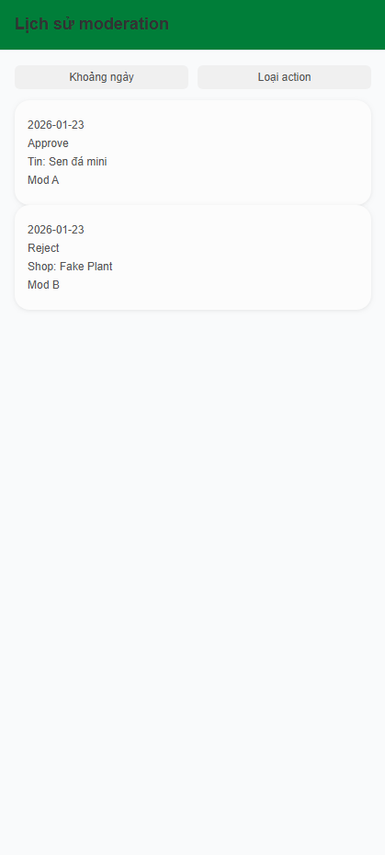

Figure 3.8.2: Moderation history screen of GreenMarket
This screen allows the User to:
- View moderation history: view past moderation actions.
- Filter history: filter moderation records by date range and action type.
- Review action details: view details of each moderation action.
Field Name | Description
Khoảng ngày | Filter. Filter moderation history by date range.
Loại action | Filter. Filter moderation history by action type.
Lịch sử moderation | List. Display moderation history records.
Ngày | Date. Display moderation action date.
Action | String. Display moderation action type.
Đối tượng | String. Display moderated target.
Moderator | String. Display moderator information.

3.8.3 Moderate Post Detail

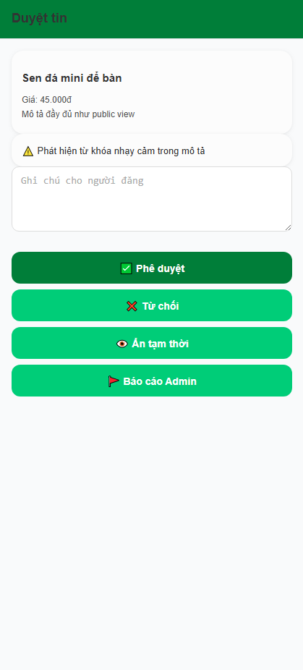
Figure 3.8.3: Moderate post detail screen of GreenMarket
This screen allows the User to:
- View post details: view full post information before moderation.
- Review system warnings: view detected sensitive content warnings.
- Add moderation notes: add notes for the post owner.
- Approve post: approve and publish the post.
- Reject post: reject the post.
- Hide post: temporarily hide the post from public view.
- Escalate issue: report the post to admin for further review.
Field Name | Description
Thông tin tin đăng | View. Display post title, price, and description.
Cảnh báo hệ thống | Warning. Display detected sensitive content alerts.
Ghi chú cho người đăng | Text, optional. Add moderation notes.
“Phê duyệt” button | Action. Approve and publish the post.
“Từ chối” button | Action. Reject the post.
“Ẩn tạm thời” button | Action. Temporarily hide the post.
“Báo cáo Admin” button | Action. Escalate post to admin for further moderation.

3.8.4 Moderate Post Detail

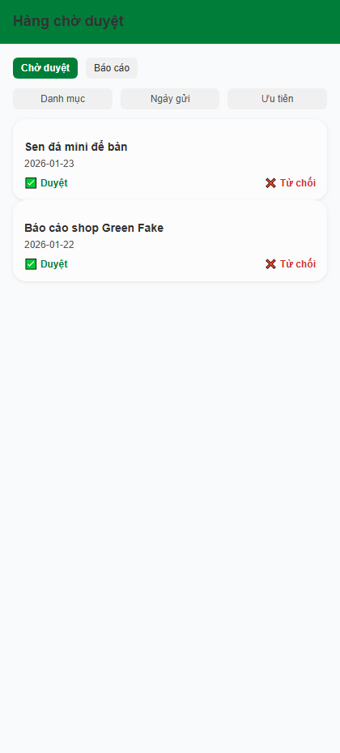
Figure 3.8.4: Moderate post detail screen of GreenMarket
This screen allows the User to:
- View post details: view full post information before moderation.
- Review system warnings: view detected sensitive content warnings.
- Add moderation notes: add notes for the post owner.
- Approve post: approve and publish the post.
- Reject post: reject the post.
- Hide post: temporarily hide the post from public view.
- Escalate issue: report the post to admin for further review.

Field Name | Description
Thông tin tin đăng | View. Display post title, price, and description.
Cảnh báo hệ thống | Warning. Display detected sensitive content alerts.
Ghi chú cho người đăng | Text, optional. Add moderation notes.
“Phê duyệt” button | Action. Approve and publish the post.
“Từ chối” button | Action. Reject the post.
“Ẩn tạm thời” button | Action. Temporarily hide the post.
“Báo cáo Admin” button | Action. Escalate post to admin for further moderation.

3.8.5 Moderation Statistics

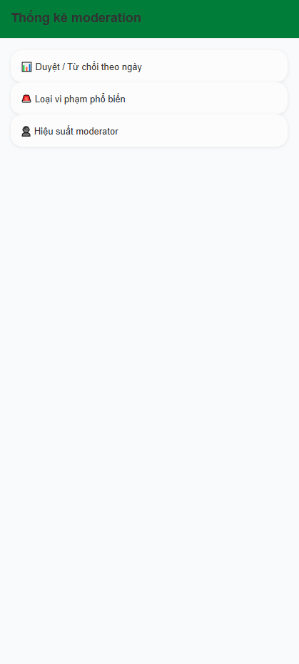
Figure 3.8.5: Moderation statistics screen of GreenMarket
This screen allows the User to:
- View moderation trends: view approval and rejection statistics over time.
- Analyze violation types: view most common violation categories.
- Evaluate moderator performance: view moderation performance by moderator.

Field Name | Description
Duyệt / Từ chối theo ngày | Chart. Display number of approved and rejected posts by date.
Loại vi phạm phổ biến | Chart/List. Display most frequent violation types detected during moderation.
Hiệu suất moderator | Chart/List. Display moderation activity and performance per moderator.

3.9 Operations

3.9.1 Daily Workload
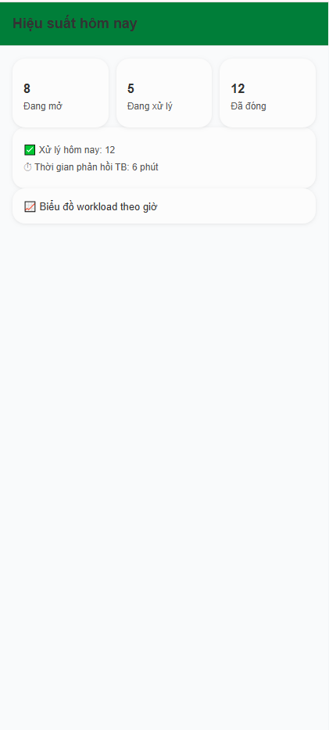
Figure 3.9.1: Daily workload screen of GreenMarket
This screen allows the User to:
- View current workload status: view number of open, in-progress, and closed tasks.
- Monitor daily performance: view number of tasks resolved today.
- Track response efficiency: view average response time for today.
- Analyze workload distribution: view workload trends by hour.
Field Name | Description
Đang mở | Number. Display total tasks currently open.
Đang xử lý | Number. Display tasks currently in progress.
Đã đóng | Number. Display tasks completed and closed today.
Xử lý hôm nay | Number. Display total tasks resolved today.
Thời gian phản hồi TB | Time. Display average response time for tasks today.
Biểu đồ workload theo giờ | Chart. Display task workload distribution by hour.

3.9.2 Task Detail

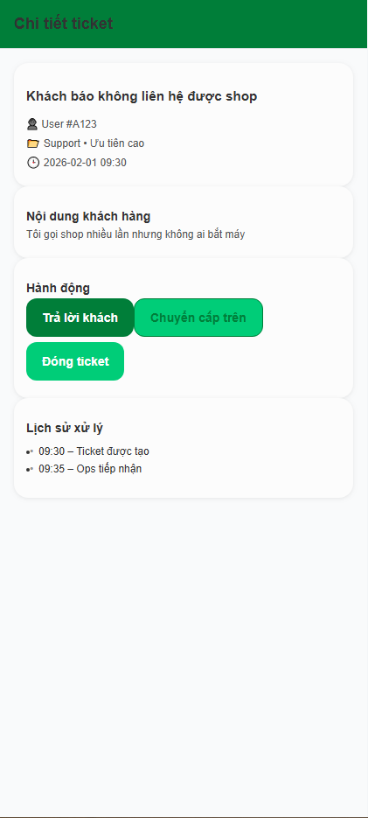
Figure 3.9.2: Task detail screen of GreenMarket
This screen allows the User to:
- View ticket information: view title, user, category, priority, and creation time.
- Read customer content: view detailed issue reported by the customer.
- Perform ticket actions: reply to customer, escalate the ticket, or close the ticket.
- Track processing history: view the timeline of actions taken on the ticket.
Field Name | Description
Tiêu đề ticket | Text. Display the main issue title reported by the customer.
Người gửi | Text. Display user identifier related to the ticket.
Danh mục & ưu tiên | Text. Display ticket category and priority level.
Thời gian tạo | DateTime. Display when the ticket was created.
Nội dung khách hàng | Text. Display full message from the customer.
Trả lời khách | Action button. Allow operator to respond to the customer.
Chuyển cấp trên | Action button. Escalate ticket to higher-level support or admin.
Đóng ticket | Action button. Mark the ticket as resolved and closed.
Lịch sử xử lý | Timeline. Display chronological list of actions on the ticket.

3.9.3 Task Queue

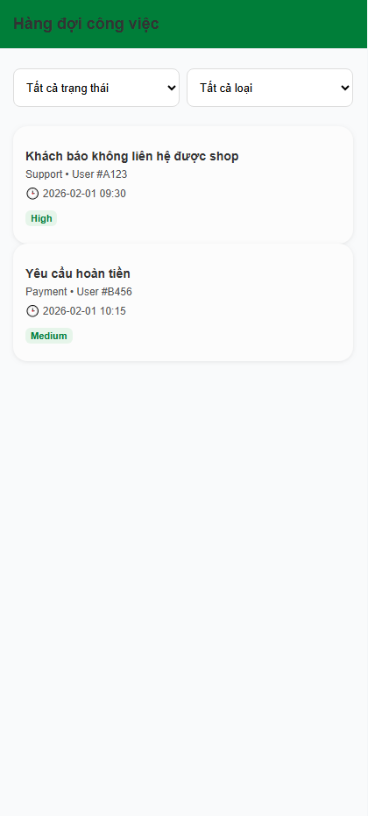
Figure 3.9.3: Task queue screen of GreenMarket
This screen allows the User to:
- View task list: view all assigned tasks in the work queue.
- Filter tasks: filter tasks by status and task type.
- Identify priority: quickly recognize task priority levels.
- Access task detail: select a task to view its detailed information.

Field Name | Description
Bộ lọc trạng thái | Select. Filter tasks by status (Open, In Progress, Closed).
Bộ lọc loại ticket | Select. Filter tasks by type (Support, Payment, Report).
Tiêu đề ticket | Text. Display short description of the task.
Loại ticket | Text. Display task category.
Khách hàng | Text. Display customer identifier related to the task.
Thời gian tạo | DateTime. Display when the task was created.
Độ ưu tiên | Badge. Display task priority level (Low, Medium, High).
Thẻ task | Action item. Navigate to task detail screen when selected.

3.10 Reports

3.10.1 My Reports

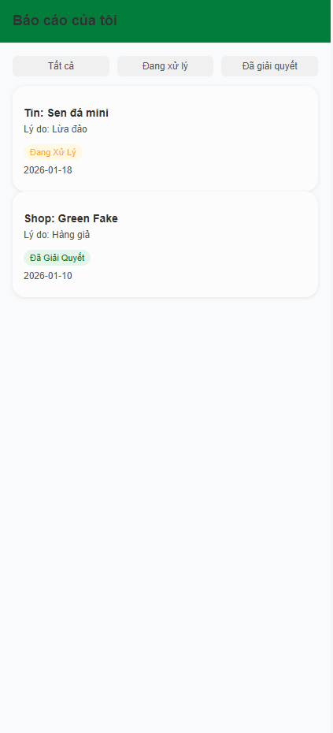
Figure 3.10.1: My Reports screen of GreenMarket
This screen allows the User to:
- View submitted reports: view all reports submitted by the user.
- Filter reports: filter reports by processing status.
- Track resolution status: monitor the handling progress of each report.
- Review report details: view report target, reason, and submission date.

Field Name | Description
Bộ lọc trạng thái | Tabs. Filter reports by status (All, Processing, Resolved).
Đối tượng báo cáo | Text. Display the reported post, shop, or user.
Lý do báo cáo | Text. Display the reason provided by the user.
Trạng thái báo cáo | Status label. Processing / Resolved / Cancelled.
Ngày gửi | Date. Display report submission date.
Thẻ báo cáo | View-only item. Display report summary information.

3.10.2 Edit shop

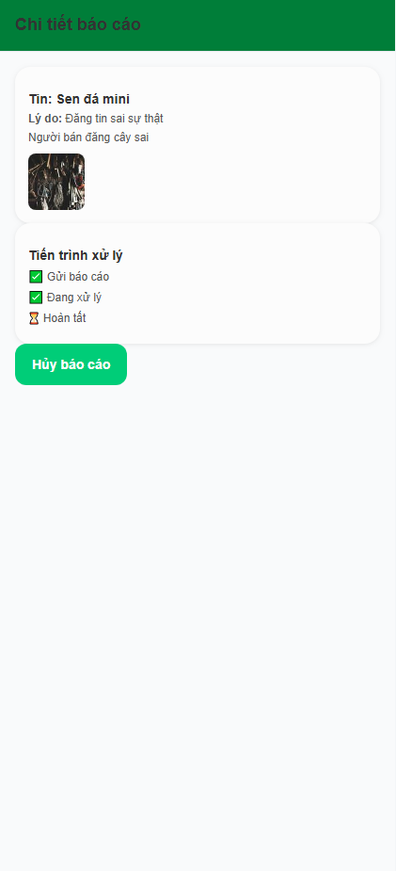
Figure 3.10.2: Report detail screen of GreenMarket
This screen allows the User to:
- View report information: view reported target, reason, and detailed description.
- View attached evidence: view images or files attached to the report.
- Track processing progress: follow each step of the report handling timeline.
- View final result: view the resolution result once the report is completed.
- Cancel report: cancel the report while it is still under processing.

Field Name | Description
Đối tượng báo cáo | Text. Display the reported post, shop, or user.
Lý do báo cáo | Text. Display the selected report reason.
Mô tả chi tiết | Text. Display additional explanation provided by the user.
Hình ảnh đính kèm | Image gallery. Display all evidence images attached to the report.
Tiến trình xử lý | Timeline. Display report handling steps with status indicators (Pending / Completed).
Kết quả xử lý | Text. Display final resolution result after report is resolved.
Trạng thái báo cáo | Status. Processing / Resolved / Cancelled.
Nút hủy báo cáo | Action button. Allow user to cancel the report when status is Processing.

3.10.3 Create Report

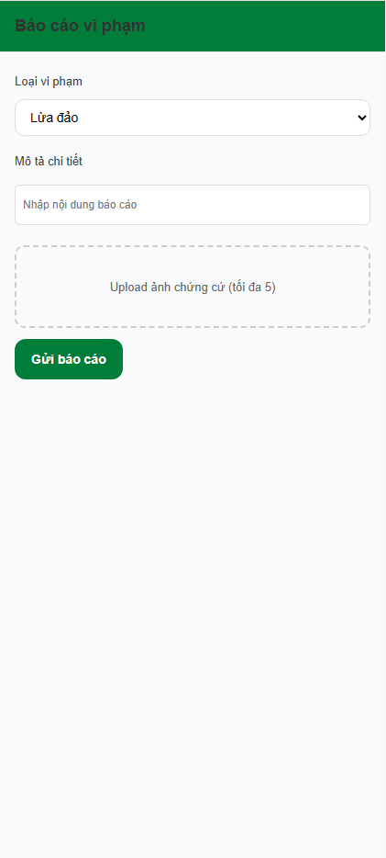
Figure 3.10.3: Create report screen of GreenMarket
This screen allows the User to:
- Select violation type: choose the type of violation being reported.
- Provide report description: enter detailed information about the violation.
- Upload evidence: attach images as evidence for the report.
- Submit report: send the report to the moderation system for review.

Field Name | Description
Loại vi phạm | Dropdown. Required. Select one violation type from predefined list.
Mô tả chi tiết | String, multiline, required. User description of the violation.
Ảnh chứng cứ | Image upload, optional. Up to 5 images.
Nút gửi báo cáo | Action button. Submit the report to the system.

3.10.4 Blocked Shops

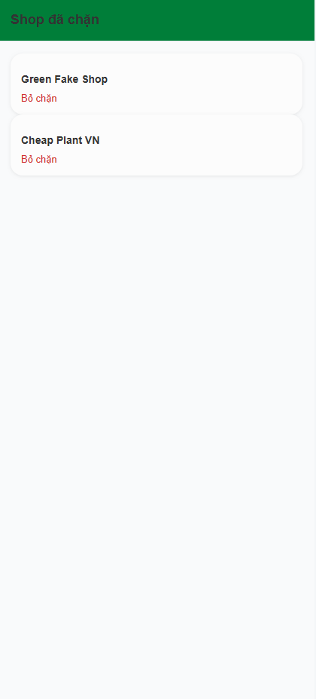
Figure 3.10.4: Blocked shops screen of GreenMarket
This screen allows the User to:
- View blocked shops: see the list of shops that the user has blocked.
- Manage blocked shops: remove a shop from the blocked list.

Field / Component | Description
Danh sách shop đã chặn | List of blocked shops associated with the user account.
Tên shop | Display the name of the blocked shop.
Nút “Bỏ chặn” | Action control to unblock the selected shop.

3.11 Settings

3.11.1 Feedback
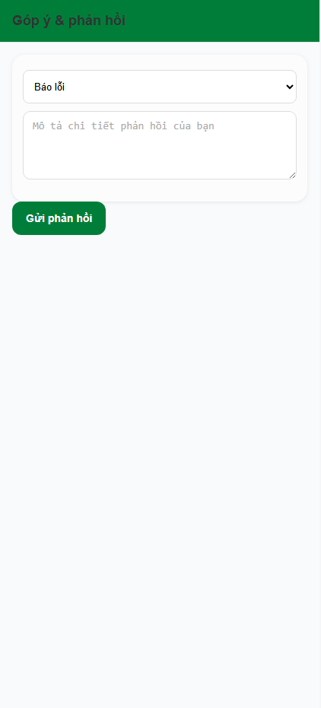
Figure 3.11.1: Feedback screen of GreenMarket
This screen allows the User to:
- Submit feedback: send feedback, bug reports, or inappropriate content reports.
- Select feedback type: choose the category of feedback.
- Provide details: describe the feedback content in text form.
Field name | Description
Loại phản hồi | Select option, required. Used to categorize feedback (bug, suggestion, inappropriate content).
Nội dung phản hồi | Text, multiline, required. Detailed description of the feedback.
Nút “Gửi phản hồi” | Action button, required. Submit feedback to the system.

3.11.2 Notifications

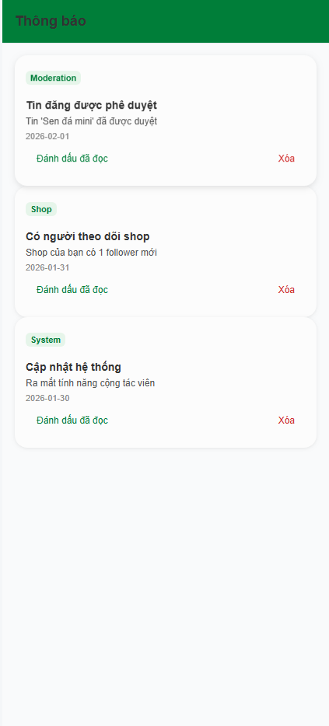
Figure 3.11.2: Notifications screen of GreenMarket
This screen allows the User to:
- View notifications: view the list of system notifications.
- Identify unread notifications: distinguish unread notifications from read ones.
- Mark as read: mark a notification as read.
- Delete notification: remove a notification from the list

Field name | Description
Loại thông báo | String, label, required. Indicates notification type (system, order, moderation, promotion).
Tiêu đề | String, required. Short summary of the notification content.
Nội dung | String, required. Detailed notification message.
Thời gian | Datetime, required. Time when the notification was generated.
Trạng thái đã đọc | Boolean, required. Indicates whether the notification has been read.
Nút “Đánh dấu đã đọc” | Action button, optional. Mark the notification as read.
Nút “Xóa” | Action button, optional. Delete the notification.
3.11.3 System Announcements

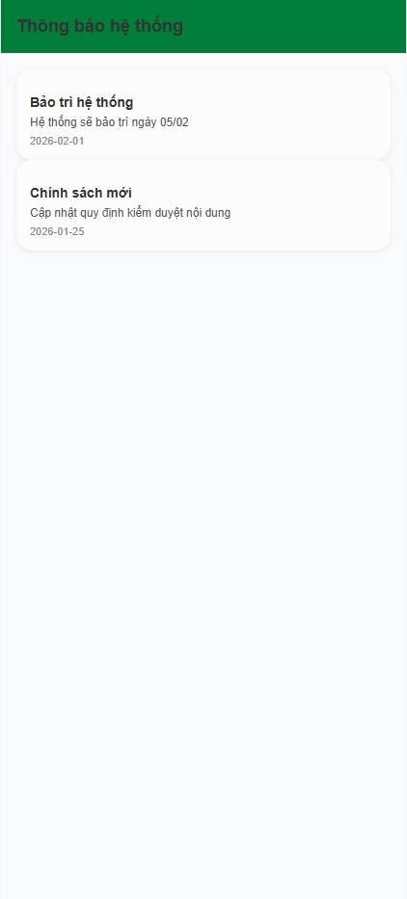
Figure 3.11.3: system announcements screen of GreenMarket
This screen allows the User to:
- View system announcements: read official announcements from the system.
- Stay updated: check important updates, maintenance notices, and policy changes.
Field name | Description
Tiêu đề | String, read-only. Announcement title.
Nội dung | String, read-only. Announcement detailed content.
Ngày thông báo | DateTime, read-only. Announcement published date.

3.12 Shop

3.12.1 Shop Detail

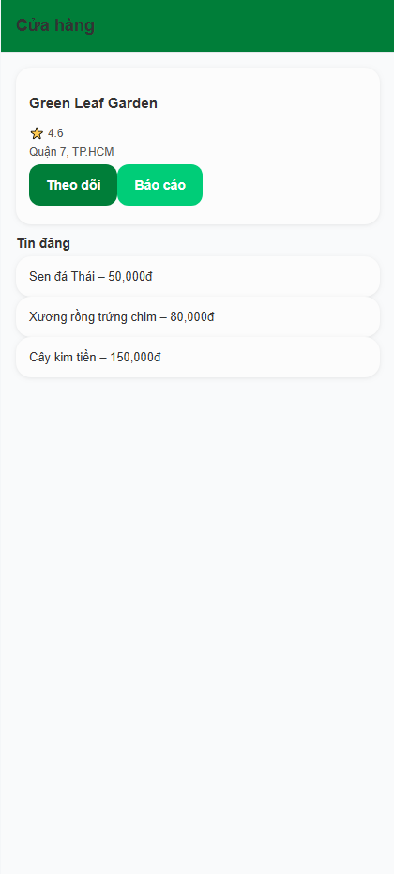
Figure 3.12.1: shop detail screen of GreenMarket
This screen allows the User to:
- View shop information: view shop name, rating, and address.
- Follow shop: follow a shop to receive updates on new listings.
- Report shop: report a shop for violations.
- View shop listings: browse all listings posted by the shop.
- Navigate to listing detail: access detail of a selected shop listing.

Field name | Description
Tên cửa hàng | String, read-only. Shop display name.
Đánh giá | Number, read-only. Average shop rating.
Địa chỉ | String, read-only. Shop location address.
Theo dõi | Action button, optional. Follow or unfollow the shop.
Báo cáo | Action button, optional. Submit a report for the shop.
Tin đăng | Listing list, read-only. Display all posts created by the shop.

3.12.2 Shop Form

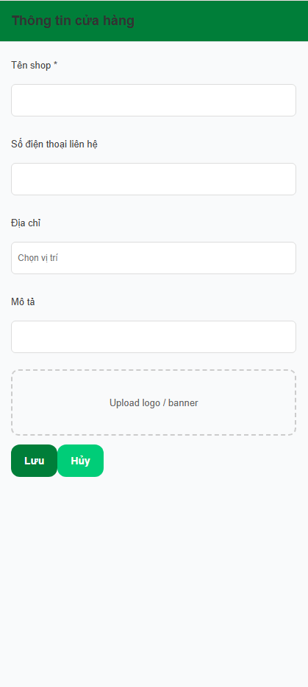
Figure 3.12.2: shop information form screen of GreenMarket
This screen allows the User to:
- Create or update shop information: enter and manage basic shop details.
- Upload shop media: upload shop logo or banner image.
- Save or cancel changes: submit or discard updated shop information.
Field name | Description
Tên shop | String, required. Shop display name.
Số điện thoại liên hệ | String, optional. Contact phone number for the shop.
Địa chỉ | String, optional. Shop location selected by the user.
Mô tả | String, optional. Short description about the shop.
Upload logo / banner | File upload, optional. Upload shop logo or banner image.
Lưu | Action button, required. Save shop information changes.
Hủy | Action button, optional. Cancel and discard changes.

3.12.3 Shop Search

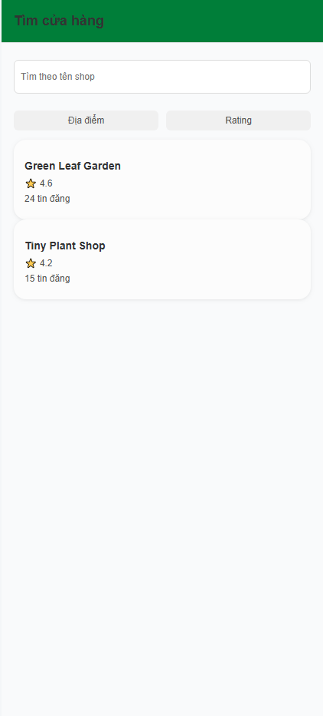
Figure 3.12.3: shop search screen of GreenMarket
This screen allows the User to:
- Search shops: search shops by name keyword.
- Filter shops: filter shop list by location and rating.
- View shop summary: view basic information of available shops.
- Navigate to shop detail: access detail of a selected shop.

Field name | Description
Tìm theo tên shop | String, optional. Keyword input for shop name search.
Địa điểm | Filter option, optional. Filter shops by selected location.
Rating | Filter option, optional. Filter shops by rating level.
Danh sách cửa hàng | Listing list, read-only. Display shops matching search and filter criteria.

3.13 Promotions

3.13.1 Promotion Packages Screen

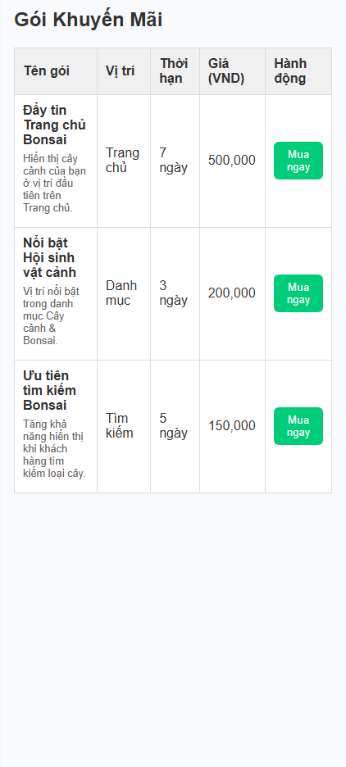
Figure 3.13.1: Promotion Packages list screen of GreenMarket
This screen allows the User to:
- View all available promotion packages.
- Compare package information including name, slot position, duration, and price.
- Select a package to purchase.
Field name | Description
Tên gói | String. Display name of the promotion package.
Mô tả (inline) | String. Short description of the promotion package shown under the package name.
Vị trí | String/Number. Slot or placement position of the promotion package.
Thời hạn | String. Duration of the promotion package.
Giá (VND) | Number. Price of the package in VND, displayed with thousand separators.
Hành động | Column containing the action button for package selection.
Mua ngay | Action button. Navigates to purchase flow for the selected package.

3.13.2 Purchase Package

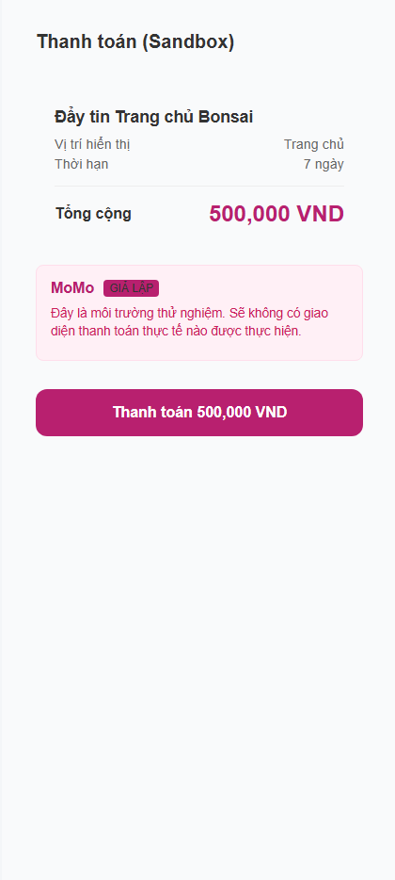
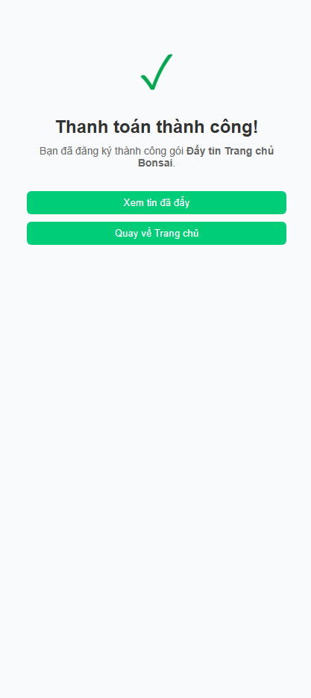
Figure 3.13.2: Purchase promotion package screen of GreenMarket
This screen allows the User to:
- View promotion package details including placement, duration, and price.
- Confirm payment using a simulated MoMo Sandbox environment.
- Complete the purchase flow and receive confirmation.
- Navigate to boosted posts or return to the Home screen after successful payment.

Field name | Description
Tên gói | String. Display name of the selected promotion package.
Vị trí hiển thị | String/Number. Placement slot of the promotion package.
Thời hạn | String. Valid duration of the promotion package.
Tổng cộng | Number. Total price of the package shown in VND with thousand separators.
MoMo (GIẢ LẬP) | Informational section. Indicates that payment is simulated in sandbox mode.
Thanh toán (button) | Action button, required. Initiates payment simulation for the selected package.
Đang xử lý… | Processing state. Displayed while the payment simulation runs.
Thanh toán thành công | Confirmation message shown after payment simulation completes.
Xem tin đã đẩy | Action button. Navigates to the “My Boosts” screen after successful payment.
Quay về Trang chủ | Action button. Returns the User to the Home screen.
Không tìm thấy gói khuyến mãi | Error state displayed when the package ID is invalid or unavailable.

3.13.3 Boost Post

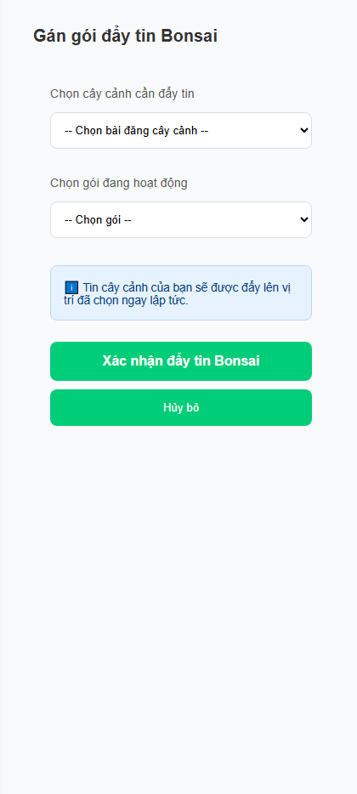
Figure 3.13.3: Assign promotion package to a Bonsai post screen of GreenMarket
This screen allows the User to:
- Select one of their existing Bonsai posts to boost.
- Select an active promotion package to apply.
- Submit the boost request and immediately push the post to the selected position.
- Cancel the action and return to the previous screen.

Field name | Description
Chọn cây cảnh cần đẩy tin | Dropdown, required. Allows the user to select one of their own Bonsai posts.
Chọn gói đang hoạt động | Dropdown, required. Allows the user to select an active promotion package.
Thông báo hướng dẫn | Info box. Explains that the selected post will be boosted immediately.
Xác nhận đẩy tin Bonsai | Action button, required. Submits the boost request for the selected post.
Hủy bỏ | Action button, optional. Cancels the operation and returns to the previous page.

3.13.4 My Boosts

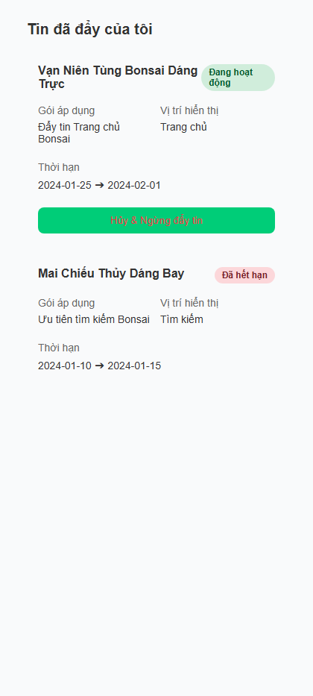
Figure 3.13.4: User’s active and past boosted posts screen of GreenMarket
This screen allows the User to:
- View all posts that are currently being boosted or have been boosted before.
- See boost details such as applied package, display slot, and time period.
- Cancel an active boost, returning the post to its normal ranking.
- Review expired or inactive boosts.

Field name | Description
Tiêu đề bài đăng | String. Title of the Bonsai post that is being boosted.
Trạng thái Boost | Enum. Indicates whether the boost is:
 | • Đang hoạt động – active boost
 | • Đã kết thúc – expired boost
Gói áp dụng | String. Name of the promotion package being applied to the post.
Vị trí hiển thị | Number/String. Display slot assigned by the package.
Thời hạn | Date Range. The start and end date of the boost.
Hủy & Ngừng đẩy tin | Action button, conditional. Appears only when the boost is active.
 | Allows the user to cancel the boost early.
Không tìm thấy tin nào đang được đẩy | Empty state message shown when the user has no active boosts.

3.13.5 Transaction History

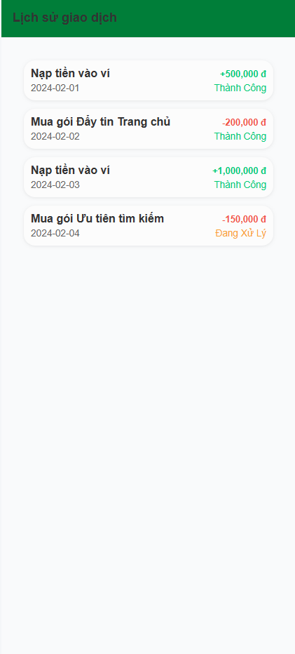
Figure 3.13.5: User’s transaction history screen of GreenMarket

This screen allows the User to:
- View all wallet/account-related transactions in chronological order.
- Check the amount of each transaction, whether it is a credit (+) or debit (–).
- Review transaction details such as description, date, and status.
- Identify pending or completed transactions easily through color-coded labels.
Field name | Description
Mô tả giao dịch | String. Title/description of the transaction (e.g., nạp tiền, thanh toán gói đẩy tin, hoàn tiền).
Số tiền | Number. Transaction amount shown with thousands separators. • Hiển thị màu xanh và có dấu “+” nếu là credit. • Hiển thị màu đỏ nếu là debit.
Loại giao dịch | Enum. Indicates whether the transaction is: • credit – tiền vào • debit – tiền ra
Ngày giao dịch | Date String. The date when the transaction occurred.
Trạng thái giao dịch | Enum. Indicates whether the transaction is: • Thành công – success • Đang xử lý – pending
Không có giao dịch nào | Empty state message shown when the User has no transaction history.

3.14 Analytics

3.14.1 AI Recommendations

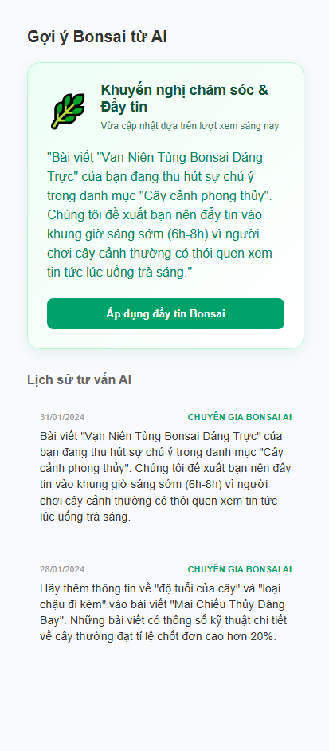
Figure 3.14.1: AI Bonsai recommendation and suggestion history screen of GreenMarket
This screen allows the User to:
- View the latest AI recommendation for improving visibility or boosting a Bonsai post.
- Apply the suggested “Đẩy tin” (Boost) flow directly from this recommendation.
- Review past AI-generated recommendations in a chronological list.
- Understand the context (date, system source) of each AI suggestion.
- If the User has no AI recommendations available, the screen displays an empty-state message.

Field name | Description
Khuyến nghị mới nhất | String. The latest AI-generated recommendation content for boosting or caring for a Bonsai post. Displayed prominently at the top of the screen.
Ngày cập nhật | Date. Timestamp showing when the latest recommendation was generated.
Nút “Áp dụng đẩy tin Bonsai” | Action button. Allows the User to immediately start a boost workflow based on the AI recommendation.
Lịch sử tư vấn AI | List. Previous AI recommendations shown in descending chronological order (newest first).
Thời gian tư vấn | Date. When the AI generated the specific recommendation.
Nguồn tư vấn | Enum/String. Always displayed as “CHUYÊN GIA BONSAI AI” to indicate system-generated advice.
Nội dung tư vấn | String. AI-generated message describing the recommended action or observation.
Không có gợi ý từ AI | Empty-state message. Displayed when there are no past or present recommendations.

3.14.2 Post Analytics
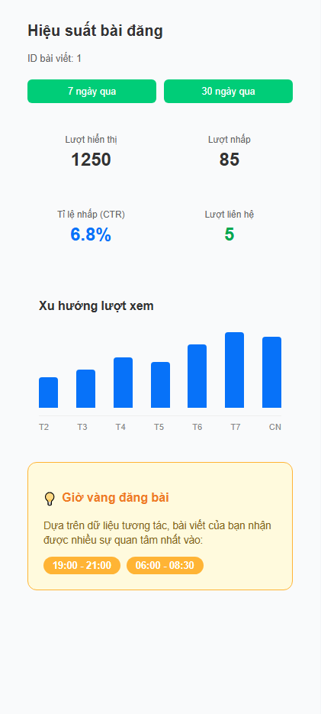
Figure 3.14.2: Post performance analytics screen of GreenMarket
This screen allows the User to:
- View performance metrics of a selected Bonsai post.
- Switch between 7-day and 30-day performance ranges.
- Monitor impressions, clicks, contact interactions, and CTR.
- Observe daily view trends through a bar-style trend graph.
- Identify recommended "golden hours" for posting to maximize visibility.
- Review the post ID for context.
- If no performance data exists, an empty-state message is displayed.
Field name | Description
ID bài viết | String. The identifier of the Bonsai post being analyzed.
Bộ lọc thời gian (7 ngày / 30 ngày) | Toggle buttons. Allows the User to switch between different time ranges for performance analytics.
Lượt hiển thị | Number. The total number of times the post appeared to viewers.
Lượt nhấp | Number. The number of times users clicked on the post.
Tỉ lệ nhấp (CTR) | Percentage. Calculated as clicks divided by impressions.
Lượt liên hệ | Number. Number of users who tapped the contact button on the post.
Xu hướng lượt xem (biểu đồ) | Bar chart. Displays daily views within the selected time range. Each bar represents one day.
Ngày trong biểu đồ | String. Labels showing the days corresponding to each bar in the trend chart.
Giờ vàng đăng bài | List of Time Strings. Recommended time slots that historically generate the highest engagement for this post. Displayed as highlighted badges.
Không có dữ liệu hiệu suất | Empty-state message. Shown when there is no performance data for the selected post.

3.15 Admin Web

3.15.1 System Analytics (Admin)

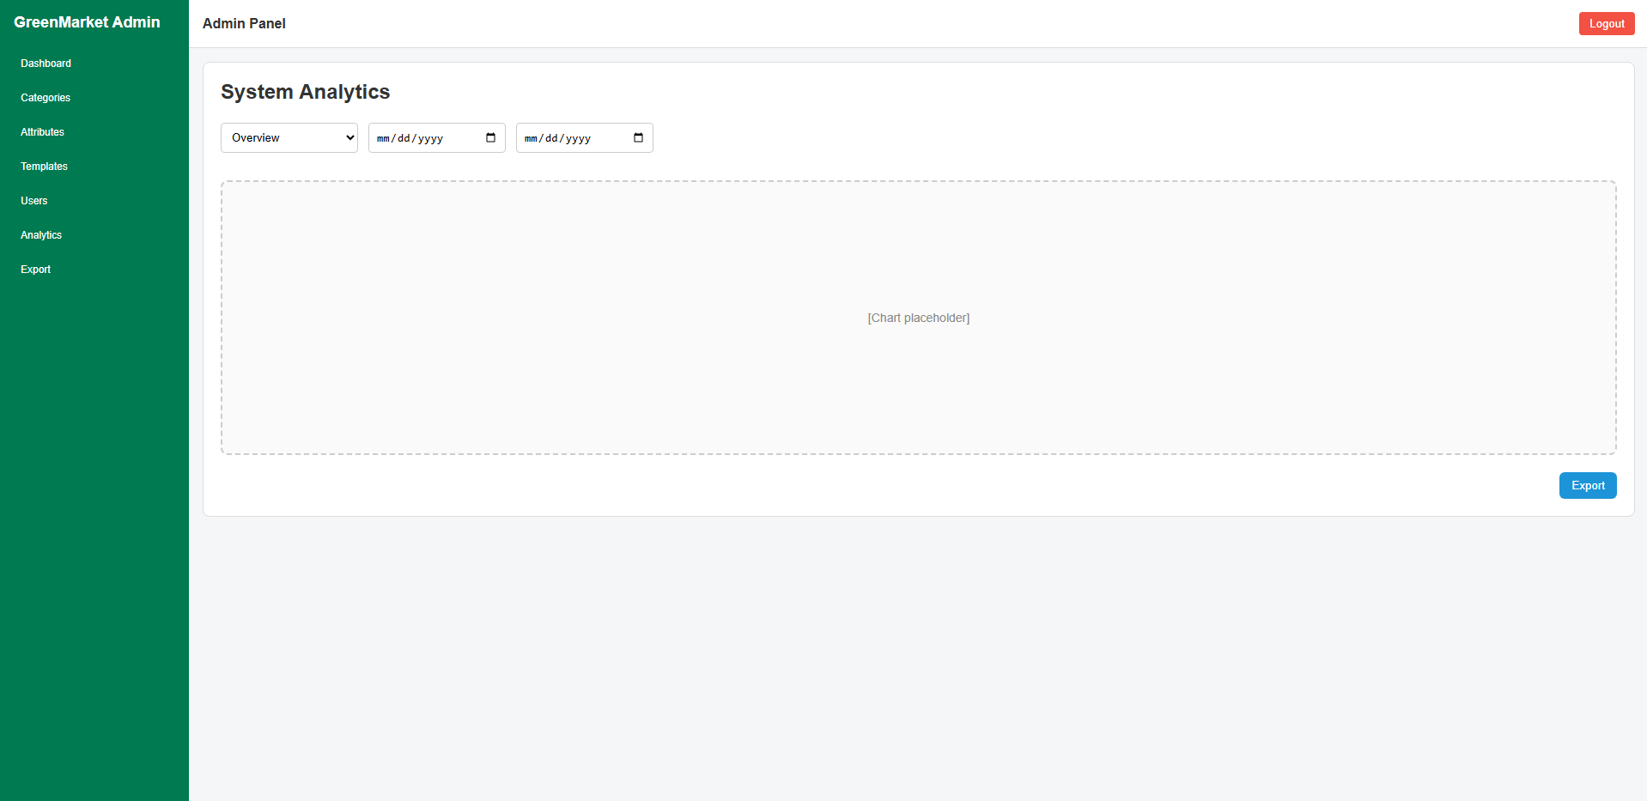
Figure 3.13.1: system analytics screen of GreenMarket (Admin)

This screen allows the Admin to:
- View system analytics: monitor overall system performance and statistics.
- Filter analytics data: view analytics by category and date range.
- Analyze trends: review visualized data through charts.
- Export reports: export analytics data for reporting or auditing purposes.

Field name | Description
Loại thống kê | Enum (Overview, Posts, Users, Revenue), required. Select analytics category.
Ngày bắt đầu | Date, optional. Start date for analytics filtering.
Ngày kết thúc | Date, optional. End date for analytics filtering.
Biểu đồ thống kê | Chart view, read-only. Display analytics data visually.
Export | Action button, optional. Export analytics data to file.

3.15.2 Attribute Management (Admin)

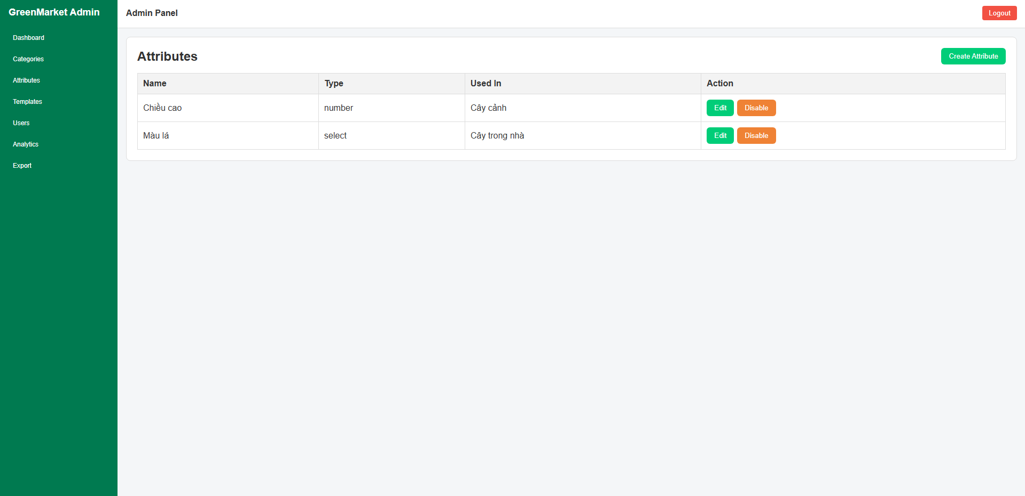
Figure 3.13.2: attribute management screen of GreenMarket (Admin)
This screen allows the Admin to:
- View attributes: view the list of all system attributes.
- Create attribute: create a new attribute for product or listing classification.
- Edit attribute: update attribute information and configuration.
- Disable attribute: disable an attribute from being used in the system.
- Review attribute usage: see where each attribute is applied.

Field name | Description
Name | String, read-only. Attribute display name.
Type | Enum, read-only. Attribute data type (e.g. text, number, select).
Used In | List of String, read-only. Categories or modules using the attribute.
Create Attribute | Action button, optional. Navigate to create attribute screen.
Edit | Action button, optional. Edit selected attribute information.
Disable | Action button, optional. Disable selected attribute from active use.

3.13.3 Attribute Create /Edit
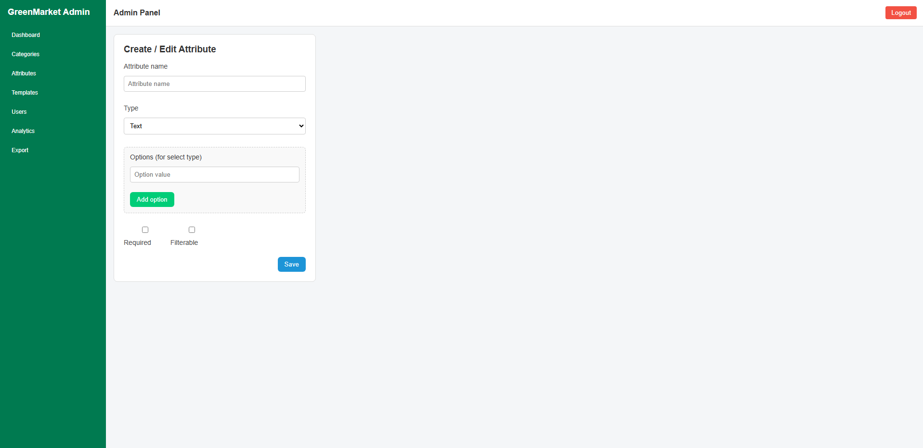
Figure 3.13.3: create / edit attribute screen of GreenMarket (Admin)
This screen allows the Admin to:
- Create attribute: define a new attribute for listings or products.
- Edit attribute: update existing attribute configuration.
- Configure attribute behavior: set required and filterable properties.
- Manage attribute options: define selectable values for select-type attributes.

Field name | Description
Attribute name | String, required. Attribute display name.
Type | Enum (Text, Number, Select), required. Attribute data type.
Options | List of String, optional. Selectable values, applicable only for select type.
Required | Boolean, optional. Mark attribute as mandatory when creating listings.
Filterable | Boolean, optional. Allow attribute to be used in search filters.
Save | Action button, required. Save attribute configuration.

3.15.4 Admin Login
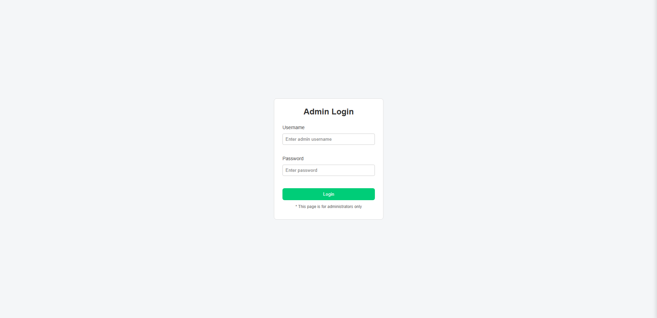
Figure 3.13.4: admin login screen of GreenMarket
This screen allows the Admin to:
- Authenticate admin account: log in using admin credentials.
- Access admin system: enter the admin dashboard after successful authentication.

Field name | Description
Username | String, required. Admin account username.
Password | String, masked, required. Admin account password.
Login | Action button, required. Authenticate admin credentials and log in.
Admin note | Text, read-only. Inform that the page is restricted to administrators only.

3.15.5 Category Management (List)
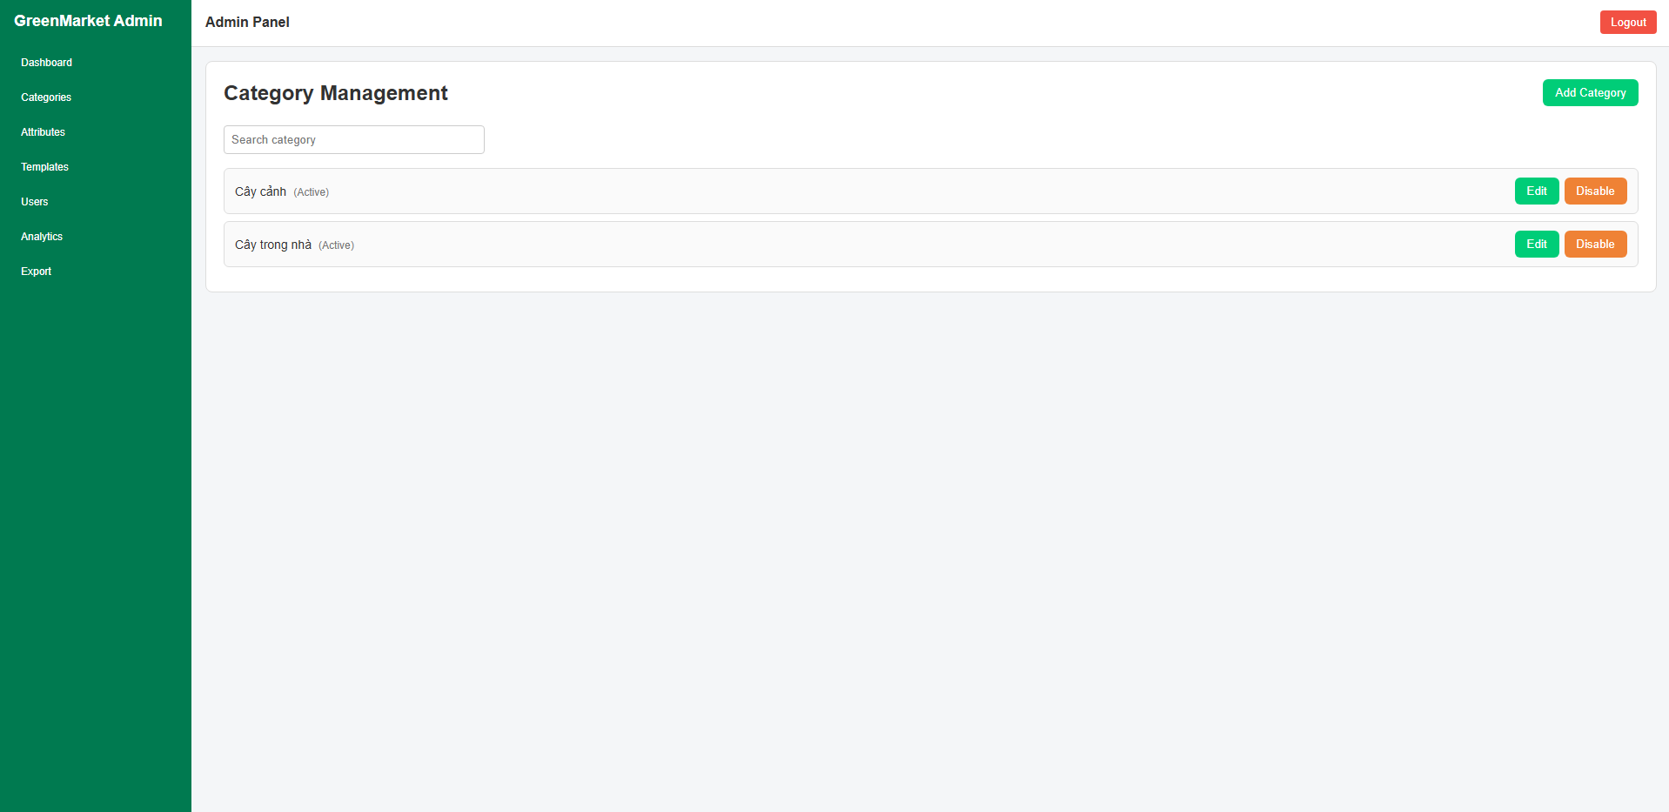
Figure 3.13.5: category management screen of GreenMarket (Admin)
This screen allows the Admin to:
- View all categories in the system.
- Search categories by name.
- Identify category status (Active / Disabled).
- Create new categories.
- Edit existing categories.
- Disable categories without deleting historical data.

Component | Description
Category list | Display all categories with name and status.
Category status | Show whether the category is Active or Disabled.
Search category | Text input to filter categories by name.
Add Category | Action button to navigate to Create Category screen.
Edit | Action button to navigate to Edit Category screen.
Disable | Action button to deactivate a category.

3.15.6 Category Create / Edit
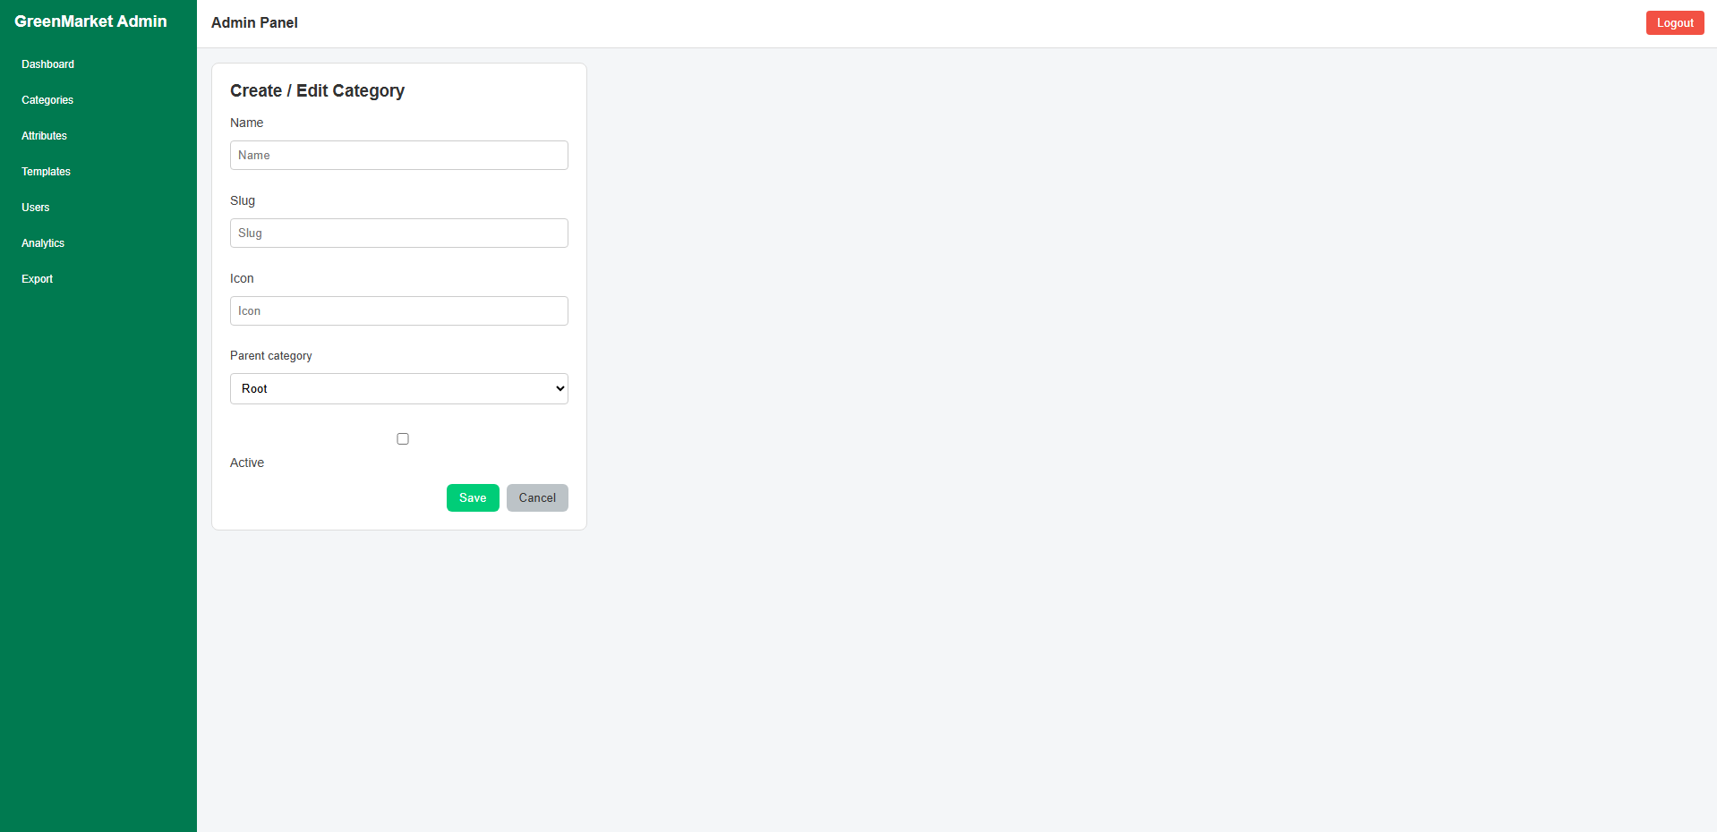
Figure 3.13.6: create / edit category screen of GreenMarket (Admin)
This screen allows the Admin to:
- Create category: define a new category for organizing listings.
- Edit category: update category information and hierarchy.
- Manage category hierarchy: assign parent category to build a tree structure.
- Control category visibility: activate or deactivate categories.
Field name | Description
Name | String, required. Display name of the category.
Slug | String, required. URL-friendly unique identifier.
Icon | String, optional. Icon name or icon reference for UI display.
Parent category | Category reference, optional. Define category hierarchy (Root if none).
Active | Boolean, optional. Control whether the category is visible to users.
Save | Action button, required. Save category information.
Cancel | Action button, optional. Discard changes and return to category list.

3.15.7 Data Export
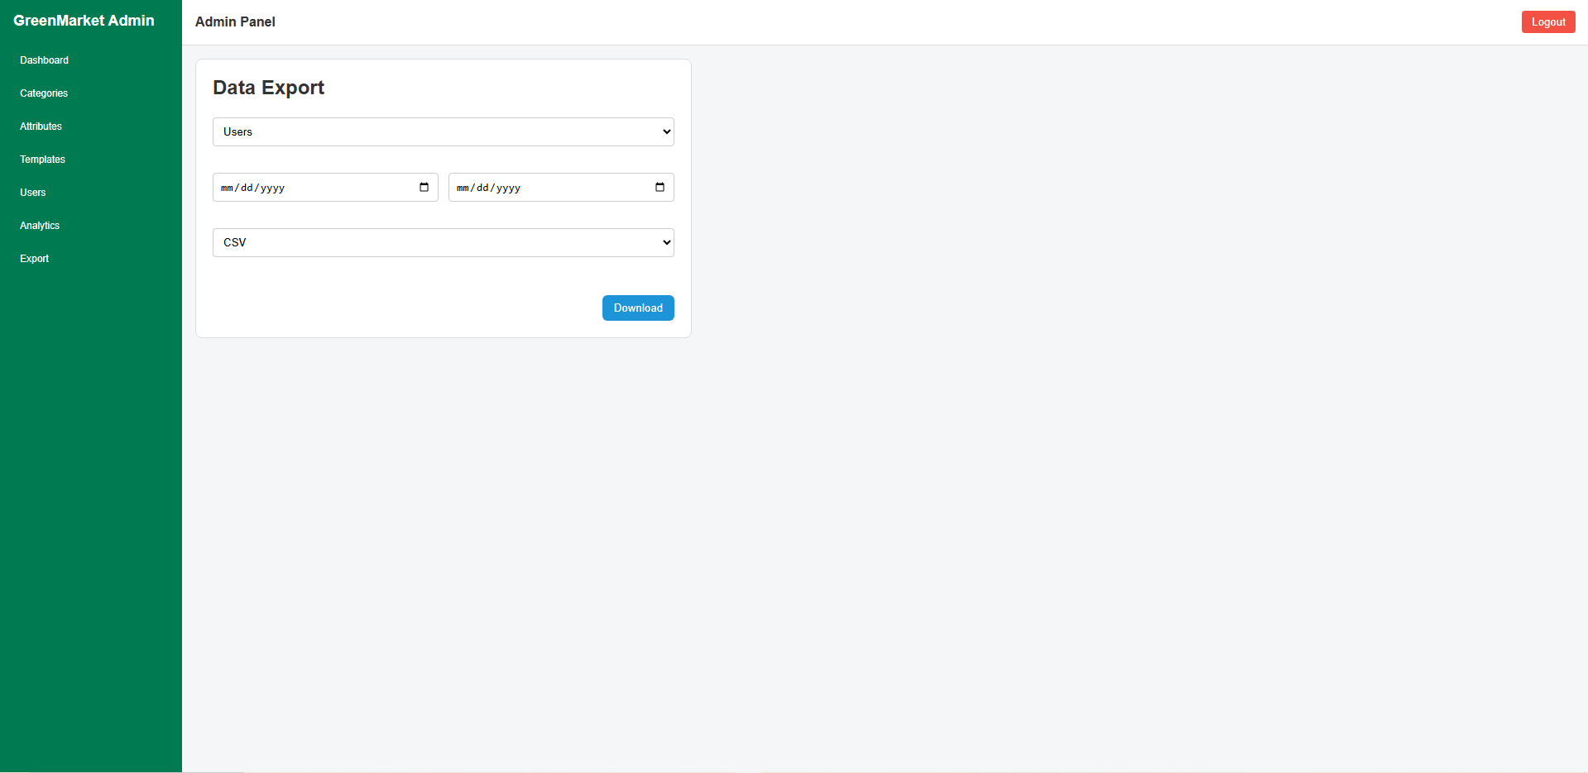
Figure 3.13.7: data export screen of GreenMarket (Admin)
This screen allows the Admin to:
- Select system data to export.
- Filter data by date range.
- Choose export file format.
- Download exported data for reporting or backup purposes.
Field name | Description
Data type selector | Dropdown to select the type of data to export (Users, Posts, Transactions).
Date range | Start date and end date inputs to filter exported data.
File format | Dropdown to select export format (CSV, Excel).
Download button | Trigger data export and file download.

3.15.8 Category – Attribute Mapping
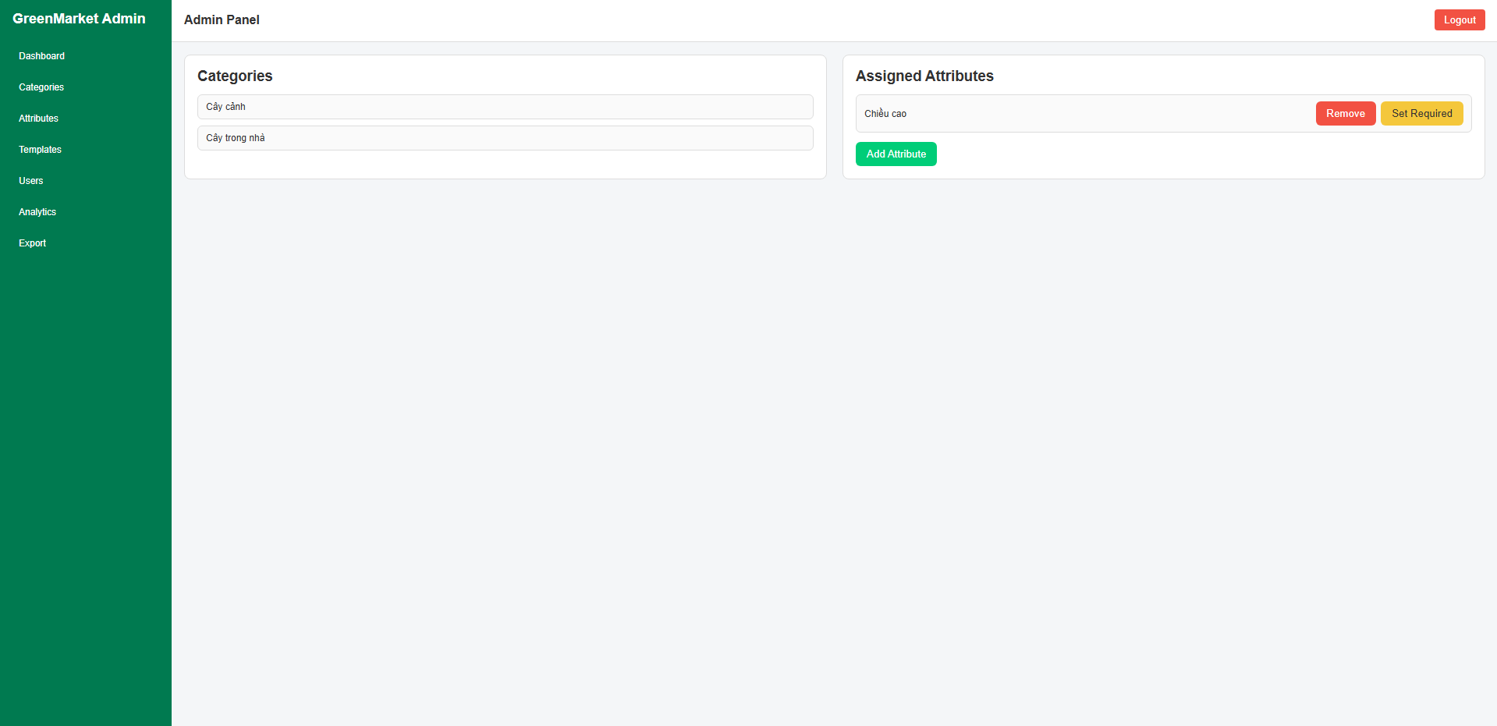
Figure 3.13.8: category attribute mapping screen of GreenMarket (Admin)
This screen allows the Admin to:
- Select a product category.
- View attributes assigned to the selected category.
- Add new attributes to a category.
- Remove attributes from a category.
- Configure attribute rules (e.g. required or optional).
Field name | Description
Category list | Displays all available categories. Admin selects one category at a time.
Assigned attributes list | Shows attributes currently mapped to the selected category.
Remove attribute | Allows admin to detach an attribute from the category.
Set required | Allows admin to mark an attribute as required for that category.
Add attribute button | Opens attribute selection modal to assign new attributes.

3.15.9 Template Management
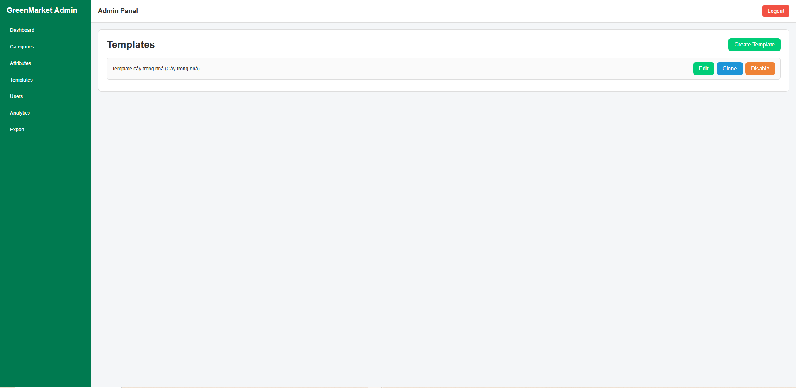
Figure 3.13.9: Template management screen of GreenMarket (Admin)
This screen allows the Admin to:
- View all available templates.
- Create a new template.
- Edit an existing template.
- Clone an existing template.
- Disable a template.

Field name | Description
Template list | Displays all existing templates along with their associated categories.
Template name | Shows the name of the template.
Category | Indicates the category to which the template belongs.
Create Template button | Allows the Admin to create a new template.
Edit button | Opens the template edit screen to modify template details.
Clone button | Creates a duplicate of the selected template for faster setup.
Disable button | Disables the selected template, making it unavailable for use.

3.15.10 Template Builder
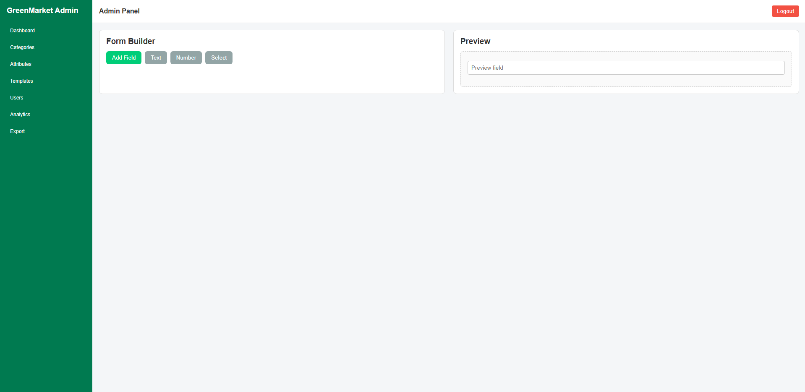
Figure 3.13.10: Template builder screen of GreenMarket (Admin)
This screen allows the Admin to:
- Design a template by adding form fields.
- Choose field types for the template.
- Configure the structure of a template.
- Preview the template layout in real time.
Field name | Description
Form Builder panel | Displays tools for building and configuring template fields.
Add Field button | Allows the Admin to add a new field to the template.
Text button | Adds a text-type field to the template.
Number button | Adds a numeric field to the template.
Select button | Adds a selectable (dropdown) field to the template.
Preview panel | Shows a live preview of the template as it is being built.
Preview field | Displays a sample representation of the added fields.

3.15.11 User List
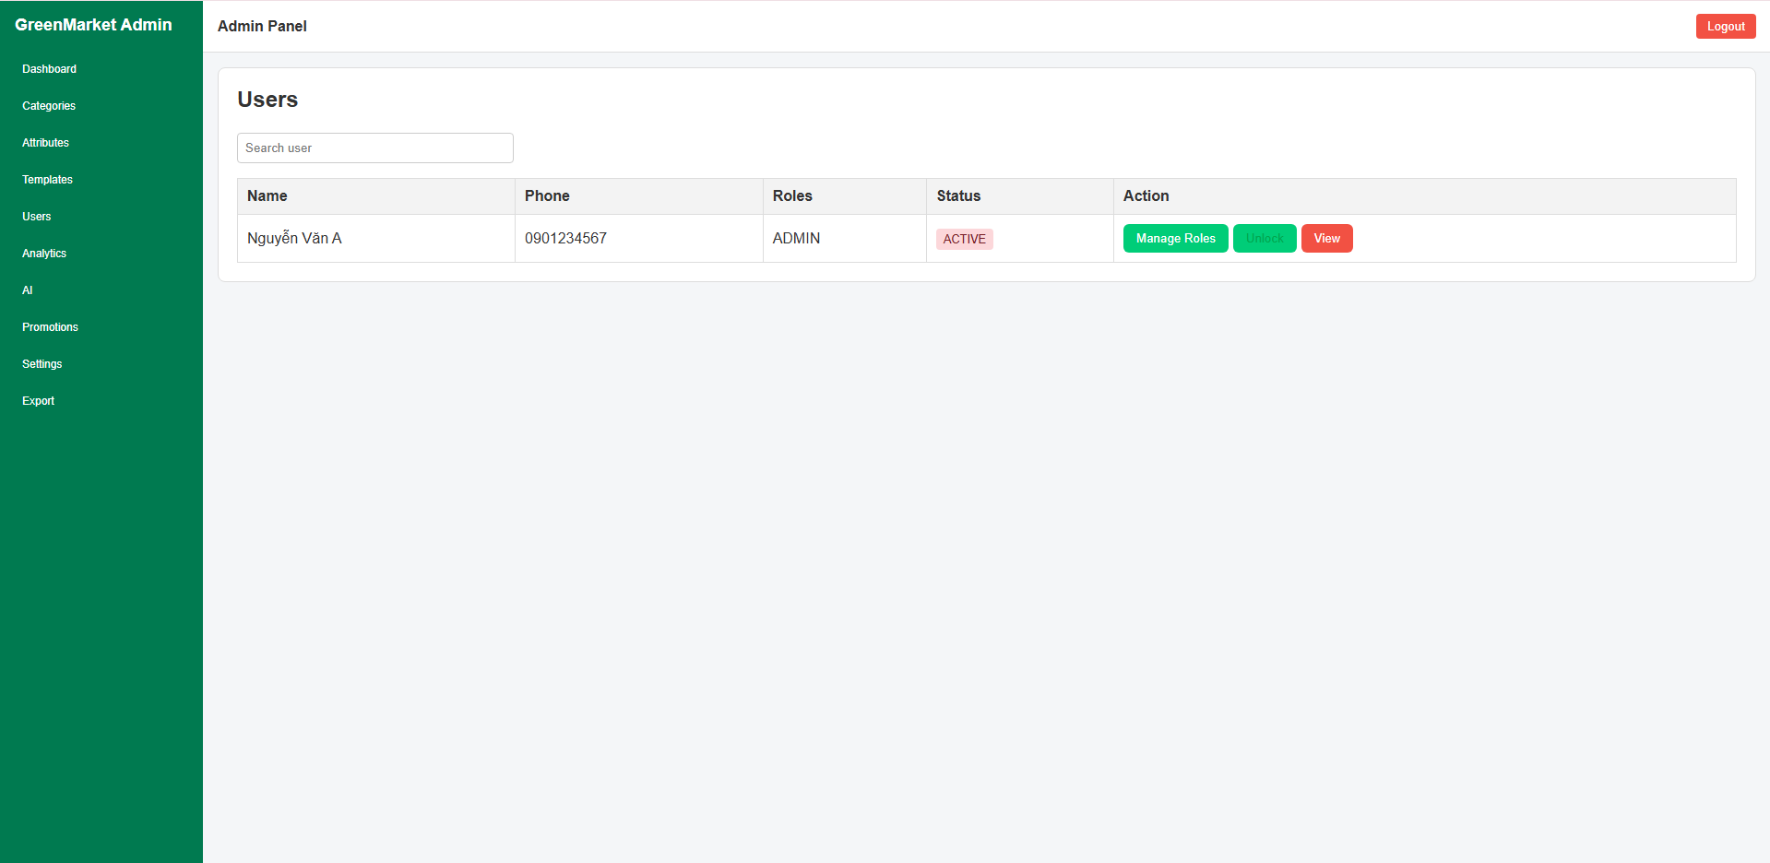
Figure 3.13.11: User list screen of GreenMarket (Admin)
This screen allows the Admin to:
- View all users registered in the system.
- Search users by name or phone number.
- View each user’s assigned roles.
- Monitor current account status (Active / Locked).
- Perform user-related actions such as managing roles, locking/unlocking the user, or viewing user details.
Field name | Description
Search user | Input field. Allows the Admin to filter users by name or phone number.
Name | Displays the user's full name.
Phone | Shows the registered phone number of the user.
Roles | List of assigned roles (e.g., Buyer, Seller, Admin). Multiple roles are displayed as comma-separated values.
Status | Shows whether the user is Active or Locked. Color-coded badge: green for Active, red for Locked.
Manage Roles button | Opens a role-management dialog allowing the Admin to add or remove roles for the selected user.
Lock / Unlock button | Toggles the user’s status. “Lock” turns the account into Locked; “Unlock” reactivates it.
View button | Opens the detailed user profile page.
User table | Displays all user entries in a tabular layout.
User list container | The main content area containing search input and the user table.

3.15.12 User Detail

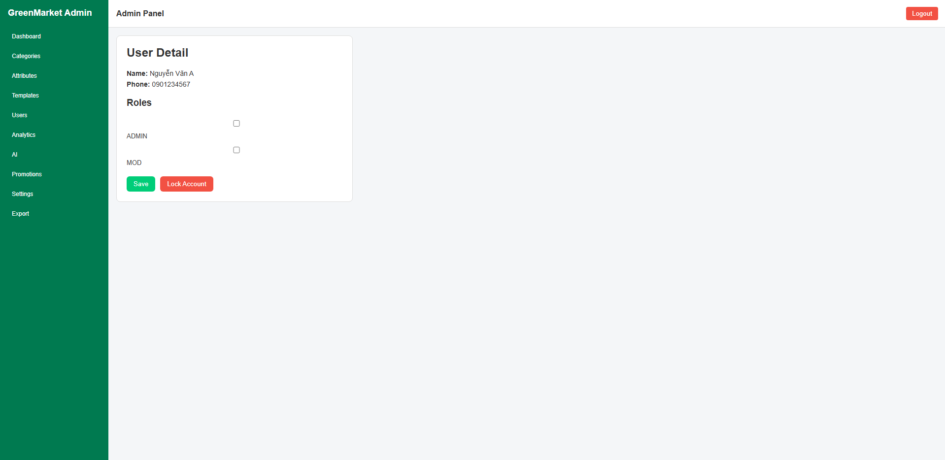
Figure 3.13.12: User detail management screen of GreenMarket (Admin)
This screen allows the Admin to:
- View full information of a selected user.
- Review the user's phone number and basic profile details.
- Manage assigned roles using checkboxes.
- Activate or lock the user account.
- Save role changes.
Field name | Description
Tên | String. The full name of the selected user.
Số điện thoại | String. The user’s registered phone number.
Roles section | A list of available system roles (e.g., ADMIN, MOD). Each role is represented as a checkbox for assignment.
ADMIN checkbox | Boolean. Assigns or removes the ADMIN role for the user.
MOD checkbox | Boolean. Assigns or removes the MOD role for the user.
Save button | Saves all updates to the user’s roles.
Lock Account button | Locks the user’s account, preventing login. This button may toggle to Unlock Account if the user is currently locked.
User detail container | The main layout that groups user info, roles, and available actions.

3.15.13 Activity Log
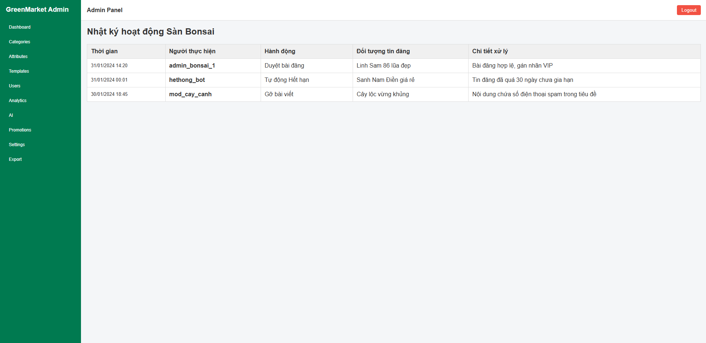
Figure 3.13.13: Activity log monitoring screen of GreenMarket (Admin)
This screen allows the Admin to:
- View the full history of system and moderator actions.
- Track who performed an action, when it occurred, and which post was affected.
- Review details of moderation activities such as approvals, removals, expirations, and automated tasks
- Monitor actions from both humans (Admin/MOD) and automated system agents (e.g., hethong_bot).
- Audit changes for transparency and quality control.
Field name | Description
Thời gian | Date/Time. When the action occurred. Displayed in dd/MM/yyyy HH:mm format.
Người thực hiện | String. Username of the admin, moderator, or system bot that executed the action.
Hành động | String. The type of activity performed (e.g., Duyệt bài đăng, Gỡ bài viết, Tự động Hết hạn).
Đối tượng tin đăng | String. Title of the Bonsai post affected by the action.
Chi tiết xử lý | String. Additional information explaining why the action happened or what rule was applied.
Log entry row | Represents one activity record containing all associated fields.
Activity table | Displays all logs in chronological or reverse-chronological format.
Empty state | Message shown when the system has no logged activities.

3.15.14 Admin Dashboard
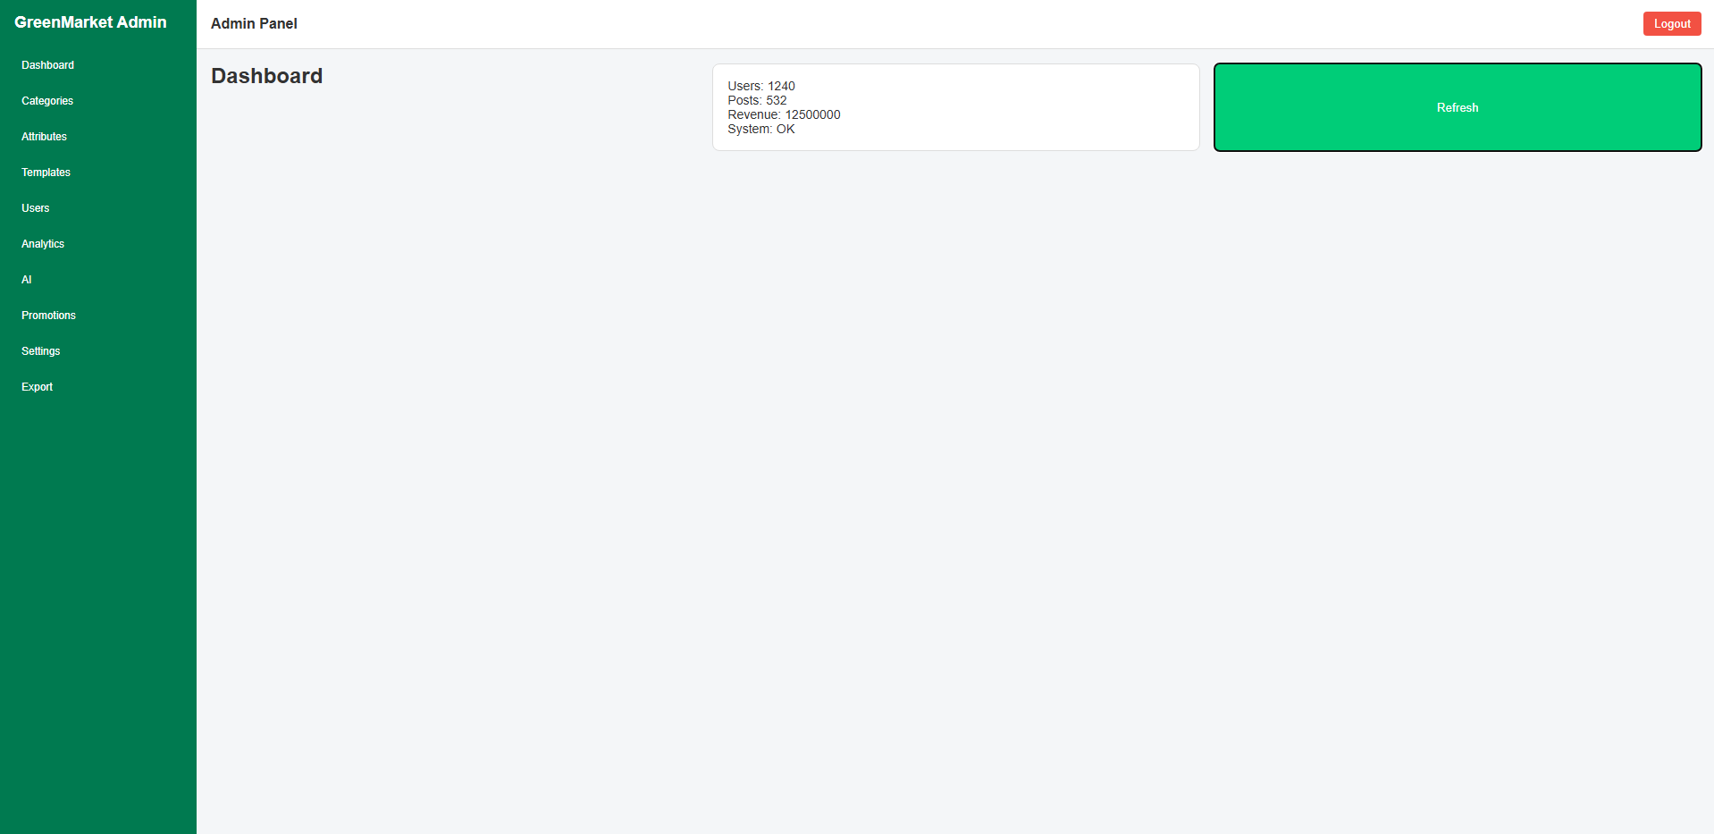
Figure 3.13.14: Overview dashboard screen of GreenMarket (Admin)
This screen allows the Admin to:
- View key statistics including total users, total posts, total revenue, and current system health status.
- Monitor the overall performance and workload of the GreenMarket platform.
- Refresh the metrics to fetch the latest real-time updated data.
- Detect anomalies early, such as sudden drops in user activity, unexpected increases in post volume, or system health warnings.

Field name | Description
Users | Number. Total number of registered user accounts in the system. Pulled from the admin metrics API.
Posts | Number. Total number of active posts currently available on the marketplace, including bonsai listings and promotional posts.
Revenue | Number/String. Total revenue generated by the platform (e.g., premium posts, subscriptions, ads). Displayed as a numeric value or currency format depending on configuration.
System | String. Indicates the current system health status (e.g., OK, Degraded, Critical). Used to monitor overall operational stability.
Dashboard cards | A group of metric boxes summarizing the platform’s key performance indicators (KPIs). Displays Users, Posts, Revenue, and System Health.
Refresh button | Action. Fetches the latest metrics from the server and updates all dashboard values in real time.

3.15.15 Placement Slot Management
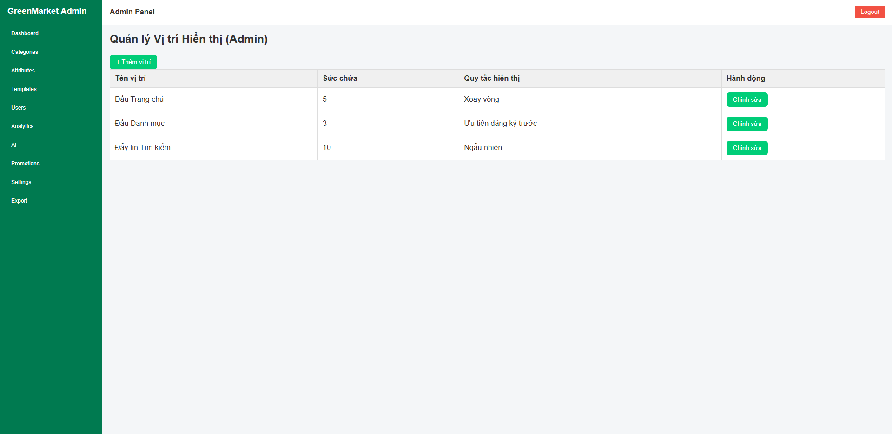
Figure 3.15.15: Placement slot management screen of GreenMarket (Admin)
This screen allows the Admin to:
- Manage all premium or highlighted placement slots used to display promoted posts across the platform.
- View the list of available display positions including homepage top, category header, and search-boost areas.
- Review slot configuration such as capacity and display rotation rules.
- Edit existing placement slots or create new ones.
- Control how many posts can appear in each slot and how they rotate or prioritize.

Field name | Description
Tên vị trí | String. The display slot name (e.g., Đầu Trang chủ, Đầu Danh mục, Đẩy tin Tìm kiếm). Describes where promoted posts will appear.
Sức chứa | Number. Maximum number of posts that can appear in the slot at any given time.
Quy tắc hiển thị | String. Defines how posts are rotated or prioritized (e.g., Xoay vòng, Ưu tiên đăng ký trước, Ngẫu nhiên).
Hành động | Action column. Allows the Admin to edit the configuration of a placement slot.
Add Slot button | Action. Opens a form to create a new placement slot with name, capacity, and display rule.
Slot row | Represents a single slot entry containing its name, capacity, display rule, and available actions.
Placement table | Table listing all existing placement slots in the system.
Empty state | Shown when no placement slots have been configured yet.

3.15.16 Promotion Package Management
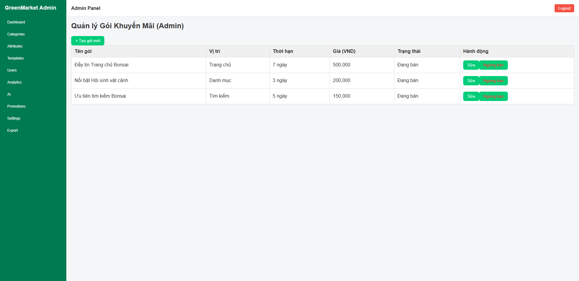
Figure 3.15.16: Promotion package management screen of GreenMarket (Admin)
This screen allows the Admin to:
- Manage all promotional packages available for users to purchase (e.g., tin VIP, vị trí nổi bật).
- View package attributes including display slot, duration, price, and status.
- Create new promotional packages for marketing strategies or seasonal campaigns.
- Edit existing packages, update pricing, modify duration, or adjust assigned placement slots.
- Enable or disable a package from being sold to users.
- Oversee the monetization structure of posts promoted on the GreenMarket platform.

Field name | Description
Tên gói | String. The name of the promotion package (e.g., VIP 7 ngày, Đẩy tin danh mục).
Vị trí | String. The display slot where the promoted post will appear (e.g., Đầu Trang chủ, Đẩy tin Tìm kiếm).
Thời hạn | String/Number. Duration of the package (e.g., 3 ngày, 7 ngày, 30 ngày). Determines how long the promotion remains active.
Giá (VND) | Number. The selling price of the package in Vietnamese đồng. Displayed with thousands separators for readability.
Trạng thái | String. Current selling status of the package (e.g., Đang bán, Ngừng bán). Controls whether users can purchase it.
Hành động | Column containing actions for Admin: edit package details or disable sales.
“Tạo gói mới” | Button. Opens a form to create a new promotion package including name, slot, duration, and price.
Package row | Represents a single promotion package entry with all its attributes.
Package table | Table listing all promotion packages registered in the system.
Empty state | Shown when no promotion packages are available.

3.15.17 Boosted Posts Management
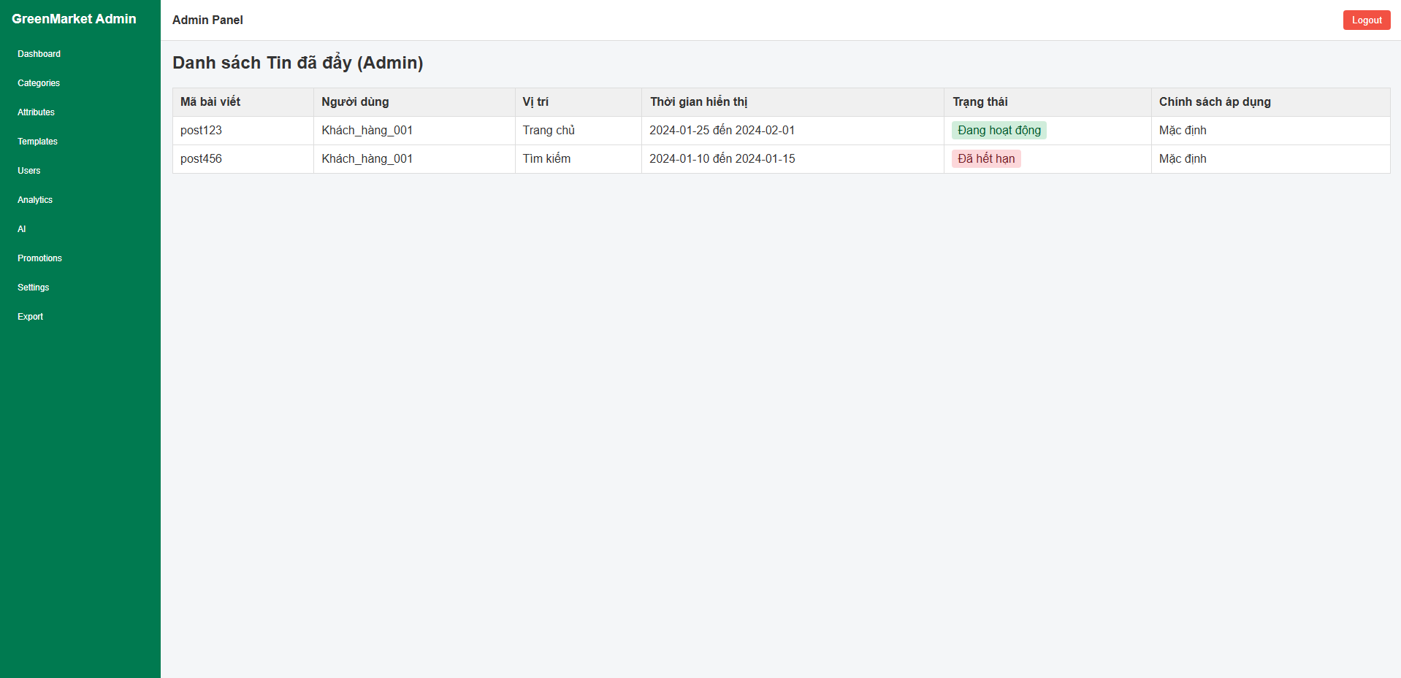
Figure 3.15.17: Boosted posts management screen of GreenMarket (Admin)
This screen allows the Admin to:
- View all promoted (boosted) posts from every user on the platform.
- Monitor which posts are currently being boosted and which boosts have expired.
- Check placement slot, duration, and policies applied to each boost.
- Audit promotion activity to ensure fair placement and prevent abuse.
- Identify problematic boosts (e.g., banned posts still being boosted).
- Track promotion history for transparency and billing validation.

Field name | Description
Mã bài viết | String. Unique identifier of the boosted post. Used for tracing content, billing, and resolving disputes.
Người dùng | String. Username or account ID of the user who purchased the boost.
Vị trí | String. The display slot where the post is boosted (e.g., Đầu Trang chủ, Đẩy tin Tìm kiếm).
Thời gian hiển thị | Date Range. The boost's active duration in start → end format (dd/MM/yyyy).
Trạng thái | Enum. Status of the boost: • Đang hoạt động – currently boosted• Đã kết thúc – promotion period is over
Chính sách áp dụng | String. The display or rotation policy applied to the boost (e.g., Mặc định, Xoay vòng, Ưu tiên đăng ký trước).
Boost row | Represents a single entry containing all data for one boosted post.
Boost table | Displays all boosted posts in a structured table. Used for platform-wide promotion supervision.
Empty state | Shown when no posts have been boosted on the platform.

3.15.18 AI Insights & Recommendation Settings
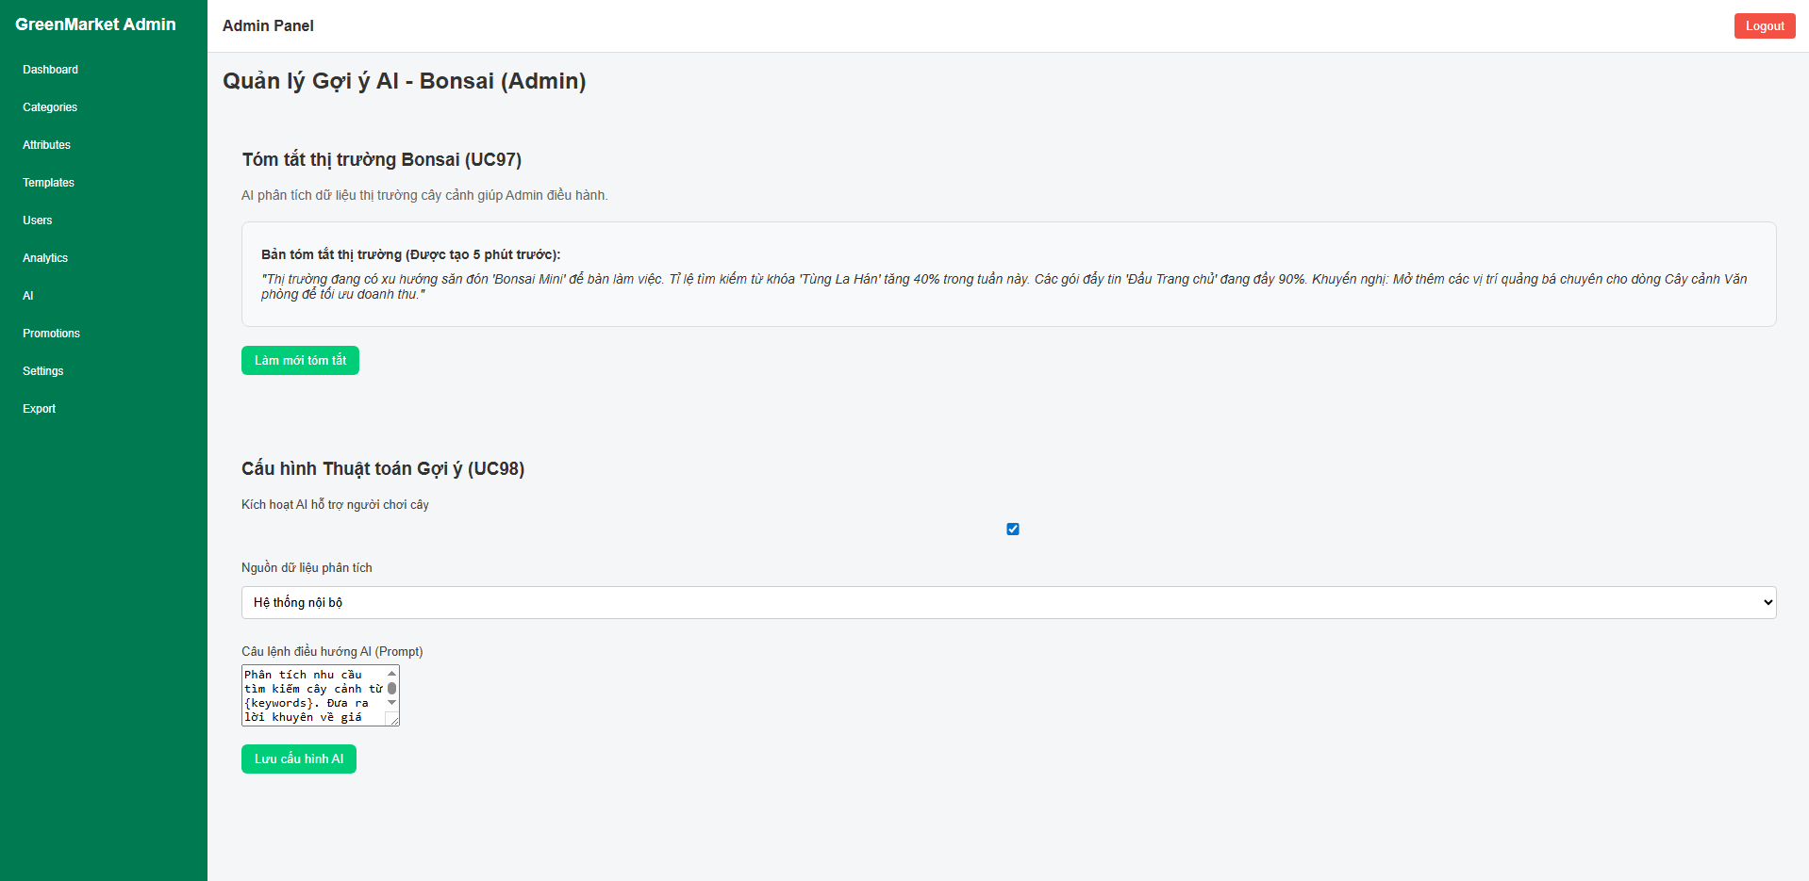
Figure 3.15.18: AI insights and recommendation configuration screen of GreenMarket (Admin)
This screen allows the Admin to:
- View AI-generated market insights summarizing current bonsai trends, keywords, and slot usage.
- Refresh the AI summary to obtain updated, real-time market intelligence.
- Configure the AI recommendation engine, including enabling/disabling AI, selecting data sources, and defining prompt instructions.
- Adjust how the AI analyzes user behavior, search trends, and bonsai market movements.
- Maintain control over the system’s suggestion logic to optimize accuracy and business outcomes.

Field name | Description
Tóm tắt thị trường Bonsai | Section. Displays the AI-generated market summary (UC97). Provides trends, keyword spikes, and recommendations for Admin decision-making.
Bản tóm tắt thị trường | Text/Paragraph. The actual AI-generated insight. Includes trending bonsai types, search increases, slot capacity usage, and revenue suggestions.
Làm mới tóm tắt | Button. Requests the AI engine to regenerate a new market summary with the latest data.
Cấu hình Thuật toán Gợi ý | Section for AI recommendation settings (UC98). Allows Admin to control how the AI behaves and what data it uses.
Kích hoạt AI hỗ trợ người chơi cây | Checkbox. Enables or disables the AI recommendation engine entirely. If disabled, users will not receive AI-based suggestions.
Nguồn dữ liệu phân tích | Dropdown. Allows the Admin to select which datasets the AI should use (internal system data, national bonsai associations, social media trends, etc.).
Câu lệnh điều hướng AI (Prompt) | Textarea. The instruction template used to guide AI behavior. Admin can customize how AI should interpret keywords, bonsai types, pricing, and promotional recommendations.
Lưu cấu hình AI | Button. Saves all AI configuration changes to the system and updates the behavior of the AI recommendation engine.
AI Insight card | Container displaying the generated insights and actions related to AI summaries.
AI Configuration card | Container showing all configurable fields related to AI behavior and data sources.
Empty state (optional) | If AI has not generated any summary yet, the interface displays a placeholder message instead of a market report.

3.15.19 System Settings
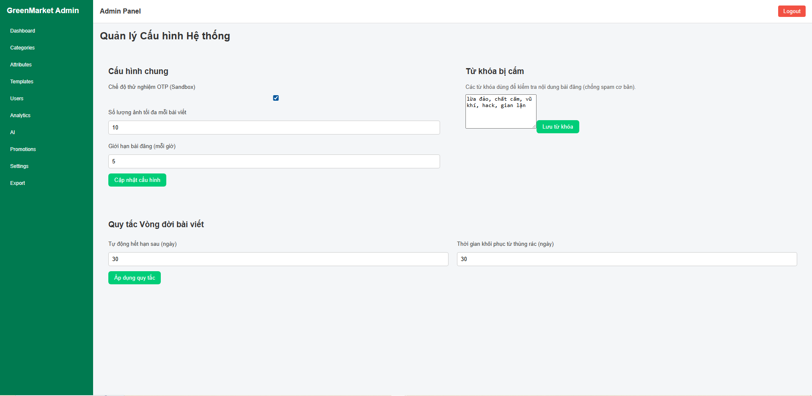
Figure 3.15.19: System configuration screen of GreenMarket (Admin)
This screen allows the Admin to:
- Manage global system rules affecting posting, content validation, and operational modes.
- Configure platform-level limitations such as image limits, post rate limits, and lifecycle rules.
- Toggle sandbox/testing modes for OTP or other system functions.
- Manage prohibited keywords used for basic content filtering.
- Define lifecycle rules determining how long posts remain active and how long they stay in trash before deletion.
- Ensure stable system operations through clear, centralized configuration controls.
Field name | Description
Cấu hình chung | Section. Contains global system settings such as sandbox mode, upload limits, and posting limits.
Chế độ thử nghiệm OTP (Sandbox) | Checkbox. Enables or disables OTP sandbox mode. When enabled, OTP verification uses test values instead of real SMS providers.
Số lượng ảnh tối đa mỗi bài viết | Number input. Defines how many images a user may upload per post. Used for performance and storage control.
Giới hạn bài đăng (mỗi giờ) | Number input. Defines the maximum number of posts a user can create per hour. Helps prevent spam.
Cập nhật cấu hình | Button. Saves all general configuration changes in this section.
Từ khóa bị cấm | Section. Lists prohibited keywords used in content scanning to block spam, illegal content, or harmful terms.
Danh sách từ khóa bị cấm | Textarea. Contains a comma-separated list of all restricted keywords. Admin can add/remove keywords as needed.
Lưu từ khóa | Button. Saves updates to the prohibited keyword list into the system.
Quy tắc Vòng đời bài viết | Section. Defines how posts expire, how long they remain active, and how trash cleanup works.
Tự động hết hạn sau (ngày) | Number input. Determines how long a post stays active before automatically expiring.
Thời gian khôi phục từ thùng rác (ngày) | Number input. Determines how long a deleted post remains in trash before permanent removal.
Áp dụng quy tắc | Button. Saves lifecycle settings and applies them to future and existing posts.
General Settings card | Container displaying all global configuration fields, including upload limits, sandbox toggles, and posting rules.
Keyword Filtering card | Container holding the prohibited keywords textarea and related actions.
Post Lifecycle card | Container containing lifecycle rule fields and apply button.
Empty state (optional) | If no configuration has been set yet, the interface displays default placeholder values until Admin saves new settings.

3.15.20 Bonsai Post Form Preview
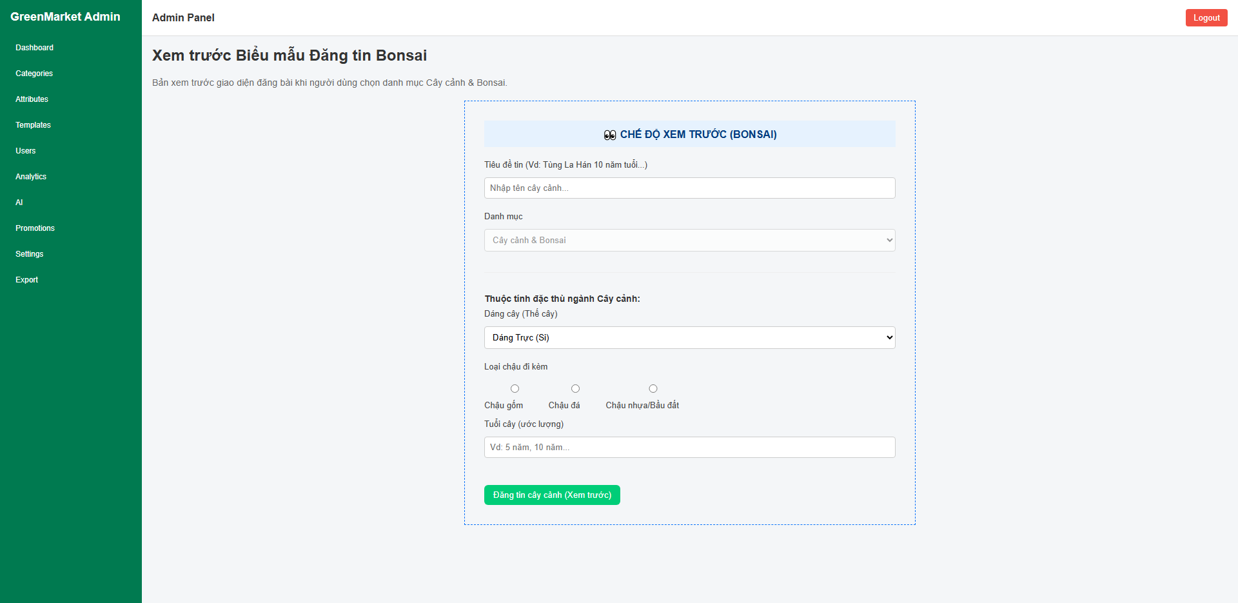
Figure 3.15.20: Bonsai posting form preview screen of GreenMarket (Admin)
This screen allows the Admin to:
- Preview the Bonsai-specific posting form before releasing it to users.
- Verify that the UI elements, labels, placeholders, and domain-specific fields for the Bonsai category are properly structured.
- Ensure that required attributes such as tree shape, pot type, and age estimation follow industry standards.
- Simulate the user experience when posting a Bonsai listing without allowing real submission.
- Review how category-specific rules and fields appear in the final posting interface.
Field name | Description
Tiêu đề tin | Text input. Title of the Bonsai listing. Placeholder suggests typical naming patterns such as tree type + age.
Danh mục | Dropdown (disabled). Preselected as “Cây cảnh & Bonsai” to indicate this preview is locked to the Bonsai category.
Thuộc tính đặc thù ngành Cây cảnh | Section. Contains all Bonsai-specific fields including tree shape, pot type, and estimated age.
Dáng cây (Thế cây) | Dropdown. Allows choosing the tree’s structural style (e.g., Straight, Cascade, Literati). Used to classify Bonsai aesthetics.
Loại chậu đi kèm | Radio group. Selects the type of pot included with the tree (ceramic, stone, or plastic/soil bag). Important for valuation.
Tuổi cây (ước lượng) | Text input. Estimated age of the Bonsai, often used to determine value.
Đăng tin cây cảnh (Xem trước) | Button (disabled). Display-only button to mimic the final form layout. Submission is not allowed in preview mode.
Preview banner | Container. Highlights that the user is viewing the Bonsai posting form in preview mode only.
Form Preview card | Container holding the entire previewed form, including category, attributes, and disabled actions.
Empty state (optional) | If no preview data or configuration is loaded, the screen displays only a placeholder layout instead of component previews.

3.15.21 Admin Analytics
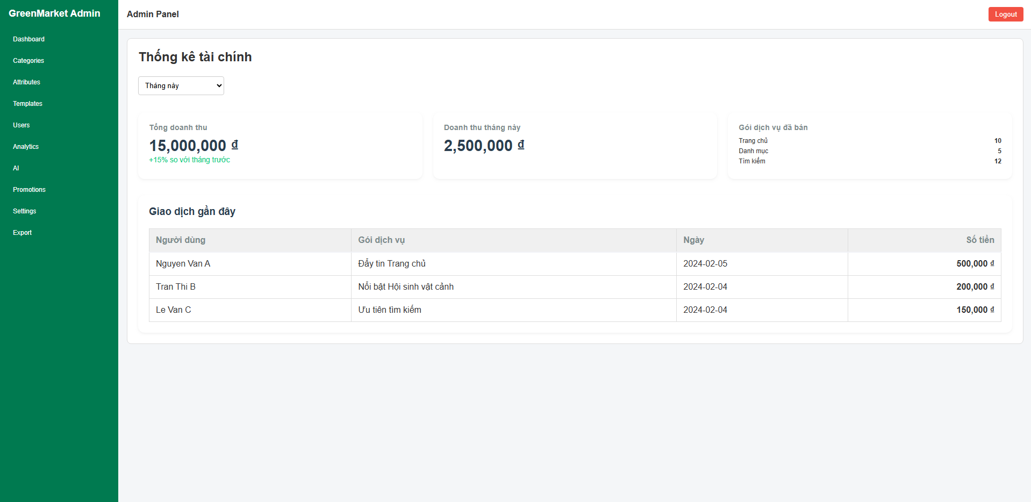
Figure 3.xx: Financial analytics dashboard screen of GreenMarket (Admin Panel)
This screen allows the Admin to:
- View key financial metrics such as total revenue, revenue this month, and number of packages sold.
- Filter revenue data by predefined time ranges (Tháng này, Tháng trước, Năm nay).
- Review a breakdown of sold promotion packages.
- View a table of recent transactions including user, package, date, and payment amount.

Field name | Description
Bộ lọc thời gian | Dropdown. Allows the Admin to filter analytics data by preset ranges: Tháng này, Tháng trước, Năm nay.
Tổng doanh thu | Number. Total accumulated revenue. Displayed as a large metric card, includes percentage growth compared to previous month.
Doanh thu tháng này | Number. Revenue generated within the currently selected month.
Gói dịch vụ đã bán | Group List. Breakdown of sold promotion packages: • Trang chủ – number sold • Danh mục – number sold • Tìm kiếm – number sold
Người dùng | String. Name or identifier of the user who performed the transaction. Shown in the recent transactions table.
Gói dịch vụ | String. Name of the purchased promotion package.
Ngày | Date String. The transaction date.
Số tiền | Number. Transaction amount formatted with thousands separators. Displayed right-aligned in the table.

4. Non-Functional Requirements

4.1 External Interfaces

4.1.1 User Interface (UI)
• Accessibility: The system UI must be optimized for non-technical users, specifically plant hobbyists and small shop owners, ensuring core tasks such as posting a listing, searching/filtering , and reporting are accessible within three taps or clicks.
• Multi-platform Support:
◦ Mobile App (React Native): Must operate stably on both Android and iOS, providing clear call-to-action buttons like "Contact," "Post Listing," and "Report".
◦ Web Portal (ReactJS): Dedicated to Admin functions, requiring a responsive layout compatible with major browsers such as Chrome, Firefox, and Edge.
• Role-Based Display: The interface must automatically adjust based on the Actor’s role after a successful login, ensuring Managers see moderation queues and Admins access the system dashboard and account controls.

4.1.2 Hardware Interfaces
• The system does not require specialized hardware but must be compatible with standard smartphones and personal computers with an active internet connection to run the Mobile App and Web Admin portal.

4.1.3 Software Integration Based on the secondary actors defined in the Use Case specifications, the system must integrate the following software interfaces:
• OTP/SMS Sandbox: Integrated to simulate the generation and verification of OTP codes for registration and login without incurring real SMS costs.
• Payment Gateway (MoMo Sandbox): Integrated to demonstrate the payment workflow for featured listings or plans .
• Cloud Storage (Cloudinary/S3): Provides APIs for uploading, storing, and distributing images via CDN for listings , report evidence, and collaborator job deliverables.
• Database Interface: Utilizes PostgreSQL to manage structured data, requiring the implementation of B-tree/GIN indexes to support multi-criteria searching/filtering and efficient moderation queue processing.

4.2 Quality Attributes

4.2.1 Usability
• The system must provide a seamless experience for all seven defined user roles (Guest, Customer, Manager, Admin, Host, Collaborator, and Operations Staff).
• The learning curve for new users to complete shop creation or create a listing should not exceed 10 minutes.

4.2.2 Security
• Authentication & Authorization: Implements JSON Web Tokens (JWT) for session management and enforces Role-Based Access Control (RBAC) on all APIs to prevent unauthorized access.
• Account Protection: Sensitive actions, such as role reassignment or locking accounts, must be restricted to Admins and recorded in the audit logs.

4.2.3 Performance
• Search Speed: Search and filter queries for listings must return results in under 2 seconds by leveraging optimized PostgreSQL indexing.
• Image Processing: The system must validate file types and sizes before uploading to ensure that high-resolution images do not degrade application performance.

4.2.4 Reliability & Availability
• The system must ensure that once a post is approved, it becomes immediately visible on the public news feed for other users.
• The soft-delete mechanism must guarantee data integrity for posts moved to the trash, allowing restoration within a 30-day window as per business rules.5. Requirement Appendix

5.1 Business Rules
ID | Rule Definition
BR-01 | The phone number must be unique per Account.
BR-02 | First-time users must register their phone number before OTP login.
BR-03 | OTP is valid for a limited time in demo (e.g., 60–120 seconds).
BR-04 | OTP requests must be rate-limited per phone number/device/IP (demo).
BR-05 | Users must be authenticated to create shops, posts, favorites, block shops, or submit payout requests.
BR-06 | A Customer must have an active Shop before creating posts.
BR-07 | Post status transitions: Draft → Pending → Approved/Rejected; Approved can be Hidden by Manager.
BR-08 | Rejected posts must store a rejection reason/template and optional note.
BR-09 | Only managers can approve/reject/hide/unhide posts.
BR-10 | Trash retention: posts in Trash can be restored within 30 days; after that, permanent delete is allowed.
BR-11 | Pending posts are not visible in public feed.
BR-12 | Guests can browse/search/view and submit reports; cannot create posts/shops/favorites.
BR-13 | The report must include a reason code; note and evidence are optional.
BR-14 | Anti-spam: repeated reports on the same target by the same reporter within the window may be blocked.
BR-15 | Resolved reports must store final action and resolution notes.
BR-16 | Blocking a shop hides its posts only for that customer.
BR-17 | Category-Attribute config must not contain duplicate attribute mapping in the same category.
BR-18 | Required attributes must be provided when submitting a post for moderation.
BR-19 | File uploads must validate file type and size limits.
BR-20 | RBAC enforcement: each role can only perform permitted actions; unauthorized requests return access denied.
BR-21 | Admin assigns internal roles (Manager/Host/Collaborator/Operations Staff) by phone number.
BR-22 | Locked accounts cannot login and cannot perform authenticated actions.
BR-23 | Exports are Admin-only; each export must be logged.
BR-24 | Earnings and payout are mock only (no real withdrawal) in academic scope.
BR-25 | MoMo sandbox payment (optional) is mock/demo only; no real money processing.

5.2 System Messages
# | Message code | Message Type | Context | Content
1 | MSG001 | Toast | Unexpected error | Something went wrong. Please try again.
2 | MSG002 | Inline | Phone invalid | Invalid phone number format.
3 | MSG003 | Toast | OTP sent | OTP has been sent (demo).
4 | MSG004 | Inline | OTP invalid | OTP is incorrect. Please try again.
5 | MSG005 | Toast | OTP expired | OTP expired. Please request a new OTP.
6 | MSG006 | Toast | Rate limit | Too many requests. Please wait and try again.
7 | MSG007 | Toast | Login required | Please login to continue.
8 | MSG008 | Toast | Access denied | You do not have permission to perform this action.
9 | MSG009 | Toast | Registration success | Registration successful. Please login with OTP.
10 | MSG010 | Toast | Logout success | Logged out successfully.
11 | MSG011 | Inline | Required field | This field is required.
12 | MSG012 | Inline | Invalid price | Price must be a valid number ≥ 0.
13 | MSG013 | Toast | Shop created | Shop created successfully.
14 | MSG014 | Toast | Shop updated | Shop updated successfully.
15 | MSG015 | Toast | Post saved | Post saved as draft.
16 | MSG016 | Toast | Post submitted | Post submitted for moderation.
17 | MSG017 | Toast | Post approved | Your post has been approved.
18 | MSG018 | Toast | Post rejected | Your post was rejected. Please check the reason.
19 | MSG019 | Toast | Moved to trash | Post moved to trash.
20 | MSG020 | Toast | Restored | Post restored successfully.
21 | MSG021 | Dialog | Confirm delete | Are you sure you want to delete this post?
22 | MSG022 | Toast | Favorite added | Added to favorites.
23 | MSG023 | Toast | Favorite removed | Removed from favorites.
24 | MSG024 | Toast | Report submitted | Report submitted. Thank you.
25 | MSG025 | Toast | Report cancelled | Report cancelled.
26 | MSG026 | Toast | Report resolved | Your report has been resolved.
27 | MSG027 | Toast | Upload failed | Upload failed. Please try again.
28 | MSG028 | Inline | File too large | File size exceeds the limit.
29 | MSG029 | Inline | Unsupported file | Unsupported file type.
30 | MSG030 | Toast | Account locked | Your account is locked. Contact support.
31 | MSG031 | Toast | Export ready | CSV export is ready to download.
32 | MSG032 | Toast | Payment sandbox | Payment initiated (sandbox demo).
33 | MSG033 | Toast | Payout requested | Payout request submitted (mock).
34 | MSG034 | Toast | Job accepted | Job accepted successfully.
35 | MSG035 | Toast | Job declined | My job declined.
36 | MSG036 | Toast | Deliverable submitted | Deliverable submitted successfully.
37 | MSG037 | Toast | Blocked shop | The shop was blocked. Its posts will be hidden.
38 | MSG038 | Toast | Unblocked shop | Shop unblocked.
39 | MSG039 | Toast | No results | No results found. Try different filters.

