DIP Proposal Report
Team07

I. Paper title
Image modification with replacing blinked eyes.

II. Motivation
Nowadays, many people like to take pictures when gathering with friends or family in order to leave a wonderful memories. However, it could not guarantee that everybody open their eyes when the moment of pressing the button, especially there are more and more people. One example are shown as Figure 1. Although taking more pictures at the same time may solve this problem, it is still possible that there are different people taking turns to blink their eyes or someone just prefer to the photo when others blink their eyes. Therefore, we would like to construct a system that can perfectly solve this problem and make the photo fitter to users.

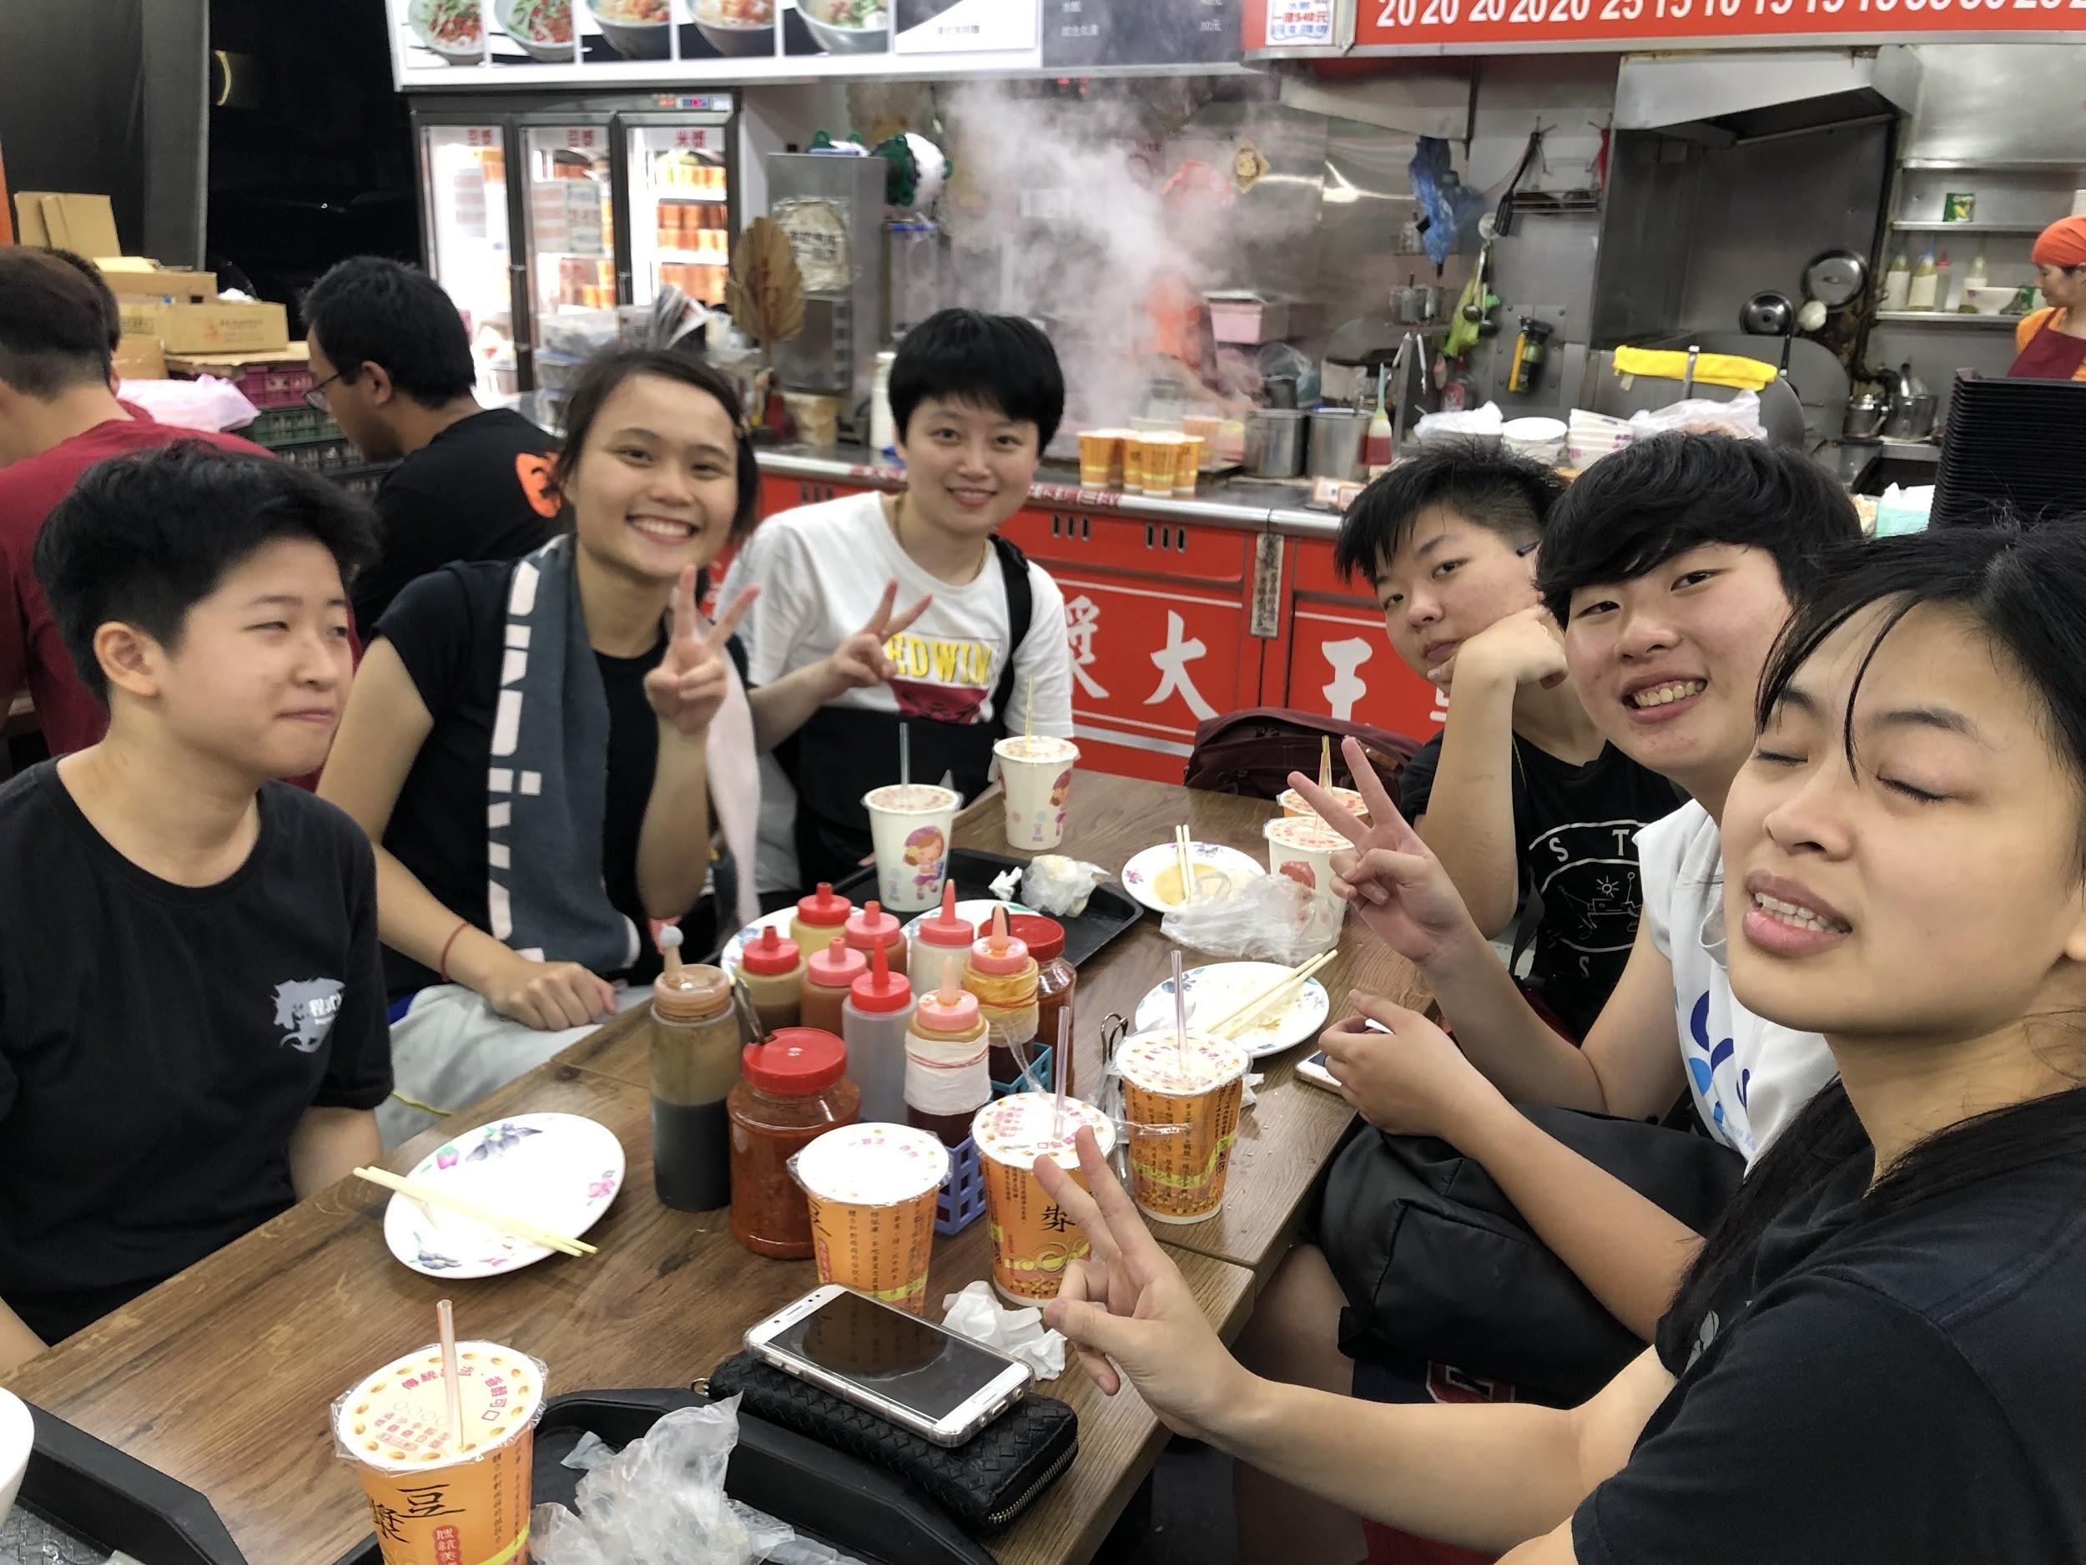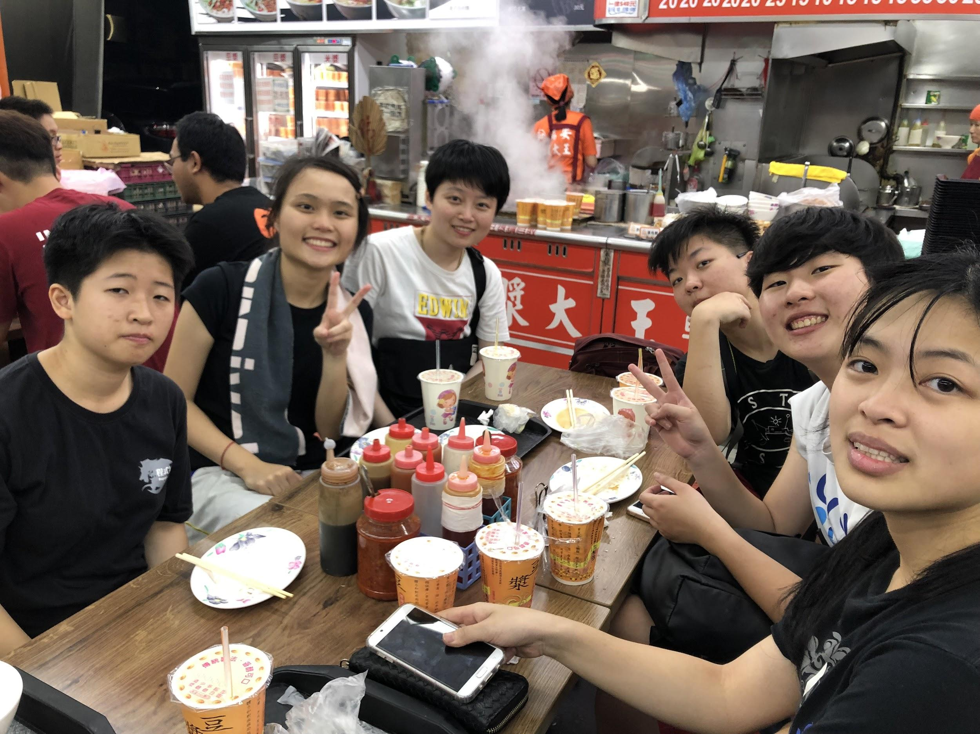
Figure 1. There is someone blinking eyes in the left picture. However, compared to the right picture, users would prefer to the left one according to expressions, actions of people or brightness of the picture.

III. Problem definition
Given two photos as input images. One is the image that there is someone blinking eyes, and the other is the image provided the normal eyes of the person who blink eyes in the first image. Through some manipulation, we hope that the perfectly merged image would be generated. The workflow of the system is shown as Figure 2.

Ground Image
Face Alignment
Eye Localization
Open Eye Image
Blink Detection
Eye Localization
Eye Replacement

Figure 2. The workflow of this project.

IV. Algorithm

Step 1. Eye localization.
- Find the eyes within faces.[1][2][3]

Step 2. Blink detection.
- Use “eye aspect ratio” to decide if the eyes are blinked.[4]

Step 3. Face alignment.
- For those with blinked eyes. Find its matching face.

Step 4. Eye Replacement.
- Find a good boundary for the normal eyes. [5]
- Replace the blinked eyes by image composition.

V. Implementation details
This project is fully implemented using OpenCV with Python3.6 on Ubuntu 18.04. Implementation details of each step is showed as follows.

Step 1. Eye localization.
- We used a pretrained model form dlib to Find the eyes of each face.[1][2][3]

Step 2. Blink detection.
- Compare the “eye aspect ratio” of two images to decide if the eyes are blinked.[4]

Step 3. Face alignment.
- We handle two modes, which should be decided by the user. Mode 1, the two input images are taken successively. Mode 2, impulsively matching the most blinked eye with the most opened eye.

Step 4. Eye Replacement.
- Find a good boundary for the normal eyes. [5]
- Replace the blinked eyes by image composition.
VI. Experiment and results
We collect data from 2016-2018 graduation ceremony of CSIE and some daily photos. Experiments are run on a Ubuntu 18.04 machine with i5-8250U x 8 and sufficient memory.
Execution time.

VII. Reference
[1] Accurate eye centre localisation by means of gradients. Fabian Timm, Erhardt Barth. 2011 Visapp.
[2] Human-Eye Tracking and Location Algorithm Based on AdaBoost-STC and RF. Lintao Liu, Jun Liu, Ziqiang Huang. University of Electronic Science and Technology of China Cheng Du, China. 2017 IEEE.
[3] Fast and Accurate Algorithm for Eye Localization for Gaze Tracking in Low Resolution Images. Anjith George, Member, IEEE, and Aurobinda Routray, Member, IEEE. 2016.
[4] Eye Blink Detection Using Facial Landmarks. Tereza Soukupov ́a, JanˇCech. Czech Technical University, Prague. 2016 CVWW.
[5] Drag-and-Drop Pasting. J Jia, J Sun, CK Tang, HY Shum. 2006 ACM Transactions on Graphics.

