Quot PSE - Module Process Flows
  - Public-Sector IFMIS Architecture Reference
Quot PSE Engineering
2026-05-08
Table of Contents

Quot PSE — Module Process Flows
Public-sector IFMIS (Integrated Financial Management Information System) for Nigerian state governments. Multi-tenant Django + DRF backend with a React 19 + Vite frontend. Each tenant is a PostgreSQL schema (django-tenants).
This document maps each module’s domain process flow and the points where it integrates with other modules. Diagrams are Mermaid; render in any Markdown viewer that supports Mermaid (GitHub, VS Code with extension, MkDocs Material, etc.).
Last revalidated: 2026-05-08 — after the 9-finding audit fix-set (see docs/AUDIT/2026-05-08-fix-set.md if present, or the session summary).

Table of contents
- System overview
- Cross-module integration map
- Tenants module
- Core module
- Superadmin module
- Budget module
- Accounting module
- Procurement module
- Contracts module
- Inventory module
- HRM module
- Workflow module
- End-to-end canonical flows

1. System overview
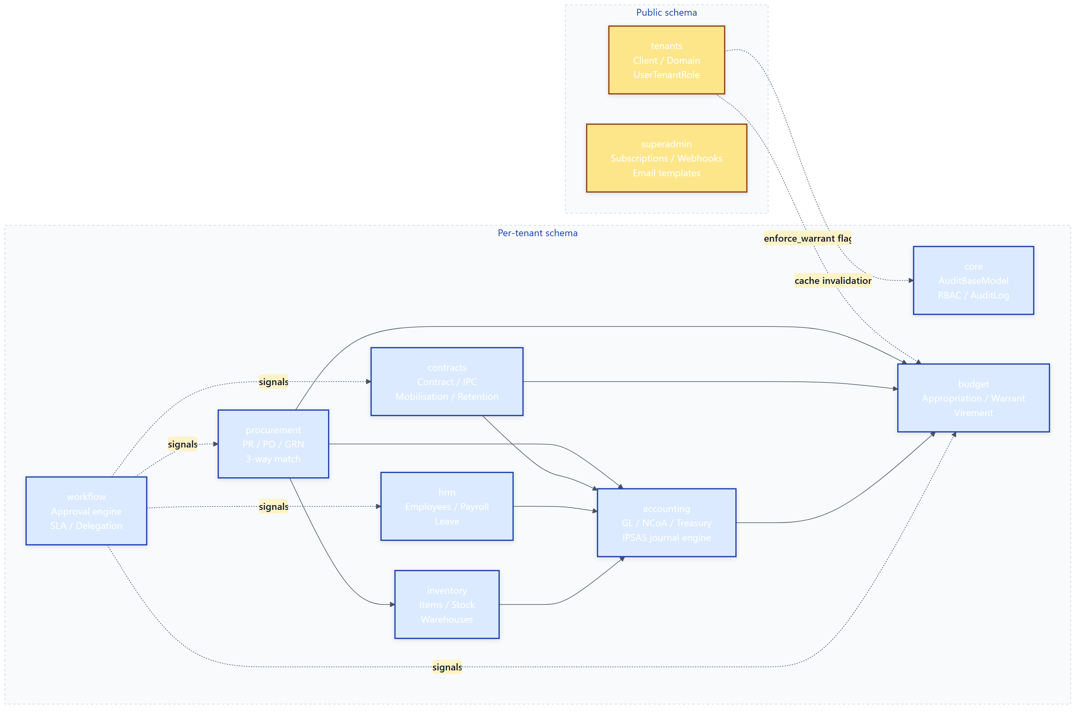
Key architectural facts: - tenants and superadmin live in the public schema. Everything else is per-tenant (one PostgreSQL schema per state government / MDA). - core is the leaf dependency — every domain module inherits AuditBaseModel / StatusTransitionMixin / ImmutableModelMixin from it. Core has no domain logic. - accounting is the GL hub. Procurement, Contracts, HRM, Inventory all ultimately call IPSASJournalService.post_journal() to land their effects in the ledger. - budget is the spending gate. Every JournalHeader → Posted triggers accounting.signals.budget_enforcement which calls into budget.services for STRICT / WARNING / NONE policy decisions. - workflow is a generic multi-step approval engine that any document in any module can opt into via a Generic Foreign Key.

2. Cross-module integration map
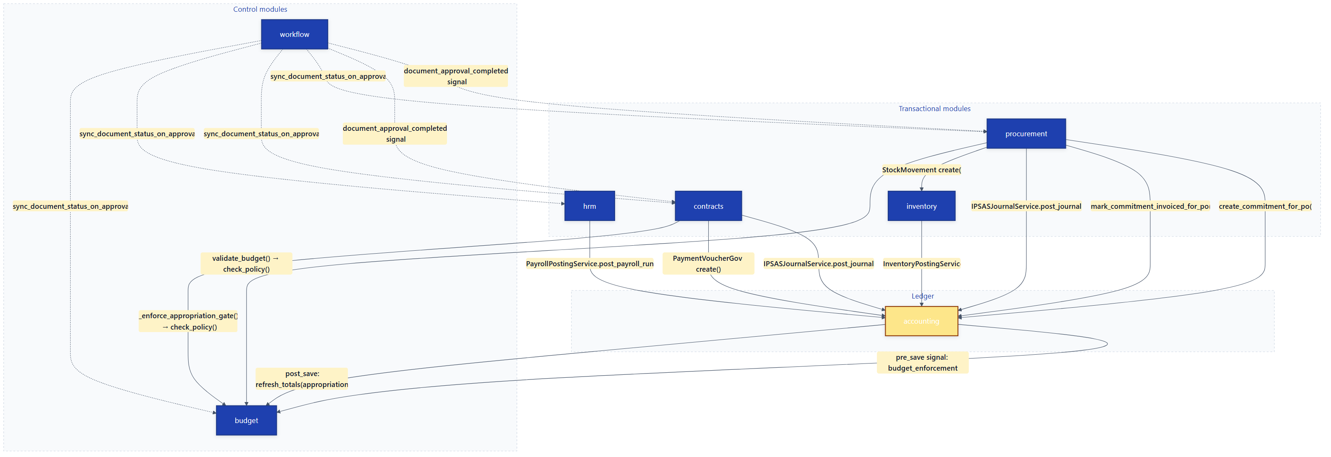
Integration patterns used:
Pattern | Where | Purpose
Direct service call | IPCService → IPSASJournalService.post_journal() | Synchronous, atomic GL posting
Django signal | JournalHeader.pre_save → check_policy() | Cross-cutting budget enforcement
Custom Signal | workflow.signals.document_approval_completed | Decoupled post-approval auto-actions
Generic FK | workflow.Approval.content_type / object_id | One approval engine for any document
Helper service | inventory.services.get_default_warehouse_for_mda() | Cross-module lookup without circular import

3. Tenants module
Purpose: Multi-tenant bootstrap. Each Nigerian state government (or MDA) gets its own PostgreSQL schema. Client rows in the public schema describe each tenant; django-tenants middleware routes requests to the right schema.

Key models
Model | File:Line | Role
Client | tenants/models.py:61 | Tenant root — schema name, branding, feature flags
Domain | tenants/models.py:257 | Hostnames mapping to Client
TenantModule | tenants/models.py:278 | Per-tenant feature toggles (HR, contracts, etc.)
TenantSubscription | tenants/models.py:378 | Plan / billing lifecycle
UserTenantRole | tenants/models.py:408 | User ↔ tenant ↔ role mapping
SubscriptionPlan | tenants/models.py:307 | Pricing tier definitions

Process flow
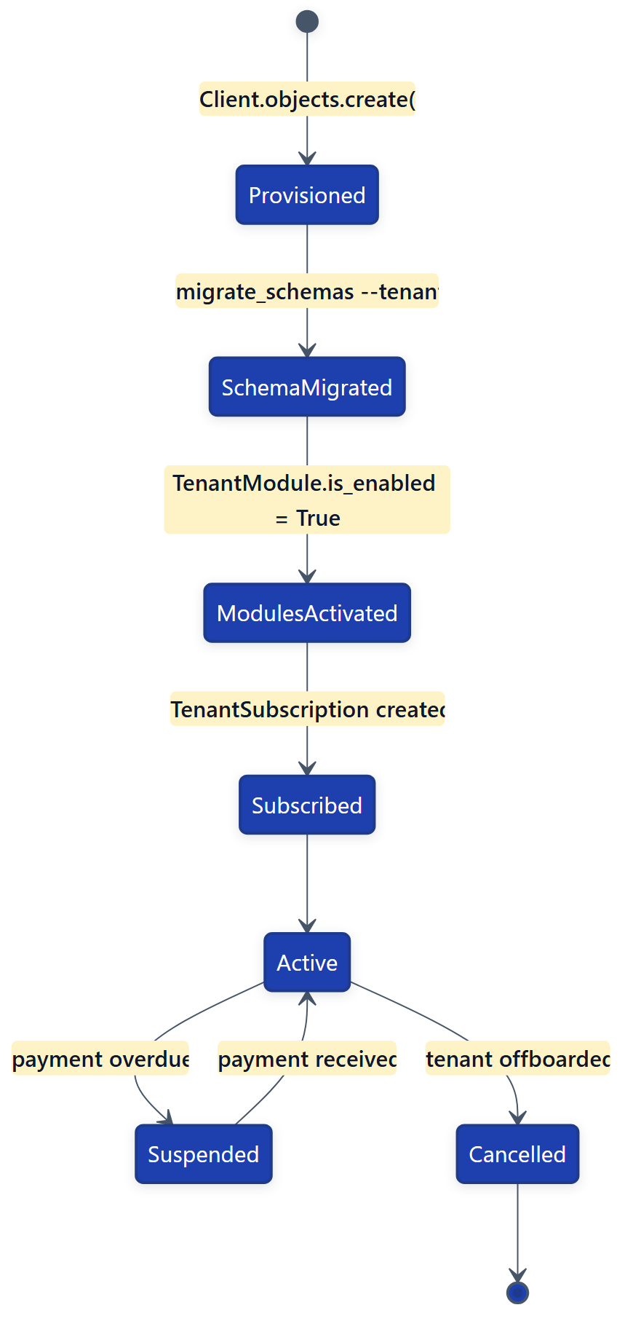

Integration points
- Out: UserTenantRole save/delete fires core.permissions.invalidate_permission_cache() and core.cache_utils.invalidate_access_cache().
- Out: TenantSubscription save fires core.cache_utils.invalidate_subscription_cache().
- In: budget.services._is_warrant_enforced() reads connection.tenant.enforce_warrant at posting time.
- In: Every request: django-tenants middleware sets connection.tenant from the hostname; all per-tenant ORM operations rely on this.

4. Core module
Purpose: Pure infrastructure — base model mixins, RBAC, audit log, MFA, session management, and cross-cutting utilities. No domain business logic.

Key abstractions
Abstraction | File:Line | Role
AuditBaseModel | core/models.py:26 | created_at / updated_at / created_by / updated_by on every domain model
StatusTransitionMixin | core/models.py:86 | Declarative ALLOWED_TRANSITIONS dict; gate at save()
ImmutableModelMixin | core/models.py:48 | Block field edits once a record is Posted / Approved
AuditLog | core/models.py:118 | Append-only audit trail (who-did-what-when)
Role / RoleAssignment | core/models.py:476 / 610 | RBAC primitives — used by every module’s permissions
Organization | core/models.py:929 | Optional org structure for non-government tenants

Process flow
Core has no state machine of its own — it provides building blocks. The pattern every domain module follows:
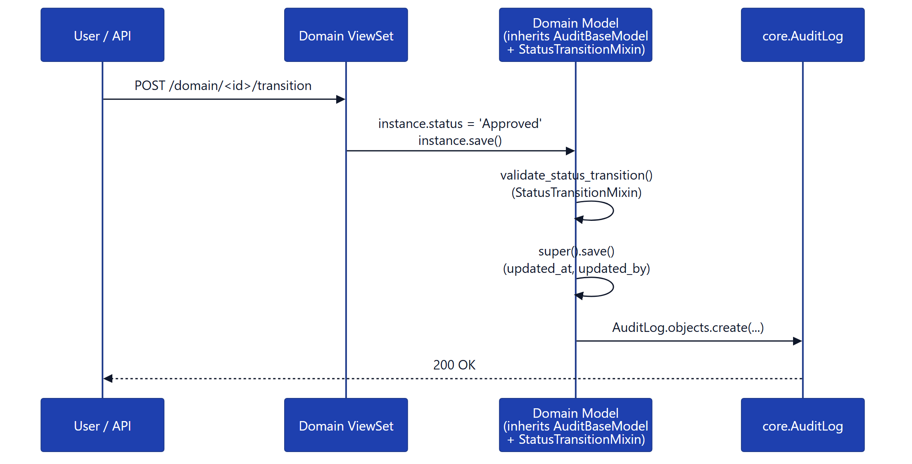

Integration points
- Out: None — leaf dependency.
- In: Every domain module imports from core. accounting, procurement, budget, contracts, hrm, inventory, workflow all inherit AuditBaseModel / StatusTransitionMixin / ImmutableModelMixin.

5. Superadmin module
Purpose: Platform-operator (SaaS) layer. Manages tenants, subscriptions, support tickets, email templates, webhooks, referral commissions, and global announcements. Lives in the public schema.

Key models
Model | File:Line | Role
SuperAdminProfile | superadmin/models.py:14 | Platform staff user profile
ImpersonationLog | superadmin/models.py:144 | Audit trail when staff “log in as” tenant user
Referral / Commission | superadmin/models.py:220 / 248 | Partner / referral payouts
SupportTicket | superadmin/models.py:331 | Inbound support queue
WebhookConfig / WebhookDelivery | superadmin/models.py:590 / 631 | Outbound webhook + retry tracking
EmailTemplate | superadmin/models.py:79 | Multi-language editable templates

Process flow — typical operator workflow
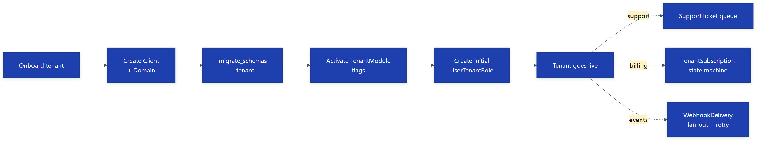

Integration points
- Largely self-contained at the public schema. Reads tenants.Client for impersonation and subscription reporting.
- No inbound module dependencies (per-tenant modules don’t reach into superadmin).

6. Budget module
Purpose: Nigerian IFMIS budget lifecycle — annual appropriation enacted by the State House of Assembly, then released in tranches as Warrants (AIE — Authority to Incur Expenditure). Enforces spending gates against the Appropriation register.

Key models
Model | File:Line | Role
UnifiedBudget | budget/models.py:29 | Logical budget container — wraps Appropriation, Revenue, Virement
Appropriation | budget/models.py:660 | The legal spending authority for one (MDA × economic × fund × FY) tuple
Warrant | budget/models.py:1223 | AIE — releases cash within [effective_from, effective_to]
AppropriationVirement | budget/models.py:1521 | Reallocation between appropriation lines
RevenueBudget | budget/models.py:1432 | Revenue targets (separate from expenditure budget)
WarrantPrintoutSettings | budget/models.py | Tenant-wide letterhead/signatures config for printed AIEs

Process flow — Appropriation
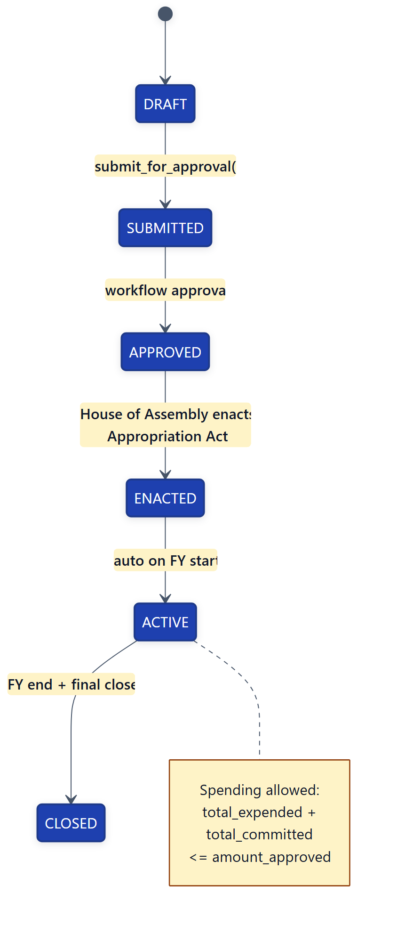

Process flow — Warrant (AIE)
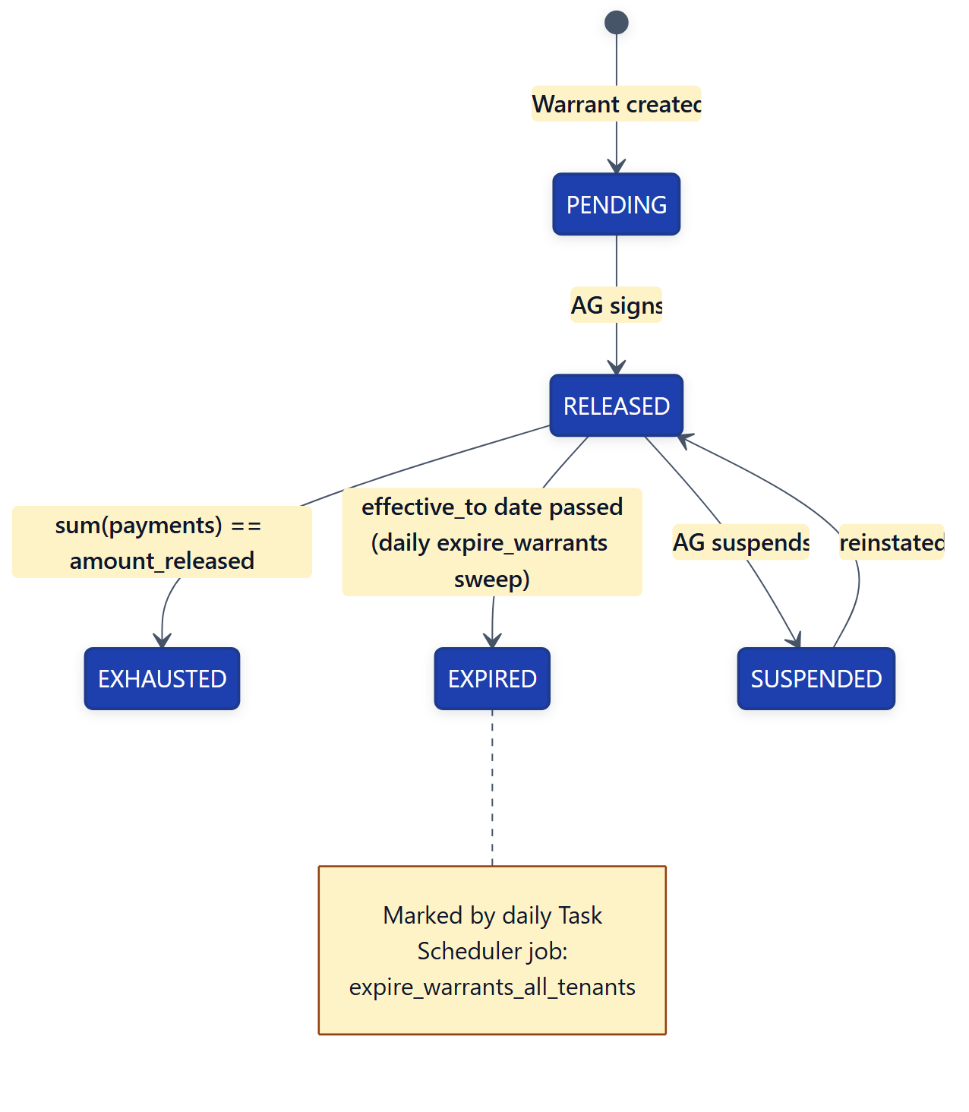

Process flow — spend authorisation
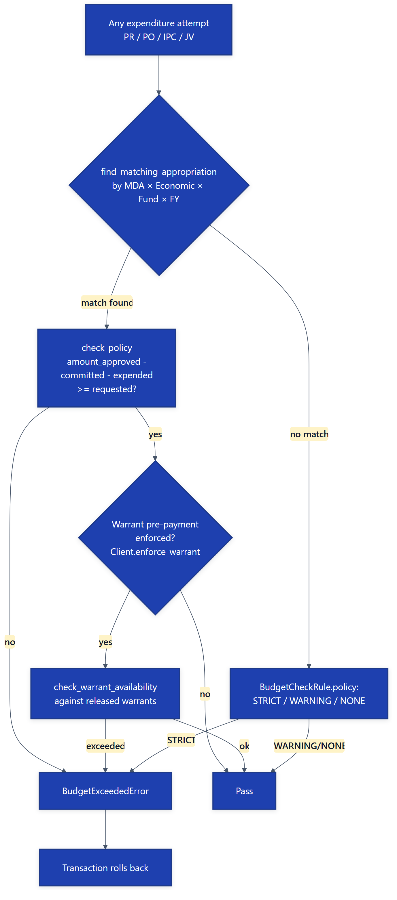

Integration points
- Out: budget.services.BudgetValidationService.validate_expenditure() — called by accounting, procurement, contracts before any expenditure.
- Out: _is_warrant_enforced() reads tenants.Client.enforce_warrant.
- In: accounting.signals.budget_enforcement.pre_save(JournalHeader) calls check_policy() and check_warrant_availability().
- In: accounting.signals.budget_enforcement.post_save(JournalHeader) calls appropriation_totals.refresh_totals(appropriation) to keep cached_total_committed / cached_total_expended fresh.
- In: procurement.PurchaseRequest.validate_budget() and PurchaseOrder.process_budget_encumbrance() call accounting.services.budget_check_rules.check_policy().
- In: contracts.IPCService._enforce_appropriation_gate() calls check_policy() before posting the IPC accrual journal.

7. Accounting module
Purpose: Single source of truth for the General Ledger. Implements the 6-segment Nigerian Chart of Accounts (NCoA), IPSAS-accrual journal engine, TSA / treasury cash management, fixed assets, payroll posting (delegated target), tax / WHT, period close, and statutory reporting.

Key models
Model | File:Line | Role
JournalHeader / JournalLine | accounting/models/gl.py:263 | The GL — DR=CR enforced
Account | accounting/models/gl.py:128 | Chart of Accounts row
NCoACode | accounting/models/ncoa.py:389 | 6-segment classification (admin, economic, functional, programme, fund, geo)
PaymentVoucherGov | accounting/models/treasury.py:124 | Government payment voucher — primary cash-out document
TreasuryAccount | accounting/models/treasury.py:16 | TSA hierarchy (Main, Sub-Account, Zero-Balance)
PaymentInstruction | accounting/models/treasury.py:308 | Bank-bound instruction (NIBSS / RTGS)
BudgetCheckRule | accounting/models/... | Per-account policy: STRICT / WARNING / NONE

Process flow — Journal Header
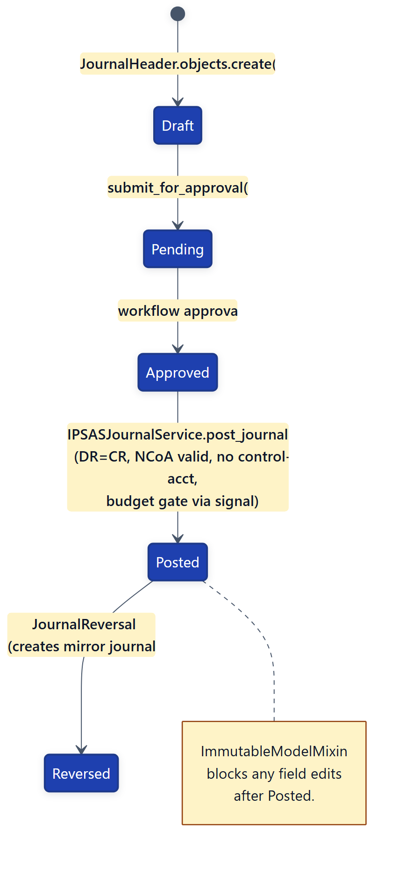

Process flow — Payment Voucher (PV)
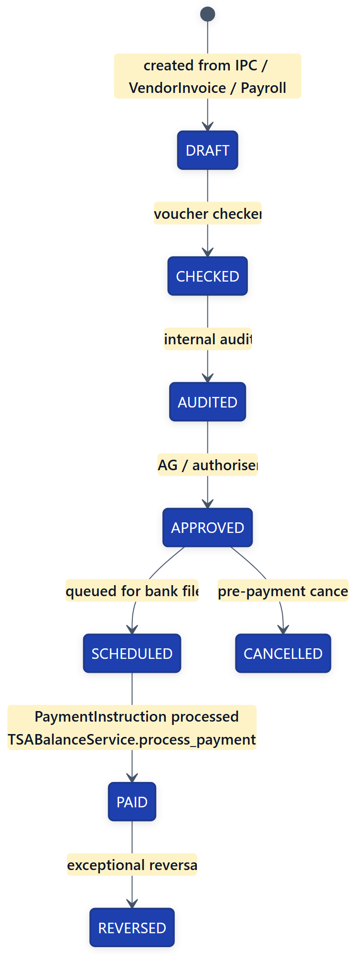

Process flow — IPSAS journal posting
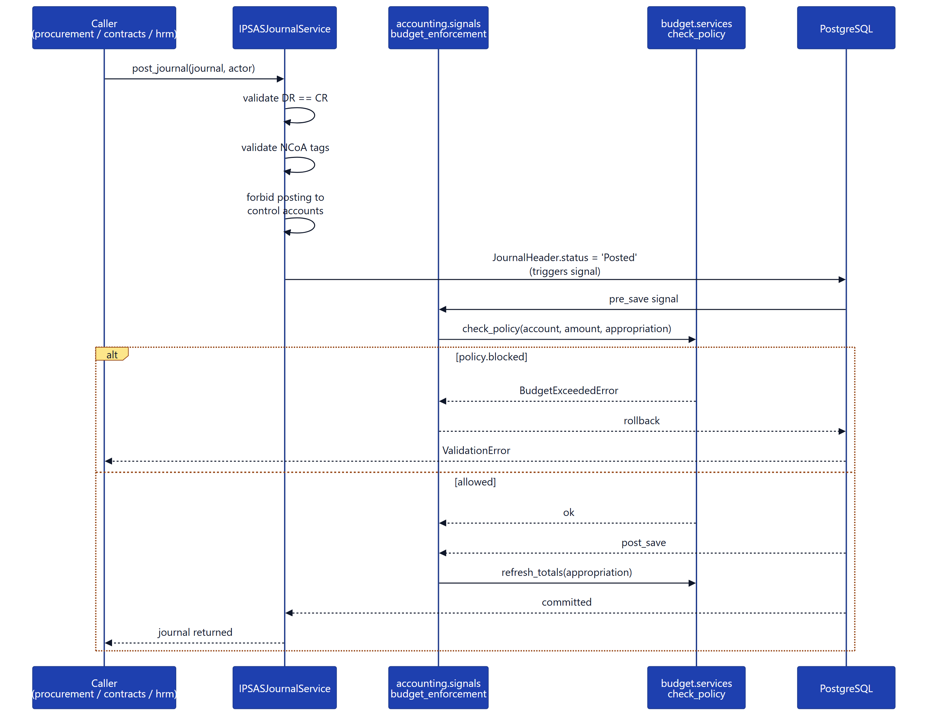

Integration points
- Out: accounting/signals/budget_enforcement.py → budget.models.Appropriation (refresh totals).
- Out: accounting/signals/coa_to_ncoa.py on Account save → upserts NCoACode / EconomicSegment (internal CoA ↔ NCoA mirror).
- In (procurement): ProcurementPostingService, create_commitment_for_po(), mark_commitment_invoiced_for_po(), _post_matching_to_gl_inner().
- In (contracts): IPSASJournalService.post_journal() from IPCService.approve(), PaymentVoucherGov.objects.create() from IPCService.create_draft_voucher().
- In (hrm): PayrollPostingService.post_payroll_run() from PayrollRun.save() on Approved.
- In (inventory): InventoryPostingService on StockMovement create.

8. Procurement module
Purpose: Procurement-to-payment (P2P) cycle. Vendor registry, purchase requests, purchase orders with budget commitment, goods received notes, 3-way invoice match, and vendor performance.

Key models
Model | File:Line | Role
Vendor | procurement/models.py:77 | Supplier master (with KYC, bank, tax IDs)
PurchaseRequest | procurement/models.py:244 | Internal request — pre-PO
PurchaseOrder | procurement/models.py:448 | Authorised order to vendor — budget commitment
GoodsReceivedNote | procurement/models.py:926 | Receipt confirmation — feeds inventory
InvoiceMatching | procurement/models.py:1431 | 3-way match: PO ↔ GRN ↔ Vendor Invoice
ProcurementBudgetLink | (in accounting models) | Per-PO encumbrance row in Appropriation register

Process flow — full P2P cycle
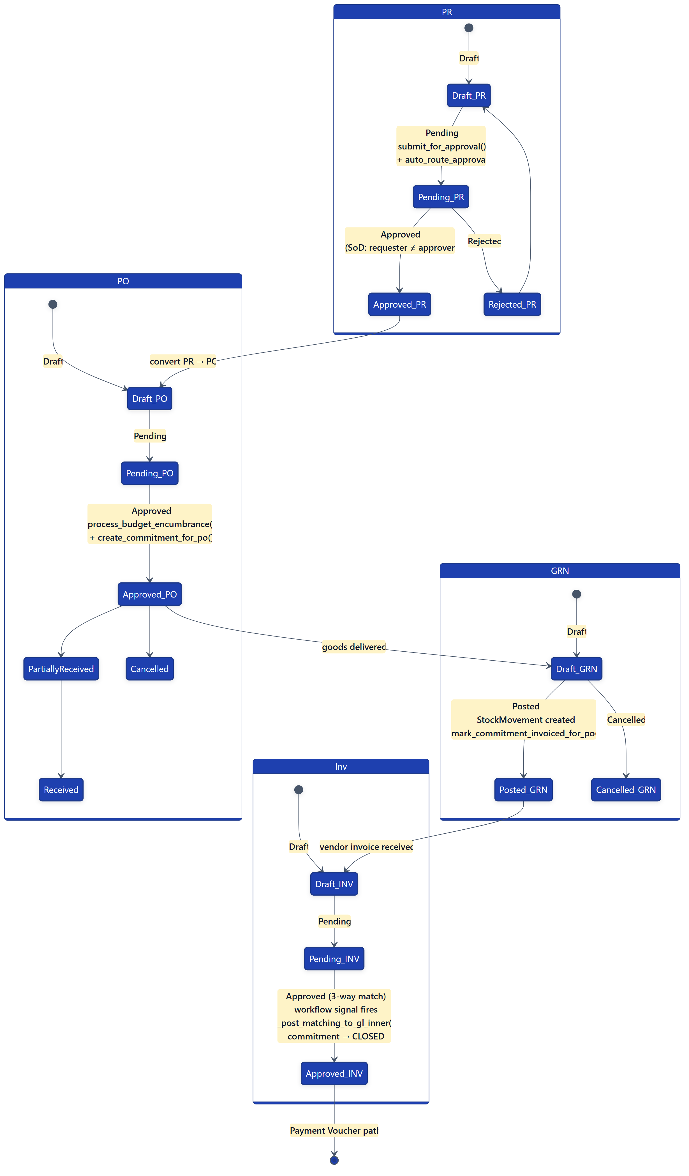

Process flow — sequence (PR → Payment)
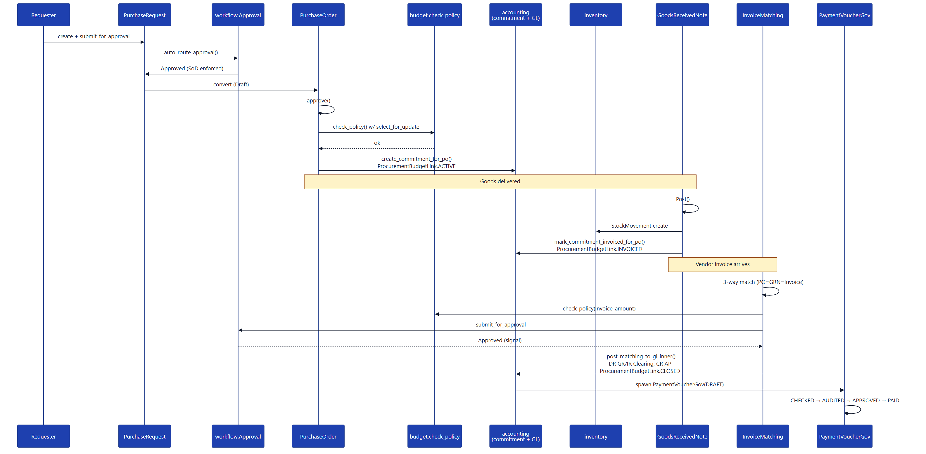

Integration points
- Out (accounting): create_commitment_for_po(), mark_commitment_invoiced_for_po(), cancel_commitment_for_po(), IPSASJournalService.post_journal(), ProcurementPostingService.
- Out (inventory): StockMovement created inline in GoodsReceivedNote.save(); inventory.services.get_default_warehouse_for_mda() resolves MDA → Warehouse.
- Out (budget): PurchaseRequest.validate_budget() and PurchaseOrder.process_budget_encumbrance() call accounting.services.budget_check_rules.check_policy().
- In (workflow): workflow.signals.document_approval_completed → procurement.signals.auto_post_invoicematching_on_approval.

9. Contracts module
Purpose: Capital / infrastructure contract management — activation, milestones, measurement books, Interim Payment Certificates (IPCs) with ten structural overpayment-prevention controls, mobilisation advances, retention holdback, and variations / write-ups.

Key models
Model | File:Line | Role
Contract | contracts/models/contract.py:78 | Aggregate root — vendor, NCoA, fiscal year, ceiling
ContractBalance | contracts/models/contract.py:324 | Real-time spending ledger (locked per IPC)
ContractYearPlan | contracts/models/year_plan.py | Multi-year split — one row per fiscal year
MilestoneSchedule | contracts/models/contract.py:465 | Deliverables + payment triggers
MeasurementBook | contracts/models/payment.py:42 | On-site quantity record
InterimPaymentCertificate | contracts/models/payment.py:161 | Periodic payment certificate
MobilizationPayment | contracts/models/payment.py:414 | Up-front advance
RetentionRelease | contracts/models/payment.py:470 | Practical / final retention release
Variation | contracts/models/variation.py | “Write-up” — upward contract revision

Process flow — Contract lifecycle
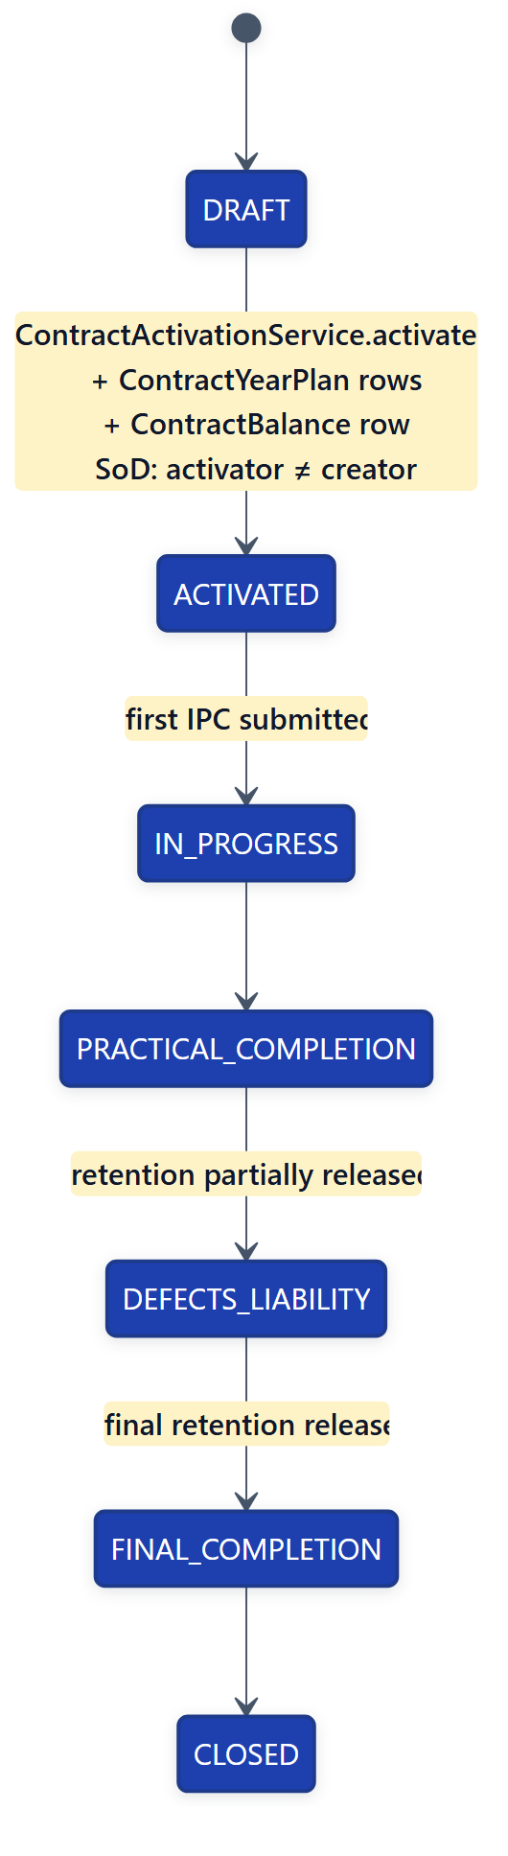

Process flow — IPC lifecycle (the 10-control engine)
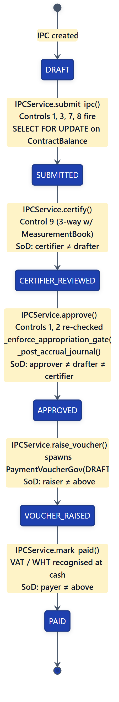
Ten structural controls (enforced by IPCService): 1. Ceiling — certified + pending ≤ contract_ceiling 2. Coherence — net_payable recomputed and reconciled 3. Monotonicity — cumulative work-done never decreases 4. Mobilization recovery — delegated to MobilizationService 5. Retention cap — delegated to RetentionService 6. Variation approval — only APPROVED variations count 7. Duplicate IPC — integrity_hash uniqueness (DB partial index) 8. Fiscal-year boundary — posting_date inside year_plan.fiscal_year 9. Three-way match — IPC ↔ MeasurementBook ↔ PaymentVoucher 10. Segregation of Duties — submitter ≠ certifier ≠ approver ≠ voucher-raiser ≠ payer

Process flow — IPC approval sequence
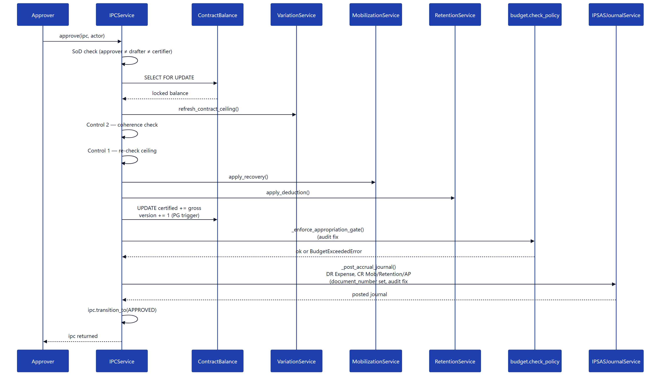

Integration points
- Out (accounting): IPSASJournalService.post_journal() (IPC approval), PaymentVoucherGov.objects.create() (voucher raise), accounting.services.procurement_posting.get_vendor_ap_account().
- Out (budget): IPCService._enforce_appropriation_gate() calls find_matching_appropriation() + check_policy() against the IPSAS Appropriation register before the accrual journal is created.
- Out (workflow): Variation and IPC approval steps optionally route via workflow.Approval.
- In (workflow): workflow.signals.sync_document_status_on_approval writes back into ContractApprovalStep.status.

10. Inventory module
Purpose: Item / stock master, warehouse stock ledger, reservations, batch / serial tracking, reorder alerts, inter-warehouse transfers.

Key models
Model | File:Line | Role
Item | inventory/models.py:11 | Item master — SKU, unit, GL accounts
ItemStock | inventory/models.py:264 | Per-warehouse quantity + reserved snapshot
StockMovement | inventory/models.py:503 | Atomic IN / OUT / ADJ / TRF event
ItemBatch | inventory/models.py:207 | Batch / lot tracking with expiry
Warehouse | inventory/models.py:675 | Physical / virtual location
Reservation | inventory/models.py:766 | Soft-allocation against a future need

Process flow — stock movement
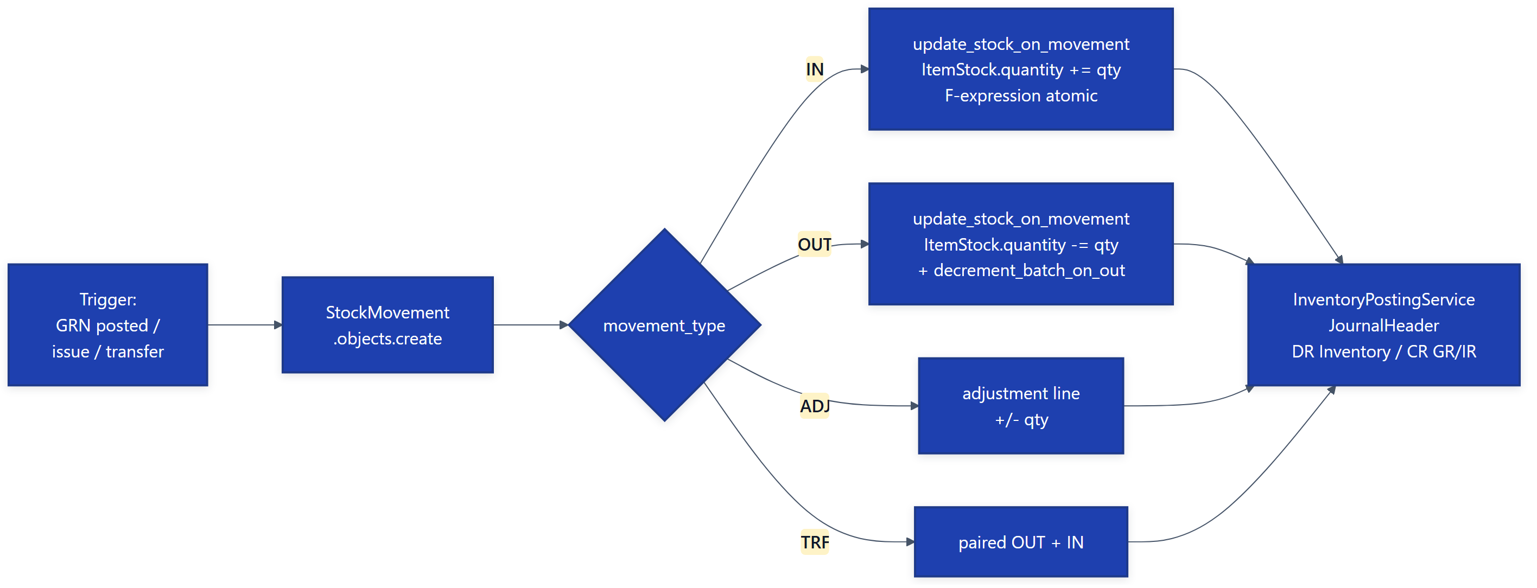

Process flow — reservation
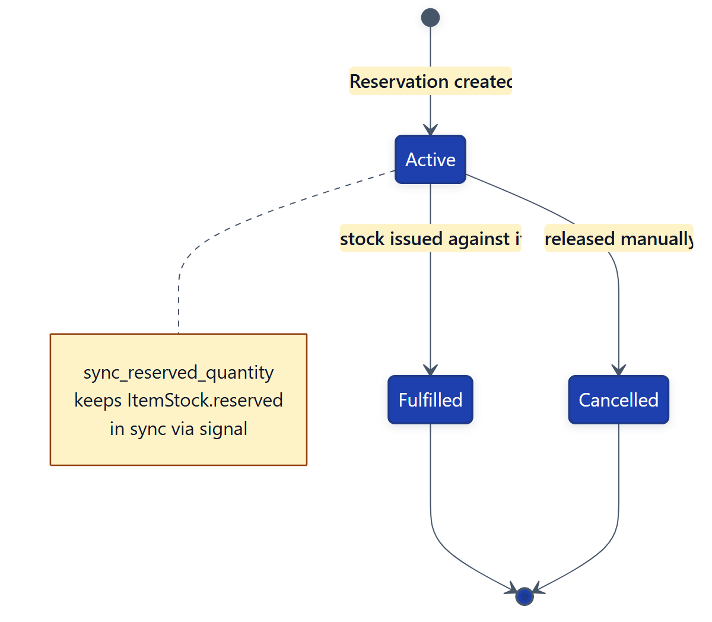

Integration points
- Out (accounting): InventoryPostingService creates JournalHeader / JournalLine for stock movements (capitalised inventory accounting).
- In (procurement): GoodsReceivedNote.save() creates StockMovement rows inline; calls inventory.services.get_default_warehouse_for_mda().

11. HRM module
Purpose: Employee master, leave / attendance, recruitment pipeline, payroll runs with salary structures and Nigerian statutory deductions (PAYE, pension, NHF, NSITF).

Key models
Model | File:Line | Role
Employee | hrm/models.py:56 | Staff master — grade, MDA, bank, tax IDs
SalaryStructure | hrm/models.py:460 | Grade × component matrix
PayrollPeriod | hrm/models.py:544 | Monthly payroll cycle row
PayrollRun | hrm/models.py:573 | One run = one MDA × one period
PayrollLine | hrm/models.py:632 | Per-employee gross / deductions / net
LeaveRequest | hrm/models.py:171 | Leave application + balance tracking

Process flow — Payroll Run
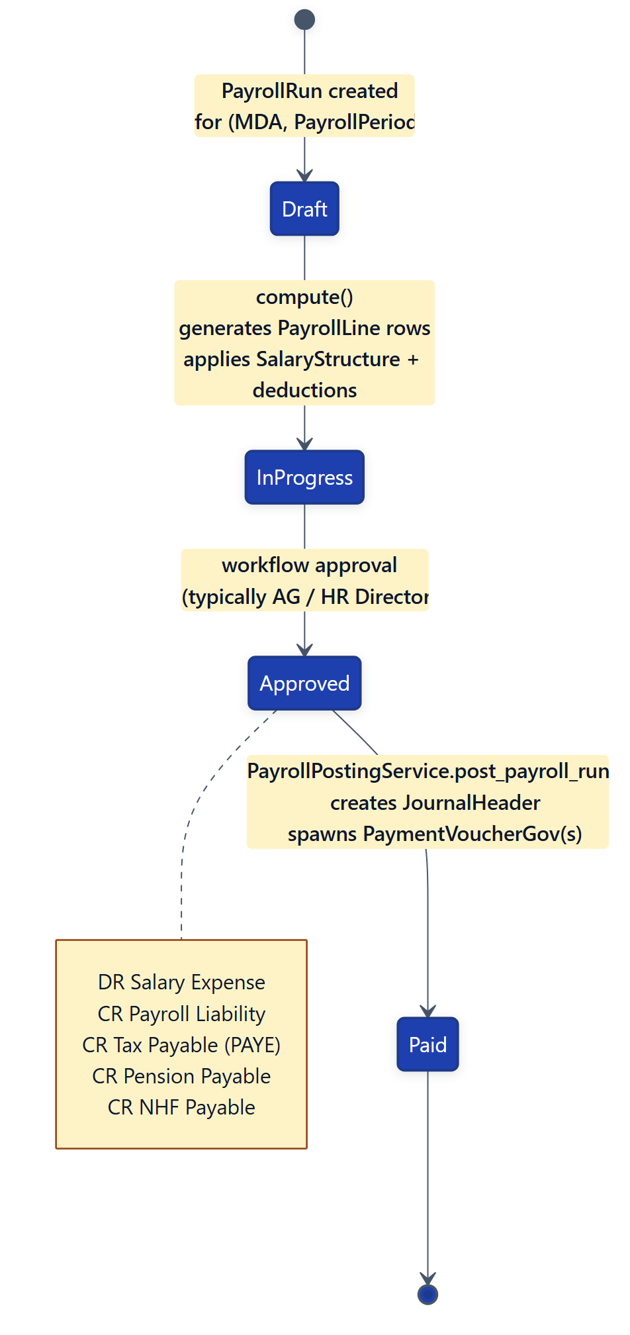

Process flow — Leave Request
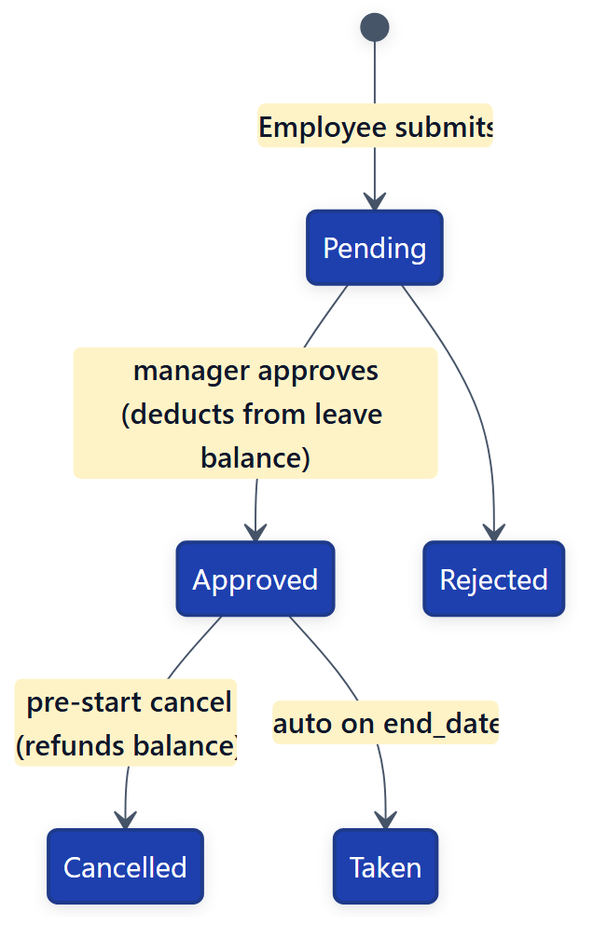

Integration points
- Out (accounting): PayrollPostingService.post_payroll_run() creates JournalHeader; PayrollRun.payroll_expense_account is a FK to accounting.Account; PayrollRun.journal_entry FK is set on completion.
- In: None — no other module calls into HRM.

12. Workflow module
Purpose: Generic multi-step approval engine. Any document in any module can attach an Approval (via ContentType GFK) with one or more ApprovalSteps, SLA tracking, and delegation.

Key models
Model | File:Line | Role
Approval | workflow/models.py:162 | The approval instance, points at any document
ApprovalStep | workflow/models.py:218 | One reviewer’s step
ApprovalTemplate | workflow/models.py:116 | Named template (e.g. “PO ≥ ₦10M”)
ApprovalTemplateStep | workflow/models.py:148 | Template step definition (tier, role, threshold)
ApprovalDelegation | workflow/models.py:340 | “While I’m on leave, route to X”
ApprovalSLAViolation | workflow/models.py:298 | SLA breach record for reporting

Process flow — generic approval
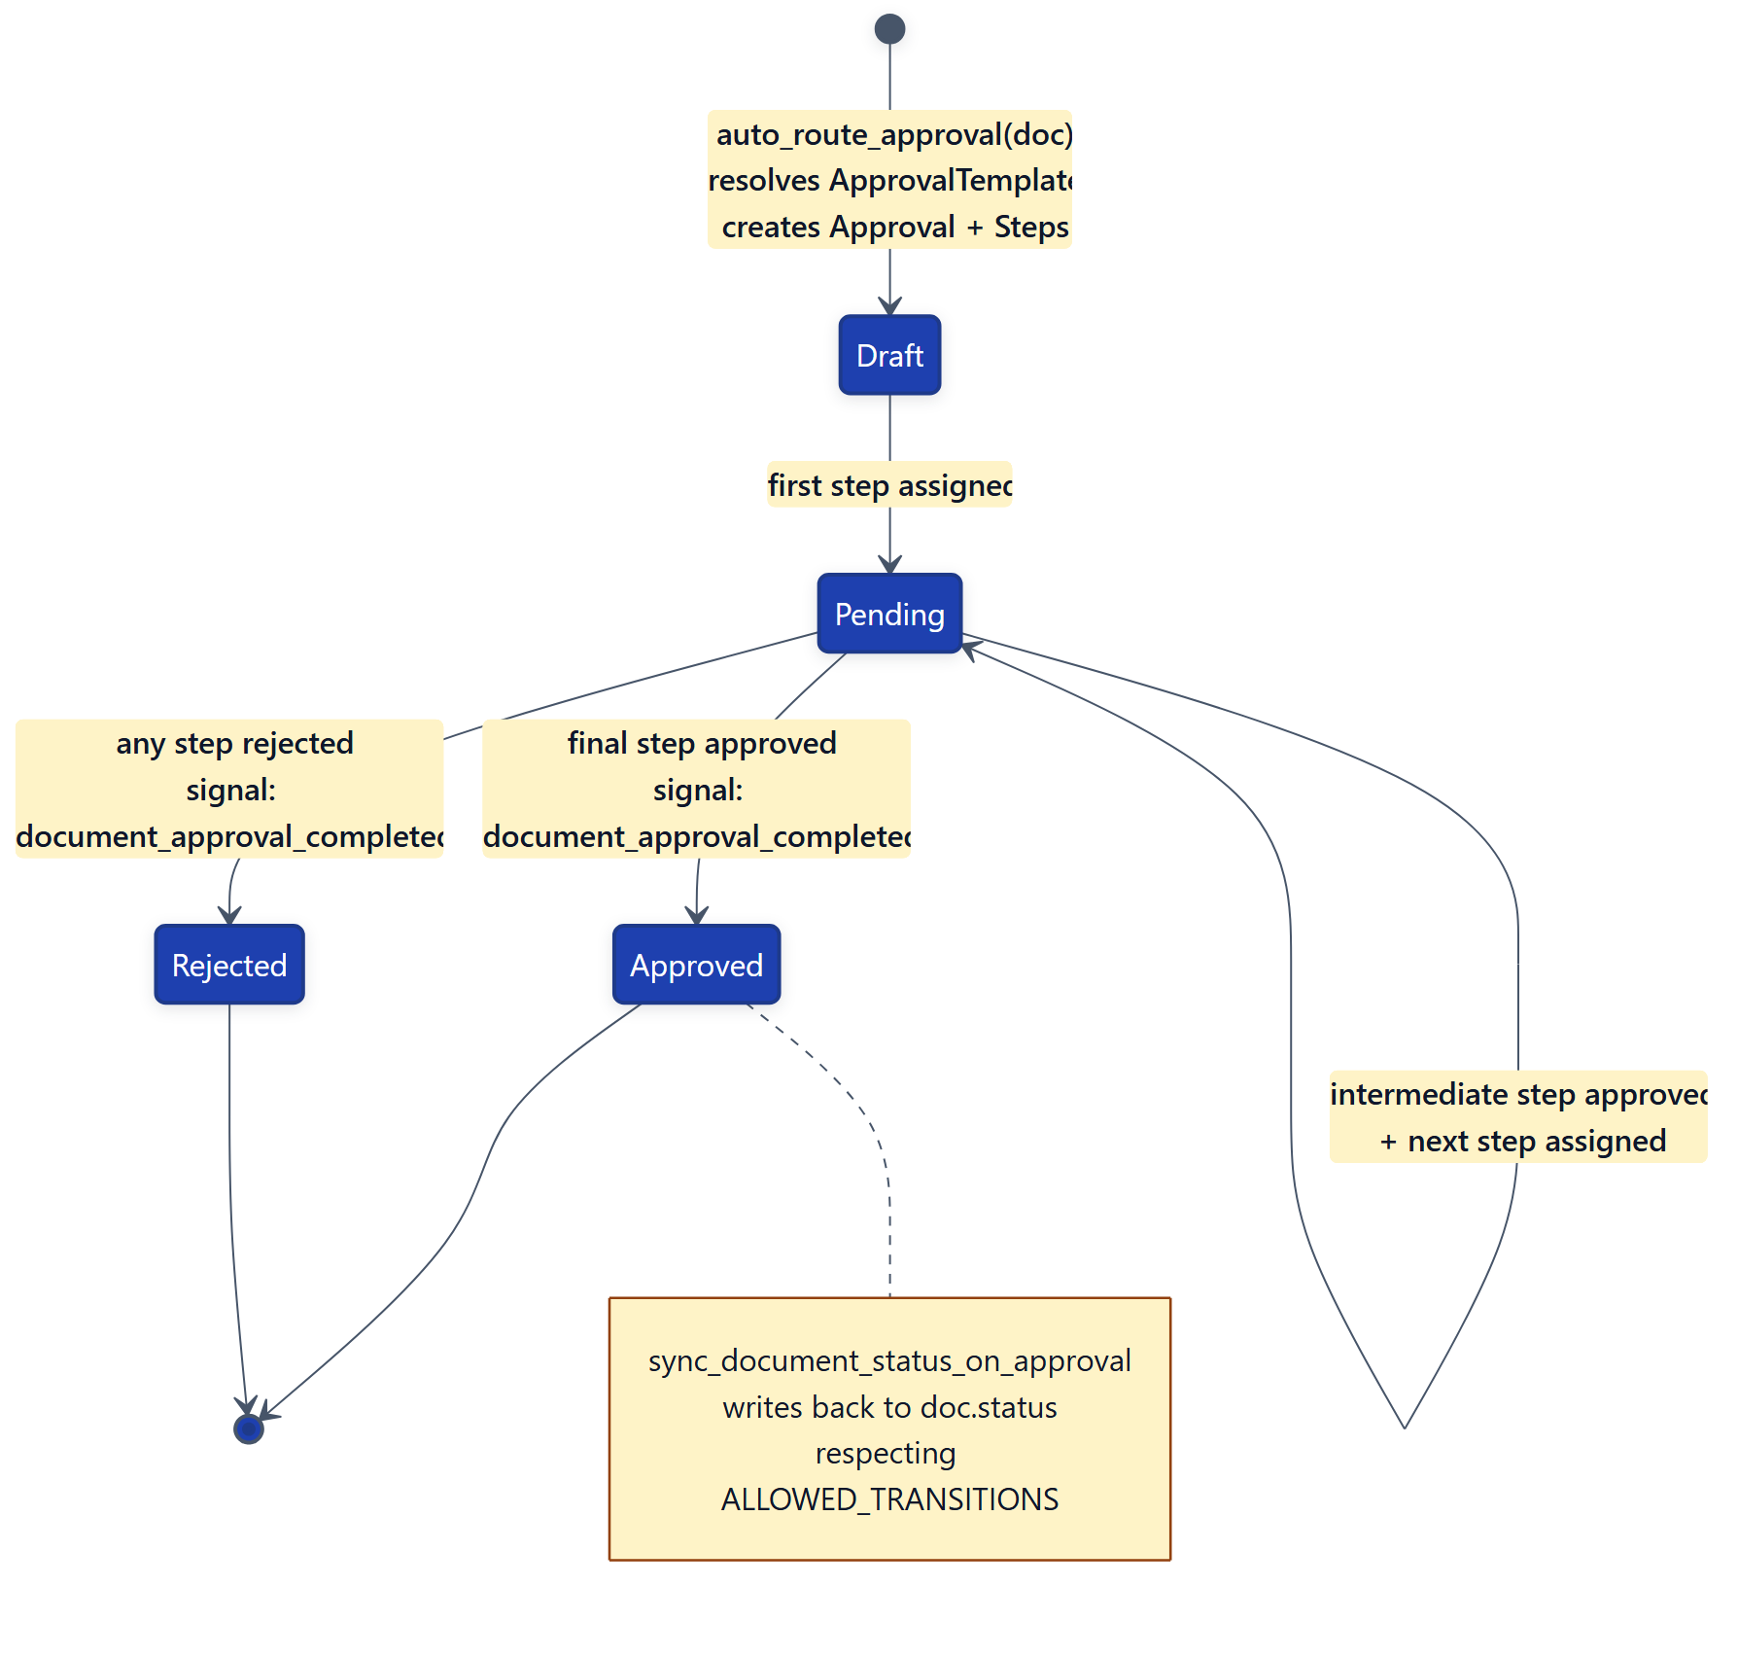

Process flow — multi-tier approval (example: PO ≥ ₦10M)
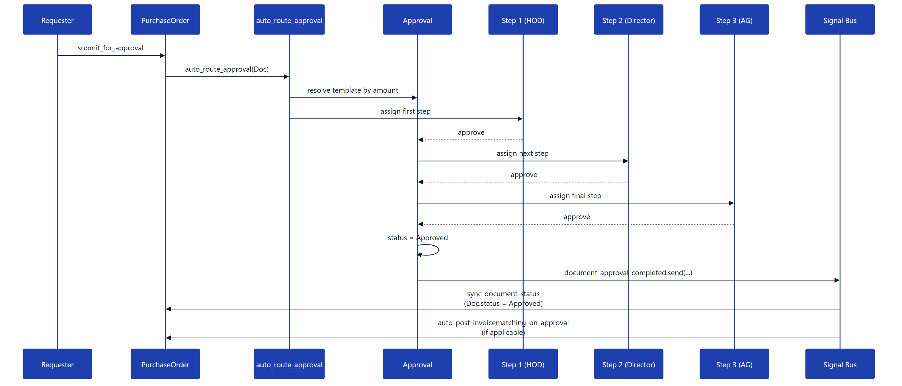

Integration points
- Out: Custom Django Signal document_approval_completed (consumed by procurement.signals.auto_post_invoicematching_on_approval).
- Out: sync_document_status_on_approval writes back to any document with a status field across all modules.
- In: Every module that wants workflow-gated approval calls auto_route_approval(document, ...) from its submit_for_approval action — procurement, contracts, budget, hrm all use this.

13. End-to-end canonical flows

13.1 Procurement-to-Payment (P2P) — full flow
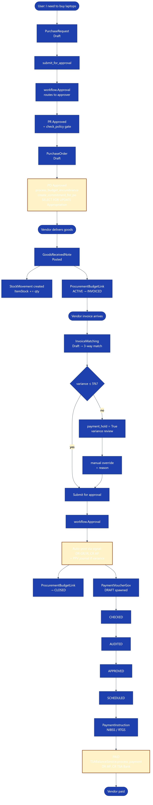

13.2 Contract-to-Payment (C2P) — full flow
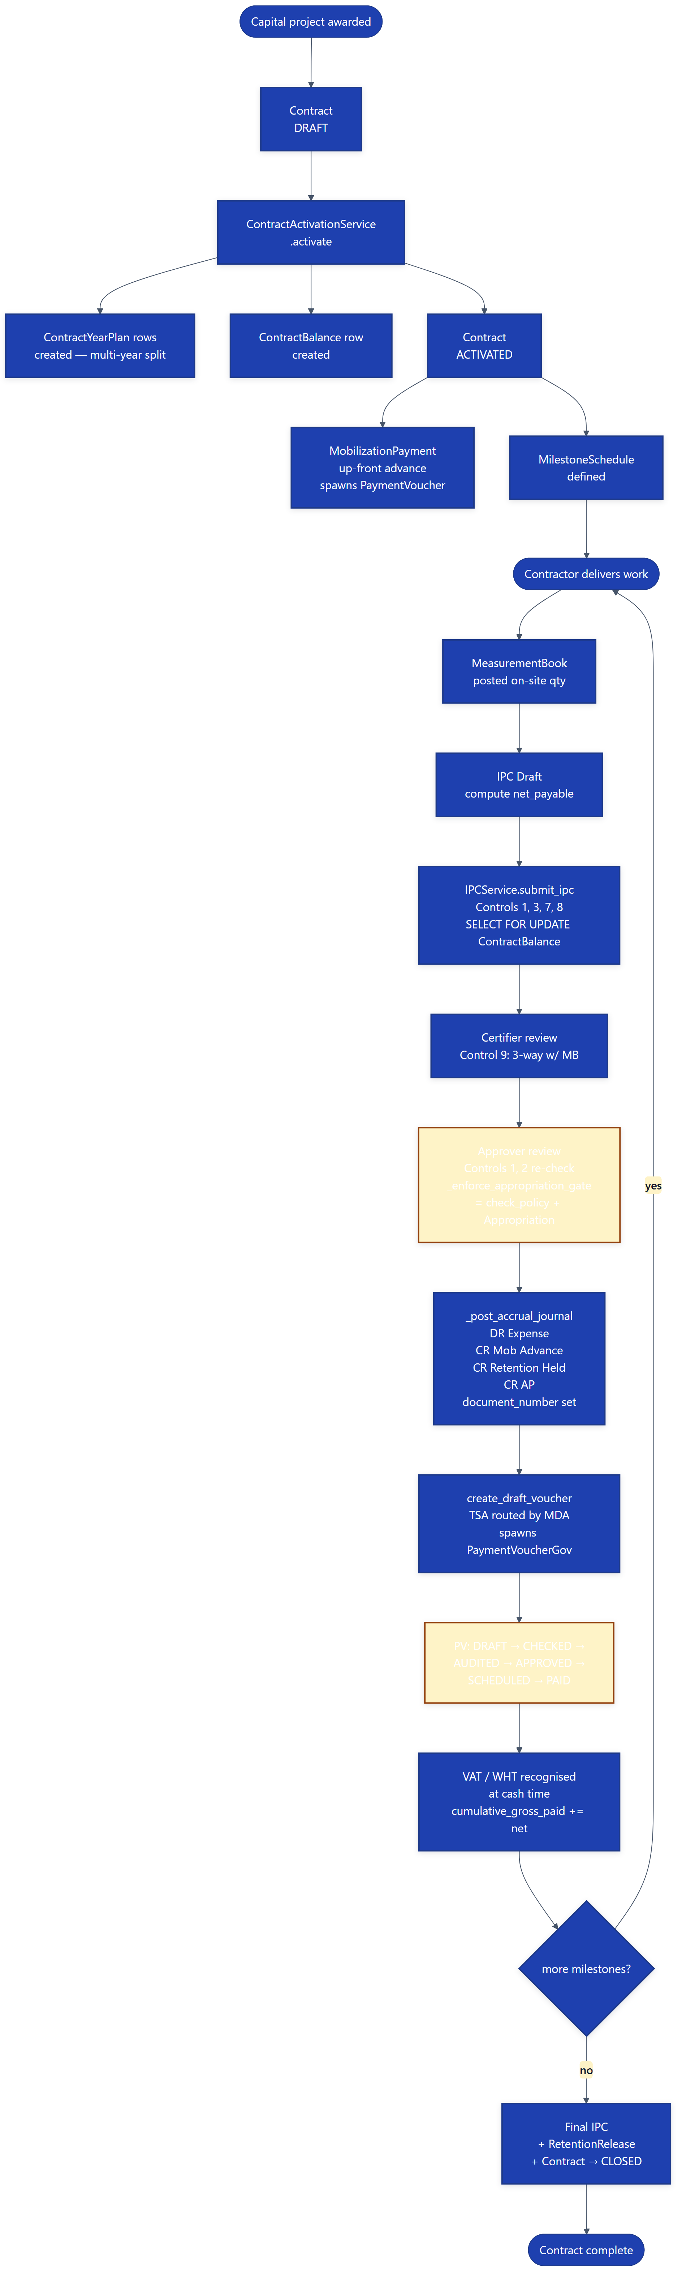

13.3 Budget enactment → Spend gate
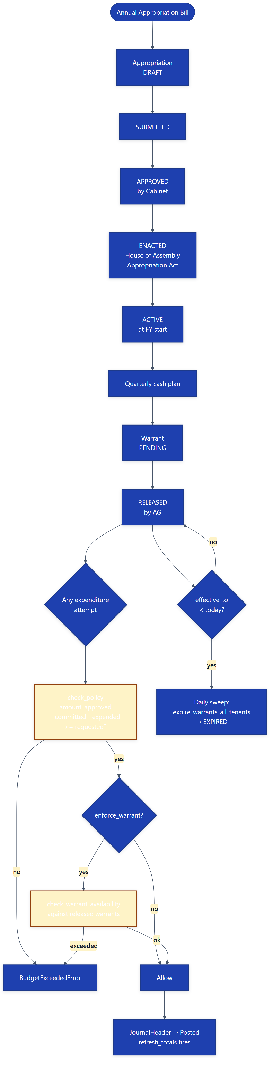

13.4 Payroll → GL → Treasury

Appendix A — Files map (where to look)
Concern | Primary location
GL posting engine | accounting/services/ipsas_journal_service.py
Budget policy resolver | accounting/services/budget_check_rules.py
Budget enforcement signal | accounting/signals/budget_enforcement.py
Procurement commitments | accounting/services/procurement_commitments.py
Contract IPC engine | contracts/services/ipc_service.py
Contract activation | contracts/services/contract_activation.py
Mobilisation / retention | contracts/services/mobilization_service.py, retention_service.py
Workflow auto-routing | workflow/views.py: auto_route_approval()
Workflow signals | workflow/signals.py
TSA cash service | accounting/services/tsa_balance_service.py
Payroll posting | accounting/services/payroll_posting.py
Inventory posting | accounting/services/inventory_posting.py
Tenant-scope routing | tenants/middleware.py (django-tenants)
Daily warrant expiry | budget/management/commands/expire_warrants_all_tenants.py

Appendix B — Status palette (UI reference)
Status | Hex | Used by
DRAFT / Pending | #f59e0b (amber) | All modules
APPROVED / RELEASED / POSTED | #22c55e (green) | All modules
REJECTED / FAILED / CANCELLED | #ef4444 (red) | All modules
EXPIRED / SUSPENDED | #b45309 (rust) | budget.Warrant
EXHAUSTED | #64748b (slate) | budget.Warrant
Posted (immutable) | #166534 (deep green) | accounting.JournalHeader
PAID | #16a34a (emerald) | accounting.PaymentVoucherGov

End of document.

