# **How to Sign Up on OKX: Step-by-Step Guide**

As cryptocurrency adoption continues to surge, securing an account on a trusted and efficient exchange is crucial. **OKX** stands out as one of the most reputable and feature-rich cryptocurrency exchanges available today. Whether you are a beginner or an experienced trader, this guide will provide a **detailed, step-by-step walkthrough** to help you create your OKX account effortlessly.

From **initial registration** to **identity verification (KYC)** and **enhancing account security**, this guide covers everything you need to know about signing up on OKX.

## **Why Choose OKX?**

OKX is a globally recognized cryptocurrency exchange, known for:

* **A user-friendly interface** – Suitable for both beginners and experienced traders.
* **Robust security** – Multiple security layers, including **Two-Factor Authentication (2FA)** and **anti-phishing protection**.
* **Diverse trading options** – Spot trading, margin trading, futures, and staking opportunities.
* **Low fees** – Competitive trading fees compared to other exchanges.
* **High liquidity** – Fast transactions with minimal slippage.
* **Mobile and desktop accessibility** – Seamless experience across devices.

## **Prerequisites for Creating an OKX Account**

Before signing up, ensure you have the following:

* **A valid email address** – Required for registration and verification.
* **A secure password** – A combination of uppercase and lowercase letters, numbers, and symbols is recommended.
* **A mobile device** – Useful for **2FA (Two-Factor Authentication)** and security confirmations.
* **A government-issued ID** – Necessary for completing **KYC verification** to unlock all features.

## **Step 1: Access the Official OKX Website**

To start the registration process, follow these steps:

1. Open your web browser and go to [**OKX’s official website**](https://www.okx.com/join/10741945).
2. Ensure that the URL is correct to avoid phishing scams. The official URL is [**https://www.okx.com/**](https://www.okx.com/join/10741945).
3. Click on the **"Sign Up"** button at the top right corner of the homepage.

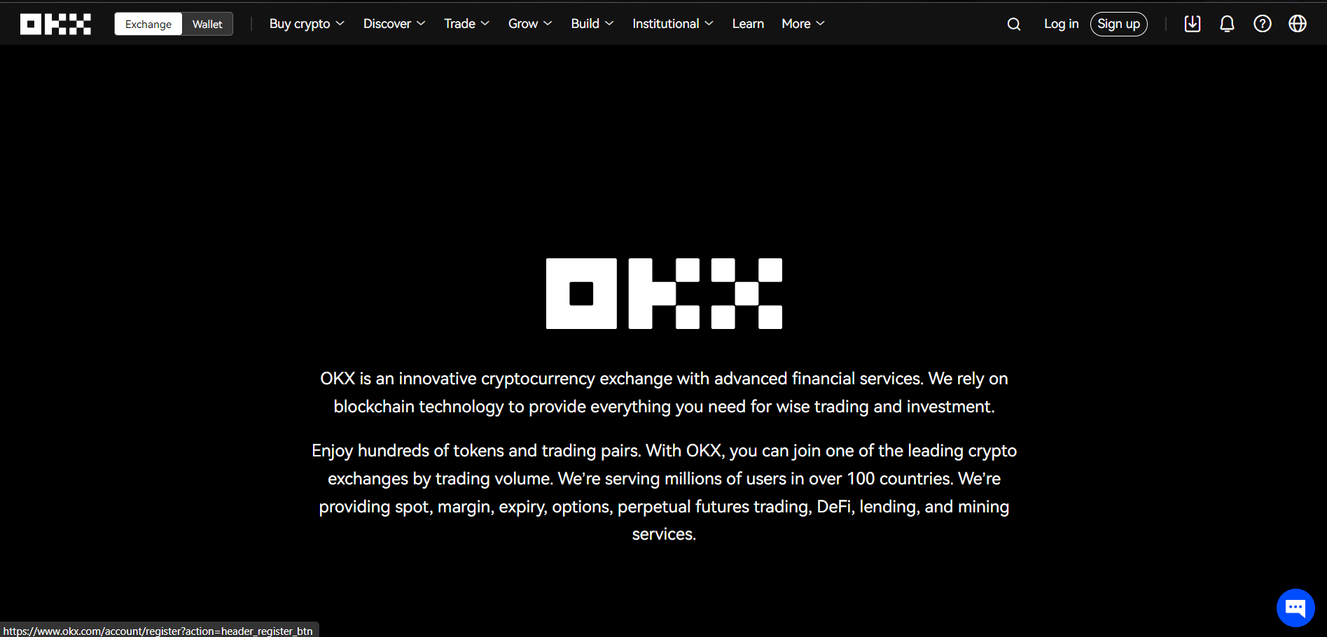

## **Step 2: Register an OKX Account**

You will now be asked to provide your **email address or mobile number** to begin the signup process.

### **Choose Your Signup Method**

OKX allows two primary ways to register:

* **Via Email**: Enter your **active email address** in the signup field.
* **Via Phone Number**: If you prefer, you can use your **mobile number** instead.

Once you've entered your details, click **"Sign Up"** to proceed.

## **Step 3: Verify Your Email or Phone Number**

After submitting your email or phone number, OKX will send a **6-digit verification code** to your registered email or SMS.

1. Open your inbox or SMS and find the email/message from OKX.
2. Copy the **6-digit code** and paste it into the OKX verification field.
3. Click **"Confirm"** to proceed.

**Important Tips:**

✔️ Check your spam folder if you don't see the email.  
✔️ The code expires within 10 minutes, so enter it promptly.

## **Step 4: Create a Strong Password**

Now, you need to set up a **strong and secure password**. A good password should:

* Be at least **8-12 characters long**.
* Include **uppercase and lowercase letters, numbers, and special characters**.
* Avoid using obvious words like your name or date of birth.

Once you've set your password, click **"Confirm"** to continue.

## **Step 5: Enable Two-Factor Authentication (2FA) for Security**

To enhance the security of your OKX account, enabling **Two-Factor Authentication (2FA)** is highly recommended.

1. Navigate to **Settings** > **Security Settings**.
2. Choose **Google Authenticator** or **SMS Authentication**.
3. Follow the instructions to link your device.
4. Store your **backup codes** safely in case you need to recover access.

✔️ **Why Enable 2FA?**

* Prevents unauthorized access to your account.
* Adds an extra layer of security beyond your password.

## **Step 6: Complete OKX Identity Verification (KYC)**

While you can access some features without verification, completing **KYC (Know Your Customer)** unlocks **higher withdrawal limits and additional trading options**.

### **Level 1 Verification (Basic Verification)**

This step requires minimal information and unlocks basic platform functionality.

1. Navigate to **Settings** > **Identity Verification**.
2. Enter your **full name**, **country of residence**, and **date of birth**.
3. Click **"Submit"**.

### **Level 2 Verification (Advanced Verification)**

This step is necessary for **higher withdrawal limits and advanced features**.

1. Upload a **government-issued ID** (passport, driver’s license, or national ID).
2. Take a **selfie for facial verification**.
3. Ensure your ID details are clearly visible.
4. Submit the verification request.

✔️ **Tips for Fast Approval:**

* Use **high-quality images** for document uploads.
* Ensure your face is **clearly visible** without sunglasses, hats, or filters.
* Use a **well-lit environment** for the selfie.

Verification is usually completed **within a few hours**, but it may take up to **24 hours**.

## **Step 7: Secure Your Account Further**

To protect your account, follow these additional security measures:

🔹 **Set Up an Anti-Phishing Code**: Adds an extra layer of email security.  
🔹 **Enable Withdrawal Whitelist**: Limits withdrawals to approved addresses.  
🔹 **Monitor Account Activity**: Regularly check for any suspicious login attempts.

## **Step 8: Deposit Funds into Your OKX Account**

Now that your account is fully set up, you can **deposit funds** to start trading.

1. Go to **Wallet** > **Deposit**.
2. Choose your preferred cryptocurrency (e.g., **Bitcoin, Ethereum, USDT**).
3. Copy the **wallet address** and send funds from an external wallet.

✔️ OKX also supports **fiat deposits** via bank transfers or credit/debit cards.

## **Step 9: Start Trading on OKX**

Once your funds are deposited, you can start trading!

1. Navigate to **"Trade"** on the top menu.
2. Choose your preferred trading option:
   * **Spot Trading** – Buy and sell cryptocurrencies at real-time prices.
   * **Margin Trading** – Trade with leverage for higher potential gains.
   * **Futures & Options** – Advanced derivatives trading for experienced traders.
3. Analyze market trends and place your trades accordingly.

✔️ **For beginners**, OKX also offers **Demo Trading** to practice without using real funds.

## **Final Thoughts**

Creating an OKX account is a **straightforward** yet **crucial step** in your cryptocurrency journey. By following the **step-by-step guide** above, you can:

✅ **Register and verify your account efficiently**.  
✅ **Enhance security with 2FA and anti-phishing measures**.  
✅ **Unlock advanced trading options** by completing KYC.  
✅ **Start trading securely and effectively on OKX**.

With your account set up, you are now ready to explore **OKX’s vast crypto trading ecosystem** and make the most of its innovative features. 🚀

## **Frequently Asked Questions (FAQs)**

**1. Can I use OKX without KYC?**Yes, but unverified users have **limited withdrawal limits and trading features**. Completing **KYC** unlocks full platform access.

**2. How long does OKX verification take?**Basic KYC verification takes **a few minutes**, while full verification can take up to **24 hours**.

**3. Is OKX available worldwide?**Yes, but some countries have restrictions. Check the official website for an updated list.

**4. Can I trade on OKX using a mobile app?**Yes! OKX has **a mobile app for both iOS and Android**, offering seamless trading on the go.

Now that you have all the necessary information, [**sign up on OKX today**](https://www.okx.com/join/10741945) and start your cryptocurrency journey! 🚀