Ooyala Backlot SharePoint Plugin
User Manual Document

Version: 0.2
Date: 06-September-2012

Submitted to:
Ooyala Backlot

By:
CSS Corp Pvt Ltd
3031 Tisch Way, Ste 1002, San Jose, CA 95128
Tel: 408-615-5700 Fax: 408-615-5707
URL: http://www.csscorp.com

Revision History
Version | Date | Revision Notes | Author(s)
0.1 | 08/23/12 | Initial draft | Jayapriya
0.2 | 09/06/12 | Added user access permission and alignment changes. | Jayapriya

Table of Contents

Table of Contents 3
Objective 4
User Access Permission 4
Ooyala Plugin Web Parts 4
API Settings 4
1.1.1 Save API 5
1.1.2 Reset API 5
Label Taxonomy 5
5
1.1.3 Add New label 5
1.1.4 Edit label 6
1.1.5 Delete label 6
Upload From Local 6
1.1.6 Asset Upload by Live status 7
1.1.7 Asset Upload by Pending Approval status 7
1.1.8 Associating an Asset with Label 8
1.1.9 Associating an Asset with a custom Meta data 8
Upload From SharePoint 8
1.1.10 Asset Upload by Live status 9
1.1.11 Asset Upload by Pending Approval status 9
1.1.12 Associating an Asset with Label 10
1.1.13 Associating an Asset with a custom Meta data 10
Media Player Settings 10
1.1.14 Add New Player 11
1.1.15 Edit Player 11
1.1.16 Delete Player 11
Media Player 12
12
1.1.17 Playing the asset 12
Thumbnail View 12
1.1.18 Asset with search facility 13
1.1.19 Pagination 13
Detail View 13
14
1.1.20 Asset with search facility 14
1.1.21 Pagination 14
1.1.22 Edit Asset 15
1.1.23 Delete Asset 15

Objective
The user manual aims to familiarize you with the functionalities of SharePoint plugin. It will enable the user to understand the details of the tasks that can be performed using plugin.

User Access Permission
User Access Permission enables the user to access with the plug-in features. Plug In access permission will work as like OoyalaAPI.

The following types of users available are:
- Administrators: Admin users have access to all the features provided in the plug-in.
- Manager: Managers too have access to all the features provided in the plug-in.
- Upload Only: Users with this access level can only see videos that they upload; they do not have access to the videos uploaded by other users.
- Analytics Only: All levels of access including saving their user credentials are restricted to these users.
- Read Only: Reads only users can save their credentials. Further it allows the users to view all the Plug-in pages, but prevents them from making any changes to it.

Ooyala Plugin Web Parts
API Settings
The API Settings is the page where the user enters the credentials like Partner Code, API Key and Secret Key. The credentials are validated with the Ooyala backlot and saved if found valid. Once the credentials are saved the application validates it internally when ever any web parts are being accessed and the user need not enter it again and again. If the credentials are not valid the application throws an error message and the user is not able to access any web parts.

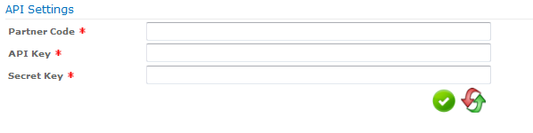

Save API
To Save the user credentials in the database:
- Enter the following field values: Partner Code, API Key, Secret Key.
- Click on Save button.
- The API settings will be saved in the database.

Reset API
To Reset the user credentials in the API settings page:
- Enter the following field values: Partner Code, API Key, Secret Key.
- Click on Reset button.
- The Field values will be cleared.

Label Taxonomy
The Label Taxonomy is the page where user can create labels and associate it to
the media assets. The media assets can be grouped and searched using the
labels to which they are associated.

The Label Taxonomy page contains the following features:
- Add New label
- Edit label
- Delete label

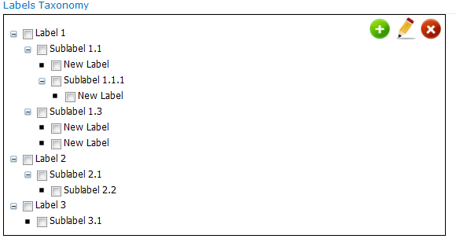

Add New label
To add a top-level label, child label to the labels taxonomy:
- To add a top-level Label: Click on the Plus icon on the top of the tree view hierarchy.
- A label called New Label will be added.
- To add a child Label: Select the existing label to which you want to add the child label.
- Click on the Plus icon on the top of the tree view hierarchy.
- A label called New Label will be added.

Edit label
To Update the existing Label present in the labels taxonomy:
- Select the Label in which you want to update the name.
- Click on the Edit Icon on the top of the tree view hierarchy.
- The label text appears in textbox on the bottom of the tree view hierarchy.
- Input the revised text click on Tick icon.
- The label name will be updated.

Delete label
To delete one or more labels in the labels taxonomy:
- Select one or more labels for deletion.
- Click on the Delete icon on the top of the tree view hierarchy
- A confirmation box will be prompted with ‘Ok’, ’Cancel’ button.
- Click on ‘Ok’ button to delete the label.
- The selected labels will be deleted.

Upload From Local
Upload From Local allows the user to upload the media asset available in the
local computer to the Ooyala backlot. The media asset can be uploaded with the
following status:’Live’,’Pending Approval’. Labels and Metadata can be
associated with the media asset while uploading. The uploaded asset will be
available in the Ooyala Backlot, the same can be viewed in the Thumbnail view
and Detail view pages.

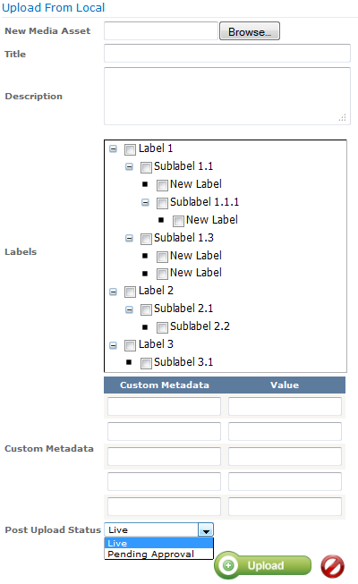

Asset Upload by Live status
- Click on the Browse button from the ’New Media Asset’ field, the plugin will list out the assets available in Local Computer.
- Select the asset from Local computer which you want to upload.
- Enter the Title and Description field.
- Select the Post Upload Status as Live.
- Click on the Upload button.
- The uploaded asset can be viewed in the Thumbnail view, Detail view.
- The uploaded asset will be available in the Backlot application with the ‘Live’ status.

Asset Upload by Pending Approval status
- Click on the Browse button from the ’New Media Asset’ field, the plugin will list out the assets available in Local Computer.
- Select the asset from Local computer which you want to upload.
- Enter the Title and Description field.
- Select the Post Upload Status as Pending Approval.
- Click on the Upload button.
- The uploaded asset can be viewed in the Thumbnail view, Detail view.
- The uploaded asset will be available in the Backlot application with the ‘Paused’ status.

Associating an Asset with Label
Labels are useful for organize video library, searching for videos.
- Click on the Browse button from the ’New Media Asset’ field, the plugin will list out the assets available in Local Computer.
- Select the asset from Local computer which you want to upload.
- Select one or more label for uploading.
- Click on the Upload button.
- The asset will be uploaded with the label.
- Search by Label can be done in the Thumbnail view, Detail view.
- The uploaded asset will be available in the Backlot application along with the Labels.

Associating an Asset with a custom Meta data
Custom metadata enables to add useful information to your assets.
- Click on the Browse button from the ’New Media Asset’ field, the plugin will list out the assets available in Local Computer.
- Select the asset from Local computer which you want to upload.
- Enter the Custom Metadata and Value
- Click on the Upload button.
- The asset will be uploaded with the Custom Metadata.
- Search by Custom metadata ‘key’, ‘value’ can be done in the Thumbnail view, Detail view.
- The uploaded asset will be available in the Backlot application along with the Custom Metadata.

Upload From SharePoint
Upload From SharePoint allows the user to upload the media asset available in
the SharePoint to the Ooyala backlot. The media asset can be uploaded with the
following status:’Live’,’Pending Approval’. Labels and Metadata can be
associated with the media asset while uploading. The uploaded asset will be
available in the Ooyala Backlot, the same can be viewed in the Thumbnail view
and Detail view pages.

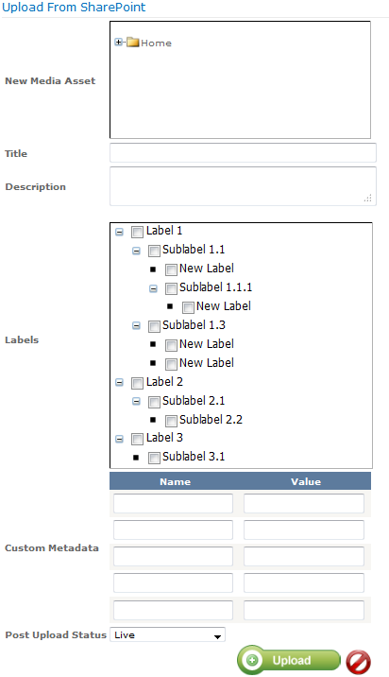

Asset Upload by Live status
- The media asset files in the SharePoint library will be listed in the form of Tree view structure in ’New Media Asset’ field.
- Select the asset from the ’New Media Asset’ field which you want to upload.
- Enter the Title and Description field.
- Select the Post Upload Status as Live.
- Click on the Upload button.
- The uploaded asset can be viewed in the Thumbnail view, Detail view.
- The uploaded asset will be available in the Backlot application with the ‘Live’ status.

Asset Upload by Pending Approval status
- The media asset files in the SharePoint library will be listed in the form of Tree view structure in ’New Media Asset’ field.
- Select the asset from the ’New Media Asset’ field which you want to upload.
- Enter the Title and Description field.
- Select the Post Upload Status as Pending Approval.
- Click on the Upload button.
- The uploaded asset can be viewed in the Thumbnail view, Detail view.
- The uploaded asset will be available in the Backlot application with the ‘Paused’ status.

Associating an Asset with Label
Labels are useful for organize video library, searching for videos.
- The media asset files in the SharePoint library will be listed in the form of Tree view structure in ’New Media Asset’ field.
- Select the asset from the ’New Media Asset’ field which you want to upload.
- Select one or more label for uploading.
- Click on the Upload button.
- The asset will be uploaded with the label.
- Search by Label can be done in the Thumbnail view, Detail view.
- The uploaded asset will be available in the Backlot application along with the Labels.

Associating an Asset with a custom Meta data
Custom metadata enables to add useful information to your assets.
- The media asset files in the SharePoint library will be listed in the form of Tree view structure in ’New Media Asset’ field.
- Select the asset from the ’New Media Asset’ field which you want to upload.
- Enter the Custom Metadata and Value
- Click on the Upload button.
- The asset will be uploaded with the Custom Metadata.
- Search by Custom metadata ‘key’, ‘value’ can be done in the Thumbnail view, Detail view.
- The uploaded asset will be available in the Backlot application along with the Custom Metadata.

Media Player Settings
The Media Player Settings page enables the user to add a new player and
configure its settings according to the user preferences. It contains the following
features:

- Add New Player
- Edit player
- Delete player

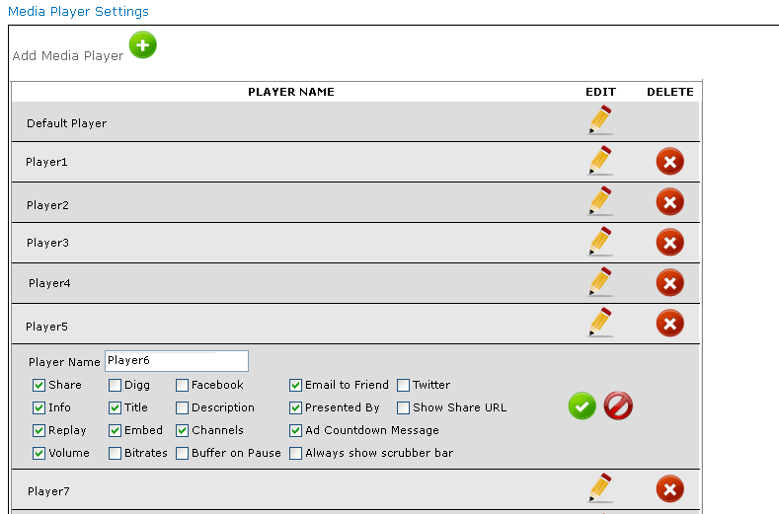

Add New Player
To add a new player to the media player settings:
- Click on the Plus icon on the top.
- A player called New Player will be added.

Edit Player
To Update the existing player present in the media player settings:
- To Edit player name: Click on the Edit Icon for the player which needs to be updated with the name.
- The player name text appears in textbox.
- Input the revised text click on the Tick icon.
- The player name will be updated.
- To Edit player properties: Click on the Edit Icon for the player which needs to be updated with the properties.
- Select or Deselect the following options:
'Share', 'Digg','Facebook','Email to friend','Twitter', 'Info','Title','Description','Presented By','Show Share URL','Replay','Embed','Channels','Ad Countdown Message','Volume','Bitrates','Buffer on Pause','Always show scrubber bar'.
- Click on the Tick icon.
- The player properties will be updated.

Delete Player
To delete a player in the labels taxonomy:
- Click on the Delete icon for the player which needs to be deleted.
- A confirmation box will be prompted with ‘Ok’, ’Cancel’ button.
- Click on ‘Ok’ button to delete the player.
- The player will be deleted.

Media Player
In media player page the user can select the asset and the desired player in
which they want the media file to be played.
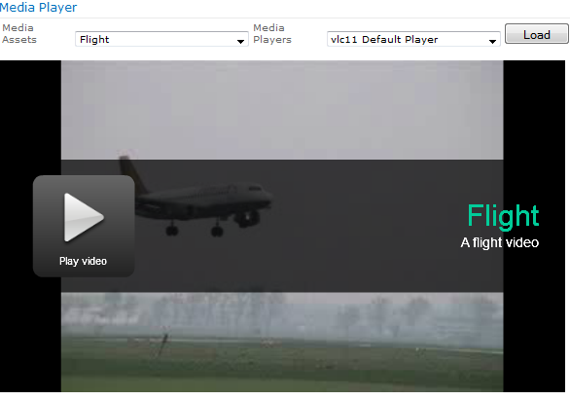

Playing the asset
- Select the asset from the ’Media Assets’ drop down field and then select the player from the ’Media Players’ drop down field.
- Click on the ‘Load’ button.
- The asset will be loaded in the media player with a Play button.
- Click on the play button to play the asset.
- Click on the pause button to pause the asset.

Thumbnail View
The media files which are available in the backlot application can be viewed as
thumbnail format.

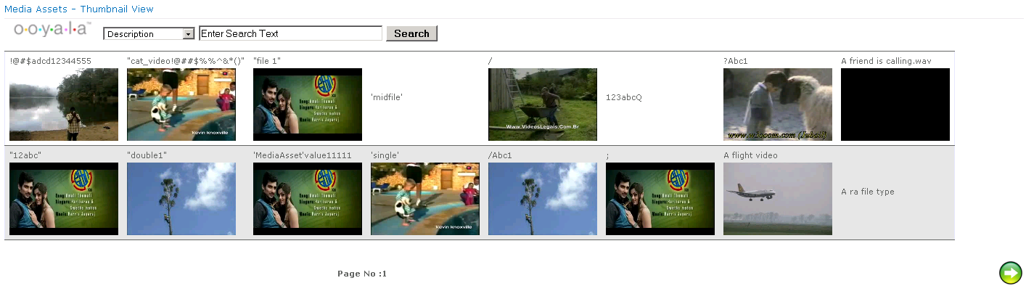

Asset with search facility
To search the asset with Name ,Description, Label, Status, Custom Metadata.
- Search the asset with name: Select the ‘Name’ option from the dropdown list field.
- Enter the name in the textbox and click on Search button.
- The Search with name results will be displayed.
- Search the asset with description: Select the ‘Description’ option from the dropdown list field.
- Enter the description in the textbox and click on Search button.
- The Search with description results will be displayed.
- Search the asset with label: Select the ‘Label’ option from the dropdown list field.
- Enter the label in the textbox and click on Search button.
- The Search with label results will be displayed.
- Search the asset with status: Select the ‘Status’ option from the dropdown list field.
- Enter the status in the textbox and click on Search button.
- The Search with status results will be displayed.
- Search the asset with Custom metadata: Select the ‘Custom Metadata’ option from the dropdown list field.
- Enter the ‘key’, ’value’ in the textbox and click on Search button.
- The Search with custom metadata results will be displayed.

Pagination
To view the pagination in detail view:
- The thumbnail view will be displayed with ‘2 rows and 8 columns’ per page by default.
- Click on the next button to view the next set of records.
- Click on Previous button to view the previous set of records.

Detail View
The media files which are available in the backlot application can be viewed in a
detailed manner along with the details.

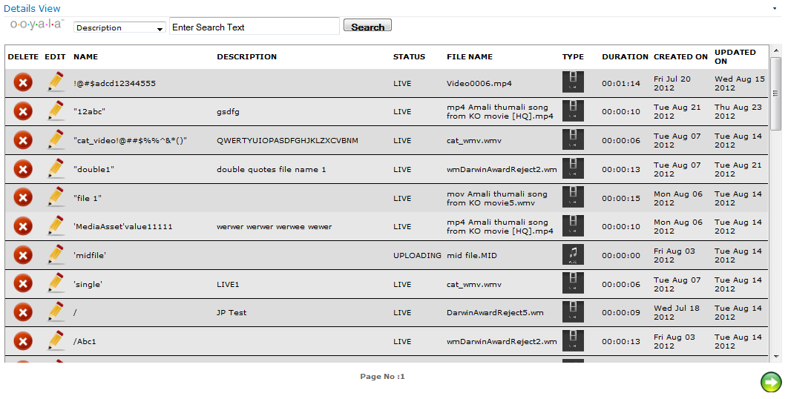

Asset with search facility
To search the asset with Name ,Description, Label, Status, Custom Metadata.
- Search the asset with name: Select the ‘Name’ option from the dropdown list field.
- Enter the name in the textbox and click on Search button.
- The Search with name results will be displayed.
- Search the asset with description: Select the ‘Description’ option from the dropdown list field.
- Enter the description in the textbox and click on Search button.
- The Search with description results will be displayed.
- Search the asset with label: Select the ‘Label’ option from the dropdown list field.
- Enter the label in the textbox and click on Search button.
- The Search with label results will be displayed.
- Search the asset with status: Select the ‘Status’ option from the dropdown list field.
- Enter the status in the textbox and click on Search button.
- The Search with status results will be displayed.
- Search the asset with Custom metadata: Select the ‘Custom Metadata’ option from the dropdown list field.
- Enter the ‘key’, ’value’ in the textbox and click on Search button.
- The Search with custom metadata results will be displayed.

Pagination
To view the pagination in detail view:
- The detail view will be displayed with ‘10 records’ per page by default.
- Click on the next button to view the next set of records.
- Click on Previous button to view the previous set of records.

Edit Asset
To Update the existing asset present in the detail view:
- To Edit asset name: Click on the Edit Icon for the asset which needs to be updated with the name.
- The asset name text appears in textbox.
- Input the revised text click on the Tick icon.
- The asset name will be updated.
- To Edit asset description: Click on the Edit Icon for the asset which needs to be updated with the description.
- The asset description text appears in textbox.
- Input the text click on the Tick icon.
- The asset description will be updated.
- To Edit asset label: Click on the Edit Icon for the asset which needs to be updated with the label.
- Select one or more label.
- Click on the Tick icon.
- The asset label will be updated.
- To Edit asset custom metadata: Click on the Edit Icon for the asset which needs to be updated with the custom metadata.
- Input the custom metadata with ‘Key’, ’Value’.
- Click on the Tick icon.
- The asset custom metadata will be updated.
- The updated asset properties will be available the backlot application.

Delete Asset
To delete the asset in the detail view:
- Click on the Delete icon for the asset which needs to be deleted.
- A confirmation box will be prompted with ‘Ok’, ’Cancel’ button.
- Click on ‘Ok’ button to delete the asset.
- The asset will be deleted.

