
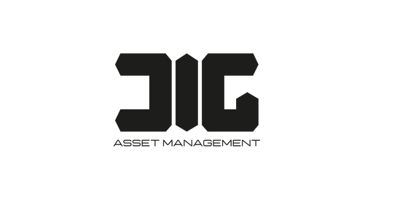
To :
Mr. Daniel Gallego
Salford.co
August 5, 2024

Greetings!

A letterhead is the heading at the top of a sheet of letter paper (stationery).
That heading usually consists of a name and an address, and a logo or corporate design, and sometimes a background pattern. The term "letterhead" is often used to refer to the whole sheet imprinted with such a heading. Many companies and individuals prefer to create a letterhead template in a word processor or other software application.

This generally includes the same information as pre-printed stationery but without the additional costs involved. Letterhead can then be printed on stationery (or plain paper) as needed on a local output device or sent electronically. That heading vusually consists of a name and an address, and
a logo or corporate design, and sometimes a background pattern. The term "letterhead" is often used to refer to the whole sheet imprinted with such
a heading.

The term "letterhead" is often used to refer to the whole sheet imprinted with such a heading. Many companies and individuals prefer to create a letterhead template in a word processor or other software application.

Sincerely,

Muhammad Ali Janjua
CEO



123-456-7890
123 Anywhere St., Any City
hello@reallygreatsite.com www.reallygreatsite.com

