Procedural Learning 110320

Ola Ozernov-Palchik

11/4/2020

# Sample Size

##   
## Frequency table:  
## Subgroup  
## DD TYP   
## 31 32

# Rotary Pursuit

###Statstical Analysis by Trial

## Analysis of Variance Table  
##   
## Response: prop_on  
## Df Sum Sq Mean Sq F value Pr(>F)   
## Subgroup 1 0.2285 0.228526 11.8973 0.0005905 ***  
## as.factor(trial) 15 2.0355 0.135697 7.0645 1.054e-14 ***  
## Subgroup:as.factor(trial) 15 0.2224 0.014826 0.7719 0.7099146   
## Residuals 828 15.9044 0.019208   
## ---  
## Signif. codes: 0 '***' 0.001 '**' 0.01 '*' 0.05 '.' 0.1 ' ' 1

## NOTE: Results may be misleading due to involvement in interactions

## $`lsmeans of Subgroup`  
## Subgroup lsmean SE df lower.CL upper.CL  
## DD 0.337 0.00682 828 0.321 0.352  
## TYP 0.304 0.00656 828 0.289 0.318  
##   
## Results are averaged over the levels of: trial   
## Confidence level used: 0.95   
## Conf-level adjustment: sidak method for 2 estimates   
##   
## $`pairwise differences of Subgroup`  
## contrast estimate SE df t.ratio p.value  
## DD - TYP 0.033 0.00946 828 3.493 0.0005   
##   
## Results are averaged over the levels of: trial

##Extract Slope

####how many polynomial terms?

##   
## Call:  
## lm(formula = prop_on ~ poly(trial, 6, raw = TRUE), data = rp2)  
##   
## Residuals:  
## Min 1Q Median 3Q Max   
## -0.35964 -0.09182 -0.00255 0.08189 0.45527   
##   
## Coefficients:  
## Estimate Std. Error t value Pr(>|t|)   
## (Intercept) -2.860e-02 8.674e-02 -0.330 0.74173   
## poly(trial, 6, raw = TRUE)1 3.342e-01 1.183e-01 2.825 0.00483 **  
## poly(trial, 6, raw = TRUE)2 -1.117e-01 5.399e-02 -2.069 0.03885 *   
## poly(trial, 6, raw = TRUE)3 1.953e-02 1.121e-02 1.741 0.08204 .   
## poly(trial, 6, raw = TRUE)4 -1.903e-03 1.164e-03 -1.635 0.10252   
## poly(trial, 6, raw = TRUE)5 9.545e-05 5.880e-05 1.623 0.10488   
## poly(trial, 6, raw = TRUE)6 -1.893e-06 1.150e-06 -1.646 0.10006   
## ---  
## Signif. codes: 0 '***' 0.001 '**' 0.01 '*' 0.05 '.' 0.1 ' ' 1  
##   
## Residual standard error: 0.1409 on 853 degrees of freedom  
## (4 observations deleted due to missingness)  
## Multiple R-squared: 0.07883, Adjusted R-squared: 0.07235   
## F-statistic: 12.17 on 6 and 853 DF, p-value: 3.709e-13

## Warning: Removed 4 rows containing non-finite values (stat_smooth).

## Warning: Removed 4 rows containing missing values (geom_point).

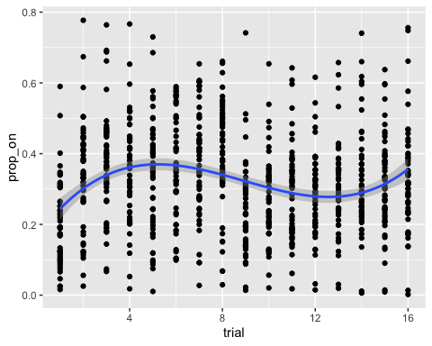

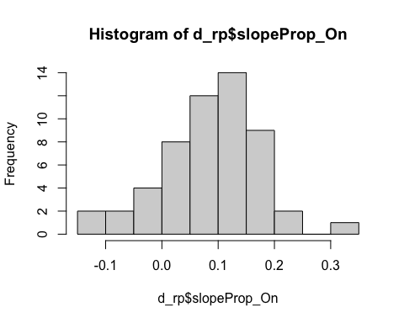

## Plot task

###Prop On by Trial

## `summarise()` regrouping output by 'Subgroup' (override with `.groups` argument)

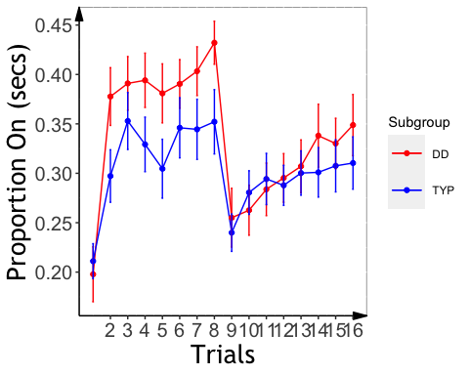

###Analysis

##   
## Welch Two Sample t-test  
##   
## data: d_rp$slopeProp_On by d_rp$Subgroup  
## t = 2.0638, df = 47.426, p-value = 0.04453  
## alternative hypothesis: true difference in means is not equal to 0  
## 95 percent confidence interval:  
## 0.001144116 0.088664839  
## sample estimates:  
## mean in group DD mean in group TYP   
## 0.11171784 0.06681336

## Analysis of Variance Table  
##   
## Response: slopeProp_On  
## Df Sum Sq Mean Sq F value Pr(>F)   
## background_age 1 0.00054 0.0005434 0.0796 0.77903   
## background_sex 1 0.00039 0.0003939 0.0577 0.81118   
## Subgroup 1 0.02639 0.0263869 3.8644 0.05489 .  
## Residuals 50 0.34141 0.0068282   
## ---  
## Signif. codes: 0 '***' 0.001 '**' 0.01 '*' 0.05 '.' 0.1 ' ' 1

## $`lsmeans of Subgroup`  
## Subgroup lsmean SE df lower.CL upper.CL  
## DD 0.1117 0.0165 50 0.0737 0.150  
## TYP 0.0669 0.0156 50 0.0309 0.103  
##   
## Results are averaged over the levels of: background_sex   
## Confidence level used: 0.95   
## Conf-level adjustment: sidak method for 2 estimates   
##   
## $`pairwise differences of Subgroup`  
## contrast estimate SE df t.ratio p.value  
## DD - TYP 0.0448 0.0228 50 1.966 0.0549   
##   
## Results are averaged over the levels of: background_sex

###Slope Effects

## `summarise()` regrouping output by 'PartID' (override with `.groups` argument)

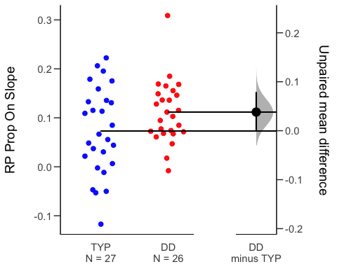

# Mirror Tracing

## QC

##MT: Analysis

## Analysis of Variance Table  
##   
## Response: time  
## Df Sum Sq Mean Sq F value Pr(>F)   
## Subgroup 1 2034 2034.0 12.8079 0.000379 ***  
## as.factor(trial) 9 36159 4017.6 25.2985 < 2.2e-16 ***  
## Subgroup:as.factor(trial) 9 2628 292.0 1.8387 0.059118 .   
## Residuals 497 78928 158.8   
## ---  
## Signif. codes: 0 '***' 0.001 '**' 0.01 '*' 0.05 '.' 0.1 ' ' 1

## Analysis of Variance Table  
##   
## Response: error  
## Df Sum Sq Mean Sq F value Pr(>F)   
## Subgroup 1 3093 3093.3 11.5042 0.0007502 ***  
## as.factor(trial) 9 36113 4012.5 14.9227 < 2.2e-16 ***  
## Subgroup:as.factor(trial) 9 4565 507.2 1.8862 0.0518115 .   
## Residuals 493 132561 268.9   
## ---  
## Signif. codes: 0 '***' 0.001 '**' 0.01 '*' 0.05 '.' 0.1 ' ' 1

## MT: Plot Time/Error by Trial

## `summarise()` regrouping output by 'Subgroup' (override with `.groups` argument)  
## `summarise()` regrouping output by 'Subgroup' (override with `.groups` argument)

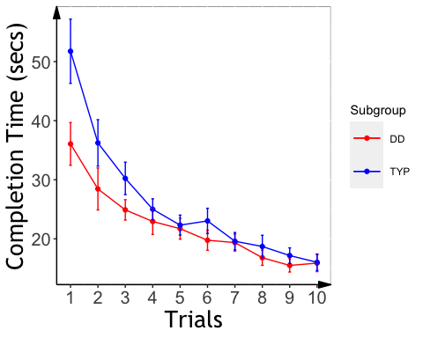

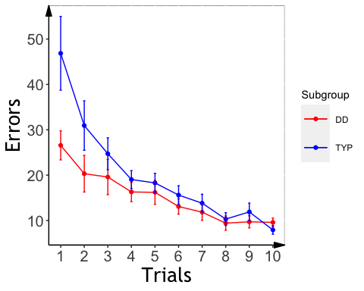

##Slopes

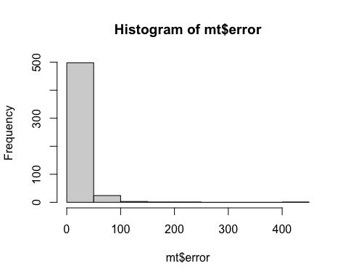

##   
## Call:  
## lm(formula = error ~ poly(trial, 4, raw = TRUE), data = mt2)  
##   
## Residuals:  
## Min 1Q Median 3Q Max   
## -33.374 -8.363 -2.510 3.582 163.626   
##   
## Coefficients:  
## Estimate Std. Error t value Pr(>|t|)   
## (Intercept) 54.23669 7.67002 7.071 5.11e-12 ***  
## poly(trial, 4, raw = TRUE)1 -21.10834 8.64435 -2.442 0.015 *   
## poly(trial, 4, raw = TRUE)2 4.72718 2.99446 1.579 0.115   
## poly(trial, 4, raw = TRUE)3 -0.50065 0.40030 -1.251 0.212   
## poly(trial, 4, raw = TRUE)4 0.01940 0.01811 1.071 0.285   
## ---  
## Signif. codes: 0 '***' 0.001 '**' 0.01 '*' 0.05 '.' 0.1 ' ' 1  
##   
## Residual standard error: 16.61 on 508 degrees of freedom  
## (4 observations deleted due to missingness)  
## Multiple R-squared: 0.2048, Adjusted R-squared: 0.1985   
## F-statistic: 32.71 on 4 and 508 DF, p-value: < 2.2e-16

##   
## Call:  
## lm(formula = time ~ poly(trial, 4, raw = TRUE), data = mt2)  
##   
## Residuals:  
## Min 1Q Median 3Q Max   
## -32.286 -7.193 -1.995 5.005 73.454   
##   
## Coefficients:  
## Estimate Std. Error t value Pr(>|t|)   
## (Intercept) 63.56706 5.89041 10.792 < 2e-16 ***  
## poly(trial, 4, raw = TRUE)1 -23.91590 6.63481 -3.605 0.000343 ***  
## poly(trial, 4, raw = TRUE)2 5.44207 2.29652 2.370 0.018172 *   
## poly(trial, 4, raw = TRUE)3 -0.56874 0.30669 -1.854 0.064251 .   
## poly(trial, 4, raw = TRUE)4 0.02161 0.01386 1.560 0.119460   
## ---  
## Signif. codes: 0 '***' 0.001 '**' 0.01 '*' 0.05 '.' 0.1 ' ' 1  
##   
## Residual standard error: 12.77 on 512 degrees of freedom  
## Multiple R-squared: 0.3029, Adjusted R-squared: 0.2974   
## F-statistic: 55.61 on 4 and 512 DF, p-value: < 2.2e-16

## Warning: Removed 4 rows containing non-finite values (stat_smooth).

## Warning: Removed 4 rows containing missing values (geom_point).

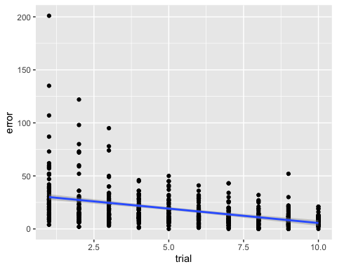 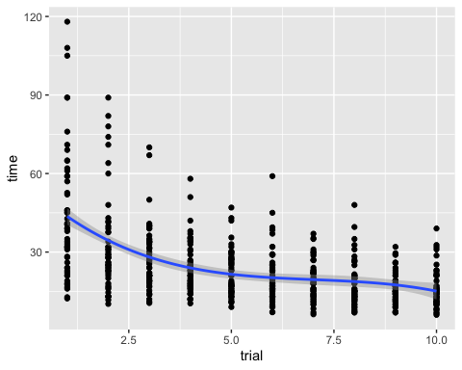

### Extract slopes

#####Time slope

##Error slope 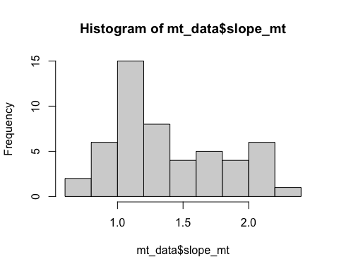

###MT: Slope Analysis

## Analysis of Variance Table  
##   
## Response: slope_mt  
## Df Sum Sq Mean Sq F value Pr(>F)  
## background_age 1 0.0099 0.00988 0.0625 0.8037  
## background_sex 1 0.3449 0.34489 2.1802 0.1463  
## as.factor(Subgroup) 1 0.3809 0.38086 2.4076 0.1273  
## Residuals 48 7.5933 0.15819

## Analysis of Variance Table  
##   
## Response: slope_me  
## Df Sum Sq Mean Sq F value Pr(>F)   
## background_age 1 0.0054 0.00541 0.0364 0.84953   
## background_sex 1 0.8741 0.87408 5.8823 0.01910 *  
## as.factor(Subgroup) 1 1.0102 1.01021 6.7984 0.01212 *  
## Residuals 48 7.1325 0.14859   
## ---  
## Signif. codes: 0 '***' 0.001 '**' 0.01 '*' 0.05 '.' 0.1 ' ' 1

## $`lsmeans of Subgroup`  
## Subgroup lsmean SE df lower.CL upper.CL  
## DD 0.057 0.0805 48 -0.129 0.243  
## TYP 0.341 0.0729 48 0.173 0.509  
##   
## Results are averaged over the levels of: background_sex   
## Confidence level used: 0.95   
## Conf-level adjustment: sidak method for 2 estimates   
##   
## $`pairwise differences of Subgroup`  
## contrast estimate SE df t.ratio p.value  
## DD - TYP -0.284 0.109 48 -2.607 0.0121   
##   
## Results are averaged over the levels of: background_sex

## MT: Plot Slope Effects

## `summarise()` regrouping output by 'PartID' (override with `.groups` argument)

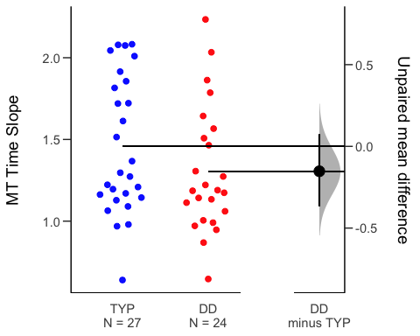

## `summarise()` regrouping output by 'PartID' (override with `.groups` argument)

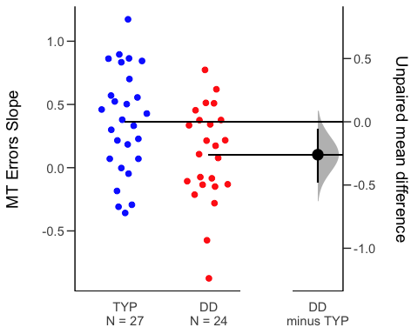

# Statistical Learning

##   
## Dyslexic Typical   
## 17 24

## Slope analyses

## Analysis of Variance Table  
##   
## Response: aud_slope_scale  
## Df Sum Sq Mean Sq F value Pr(>F)  
## background_age 1 0.0000828 0.00008280 0.2047 0.6547  
## background_sex 1 0.0010277 0.00102775 2.5408 0.1230  
## Subgroup 1 0.0002015 0.00020154 0.4982 0.4865  
## Residuals 26 0.0105169 0.00040450

##ASL Slope Effects

## `summarise()` regrouping output by 'PartID' (override with `.groups` argument)

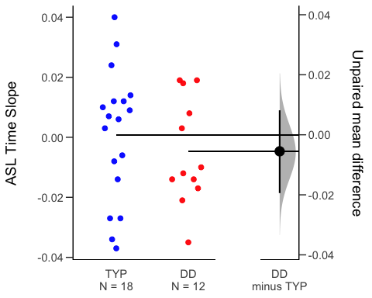

##VSL Slope Analysis

## Analysis of Variance Table  
##   
## Response: vis_slope_scale  
## Df Sum Sq Mean Sq F value Pr(>F)   
## background_age 1 0.002912 0.0029119 1.8070 0.18803   
## background_sex 1 0.000524 0.0005236 0.3250 0.57251   
## Subgroup 1 0.005461 0.0054615 3.3892 0.07463 .  
## Residuals 33 0.053177 0.0016114   
## ---  
## Signif. codes: 0 '***' 0.001 '**' 0.01 '*' 0.05 '.' 0.1 ' ' 1

##VSL Effect Plot

## `summarise()` regrouping output by 'PartID' (override with `.groups` argument)

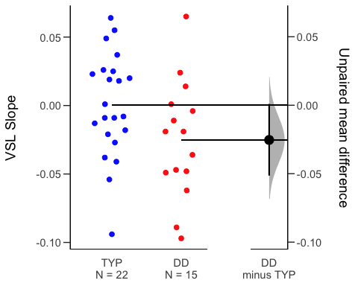 ##RT Slope

## Analysis of Variance Table  
##   
## Response: aud_fam_rt  
## Df Sum Sq Mean Sq F value Pr(>F)  
## background_age 1 4 3.5 0.0004 0.9846  
## background_sex 1 14408 14408.0 1.5540 0.2237  
## as.factor(Subgroup) 1 14961 14960.5 1.6136 0.2152  
## Residuals 26 241064 9271.7

## Analysis of Variance Table  
##   
## Response: vis_fam_rt  
## Df Sum Sq Mean Sq F value Pr(>F)  
## background_age 1 7954 7954.0 1.6336 0.2101  
## background_sex 1 13664 13664.0 2.8064 0.1033  
## as.factor(Subgroup) 1 2942 2941.5 0.6041 0.4425  
## Residuals 33 160674 4868.9

###Cross-task correlations

## kbit_ss_2 wrmt_id_ss_2 wrmt_wa_ss_2 ctopp_nonword_raw_2  
## kbit_ss_2   
## wrmt_id_ss_2 0.40*   
## wrmt_wa_ss_2 0.45** 0.79****   
## ctopp_nonword_raw_2 0.17 0.39* 0.44**   
## ctopp_elision_raw_2 0.43** 0.50** 0.53*** 0.13   
## ctopp_blending_raw_2 0.21 0.38* 0.33* 0.17   
## wais_dsb_ss_2 0.53*** 0.48** 0.45** 0.34*   
## slopeProp_On 0.05 0.15 0.13 0.07   
## slope_mt -0.09 0.19 0.15 -0.02   
## slope_me 0.19 0.38* 0.37* 0.10   
## vis_slope_scale 0.12 0.26 0.20 0.11   
## aud_slope_scale 0.01 0.13 0.18 0.10   
## quicksin_snr_loss_2 -0.15 -0.37* -0.20 -0.33*   
## ctopp_elision_raw_2 ctopp_blending_raw_2 wais_dsb_ss_2  
## kbit_ss_2   
## wrmt_id_ss_2   
## wrmt_wa_ss_2   
## ctopp_nonword_raw_2   
## ctopp_elision_raw_2   
## ctopp_blending_raw_2 0.40*   
## wais_dsb_ss_2 0.43** 0.54***   
## slopeProp_On 0.14 0.21 0.33*   
## slope_mt 0.17 0.10 0.15   
## slope_me 0.36* 0.08 0.15   
## vis_slope_scale 0.08 -0.21 0.20   
## aud_slope_scale 0.05 0.09 0.02   
## quicksin_snr_loss_2 -0.17 -0.40* -0.36*   
## slopeProp_On slope_mt slope_me vis_slope_scale  
## kbit_ss_2   
## wrmt_id_ss_2   
## wrmt_wa_ss_2   
## ctopp_nonword_raw_2   
## ctopp_elision_raw_2   
## ctopp_blending_raw_2   
## wais_dsb_ss_2   
## slopeProp_On   
## slope_mt 0.02   
## slope_me 0.13 0.39*   
## vis_slope_scale 0.20 -0.06 0.13   
## aud_slope_scale -0.11 -0.08 -0.06 -0.23   
## quicksin_snr_loss_2 -0.30 0.39* -0.12 -0.08   
## aud_slope_scale  
## kbit_ss_2   
## wrmt_id_ss_2   
## wrmt_wa_ss_2   
## ctopp_nonword_raw_2   
## ctopp_elision_raw_2   
## ctopp_blending_raw_2   
## wais_dsb_ss_2   
## slopeProp_On   
## slope_mt   
## slope_me   
## vis_slope_scale   
## aud_slope_scale   
## quicksin_snr_loss_2 -0.02