Procedural Learning 110320

Ola Ozernov-Palchik

11/4/2020

# Sample Size

##   
## Frequency table:  
## Subgroup  
## DD TYP   
## 31 31

# Rotary Pursuit

####Question for JDE: Factor or continuous for trial?

### Statstical Analysis by Trial

####There is a significant learning effect with increasing time on target on across trials. ####OOP::The problem with continuous trial that the interaction is significant at trial 8.47..not sure how to interpret.

##   
## Call:  
## lm(formula = prop_on ~ Subgroup * trial, data = rp2)  
##   
## Residuals:  
## Min 1Q Median 3Q Max   
## -0.38584 -0.08919 -0.00460 0.07904 0.49058   
##   
## Coefficients:  
## Estimate Std. Error t value Pr(>|t|)   
## (Intercept) 0.224478 0.014127 15.890 <2e-16 ***  
## SubgroupTYP 0.015062 0.019782 0.761 0.4466   
## trial 0.013220 0.001469 9.002 <2e-16 ***  
## SubgroupTYP:trial -0.005245 0.002053 -2.554 0.0108 *   
## ---  
## Signif. codes: 0 '***' 0.001 '**' 0.01 '*' 0.05 '.' 0.1 ' ' 1  
##   
## Residual standard error: 0.1371 on 840 degrees of freedom  
## (4 observations deleted due to missingness)  
## Multiple R-squared: 0.1263, Adjusted R-squared: 0.1232   
## F-statistic: 40.47 on 3 and 840 DF, p-value: < 2.2e-16

## $`lsmeans of Subgroup | trial`  
## trial = 8.47:  
## Subgroup lsmean SE df lower.CL upper.CL  
## DD 0.336 0.00674 840 0.321 0.352  
## TYP 0.307 0.00660 840 0.292 0.322  
##   
## Confidence level used: 0.95   
## Conf-level adjustment: sidak method for 2 estimates   
##   
## $`pairwise differences of Subgroup | trial`  
## trial = 8.47:  
## contrast estimate SE df t.ratio p.value  
## DD - TYP 0.0293 0.00944 840 3.110 0.0019

###linear mixed-effect modeling: treating trial as a continuous variable ####OOP: i added model testing here. I would include Subject as random effects, but not trials.

##Extract Slope ####growth curve analysis - ZQ note: the growth curve analyses suggested that the two groups are significantly different on the quadratic terms

####Extract indiviudal slope ####OOP:Looks like the slopes are linear now

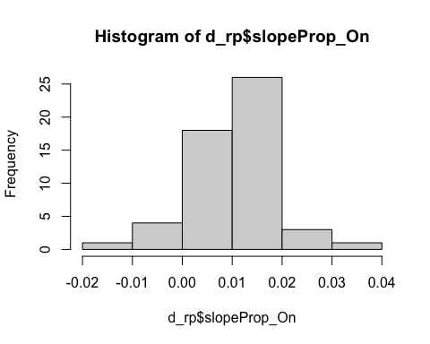

## Plot task

###Prop On by Trial

## `summarise()` regrouping output by 'Subgroup' (override with `.groups` argument)

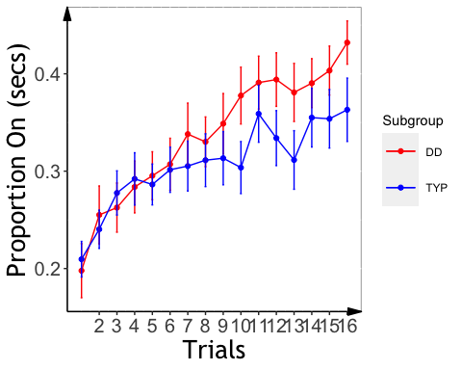 ### alternative plots with fitted curve ####OOP: this doesn’t work for me

###Slope Analysis- No significant effects for RP slopes

## Analysis of Variance Table  
##   
## Response: slopeProp_On  
## Df Sum Sq Mean Sq F value Pr(>F)   
## background_age 1 0.0001323 1.3232e-04 1.6584 0.20387   
## background_sex 1 0.0000003 3.0400e-07 0.0038 0.95102   
## Subgroup 1 0.0002347 2.3465e-04 2.9410 0.09267 .  
## Residuals 49 0.0039095 7.9785e-05   
## ---  
## Signif. codes: 0 '***' 0.001 '**' 0.01 '*' 0.05 '.' 0.1 ' ' 1

## $`lsmeans of Subgroup`  
## Subgroup lsmean SE df lower.CL upper.CL  
## DD 0.01224 0.00179 49 0.00812 0.0164  
## TYP 0.00798 0.00172 49 0.00400 0.0120  
##   
## Results are averaged over the levels of: background_sex   
## Confidence level used: 0.95   
## Conf-level adjustment: sidak method for 2 estimates   
##   
## $`pairwise differences of Subgroup`  
## contrast estimate SE df t.ratio p.value  
## DD - TYP 0.00426 0.00248 49 1.715 0.0927   
##   
## Results are averaged over the levels of: background_sex

###Slope Effects

## `summarise()` regrouping output by 'PartID' (override with `.groups` argument)

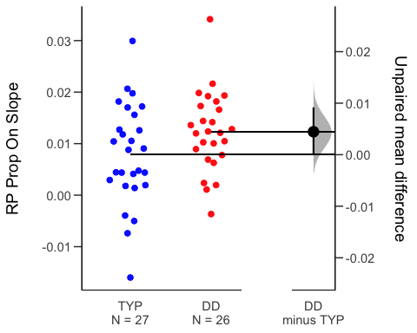

# Mirror Tracing

## QC

#### John: should we exclude outliers?

##MT: Analysis:

##   
## Call:  
## lm(formula = time ~ Subgroup * trial, data = mt2)  
##   
## Residuals:  
## Min 1Q Median 3Q Max   
## -31.22 -10.94 -2.96 4.27 713.19   
##   
## Coefficients:  
## Estimate Std. Error t value Pr(>|t|)   
## (Intercept) 47.9853 5.0009 9.595 < 2e-16 ***  
## SubgroupTYP -4.2821 6.8570 -0.624 0.533   
## trial -3.9905 0.8045 -4.960 9.62e-07 ***  
## SubgroupTYP:trial 0.7466 1.1040 0.676 0.499   
## ---  
## Signif. codes: 0 '***' 0.001 '**' 0.01 '*' 0.05 '.' 0.1 ' ' 1  
##   
## Residual standard error: 35.68 on 505 degrees of freedom  
## (21 observations deleted due to missingness)  
## Multiple R-squared: 0.07849, Adjusted R-squared: 0.07302   
## F-statistic: 14.34 on 3 and 505 DF, p-value: 5.59e-09

## $`lsmeans of Subgroup | trial`  
## trial = 5.51:  
## Subgroup lsmean SE df lower.CL upper.CL  
## DD 26.0 2.31 505 20.8 31.2  
## TYP 25.8 2.17 505 21.0 30.7  
##   
## Confidence level used: 0.95   
## Conf-level adjustment: sidak method for 2 estimates   
##   
## $`pairwise differences of Subgroup | trial`  
## trial = 5.51:  
## contrast estimate SE df t.ratio p.value  
## DD - TYP 0.17 3.17 505 0.054 0.9571

## Analysis of Variance Table  
##   
## Response: error  
## Df Sum Sq Mean Sq F value Pr(>F)   
## Subgroup 1 722 722 1.1956 0.2747   
## trial 1 47080 47080 77.9114 <2e-16 ***  
## Subgroup:trial 1 220 220 0.3647 0.5462   
## Residuals 516 311807 604   
## ---  
## Signif. codes: 0 '***' 0.001 '**' 0.01 '*' 0.05 '.' 0.1 ' ' 1

## $`lsmeans of Subgroup | trial`  
## trial = 5.47:  
## Subgroup lsmean SE df lower.CL upper.CL  
## DD 17.4 1.55 516 13.9 20.8  
## TYP 19.7 1.50 516 16.4 23.1  
##   
## Confidence level used: 0.95   
## Conf-level adjustment: sidak method for 2 estimates   
##   
## $`pairwise differences of Subgroup | trial`  
## trial = 5.47:  
## contrast estimate SE df t.ratio p.value  
## DD - TYP -2.38 2.16 516 -1.102 0.2710

## boundary (singular) fit: see ?isSingular

## Linear mixed model fit by REML. t-tests use Satterthwaite's method [  
## lmerModLmerTest]  
## Formula: time ~ Subgroup * trial + (1 + trial | PartID)  
## Data: mt2  
##   
## REML criterion at convergence: 4568.1  
##   
## Scaled residuals:   
## Min 1Q Median 3Q Max   
## -12.6887 -0.2834 -0.1014 0.1947 12.5674   
##   
## Random effects:  
## Groups Name Variance Std.Dev. Corr   
## PartID (Intercept) 6740.1 82.10   
## trial 102.2 10.11 -1.00  
## Residual 321.6 17.93   
## Number of obs: 509, groups: PartID, 52  
##   
## Fixed effects:  
## Estimate Std. Error df t value Pr(>|t|)   
## (Intercept) 56.870 16.618 48.263 3.422 0.00127 **  
## SubgroupTYP -13.166 23.051 48.171 -0.571 0.57053   
## trial -4.954 2.063 36.093 -2.401 0.02161 *   
## SubgroupTYP:trial 1.710 2.861 36.007 0.598 0.55382   
## ---  
## Signif. codes: 0 '***' 0.001 '**' 0.01 '*' 0.05 '.' 0.1 ' ' 1  
##   
## Correlation of Fixed Effects:  
## (Intr) SbgTYP trial   
## SubgroupTYP -0.721   
## trial -0.996 0.718   
## SbgrpTYP:tr 0.718 -0.996 -0.721  
## convergence code: 0  
## boundary (singular) fit: see ?isSingular

####Need to decide on whether we want lme models

## boundary (singular) fit: see ?isSingular

## Linear mixed model fit by REML. t-tests use Satterthwaite's method [  
## lmerModLmerTest]  
## Formula: error ~ Subgroup * trial + (1 + trial | PartID)  
## Data: mt2  
##   
## REML criterion at convergence: 4544  
##   
## Scaled residuals:   
## Min 1Q Median 3Q Max   
## -8.7381 -0.3129 -0.0630 0.2329 10.0688   
##   
## Random effects:  
## Groups Name Variance Std.Dev. Corr   
## PartID (Intercept) 1794.18 42.358   
## trial 22.98 4.794 -1.00  
## Residual 281.19 16.769   
## Number of obs: 520, groups: PartID, 53  
##   
## Fixed effects:  
## Estimate Std. Error df t value Pr(>|t|)   
## (Intercept) 37.7084 8.6126 48.2532 4.378 6.4e-05 ***  
## SubgroupTYP 1.3564 12.0626 48.1900 0.112 0.91094   
## trial -3.3634 1.0092 43.3039 -3.333 0.00177 **   
## SubgroupTYP:trial -0.1694 1.4134 43.2389 -0.120 0.90516   
## ---  
## Signif. codes: 0 '***' 0.001 '**' 0.01 '*' 0.05 '.' 0.1 ' ' 1  
##   
## Correlation of Fixed Effects:  
## (Intr) SbgTYP trial   
## SubgroupTYP -0.714   
## trial -0.983 0.702   
## SbgrpTYP:tr 0.702 -0.984 -0.714  
## convergence code: 0  
## boundary (singular) fit: see ?isSingular

## MT: Plot Time/Error by Trial

## `summarise()` regrouping output by 'Subgroup' (override with `.groups` argument)  
## `summarise()` regrouping output by 'Subgroup' (override with `.groups` argument)

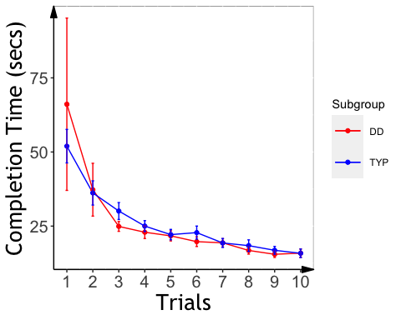

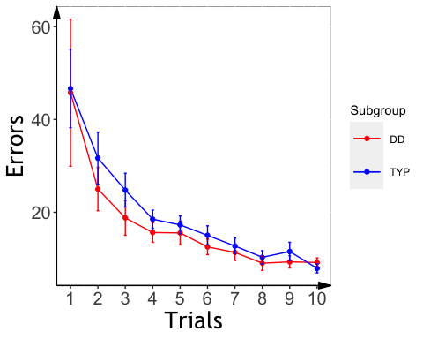

##Mirror Tracing Slopes ### growth curve analysis suggested the two groups are signficiantly different on quardratic terms #### completion time

## PartID Subgroup Type trial   
## Length:507 Length:507 Length:507 Min. : 1.000   
## Class :character Class :character Class :character 1st Qu.: 3.000   
## Mode :character Mode :character Mode :character Median : 5.000   
## Mean : 5.493   
## 3rd Qu.: 8.000   
## Max. :10.000   
## time error otrial1 otrial2   
## Min. : 6.00 Min. : 0.00 Min. :-0.49543 Min. :-0.348155   
## 1st Qu.: 14.11 1st Qu.: 8.00 1st Qu.:-0.27524 1st Qu.:-0.261116   
## Median : 20.00 Median : 12.00 Median :-0.05505 Median :-0.087039   
## Mean : 25.93 Mean : 18.45 Mean :-0.00076 Mean :-0.001202   
## 3rd Qu.: 29.00 3rd Qu.: 21.00 3rd Qu.: 0.27524 3rd Qu.: 0.174078   
## Max. :757.18 Max. :409.00 Max. : 0.49543 Max. : 0.522233

## boundary (singular) fit: see ?isSingular  
## boundary (singular) fit: see ?isSingular  
## boundary (singular) fit: see ?isSingular

## Data: mt2  
## Models:  
## m.base: time ~ (otrial1 + otrial2) + (otrial1 + otrial2 | PartID)  
## m.0: time ~ (otrial1 + otrial2) + Subgroup + (otrial1 + otrial2 |   
## m.0: PartID)  
## m.1: time ~ (otrial1 + otrial2) * Subgroup + (otrial1 + otrial2 |   
## m.1: PartID)  
## npar AIC BIC logLik deviance Chisq Df Pr(>Chisq)  
## m.base 10 3986.6 4028.9 -1983.3 3966.6   
## m.0 11 3988.1 4034.6 -1983.0 3966.1 0.4901 1 0.4839  
## m.1 13 3987.5 4042.5 -1980.8 3961.5 4.5661 2 0.1020

## Linear mixed model fit by maximum likelihood . t-tests use Satterthwaite's  
## method [lmerModLmerTest]  
## Formula: time ~ (otrial1 + otrial2) * Subgroup + (otrial1 + otrial2 |   
## PartID)  
## Data: mt2  
##   
## AIC BIC logLik deviance df.resid   
## 3987.5 4042.5 -1980.8 3961.5 494   
##   
## Scaled residuals:   
## Min 1Q Median 3Q Max   
## -4.5351 -0.4102 -0.0301 0.2955 5.0174   
##   
## Random effects:  
## Groups Name Variance Std.Dev. Corr   
## PartID (Intercept) 1498.68 38.713   
## otrial1 9436.00 97.139 0.94   
## otrial2 28272.08 168.143 -0.97 -1.00  
## Residual 53.81 7.335   
## Number of obs: 507, groups: PartID, 52  
##   
## Fixed effects:  
## Estimate Std. Error df t value Pr(>|t|)   
## (Intercept) 11.143 7.769 19.728 1.434 0.1672   
## otrial1 -46.631 19.492 16.759 -2.392 0.0287 *  
## otrial2 55.380 33.673 46.536 1.645 0.1068   
## SubgroupTYP 14.690 10.774 19.684 1.364 0.1881   
## otrial1:SubgroupTYP 17.065 27.045 16.751 0.631 0.5366   
## otrial2:SubgroupTYP -42.227 46.723 46.506 -0.904 0.3708   
## ---  
## Signif. codes: 0 '***' 0.001 '**' 0.01 '*' 0.05 '.' 0.1 ' ' 1  
##   
## Correlation of Fixed Effects:  
## (Intr) otril1 otril2 SbgTYP o1:STY  
## otrial1 0.931   
## otrial2 -0.963 -0.991   
## SubgroupTYP -0.721 -0.671 0.695   
## otrl1:SbTYP -0.671 -0.721 0.714 0.932   
## otrl2:SbTYP 0.694 0.714 -0.721 -0.964 -0.991  
## convergence code: 0  
## boundary (singular) fit: see ?isSingular

#### errors

## boundary (singular) fit: see ?isSingular  
## boundary (singular) fit: see ?isSingular  
## boundary (singular) fit: see ?isSingular

## Data: mt2  
## Models:  
## m.base: error ~ (otrial1 + otrial2) + (otrial1 + otrial2 | PartID)  
## m.0: error ~ (otrial1 + otrial2) + Subgroup + (otrial1 + otrial2 |   
## m.0: PartID)  
## m.1: error ~ (otrial1 + otrial2) * Subgroup + (otrial1 + otrial2 |   
## m.1: PartID)  
## npar AIC BIC logLik deviance Chisq Df Pr(>Chisq)   
## m.base 10 4186.0 4228.3 -2083 4166.0   
## m.0 11 4188.0 4234.6 -2083 4166.0 0.0015 1 0.96860   
## m.1 13 4185.9 4240.9 -2080 4159.9 6.1214 2 0.04685 *  
## ---  
## Signif. codes: 0 '***' 0.001 '**' 0.01 '*' 0.05 '.' 0.1 ' ' 1

## Linear mixed model fit by maximum likelihood . t-tests use Satterthwaite's  
## method [lmerModLmerTest]  
## Formula: error ~ (otrial1 + otrial2) * Subgroup + (otrial1 + otrial2 |   
## PartID)  
## Data: mt2  
##   
## AIC BIC logLik deviance df.resid   
## 4185.9 4240.9 -2080.0 4159.9 494   
##   
## Scaled residuals:   
## Min 1Q Median 3Q Max   
## -4.7509 -0.3791 -0.0396 0.3064 4.4986   
##   
## Random effects:  
## Groups Name Variance Std.Dev. Corr   
## PartID (Intercept) 585.1 24.188   
## otrial1 1426.1 37.763 0.56   
## otrial2 12012.7 109.603 -0.87 -0.90  
## Residual 94.8 9.737   
## Number of obs: 507, groups: PartID, 52  
##   
## Fixed effects:  
## Estimate Std. Error df t value Pr(>|t|)   
## (Intercept) 8.773 4.904 19.106 1.789 0.08949 .   
## otrial1 -25.453 7.828 13.974 -3.251 0.00581 **  
## otrial2 35.910 22.048 39.567 1.629 0.11131   
## SubgroupTYP 10.914 6.788 18.980 1.608 0.12436   
## otrial1:SubgroupTYP -6.467 10.847 13.896 -0.596 0.56064   
## otrial2:SubgroupTYP -22.429 30.571 39.449 -0.734 0.46748   
## ---  
## Signif. codes: 0 '***' 0.001 '**' 0.01 '*' 0.05 '.' 0.1 ' ' 1  
##   
## Correlation of Fixed Effects:  
## (Intr) otril1 otril2 SbgTYP o1:STY  
## otrial1 0.529   
## otrial2 -0.856 -0.861   
## SubgroupTYP -0.722 -0.382 0.618   
## otrl1:SbTYP -0.382 -0.722 0.622 0.532   
## otrl2:SbTYP 0.617 0.621 -0.721 -0.857 -0.863  
## convergence code: 0  
## boundary (singular) fit: see ?isSingular

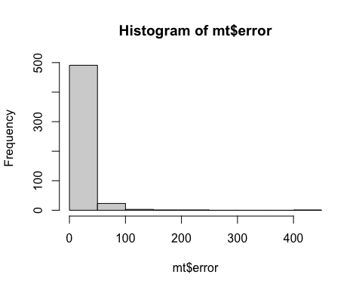

##   
## Call:  
## lm(formula = error ~ poly(trial, 2, raw = TRUE), data = mt2)  
##   
## Residuals:  
## Min 1Q Median 3Q Max   
## -35.56 -8.73 -2.27 3.74 369.44   
##   
## Coefficients:  
## Estimate Std. Error t value Pr(>|t|)   
## (Intercept) 48.4660 3.8760 12.504 < 2e-16 ***  
## poly(trial, 2, raw = TRUE)1 -9.4849 1.6185 -5.860 8.36e-09 ***  
## poly(trial, 2, raw = TRUE)2 0.5752 0.1435 4.009 7.02e-05 ***  
## ---  
## Signif. codes: 0 '***' 0.001 '**' 0.01 '*' 0.05 '.' 0.1 ' ' 1  
##   
## Residual standard error: 23.47 on 504 degrees of freedom  
## Multiple R-squared: 0.154, Adjusted R-squared: 0.1506   
## F-statistic: 45.86 on 2 and 504 DF, p-value: < 2.2e-16

##   
## Call:  
## lm(formula = time ~ poly(trial, 3, raw = TRUE), data = mt2)  
##   
## Residuals:  
## Min 1Q Median 3Q Max   
## -44.07 -8.22 -2.52 4.23 700.85   
##   
## Coefficients:  
## Estimate Std. Error t value Pr(>|t|)   
## (Intercept) 79.49665 9.56279 8.313 8.76e-16 ***  
## poly(trial, 3, raw = TRUE)1 -26.97402 7.17283 -3.761 0.000189 ***  
## poly(trial, 3, raw = TRUE)2 3.99919 1.48101 2.700 0.007161 **   
## poly(trial, 3, raw = TRUE)3 -0.19567 0.08889 -2.201 0.028159 *   
## ---  
## Signif. codes: 0 '***' 0.001 '**' 0.01 '*' 0.05 '.' 0.1 ' ' 1  
##   
## Residual standard error: 35.15 on 503 degrees of freedom  
## Multiple R-squared: 0.1095, Adjusted R-squared: 0.1041   
## F-statistic: 20.61 on 3 and 503 DF, p-value: 1.312e-12

#### fit polynomial curves for the MT time plots

## No summary function supplied, defaulting to `mean_se()`

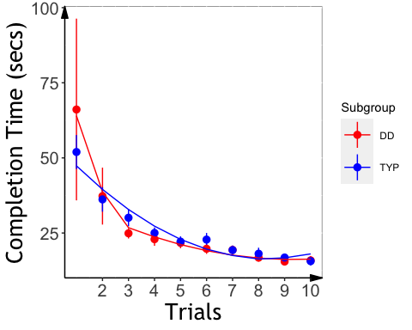 #### fit polynomial curves for the MT error plots

## No summary function supplied, defaulting to `mean_se()`

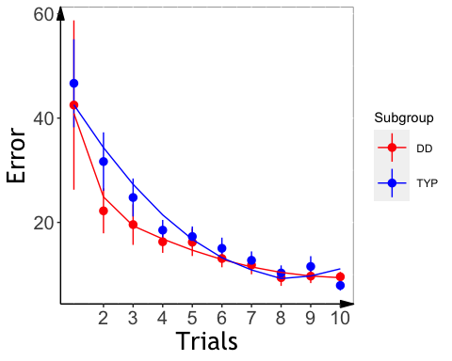

### Extract slopes

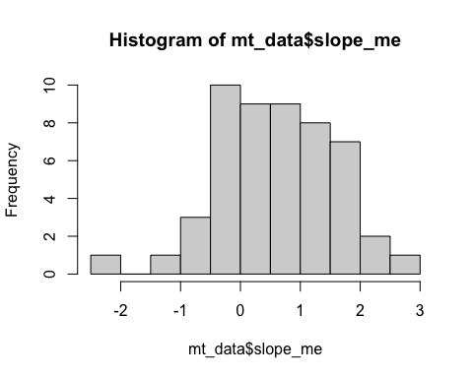

###MT: Slope Analysis

## Analysis of Variance Table  
##   
## Response: slope_mt_t  
## Df Sum Sq Mean Sq F value Pr(>F)   
## background_age 1 0.5225 0.52246 2.5649 0.1158   
## background_sex 1 0.5741 0.57408 2.8183 0.0997 .  
## Subgroup 1 0.2947 0.29470 1.4468 0.2349   
## Residuals 48 9.7775 0.20370   
## ---  
## Signif. codes: 0 '***' 0.001 '**' 0.01 '*' 0.05 '.' 0.1 ' ' 1

## Analysis of Variance Table  
##   
## Response: slope_me_t  
## Df Sum Sq Mean Sq F value Pr(>F)   
## background_age 1 0.2398 0.23975 1.8347 0.181915   
## background_sex 1 1.0498 1.04983 8.0338 0.006698 **  
## Subgroup 1 0.1320 0.13200 1.0101 0.319913   
## Residuals 48 6.2725 0.13068   
## ---  
## Signif. codes: 0 '***' 0.001 '**' 0.01 '*' 0.05 '.' 0.1 ' ' 1

## $`lsmeans of Subgroup`  
## Subgroup lsmean SE df lower.CL upper.CL  
## DD 0.462 0.0746 48 0.290 0.634  
## TYP 0.565 0.0698 48 0.404 0.726  
##   
## Results are averaged over the levels of: background_sex   
## Confidence level used: 0.95   
## Conf-level adjustment: sidak method for 2 estimates   
##   
## $`pairwise differences of Subgroup`  
## contrast estimate SE df t.ratio p.value  
## DD - TYP -0.103 0.102 48 -1.005 0.3199   
##   
## Results are averaged over the levels of: background_sex

## MT: Plot Slope Effects

## `summarise()` regrouping output by 'PartID' (override with `.groups` argument)

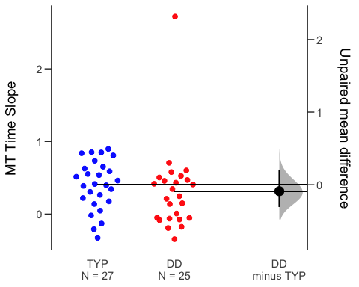

## `summarise()` regrouping output by 'PartID' (override with `.groups` argument)

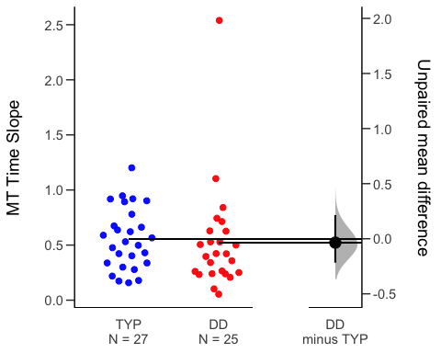

# Statistical Learning

##   
## Dyslexic Typical   
## 17 24

## Slope analyses (ZQ notes: the group difference analysis should refer to abcd_sl_analysis.pdf)

## Analysis of Variance Table  
##   
## Response: aud_slope_scale  
## Df Sum Sq Mean Sq F value Pr(>F)  
## background_age 1 0.0000258 0.00002580 0.0635 0.8029  
## background_sex 1 0.0011417 0.00114166 2.8110 0.1052  
## Subgroup 1 0.0000973 0.00009727 0.2395 0.6285  
## Residuals 27 0.0109657 0.00040614

##ASL Slope Effects (ZQ notes: the group difference analysis should refer to abcd_sl_analysis.pdf)

## `summarise()` regrouping output by 'PartID' (override with `.groups` argument)

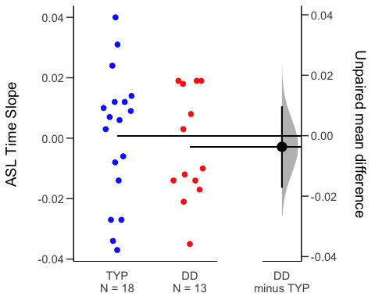

##VSL Slope Analysis (ZQ notes: the group difference analysis should refer to abcd_sl_analysis.pdf)

## Analysis of Variance Table  
##   
## Response: vis_slope_scale  
## Df Sum Sq Mean Sq F value Pr(>F)  
## background_age 1 0.002070 0.0020696 1.2302 0.2752  
## background_sex 1 0.000336 0.0003361 0.1998 0.6577  
## Subgroup 1 0.004031 0.0040306 2.3958 0.1309  
## Residuals 34 0.057200 0.0016823

##VSL Effect Plot (ZQ notes: the group difference analysis should refer to abcd_sl_analysis.pdf, significant group effect)

## `summarise()` regrouping output by 'PartID' (override with `.groups` argument)

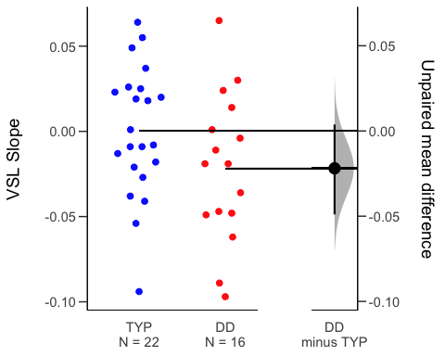 ##RT Slope

## Analysis of Variance Table  
##   
## Response: aud_fam_rt  
## Df Sum Sq Mean Sq F value Pr(>F)  
## background_age 1 0 0.0 0.0000 0.9984  
## background_sex 1 14523 14523.4 1.6219 0.2137  
## Subgroup 1 14248 14248.2 1.5911 0.2180  
## Residuals 27 241777 8954.7

## Analysis of Variance Table  
##   
## Response: vis_fam_rt  
## Df Sum Sq Mean Sq F value Pr(>F)  
## background_age 1 6080 6079.7 1.2305 0.2751  
## background_sex 1 12178 12178.2 2.4649 0.1257  
## Subgroup 1 1555 1555.3 0.3148 0.5784  
## Residuals 34 167984 4940.7

###Cross-task correlations

###Everyone

## kbit_ss_2 gort_ori_ss_2 ctopp_nonword_raw_2  
## kbit_ss_2   
## gort_ori_ss_2 0.25   
## ctopp_nonword_raw_2 0.17 0.48***   
## ctopp_elision_raw_2 0.47*** 0.42** 0.15   
## ctopp_blending_raw_2 0.26 0.42** 0.24   
## wais_dsb_ss_2 0.51**** 0.43** 0.26   
## slopeProp_On -0.05 -0.05 -0.19   
## slope_mt_t -0.09 0.14 -0.04   
## slope_me_t -0.14 0.00 -0.05   
## vis_slope_scale 0.14 0.28 0.09   
## aud_slope_scale 0.04 -0.09 0.07   
## quicksin_snr_loss_2 -0.12 -0.59**** -0.37**   
## ctopp_elision_raw_2 ctopp_blending_raw_2 wais_dsb_ss_2  
## kbit_ss_2   
## gort_ori_ss_2   
## ctopp_nonword_raw_2   
## ctopp_elision_raw_2   
## ctopp_blending_raw_2 0.56****   
## wais_dsb_ss_2 0.42** 0.41**   
## slopeProp_On 0.08 0.06 0.08   
## slope_mt_t 0.12 0.06 0.06   
## slope_me_t 0.16 0.04 -0.06   
## vis_slope_scale 0.09 -0.26 0.21   
## aud_slope_scale 0.07 0.00 0.03   
## quicksin_snr_loss_2 -0.17 -0.35* -0.13   
## slopeProp_On slope_mt_t slope_me_t vis_slope_scale  
## kbit_ss_2   
## gort_ori_ss_2   
## ctopp_nonword_raw_2   
## ctopp_elision_raw_2   
## ctopp_blending_raw_2   
## wais_dsb_ss_2   
## slopeProp_On   
## slope_mt_t 0.21   
## slope_me_t 0.19 0.88****   
## vis_slope_scale 0.19 -0.01 0.04   
## aud_slope_scale -0.06 -0.02 -0.01 -0.18   
## quicksin_snr_loss_2 -0.07 0.01 0.10 -0.08   
## aud_slope_scale  
## kbit_ss_2   
## gort_ori_ss_2   
## ctopp_nonword_raw_2   
## ctopp_elision_raw_2   
## ctopp_blending_raw_2   
## wais_dsb_ss_2   
## slopeProp_On   
## slope_mt_t   
## slope_me_t   
## vis_slope_scale   
## aud_slope_scale   
## quicksin_snr_loss_2 -0.02

###Dys only

## wrmt_id_ss_2 wrmt_wa_ss_2 towre_sw_ss_2 towre_pde_ss_2  
## wrmt_id_ss_2   
## wrmt_wa_ss_2 0.67***   
## towre_sw_ss_2 0.40* 0.07   
## towre_pde_ss_2 0.28 0.58** 0.46*   
## slopeProp_On 0.58** 0.61*** -0.08 0.09   
## slope_mt 0.08 -0.35 0.22 -0.13   
## slope_me 0.08 -0.35 0.22 -0.13   
## aud_acc 0.41 0.50 0.14 0.33   
## vis_acc -0.31 -0.22 0.00 0.20   
## aud_slope_scale 0.00 -0.43 -0.14 -0.50   
## vis_slope_scale -0.31 -0.23 -0.25 -0.28   
## slopeProp_On slope_mt slope_me aud_acc vis_acc  
## wrmt_id_ss_2   
## wrmt_wa_ss_2   
## towre_sw_ss_2   
## towre_pde_ss_2   
## slopeProp_On   
## slope_mt -0.21   
## slope_me -0.20 1.00****   
## aud_acc 0.22 0.49 0.35   
## vis_acc -0.20 0.42 0.34 -0.08   
## aud_slope_scale 0.08 0.30 -0.33 0.07 -0.16   
## vis_slope_scale 0.27 -0.01 -0.04 -0.22 -0.28   
## aud_slope_scale  
## wrmt_id_ss_2   
## wrmt_wa_ss_2   
## towre_sw_ss_2   
## towre_pde_ss_2   
## slopeProp_On   
## slope_mt   
## slope_me   
## aud_acc   
## vis_acc   
## aud_slope_scale   
## vis_slope_scale 0.16

###Typ only

## wrmt_id_ss_2 wrmt_wa_ss_2 towre_sw_ss_2 towre_pde_ss_2  
## wrmt_id_ss_2   
## wrmt_wa_ss_2 -0.04   
## towre_sw_ss_2 0.15 0.17   
## towre_pde_ss_2 0.38* 0.12 0.44*   
## slopeProp_On -0.08 0.16 -0.11 -0.20   
## slope_mt -0.11 -0.19 -0.10 0.16   
## slope_me -0.17 -0.04 0.02 0.14   
## aud_acc 0.29 0.02 0.26 -0.01   
## vis_acc 0.11 0.01 -0.12 0.11   
## aud_slope_scale -0.10 0.24 -0.29 0.04   
## vis_slope_scale 0.14 -0.20 0.27 0.51*   
## slopeProp_On slope_mt slope_me aud_acc vis_acc  
## wrmt_id_ss_2   
## wrmt_wa_ss_2   
## towre_sw_ss_2   
## towre_pde_ss_2   
## slopeProp_On   
## slope_mt -0.38*   
## slope_me -0.27 0.83****   
## aud_acc 0.16 -0.20 -0.27   
## vis_acc -0.16 -0.11 -0.22 -0.12   
## aud_slope_scale -0.13 0.15 0.23 -0.36 0.25   
## vis_slope_scale 0.15 0.17 0.14 0.08 -0.36   
## aud_slope_scale  
## wrmt_id_ss_2   
## wrmt_wa_ss_2   
## towre_sw_ss_2   
## towre_pde_ss_2   
## slopeProp_On   
## slope_mt   
## slope_me   
## aud_acc   
## vis_acc   
## aud_slope_scale   
## vis_slope_scale -0.48*