Procedural Learning 110320

Ola Ozernov-Palchik

11/4/2020

# Sample Size

##   
## Frequency table:  
## Subgroup  
## DD TYP   
## 31 31

# Rotary Pursuit

Question for JDE: Factor or continuous for trial?

### Statstical Analysis by Trial

There is no significant group difference in baseline speed for RP. There is a significant learning effect with increasing time on target on across trials. The interaction is significant with faster learning for the Dys group. The results remain the same after controlling for sex, age, and IQ.

##   
## Welch Two Sample t-test  
##   
## data: d$rotarypursuit_0_2 by d$Subgroup  
## t = -0.060585, df = 45.388, p-value = 0.952  
## alternative hypothesis: true difference in means is not equal to 0  
## 95 percent confidence interval:  
## -4.38929 4.13288  
## sample estimates:  
## mean in group DD mean in group TYP   
## 26.53846 26.66667

##   
## Call:  
## lm(formula = prop_on ~ Subgroup * trial, data = rp2)  
##   
## Residuals:  
## Min 1Q Median 3Q Max   
## -0.38584 -0.08919 -0.00460 0.07904 0.49058   
##   
## Coefficients:  
## Estimate Std. Error t value Pr(>|t|)   
## (Intercept) 0.224478 0.014127 15.890 <2e-16 ***  
## SubgroupTYP 0.015062 0.019782 0.761 0.4466   
## trial 0.013220 0.001469 9.002 <2e-16 ***  
## SubgroupTYP:trial -0.005245 0.002053 -2.554 0.0108 *   
## ---  
## Signif. codes: 0 '***' 0.001 '**' 0.01 '*' 0.05 '.' 0.1 ' ' 1  
##   
## Residual standard error: 0.1371 on 840 degrees of freedom  
## (4 observations deleted due to missingness)  
## Multiple R-squared: 0.1263, Adjusted R-squared: 0.1232   
## F-statistic: 40.47 on 3 and 840 DF, p-value: < 2.2e-16

##   
## Call:  
## lm(formula = prop_on ~ Subgroup * trial + background_age + background_sex +   
## kbit_ss, data = rp2_age_gender_iq)  
##   
## Residuals:  
## Min 1Q Median 3Q Max   
## -0.36739 -0.08772 -0.00276 0.07962 0.48331   
##   
## Coefficients:  
## Estimate Std. Error t value Pr(>|t|)   
## (Intercept) 1.162e-01 5.126e-02 2.268 0.0236 *   
## SubgroupTYP 9.200e-03 1.996e-02 0.461 0.6450   
## trial 1.318e-02 1.467e-03 8.986 <2e-16 ***  
## background_age 7.866e-04 8.676e-04 0.907 0.3648   
## background_sex -3.303e-05 1.014e-02 -0.003 0.9974   
## kbit_ss 8.195e-04 3.649e-04 2.246 0.0250 *   
## SubgroupTYP:trial -5.217e-03 2.050e-03 -2.544 0.0111 *   
## ---  
## Signif. codes: 0 '***' 0.001 '**' 0.01 '*' 0.05 '.' 0.1 ' ' 1  
##   
## Residual standard error: 0.1369 on 837 degrees of freedom  
## (4 observations deleted due to missingness)  
## Multiple R-squared: 0.1318, Adjusted R-squared: 0.1256   
## F-statistic: 21.17 on 6 and 837 DF, p-value: < 2.2e-16

## $`lsmeans of Subgroup | trial`  
## trial = 8.47:  
## Subgroup lsmean SE df lower.CL upper.CL  
## DD 0.336 0.00674 840 0.321 0.352  
## TYP 0.307 0.00660 840 0.292 0.322  
##   
## Confidence level used: 0.95   
## Conf-level adjustment: sidak method for 2 estimates   
##   
## $`pairwise differences of Subgroup | trial`  
## trial = 8.47:  
## contrast estimate SE df t.ratio p.value  
## DD - TYP 0.0293 0.00944 840 3.110 0.0019

#### Linear mixed-effect modeling:

marginal group differences, significant trial differences. Same results when controlling for age, sex, and IQ

## refitting model(s) with ML (instead of REML)

## Data: rp2  
## Models:  
## lmerrp1: prop_on ~ Subgroup * trial + (1 | PartID)  
## lmerrp2: prop_on ~ Subgroup * trial + (1 + trial | PartID)  
## npar AIC BIC logLik deviance Chisq Df Pr(>Chisq)   
## lmerrp1 6 -1868.4 -1839.9 940.18 -1880.4   
## lmerrp2 8 -2033.4 -1995.5 1024.71 -2049.4 169.05 2 < 2.2e-16 ***  
## ---  
## Signif. codes: 0 '***' 0.001 '**' 0.01 '*' 0.05 '.' 0.1 ' ' 1

## Linear mixed model fit by REML. t-tests use Satterthwaite's method [  
## lmerModLmerTest]  
## Formula: prop_on ~ Subgroup * trial + (1 + trial | PartID)  
## Data: rp2  
##   
## REML criterion at convergence: -2016.1  
##   
## Scaled residuals:   
## Min 1Q Median 3Q Max   
## -3.0400 -0.5958 0.0145 0.5950 3.5228   
##   
## Random effects:  
## Groups Name Variance Std.Dev. Corr   
## PartID (Intercept) 1.475e-02 0.12146   
## trial 6.756e-05 0.00822 -0.28  
## Residual 3.527e-03 0.05939   
## Number of obs: 844, groups: PartID, 53  
##   
## Fixed effects:  
## Estimate Std. Error df t value Pr(>|t|)   
## (Intercept) 0.228919 0.024599 50.994936 9.306 1.41e-12 ***  
## SubgroupTYP 0.011288 0.034461 50.975831 0.328 0.7446   
## trial 0.012373 0.001735 50.770798 7.132 3.44e-09 ***  
## SubgroupTYP:trial -0.004515 0.002429 50.641920 -1.859 0.0688 .   
## ---  
## Signif. codes: 0 '***' 0.001 '**' 0.01 '*' 0.05 '.' 0.1 ' ' 1  
##   
## Correlation of Fixed Effects:  
## (Intr) SbgTYP trial   
## SubgroupTYP -0.714   
## trial -0.336 0.240   
## SbgrpTYP:tr 0.240 -0.336 -0.714

## Slope Analysis

## Plot Rotary Pursuit

## `summarise()` regrouping output by 'Subgroup' (override with `.groups` argument)

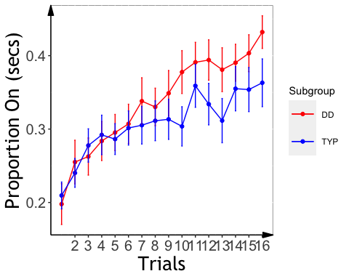

### Alternative plots with fitted curve

## ANCOVA on individual slope

marginal group effect

## Analysis of Variance Table  
##   
## Response: slopeProp_On  
## Df Sum Sq Mean Sq F value Pr(>F)   
## kbit_ss 1 0.0000093 9.2530e-06 0.1153 0.7356   
## Subgroup 1 0.0002563 2.5635e-04 3.1955 0.0799 .  
## Residuals 50 0.0040111 8.0223e-05   
## ---  
## Signif. codes: 0 '***' 0.001 '**' 0.01 '*' 0.05 '.' 0.1 ' ' 1

## $`lsmeans of Subgroup`  
## Subgroup lsmean SE df lower.CL upper.CL  
## DD 0.01238 0.00179 50 0.00824 0.0165  
## TYP 0.00779 0.00176 50 0.00374 0.0118  
##   
## Confidence level used: 0.95   
## Conf-level adjustment: sidak method for 2 estimates   
##   
## $`pairwise differences of Subgroup`  
## contrast estimate SE df t.ratio p.value  
## DD - TYP 0.00458 0.00256 50 1.788 0.0799

## Plotting RP Slope Effects

## `summarise()` regrouping output by 'PartID' (override with `.groups` argument)

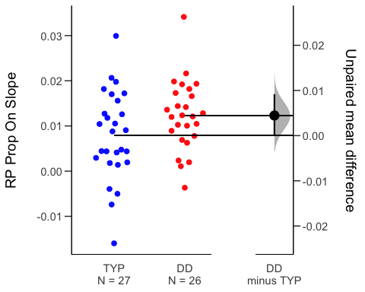

# Mirror Tracing

### Statistical Analysis by Trial

Significant group differences in learning across trials for time, but not error, with better learning for Typ. Differences survive after controlling for age, sex, and IQ

##   
## Call:  
## lm(formula = time ~ Subgroup * trial, data = mt2)  
##   
## Residuals:  
## Min 1Q Median 3Q Max   
## -22.342 -6.816 -1.745 4.497 40.112   
##   
## Coefficients:  
## Estimate Std. Error t value Pr(>|t|)   
## (Intercept) 30.8981 1.4938 20.684 < 2e-16 ***  
## SubgroupTYP 6.0609 2.0732 2.924 0.00362 **   
## trial -1.6976 0.2380 -7.132 3.57e-12 ***  
## SubgroupTYP:trial -0.6595 0.3303 -1.997 0.04640 *   
## ---  
## Signif. codes: 0 '***' 0.001 '**' 0.01 '*' 0.05 '.' 0.1 ' ' 1  
##   
## Residual standard error: 10.36 on 489 degrees of freedom  
## Multiple R-squared: 0.2501, Adjusted R-squared: 0.2455   
## F-statistic: 54.35 on 3 and 489 DF, p-value: < 2.2e-16

##   
## Call:  
## lm(formula = error ~ Subgroup * trial, data = mt2)  
##   
## Residuals:  
## Min 1Q Median 3Q Max   
## -19.877 -7.317 -1.756 4.121 55.513   
##   
## Coefficients:  
## Estimate Std. Error t value Pr(>|t|)   
## (Intercept) 23.2483 1.6255 14.303 < 2e-16 ***  
## SubgroupTYP 5.8235 2.2558 2.582 0.0101 *   
## trial -1.5616 0.2590 -6.029 3.25e-09 ***  
## SubgroupTYP:trial -0.6335 0.3594 -1.763 0.0786 .   
## ---  
## Signif. codes: 0 '***' 0.001 '**' 0.01 '*' 0.05 '.' 0.1 ' ' 1  
##   
## Residual standard error: 11.27 on 489 degrees of freedom  
## Multiple R-squared: 0.1955, Adjusted R-squared: 0.1906   
## F-statistic: 39.61 on 3 and 489 DF, p-value: < 2.2e-16

##   
## Call:  
## lm(formula = time ~ Subgroup * trial + background_age + background_sex +   
## kbit_ss, data = mt2_age_gender_iq)  
##   
## Residuals:  
## Min 1Q Median 3Q Max   
## -20.306 -6.244 -1.537 4.308 40.171   
##   
## Coefficients:  
## Estimate Std. Error t value Pr(>|t|)   
## (Intercept) 16.73023 4.84782 3.451 0.000607 ***  
## SubgroupTYP 6.32562 2.02099 3.130 0.001854 **   
## trial -1.70969 0.22945 -7.451 4.26e-13 ***  
## background_age 0.49088 0.08505 5.771 1.40e-08 ***  
## background_sex -4.58294 0.98902 -4.634 4.62e-06 ***  
## kbit_ss 0.06995 0.03459 2.022 0.043706 *   
## SubgroupTYP:trial -0.64490 0.31839 -2.026 0.043357 *   
## ---  
## Signif. codes: 0 '***' 0.001 '**' 0.01 '*' 0.05 '.' 0.1 ' ' 1  
##   
## Residual standard error: 9.986 on 486 degrees of freedom  
## Multiple R-squared: 0.3074, Adjusted R-squared: 0.2989   
## F-statistic: 35.96 on 6 and 486 DF, p-value: < 2.2e-16

##   
## Call:  
## lm(formula = error ~ Subgroup * trial + background_age + background_sex +   
## kbit_ss, data = mt2_age_gender_iq)  
##   
## Residuals:  
## Min 1Q Median 3Q Max   
## -22.316 -7.366 -1.835 4.154 54.203   
##   
## Coefficients:  
## Estimate Std. Error t value Pr(>|t|)   
## (Intercept) 27.08308 5.39364 5.021 7.22e-07 ***  
## SubgroupTYP 6.89709 2.24854 3.067 0.00228 **   
## trial -1.57205 0.25529 -6.158 1.55e-09 ***  
## background_age 0.26758 0.09463 2.828 0.00488 **   
## background_sex -1.82857 1.10037 -1.662 0.09720 .   
## kbit_ss -0.07951 0.03848 -2.066 0.03934 *   
## SubgroupTYP:trial -0.62354 0.35423 -1.760 0.07900 .   
## ---  
## Signif. codes: 0 '***' 0.001 '**' 0.01 '*' 0.05 '.' 0.1 ' ' 1  
##   
## Residual standard error: 11.11 on 486 degrees of freedom  
## Multiple R-squared: 0.2232, Adjusted R-squared: 0.2137   
## F-statistic: 23.28 on 6 and 486 DF, p-value: < 2.2e-16

### linear mixed modeling

main effect of trial, no effect of subgroups

## MT: Plot Time/Error by Trial

## `summarise()` regrouping output by 'Subgroup' (override with `.groups` argument)  
## `summarise()` regrouping output by 'Subgroup' (override with `.groups` argument)

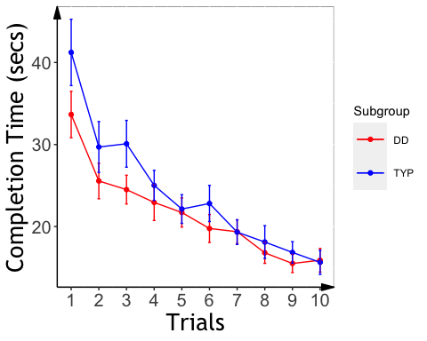

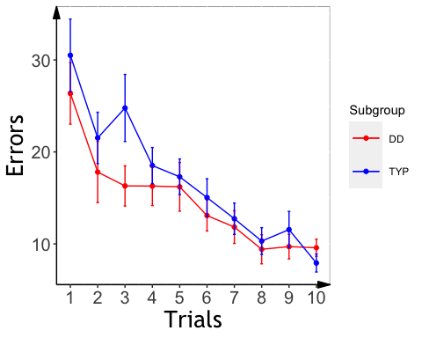

## Mirror Tracing Slopes

Significant group effects for error and time, with steeper slopes in Typ as compared to Dys

### MT Slope Analysis:

A significant group effects for slope, with faster learning for Typ, even after controlling for age, sex, and IQ. If one outlier included, then no significant effect

## Analysis of Variance Table  
##   
## Response: slope_mt_t  
## Df Sum Sq Mean Sq F value Pr(>F)   
## background_age 1 0.0397 0.03970 0.3819 0.53963   
## background_sex 1 0.0885 0.08854 0.8517 0.36089   
## kbit_ss 1 0.0031 0.00307 0.0295 0.86440   
## Subgroup 1 0.5805 0.58051 5.5839 0.02241 *  
## Residuals 46 4.7822 0.10396   
## ---  
## Signif. codes: 0 '***' 0.001 '**' 0.01 '*' 0.05 '.' 0.1 ' ' 1

## Analysis of Variance Table  
##   
## Response: slope_me_t  
## Df Sum Sq Mean Sq F value Pr(>F)   
## background_age 1 0.0104 0.01036 0.0681 0.795257   
## background_sex 1 1.2341 1.23409 8.1151 0.006544 **  
## kbit_ss 1 0.0145 0.01453 0.0955 0.758656   
## Subgroup 1 0.9098 0.90984 5.9829 0.018330 *   
## Residuals 46 6.9954 0.15207   
## ---  
## Signif. codes: 0 '***' 0.001 '**' 0.01 '*' 0.05 '.' 0.1 ' ' 1

## $`lsmeans of Subgroup`  
## Subgroup lsmean SE df lower.CL upper.CL  
## DD 0.0965 0.0831 46 -0.0955 0.289  
## TYP 0.3794 0.0769 46 0.2015 0.557  
##   
## Results are averaged over the levels of: background_sex   
## Confidence level used: 0.95   
## Conf-level adjustment: sidak method for 2 estimates   
##   
## $`pairwise differences of Subgroup`  
## contrast estimate SE df t.ratio p.value  
## DD - TYP -0.283 0.116 46 -2.446 0.0183   
##   
## Results are averaged over the levels of: background_sex

## MT: Plot Slope Effects

## `summarise()` regrouping output by 'PartID' (override with `.groups` argument)

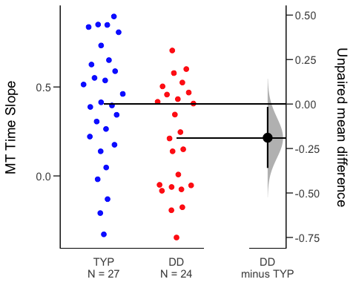

## `summarise()` regrouping output by 'PartID' (override with `.groups` argument)

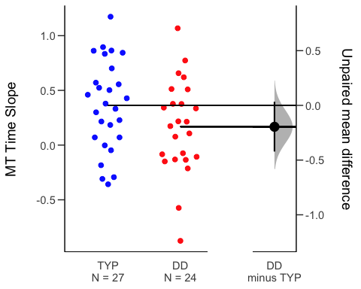

# Statistical Learning

##   
## Dyslexic Typical   
## 17 24

## Slope analyses

(ZQ notes: the group difference analysis should refer to abcd_sl_analysis.pdf)

## Analysis of Variance Table  
##   
## Response: aud_slope_scale  
## Df Sum Sq Mean Sq F value Pr(>F)  
## Subgroup 1 0.0001022 0.00010219 0.2444 0.6248  
## Residuals 29 0.0121282 0.00041821

###ASL Slope Effects (ZQ notes: the group difference analysis should refer to abcd_sl_analysis.pdf)

## `summarise()` regrouping output by 'PartID' (override with `.groups` argument)

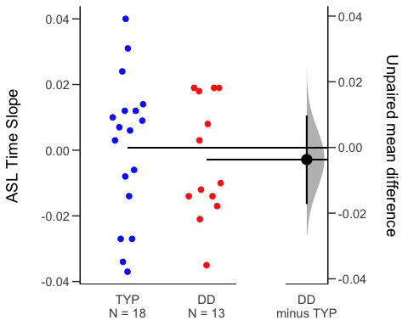

##VSL Slope Analysis (ZQ notes: the group difference analysis should refer to abcd_sl_analysis.pdf, both the linear models and the lmer models are available with trials entered as continuous variables)

## Analysis of Variance Table  
##   
## Response: vis_slope_scale  
## Df Sum Sq Mean Sq F value Pr(>F)  
## background_age 1 0.002070 0.0020696 1.2302 0.2752  
## background_sex 1 0.000336 0.0003361 0.1998 0.6577  
## Subgroup 1 0.004031 0.0040306 2.3958 0.1309  
## Residuals 34 0.057200 0.0016823

###VSL Effect Plot (ZQ notes: the group difference analysis should refer to abcd_sl_analysis.pdf, significant group effect)

## `summarise()` regrouping output by 'PartID' (override with `.groups` argument)

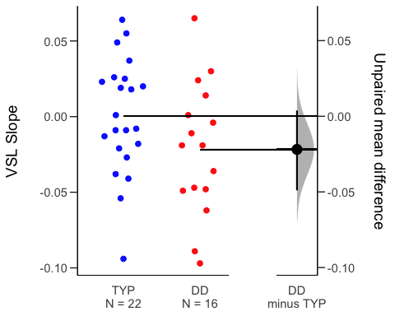

###RT Slope No significant differences in RT for either task.

## Analysis of Variance Table  
##   
## Response: aud_fam_rt  
## Df Sum Sq Mean Sq F value Pr(>F)  
## background_age 1 0 0.0 0.0000 0.9984  
## background_sex 1 14523 14523.4 1.6219 0.2137  
## Subgroup 1 14248 14248.2 1.5911 0.2180  
## Residuals 27 241777 8954.7

## Analysis of Variance Table  
##   
## Response: vis_fam_rt  
## Df Sum Sq Mean Sq F value Pr(>F)  
## background_age 1 6080 6079.7 1.2305 0.2751  
## background_sex 1 12178 12178.2 2.4649 0.1257  
## Subgroup 1 1555 1555.3 0.3148 0.5784  
## Residuals 34 167984 4940.7

**Accuracy (group x task): marginal interaction**

# Cross-task correlations

###Everyone

## kbit_ss_2 gort_ori_ss_2 ctopp_nonword_raw_2  
## kbit_ss_2   
## gort_ori_ss_2 0.25*   
## ctopp_nonword_raw_2 0.17 0.48****   
## ctopp_elision_raw_2 0.47*** 0.42*** 0.15   
## ctopp_blending_raw_2 0.26* 0.42*** 0.24*   
## wais_dsb_ss_2 0.51**** 0.43*** 0.26*   
## slopeProp_On -0.05 -0.05 -0.19   
## slope_mt_t -0.02 0.26* -0.04   
## slope_me_t -0.11 0.08 -0.07   
## vis_slope_scale 0.14 0.28* 0.09   
## aud_slope_scale 0.04 -0.09 0.07   
## vis_acc 0.06 0.06 0.20   
## aud_acc 0.12 0.38** 0.17   
## quicksin_snr_loss_2 -0.12 -0.59**** -0.37**   
## ctopp_elision_raw_2 ctopp_blending_raw_2 wais_dsb_ss_2  
## kbit_ss_2   
## gort_ori_ss_2   
## ctopp_nonword_raw_2   
## ctopp_elision_raw_2   
## ctopp_blending_raw_2 0.56****   
## wais_dsb_ss_2 0.42*** 0.41***   
## slopeProp_On 0.08 0.06 0.08   
## slope_mt_t 0.14 0.08 0.01   
## slope_me_t 0.18 -0.01 -0.15   
## vis_slope_scale 0.09 -0.26 0.21   
## aud_slope_scale 0.07 0.00 0.03   
## vis_acc 0.19 0.17 0.00   
## aud_acc 0.19 0.24 0.26   
## quicksin_snr_loss_2 -0.17 -0.35** -0.13   
## slopeProp_On slope_mt_t slope_me_t vis_slope_scale  
## kbit_ss_2   
## gort_ori_ss_2   
## ctopp_nonword_raw_2   
## ctopp_elision_raw_2   
## ctopp_blending_raw_2   
## wais_dsb_ss_2   
## slopeProp_On   
## slope_mt_t 0.14   
## slope_me_t 0.13 0.77****   
## vis_slope_scale 0.19 -0.01 0.10   
## aud_slope_scale -0.06 -0.02 0.04 -0.18   
## vis_acc -0.18 -0.10 0.02 -0.35*   
## aud_acc 0.20 0.06 0.00 0.07   
## quicksin_snr_loss_2 -0.07 0.08 0.23 -0.08   
## aud_slope_scale vis_acc aud_acc  
## kbit_ss_2   
## gort_ori_ss_2   
## ctopp_nonword_raw_2   
## ctopp_elision_raw_2   
## ctopp_blending_raw_2   
## wais_dsb_ss_2   
## slopeProp_On   
## slope_mt_t   
## slope_me_t   
## vis_slope_scale   
## aud_slope_scale   
## vis_acc 0.08   
## aud_acc -0.16 -0.12   
## quicksin_snr_loss_2 -0.02 -0.02 -0.23

###Dys only both the rotary pursuit and ASL accuracy/RT are related to reading

## kbit_ss_2 gort_ori_ss_2 wrmt_id_ss_2 wrmt_wa_ss_2 towre_sw_ss_2  
## kbit_ss_2   
## gort_ori_ss_2 0.06   
## wrmt_id_ss_2 0.18 0.41*   
## wrmt_wa_ss_2 0.08 0.22 0.67****   
## towre_sw_ss_2 -0.10 0.52** 0.40* 0.07   
## towre_pde_ss_2 0.03 0.29 0.28 0.58*** 0.46**   
## slopeProp_On 0.07 0.26 0.58** 0.61*** -0.08   
## slope_mt 0.14 -0.15 -0.12 -0.11 -0.34   
## slope_me 0.24 0.60** 0.18 0.01 0.01   
## aud_acc -0.26 0.13 0.41 0.50* 0.14   
## vis_acc 0.11 0.17 -0.31 -0.22 0.00   
## aud_slope_scale 0.19 -0.38 0.00 -0.43 -0.14   
## vis_slope_scale -0.07 0.05 -0.31 -0.23 -0.25   
## towre_pde_ss_2 slopeProp_On slope_mt slope_me aud_acc  
## kbit_ss_2   
## gort_ori_ss_2   
## wrmt_id_ss_2   
## wrmt_wa_ss_2   
## towre_sw_ss_2   
## towre_pde_ss_2   
## slopeProp_On 0.09   
## slope_mt -0.07 0.04   
## slope_me -0.05 0.20 0.42*   
## aud_acc 0.33 0.22 0.49* 0.35   
## vis_acc 0.20 -0.20 0.42 0.34 -0.08   
## aud_slope_scale -0.50* 0.08 0.30 -0.33 0.07   
## vis_slope_scale -0.28 0.27 -0.01 -0.04 -0.22   
## vis_acc aud_slope_scale  
## kbit_ss_2   
## gort_ori_ss_2   
## wrmt_id_ss_2   
## wrmt_wa_ss_2   
## towre_sw_ss_2   
## towre_pde_ss_2   
## slopeProp_On   
## slope_mt   
## slope_me   
## aud_acc   
## vis_acc   
## aud_slope_scale -0.16   
## vis_slope_scale -0.28 0.16

###Typ only better VSL is related to worse reading…

## kbit_ss_2 gort_ori_ss_2 wrmt_id_ss_2 wrmt_wa_ss_2 towre_sw_ss_2  
## kbit_ss_2   
## gort_ori_ss_2 0.30   
## wrmt_id_ss_2 0.16 0.38*   
## wrmt_wa_ss_2 -0.04 0.11 -0.04   
## towre_sw_ss_2 0.12 0.43* 0.15 0.17   
## towre_pde_ss_2 0.14 0.69**** 0.38* 0.12 0.44*   
## slopeProp_On -0.01 0.10 -0.08 0.16 -0.11   
## slope_mt 0.10 -0.09 -0.11 -0.19 -0.10   
## slope_me 0.07 -0.24 -0.17 -0.04 0.02   
## aud_acc 0.08 0.19 0.29 0.02 0.26   
## vis_acc 0.10 0.23 0.11 0.01 -0.12   
## aud_slope_scale -0.13 -0.05 -0.10 0.24 -0.29   
## vis_slope_scale 0.15 0.30 0.14 -0.20 0.27   
## towre_pde_ss_2 slopeProp_On slope_mt slope_me aud_acc  
## kbit_ss_2   
## gort_ori_ss_2   
## wrmt_id_ss_2   
## wrmt_wa_ss_2   
## towre_sw_ss_2   
## towre_pde_ss_2   
## slopeProp_On -0.20   
## slope_mt 0.16 -0.38*   
## slope_me 0.14 -0.27 0.83****   
## aud_acc -0.01 0.16 -0.20 -0.27   
## vis_acc 0.11 -0.16 -0.11 -0.22 -0.12   
## aud_slope_scale 0.04 -0.13 0.15 0.23 -0.36   
## vis_slope_scale 0.51** 0.15 0.17 0.14 0.08   
## vis_acc aud_slope_scale  
## kbit_ss_2   
## gort_ori_ss_2   
## wrmt_id_ss_2   
## wrmt_wa_ss_2   
## towre_sw_ss_2   
## towre_pde_ss_2   
## slopeProp_On   
## slope_mt   
## slope_me   
## aud_acc   
## vis_acc   
## aud_slope_scale 0.25   
## vis_slope_scale -0.36* -0.48*