Procedural Learning 110320

Ola Ozernov-Palchik & Zhenghan Qi

03/03/2021

# Sample Size

##   
## Frequency table:  
## Subgroup  
## DD TYP   
## 31 31

# Descriptives Table

##   
## 1 2  
## DD 20 11  
## TYP 17 14

##   
## Table: Descriptives  
##   
## | | DD (N=31) | TYP (N=31) | p value|  
## |:--------------|:--------------:|:--------------:|-------:|  
## |Age | | | 0.848|  
## |- Mean (SD) | 26.35 (6.59) | 26.68 (6.58) | |  
## |IQ | | | 0.106|  
## |- Mean (SD) | 107.30 (14.84) | 113.68 (13.97) | |  
## |WID | | | < 0.001|  
## |- Mean (SD) | 89.44 (9.54) | 110.75 (7.40) | |  
## |WA | | | < 0.001|  
## |- Mean (SD) | 77.59 (9.71) | 102.46 (7.97) | |  
## |SWE | | | < 0.001|  
## |- Mean (SD) | 89.19 (9.19) | 110.25 (12.50) | |  
## |PDE | | | < 0.001|  
## |- Mean (SD) | 83.52 (8.19) | 106.54 (7.78) | |  
## |Vocabulary | | | 0.004|  
## |- Mean (SD) | 106.15 (10.02) | 113.93 (8.51) | |  
## |ORI | | | < 0.001|  
## |- Mean (SD) | 83.07 (15.40) | 107.11 (8.80) | |  
## |Elision | | | 0.005|  
## |- Mean (SD) | 8.22 (2.31) | 9.89 (1.91) | |  
## |Nonword | | | < 0.001|  
## |- Mean (SD) | 6.41 (1.69) | 8.89 (2.10) | |  
## |RAN_2Set | | | < 0.001|  
## |- Mean (SD) | 102.04 (8.46) | 114.82 (8.94) | |  
## |DigitsForward | | | 0.930|  
## |- Mean (SD) | 11.37 (15.52) | 11.11 (2.64) | |  
## |DigitsBackward | | | 0.074|  
## |- Mean (SD) | 9.04 (2.56) | 10.36 (2.80) | |

# Rotary Pursuit

### RP Statstical Analysis by Trial

#### RP Baseline differences

* There is no significant group difference in baseline speed for RP.

##   
## Welch Two Sample t-test  
##   
## data: d$rotarypursuit_0_2 by d$Subgroup  
## t = -0.060585, df = 45.388, p-value = 0.952  
## alternative hypothesis: true difference in means is not equal to 0  
## 95 percent confidence interval:  
## -4.38929 4.13288  
## sample estimates:  
## mean in group DD mean in group TYP   
## 26.53846 26.66667

#### RP Linear mixed-effect modeling

* model with trial and participant as random effects (controlling for age and sex)
* borderline significant effect trial x subgroup (faster learning in Dys)

## refitting model(s) with ML (instead of REML)

## Data: rp2_age_gender_iq  
## Models:  
## lmerrp1: prop_on ~ Subgroup * trial + Age + Sex + (1 | PartID)  
## lmerrp2: prop_on ~ Subgroup * trial + Age + Sex + (1 + trial | PartID)  
## npar AIC BIC logLik deviance Chisq Df Pr(>Chisq)   
## lmerrp1 8 -1864.4 -1826.5 940.21 -1880.4   
## lmerrp2 10 -2029.4 -1982.1 1024.72 -2049.4 169.02 2 < 2.2e-16 ***  
## ---  
## Signif. codes: 0 '***' 0.001 '**' 0.01 '*' 0.05 '.' 0.1 ' ' 1

## Linear mixed model fit by REML. t-tests use Satterthwaite's method [  
## lmerModLmerTest]  
## Formula: prop_on ~ Subgroup * trial + Age + Sex + (1 + trial | PartID)  
## Data: rp2_age_gender_iq  
##   
## REML criterion at convergence: -2001.3  
##   
## Scaled residuals:   
## Min 1Q Median 3Q Max   
## -3.0400 -0.5959 0.0149 0.5949 3.5227   
##   
## Random effects:  
## Groups Name Variance Std.Dev. Corr   
## PartID (Intercept) 1.530e-02 0.123688   
## trial 6.755e-05 0.008219 -0.28  
## Residual 3.527e-03 0.059390   
## Number of obs: 844, groups: PartID, 53  
##   
## Fixed effects:  
## Estimate Std. Error df t value Pr(>|t|)   
## (Intercept) 0.2329960 0.0823771 49.9046011 2.828 0.00672 **   
## SubgroupTYP 0.0105068 0.0354368 49.3633765 0.296 0.76810   
## trial 0.0123732 0.0017347 50.7865899 7.133 3.43e-09 ***  
## Age -0.0003613 0.0028760 48.9958367 -0.126 0.90053   
## Sex 0.0040717 0.0350641 48.9954644 0.116 0.90803   
## SubgroupTYP:trial -0.0045152 0.0024286 50.6576559 -1.859 0.06882 .   
## ---  
## Signif. codes: 0 '***' 0.001 '**' 0.01 '*' 0.05 '.' 0.1 ' ' 1  
##   
## Correlation of Fixed Effects:  
## (Intr) SbgTYP trial Age Sex   
## SubgroupTYP -0.251   
## trial -0.100 0.232   
## Age -0.768 0.115 0.000   
## Sex -0.317 -0.121 0.000 -0.290   
## SbgrpTYP:tr 0.071 -0.325 -0.714 0.000 0.000

#### RP Plot by trial

## `summarise()` has grouped output by 'Subgroup'. You can override using the `.groups` argument.

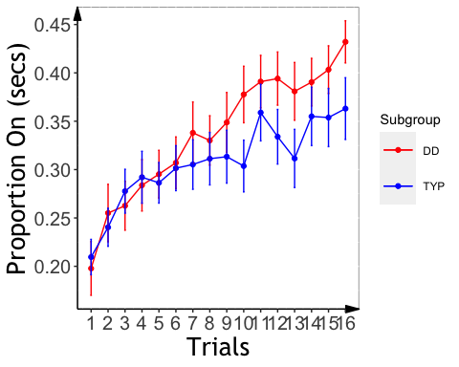

### RP Slope Analysis

#### ANCOVA on individual RP slopes

* Excluded negative slopes (n=5)
* No significant group effect on slope
* Should we control for IQ?

##   
## Call:  
## lm(formula = slopeProp_On ~ Sex + Age + kbit_ss + Subgroup, data = d_rp)  
##   
## Residuals:  
## Min 1Q Median 3Q Max   
## -0.0125922 -0.0045708 0.0000446 0.0043318 0.0214148   
##   
## Coefficients:  
## Estimate Std. Error t value Pr(>|t|)   
## (Intercept) -8.991e-03 1.150e-02 -0.782 0.4387   
## Sex 3.017e-03 2.158e-03 1.398 0.1692   
## Age 3.402e-04 1.882e-04 1.807 0.0777 .  
## kbit_ss 7.887e-05 8.234e-05 0.958 0.3435   
## SubgroupTYP -2.174e-03 2.098e-03 -1.036 0.3059   
## ---  
## Signif. codes: 0 '***' 0.001 '**' 0.01 '*' 0.05 '.' 0.1 ' ' 1  
##   
## Residual standard error: 0.006994 on 43 degrees of freedom  
## Multiple R-squared: 0.1689, Adjusted R-squared: 0.09155   
## F-statistic: 2.184 on 4 and 43 DF, p-value: 0.08681

## $`lsmeans of Subgroup`  
## Subgroup lsmean SE df lower.CL upper.CL  
## DD 0.0132 0.00144 43 0.01029 0.0161  
## TYP 0.0110 0.00151 43 0.00798 0.0141  
##   
## Results are averaged over the levels of: Sex   
## Confidence level used: 0.95   
##   
## $`pairwise differences of Subgroup`  
## 1 estimate SE df t.ratio p.value  
## DD - TYP 0.00217 0.0021 43 1.036 0.3059   
##   
## Results are averaged over the levels of: Sex

#### Plotting RP Slope Effects

## `summarise()` has grouped output by 'PartID'. You can override using the `.groups` argument.

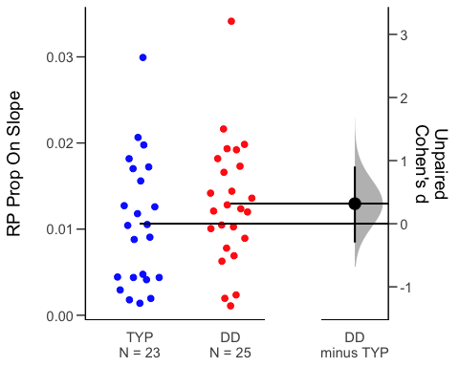

# Mirror Tracing

### Statistical Analysis by Trial

#### Baseline differences on trial one

* No significant group differences on first trial

summary(lm(time~Age+Sex+kbit_ss+Subgroup,data=me_1))

##   
## Call:  
## lm(formula = time ~ Age + Sex + kbit_ss + Subgroup, data = me_1)  
##   
## Residuals:  
## Min 1Q Median 3Q Max   
## -114.54 -39.66 -10.16 18.22 626.00   
##   
## Coefficients:  
## Estimate Std. Error t value Pr(>|t|)   
## (Intercept) -3.28602 147.78880 -0.022 0.9824   
## Age 5.12614 2.61892 1.957 0.0564 .  
## Sex -51.24706 31.00940 -1.653 0.1052   
## kbit_ss 0.01171 1.10010 0.011 0.9916   
## SubgroupTYP -2.50311 30.07316 -0.083 0.9340   
## ---  
## Signif. codes: 0 '***' 0.001 '**' 0.01 '*' 0.05 '.' 0.1 ' ' 1  
##   
## Residual standard error: 101.5 on 46 degrees of freedom  
## (2 observations deleted due to missingness)  
## Multiple R-squared: 0.1054, Adjusted R-squared: 0.02756   
## F-statistic: 1.354 on 4 and 46 DF, p-value: 0.2645

summary(lm(time~Age+Sex+kbit_ss+Subgroup,data=mt_1))

##   
## Call:  
## lm(formula = time ~ Age + Sex + kbit_ss + Subgroup, data = mt_1)  
##   
## Residuals:  
## Min 1Q Median 3Q Max   
## -114.54 -39.66 -10.16 18.22 626.00   
##   
## Coefficients:  
## Estimate Std. Error t value Pr(>|t|)   
## (Intercept) -3.28602 147.78880 -0.022 0.9824   
## Age 5.12614 2.61892 1.957 0.0564 .  
## Sex -51.24706 31.00940 -1.653 0.1052   
## kbit_ss 0.01171 1.10010 0.011 0.9916   
## SubgroupTYP -2.50311 30.07316 -0.083 0.9340   
## ---  
## Signif. codes: 0 '***' 0.001 '**' 0.01 '*' 0.05 '.' 0.1 ' ' 1  
##   
## Residual standard error: 101.5 on 46 degrees of freedom  
## (2 observations deleted due to missingness)  
## Multiple R-squared: 0.1054, Adjusted R-squared: 0.02756   
## F-statistic: 1.354 on 4 and 46 DF, p-value: 0.2645

### Linear mixed modeling

* Filtered out first trial
* Main effect of trial, no significant effect of subgroup on time or error

## MT: Plot Time/Error by Trial

## `summarise()` has grouped output by 'Subgroup'. You can override using the `.groups` argument.  
## `summarise()` has grouped output by 'Subgroup'. You can override using the `.groups` argument.

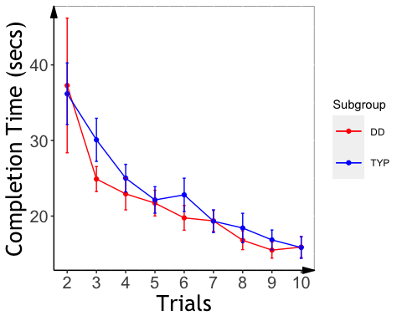

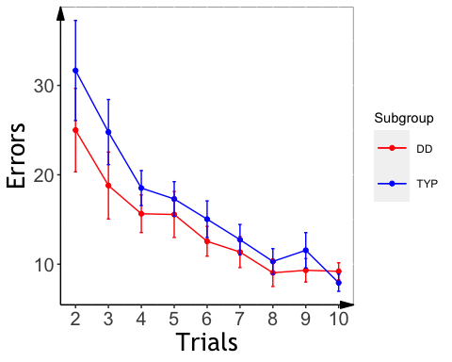

### Mirror Tracing Slopes

## Final Sample

##   
## DD TYP   
## 26 27

##### MT Slope analysis

* A significant group effects for slope, with faster learning for Typ, even after controlling for age, sex, and IQ.
* Removed participants with slopes above zero (opposite learning pattern-N=2)

##   
## Call:  
## lm(formula = slope_mt ~ Age + Sex + kbit_ss + Subgroup, data = d2,   
## na.action = na.exclude)  
##   
## Residuals:  
## Min 1Q Median 3Q Max   
## -2.4333 -1.0219 -0.3748 0.8216 4.2997   
##   
## Coefficients:  
## Estimate Std. Error t value Pr(>|t|)   
## (Intercept) 0.182835 2.672474 0.068 0.9458   
## Age 0.080075 0.045937 1.743 0.0890 .  
## Sex -0.259482 0.524073 -0.495 0.6232   
## kbit_ss -0.004151 0.019496 -0.213 0.8325   
## SubgroupTYP 1.273246 0.509948 2.497 0.0167 *  
## ---  
## Signif. codes: 0 '***' 0.001 '**' 0.01 '*' 0.05 '.' 0.1 ' ' 1  
##   
## Residual standard error: 1.614 on 40 degrees of freedom  
## (8 observations deleted due to missingness)  
## Multiple R-squared: 0.1747, Adjusted R-squared: 0.09216   
## F-statistic: 2.117 on 4 and 40 DF, p-value: 0.09659

## $`lsmeans of Subgroup`  
## Subgroup lsmean SE df lower.CL upper.CL  
## DD 1.42 0.352 40 0.708 2.13  
## TYP 2.69 0.361 40 1.964 3.42  
##   
## Results are averaged over the levels of: Sex   
## Confidence level used: 0.95   
##   
## $`pairwise differences of Subgroup`  
## 1 estimate SE df t.ratio p.value  
## DD - TYP -1.27 0.51 40 -2.497 0.0167   
##   
## Results are averaged over the levels of: Sex

##   
## Call:  
## lm(formula = slope_me ~ Age + Sex + kbit_ss + Subgroup, data = d2,   
## na.action = na.exclude)  
##   
## Residuals:  
## Min 1Q Median 3Q Max   
## -2.6223 -1.2953 -0.6360 0.2702 5.2454   
##   
## Coefficients:  
## Estimate Std. Error t value Pr(>|t|)   
## (Intercept) -2.08422 3.49194 -0.597 0.5540   
## Age 0.10927 0.06002 1.820 0.0762 .  
## Sex -0.54470 0.68477 -0.795 0.4310   
## kbit_ss 0.01256 0.02547 0.493 0.6248   
## SubgroupTYP 1.54459 0.66631 2.318 0.0256 *  
## ---  
## Signif. codes: 0 '***' 0.001 '**' 0.01 '*' 0.05 '.' 0.1 ' ' 1  
##   
## Residual standard error: 2.109 on 40 degrees of freedom  
## (8 observations deleted due to missingness)  
## Multiple R-squared: 0.173, Adjusted R-squared: 0.09026   
## F-statistic: 2.091 on 4 and 40 DF, p-value: 0.09994

## $`lsmeans of Subgroup`  
## Subgroup lsmean SE df lower.CL upper.CL  
## DD 1.33 0.460 40 0.403 2.26  
## TYP 2.88 0.471 40 1.925 3.83  
##   
## Results are averaged over the levels of: Sex   
## Confidence level used: 0.95   
##   
## $`pairwise differences of Subgroup`  
## 1 estimate SE df t.ratio p.value  
## DD - TYP -1.54 0.666 40 -2.318 0.0256   
##   
## Results are averaged over the levels of: Sex

## MT: Plot Slope Effects

## `summarise()` has grouped output by 'PartID'. You can override using the `.groups` argument.

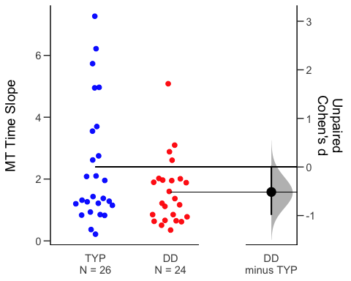

## `summarise()` has grouped output by 'PartID'. You can override using the `.groups` argument.

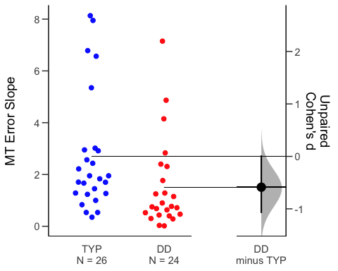

# Statistical Learning

##   
## Dyslexic Typical   
## 17 24

* remove outliers who have hit rate lower than and equal to 0.25 (remaining participant: 14 DD and 18 TYP)
* participants removed from analysis: ABCD_1705 ABCD_1720 ABCD_1747 ABCD_1767 ABCD_1783 ABCD_1788 ABCD_1709 ABCD_1724

# TSL Analysis

### RT by Trial Analysis

* There is no significant group difference in baseline speed for TSL.

##   
## Welch Two Sample t-test  
##   
## data: subj_table_tsl_usable$mean_rt by subj_table_tsl_usable$Subgroup  
## t = 1.5232, df = 25.85, p-value = 0.1399  
## alternative hypothesis: true difference in means is not equal to 0  
## 95 percent confidence interval:  
## -18.3764 123.4250  
## sample estimates:  
## mean in group DD mean in group TYP   
## 408.5518 356.0275

* There is no significant group difference in detection accuracy for TSL

##   
## Welch Two Sample t-test  
##   
## data: dprime by Subgroup  
## t = -1.5595, df = 29.993, p-value = 0.1294  
## alternative hypothesis: true difference in means is not equal to 0  
## 95 percent confidence interval:  
## -0.9410684 0.1261565  
## sample estimates:  
## mean in group DD mean in group TYP   
## 1.152703 1.560159

* No RT effect of group or interaction tested either by lm or lmer

##   
## Call:  
## lm(formula = rt_col ~ Age + Sex + kbit_ss + reindex * Subgroup,   
## data = fam_tsl_age_gender_iq)  
##   
## Residuals:  
## Min 1Q Median 3Q Max   
## -483.18 -207.16 -8.81 217.51 600.62   
##   
## Coefficients:  
## Estimate Std. Error t value Pr(>|t|)   
## (Intercept) 175.51124 116.70783 1.504 0.1330   
## Age 1.32870 1.80792 0.735 0.4626   
## Sex 16.18701 20.03594 0.808 0.4194   
## kbit_ss 1.67834 0.86538 1.939 0.0528 .  
## reindex 0.08553 1.00047 0.085 0.9319   
## SubgroupTYP -63.12174 37.14321 -1.699 0.0896 .  
## reindex:SubgroupTYP -0.21438 1.28027 -0.167 0.8671   
## ---  
## Signif. codes: 0 '***' 0.001 '**' 0.01 '*' 0.05 '.' 0.1 ' ' 1  
##   
## Residual standard error: 265.1 on 906 degrees of freedom  
## (32 observations deleted due to missingness)  
## Multiple R-squared: 0.01514, Adjusted R-squared: 0.008618   
## F-statistic: 2.321 on 6 and 906 DF, p-value: 0.03133

## Linear mixed model fit by REML. t-tests use Satterthwaite's method [  
## lmerModLmerTest]  
## Formula: rt_col ~ Age + Sex + kbit_ss + reindex * Subgroup + (1 + reindex |   
## PartID)  
## Data: fam_tsl_age_gender_iq  
##   
## REML criterion at convergence: 12675.7  
##   
## Scaled residuals:   
## Min 1Q Median 3Q Max   
## -2.0964 -0.7029 -0.1885 0.6753 2.6740   
##   
## Random effects:  
## Groups Name Variance Std.Dev. Corr   
## PartID (Intercept) 15630.83 125.023   
## reindex 15.93 3.991 -0.74  
## Residual 60788.67 246.554   
## Number of obs: 913, groups: PartID, 31  
##   
## Fixed effects:  
## Estimate Std. Error df t value Pr(>|t|)  
## (Intercept) 236.9372 219.1478 30.1461 1.081 0.288  
## Age 0.2308 3.6622 26.2782 0.063 0.950  
## Sex 31.0451 40.6802 26.3896 0.763 0.452  
## kbit_ss 1.1763 1.6688 27.7586 0.705 0.487  
## reindex -0.2028 1.4839 29.7831 -0.137 0.892  
## SubgroupTYP -67.2181 60.8708 31.2198 -1.104 0.278  
## reindex:SubgroupTYP 0.2394 1.9209 28.4274 0.125 0.902  
##   
## Correlation of Fixed Effects:  
## (Intr) Age Sex kbt_ss reindx SbgTYP  
## Age -0.712   
## Sex 0.220 -0.450   
## kbit_ss -0.916 0.534 -0.373   
## reindex -0.158 0.002 0.011 -0.004   
## SubgroupTYP 0.170 -0.195 0.133 -0.341 0.569   
## rndx:SbgTYP 0.130 -0.008 -0.007 -0.004 -0.773 -0.737  
## optimizer (nloptwrap) convergence code: 0 (OK)  
## Model failed to converge with max|grad| = 0.00524202 (tol = 0.002, component 1)

* ANCOVA with covariates (RT slope data) - no group effect

## Df Sum Sq Mean Sq F value Pr(>F)  
## Subgroup 1 2.7 2.71 0.092 0.764  
## Age 1 2.7 2.73 0.093 0.763  
## Sex 1 60.6 60.61 2.065 0.163  
## kbit_ss 1 11.1 11.05 0.377 0.545  
## Residuals 26 763.0 29.35   
## 1 observation deleted due to missingness

#### Plot of TSL RT

* RT as the function of Target repetition

## `summarise()` has grouped output by 'Subgroup'. You can override using the `.groups` argument.

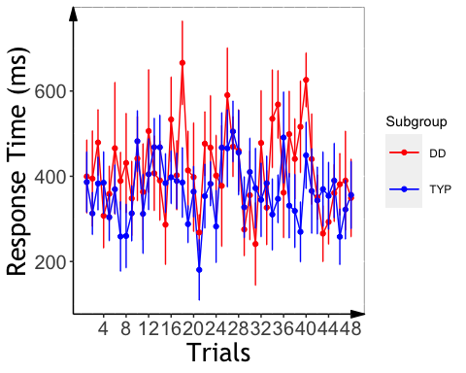

### Plot ASL RT Slope

## `summarise()` has grouped output by 'PartID'. You can override using the `.groups` argument.

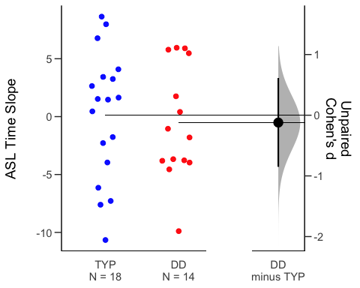

####VSL Slope Analysis

## # A tibble: 2 x 5  
## Subgroup count rt slope d_prime   
## * <chr> <int> <chr> <chr> <chr>   
## 1 DD 17 "475.36 $\\pm$ 70.75" "-2.69 $\\pm$ 4.19" "6.57 $\\pm$ 2.30"  
## 2 TYP 23 "491.24 $\\pm$ 70.15" "-0.53 $\\pm$ 3.02" "7.44 $\\pm$ 1.63"

* There is no significant group difference in baseline speed for VSL.

##   
## Welch Two Sample t-test  
##   
## data: subj_table_vsl$mean_rt by subj_table_vsl$Subgroup  
## t = -0.7043, df = 34.466, p-value = 0.486  
## alternative hypothesis: true difference in means is not equal to 0  
## 95 percent confidence interval:  
## -61.68091 29.91985  
## sample estimates:  
## mean in group DD mean in group TYP   
## 475.3603 491.2408

* There is no significant group difference in target detection accuracy for VSL

##   
## Welch Two Sample t-test  
##   
## data: dprime by Subgroup  
## t = -1.3305, df = 27.27, p-value = 0.1944  
## alternative hypothesis: true difference in means is not equal to 0  
## 95 percent confidence interval:  
## -2.2095266 0.4707495  
## sample estimates:  
## mean in group DD mean in group TYP   
## 6.566801 7.436190

* The DD group had a faster RT acceleration than the TYP group (significant group x trial index interaction tested by lm and marginal interaction tested by lmer)

##   
## Call:  
## lm(formula = rt_col ~ Age + Sex + kbit_ss + reindex * Subgroup,   
## data = fam_vsl_age_gender_iq)  
##   
## Residuals:  
## Min 1Q Median 3Q Max   
## -938.12 -66.98 4.54 65.70 291.75   
##   
## Coefficients:  
## Estimate Std. Error t value Pr(>|t|)   
## (Intercept) 445.5710 43.0471 10.351 < 2e-16 ***  
## Age 1.1948 0.6448 1.853 0.064244 .   
## Sex 36.9579 7.7025 4.798 1.88e-06 ***  
## kbit_ss -0.1520 0.3186 -0.477 0.633401   
## reindex -2.8813 0.8101 -3.557 0.000395 ***  
## SubgroupTYP -11.8199 15.3951 -0.768 0.442830   
## reindex:SubgroupTYP 2.4464 1.0567 2.315 0.020833 *   
## ---  
## Signif. codes: 0 '***' 0.001 '**' 0.01 '*' 0.05 '.' 0.1 ' ' 1  
##   
## Residual standard error: 107.1 on 884 degrees of freedom  
## (46 observations deleted due to missingness)  
## Multiple R-squared: 0.0613, Adjusted R-squared: 0.05493   
## F-statistic: 9.622 on 6 and 884 DF, p-value: 2.842e-10

## Linear mixed model fit by REML. t-tests use Satterthwaite's method [  
## lmerModLmerTest]  
## Formula: rt_col ~ Age + Sex + kbit_ss + reindex * Subgroup + (1 + reindex |   
## PartID)  
## Data: fam_vsl_age_gender_iq  
##   
## REML criterion at convergence: 10524.2  
##   
## Scaled residuals:   
## Min 1Q Median 3Q Max   
## -9.8278 -0.4930 -0.0449 0.4939 4.0270   
##   
## Random effects:  
## Groups Name Variance Std.Dev. Corr  
## PartID (Intercept) 3289.941 57.358   
## reindex 6.739 2.596 0.12  
## Residual 7130.657 84.443   
## Number of obs: 891, groups: PartID, 38  
##   
## Fixed effects:  
## Estimate Std. Error df t value Pr(>|t|)   
## (Intercept) 500.1099 124.8143 32.5935 4.007 0.000335 ***  
## Age 0.1431 1.9229 32.5132 0.074 0.941128   
## Sex 30.2208 22.8003 32.6476 1.325 0.194221   
## kbit_ss -0.3433 0.9479 32.5216 -0.362 0.719592   
## reindex -2.5600 0.9120 36.7614 -2.807 0.007955 **   
## SubgroupTYP -8.1461 24.4311 33.1008 -0.333 0.740912   
## reindex:SubgroupTYP 2.0993 1.1936 36.2279 1.759 0.087049 .   
## ---  
## Signif. codes: 0 '***' 0.001 '**' 0.01 '*' 0.05 '.' 0.1 ' ' 1  
##   
## Correlation of Fixed Effects:  
## (Intr) Age Sex kbt_ss reindx SbgTYP  
## Age -0.619   
## Sex -0.042 -0.269   
## kbit_ss -0.916 0.375 -0.119   
## reindex -0.036 -0.001 0.001 0.001   
## SubgroupTYP 0.293 -0.142 -0.077 -0.393 0.178   
## rndx:SbgTYP 0.028 0.001 -0.002 -0.001 -0.764 -0.231  
## optimizer (nloptwrap) convergence code: 0 (OK)  
## Model failed to converge with max|grad| = 0.00361062 (tol = 0.002, component 1)

* ANCOVA with covariates (from the slope data): marginal group effect.

## Df Sum Sq Mean Sq F value Pr(>F)   
## Subgroup 1 39.9 39.86 3.015 0.0918 .  
## Age 1 25.3 25.33 1.916 0.1756   
## Sex 1 6.6 6.63 0.501 0.4839   
## kbit_ss 1 1.9 1.92 0.145 0.7056   
## Residuals 33 436.3 13.22   
## ---  
## Signif. codes: 0 '***' 0.001 '**' 0.01 '*' 0.05 '.' 0.1 ' ' 1  
## 2 observations deleted due to missingness

####Plot of VSL RT

* RT as the function of Target repetition

## `summarise()` has grouped output by 'Subgroup'. You can override using the `.groups` argument.

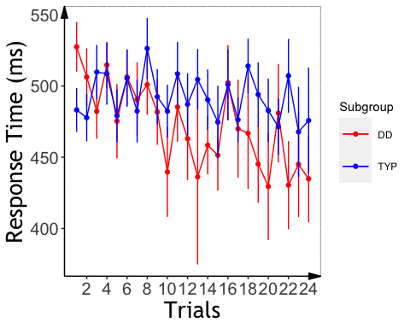 #### plot mean RT slope across the two groups

## `summarise()` has grouped output by 'PartID'. You can override using the `.groups` argument.

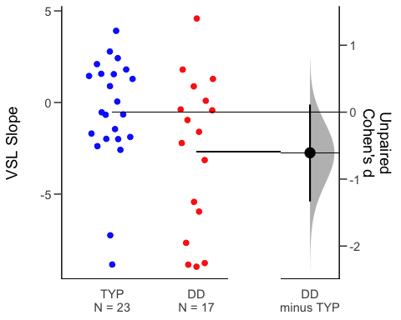

#### Combine slope data of both tasks

#### Using scaled RT, check interactions between task and group.

* both lm and lmer models: task x trial interaction: visual task show faster acceleration across the two groups; task x trial x group interaction (marginal): group difference in slope is greater in VSL than ASL

##   
## Call:  
## lm(formula = rt_col ~ Age + Sex + kbit_ss + task * reindex *   
## Subgroup, data = all_fam_trials_age_gender_iq)  
##   
## Residuals:  
## Min 1Q Median 3Q Max   
## -4.4542 -0.7023 -0.1211 0.6631 3.6851   
##   
## Coefficients:  
## Estimate Std. Error t value Pr(>|t|)   
## (Intercept) 4.557e-02 2.968e-01 0.154 0.8780   
## Age -1.102e-06 4.395e-03 0.000 0.9998   
## Sex -4.429e-05 5.059e-02 -0.001 0.9993   
## kbit_ss 5.097e-05 2.128e-03 0.024 0.9809   
## taskVisual 2.320e-01 1.484e-01 1.563 0.1182   
## reindex -2.087e-03 3.702e-03 -0.564 0.5729   
## SubgroupTYP -6.261e-02 1.349e-01 -0.464 0.6426   
## taskVisual:reindex -2.076e-02 8.290e-03 -2.504 0.0124 *  
## taskVisual:SubgroupTYP -2.185e-01 1.912e-01 -1.142 0.2535   
## reindex:SubgroupTYP 2.555e-03 4.737e-03 0.539 0.5897   
## taskVisual:reindex:SubgroupTYP 2.011e-02 1.077e-02 1.867 0.0621 .  
## ---  
## Signif. codes: 0 '***' 0.001 '**' 0.01 '*' 0.05 '.' 0.1 ' ' 1  
##   
## Residual standard error: 0.981 on 1793 degrees of freedom  
## (78 observations deleted due to missingness)  
## Multiple R-squared: 0.005453, Adjusted R-squared: -9.36e-05   
## F-statistic: 0.9831 on 10 and 1793 DF, p-value: 0.4559

## boundary (singular) fit: see ?isSingular

## Linear mixed model fit by REML. t-tests use Satterthwaite's method [  
## lmerModLmerTest]  
## Formula: rt_col ~ Age + Sex + kbit_ss + task * reindex * Subgroup + (1 +   
## task | PartID) + (task | reindex)  
## Data: all_fam_trials_age_gender_iq  
##   
## REML criterion at convergence: 5113.5  
##   
## Scaled residuals:   
## Min 1Q Median 3Q Max   
## -4.5626 -0.6958 -0.1335 0.6735 3.7730   
##   
## Random effects:  
## Groups Name Variance Std.Dev. Corr   
## reindex (Intercept) 1.764e-02 1.328e-01   
## taskVisual 1.828e-02 1.352e-01 -0.99  
## PartID (Intercept) 9.443e-11 9.717e-06   
## taskVisual 1.382e-10 1.175e-05 -1.00  
## Residual 9.536e-01 9.765e-01   
## Number of obs: 1804, groups: reindex, 48; PartID, 39  
##   
## Fixed effects:  
## Estimate Std. Error df t value  
## (Intercept) 4.373e-02 2.983e-01 1.641e+03 0.147  
## Age 1.056e-04 4.379e-03 1.744e+03 0.024  
## Sex -2.553e-05 5.040e-02 1.744e+03 -0.001  
## kbit_ss 7.455e-05 2.121e-03 1.746e+03 0.035  
## taskVisual 2.285e-01 1.532e-01 1.904e+02 1.492  
## reindex -2.190e-03 3.943e-03 2.027e+02 -0.555  
## SubgroupTYP -6.675e-02 1.345e-01 1.750e+03 -0.496  
## taskVisual:reindex -2.066e-02 8.387e-03 1.833e+02 -2.463  
## taskVisual:SubgroupTYP -2.146e-01 1.905e-01 1.741e+03 -1.126  
## reindex:SubgroupTYP 2.628e-03 4.723e-03 1.752e+03 0.556  
## taskVisual:reindex:SubgroupTYP 2.004e-02 1.073e-02 1.735e+03 1.868  
## Pr(>|t|)   
## (Intercept) 0.8835   
## Age 0.9808   
## Sex 0.9996   
## kbit_ss 0.9720   
## taskVisual 0.1374   
## reindex 0.5792   
## SubgroupTYP 0.6197   
## taskVisual:reindex 0.0147 *  
## taskVisual:SubgroupTYP 0.2602   
## reindex:SubgroupTYP 0.5780   
## taskVisual:reindex:SubgroupTYP 0.0620 .  
## ---  
## Signif. codes: 0 '***' 0.001 '**' 0.01 '*' 0.05 '.' 0.1 ' ' 1  
##   
## Correlation of Fixed Effects:  
## (Intr) Age Sex kbt_ss tskVsl reindx SbgTYP tskVs: tV:STY  
## Age -0.638   
## Sex 0.063 -0.328   
## kbit_ss -0.864 0.479 -0.240   
## taskVisual -0.262 -0.025 0.029 -0.011   
## reindex -0.317 0.006 0.005 -0.011 0.628   
## SubgroupTYP -0.120 -0.091 0.041 -0.172 0.531 0.628   
## tskVsl:rndx 0.155 -0.005 -0.003 -0.001 -0.823 -0.471 -0.294   
## tskVsl:STYP 0.188 0.012 -0.037 0.010 -0.749 -0.442 -0.687 0.630   
## rndx:SbgTYP 0.243 -0.017 -0.006 0.000 -0.459 -0.732 -0.849 0.344 0.600  
## tskVs::STYP -0.112 0.009 0.004 0.005 0.613 0.322 0.373 -0.757 -0.828  
## r:STYP  
## Age   
## Sex   
## kbit_ss   
## taskVisual   
## reindex   
## SubgroupTYP   
## tskVsl:rndx   
## tskVsl:STYP   
## rndx:SbgTYP   
## tskVs::STYP -0.440  
## optimizer (nloptwrap) convergence code: 0 (OK)  
## boundary (singular) fit: see ?isSingular

* ANCOVA for interaction between task and group (no significant interaction)

## Df Sum Sq Mean Sq F value Pr(>F)  
## Subgroup 1 0.00212 0.0021215 1.897 0.174  
## task 1 0.00108 0.0010848 0.970 0.329  
## Age 1 0.00090 0.0008987 0.804 0.374  
## Sex 1 0.00023 0.0002253 0.201 0.655  
## kbit_ss 1 0.00255 0.0025480 2.278 0.137  
## Subgroup:task 1 0.00094 0.0009415 0.842 0.363  
## Residuals 55 0.06151 0.0011183   
## 2 observations deleted due to missingness

## SL Accuracy Analysis

#### Accuracy Data Summary (mean +/- sd)

## `summarise()` has grouped output by 'Subgroup'. You can override using the `.groups` argument.

## # A tibble: 4 x 4  
## # Groups: Subgroup [2]  
## Subgroup task count accuracy   
## <chr> <chr> <int> <chr>   
## 1 DD Auditory 16 "0.55 $\\pm$ 0.09"  
## 2 DD Visual 17 "0.72 $\\pm$ 0.21"  
## 3 TYP Auditory 24 "0.66 $\\pm$ 0.13"  
## 4 TYP Visual 23 "0.67 $\\pm$ 0.23"

#### ASL and VSL Accuracy

* both groups performed above chance for both tasks
* generalized linear effect modeling within each task (both models failed to converge with IQ included, removing IQ from the covariates fix the issues)
* VSL, no group effect

## Generalized linear mixed model fit by maximum likelihood (Laplace  
## Approximation) [glmerMod]  
## Family: binomial ( logit )  
## Formula: corr ~ Age + Sex + Subgroup + (1 | PartID) + (1 | trial)  
## Data: vsl_accuracy_age_gender_iq  
## Control: glmerControl(optimizer = "bobyqa", optCtrl = list(maxfun = 2e+05))  
##   
## AIC BIC logLik deviance df.resid   
## 1343.9 1374.5 -665.9 1331.9 1210   
##   
## Scaled residuals:   
## Min 1Q Median 3Q Max   
## -3.9687 -0.7904 0.3270 0.6714 1.9670   
##   
## Random effects:  
## Groups Name Variance Std.Dev.  
## PartID (Intercept) 1.20093 1.0959   
## trial (Intercept) 0.04604 0.2146   
## Number of obs: 1216, groups: PartID, 38; trial, 32  
##   
## Fixed effects:  
## Estimate Std. Error z value Pr(>|z|)   
## (Intercept) 3.06687 0.91221 3.362 0.000774 ***  
## Age -0.03869 0.03200 -1.209 0.226645   
## Sex -0.71398 0.40798 -1.750 0.080110 .   
## SubgroupTYP -0.14362 0.39522 -0.363 0.716317   
## ---  
## Signif. codes: 0 '***' 0.001 '**' 0.01 '*' 0.05 '.' 0.1 ' ' 1  
##   
## Correlation of Fixed Effects:  
## (Intr) Age Sex   
## Age -0.744   
## Sex -0.394 -0.229   
## SubgroupTYP -0.177 0.013 -0.137

* Significant group effects for ASL (Typ>Dys)

## Generalized linear mixed model fit by maximum likelihood (Laplace  
## Approximation) [glmerMod]  
## Family: binomial ( logit )  
## Formula: corr ~ Age + Sex + Subgroup + (1 | PartID) + (1 | trial)  
## Data: tsl_accuracy_age_gender_iq  
## Control: glmerControl(optimizer = "bobyqa", optCtrl = list(maxfun = 2e+05))  
##   
## AIC BIC logLik deviance df.resid   
## 1602.3 1632.9 -795.2 1590.3 1210   
##   
## Scaled residuals:   
## Min 1Q Median 3Q Max   
## -2.2425 -1.0842 0.6266 0.7942 1.2693   
##   
## Random effects:  
## Groups Name Variance Std.Dev.  
## PartID (Intercept) 0.06019 0.2453   
## trial (Intercept) 0.11888 0.3448   
## Number of obs: 1216, groups: PartID, 38; trial, 32  
##   
## Fixed effects:  
## Estimate Std. Error z value Pr(>|z|)   
## (Intercept) 0.26419 0.34304 0.770 0.44121   
## Age -0.02152 0.01209 -1.781 0.07499 .   
## Sex 0.36839 0.15527 2.373 0.01766 *   
## SubgroupTYP 0.41103 0.14821 2.773 0.00555 **  
## ---  
## Signif. codes: 0 '***' 0.001 '**' 0.01 '*' 0.05 '.' 0.1 ' ' 1  
##   
## Correlation of Fixed Effects:  
## (Intr) Age Sex   
## Age -0.723   
## Sex -0.376 -0.257   
## SubgroupTYP -0.195 -0.007 -0.083

#### Plot VSL Accuracy

## `summarise()` has grouped output by 'PartID'. You can override using the `.groups` argument.

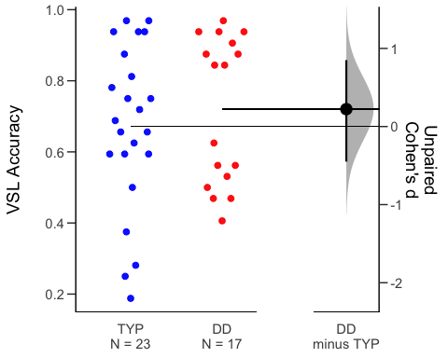 #### Plot ASL Accuracy

## `summarise()` has grouped output by 'PartID'. You can override using the `.groups` argument.

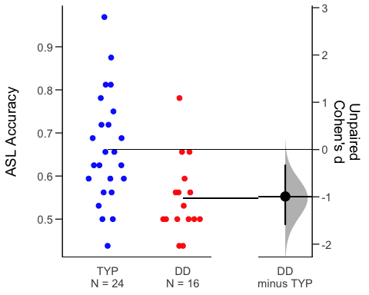

#### Task by Group Interaction

* LME: main effect of task (visual > auditory); main effect of group (TYP > DD);

## Generalized linear mixed model fit by maximum likelihood (Laplace  
## Approximation) [glmerMod]  
## Family: binomial ( logit )  
## Formula: corr ~ task * Subgroup + Age + Sex + (1 + task | PartID) + (1 |   
## trial)  
## Data: all_accuracy_age_gender_iq  
## Control: glmerControl(optimizer = "bobyqa", optCtrl = list(maxfun = 2e+05))  
##   
## AIC BIC logLik deviance df.resid   
## 2956.8 3014.8 -1468.4 2936.8 2422   
##   
## Scaled residuals:   
## Min 1Q Median 3Q Max   
## -4.0109 -1.0438 0.4304 0.7543 1.8858   
##   
## Random effects:  
## Groups Name Variance Std.Dev. Corr   
## PartID (Intercept) 0.05991 0.2448   
## taskVisual 1.59200 1.2617 -0.39  
## trial (Intercept) 0.02892 0.1701   
## Number of obs: 2432, groups: PartID, 39; trial, 32  
##   
## Fixed effects:  
## Estimate Std. Error z value Pr(>|z|)   
## (Intercept) 0.50152 0.32383 1.549 0.12145   
## taskVisual 0.94959 0.35048 2.709 0.00674 **  
## SubgroupTYP 0.41899 0.14725 2.845 0.00444 **  
## Age -0.02335 0.01094 -2.133 0.03290 *   
## Sex 0.21885 0.14832 1.475 0.14008   
## taskVisual:SubgroupTYP -0.69996 0.45836 -1.527 0.12674   
## ---  
## Signif. codes: 0 '***' 0.001 '**' 0.01 '*' 0.05 '.' 0.1 ' ' 1  
##   
## Correlation of Fixed Effects:  
## (Intr) tskVsl SbgTYP Age Sex   
## taskVisual -0.149   
## SubgroupTYP -0.191 0.317   
## Age -0.718 -0.005 -0.016   
## Sex -0.439 0.014 -0.099 -0.201   
## tskVsl:STYP 0.110 -0.762 -0.413 0.009 -0.011

* ANCOVA: marginal effect of task (Visual > Auditory)

## Df Sum Sq Mean Sq F value Pr(>F)   
## task 1 0.0913 0.09128 2.869 0.0950 .  
## Subgroup 1 0.0179 0.01792 0.563 0.4556   
## Age 1 0.0981 0.09812 3.084 0.0837 .  
## Sex 1 0.0022 0.00216 0.068 0.7950   
## kbit_ss 1 0.0009 0.00094 0.030 0.8638   
## task:Subgroup 1 0.0764 0.07639 2.401 0.1260   
## Residuals 67 2.1320 0.03182   
## ---  
## Signif. codes: 0 '***' 0.001 '**' 0.01 '*' 0.05 '.' 0.1 ' ' 1  
## 4 observations deleted due to missingness

#### Plot accuracy by group and task

## # A tibble: 2 x 10  
## task term group1 group2 null.value estimate conf.low conf.high p.adj  
## * <chr> <chr> <chr> <chr> <dbl> <dbl> <dbl> <dbl> <dbl>  
## 1 Audi… Subg… DD TYP 0 0.113 0.0384 0.187 0.00391  
## 2 Visu… Subg… DD TYP 0 -0.0493 -0.193 0.0941 0.491   
## # … with 1 more variable: p.adj.signif <chr>

## Warning: Ignoring unknown parameters: fun.y, fun.ymin, fun.ymax

## No summary function supplied, defaulting to `mean_se()`  
## No summary function supplied, defaulting to `mean_se()`

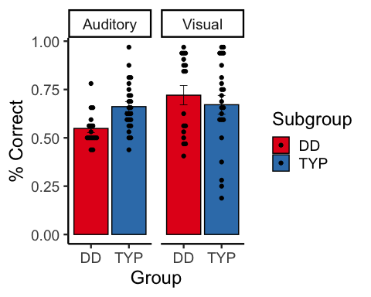

# Cross-task correlations

###Everyone

##   
## Correlation method: 'pearson'  
## Missing treated using: 'pairwise.complete.obs'

## term slope_me slope_mt slopeProp_On vis_slope_scale  
## 1 IQ .07 -.01 -.05 .14  
## 2 WID .29 .23 -.06 .19  
## 3 WA .32 .34 .00 .15  
## 4 Vocabulary .23 .12 .06 .02  
## 5 ORI .31 .19 -.05 .28  
## 6 Elision .30 .19 .05 .12  
## 7 Nonword .13 .03 -.19 -.01  
## 8 RAN_2Set .15 .11 -.25 .23  
## 9 DigitsForward -.00 -.03 -.07 .32  
## 10 DigitsBackward .05 .03 .08 .21  
## aud_slope_scale aud_fam_rt vis_fam_rt  
## 1 .04 .07 -.01  
## 2 .04 -.16 .07  
## 3 .11 -.18 .13  
## 4 -.07 -.15 -.11  
## 5 -.09 -.16 -.03  
## 6 .04 .09 -.33  
## 7 .14 -.25 .07  
## 8 -.39 .24 .07  
## 9 -.09 -.36 -.03  
## 10 .03 .03 -.11

### Dys only

* both the rotary pursuit and ASL accuracy/RT are related to reading
* RP performance is associated with better reading

##   
## Correlation method: 'pearson'  
## Missing treated using: 'pairwise.complete.obs'

## term slope_me slope_mt slopeProp_On vis_slope_scale  
## 1 IQ .07 -.11 .07 -.07  
## 2 WID .11 .16 .58 -.31  
## 3 WA -.01 .08 .61 -.23  
## 4 Vocabulary -.07 -.09 .21 -.15  
## 5 ORI .13 .08 .26 .05  
## 6 Elision .23 .08 .20 -.30  
## 7 Nonword -.08 -.27 -.26 -.01  
## 8 RAN_2Set .12 .27 .08 -.18  
## 9 DigitsForward -.01 -.11 -.07 .52  
## 10 DigitsBackward -.07 .03 .65 -.04  
## 11 aud_fam_rt .27 .39 -.20 -.35  
## 12 vis_fam_rt -.25 .11 .00 .48  
## aud_slope_scale  
## 1 .19  
## 2 -.00  
## 3 -.43  
## 4 -.25  
## 5 -.38  
## 6 .01  
## 7 -.27  
## 8 -.67  
## 9 -.20  
## 10 .19  
## 11 -.24  
## 12 .15

## Warning: Removed 5 rows containing non-finite values (stat_smooth).

## Warning: Removed 5 rows containing missing values (geom_point).

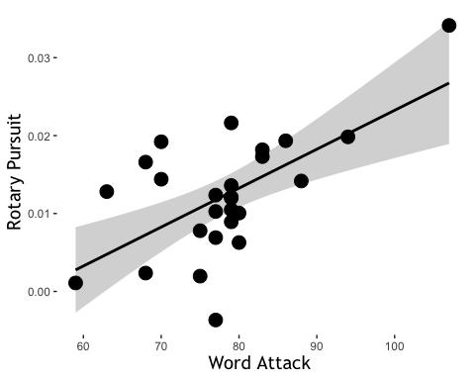

## Warning: Removed 18 rows containing non-finite values (stat_smooth).

## Warning: Removed 18 rows containing missing values (geom_point).

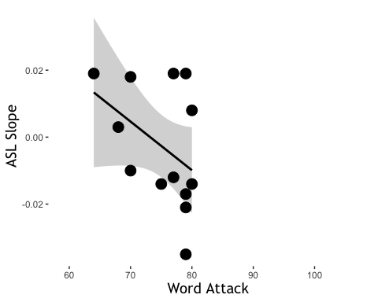

### Typ only

* better VSL is related to worse reading

##   
## Correlation method: 'pearson'  
## Missing treated using: 'pairwise.complete.obs'

## term slope_me slope_mt slopeProp_On vis_slope_scale  
## 1 IQ -.10 -.11 -.01 .15  
## 2 WID .12 .01 -.08 .14  
## 3 WA .29 .36 .16 -.20  
## 4 Vocabulary .30 .08 .17 -.14  
## 5 ORI .23 -.03 .10 .30  
## 6 Elision .21 .12 .12 .26  
## 7 Nonword -.00 -.08 .04 -.30  
## 8 RAN_2Set -.11 -.21 -.29 .37  
## 9 DigitsForward .07 .20 -.22 -.08  
## 10 DigitsBackward -.04 -.10 -.19 .18  
## 11 aud_fam_rt -.36 -.28 -.19 .07  
## 12 vis_fam_rt -.29 -.05 .05 .25  
## aud_slope_scale  
## 1 -.13  
## 2 -.10  
## 3 .24  
## 4 -.08  
## 5 -.05  
## 6 .00  
## 7 .33  
## 8 -.42  
## 9 .30  
## 10 -.11  
## 11 -.04  
## 12 .10