Procedural Learning 110320

Ola Ozernov-Palchik & Zhenghan Qi

03/03/2021

# Sample Size

##   
## Frequency table:  
## Subgroup  
## DD TYP   
## 31 31

# Rotary Pursuit

### RP Statstical Analysis by Trial

#### RP Baseline differences

* There is no significant group difference in baseline speed for RP.

##   
## Welch Two Sample t-test  
##   
## data: d$rotarypursuit_0_2 by d$Subgroup  
## t = -0.060585, df = 45.388, p-value = 0.952  
## alternative hypothesis: true difference in means is not equal to 0  
## 95 percent confidence interval:  
## -4.38929 4.13288  
## sample estimates:  
## mean in group DD mean in group TYP   
## 26.53846 26.66667

#### RP Linear mixed-effect modeling

* model with trial and participant as random effects (controlling for age and sex)
* borderline significant effect trial x subgroup (faster learning in Dys)

## refitting model(s) with ML (instead of REML)

## Data: rp2_age_gender_iq  
## Models:  
## lmerrp1: prop_on ~ Subgroup * trial + background_age + background_sex +   
## lmerrp1: (1 | PartID)  
## lmerrp2: prop_on ~ Subgroup * trial + background_age + background_sex +   
## lmerrp2: (1 + trial | PartID)  
## npar AIC BIC logLik deviance Chisq Df Pr(>Chisq)   
## lmerrp1 8 -1864.4 -1826.5 940.21 -1880.4   
## lmerrp2 10 -2029.4 -1982.1 1024.72 -2049.4 169.02 2 < 2.2e-16 ***  
## ---  
## Signif. codes: 0 '***' 0.001 '**' 0.01 '*' 0.05 '.' 0.1 ' ' 1

## Linear mixed model fit by REML. t-tests use Satterthwaite's method [  
## lmerModLmerTest]  
## Formula: prop_on ~ Subgroup * trial + background_age + background_sex +   
## (1 + trial | PartID)  
## Data: rp2_age_gender_iq  
##   
## REML criterion at convergence: -2001.3  
##   
## Scaled residuals:   
## Min 1Q Median 3Q Max   
## -3.0400 -0.5959 0.0149 0.5949 3.5227   
##   
## Random effects:  
## Groups Name Variance Std.Dev. Corr   
## PartID (Intercept) 1.530e-02 0.123688   
## trial 6.755e-05 0.008219 -0.28  
## Residual 3.527e-03 0.059390   
## Number of obs: 844, groups: PartID, 53  
##   
## Fixed effects:  
## Estimate Std. Error df t value Pr(>|t|)   
## (Intercept) 0.2329960 0.0823771 49.9046011 2.828 0.00672 **   
## SubgroupTYP 0.0105068 0.0354368 49.3633765 0.296 0.76810   
## trial 0.0123732 0.0017347 50.7865899 7.133 3.43e-09 ***  
## background_age -0.0003613 0.0028760 48.9958367 -0.126 0.90053   
## background_sex 0.0040717 0.0350641 48.9954644 0.116 0.90803   
## SubgroupTYP:trial -0.0045152 0.0024286 50.6576559 -1.859 0.06882 .   
## ---  
## Signif. codes: 0 '***' 0.001 '**' 0.01 '*' 0.05 '.' 0.1 ' ' 1  
##   
## Correlation of Fixed Effects:  
## (Intr) SbgTYP trial bckgrnd_g bckgrnd_s  
## SubgroupTYP -0.251   
## trial -0.100 0.232   
## backgrond_g -0.768 0.115 0.000   
## backgrnd_sx -0.317 -0.121 0.000 -0.290   
## SbgrpTYP:tr 0.071 -0.325 -0.714 0.000 0.000

#### RP Plot by trial

## `summarise()` has grouped output by 'Subgroup'. You can override using the `.groups` argument.

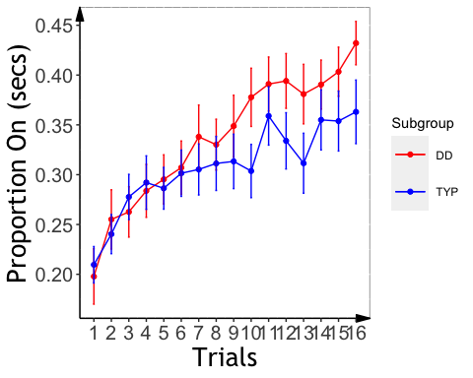

### RP Slope Analysis

#### ANCOVA on individual RP slopes

* Excluded negative slopes (n=5)
* No significant group effect on slope
* Should we control for IQ?

##   
## Call:  
## lm(formula = slopeProp_On ~ background_sex + background_age +   
## kbit_ss + Subgroup, data = d_rp)  
##   
## Residuals:  
## Min 1Q Median 3Q Max   
## -0.0125922 -0.0045708 0.0000446 0.0043318 0.0214148   
##   
## Coefficients:  
## Estimate Std. Error t value Pr(>|t|)   
## (Intercept) -8.991e-03 1.150e-02 -0.782 0.4387   
## background_sex 3.017e-03 2.158e-03 1.398 0.1692   
## background_age 3.402e-04 1.882e-04 1.807 0.0777 .  
## kbit_ss 7.887e-05 8.234e-05 0.958 0.3435   
## SubgroupTYP -2.174e-03 2.098e-03 -1.036 0.3059   
## ---  
## Signif. codes: 0 '***' 0.001 '**' 0.01 '*' 0.05 '.' 0.1 ' ' 1  
##   
## Residual standard error: 0.006994 on 43 degrees of freedom  
## Multiple R-squared: 0.1689, Adjusted R-squared: 0.09155   
## F-statistic: 2.184 on 4 and 43 DF, p-value: 0.08681

## $`lsmeans of Subgroup`  
## Subgroup lsmean SE df lower.CL upper.CL  
## DD 0.0132 0.00144 43 0.01029 0.0161  
## TYP 0.0110 0.00151 43 0.00798 0.0141  
##   
## Results are averaged over the levels of: background_sex   
## Confidence level used: 0.95   
##   
## $`pairwise differences of Subgroup`  
## 1 estimate SE df t.ratio p.value  
## DD - TYP 0.00217 0.0021 43 1.036 0.3059   
##   
## Results are averaged over the levels of: background_sex

#### Plotting RP Slope Effects

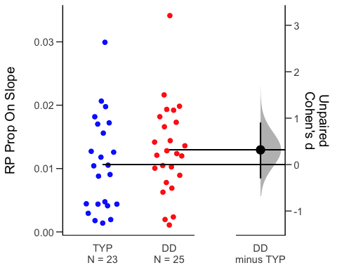

# Mirror Tracing

### Statistical Analysis by Trial

#### Baseline differences on trial one

* No significant group differences on first trial

summary(lm(time~background_age+background_sex+kbit_ss+Subgroup,data=me_1))

##   
## Call:  
## lm(formula = time ~ background_age + background_sex + kbit_ss +   
## Subgroup, data = me_1)  
##   
## Residuals:  
## Min 1Q Median 3Q Max   
## -114.54 -39.66 -10.16 18.22 626.00   
##   
## Coefficients:  
## Estimate Std. Error t value Pr(>|t|)   
## (Intercept) -3.28602 147.78880 -0.022 0.9824   
## background_age 5.12614 2.61892 1.957 0.0564 .  
## background_sex -51.24706 31.00940 -1.653 0.1052   
## kbit_ss 0.01171 1.10010 0.011 0.9916   
## SubgroupTYP -2.50311 30.07316 -0.083 0.9340   
## ---  
## Signif. codes: 0 '***' 0.001 '**' 0.01 '*' 0.05 '.' 0.1 ' ' 1  
##   
## Residual standard error: 101.5 on 46 degrees of freedom  
## (2 observations deleted due to missingness)  
## Multiple R-squared: 0.1054, Adjusted R-squared: 0.02756   
## F-statistic: 1.354 on 4 and 46 DF, p-value: 0.2645

summary(lm(time~background_age+background_sex+kbit_ss+Subgroup,data=mt_1))

##   
## Call:  
## lm(formula = time ~ background_age + background_sex + kbit_ss +   
## Subgroup, data = mt_1)  
##   
## Residuals:  
## Min 1Q Median 3Q Max   
## -114.54 -39.66 -10.16 18.22 626.00   
##   
## Coefficients:  
## Estimate Std. Error t value Pr(>|t|)   
## (Intercept) -3.28602 147.78880 -0.022 0.9824   
## background_age 5.12614 2.61892 1.957 0.0564 .  
## background_sex -51.24706 31.00940 -1.653 0.1052   
## kbit_ss 0.01171 1.10010 0.011 0.9916   
## SubgroupTYP -2.50311 30.07316 -0.083 0.9340   
## ---  
## Signif. codes: 0 '***' 0.001 '**' 0.01 '*' 0.05 '.' 0.1 ' ' 1  
##   
## Residual standard error: 101.5 on 46 degrees of freedom  
## (2 observations deleted due to missingness)  
## Multiple R-squared: 0.1054, Adjusted R-squared: 0.02756   
## F-statistic: 1.354 on 4 and 46 DF, p-value: 0.2645

### Linear mixed modeling

* Filtered out first trial
* Main effect of trial, no significant effect of subgroup on time or error

## MT: Plot Time/Error by Trial

## `summarise()` has grouped output by 'Subgroup'. You can override using the `.groups` argument.  
## `summarise()` has grouped output by 'Subgroup'. You can override using the `.groups` argument.

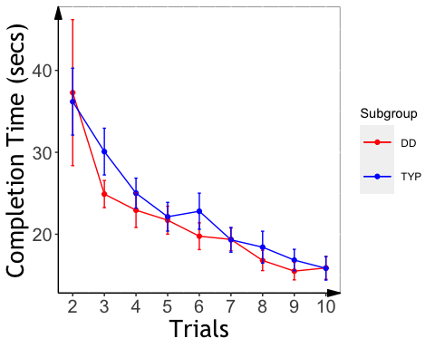

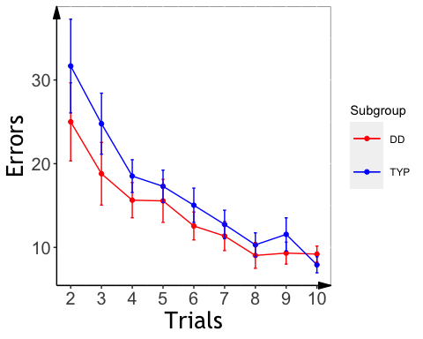

### Mirror Tracing Slopes

## Final Sample

##   
## DD TYP   
## 26 27

##### MR Slope analysis

* A significant group effects for slope, with faster learning for Typ, even after controlling for age, sex, and IQ.
* Removed participants with slopes above zero (opposite learning pattern, N=2)

##   
## Call:  
## lm(formula = slope_mt ~ background_age + background_sex + kbit_ss +   
## Subgroup, data = d2, na.action = na.exclude)  
##   
## Residuals:  
## Min 1Q Median 3Q Max   
## -2.4333 -1.0219 -0.3748 0.8216 4.2997   
##   
## Coefficients:  
## Estimate Std. Error t value Pr(>|t|)   
## (Intercept) 0.182835 2.672474 0.068 0.9458   
## background_age 0.080075 0.045937 1.743 0.0890 .  
## background_sex -0.259482 0.524073 -0.495 0.6232   
## kbit_ss -0.004151 0.019496 -0.213 0.8325   
## SubgroupTYP 1.273246 0.509948 2.497 0.0167 *  
## ---  
## Signif. codes: 0 '***' 0.001 '**' 0.01 '*' 0.05 '.' 0.1 ' ' 1  
##   
## Residual standard error: 1.614 on 40 degrees of freedom  
## (8 observations deleted due to missingness)  
## Multiple R-squared: 0.1747, Adjusted R-squared: 0.09216   
## F-statistic: 2.117 on 4 and 40 DF, p-value: 0.09659

## $`lsmeans of Subgroup`  
## Subgroup lsmean SE df lower.CL upper.CL  
## DD 1.42 0.352 40 0.708 2.13  
## TYP 2.69 0.361 40 1.964 3.42  
##   
## Results are averaged over the levels of: background_sex   
## Confidence level used: 0.95   
##   
## $`pairwise differences of Subgroup`  
## 1 estimate SE df t.ratio p.value  
## DD - TYP -1.27 0.51 40 -2.497 0.0167   
##   
## Results are averaged over the levels of: background_sex

##   
## Call:  
## lm(formula = slope_me ~ background_age + background_sex + kbit_ss +   
## Subgroup, data = d2, na.action = na.exclude)  
##   
## Residuals:  
## Min 1Q Median 3Q Max   
## -2.6223 -1.2953 -0.6360 0.2702 5.2454   
##   
## Coefficients:  
## Estimate Std. Error t value Pr(>|t|)   
## (Intercept) -2.08422 3.49194 -0.597 0.5540   
## background_age 0.10927 0.06002 1.820 0.0762 .  
## background_sex -0.54470 0.68477 -0.795 0.4310   
## kbit_ss 0.01256 0.02547 0.493 0.6248   
## SubgroupTYP 1.54459 0.66631 2.318 0.0256 *  
## ---  
## Signif. codes: 0 '***' 0.001 '**' 0.01 '*' 0.05 '.' 0.1 ' ' 1  
##   
## Residual standard error: 2.109 on 40 degrees of freedom  
## (8 observations deleted due to missingness)  
## Multiple R-squared: 0.173, Adjusted R-squared: 0.09026   
## F-statistic: 2.091 on 4 and 40 DF, p-value: 0.09994

## $`lsmeans of Subgroup`  
## Subgroup lsmean SE df lower.CL upper.CL  
## DD 1.33 0.460 40 0.403 2.26  
## TYP 2.88 0.471 40 1.925 3.83  
##   
## Results are averaged over the levels of: background_sex   
## Confidence level used: 0.95   
##   
## $`pairwise differences of Subgroup`  
## 1 estimate SE df t.ratio p.value  
## DD - TYP -1.54 0.666 40 -2.318 0.0256   
##   
## Results are averaged over the levels of: background_sex

## MT: Plot Slope Effects

## `summarise()` has grouped output by 'PartID'. You can override using the `.groups` argument.

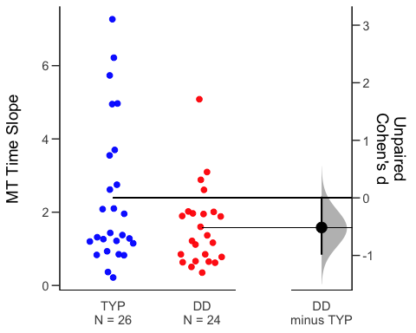

## `summarise()` has grouped output by 'PartID'. You can override using the `.groups` argument.

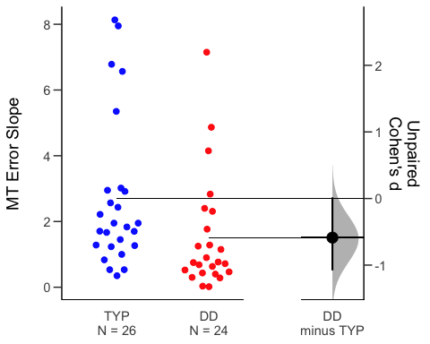

# Statistical Learning

##   
## Dyslexic Typical   
## 17 24

### Slope analyses

###ASL Slope Effects

* Remove outliers who have hit rate lower than and equal to 0.25 (remaining participant: 14 DD and 18 TYP)
* participants removed from analysis: ABCD_1705 ABCD_1720 ABCD_1747 ABCD_1767 ABCD_1783 ABCD_1788 ABCD_1709 ABCD_1724
* the two groups are not different in RT slope.

##   
## Welch Two Sample t-test  
##   
## data: dprime by Subgroup  
## t = -1.5595, df = 29.993, p-value = 0.1294  
## alternative hypothesis: true difference in means is not equal to 0  
## 95 percent confidence interval:  
## -0.9410684 0.1261565  
## sample estimates:  
## mean in group DD mean in group TYP   
## 1.152703 1.560159

##   
## Welch Two Sample t-test  
##   
## data: rt_slope by Subgroup  
## t = -0.34509, df = 29.433, p-value = 0.7325  
## alternative hypothesis: true difference in means is not equal to 0  
## 95 percent confidence interval:  
## -4.428877 3.149384  
## sample estimates:  
## mean in group DD mean in group TYP   
## -0.5178571 0.1218889

##   
## Call:  
## lm(formula = rt_col ~ reindex * Subgroup, data = fam_trial_tsl_usable)  
##   
## Residuals:  
## Min 1Q Median 3Q Max   
## -518.45 -206.05 -9.07 233.37 582.65   
##   
## Coefficients:  
## Estimate Std. Error t value Pr(>|t|)   
## (Intercept) 416.3073 27.5729 15.098 <2e-16 ***  
## reindex 0.1412 0.9726 0.145 0.885   
## SubgroupTYP -53.7814 35.3733 -1.520 0.129   
## reindex:SubgroupTYP -0.2229 1.2596 -0.177 0.860   
## ---  
## Signif. codes: 0 '***' 0.001 '**' 0.01 '*' 0.05 '.' 0.1 ' ' 1  
##   
## Residual standard error: 265.7 on 941 degrees of freedom  
## Multiple R-squared: 0.0118, Adjusted R-squared: 0.008652   
## F-statistic: 3.746 on 3 and 941 DF, p-value: 0.0108

##   
## Call:  
## lm(formula = rt_col ~ reindex * Subgroup, data = fam_trial_tsl_usable_s)  
##   
## Residuals:  
## Min 1Q Median 3Q Max   
## -2.2128 -0.7757 -0.2198 0.7533 3.2618   
##   
## Coefficients:  
## Estimate Std. Error t value Pr(>|t|)  
## (Intercept) 0.054084 0.102180 0.529 0.597  
## reindex -0.002201 0.003604 -0.611 0.541  
## SubgroupTYP -0.065300 0.131087 -0.498 0.619  
## reindex:SubgroupTYP 0.002670 0.004668 0.572 0.568  
##   
## Residual standard error: 0.9848 on 941 degrees of freedom  
## Multiple R-squared: 0.0004228, Adjusted R-squared: -0.002764   
## F-statistic: 0.1327 on 3 and 941 DF, p-value: 0.9406

## Linear mixed model fit by REML. t-tests use Satterthwaite's method [  
## lmerModLmerTest]  
## Formula: rt_col ~ reindex * Subgroup + (1 | PartID) + (0 + reindex | PartID)  
## Data: fam_trial_tsl_usable  
##   
## REML criterion at convergence: 13150  
##   
## Scaled residuals:   
## Min 1Q Median 3Q Max   
## -2.1924 -0.7007 -0.1916 0.6834 2.6746   
##   
## Random effects:  
## Groups Name Variance Std.Dev.  
## PartID (Intercept) 6451.083 80.319   
## PartID.1 reindex 5.044 2.246   
## Residual 62182.155 249.364   
## Number of obs: 945, groups: PartID, 32  
##   
## Fixed effects:  
## Estimate Std. Error df t value Pr(>|t|)   
## (Intercept) 415.7087 33.9537 66.1478 12.243 <2e-16 ***  
## reindex -0.1612 1.1229 63.9070 -0.144 0.886   
## SubgroupTYP -57.8659 44.3241 60.3298 -1.306 0.197   
## reindex:SubgroupTYP 0.1430 1.4589 59.3251 0.098 0.922   
## ---  
## Signif. codes: 0 '***' 0.001 '**' 0.01 '*' 0.05 '.' 0.1 ' ' 1  
##   
## Correlation of Fixed Effects:  
## (Intr) reindx SbgTYP  
## reindex -0.558   
## SubgroupTYP -0.766 0.428   
## rndx:SbgTYP 0.430 -0.770 -0.544  
## optimizer (nloptwrap) convergence code: 0 (OK)  
## Model failed to converge with max|grad| = 0.0173469 (tol = 0.002, component 1)

## boundary (singular) fit: see ?isSingular

## Linear mixed model fit by REML. t-tests use Satterthwaite's method [  
## lmerModLmerTest]  
## Formula: rt_col ~ reindex * Subgroup + (1 | PartID) + (0 + reindex | PartID)  
## Data: fam_trial_tsl_usable_s  
##   
## REML criterion at convergence: 2676.7  
##   
## Scaled residuals:   
## Min 1Q Median 3Q Max   
## -2.2469 -0.7877 -0.2232 0.7649 3.3122   
##   
## Random effects:  
## Groups Name Variance Std.Dev.  
## PartID (Intercept) 0.0000 0.0000   
## PartID.1 reindex 0.0000 0.0000   
## Residual 0.9698 0.9848   
## Number of obs: 945, groups: PartID, 32  
##   
## Fixed effects:  
## Estimate Std. Error df t value Pr(>|t|)  
## (Intercept) 0.054084 0.102180 941.000000 0.529 0.597  
## reindex -0.002201 0.003604 941.000000 -0.611 0.541  
## SubgroupTYP -0.065300 0.131087 941.000000 -0.498 0.619  
## reindex:SubgroupTYP 0.002670 0.004668 941.000000 0.572 0.568  
##   
## Correlation of Fixed Effects:  
## (Intr) reindx SbgTYP  
## reindex -0.867   
## SubgroupTYP -0.779 0.675   
## rndx:SbgTYP 0.669 -0.772 -0.866  
## optimizer (nloptwrap) convergence code: 0 (OK)  
## boundary (singular) fit: see ?isSingular

##   
## Call:  
## lm(formula = rt_col ~ background_age + background_sex + kbit_ss +   
## reindex * Subgroup, data = fam_tsl_age_gender_iq)  
##   
## Residuals:  
## Min 1Q Median 3Q Max   
## -483.18 -207.16 -8.81 217.51 600.62   
##   
## Coefficients:  
## Estimate Std. Error t value Pr(>|t|)   
## (Intercept) 175.51124 116.70783 1.504 0.1330   
## background_age 1.32870 1.80792 0.735 0.4626   
## background_sex 16.18701 20.03594 0.808 0.4194   
## kbit_ss 1.67834 0.86538 1.939 0.0528 .  
## reindex 0.08553 1.00047 0.085 0.9319   
## SubgroupTYP -63.12174 37.14321 -1.699 0.0896 .  
## reindex:SubgroupTYP -0.21438 1.28027 -0.167 0.8671   
## ---  
## Signif. codes: 0 '***' 0.001 '**' 0.01 '*' 0.05 '.' 0.1 ' ' 1  
##   
## Residual standard error: 265.1 on 906 degrees of freedom  
## (32 observations deleted due to missingness)  
## Multiple R-squared: 0.01514, Adjusted R-squared: 0.008618   
## F-statistic: 2.321 on 6 and 906 DF, p-value: 0.03133

##   
## Call:  
## lm(formula = rt_col ~ background_age + background_sex + kbit_ss +   
## reindex * Subgroup, data = fam_tsl_s_age_gender_iq)  
##   
## Residuals:  
## Min 1Q Median 3Q Max   
## -2.2149 -0.7727 -0.2199 0.7497 3.2613   
##   
## Coefficients:  
## Estimate Std. Error t value Pr(>|t|)  
## (Intercept) 5.102e-02 4.344e-01 0.117 0.907  
## background_age -5.547e-05 6.729e-03 -0.008 0.993  
## background_sex -3.716e-04 7.457e-02 -0.005 0.996  
## kbit_ss 1.609e-05 3.221e-03 0.005 0.996  
## reindex -2.087e-03 3.724e-03 -0.561 0.575  
## SubgroupTYP -6.222e-02 1.382e-01 -0.450 0.653  
## reindex:SubgroupTYP 2.556e-03 4.765e-03 0.536 0.592  
##   
## Residual standard error: 0.9865 on 906 degrees of freedom  
## (32 observations deleted due to missingness)  
## Multiple R-squared: 0.0003741, Adjusted R-squared: -0.006246   
## F-statistic: 0.05652 on 6 and 906 DF, p-value: 0.9993

## Linear mixed model fit by REML. t-tests use Satterthwaite's method [  
## lmerModLmerTest]  
## Formula: rt_col ~ background_age + background_sex + kbit_ss + reindex *   
## Subgroup + (1 | PartID) + (0 + reindex | PartID)  
## Data: fam_tsl_age_gender_iq  
##   
## REML criterion at convergence: 12683.8  
##   
## Scaled residuals:   
## Min 1Q Median 3Q Max   
## -2.2228 -0.6973 -0.2007 0.6541 2.6910   
##   
## Random effects:  
## Groups Name Variance Std.Dev.  
## PartID (Intercept) 6791.61 82.411   
## PartID.1 reindex 6.17 2.484   
## Residual 61903.44 248.804   
## Number of obs: 913, groups: PartID, 31  
##   
## Fixed effects:  
## Estimate Std. Error df t value Pr(>|t|)  
## (Intercept) 299.6990 239.7852 24.3563 1.250 0.223  
## background_age -1.3184 4.0392 22.2142 -0.326 0.747  
## background_sex 60.9269 44.9298 22.1813 1.356 0.189  
## kbit_ss 0.5156 1.8428 23.2771 0.280 0.782  
## reindex -0.1513 1.1995 53.1459 -0.126 0.900  
## SubgroupTYP -54.5875 50.9845 39.4488 -1.071 0.291  
## reindex:SubgroupTYP 0.1308 1.5392 49.9564 0.085 0.933  
##   
## Correlation of Fixed Effects:  
## (Intr) bckgrnd_g bckgrnd_s kbt_ss reindx SbgTYP  
## backgrond_g -0.721   
## backgrnd_sx 0.229 -0.454   
## kbit_ss -0.925 0.538 -0.378   
## reindex -0.092 0.015 -0.008 0.012   
## SubgroupTYP 0.316 -0.257 0.169 -0.445 0.362   
## rndx:SbgTYP 0.078 -0.014 0.009 -0.017 -0.779 -0.456

## boundary (singular) fit: see ?isSingular

## Linear mixed model fit by REML. t-tests use Satterthwaite's method [  
## lmerModLmerTest]  
## Formula: rt_col ~ background_age + background_sex + kbit_ss + reindex *   
## Subgroup + (1 | PartID) + (0 + reindex | PartID)  
## Data: fam_tsl_s_age_gender_iq  
##   
## REML criterion at convergence: 2608.6  
##   
## Scaled residuals:   
## Min 1Q Median 3Q Max   
## -2.2452 -0.7833 -0.2229 0.7599 3.3060   
##   
## Random effects:  
## Groups Name Variance Std.Dev.  
## PartID (Intercept) 0.0000 0.0000   
## PartID.1 reindex 0.0000 0.0000   
## Residual 0.9731 0.9865   
## Number of obs: 913, groups: PartID, 31  
##   
## Fixed effects:  
## Estimate Std. Error df t value Pr(>|t|)  
## (Intercept) 5.102e-02 4.344e-01 9.060e+02 0.117 0.907  
## background_age -5.547e-05 6.729e-03 9.060e+02 -0.008 0.993  
## background_sex -3.716e-04 7.457e-02 9.060e+02 -0.005 0.996  
## kbit_ss 1.609e-05 3.221e-03 9.060e+02 0.005 0.996  
## reindex -2.087e-03 3.724e-03 9.060e+02 -0.561 0.575  
## SubgroupTYP -6.222e-02 1.382e-01 9.060e+02 -0.450 0.653  
## reindex:SubgroupTYP 2.556e-03 4.765e-03 9.060e+02 0.536 0.592  
##   
## Correlation of Fixed Effects:  
## (Intr) bckgrnd_g bckgrnd_s kbt_ss reindx SbgTYP  
## backgrond_g -0.735   
## backgrnd_sx 0.208 -0.408   
## kbit_ss -0.913 0.584 -0.373   
## reindex -0.201 0.007 0.009 -0.016   
## SubgroupTYP 0.053 -0.160 0.095 -0.256 0.660   
## rndx:SbgTYP 0.175 -0.023 -0.006 -0.003 -0.781 -0.833  
## optimizer (nloptwrap) convergence code: 0 (OK)  
## boundary (singular) fit: see ?isSingular

Plot of TSL RT

### RT as the function of Target repetition

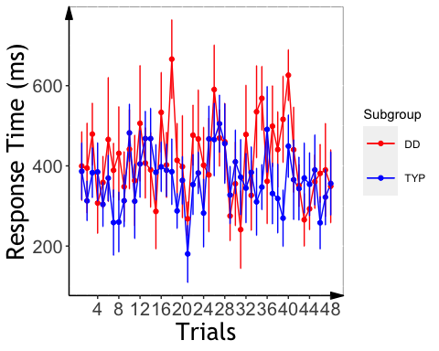 ### plot Scaled RT slope across the two groups * mean RT slope

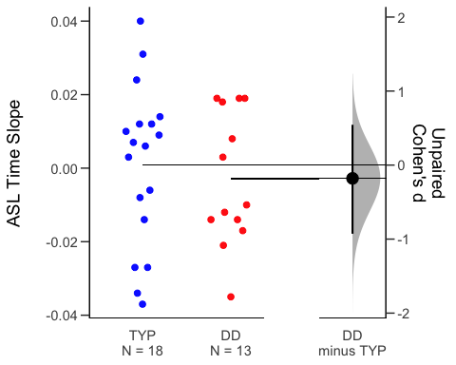

##VSL Slope Analysis

## # A tibble: 2 x 5  
## Subgroup count rt slope d_prime   
## * <chr> <int> <chr> <chr> <chr>   
## 1 DD 17 "475.36 $\\pm$ 70.75" "-2.69 $\\pm$ 4.19" "6.57 $\\pm$ 2.30"  
## 2 TYP 23 "491.24 $\\pm$ 70.15" "-0.53 $\\pm$ 3.02" "7.44 $\\pm$ 1.63"

* The DD group had a faster RT acceleration than the TYP group tested by linear regression models

##   
## Call:  
## lm(formula = rt_col ~ reindex * Subgroup, data = fam_trial_vsl)  
##   
## Residuals:  
## Min 1Q Median 3Q Max   
## -955.47 -61.12 3.55 67.06 312.66   
##   
## Coefficients:  
## Estimate Std. Error t value Pr(>|t|)   
## (Intercept) 509.8174 11.3636 44.864 < 2e-16 ***  
## reindex -3.0266 0.8014 -3.777 0.000169 ***  
## SubgroupTYP -11.3419 14.9059 -0.761 0.446907   
## reindex:SubgroupTYP 2.4915 1.0492 2.375 0.017764 *   
## ---  
## Signif. codes: 0 '***' 0.001 '**' 0.01 '*' 0.05 '.' 0.1 ' ' 1  
##   
## Residual standard error: 109.3 on 933 degrees of freedom  
## Multiple R-squared: 0.02318, Adjusted R-squared: 0.02004   
## F-statistic: 7.381 on 3 and 933 DF, p-value: 6.86e-05

##   
## Call:  
## lm(formula = rt_col ~ reindex * Subgroup, data = fam_trial_vsl_scale)  
##   
## Residuals:  
## Min 1Q Median 3Q Max   
## -4.4363 -0.6037 -0.0520 0.5850 3.6945   
##   
## Coefficients:  
## Estimate Std. Error t value Pr(>|t|)   
## (Intercept) 0.294333 0.101298 2.906 0.00375 **   
## reindex -0.023750 0.007144 -3.325 0.00092 ***  
## SubgroupTYP -0.273308 0.132874 -2.057 0.03997 *   
## reindex:SubgroupTYP 0.022062 0.009353 2.359 0.01853 *   
## ---  
## Signif. codes: 0 '***' 0.001 '**' 0.01 '*' 0.05 '.' 0.1 ' ' 1  
##   
## Residual standard error: 0.9747 on 933 degrees of freedom  
## Multiple R-squared: 0.01179, Adjusted R-squared: 0.008613   
## F-statistic: 3.711 on 3 and 933 DF, p-value: 0.01134

##   
## Call:  
## lm(formula = rt_col ~ background_age + background_sex + kbit_ss +   
## reindex * Subgroup, data = fam_vsl_age_gender_iq)  
##   
## Residuals:  
## Min 1Q Median 3Q Max   
## -938.12 -66.98 4.54 65.70 291.75   
##   
## Coefficients:  
## Estimate Std. Error t value Pr(>|t|)   
## (Intercept) 445.5710 43.0471 10.351 < 2e-16 ***  
## background_age 1.1948 0.6448 1.853 0.064244 .   
## background_sex 36.9579 7.7025 4.798 1.88e-06 ***  
## kbit_ss -0.1520 0.3186 -0.477 0.633401   
## reindex -2.8813 0.8101 -3.557 0.000395 ***  
## SubgroupTYP -11.8199 15.3951 -0.768 0.442830   
## reindex:SubgroupTYP 2.4464 1.0567 2.315 0.020833 *   
## ---  
## Signif. codes: 0 '***' 0.001 '**' 0.01 '*' 0.05 '.' 0.1 ' ' 1  
##   
## Residual standard error: 107.1 on 884 degrees of freedom  
## (46 observations deleted due to missingness)  
## Multiple R-squared: 0.0613, Adjusted R-squared: 0.05493   
## F-statistic: 9.622 on 6 and 884 DF, p-value: 2.842e-10

##   
## Call:  
## lm(formula = rt_col ~ background_age + background_sex + kbit_ss +   
## reindex * Subgroup, data = fam_vsl_s_age_gender_iq)  
##   
## Residuals:  
## Min 1Q Median 3Q Max   
## -4.4541 -0.5945 -0.0604 0.5945 3.6852   
##   
## Coefficients:  
## Estimate Std. Error t value Pr(>|t|)   
## (Intercept) 2.724e-01 3.926e-01 0.694 0.48799   
## background_age 3.594e-05 5.882e-03 0.006 0.99513   
## background_sex 5.209e-04 7.025e-02 0.007 0.99409   
## kbit_ss 8.401e-05 2.906e-03 0.029 0.97694   
## reindex -2.285e-02 7.388e-03 -3.093 0.00205 **  
## SubgroupTYP -2.815e-01 1.404e-01 -2.005 0.04528 *   
## reindex:SubgroupTYP 2.267e-02 9.638e-03 2.352 0.01889 *   
## ---  
## Signif. codes: 0 '***' 0.001 '**' 0.01 '*' 0.05 '.' 0.1 ' ' 1  
##   
## Residual standard error: 0.977 on 884 degrees of freedom  
## (46 observations deleted due to missingness)  
## Multiple R-squared: 0.01071, Adjusted R-squared: 0.003991   
## F-statistic: 1.594 on 6 and 884 DF, p-value: 0.1456

* marginal results with the raw RT data and significant results (same as linear regression) with the scaled data tested by lmer.

## Linear mixed model fit by REML. t-tests use Satterthwaite's method [  
## lmerModLmerTest]  
## Formula: rt_col ~ Subgroup * reindex + (1 | PartID) + (0 + reindex | PartID)  
## Data: fam_trial_vsl  
##   
## REML criterion at convergence: 11110.8  
##   
## Scaled residuals:   
## Min 1Q Median 3Q Max   
## -9.7061 -0.4878 -0.0532 0.5078 3.9472   
##   
## Random effects:  
## Groups Name Variance Std.Dev.  
## PartID (Intercept) 3229.342 56.827   
## PartID.1 reindex 7.157 2.675   
## Residual 7345.975 85.709   
## Number of obs: 937, groups: PartID, 40  
##   
## Fixed effects:  
## Estimate Std. Error df t value Pr(>|t|)   
## (Intercept) 509.3485 16.4185 46.2616 31.023 < 2e-16 ***  
## SubgroupTYP -11.2609 21.6142 45.9442 -0.521 0.60487   
## reindex -2.7352 0.9047 46.3653 -3.023 0.00406 **   
## SubgroupTYP:reindex 2.1924 1.1882 45.7058 1.845 0.07150 .   
## ---  
## Signif. codes: 0 '***' 0.001 '**' 0.01 '*' 0.05 '.' 0.1 ' ' 1  
##   
## Correlation of Fixed Effects:  
## (Intr) SbgTYP reindx  
## SubgroupTYP -0.760   
## reindex -0.331 0.251   
## SbgrpTYP:rn 0.252 -0.328 -0.761

## boundary (singular) fit: see ?isSingular

## Linear mixed model fit by REML. t-tests use Satterthwaite's method [  
## lmerModLmerTest]  
## Formula: rt_col ~ Subgroup * reindex + (1 | PartID) + (0 + reindex | PartID)  
## Data: fam_trial_vsl_scale  
##   
## REML criterion at convergence: 2632.2  
##   
## Scaled residuals:   
## Min 1Q Median 3Q Max   
## -4.5513 -0.6194 -0.0533 0.6002 3.7903   
##   
## Random effects:  
## Groups Name Variance Std.Dev.  
## PartID (Intercept) 0.0000 0.0000   
## PartID.1 reindex 0.0000 0.0000   
## Residual 0.9501 0.9747   
## Number of obs: 937, groups: PartID, 40  
##   
## Fixed effects:  
## Estimate Std. Error df t value Pr(>|t|)   
## (Intercept) 0.294333 0.101298 933.000000 2.906 0.00375 **   
## SubgroupTYP -0.273308 0.132874 933.000000 -2.057 0.03997 *   
## reindex -0.023750 0.007144 933.000000 -3.325 0.00092 ***  
## SubgroupTYP:reindex 0.022062 0.009353 933.000000 2.359 0.01853 *   
## ---  
## Signif. codes: 0 '***' 0.001 '**' 0.01 '*' 0.05 '.' 0.1 ' ' 1  
##   
## Correlation of Fixed Effects:  
## (Intr) SbgTYP reindx  
## SubgroupTYP -0.762   
## reindex -0.874 0.666   
## SbgrpTYP:rn 0.668 -0.874 -0.764  
## optimizer (nloptwrap) convergence code: 0 (OK)

## Linear mixed model fit by REML. t-tests use Satterthwaite's method [  
## lmerModLmerTest]  
## Formula: rt_col ~ background_age + background_sex + kbit_ss + reindex *   
## Subgroup + (1 | PartID) + (0 + reindex | PartID)  
## Data: fam_vsl_age_gender_iq  
##   
## REML criterion at convergence: 10524.4  
##   
## Scaled residuals:   
## Min 1Q Median 3Q Max   
## -9.8391 -0.4910 -0.0531 0.4867 4.0250   
##   
## Random effects:  
## Groups Name Variance Std.Dev.  
## PartID (Intercept) 3465.858 58.872   
## PartID.1 reindex 7.232 2.689   
## Residual 7120.289 84.382   
## Number of obs: 891, groups: PartID, 38  
##   
## Fixed effects:  
## Estimate Std. Error df t value Pr(>|t|)   
## (Intercept) 492.5827 124.9417 32.7758 3.942 0.000399 ***  
## background_age 0.2945 1.9243 32.6571 0.153 0.879318   
## background_sex 31.0979 22.8135 32.7726 1.363 0.182131   
## kbit_ss -0.3182 0.9486 32.6604 -0.335 0.739440   
## reindex -2.5634 0.9286 43.1953 -2.761 0.008434 **   
## SubgroupTYP -8.6299 24.8179 38.3066 -0.348 0.729948   
## reindex:SubgroupTYP 2.1042 1.2153 42.5741 1.731 0.090621 .   
## ---  
## Signif. codes: 0 '***' 0.001 '**' 0.01 '*' 0.05 '.' 0.1 ' ' 1  
##   
## Correlation of Fixed Effects:  
## (Intr) bckgrnd_g bckgrnd_s kbt_ss reindx SbgTYP  
## backgrond_g -0.619   
## backgrnd_sx -0.041 -0.268   
## kbit_ss -0.916 0.375 -0.119   
## reindex -0.044 0.000 0.001 0.000   
## SubgroupTYP 0.285 -0.140 -0.076 -0.387 0.220   
## rndx:SbgTYP 0.034 0.001 -0.001 -0.001 -0.764 -0.286

## boundary (singular) fit: see ?isSingular

## Linear mixed model fit by REML. t-tests use Satterthwaite's method [  
## lmerModLmerTest]  
## Formula: rt_col ~ background_age + background_sex + kbit_ss + reindex *   
## Subgroup + (1 | PartID) + (0 + reindex | PartID)  
## Data: fam_vsl_s_age_gender_iq  
##   
## REML criterion at convergence: 2527  
##   
## Scaled residuals:   
## Min 1Q Median 3Q Max   
## -4.5588 -0.6085 -0.0618 0.6085 3.7718   
##   
## Random effects:  
## Groups Name Variance Std.Dev.  
## PartID (Intercept) 0.0000 0.000   
## PartID.1 reindex 0.0000 0.000   
## Residual 0.9546 0.977   
## Number of obs: 891, groups: PartID, 38  
##   
## Fixed effects:  
## Estimate Std. Error df t value Pr(>|t|)   
## (Intercept) 2.724e-01 3.926e-01 8.840e+02 0.694 0.48799   
## background_age 3.594e-05 5.882e-03 8.840e+02 0.006 0.99513   
## background_sex 5.209e-04 7.025e-02 8.840e+02 0.007 0.99409   
## kbit_ss 8.401e-05 2.906e-03 8.840e+02 0.029 0.97694   
## reindex -2.285e-02 7.388e-03 8.840e+02 -3.093 0.00205 **  
## SubgroupTYP -2.815e-01 1.404e-01 8.840e+02 -2.005 0.04528 *   
## reindex:SubgroupTYP 2.267e-02 9.638e-03 8.840e+02 2.352 0.01889 *   
## ---  
## Signif. codes: 0 '***' 0.001 '**' 0.01 '*' 0.05 '.' 0.1 ' ' 1  
##   
## Correlation of Fixed Effects:  
## (Intr) bckgrnd_g bckgrnd_s kbt_ss reindx SbgTYP  
## backgrond_g -0.599   
## backgrnd_sx -0.046 -0.271   
## kbit_ss -0.892 0.373 -0.112   
## reindex -0.224 -0.002 -0.002 -0.009   
## SubgroupTYP 0.007 -0.076 -0.046 -0.214 0.653   
## rndx:SbgTYP 0.170 0.002 0.004 0.009 -0.767 -0.854  
## optimizer (nloptwrap) convergence code: 0 (OK)  
## boundary (singular) fit: see ?isSingular

##Plot of VSL RT ### RT as the function of Target repetition

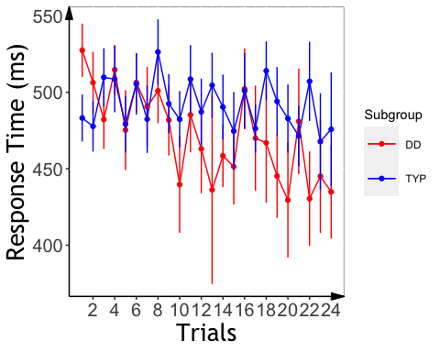 ### plot mean RT slope across the two groups * mean RT slope

## `summarise()` has grouped output by 'PartID'. You can override using the `.groups` argument.

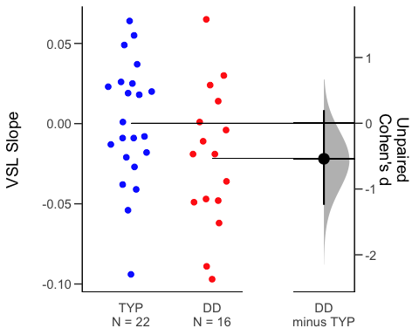

## Combine slope data of both tasks

### check interactions between task and group, using scaled RT: No interaction; anova showed marginal main effect of group (TYP is slower)

##   
## Call:  
## lm(formula = rt_slope_scale ~ task * Subgroup + mean_rt, data = all_subj_slope_complete)  
##   
## Residuals:  
## Min 1Q Median 3Q Max   
## -0.084888 -0.018087 0.002829 0.023143 0.085576   
##   
## Coefficients:  
## Estimate Std. Error t value Pr(>|t|)   
## (Intercept) -3.426e-02 2.233e-02 -1.534 0.1303   
## taskVisual -2.312e-02 1.256e-02 -1.842 0.0705 .  
## SubgroupTYP 7.790e-03 1.194e-02 0.652 0.5167   
## mean_rt 7.670e-05 5.031e-05 1.525 0.1327   
## taskVisual:SubgroupTYP 1.098e-02 1.684e-02 0.652 0.5171   
## ---  
## Signif. codes: 0 '***' 0.001 '**' 0.01 '*' 0.05 '.' 0.1 ' ' 1  
##   
## Residual standard error: 0.03268 on 59 degrees of freedom  
## Multiple R-squared: 0.1048, Adjusted R-squared: 0.04408   
## F-statistic: 1.726 on 4 and 59 DF, p-value: 0.1563

## boundary (singular) fit: see ?isSingular

## Linear mixed model fit by REML. t-tests use Satterthwaite's method [  
## lmerModLmerTest]  
## Formula: rt_col ~ task * Subgroup + (1 + task | PartID) + (1 | reindex)  
## Data: all_fam_trials  
##   
## REML criterion at convergence: 5283.5  
##   
## Scaled residuals:   
## Min 1Q Median 3Q Max   
## -4.5299 -0.7082 -0.1188 0.6724 3.7965   
##   
## Random effects:  
## Groups Name Variance Std.Dev. Corr  
## reindex (Intercept) 5.895e-03 7.678e-02   
## PartID (Intercept) 0.000e+00 0.000e+00   
## taskVisual 5.853e-13 7.650e-07 NaN  
## Residual 9.581e-01 9.788e-01   
## Number of obs: 1882, groups: reindex, 48; PartID, 41  
##   
## Fixed effects:  
## Estimate Std. Error df t value Pr(>|t|)  
## (Intercept) -1.602e-04 5.193e-02 6.381e+02 -0.003 0.998  
## taskVisual 2.496e-03 7.160e-02 1.508e+03 0.035 0.972  
## SubgroupTYP 3.455e-04 6.520e-02 1.859e+03 0.005 0.996  
## taskVisual:SubgroupTYP -1.683e-04 9.195e-02 1.849e+03 -0.002 0.999  
##   
## Correlation of Fixed Effects:  
## (Intr) tskVsl SbgTYP  
## taskVisual -0.692   
## SubgroupTYP -0.760 0.552   
## tskVsl:STYP 0.539 -0.763 -0.709  
## optimizer (nloptwrap) convergence code: 0 (OK)  
## boundary (singular) fit: see ?isSingular

##   
## Call:  
## lm(formula = rt_slope_scale ~ background_age + background_sex +   
## kbit_ss + task * Subgroup + mean_rt, data = all_subj_slope_age_gender_iq)  
##   
## Residuals:  
## Min 1Q Median 3Q Max   
## -0.06804 -0.02260 -0.00308 0.01917 0.09184   
##   
## Coefficients:  
## Estimate Std. Error t value Pr(>|t|)   
## (Intercept) -1.082e-01 5.364e-02 -2.017 0.0487 *  
## background_age 1.360e-03 9.076e-04 1.498 0.1399   
## background_sex -1.265e-02 1.012e-02 -1.249 0.2169   
## kbit_ss 5.631e-04 3.996e-04 1.409 0.1646   
## taskVisual -2.339e-02 1.335e-02 -1.752 0.0855 .  
## SubgroupTYP -4.981e-04 1.346e-02 -0.037 0.9706   
## mean_rt 7.895e-05 5.425e-05 1.455 0.1514   
## taskVisual:SubgroupTYP 1.073e-02 1.732e-02 0.619 0.5384   
## ---  
## Signif. codes: 0 '***' 0.001 '**' 0.01 '*' 0.05 '.' 0.1 ' ' 1  
##   
## Residual standard error: 0.03311 on 54 degrees of freedom  
## (2 observations deleted due to missingness)  
## Multiple R-squared: 0.1463, Adjusted R-squared: 0.0356   
## F-statistic: 1.322 on 7 and 54 DF, p-value: 0.2581

## boundary (singular) fit: see ?isSingular

## Linear mixed model fit by REML. t-tests use Satterthwaite's method [  
## lmerModLmerTest]  
## Formula: rt_col ~ task * Subgroup + (1 + task | PartID) + (1 | reindex)  
## Data: all_fam_trials  
##   
## REML criterion at convergence: 5283.5  
##   
## Scaled residuals:   
## Min 1Q Median 3Q Max   
## -4.5299 -0.7082 -0.1188 0.6724 3.7965   
##   
## Random effects:  
## Groups Name Variance Std.Dev. Corr  
## reindex (Intercept) 5.895e-03 7.678e-02   
## PartID (Intercept) 0.000e+00 0.000e+00   
## taskVisual 5.853e-13 7.650e-07 NaN  
## Residual 9.581e-01 9.788e-01   
## Number of obs: 1882, groups: reindex, 48; PartID, 41  
##   
## Fixed effects:  
## Estimate Std. Error df t value Pr(>|t|)  
## (Intercept) -1.602e-04 5.193e-02 6.381e+02 -0.003 0.998  
## taskVisual 2.496e-03 7.160e-02 1.508e+03 0.035 0.972  
## SubgroupTYP 3.455e-04 6.520e-02 1.859e+03 0.005 0.996  
## taskVisual:SubgroupTYP -1.683e-04 9.195e-02 1.849e+03 -0.002 0.999  
##   
## Correlation of Fixed Effects:  
## (Intr) tskVsl SbgTYP  
## taskVisual -0.692   
## SubgroupTYP -0.760 0.552   
## tskVsl:STYP 0.539 -0.763 -0.709  
## optimizer (nloptwrap) convergence code: 0 (OK)  
## boundary (singular) fit: see ?isSingular

### Mean RT sanity check

No significant differences in RT for either task.

## Analysis of Variance Table  
##   
## Response: aud_fam_rt  
## Df Sum Sq Mean Sq F value Pr(>F)  
## background_age 1 0 0.0 0.0000 0.9984  
## background_sex 1 14523 14523.4 1.5980 0.2174  
## kbit_ss 1 0 0.1 0.0000 0.9969  
## Subgroup 1 19719 19719.1 2.1696 0.1528  
## Residuals 26 236306 9088.7

## Analysis of Variance Table  
##   
## Response: vis_fam_rt  
## Df Sum Sq Mean Sq F value Pr(>F)  
## background_age 1 6080 6079.7 1.1953 0.2822  
## background_sex 1 12178 12178.2 2.3943 0.1313  
## kbit_ss 1 28 27.9 0.0055 0.9414  
## Subgroup 1 1664 1663.5 0.3271 0.5713  
## Residuals 33 167848 5086.3

# SL accuracy analysis

## Accuracy Data Summary (mean +/- sd)

## `summarise()` has grouped output by 'Subgroup'. You can override using the `.groups` argument.

## # A tibble: 4 x 4  
## # Groups: Subgroup [2]  
## Subgroup task count accuracy   
## <chr> <chr> <int> <chr>   
## 1 DD Auditory 16 "0.55 $\\pm$ 0.09"  
## 2 DD Visual 17 "0.72 $\\pm$ 0.21"  
## 3 TYP Auditory 24 "0.66 $\\pm$ 0.13"  
## 4 TYP Visual 23 "0.67 $\\pm$ 0.23"

##Look into group performance between Dyl and Typ ### simple t test: both groups performed above chance for both tasks

##   
## One Sample t-test  
##   
## data: DD_acc_vsl$subj_corr  
## t = 4.3948, df = 16, p-value = 0.0002261  
## alternative hypothesis: true mean is greater than 0.5  
## 95 percent confidence interval:  
## 0.6329919 Inf  
## sample estimates:  
## mean of x   
## 0.7206471

##   
## One Sample t-test  
##   
## data: DD_acc_tsl$subj_corr  
## t = 2.1928, df = 15, p-value = 0.02225  
## alternative hypothesis: true mean is greater than 0.5  
## 95 percent confidence interval:  
## 0.5097758 Inf  
## sample estimates:  
## mean of x   
## 0.54875

##   
## One Sample t-test  
##   
## data: TYP_acc_vsl$subj_corr  
## t = 3.5474, df = 22, p-value = 0.0009032  
## alternative hypothesis: true mean is greater than 0.5  
## 95 percent confidence interval:  
## 0.5883823 Inf  
## sample estimates:  
## mean of x   
## 0.6713043

##   
## One Sample t-test  
##   
## data: TYP_acc_tsl$subj_corr  
## t = 6.2175, df = 23, p-value = 1.208e-06  
## alternative hypothesis: true mean is greater than 0.5  
## 95 percent confidence interval:  
## 0.616952 Inf  
## sample estimates:  
## mean of x   
## 0.6614583

### anova: marginal main effect of task and marginal interaction between task and group

##   
## Error: PartID  
## Df Sum Sq Mean Sq F value Pr(>F)  
## Subgroup 1 0.0222 0.02218 0.754 0.391  
## Residuals 37 1.0889 0.02943   
##   
## Error: PartID:task  
## Df Sum Sq Mean Sq F value Pr(>F)   
## task 1 0.1086 0.10864 3.221 0.0809 .  
## task:Subgroup 1 0.1088 0.10877 3.225 0.0807 .  
## Residuals 37 1.2480 0.03373   
## ---  
## Signif. codes: 0 '***' 0.001 '**' 0.01 '*' 0.05 '.' 0.1 ' ' 1

### generalized linear effect modeling: main effect of task (visual > auditory); main effect of group (TYP > DD); marginal interaction between task and group

## Generalized linear mixed model fit by maximum likelihood (Laplace  
## Approximation) [glmerMod]  
## Family: binomial ( logit )  
## Formula: corr ~ task * Subgroup + (1 + task | PartID) + (1 | trial)  
## Data: all_accuracy  
##   
## AIC BIC logLik deviance df.resid   
## 3091.9 3138.6 -1537.9 3075.9 2552   
##   
## Scaled residuals:   
## Min 1Q Median 3Q Max   
## -3.8869 -1.0408 0.4311 0.7491 1.8645   
##   
## Random effects:  
## Groups Name Variance Std.Dev. Corr   
## PartID (Intercept) 0.10879 0.3298   
## taskVisual 1.54473 1.2429 -0.38  
## trial (Intercept) 0.02172 0.1474   
## Number of obs: 2560, groups: PartID, 41; trial, 32  
##   
## Fixed effects:  
## Estimate Std. Error z value Pr(>|z|)   
## (Intercept) 0.2007 0.1248 1.608 0.10786   
## taskVisual 1.0186 0.3366 3.026 0.00248 **  
## SubgroupTYP 0.4928 0.1597 3.086 0.00203 **  
## taskVisual:SubgroupTYP -0.7948 0.4412 -1.801 0.07166 .   
## ---  
## Signif. codes: 0 '***' 0.001 '**' 0.01 '*' 0.05 '.' 0.1 ' ' 1  
##   
## Correlation of Fixed Effects:  
## (Intr) tskVsl SbgTYP  
## taskVisual -0.418   
## SubgroupTYP -0.746 0.327   
## tskVsl:STYP 0.319 -0.760 -0.427

### generalized linear effect modeling within each task

## Generalized linear mixed model fit by maximum likelihood (Laplace  
## Approximation) [glmerMod]  
## Family: binomial ( logit )  
## Formula: corr ~ Subgroup + (1 | PartID) + (1 | trial)  
## Data: vsl_accuracy  
##   
## AIC BIC logLik deviance df.resid   
## 1403.8 1424.5 -697.9 1395.8 1276   
##   
## Scaled residuals:   
## Min 1Q Median 3Q Max   
## -3.7675 -0.7647 0.3292 0.6507 1.9013   
##   
## Random effects:  
## Groups Name Variance Std.Dev.  
## PartID (Intercept) 1.35302 1.1632   
## trial (Intercept) 0.03695 0.1922   
## Number of obs: 1280, groups: PartID, 40; trial, 32  
##   
## Fixed effects:  
## Estimate Std. Error z value Pr(>|z|)   
## (Intercept) 1.2235 0.3079 3.974 7.07e-05 ***  
## SubgroupTYP -0.3011 0.4011 -0.751 0.453   
## ---  
## Signif. codes: 0 '***' 0.001 '**' 0.01 '*' 0.05 '.' 0.1 ' ' 1  
##   
## Correlation of Fixed Effects:  
## (Intr)  
## SubgroupTYP -0.754

## Generalized linear mixed model fit by maximum likelihood (Laplace  
## Approximation) [glmerMod]  
## Family: binomial ( logit )  
## Formula: corr ~ Subgroup + (1 | PartID) + (1 | trial)  
## Data: tsl_accuracy  
##   
## AIC BIC logLik deviance df.resid   
## 1678.4 1699.0 -835.2 1670.4 1276   
##   
## Scaled residuals:   
## Min 1Q Median 3Q Max   
## -2.0581 -1.0900 0.6127 0.7869 1.2218   
##   
## Random effects:  
## Groups Name Variance Std.Dev.  
## PartID (Intercept) 0.1176 0.3429   
## trial (Intercept) 0.1248 0.3533   
## Number of obs: 1280, groups: PartID, 40; trial, 32  
##   
## Fixed effects:  
## Estimate Std. Error z value Pr(>|z|)   
## (Intercept) 0.2075 0.1398 1.484 0.13788   
## SubgroupTYP 0.5037 0.1636 3.079 0.00208 **  
## ---  
## Signif. codes: 0 '***' 0.001 '**' 0.01 '*' 0.05 '.' 0.1 ' ' 1  
##   
## Correlation of Fixed Effects:  
## (Intr)  
## SubgroupTYP -0.682

## Warning in checkConv(attr(opt, "derivs"), opt$par, ctrl = control$checkConv, : Model is nearly unidentifiable: large eigenvalue ratio  
## - Rescale variables?

## Generalized linear mixed model fit by maximum likelihood (Laplace  
## Approximation) [glmerMod]  
## Family: binomial ( logit )  
## Formula: corr ~ background_age + background_sex + kbit_ss + Subgroup +   
## (1 | PartID) + (1 | trial)  
## Data: vsl_accuracy_age_gender_iq  
##   
## AIC BIC logLik deviance df.resid   
## 1345.9 1381.6 -665.9 1331.9 1209   
##   
## Scaled residuals:   
## Min 1Q Median 3Q Max   
## -3.9654 -0.7900 0.3272 0.6713 1.9676   
##   
## Random effects:  
## Groups Name Variance Std.Dev.  
## PartID (Intercept) 1.20051 1.0957   
## trial (Intercept) 0.04604 0.2146   
## Number of obs: 1216, groups: PartID, 38; trial, 32  
##   
## Fixed effects:  
## Estimate Std. Error z value Pr(>|z|)   
## (Intercept) 2.9727770 2.3196971 1.282 0.2000   
## background_age -0.0380667 0.0350198 -1.087 0.2770   
## background_sex -0.7161205 0.4109217 -1.743 0.0814 .  
## kbit_ss 0.0007692 0.0174521 0.044 0.9648   
## SubgroupTYP -0.1513979 0.4326297 -0.350 0.7264   
## ---  
## Signif. codes: 0 '***' 0.001 '**' 0.01 '*' 0.05 '.' 0.1 ' ' 1  
##   
## Correlation of Fixed Effects:  
## (Intr) bckgrnd_g bckgrnd_s kbt_ss  
## backgrond_g -0.641   
## backgrnd_sx -0.043 -0.257   
## kbit_ss -0.919 0.406 -0.120   
## SubgroupTYP 0.311 -0.155 -0.075 -0.407  
## optimizer (Nelder_Mead) convergence code: 0 (OK)  
## Model is nearly unidentifiable: large eigenvalue ratio  
## - Rescale variables?

## Warning in checkConv(attr(opt, "derivs"), opt$par, ctrl = control$checkConv, : Model is nearly unidentifiable: very large eigenvalue  
## - Rescale variables?;Model is nearly unidentifiable: large eigenvalue ratio  
## - Rescale variables?

## Generalized linear mixed model fit by maximum likelihood (Laplace  
## Approximation) [glmerMod]  
## Family: binomial ( logit )  
## Formula: corr ~ background_age + background_sex + kbit_ss + Subgroup +   
## (1 | PartID) + (1 | trial)  
## Data: tsl_accuracy_age_gender_iq  
##   
## AIC BIC logLik deviance df.resid   
## 1603.2 1638.9 -794.6 1589.2 1209   
##   
## Scaled residuals:   
## Min 1Q Median 3Q Max   
## -2.2337 -1.0918 0.6282 0.7892 1.3494   
##   
## Random effects:  
## Groups Name Variance Std.Dev.  
## PartID (Intercept) 0.0537 0.2317   
## trial (Intercept) 0.1188 0.3447   
## Number of obs: 1216, groups: PartID, 38; trial, 32  
##   
## Fixed effects:  
## Estimate Std. Error z value Pr(>|z|)   
## (Intercept) 1.078544 0.831306 1.297 0.19449   
## background_age -0.026647 0.012850 -2.074 0.03811 *   
## background_sex 0.389263 0.154110 2.526 0.01154 *   
## kbit_ss -0.006780 0.006317 -1.073 0.28316   
## SubgroupTYP 0.478145 0.159001 3.007 0.00264 **  
## ---  
## Signif. codes: 0 '***' 0.001 '**' 0.01 '*' 0.05 '.' 0.1 ' ' 1  
##   
## Correlation of Fixed Effects:  
## (Intr) bckgrnd_g bckgrnd_s kbt_ss  
## backgrond_g -0.617   
## backgrnd_sx -0.029 -0.286   
## kbit_ss -0.914 0.378 -0.134   
## SubgroupTYP 0.292 -0.157 -0.022 -0.399  
## optimizer (Nelder_Mead) convergence code: 0 (OK)  
## Model is nearly unidentifiable: very large eigenvalue  
## - Rescale variables?  
## Model is nearly unidentifiable: large eigenvalue ratio  
## - Rescale variables?

## plot the accuracy within VSL

## `summarise()` has grouped output by 'PartID'. You can override using the `.groups` argument.

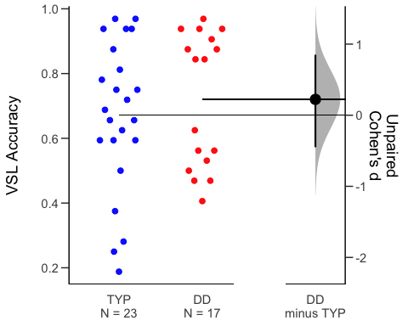 ## plot the accuracy within TSL

## `summarise()` has grouped output by 'PartID'. You can override using the `.groups` argument.

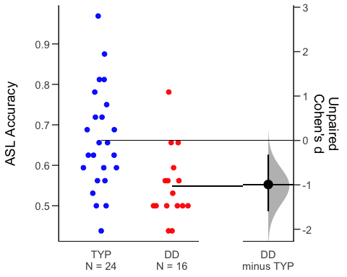 ## plot the accuracy by group and task

## # A tibble: 2 x 10  
## task term group1 group2 null.value estimate conf.low conf.high p.adj  
## * <chr> <chr> <chr> <chr> <dbl> <dbl> <dbl> <dbl> <dbl>  
## 1 Audi… Subg… DD TYP 0 0.113 0.0384 0.187 0.00391  
## 2 Visu… Subg… DD TYP 0 -0.0493 -0.193 0.0941 0.491   
## # … with 1 more variable: p.adj.signif <chr>

## alternative plots

## Warning: Ignoring unknown parameters: fun.y, fun.ymin, fun.ymax

## No summary function supplied, defaulting to `mean_se()`  
## No summary function supplied, defaulting to `mean_se()`

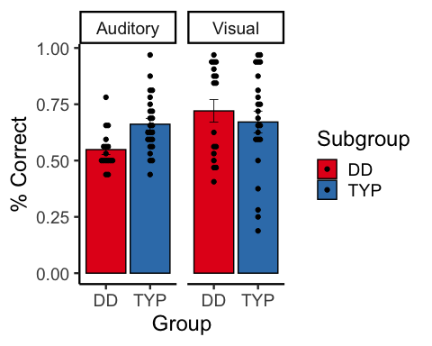 # Cross-task correlations

###Everyone

## kbit_ss_2 gort_ori_ss_2 ctopp_nonword_raw_2  
## kbit_ss_2   
## gort_ori_ss_2 0.25*   
## ctopp_nonword_raw_2 0.17 0.48****   
## ctopp_elision_raw_2 0.47*** 0.42*** 0.15   
## ctopp_blending_raw_2 0.26* 0.42*** 0.24*   
## wais_dsb_ss_2 0.51**** 0.43*** 0.26*   
## slopeProp_On -0.05 -0.05 -0.19   
## slope_mt -0.01 0.19 0.00   
## slope_me 0.07 0.31* 0.13   
## vis_slope_scale 0.14 0.28* 0.09   
## aud_slope_scale 0.04 -0.09 0.07   
## vis_acc 0.06 0.06 0.20   
## aud_acc 0.12 0.38** 0.17   
## quicksin_snr_loss_2 -0.12 -0.59**** -0.37**   
## ctopp_elision_raw_2 ctopp_blending_raw_2 wais_dsb_ss_2  
## kbit_ss_2   
## gort_ori_ss_2   
## ctopp_nonword_raw_2   
## ctopp_elision_raw_2   
## ctopp_blending_raw_2 0.56****   
## wais_dsb_ss_2 0.42*** 0.41***   
## slopeProp_On 0.08 0.06 0.08   
## slope_mt 0.18 0.13 0.03   
## slope_me 0.28* 0.19 0.05   
## vis_slope_scale 0.09 -0.26 0.21   
## aud_slope_scale 0.07 0.00 0.03   
## vis_acc 0.19 0.17 0.00   
## aud_acc 0.19 0.24 0.26   
## quicksin_snr_loss_2 -0.17 -0.35** -0.13   
## slopeProp_On slope_mt slope_me vis_slope_scale  
## kbit_ss_2   
## gort_ori_ss_2   
## ctopp_nonword_raw_2   
## ctopp_elision_raw_2   
## ctopp_blending_raw_2   
## wais_dsb_ss_2   
## slopeProp_On   
## slope_mt 0.28*   
## slope_me 0.16 0.81****   
## vis_slope_scale 0.19 -0.04 -0.02   
## aud_slope_scale -0.06 0.13 0.02 -0.18   
## vis_acc -0.18 -0.17 0.04 -0.35*   
## aud_acc 0.20 0.06 0.11 0.07   
## quicksin_snr_loss_2 -0.07 -0.09 -0.18 -0.08   
## aud_slope_scale vis_acc aud_acc  
## kbit_ss_2   
## gort_ori_ss_2   
## ctopp_nonword_raw_2   
## ctopp_elision_raw_2   
## ctopp_blending_raw_2   
## wais_dsb_ss_2   
## slopeProp_On   
## slope_mt   
## slope_me   
## vis_slope_scale   
## aud_slope_scale   
## vis_acc 0.08   
## aud_acc -0.16 -0.12   
## quicksin_snr_loss_2 -0.02 -0.02 -0.23

###Dys only both the rotary pursuit and ASL accuracy/RT are related to reading

## kbit_ss_2 gort_ori_ss_2 wrmt_id_ss_2 wrmt_wa_ss_2 towre_sw_ss_2  
## kbit_ss_2   
## gort_ori_ss_2 0.06   
## wrmt_id_ss_2 0.18 0.41*   
## wrmt_wa_ss_2 0.08 0.22 0.67****   
## towre_sw_ss_2 -0.10 0.52** 0.40* 0.07   
## towre_pde_ss_2 0.03 0.29 0.28 0.58*** 0.46**   
## slopeProp_On 0.07 0.26 0.58** 0.61*** -0.08   
## slope_mt -0.11 0.08 0.16 0.08 0.25   
## slope_me 0.07 0.13 0.11 -0.01 0.18   
## aud_acc -0.26 0.13 0.41 0.50* 0.14   
## vis_acc 0.11 0.17 -0.31 -0.22 0.00   
## aud_slope_scale 0.19 -0.38 0.00 -0.43 -0.14   
## vis_slope_scale -0.07 0.05 -0.31 -0.23 -0.25   
## towre_pde_ss_2 slopeProp_On slope_mt slope_me aud_acc  
## kbit_ss_2   
## gort_ori_ss_2   
## wrmt_id_ss_2   
## wrmt_wa_ss_2   
## towre_sw_ss_2   
## towre_pde_ss_2   
## slopeProp_On 0.09   
## slope_mt -0.01 0.03   
## slope_me -0.13 -0.07 0.74****   
## aud_acc 0.33 0.22 -0.38 -0.25   
## vis_acc 0.20 -0.20 -0.59** -0.03 -0.08   
## aud_slope_scale -0.50* 0.08 0.17 0.05 0.07   
## vis_slope_scale -0.28 0.27 0.00 -0.01 -0.22   
## vis_acc aud_slope_scale  
## kbit_ss_2   
## gort_ori_ss_2   
## wrmt_id_ss_2   
## wrmt_wa_ss_2   
## towre_sw_ss_2   
## towre_pde_ss_2   
## slopeProp_On   
## slope_mt   
## slope_me   
## aud_acc   
## vis_acc   
## aud_slope_scale -0.16   
## vis_slope_scale -0.28 0.16

###Typ only better VSL is related to worse reading…

## kbit_ss_2 gort_ori_ss_2 wrmt_id_ss_2 wrmt_wa_ss_2 towre_sw_ss_2  
## kbit_ss_2   
## gort_ori_ss_2 0.30   
## wrmt_id_ss_2 0.16 0.38*   
## wrmt_wa_ss_2 -0.04 0.11 -0.04   
## towre_sw_ss_2 0.12 0.43* 0.15 0.17   
## towre_pde_ss_2 0.14 0.69**** 0.38* 0.12 0.44*   
## slopeProp_On -0.01 0.10 -0.08 0.16 -0.11   
## slope_mt -0.11 -0.03 0.01 0.36* 0.08   
## slope_me -0.10 0.23 0.12 0.29 0.09   
## aud_acc 0.08 0.19 0.29 0.02 0.26   
## vis_acc 0.10 0.23 0.11 0.01 -0.12   
## aud_slope_scale -0.13 -0.05 -0.10 0.24 -0.29   
## vis_slope_scale 0.15 0.30 0.14 -0.20 0.27   
## towre_pde_ss_2 slopeProp_On slope_mt slope_me aud_acc  
## kbit_ss_2   
## gort_ori_ss_2   
## wrmt_id_ss_2   
## wrmt_wa_ss_2   
## towre_sw_ss_2   
## towre_pde_ss_2   
## slopeProp_On -0.20   
## slope_mt -0.22 0.48**   
## slope_me -0.10 0.39* 0.83****   
## aud_acc -0.01 0.16 -0.04 0.02   
## vis_acc 0.11 -0.16 -0.05 0.11 -0.12   
## aud_slope_scale 0.04 -0.13 0.08 -0.05 -0.36   
## vis_slope_scale 0.51** 0.15 -0.23 -0.21 0.08   
## vis_acc aud_slope_scale  
## kbit_ss_2   
## gort_ori_ss_2   
## wrmt_id_ss_2   
## wrmt_wa_ss_2   
## towre_sw_ss_2   
## towre_pde_ss_2   
## slopeProp_On   
## slope_mt   
## slope_me   
## aud_acc   
## vis_acc   
## aud_slope_scale 0.25   
## vis_slope_scale -0.36* -0.48*