Procedural Learning 110320

Ola Ozernov-Palchik

11/4/2020

# Sample Size

##   
## Frequency table:  
## Subgroup  
## DD TYP   
## 31 32

# Rotary Pursuit

###Statstical Analysis by Trial

## Analysis of Variance Table  
##   
## Response: prop_on  
## Df Sum Sq Mean Sq F value Pr(>F)   
## Subgroup 1 0.2285 0.228526 11.8973 0.0005905 ***  
## trial 15 2.0355 0.135697 7.0645 1.054e-14 ***  
## Subgroup:trial 15 0.2224 0.014826 0.7719 0.7099146   
## Residuals 828 15.9044 0.019208   
## ---  
## Signif. codes: 0 '***' 0.001 '**' 0.01 '*' 0.05 '.' 0.1 ' ' 1

## NOTE: Results may be misleading due to involvement in interactions

## $`lsmeans of Subgroup`  
## Subgroup lsmean SE df lower.CL upper.CL  
## DD 0.337 0.00682 828 0.321 0.352  
## TYP 0.304 0.00656 828 0.289 0.318  
##   
## Results are averaged over the levels of: trial   
## Confidence level used: 0.95   
## Conf-level adjustment: sidak method for 2 estimates   
##   
## $`pairwise differences of Subgroup`  
## contrast estimate SE df t.ratio p.value  
## DD - TYP 0.033 0.00946 828 3.493 0.0005   
##   
## Results are averaged over the levels of: trial

## Plot task

###Prop On by Trial

## `summarise()` regrouping output by 'Subgroup' (override with `.groups` argument)

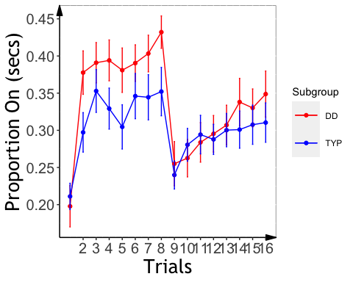

###Analysis

##   
## Welch Two Sample t-test  
##   
## data: d_rp$slopeProp_On_t by d_rp$Subgroup  
## t = 2.0056, df = 29.932, p-value = 0.05401  
## alternative hypothesis: true difference in means is not equal to 0  
## 95 percent confidence interval:  
## -0.005283916 0.579966432  
## sample estimates:  
## mean in group DD mean in group TYP   
## -0.7826527 -1.0699940

## Analysis of Variance Table  
##   
## Response: slopeProp_On_t  
## Df Sum Sq Mean Sq F value Pr(>F)   
## background_age 1 0.0752 0.07520 0.3425 0.56155   
## background_sex 1 0.7717 0.77167 3.5142 0.06781 .  
## Subgroup 1 0.6946 0.69456 3.1631 0.08256 .  
## Residuals 42 9.2226 0.21958   
## ---  
## Signif. codes: 0 '***' 0.001 '**' 0.01 '*' 0.05 '.' 0.1 ' ' 1

## $`lsmeans of Subgroup`  
## Subgroup lsmean SE df lower.CL upper.CL  
## DD -0.81 0.0975 42 -1.04 -0.584  
## TYP -1.06 0.1008 42 -1.30 -0.828  
##   
## Results are averaged over the levels of: background_sex   
## Confidence level used: 0.95   
## Conf-level adjustment: sidak method for 2 estimates   
##   
## $`pairwise differences of Subgroup`  
## contrast estimate SE df t.ratio p.value  
## DD - TYP 0.252 0.142 42 1.778 0.0826   
##   
## Results are averaged over the levels of: background_sex

###Slope Effects

## `summarise()` regrouping output by 'PartID' (override with `.groups` argument)

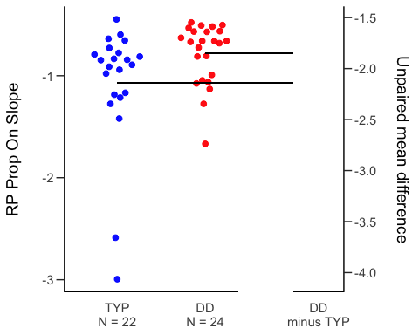

# Mirror Tracing

##MT: Analysis

## Analysis of Variance Table  
##   
## Response: time  
## Df Sum Sq Mean Sq F value Pr(>F)   
## Subgroup 1 0 0.4 0.0004 0.9850   
## trial 9 78448 8716.4 6.9966 1.539e-09 ***  
## Subgroup:trial 9 3302 366.8 0.2945 0.9762   
## Residuals 495 616678 1245.8   
## ---  
## Signif. codes: 0 '***' 0.001 '**' 0.01 '*' 0.05 '.' 0.1 ' ' 1

## Analysis of Variance Table  
##   
## Response: error  
## Df Sum Sq Mean Sq F value Pr(>F)   
## Subgroup 1 1210 1209.8 2.1812 0.1403   
## trial 9 54501 6055.7 10.9181 1.445e-15 ***  
## Subgroup:trial 9 856 95.1 0.1715 0.9967   
## Residuals 495 274549 554.6   
## ---  
## Signif. codes: 0 '***' 0.001 '**' 0.01 '*' 0.05 '.' 0.1 ' ' 1

## MT: Plot Time/Error by Trial

## `summarise()` regrouping output by 'Subgroup' (override with `.groups` argument)  
## `summarise()` regrouping output by 'Subgroup' (override with `.groups` argument)

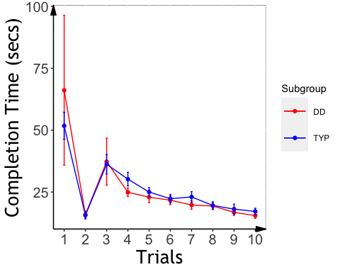

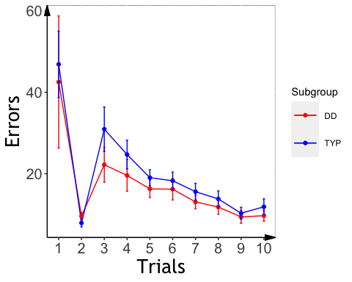

##Slopes

### Extract slopes

###MT: Slope Analysis

## Analysis of Variance Table  
##   
## Response: slope_mt_t  
## Df Sum Sq Mean Sq F value Pr(>F)   
## background_age 1 0.0845 0.08450 0.5193 0.47448   
## background_sex 1 0.1694 0.16941 1.0412 0.31246   
## Subgroup 1 0.5589 0.55889 3.4349 0.06974 .  
## Residuals 50 8.1356 0.16271   
## ---  
## Signif. codes: 0 '***' 0.001 '**' 0.01 '*' 0.05 '.' 0.1 ' ' 1

## Analysis of Variance Table  
##   
## Response: slope_me_t  
## Df Sum Sq Mean Sq F value Pr(>F)   
## background_age 1 0.1080 0.10801 0.5026 0.481665   
## background_sex 1 0.3477 0.34775 1.6181 0.209236   
## Subgroup 1 1.9867 1.98674 9.2446 0.003753 **  
## Residuals 50 10.7453 0.21491   
## ---  
## Signif. codes: 0 '***' 0.001 '**' 0.01 '*' 0.05 '.' 0.1 ' ' 1

## $`lsmeans of Subgroup`  
## Subgroup lsmean SE df lower.CL upper.CL  
## DD 1.07 0.0957 50 0.852 1.29  
## TYP 1.47 0.0863 50 1.267 1.66  
##   
## Results are averaged over the levels of: background_sex   
## Confidence level used: 0.95   
## Conf-level adjustment: sidak method for 2 estimates   
##   
## $`pairwise differences of Subgroup`  
## contrast estimate SE df t.ratio p.value  
## DD - TYP -0.393 0.129 50 -3.041 0.0038   
##   
## Results are averaged over the levels of: background_sex

## MT: Plot Slope Effects

## `summarise()` regrouping output by 'PartID' (override with `.groups` argument)

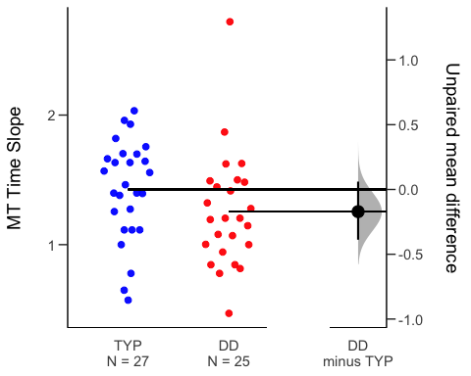

## `summarise()` regrouping output by 'PartID' (override with `.groups` argument)

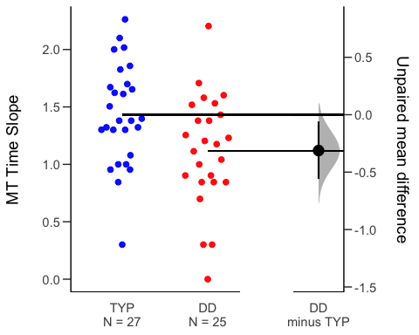

# Statistical Learning

##   
## Dyslexic Typical   
## 17 24

## Slope analyses

## Analysis of Variance Table  
##   
## Response: aud_slope_scale  
## Df Sum Sq Mean Sq F value Pr(>F)   
## background_age 1 0.0000236 0.00002362 0.0543 0.81750   
## background_sex 1 0.0013491 0.00134911 3.1022 0.08951 .  
## Subgroup 1 0.0003704 0.00037038 0.8517 0.36426   
## Residuals 27 0.0117419 0.00043488   
## ---  
## Signif. codes: 0 '***' 0.001 '**' 0.01 '*' 0.05 '.' 0.1 ' ' 1

##ASL Slope Effects

## `summarise()` regrouping output by 'PartID' (override with `.groups` argument)

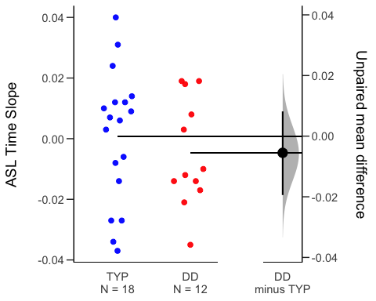

##VSL Slope Analysis

## Analysis of Variance Table  
##   
## Response: vis_slope_scale  
## Df Sum Sq Mean Sq F value Pr(>F)   
## background_age 1 0.003256 0.0032557 2.0421 0.16212   
## background_sex 1 0.000646 0.0006458 0.4050 0.52876   
## Subgroup 1 0.004899 0.0048991 3.0729 0.08862 .  
## Residuals 34 0.054206 0.0015943   
## ---  
## Signif. codes: 0 '***' 0.001 '**' 0.01 '*' 0.05 '.' 0.1 ' ' 1

##VSL Effect Plot

## `summarise()` regrouping output by 'PartID' (override with `.groups` argument)

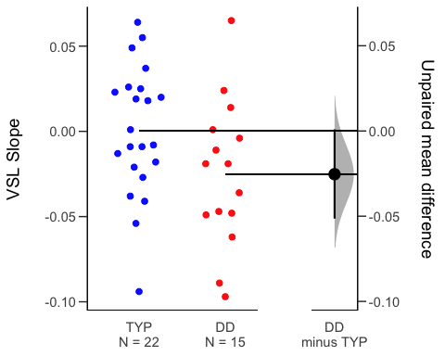 ##RT Slope

## Analysis of Variance Table  
##   
## Response: aud_fam_rt  
## Df Sum Sq Mean Sq F value Pr(>F)  
## background_age 1 153 153.2 0.0160 0.9002  
## background_sex 1 11494 11494.4 1.2022 0.2826  
## Subgroup 1 11063 11062.6 1.1571 0.2916  
## Residuals 27 258142 9560.8

## Analysis of Variance Table  
##   
## Response: vis_fam_rt  
## Df Sum Sq Mean Sq F value Pr(>F)  
## background_age 1 6330 6329.8 1.2706 0.2675  
## background_sex 1 11299 11299.1 2.2681 0.1413  
## Subgroup 1 4689 4688.8 0.9412 0.3388  
## Residuals 34 169380 4981.8

###Cross-task correlations

## kbit_ss_2 gort_ori_ss_2 ctopp_nonword_raw_2  
## kbit_ss_2   
## gort_ori_ss_2 0.41**   
## ctopp_nonword_raw_2 0.20 0.49**   
## ctopp_elision_raw_2 0.43** 0.48** 0.15   
## ctopp_blending_raw_2 0.22 0.39* 0.18   
## wais_dsb_ss_2 0.54*** 0.66**** 0.36*   
## slopeProp_On_t -0.19 0.01 -0.20   
## slope_mt_t 0.04 0.28 0.04   
## slope_me_t 0.05 0.15 0.35*   
## vis_slope_scale 0.09 0.31 0.07   
## aud_slope_scale 0.07 -0.05 0.19   
## quicksin_snr_loss_2 -0.15 -0.62**** -0.33*   
## ctopp_elision_raw_2 ctopp_blending_raw_2 wais_dsb_ss_2  
## kbit_ss_2   
## gort_ori_ss_2   
## ctopp_nonword_raw_2   
## ctopp_elision_raw_2   
## ctopp_blending_raw_2 0.40*   
## wais_dsb_ss_2 0.44** 0.54***   
## slopeProp_On_t 0.32 0.10 0.00   
## slope_mt_t 0.16 0.04 0.02   
## slope_me_t 0.13 0.15 0.00   
## vis_slope_scale 0.06 -0.22 0.18   
## aud_slope_scale 0.09 0.10 0.06   
## quicksin_snr_loss_2 -0.18 -0.40* -0.36*   
## slopeProp_On_t slope_mt_t slope_me_t vis_slope_scale  
## kbit_ss_2   
## gort_ori_ss_2   
## ctopp_nonword_raw_2   
## ctopp_elision_raw_2   
## ctopp_blending_raw_2   
## wais_dsb_ss_2   
## slopeProp_On_t   
## slope_mt_t 0.03   
## slope_me_t -0.20 0.38*   
## vis_slope_scale 0.32 0.01 0.09   
## aud_slope_scale -0.22 -0.14 -0.06 -0.25   
## quicksin_snr_loss_2 -0.12 0.03 0.02 -0.07   
## aud_slope_scale  
## kbit_ss_2   
## gort_ori_ss_2   
## ctopp_nonword_raw_2   
## ctopp_elision_raw_2   
## ctopp_blending_raw_2   
## wais_dsb_ss_2   
## slopeProp_On_t   
## slope_mt_t   
## slope_me_t   
## vis_slope_scale   
## aud_slope_scale   
## quicksin_snr_loss_2 -0.03