Procedural Learning 110320

Ola Ozernov-Palchik

11/4/2020

# Sample Size

##   
## Frequency table:  
## Subgroup  
## DD TYP   
## 31 31

# Rotary Pursuit

### Statstical Analysis by Trial: ZQ notes: I think it makes more sense to treat "trial" as a continuous variable than a factor. No group x trial interaction

## Analysis of Variance Table  
##   
## Response: prop_on  
## Df Sum Sq Mean Sq F value Pr(>F)   
## Subgroup 1 0.1778 0.177754 9.2899 0.002379 **   
## as.factor(trial) 15 2.1744 0.144962 7.5761 5.544e-16 ***  
## Subgroup:as.factor(trial) 15 0.1712 0.011416 0.5966 0.879012   
## Residuals 812 15.5369 0.019134   
## ---  
## Signif. codes: 0 '***' 0.001 '**' 0.01 '*' 0.05 '.' 0.1 ' ' 1

## NOTE: Results may be misleading due to involvement in interactions

## $`lsmeans of Subgroup`  
## Subgroup lsmean SE df lower.CL upper.CL  
## DD 0.337 0.00681 812 0.323 0.35  
## TYP 0.307 0.00666 812 0.294 0.32  
##   
## Results are averaged over the levels of: trial   
## Confidence level used: 0.95   
##   
## $`pairwise differences of Subgroup`  
## 1 estimate SE df t.ratio p.value  
## DD - TYP 0.0294 0.00953 812 3.089 0.0021   
##   
## Results are averaged over the levels of: trial

#### linear regression: treating trial as a continuous variable (no group x trial interaction)

## Analysis of Variance Table  
##   
## Response: prop_on  
## Df Sum Sq Mean Sq F value Pr(>F)   
## Subgroup 1 0.1778 0.177754 8.3680 0.003918 **  
## trial 1 0.0211 0.021055 0.9912 0.319734   
## Subgroup:trial 1 0.0180 0.018031 0.8488 0.357150   
## Residuals 840 17.8435 0.021242   
## ---  
## Signif. codes: 0 '***' 0.001 '**' 0.01 '*' 0.05 '.' 0.1 ' ' 1

#### linear mixed-effect modeling: treating trial as a continuous variable

## boundary (singular) fit: see ?isSingular

## Linear mixed model fit by REML. t-tests use Satterthwaite's method [  
## lmerModLmerTest]  
## Formula: prop_on ~ Subgroup * trial + (1 + trial | PartID)  
## Data: rp2  
##   
## REML criterion at convergence: -1530.2  
##   
## Scaled residuals:   
## Min 1Q Median 3Q Max   
## -3.3860 -0.5773 0.0500 0.6571 3.2495   
##   
## Random effects:  
## Groups Name Variance Std.Dev. Corr  
## PartID (Intercept) 1.424e-02 0.1193247   
## trial 2.541e-08 0.0001594 1.00  
## Residual 7.397e-03 0.0860075   
## Number of obs: 844, groups: PartID, 53  
##   
## Fixed effects:  
## Estimate Std. Error df t value Pr(>|t|)   
## (Intercept) 3.509e-01 2.503e-02 5.138e+01 14.020 <2e-16 ***  
## SubgroupTYP -4.314e-02 3.506e-02 5.135e+01 -1.230 0.2241   
## trial -1.958e-03 9.158e-04 7.624e+02 -2.138 0.0329 *   
## SubgroupTYP:trial 1.864e-03 1.283e-03 7.624e+02 1.453 0.1465   
## ---  
## Signif. codes: 0 '***' 0.001 '**' 0.01 '*' 0.05 '.' 0.1 ' ' 1  
##   
## Correlation of Fixed Effects:  
## (Intr) SbgTYP trial   
## SubgroupTYP -0.714   
## trial -0.279 0.199   
## SbgrpTYP:tr 0.199 -0.279 -0.714  
## optimizer (nloptwrap) convergence code: 0 (OK)  
## boundary (singular) fit: see ?isSingular

## Extract Slope

### growth curve analysis - ZQ note: the growth curve analyses suggested that the two groups are significantly different on the quadratic terms

## PartID Subgroup plType trial On   
## ABCD_1702: 16 DD :413 Length:844 Min. : 1.000 Min. : 0.040   
## ABCD_1703: 16 TYP:431 Class :character 1st Qu.: 4.000 1st Qu.: 4.338   
## ABCD_1704: 16 Mode :character Median : 9.000 Median : 6.380   
## ABCD_1705: 16 Mean : 8.506 Mean : 6.427   
## ABCD_1706: 16 3rd Qu.:13.000 3rd Qu.: 8.217   
## ABCD_1708: 16 Max. :16.000 Max. :15.540   
## (Other) :748   
## Off prop_on otrial1 otrial2   
## Min. : 4.46 Min. :0.0020 Min. :-0.406745 Min. :-0.2778595   
## 1st Qu.:11.76 1st Qu.:0.2169 1st Qu.:-0.244047 1st Qu.:-0.2513967   
## Median :13.62 Median :0.3190 Median :-0.027116 Median :-0.1190826   
## Mean :13.56 Mean :0.3214 Mean :-0.001478 Mean :-0.0007839   
## 3rd Qu.:15.65 3rd Qu.:0.4109 3rd Qu.: 0.189814 3rd Qu.: 0.1190826   
## Max. :19.96 Max. :0.7770 Max. : 0.406745 Max. : 0.4630991   
##

## Data: rp2  
## Models:  
## m.base: prop_on ~ (otrial1 + otrial2) + (otrial1 + otrial2 | PartID)  
## m.0: prop_on ~ (otrial1 + otrial2) + Subgroup + (otrial1 + otrial2 |   
## m.0: PartID)  
## m.1: prop_on ~ (otrial1 + otrial2) * Subgroup + (otrial1 + otrial2 |   
## m.1: PartID)  
## npar AIC BIC logLik deviance Chisq Df Pr(>Chisq)   
## m.base 10 -1863.8 -1816.5 941.93 -1883.8   
## m.0 11 -1861.9 -1809.7 941.93 -1883.9 0.0052 1 0.94262   
## m.1 13 -1863.2 -1801.6 944.61 -1889.2 5.3687 2 0.06827 .  
## ---  
## Signif. codes: 0 '***' 0.001 '**' 0.01 '*' 0.05 '.' 0.1 ' ' 1

## Linear mixed model fit by maximum likelihood . t-tests use Satterthwaite's  
## method [lmerModLmerTest]  
## Formula: prop_on ~ (otrial1 + otrial2) * Subgroup + (otrial1 + otrial2 |   
## PartID)  
## Data: rp2  
##   
## AIC BIC logLik deviance df.resid   
## -1863.2 -1801.6 944.6 -1889.2 831   
##   
## Scaled residuals:   
## Min 1Q Median 3Q Max   
## -3.7253 -0.5761 0.0446 0.6309 2.8541   
##   
## Random effects:  
## Groups Name Variance Std.Dev. Corr   
## PartID (Intercept) 0.014177 0.11907   
## otrial1 0.009157 0.09569 0.29   
## otrial2 0.005543 0.07445 -0.51 -0.95  
## Residual 0.004477 0.06691   
## Number of obs: 844, groups: PartID, 53  
##   
## Fixed effects:  
## Estimate Std. Error df t value Pr(>|t|)   
## (Intercept) 0.33420 0.02358 52.95772 14.172 < 2e-16 ***  
## otrial1 0.15702 0.02295 53.12784 6.841 8.04e-09 ***  
## otrial2 -0.14029 0.01965 52.66736 -7.140 2.78e-09 ***  
## SubgroupTYP -0.02726 0.03304 52.95053 -0.825 0.4131   
## otrial1:SubgroupTYP -0.07194 0.03213 52.99823 -2.239 0.0294 *   
## otrial2:SubgroupTYP 0.05363 0.02753 52.64557 1.948 0.0567 .   
## ---  
## Signif. codes: 0 '***' 0.001 '**' 0.01 '*' 0.05 '.' 0.1 ' ' 1  
##   
## Correlation of Fixed Effects:  
## (Intr) otril1 otril2 SbgTYP o1:STY  
## otrial1 0.232   
## otrial2 -0.372 -0.577   
## SubgroupTYP -0.714 -0.165 0.265   
## otrl1:SbTYP -0.166 -0.714 0.412 0.232   
## otrl2:SbTYP 0.265 0.412 -0.714 -0.372 -0.578

#### Extract indiviudal slope

##   
## Call:  
## lm(formula = prop_on ~ poly(trial, 6, raw = TRUE), data = rp2)  
##   
## Residuals:  
## Min 1Q Median 3Q Max   
## -0.36429 -0.09064 -0.00405 0.08178 0.45267   
##   
## Coefficients:  
## Estimate Std. Error t value Pr(>|t|)   
## (Intercept) -3.700e-02 8.725e-02 -0.424 0.67167   
## poly(trial, 6, raw = TRUE)1 3.464e-01 1.190e-01 2.912 0.00369 **  
## poly(trial, 6, raw = TRUE)2 -1.169e-01 5.430e-02 -2.153 0.03161 *   
## poly(trial, 6, raw = TRUE)3 2.070e-02 1.128e-02 1.835 0.06689 .   
## poly(trial, 6, raw = TRUE)4 -2.040e-03 1.171e-03 -1.742 0.08181 .   
## poly(trial, 6, raw = TRUE)5 1.032e-04 5.914e-05 1.745 0.08133 .   
## poly(trial, 6, raw = TRUE)6 -2.059e-06 1.157e-06 -1.780 0.07543 .   
## ---  
## Signif. codes: 0 '***' 0.001 '**' 0.01 '*' 0.05 '.' 0.1 ' ' 1  
##   
## Residual standard error: 0.1404 on 837 degrees of freedom  
## Multiple R-squared: 0.086, Adjusted R-squared: 0.07945   
## F-statistic: 13.13 on 6 and 837 DF, p-value: 3.102e-14

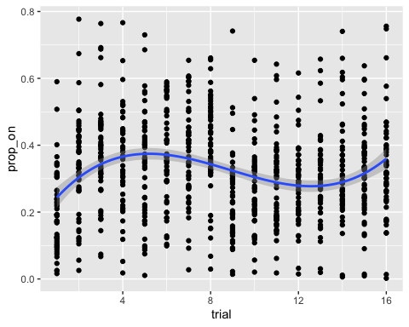

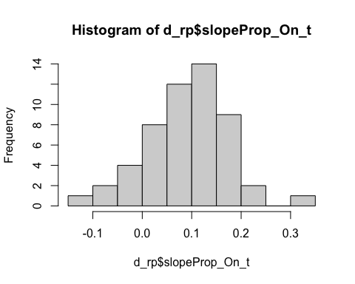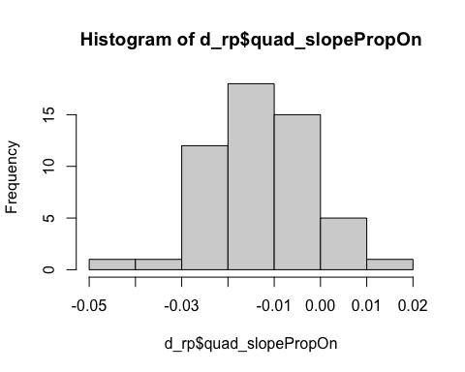

## Plot task

### Prop On by Trial: ZQ notes: Do you know why there were a dip in people's performance 30 minutes later (trial 9)? Check out Finn et al., 2015 for the developmental study on these tasks. They reported continuous growth on the time spent on target.

## `summarise()` regrouping output by 'Subgroup' (override with `.groups` argument)

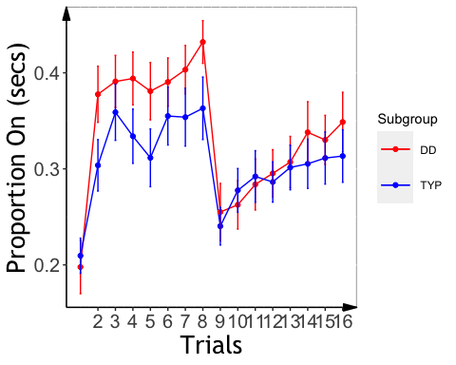 ### alternative plots with fitted curve 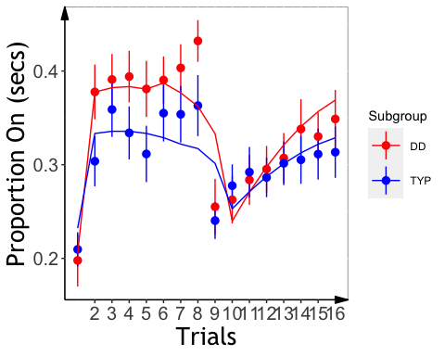

### Analysis

##   
## Welch Two Sample t-test  
##   
## data: d_rp$slopeProp_On_t by d_rp$Subgroup  
## t = 1.7996, df = 46.989, p-value = 0.07834  
## alternative hypothesis: true difference in means is not equal to 0  
## 95 percent confidence interval:  
## -0.004488942 0.080663581  
## sample estimates:  
## mean in group DD mean in group TYP   
## 0.11171784 0.07363052

## Analysis of Variance Table  
##   
## Response: slopeProp_On_t  
## Df Sum Sq Mean Sq F value Pr(>F)   
## background_age 1 0.002047 0.0020473 0.3293 0.56872   
## background_sex 1 0.000057 0.0000574 0.0092 0.92385   
## Subgroup 1 0.018834 0.0188336 3.0288 0.08808 .  
## Residuals 49 0.304690 0.0062182   
## ---  
## Signif. codes: 0 '***' 0.001 '**' 0.01 '*' 0.05 '.' 0.1 ' ' 1

## $`lsmeans of Subgroup`  
## Subgroup lsmean SE df lower.CL upper.CL  
## DD 0.1122 0.0158 49 0.0805 0.144  
## TYP 0.0741 0.0152 49 0.0435 0.105  
##   
## Results are averaged over the levels of: background_sex   
## Confidence level used: 0.95   
##   
## $`pairwise differences of Subgroup`  
## 1 estimate SE df t.ratio p.value  
## DD - TYP 0.0382 0.0219 49 1.740 0.0881   
##   
## Results are averaged over the levels of: background_sex

### Slope Effects

## `summarise()` regrouping output by 'PartID' (override with `.groups` argument)

# Mirror Tracing

## QC

## MT: Analysis: ZQ notes: I think trial should be treated as a continous variable.

## Analysis of Variance Table  
##   
## Response: time  
## Df Sum Sq Mean Sq F value Pr(>F)   
## Subgroup 1 1858 1858.1 11.5139 0.0007471 ***  
## as.factor(trial) 9 35755 3972.8 24.6179 < 2.2e-16 ***  
## Subgroup:as.factor(trial) 9 2733 303.6 1.8815 0.0525316 .   
## Residuals 487 78591 161.4   
## ---  
## Signif. codes: 0 '***' 0.001 '**' 0.01 '*' 0.05 '.' 0.1 ' ' 1

## Analysis of Variance Table  
##   
## Response: error  
## Df Sum Sq Mean Sq F value Pr(>F)   
## Subgroup 1 2614 2614.0 9.7549 0.001895 **   
## as.factor(trial) 9 35920 3991.1 14.8943 < 2.2e-16 ***  
## Subgroup:as.factor(trial) 9 4780 531.1 1.9820 0.039536 *   
## Residuals 485 129962 268.0   
## ---  
## Signif. codes: 0 '***' 0.001 '**' 0.01 '*' 0.05 '.' 0.1 ' ' 1

### linear regression: treating trial as a continuous variable (significant group x trial interaction)

## Analysis of Variance Table  
##   
## Response: time  
## Df Sum Sq Mean Sq F value Pr(>F)   
## Subgroup 1 1858 1858.1 10.8433 0.001061 **   
## trial 1 29183 29183.5 170.3069 < 2.2e-16 ***  
## Subgroup:trial 1 1702 1701.8 9.9312 0.001722 **   
## Residuals 503 86193 171.4   
## ---  
## Signif. codes: 0 '***' 0.001 '**' 0.01 '*' 0.05 '.' 0.1 ' ' 1

## Linear mixed model fit by REML. t-tests use Satterthwaite's method [  
## lmerModLmerTest]  
## Formula: time ~ Subgroup * trial + (1 + trial | PartID)  
## Data: mt2  
##   
## REML criterion at convergence: 3796.7  
##   
## Scaled residuals:   
## Min 1Q Median 3Q Max   
## -2.7721 -0.3901 -0.1107 0.2356 6.6336   
##   
## Random effects:  
## Groups Name Variance Std.Dev. Corr   
## PartID (Intercept) 280.763 16.756   
## trial 2.547 1.596 -0.96  
## Residual 78.730 8.873   
## Number of obs: 507, groups: PartID, 51  
##   
## Fixed effects:  
## Estimate Std. Error df t value Pr(>|t|)   
## (Intercept) 33.3449 3.6496 49.4227 9.137 3.41e-12 ***  
## SubgroupTYP 10.3583 5.0079 49.1407 2.068 0.0439 *   
## trial -2.0192 0.3840 49.7051 -5.259 3.07e-06 ***  
## SubgroupTYP:trial -1.2247 0.5264 49.2932 -2.326 0.0241 *   
## ---  
## Signif. codes: 0 '***' 0.001 '**' 0.01 '*' 0.05 '.' 0.1 ' ' 1  
##   
## Correlation of Fixed Effects:  
## (Intr) SbgTYP trial   
## SubgroupTYP -0.729   
## trial -0.929 0.677   
## SbgrpTYP:tr 0.678 -0.929 -0.729

## Analysis of Variance Table  
##   
## Response: error  
## Df Sum Sq Mean Sq F value Pr(>F)   
## Subgroup 1 2614 2614.0 9.5538 0.002106 **   
## trial 1 30432 30431.9 111.2260 < 2.2e-16 ***  
## Subgroup:trial 1 3155 3154.8 11.5306 0.000739 ***  
## Residuals 501 137076 273.6   
## ---  
## Signif. codes: 0 '***' 0.001 '**' 0.01 '*' 0.05 '.' 0.1 ' ' 1

## boundary (singular) fit: see ?isSingular

## Linear mixed model fit by REML. t-tests use Satterthwaite's method [  
## lmerModLmerTest]  
## Formula: error ~ Subgroup * trial + (1 + trial | PartID)  
## Data: mt2  
##   
## REML criterion at convergence: 4042.3  
##   
## Scaled residuals:   
## Min 1Q Median 3Q Max   
## -4.4189 -0.4024 -0.0649 0.2721 8.2932   
##   
## Random effects:  
## Groups Name Variance Std.Dev. Corr   
## PartID (Intercept) 484.010 22.00   
## trial 4.926 2.22 -1.00  
## Residual 140.906 11.87   
## Number of obs: 505, groups: PartID, 51  
##   
## Fixed effects:  
## Estimate Std. Error df t value Pr(>|t|)   
## (Intercept) 24.8405 4.8028 49.5477 5.172 4.17e-06 ***  
## SubgroupTYP 14.2152 6.5907 49.2784 2.157 0.03592 *   
## trial -1.7527 0.5284 51.3377 -3.317 0.00168 **   
## SubgroupTYP:trial -1.7772 0.7250 51.0816 -2.451 0.01770 *   
## ---  
## Signif. codes: 0 '***' 0.001 '**' 0.01 '*' 0.05 '.' 0.1 ' ' 1  
##   
## Correlation of Fixed Effects:  
## (Intr) SbgTYP trial   
## SubgroupTYP -0.729   
## trial -0.964 0.703   
## SbgrpTYP:tr 0.703 -0.964 -0.729  
## optimizer (nloptwrap) convergence code: 0 (OK)  
## boundary (singular) fit: see ?isSingular

## MT: Plot Time/Error by Trial

## `summarise()` regrouping output by 'Subgroup' (override with `.groups` argument)  
## `summarise()` regrouping output by 'Subgroup' (override with `.groups` argument)

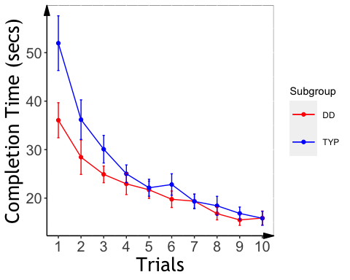

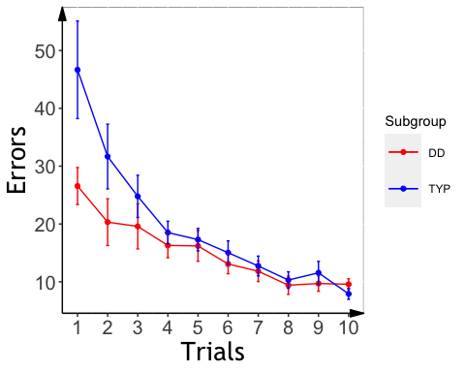

## Mirror Tracing Slopes

### growth curve analysis suggested the two groups are signficiantly different on quardratic terms

#### completion time

## PartID Subgroup Type trial time   
## ABCD_1702: 10 DD :237 Length:505 Min. : 1.000 Min. : 6.00   
## ABCD_1703: 10 TYP:268 Class :character 1st Qu.: 3.000 1st Qu.: 14.07   
## ABCD_1704: 10 Mode :character Median : 6.000 Median : 20.00   
## ABCD_1705: 10 Mean : 5.509 Mean : 24.07   
## ABCD_1708: 10 3rd Qu.: 8.000 3rd Qu.: 29.00   
## ABCD_1709: 10 Max. :10.000 Max. :118.00   
## (Other) :445   
## error otrial1 otrial2   
## Min. : 0.00 Min. :-0.4954337 Min. :-0.348155   
## 1st Qu.: 8.00 1st Qu.:-0.2752409 1st Qu.:-0.261116   
## Median : 12.00 Median : 0.0550482 Median :-0.087039   
## Mean : 17.59 Mean : 0.0009811 Mean :-0.002585   
## 3rd Qu.: 21.00 3rd Qu.: 0.2752409 3rd Qu.: 0.174078   
## Max. :201.00 Max. : 0.4954337 Max. : 0.522233   
##

## boundary (singular) fit: see ?isSingular  
## boundary (singular) fit: see ?isSingular  
## boundary (singular) fit: see ?isSingular

## Data: mt2  
## Models:  
## m.base: time ~ (otrial1 + otrial2) + (otrial1 + otrial2 | PartID)  
## m.0: time ~ (otrial1 + otrial2) + Subgroup + (otrial1 + otrial2 |   
## m.0: PartID)  
## m.1: time ~ (otrial1 + otrial2) * Subgroup + (otrial1 + otrial2 |   
## m.1: PartID)  
## npar AIC BIC logLik deviance Chisq Df Pr(>Chisq)   
## m.base 10 3670.0 3712.2 -1825.0 3650.0   
## m.0 11 3672.0 3718.4 -1825.0 3650.0 0.0282 1 0.86661   
## m.1 13 3670.6 3725.5 -1822.3 3644.6 5.3471 2 0.06901 .  
## ---  
## Signif. codes: 0 '***' 0.001 '**' 0.01 '*' 0.05 '.' 0.1 ' ' 1

## Linear mixed model fit by maximum likelihood . t-tests use Satterthwaite's  
## method [lmerModLmerTest]  
## Formula: time ~ (otrial1 + otrial2) * Subgroup + (otrial1 + otrial2 |   
## PartID)  
## Data: mt2  
##   
## AIC BIC logLik deviance df.resid   
## 3670.6 3725.5 -1822.3 3644.6 492   
##   
## Scaled residuals:   
## Min 1Q Median 3Q Max   
## -4.4059 -0.3877 -0.0713 0.2736 5.0607   
##   
## Random effects:  
## Groups Name Variance Std.Dev. Corr   
## PartID (Intercept) 74.69 8.642   
## otrial1 234.06 15.299 -0.78   
## otrial2 93.88 9.689 0.57 -0.96  
## Residual 52.64 7.255   
## Number of obs: 505, groups: PartID, 51  
##   
## Fixed effects:  
## Estimate Std. Error df t value Pr(>|t|)   
## (Intercept) 22.305 1.828 51.087 12.205 < 2e-16 ***  
## otrial1 -18.624 3.480 52.184 -5.351 1.98e-06 ***  
## otrial2 6.180 2.493 55.170 2.479 0.0163 *   
## SubgroupTYP 3.533 2.511 50.996 1.407 0.1654   
## otrial1:SubgroupTYP -10.913 4.771 51.808 -2.287 0.0263 *   
## otrial2:SubgroupTYP 7.013 3.415 54.834 2.053 0.0448 *   
## ---  
## Signif. codes: 0 '***' 0.001 '**' 0.01 '*' 0.05 '.' 0.1 ' ' 1  
##   
## Correlation of Fixed Effects:  
## (Intr) otril1 otril2 SbgTYP o1:STY  
## otrial1 -0.683   
## otrial2 0.445 -0.698   
## SubgroupTYP -0.728 0.497 -0.324   
## otrl1:SbTYP 0.498 -0.730 0.509 -0.682   
## otrl2:SbTYP -0.325 0.510 -0.730 0.444 -0.694  
## optimizer (nloptwrap) convergence code: 0 (OK)  
## boundary (singular) fit: see ?isSingular

#### errors

## boundary (singular) fit: see ?isSingular  
## boundary (singular) fit: see ?isSingular

## Data: mt2  
## Models:  
## m.base: error ~ (otrial1 + otrial2) + (otrial1 + otrial2 | PartID)  
## m.0: error ~ (otrial1 + otrial2) + Subgroup + (otrial1 + otrial2 |   
## m.0: PartID)  
## m.1: error ~ (otrial1 + otrial2) * Subgroup + (otrial1 + otrial2 |   
## m.1: PartID)  
## npar AIC BIC logLik deviance Chisq Df Pr(>Chisq)   
## m.base 10 3939.5 3981.7 -1959.7 3919.5   
## m.0 11 3941.3 3987.8 -1959.6 3919.3 0.2021 1 0.6530   
## m.1 13 3939.9 3994.8 -1956.9 3913.9 5.4272 2 0.0663 .  
## ---  
## Signif. codes: 0 '***' 0.001 '**' 0.01 '*' 0.05 '.' 0.1 ' ' 1

## Linear mixed model fit by maximum likelihood . t-tests use Satterthwaite's  
## method [lmerModLmerTest]  
## Formula: error ~ (otrial1 + otrial2) * Subgroup + (otrial1 + otrial2 |   
## PartID)  
## Data: mt2  
##   
## AIC BIC logLik deviance df.resid   
## 3939.9 3994.8 -1956.9 3913.9 492   
##   
## Scaled residuals:   
## Min 1Q Median 3Q Max   
## -5.2098 -0.3811 -0.0600 0.3027 4.8694   
##   
## Random effects:  
## Groups Name Variance Std.Dev. Corr   
## PartID (Intercept) 96.74 9.835   
## otrial1 457.86 21.398 -0.89   
## otrial2 259.26 16.102 0.65 -0.93  
## Residual 92.04 9.594   
## Number of obs: 505, groups: PartID, 51  
##   
## Fixed effects:  
## Estimate Std. Error df t value Pr(>|t|)   
## (Intercept) 15.239 2.105 51.310 7.240 2.2e-09 ***  
## otrial1 -16.086 4.820 52.768 -3.338 0.00155 **   
## otrial2 3.861 3.854 53.284 1.002 0.32096   
## SubgroupTYP 4.458 2.891 51.179 1.542 0.12923   
## otrial1:SubgroupTYP -15.757 6.606 52.380 -2.385 0.02071 *   
## otrial2:SubgroupTYP 9.743 5.282 52.943 1.845 0.07068 .   
## ---  
## Signif. codes: 0 '***' 0.001 '**' 0.01 '*' 0.05 '.' 0.1 ' ' 1  
##   
## Correlation of Fixed Effects:  
## (Intr) otril1 otril2 SbgTYP o1:STY  
## otrial1 -0.776   
## otrial2 0.535 -0.729   
## SubgroupTYP -0.728 0.565 -0.389   
## otrl1:SbTYP 0.566 -0.730 0.532 -0.774   
## otrl2:SbTYP -0.390 0.532 -0.730 0.534 -0.725

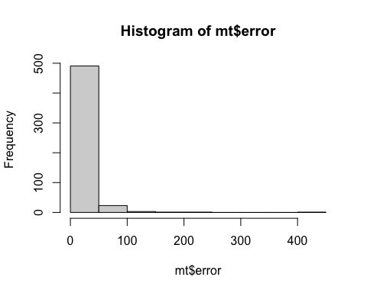

##   
## Call:  
## lm(formula = error ~ poly(trial, 2, raw = TRUE), data = mt2)  
##   
## Residuals:  
## Min 1Q Median 3Q Max   
## -30.730 -8.311 -2.198 3.945 166.270   
##   
## Coefficients:  
## Estimate Std. Error t value Pr(>|t|)   
## (Intercept) 41.4791 2.7618 15.019 < 2e-16 ***  
## poly(trial, 2, raw = TRUE)1 -7.1512 1.1496 -6.220 1.05e-09 ***  
## poly(trial, 2, raw = TRUE)2 0.4023 0.1018 3.953 8.82e-05 ***  
## ---  
## Signif. codes: 0 '***' 0.001 '**' 0.01 '*' 0.05 '.' 0.1 ' ' 1  
##   
## Residual standard error: 16.6 on 502 degrees of freedom  
## Multiple R-squared: 0.2018, Adjusted R-squared: 0.1986   
## F-statistic: 63.45 on 2 and 502 DF, p-value: < 2.2e-16

##   
## Call:  
## lm(formula = time ~ poly(trial, 3, raw = TRUE), data = mt2)  
##   
## Residuals:  
## Min 1Q Median 3Q Max   
## -31.289 -7.026 -2.398 4.938 74.451   
##   
## Coefficients:  
## Estimate Std. Error t value Pr(>|t|)   
## (Intercept) 56.03180 3.53431 15.854 < 2e-16 ***  
## poly(trial, 3, raw = TRUE)1 -14.33307 2.64334 -5.422 9.16e-08 ***  
## poly(trial, 3, raw = TRUE)2 1.94219 0.54515 3.563 0.000402 ***  
## poly(trial, 3, raw = TRUE)3 -0.09208 0.03270 -2.816 0.005051 **   
## ---  
## Signif. codes: 0 '***' 0.001 '**' 0.01 '*' 0.05 '.' 0.1 ' ' 1  
##   
## Residual standard error: 12.9 on 501 degrees of freedom  
## Multiple R-squared: 0.2988, Adjusted R-squared: 0.2946   
## F-statistic: 71.18 on 3 and 501 DF, p-value: < 2.2e-16

#### fit polynomial curves for the MT time plots

## No summary function supplied, defaulting to `mean_se()`

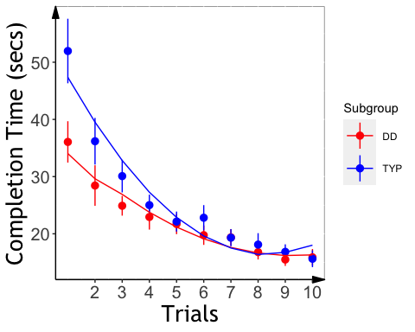 #### fit polynomial curves for the MT error plots

## No summary function supplied, defaulting to `mean_se()`

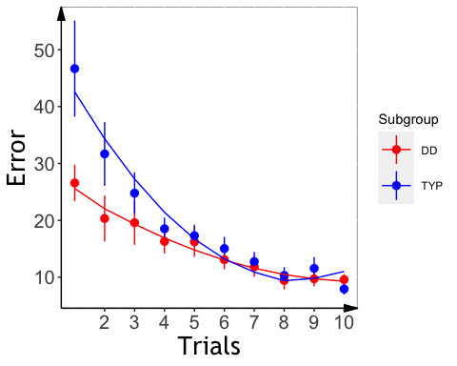

### Extract slopes

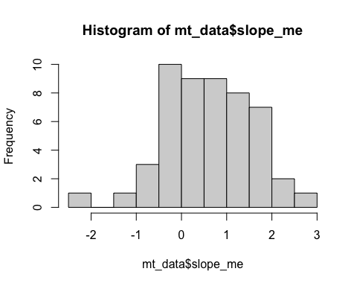

### MT: Slope Analysis

## Analysis of Variance Table  
##   
## Response: slope_mt_t  
## Df Sum Sq Mean Sq F value Pr(>F)   
## background_age 1 0.0397 0.03970 0.3881 0.53629   
## background_sex 1 0.0885 0.08854 0.8656 0.35694   
## Subgroup 1 0.5580 0.55798 5.4547 0.02384 *  
## Residuals 47 4.8078 0.10229   
## ---  
## Signif. codes: 0 '***' 0.001 '**' 0.01 '*' 0.05 '.' 0.1 ' ' 1

## Analysis of Variance Table  
##   
## Response: slope_me_t  
## Df Sum Sq Mean Sq F value Pr(>F)   
## background_age 1 0.00185 0.00185 0.0296 0.86413   
## background_sex 1 0.40609 0.40609 6.5110 0.01403 *  
## Subgroup 1 0.28199 0.28199 4.5213 0.03876 *  
## Residuals 47 2.93139 0.06237   
## ---  
## Signif. codes: 0 '***' 0.001 '**' 0.01 '*' 0.05 '.' 0.1 ' ' 1

## $`lsmeans of Subgroup`  
## Subgroup lsmean SE df lower.CL upper.CL  
## DD 0.406 0.0522 47 0.301 0.511  
## TYP 0.558 0.0481 47 0.461 0.654  
##   
## Results are averaged over the levels of: background_sex   
## Confidence level used: 0.95   
##   
## $`pairwise differences of Subgroup`  
## 1 estimate SE df t.ratio p.value  
## DD - TYP -0.151 0.0711 47 -2.126 0.0388   
##   
## Results are averaged over the levels of: background_sex

## MT: Plot Slope Effects

## `summarise()` regrouping output by 'PartID' (override with `.groups` argument)

## `summarise()` regrouping output by 'PartID' (override with `.groups` argument)

# Statistical Learning

##   
## Dyslexic Typical   
## 17 24

## Slope analyses (ZQ notes: the group difference analysis should refer to abcd_sl_analysis.pdf)

## Analysis of Variance Table  
##   
## Response: aud_slope_scale  
## Df Sum Sq Mean Sq F value Pr(>F)  
## background_age 1 0.0000258 0.00002580 0.0635 0.8029  
## background_sex 1 0.0011417 0.00114166 2.8110 0.1052  
## Subgroup 1 0.0000973 0.00009727 0.2395 0.6285  
## Residuals 27 0.0109657 0.00040614

## ASL Slope Effects (ZQ notes: the group difference analysis should refer to abcd_sl_analysis.pdf)

## `summarise()` regrouping output by 'PartID' (override with `.groups` argument)

## VSL Slope Analysis (ZQ notes: the group difference analysis should refer to abcd_sl_analysis.pdf)

## Analysis of Variance Table  
##   
## Response: vis_slope_scale  
## Df Sum Sq Mean Sq F value Pr(>F)  
## background_age 1 0.002070 0.0020696 1.2302 0.2752  
## background_sex 1 0.000336 0.0003361 0.1998 0.6577  
## Subgroup 1 0.004031 0.0040306 2.3958 0.1309  
## Residuals 34 0.057200 0.0016823

## VSL Effect Plot (ZQ notes: the group difference analysis should refer to abcd_sl_analysis.pdf, significant group effect)

## `summarise()` regrouping output by 'PartID' (override with `.groups` argument)

## RT Slope

## Analysis of Variance Table  
##   
## Response: aud_fam_rt  
## Df Sum Sq Mean Sq F value Pr(>F)  
## background_age 1 0 0.0 0.0000 0.9984  
## background_sex 1 14523 14523.4 1.6219 0.2137  
## Subgroup 1 14248 14248.2 1.5911 0.2180  
## Residuals 27 241777 8954.7

## Analysis of Variance Table  
##   
## Response: vis_fam_rt  
## Df Sum Sq Mean Sq F value Pr(>F)  
## background_age 1 6080 6079.7 1.2305 0.2751  
## background_sex 1 12178 12178.2 2.4649 0.1257  
## Subgroup 1 1555 1555.3 0.3148 0.5784  
## Residuals 34 167984 4940.7

### Cross-task correlations

## kbit_ss_2 gort_ori_ss_2 ctopp_nonword_raw_2  
## kbit_ss_2   
## gort_ori_ss_2 0.25   
## ctopp_nonword_raw_2 0.17 0.48***   
## ctopp_elision_raw_2 0.47*** 0.42** 0.15   
## ctopp_blending_raw_2 0.26 0.42** 0.24   
## wais_dsb_ss_2 0.51**** 0.43** 0.26   
## slopeProp_On 0.00 -0.05 -0.16   
## slope_mt_t -0.02 0.26 -0.04   
## slope_me_t -0.10 0.05 -0.05   
## vis_slope_scale 0.14 0.28 0.09   
## aud_slope_scale 0.04 -0.09 0.07   
## quicksin_snr_loss_2 -0.12 -0.59**** -0.37**   
## ctopp_elision_raw_2 ctopp_blending_raw_2 wais_dsb_ss_2  
## kbit_ss_2   
## gort_ori_ss_2   
## ctopp_nonword_raw_2   
## ctopp_elision_raw_2   
## ctopp_blending_raw_2 0.56****   
## wais_dsb_ss_2 0.42** 0.41**   
## slopeProp_On 0.08 0.06 0.13   
## slope_mt_t 0.14 0.08 0.01   
## slope_me_t 0.20 0.06 -0.16   
## vis_slope_scale 0.09 -0.26 0.21   
## aud_slope_scale 0.07 0.00 0.03   
## quicksin_snr_loss_2 -0.17 -0.35* -0.13   
## slopeProp_On slope_mt_t slope_me_t vis_slope_scale  
## kbit_ss_2   
## gort_ori_ss_2   
## ctopp_nonword_raw_2   
## ctopp_elision_raw_2   
## ctopp_blending_raw_2   
## wais_dsb_ss_2   
## slopeProp_On   
## slope_mt_t 0.14   
## slope_me_t 0.12 0.76****   
## vis_slope_scale 0.20 -0.01 0.04   
## aud_slope_scale -0.11 -0.02 -0.01 -0.18   
## quicksin_snr_loss_2 -0.03 0.08 0.22 -0.08   
## aud_slope_scale  
## kbit_ss_2   
## gort_ori_ss_2   
## ctopp_nonword_raw_2   
## ctopp_elision_raw_2   
## ctopp_blending_raw_2   
## wais_dsb_ss_2   
## slopeProp_On   
## slope_mt_t   
## slope_me_t   
## vis_slope_scale   
## aud_slope_scale   
## quicksin_snr_loss_2 -0.02

## wrmt_id_ss_2 wrmt_wa_ss_2 towre_sw_ss_2 towre_pde_ss_2  
## wrmt_id_ss_2   
## wrmt_wa_ss_2 0.67***   
## towre_sw_ss_2 0.40* 0.07   
## towre_pde_ss_2 0.28 0.58** 0.46*   
## slopeProp_On 0.52** 0.61*** -0.08 0.13   
## quad_slopePropOn -0.52** -0.64*** 0.04 -0.19   
## slope_mt -0.12 -0.11 -0.34 -0.07   
## slope_me 0.18 0.01 0.01 -0.05   
## aud_acc 0.41 0.50 0.14 0.33   
## vis_acc -0.31 -0.22 0.00 0.20   
## aud_slope_scale 0.00 -0.43 -0.14 -0.50   
## vis_slope_scale -0.31 -0.23 -0.25 -0.28   
## slopeProp_On quad_slopePropOn slope_mt slope_me aud_acc  
## wrmt_id_ss_2   
## wrmt_wa_ss_2   
## towre_sw_ss_2   
## towre_pde_ss_2   
## slopeProp_On   
## quad_slopePropOn -0.99****   
## slope_mt 0.05 -0.01   
## slope_me 0.19 -0.19 0.42*   
## aud_acc 0.22 -0.24 0.49 0.35   
## vis_acc -0.10 0.14 0.42 0.34 -0.08   
## aud_slope_scale 0.11 -0.10 0.30 -0.33 0.07   
## vis_slope_scale 0.26 -0.32 -0.01 -0.04 -0.22   
## vis_acc aud_slope_scale  
## wrmt_id_ss_2   
## wrmt_wa_ss_2   
## towre_sw_ss_2   
## towre_pde_ss_2   
## slopeProp_On   
## quad_slopePropOn   
## slope_mt   
## slope_me   
## aud_acc   
## vis_acc   
## aud_slope_scale -0.16   
## vis_slope_scale -0.28 0.16

## wrmt_id_ss_2 wrmt_wa_ss_2 towre_sw_ss_2 towre_pde_ss_2  
## wrmt_id_ss_2   
## wrmt_wa_ss_2 -0.04   
## towre_sw_ss_2 0.15 0.17   
## towre_pde_ss_2 0.38* 0.12 0.44*   
## slopeProp_On 0.01 0.16 -0.07 -0.14   
## quad_slopePropOn 0.00 -0.16 0.07 0.14   
## slope_mt -0.11 -0.19 -0.10 0.16   
## slope_me -0.17 -0.04 0.02 0.14   
## aud_acc 0.29 0.02 0.26 -0.01   
## vis_acc 0.11 0.01 -0.12 0.11   
## aud_slope_scale -0.10 0.24 -0.29 0.04   
## vis_slope_scale 0.14 -0.20 0.27 0.51*   
## slopeProp_On quad_slopePropOn slope_mt slope_me aud_acc  
## wrmt_id_ss_2   
## wrmt_wa_ss_2   
## towre_sw_ss_2   
## towre_pde_ss_2   
## slopeProp_On   
## quad_slopePropOn -1.00****   
## slope_mt -0.39* 0.37   
## slope_me -0.31 0.29 0.83****   
## aud_acc 0.31 -0.27 -0.20 -0.27   
## vis_acc -0.04 0.06 -0.11 -0.22 -0.12   
## aud_slope_scale -0.19 0.17 0.15 0.23 -0.36   
## vis_slope_scale 0.17 -0.17 0.17 0.14 0.08   
## vis_acc aud_slope_scale  
## wrmt_id_ss_2   
## wrmt_wa_ss_2   
## towre_sw_ss_2   
## towre_pde_ss_2   
## slopeProp_On   
## quad_slopePropOn   
## slope_mt   
## slope_me   
## aud_acc   
## vis_acc   
## aud_slope_scale 0.25   
## vis_slope_scale -0.36 -0.48*