AXI Performance Monitor IP — Design Request Specification
Purpose: This document defines the functional behavior, operating rules, and constraints for implementing an AXI performance monitor with bandwidth control and address protection in Verilog/SystemVerilog, for first delivery to the SoC IP team.
Audience: SoC and IP design, verification, and software engineers (assumes first receipt of this IP).
Scope: This document is the single normative baseline for functional and behavioral requirements of this IP. Register bitfields and addresses, pin/port lists, timing/electrical constraints, and SoC integration procedures are documented in companion material supplied by the IP provider, which MUST remain consistent with this specification.
Standalone delivery: This package (Korean and English markdown plus the block-diagram image) is sufficient to convey the requirements; no other repository markdown or internal documents need to be read.

Recommended delivery bundle
File | Description
request_for_design_busmon.md | Korean specification (normative prose and tables).
request_for_design_busmon_en.md | English specification of the same content.
busmon_architecture_overview.png | §10 overview figure; keep in the same folder as the markdown (relative image link).
You MAY generate Word/PDF from markdown. The Mermaid diagram in §10.2 may not render in all viewers; §§4–9 and tables are normative.

0. Notation: Mandatory vs Designer Discretion
Term | Meaning
MUST | Implement and verify as stated in this document.
SHOULD | Preferred practice; may be replaced if quality is equivalent or better.
MAY | Microarchitecture, implementation style, and detailed parameters are at designer discretion, provided required behavior and AXI protocol compliance are preserved.

1. Design Goals (MUST)
- Deliver an AXI performance monitor IP suitable for production-quality use.
- Bandwidth/latency logging, bandwidth throttling (multiple threshold modes), external throttle control, and address protection MUST be controllable and observable via registers within one IP.
- Provide pipeline and timing margin appropriate for high-frequency operation.

2. Interfaces (MUST)

2.1 AXI
- AXI Master Up / Master Down (or Slave Up / Master Down naming MAY vary).
  - Upstream and downstream use the same data width and same clock.
- Default data width is 256 bit (other defaults MAY use parameters; 256 is the default).
- Optional register slices on Up and/or Down MUST be selectable via parameters.

2.2 Control / Status — APB
- Control/status registers are accessed through an APB 32-bit slave interface.
- pstrb MAY be assumed fixed to 0xF.
- Same clock domain as the AXI master interface.

2.3 Interrupt
- One interrupt output (shared across logging events or masked into one line — sources and mask bits are defined in §8 and in the companion register definition for this IP).

2.4 Off-bus Input — External Throttle Control
MUST
- Provide a 2-bit input port request_throttle[1:0] separate from AXI bus ports.
- Define legal encodings as 0 through 3 (treatment of unused encodings is MAY — document as ignore or same as 0).
- SHOULD operate in the same clock domain as AXI. If asynchronous, MAY add synchronizers; MUST consider metastability.
MAY
- Port naming and module-level pin prefixes.

3. Per-Feature Enable / Disable (MUST)
Control registers MUST provide per-feature enable/disable fields. Example split (field names and bit positions MAY vary):
- Bandwidth logging
- Latency logging (single-tx / multi-tx latency via sub-enables or combined statistics in period — §5.2)
- Bandwidth throttling
- External throttle control (request_throttle path — §6.3)
- Address protection
SHOULD reduce unnecessary clock toggles when features are off.

4. Transaction Filters (MUST)
Used consistently for logging, latency measurement, and throttle scope. Filters are combined with logical AND: a transaction is included only if all of address, ID, and direction conditions match (when the relevant feature is enabled).

4.1 Address Filter
MUST
- Through control registers, allow monitoring only transactions in a start address + size (or start/end) range, or full address space tracking.
MAY
- Address compare implementation (alignment rules, upper-bit masks, etc.).

4.2 ID Filter
MUST
- Support these modes for AXI ID (ARID/AWID width per AXI parameters), selectable by register:
  - Whitelist — match one or more ID values (count and width upper bounds are design parameters).
  - Blacklist — exclude listed IDs.
  - All IDs (same effect as ID filter off).
MAY
- Number of whitelist/blacklist entries; mask/range vs exact match lists.

4.3 Direction Filter
MUST
- Register-selectable:
  - Read only
  - Write only
  - Read and Write
MAY
- Whether “Write” covers AW only vs AW+W channels per AXI rules.

4.4 Applicability Summary (MUST)
Feature | Filter combination
Bandwidth logging | Address + ID + DIRECTION
Latency logging (§5) | Same
Bandwidth throttling (§6) | Address + ID + DIRECTION (same combination as latency logging)

5. Performance Logging

5.1 Bandwidth Logging
Summary (MUST)
- Period: Select cycle count or transaction count (AW+AR handshake definition in register documentation). Repeats while enabled.
- Measurement: Derive bytes from AxSIZE × burst length, etc.; accumulate Write and Read separately; push to FIFO on period end.
- FIFO: Depth is a parameter; Even/Odd banks; switch storage bank every N periods (N < depth, set by control register).
- Interrupt: Optional level interrupt every N periods; mask via interrupt enable.
- Status: Current Even/Odd write target; which FIFO bank was written before the last interrupt.
- Filters: Count eligibility per §4.
MAY
- FIFO implementation (memory type), metadata fields.

5.2 Latency Logging

5.2.1 Period and Average Storage
MUST
- Use the same period registers as bandwidth logging.
- Single-transaction latency: store per-period averages only (sum / transaction count).
- Write latency: cycles from completed AW handshake until first B acceptance.
- Read latency:
  - From AR until first RVALID
  - From AR until last RLAST & RVALID (both statistics separately).
- Even/Odd FIFO and N-period switching: same policy as bandwidth logging.
MAY
- Internal structures (e.g. per-ID queues) as appropriate for the implementation.

5.2.2 Read / Write Multi-Transaction Latency
Goal: When outstanding transactions overlap, store end-to-end delay of a “burst segment” and accumulated bytes consistent with the Period/FIFO policy.
MUST — Read multi-transaction latency
- Segment start: For a filtered Read, when no outstanding Read exists, start the latency counter when ARVALID & ARREADY complete.
- Segment end: For the last Read transaction of that segment, stop when RLAST & RVALID & RREADY complete.
- Storage: On completion (or per §5.2.3 at period boundaries), store byte count and period (cycle count) per the chosen storage mode (FIFO / average, etc.) using the same Even/Odd FIFO scheme as §5.1 and §5.2.1.
- If outstanding Reads already exist when a new Read starts: do not reset the multi-transaction latency counter; only add bytes (same segment).
MUST — Write multi-transaction latency
- Same policy as Read. Segment start: first valid request when no outstanding Write (typically AW or first valid per protocol). Segment end: BVALID & BREADY for the last Write of the segment.
- Additional Writes in the segment add bytes without resetting the counter.
MAY
- Byte accounting for Write multi segments (AW-only vs AW+W data) — must stay consistent with document-wide byte definitions.
- Whether multi-transaction stats go into period averages or per-sample FIFO — specify in register map.

5.2.3 Multi-Transaction Statistics vs Period (MUST / partial MAY)
MUST
- Single- and multi-transaction latency stats include only transactions passing §4 filters.
- MAY share the same period timebase as bandwidth/latency logging.
MAY
- If multiple multi-transaction segments complete in one period, whether to store average, sum, or max — define in register map.

6. Bandwidth Throttling

6.1 Common
MUST
- Provide a throttle period register separate from logging period (period_throttle, naming MAY vary).
- Byte accounting for throttling uses the same byte rules as logging.
- Scope: Throttling applies only to transactions satisfying §4 address + ID + DIRECTION.
- Insert delay to limit bandwidth.
MAY
- Sliding vs fixed aggregation windows.

6.2 Threshold Mode Options (MUST)
Selectable dynamically by register.

6.2.1 Static Threshold
MUST
- Each period_throttle window, if accumulated bytes exceed the configured threshold, insert delay on AW/AR (and §6.4) acceptance timing to reduce bandwidth.
- Different delay values may be set for AW vs AR.

6.2.2 Credit-Based Threshold
MUST — Concepts
- credit_period: Independent of logging/static throttle period; register-programmable.
- Each credit_period, add number_of_credit (register) to the accumulated credit pool.
- Clamp accumulation to a maximum (register or parameter).
- On transaction request acceptance (VALID & READY on that channel — document per channel).
- Debit amount = request bytes right-shifted by credit_divider, i.e. ( / 2^{} ).
- Never let debit drive balance below zero (insufficient credit → §6.2.3).
- Separate credit pools for Read and Write.
MAY
- Credit counter width; ordering when multiple transactions debit in one cycle.

6.2.3 Insufficient Credit — Delay (MUST)
MUST
- If credit is insufficient, delay acceptance to limit bandwidth.
- Apply independently to Read and Write paths (matching separate credits).

6.3 External Throttle Control
Receive throttle intent on pins separate from AXI, and apply insertion delay on the request path using delay registers independent of §6.2 and §6.4.

6.3.1 Input Semantics (MUST)
MUST
- Port request_throttle[1:0] (§2.4).
- request_throttle == 0: No additional delay from this input (even if feature enabled).
- request_throttle == 1, 2, 3: Each selects a different delay on the request acceptance path. Delays are register-programmable and MUST use registers separate from AW/AR/W delay and credit settings in §6.2 and §6.4 — e.g. three dedicated registers (or equivalent) for encodings 1–3.
- Enable/disable of this feature MUST be dynamically programmable via APB. When disabled, request_throttle MAY be ignored (SHOULD document).
MAY
- Scope of “request signals”: typically AR/AW address-phase acceptance; extending to W/R response channels is MAY — document in register map.
- Three separate registers vs encoded table for delays 1–3.

6.3.2 Interaction with Internal Bandwidth Throttling (MUST / MAY)
MUST
- When external throttle and §6.2 internal throttling are both active, combined delay MUST preserve AXI protocol and avoid deadlock.
MAY
- Rules for sum, max, priority — document in register map / implementation.

6.3.3 Scope (MAY)
- Whether §4 filters also gate external throttle is MAY; optional register to select scope is MAY. Implementations that apply external throttle globally (all transactions) are allowed.

6.4 Write Path — WREADY Delay
MUST
- Support additional WREADY delay as part of throttling write data.
- Delay magnitude MUST be a separate register.
- Interaction with Static/Credit (e.g. WREADY delay only when credit-starved) MUST be documented in the register map; MUST comply with AXI W channel rules.
MAY
- Priority and combining rules between AW delay and W delay.

6.5 Mode Select and Registers (MUST)
MUST
- Select one of §6.2.1 or §6.2.2 at run time.
- Unused fields MAY be ignored when inactive (SHOULD document).

7. Address Protection
MAY be enabled independently of bandwidth throttle and latency log.

7.1 Protected Regions
MUST
- Define allowed regions as (base address, end address) pairs; maximum number of pairs is a design parameter.
- Each pair MAY be dynamically valid-gated.
- If a transaction address falls in no active pair, treat as protection violation (compare ARADDR/AWADDR; details MAY).

7.2 Graceful Ignore Behavior
MUST — Read
- Log AXID and ARADDR to error log registers.
- Complete handshakes without breaking AXI timing upstream or downstream.
- How illegal accesses are blocked from the downstream slave (e.g. no AR downstream + local error response) is MAY; no deadlock and VALID/READY compliance are MUST.
MUST — Write
- Log sufficient fields (AWADDR, AWID recommended).
- On the downstream write path, drive WSTRB = 0 for all bytes (MAY align/pack cycles; MUST keep protocol legal).

7.3 Error Log Register Format (MUST)
Each error source (or shared register) MUST include:
- valid: Error pending.
- multi: Encodes:
  - valid=1, multi=0: one occurrence.
  - valid=1, multi=N (N>0): N occurrences (saturate at multi width; MAY add overflow flag — document).
MUST
- Clear error logs via write-one-to-clear (W1C) through the IP’s APB CSR slave.
MAY
- Separate vs merged registers for Read/Write errors.

8. Interrupt and Status (summary)
- One interrupt line.
- MAY mask logging FIFO events, address-protection errors, etc., provided software can still distinguish events.

9. Verification (MUST)
- Sufficient assertions (SVA, etc.) for AXI protocol and counter boundary conditions in this document.

10. Structural Overview

10.1 Block Diagram
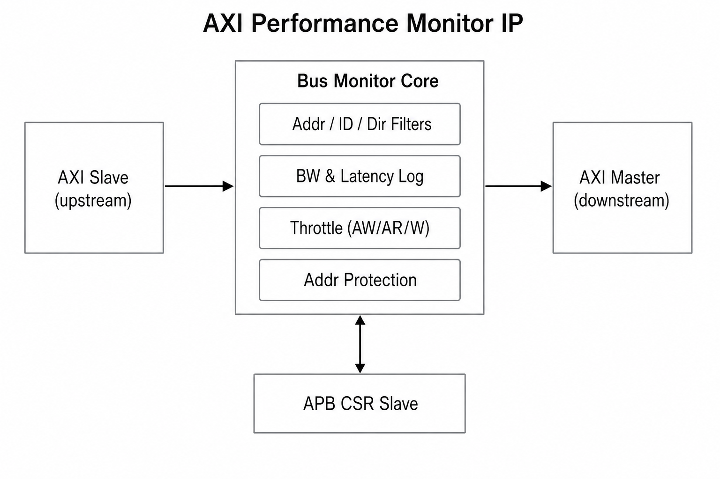
AXI Performance Monitor conceptual blocks

10.2 Filters → Features (reference Mermaid)
flowchart LR
subgraph filt [Filter stage]
A[Address]
I[ID mode]
D[Direction]
end
filt --> BW[Bandwidth log]
filt --> LAT[Latency incl multi-tx]
filt --> TH[Throttle static or credit]
XTH[External request_throttle] --> TH
filt --> AP[Address protection]

11. Implementation Deliverables (SHOULD)
The IP provider SHOULD supply, together with the implementation (directory layout MAY vary):
- RTL sources: Verilog/SystemVerilog suitable for synthesis and simulation.
- User documentation: Control register descriptions (bit meanings, addresses, reset values) consistent with this specification, plus clock/reset and parameter descriptions.
- Verification collateral: SVA assertions, test plan or verification summary.

Appendix A. Terms, Abbreviations, and AXI Channels
This appendix summarizes concepts for readability; protocol details follow AMBA AXI.
Term | Description
Upstream / Downstream | Relative to traffic flow through the monitor; connects to upstream masters/slaves on one side and downstream on the other (matches “Master Up / Master Down” naming in §2).
AR / AW / R / W / B | Read address, Write address, Read data, Write data, Write response channels.
Outstanding | A transaction whose response is not yet complete while subsequent address/data phases may be in flight; used in §5.2.2 multi-transaction segments.
APB | Low-speed configuration bus; this IP assumes a 32-bit APB slave for CSR access.
CSR | Control/status registers for configuration, statistics, and error logs.
Even/Odd FIFO | Two storage banks alternated every N periods so software can read one bank while the other continues recording.
W1C | Write 1 to Clear; writing 1 to a bit clears a flag.
SVA | SystemVerilog Assertions.
Byte counting: Phrases such as “AxSIZE × burst length” refer to transaction byte volume derived from AXI AWSIZE/ARSIZE and AWLEN/ARLEN (and related rules); the exact formula SHOULD match the AXI standard and be stated in the register/user documentation.

Companion documentation: Register maps, pin lists, and timing are provided separately by the IP provider and MUST satisfy the functional requirements of this specification.

