Battle for

Voxturia

Mock-Up from

Sébastien Godbout

01 may 2017

# Table des matières

Table des matières 1

Présentation 3

Objectifs 3

Aperçu 3

But du jeu 3

Core game loop 4

Se déplacer furtivement 4

Choisir une action 4

Observer 4

Système de sauvegarde 5

Fonctionnalités 5

Structure de niveau 6

Fonctionnalités 6

Type D’exploit 7

Fonctionnalités 7

Système de tour par tour 8

Fonctionnalités 8

Interactivité 8

Rétroactions 8

Personnage-joueur 9

Fonctionnalités 9

Interactivité 9

Rétroaction 9

contenu de niveau 10

Fonctionnalités 10

Interactivité 10

Rétroaction 10

Ennemies 11

Fonctionnalités 11

Interactivité 11

Rétroaction 11

Schéma de navigation 12

Maquettes 13

Écran de chargement 13

Écran titre 14

Liste d’exploits 15

Sélection de niveaux 16

Écran de jeu 17

HUD 18

MENU 19

Écran de fin de jeu 20

# Presentation

The objective of the document is to present the detail of all the screen of the game and the navigation between them for the future production of the game.

## Preview

|  |  |
| --- | --- |
| Platform | Standalone, Web, Mobile (Specific build) |
| Technologies | Unity C# |
| Genre | Turn base RPG |
| Point of view | 2D |
| Theme | The planet named Voxturia is a place where the best strategist is glorified, recruit mercenaries to fight under your commandment and become the best of all. |
| Visual style | * Pixel Art * Simple * Old School from SNES era |
| Target audience | Fan of strategic and turn base games.  Fan of Old School game. |

## GOAL OF THE GAME

The goal of the game is to clear the last level of the last area of the game. The secondary goal is to discover all the equipment.

After both goals are reached, an hardcore mode is available. In the hardcore mode, the goal is to surpass yourself to try to wins almost impossible battles.

NAVIGATION SCHEME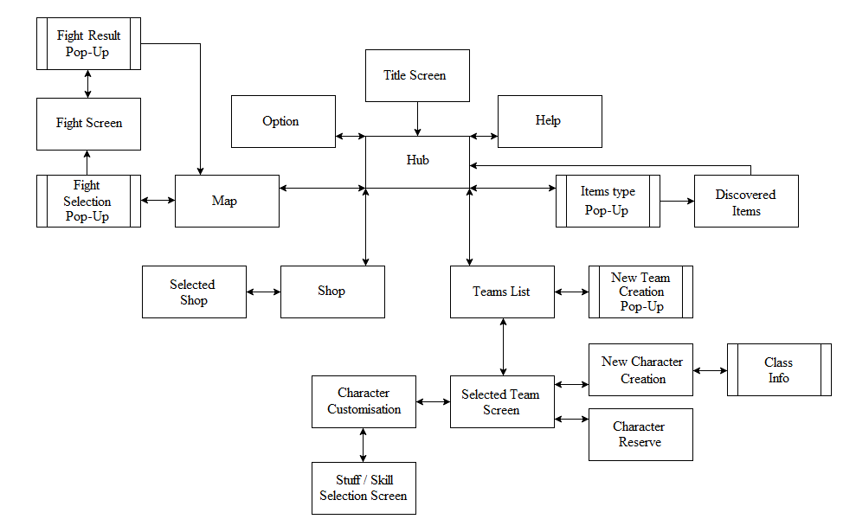

# Mock-Ups

## Title Screen

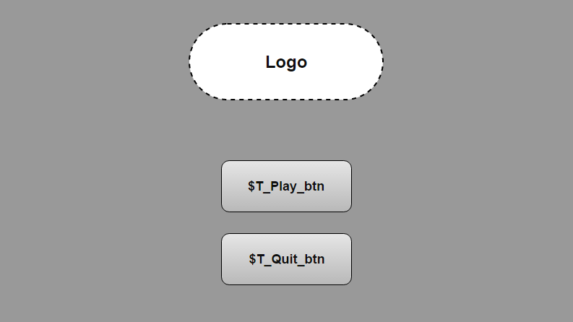

Screen Access

* This screen show-up automatically when the game start.
* The player can’t come back on at this screen unless he restarts the game.

Visual Elements

|  |  |
| --- | --- |
| Logo | The game name whit nice VFX. |
| Background image | Visual representing the essence of the game. |
| Buttons | Play, Quit. |

Interactivity and navigation

|  |  |
| --- | --- |
| $T_Play_btn | Brings up the Hub **screen**. |
| $T_Quit_btn | Quit the game. |

## Hub

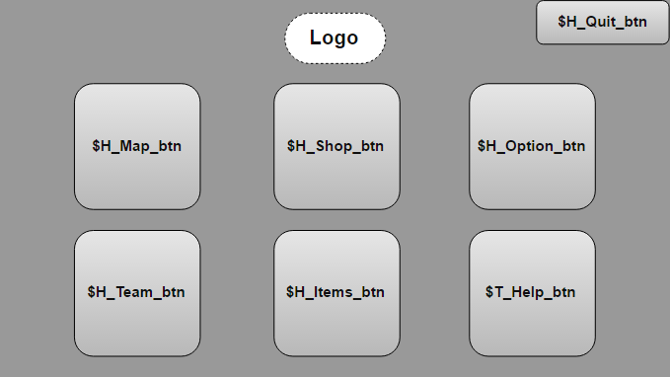

Screen Access

* From Title Screen.
* From Map.
* From Team List.
* From Shop.
* From Discovered Items.
* From Option.
* From Help.

Visual Elements

|  |  |
| --- | --- |
| Logo | The game name whit nice VFX. |
| Background image | Simple visual. |
| Buttons | Quit, Map, Team, Shop, Items, Option, Help. |
| $H_Map_btn | Icon of a planet OR a paper map (Not yet decided). Emit particle when hovering (Excluding mobile platform). |
| $H_Team_btn | Icon of multiple person shadow. Emit particle when hovering (Excluding mobile platform). |
| $H_Shop_btn | Icon of a vox (the game money). Emit particle when hovering (Excluding mobile platform). |
| $H_Items_btn | Icon of an armor. Emit particle when hovering (Excluding mobile platform). |
| $H_Option_btn | Icon of a cog. Emit particle when hovering (Excluding mobile platform). |
| $H_Help_btn | Icon of a question mark. Emit particle when hovering (Excluding mobile platform). |

Interactivity and navigation

|  |  |
| --- | --- |
| $H_Quit_btn | Quit the game. |
| $H_Map_btn | Brings up the Map **screen**. |
| $H_Team_btn | Brings up the Team List **screen**. |
| $H_Shop_btn | Brings up the Shop **screen**. |
| $H_Items_btn | Brings up the Items Type **pop-up**. |
| $H_Option_btn | Brings up the Option **screen**. |
| $H_Help_btn | Brings up the Help **screen**. |

## Items type

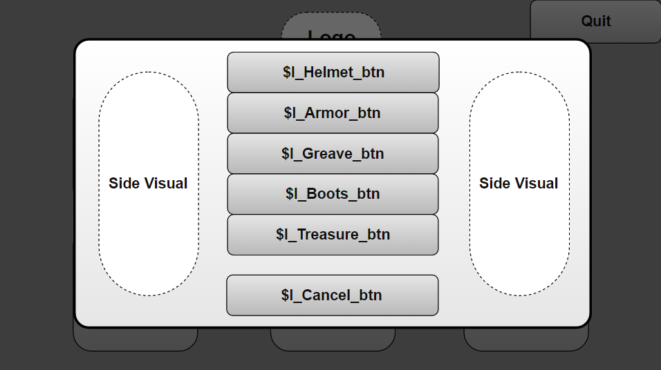

Screen Access

* From the Hub.

Visual Elements

|  |  |
| --- | --- |
| Background screen | Blurred and non-interactable. |
| Background image | Simple visual. |
| Side Visual | One sword each side whit nice fire VFX. |
| Buttons | Helmet, Armor, Greave, Boots, Treasure, Cancel. |

Interactivity and navigation

|  |  |
| --- | --- |
| $I_Helmet_btn | Brings up the Discovered Items **screen** (only helmet appear). |
| $I_Armor_btn | Brings up the Discovered Items **screen** (only armor appear). |
| $I_Greave_btn | Brings up the Discovered Items **screen** (only greave appear). |
| $I_Boots_btn | Brings up the Discovered Items **screen** (only boots appear). |
| $I_Treasure_btn | Brings up the Discovered Items **screen** (only treasure appear). |
| $I_Cancel_btn | Close the **pop-up**. |

## Discovered Items

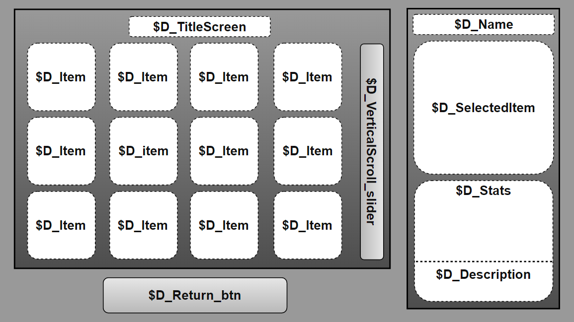

Screen Access

* From the Items Type Pop-Up (Hub).

Visual Elements

|  |  |
| --- | --- |
| Background image | Simple visual. |
| Section Background image | Simple visual. |
| $D_TitleScreen | The name of the screen depending of the item type. (Ex: Discovered Helmets, Discovered Armors) |
| $D_Item | Image of an item if discovered, else it’s a question mark visual. The item corresponds to the type of item of the screen. All the game item by type are shown. |
| $D_Name | The name of an $D_Item the mouse clicked. |
| $D_SelectedItem | The zoomed image of an $D_Item the mouse clicked. |
| $D_Stats | The stats of an $D_Item the mouse clicked. |
| $D_Description | The description of an $D_Item the mouse clicked. |
| Buttons | Return. |

Interactivity and navigation

|  |  |
| --- | --- |
| $D_Item | When clicked, show the stats of the item in the right section. |
| $D_VerticalScroll_slider | Allow to scroll vertically the $D_Item visuals |
| $D_Return_btn | Return at the Hub **screen**. |

|  |
| --- |
| Production Considerations  The screen might need to be heavily modified for mobile platform whit a pop-up for the information if the information is too small for mobile screen OR Clicking on the info bring a pop-up to zoom in the region. |

## Option

Screen Access

* From the Hub.

Visual Elements

|  |  |
| --- | --- |
| Background image | - |
| Buttons | Return. |

Interactivity and navigation

|  |  |
| --- | --- |
| - | - |
| $O_Return_btn | Return at the Hub **screen**. |

|  |
| --- |
| Production Considerations  The screen might need to be turned into a pop-up available from any screen for commodity.  OR  The screen might need to be removed if no real use for it. |

## Help

Screen Access

* From the Hub.

Visual Elements

|  |  |
| --- | --- |
| Background image | - |
| Buttons | Return. |

Interactivity and navigation

|  |  |
| --- | --- |
| - | - |
| $H_Return_btn | Return at the Hub **screen**. |

|  |
| --- |
| Production Considerations  The screen need to be defined after the game is made, and after player’s feedback to know where the help should focus. |

## Shop

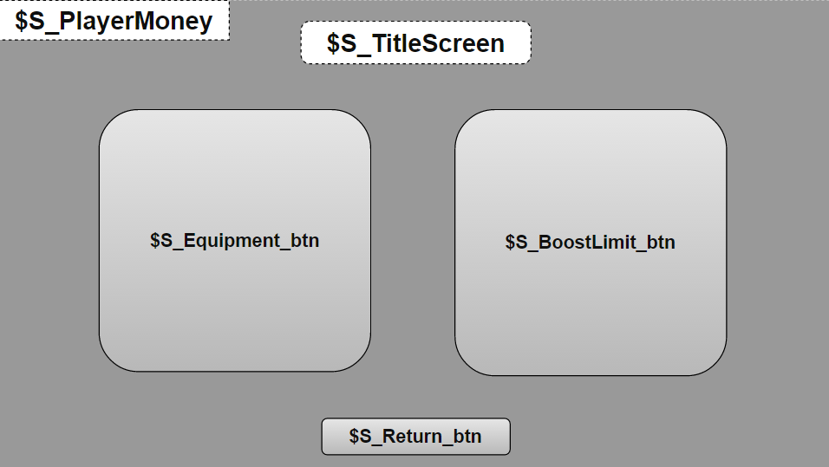

Screen Access

* From the Hub.
* Back from the Selected Shop.

Visual Elements

|  |  |
| --- | --- |
| Background image | Simple visual. |
| $S_TitleScreen | The name of the screen. |
| $S_PlayerMoney | The amount of “Vox” (game currency) the player has. |
| Buttons | Equipment, BoostLimit, Return. |

Interactivity and navigation

|  |  |
| --- | --- |
| $S_Equipment_btn | Brings up the Selected Shop **screen** (only Undiscovered equipment appear). |
| $S_BoostLimit_btn | Brings up the Selected Shop **screen** (Different deal, small amount cost more per ratio) |
| $S_Return_btn | Return at the Hub **screen**. |

## Selected Shop

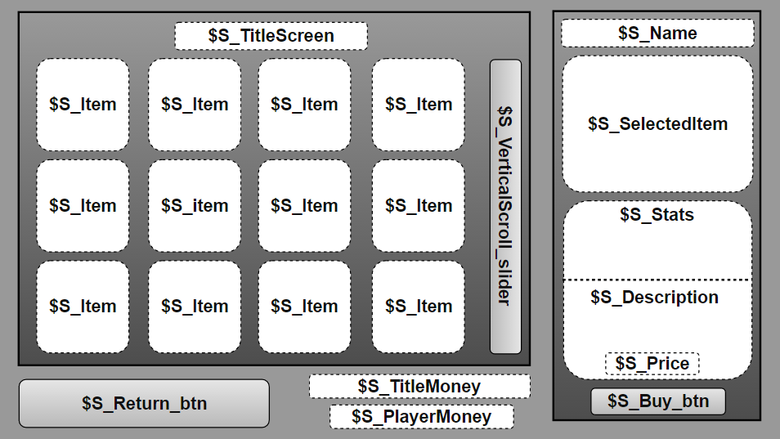

Screen Access

* From the Shop.

Visual Elements

|  |  |
| --- | --- |
| Background image | Simple visual. |
| Section Background image | Simple visual. |
| $S_TitleScreen | The name of the screen depending of the shop type. (Ex: Equipment Shop, Upgrade Shop) |
| $S_Item | If equipment shop, show undiscovered equipment. If upgrade shop, show the possible upgrade. |
| $S_TitleMoney | Show the money title (My Vox). |
| $S_PlayerMoney | Show the total of Vox the player has. |
| $S_Name | The name of an $S_Item the mouse clicked. |
| $S_SelectedItem | The zoomed image of an $S_Item the mouse clicked. |
| $S_Stats | The stats of an $S_Item the mouse clicked. |
| $S_Description | The description of an $S_Item the mouse clicked. |
| $S_Price | The price of an $S_Item the mouse clicked. |
| Buttons | Return. |

Interactivity and navigation

|  |  |
| --- | --- |
| $S_Item | When clicked, show the stats of the item in the right section. |
| $S_VerticalScroll_slider | Allow to scroll vertically the $S_Item visuals |
| $S_Buy_btn | Buy the item, reduct the $S_PlayerMoney and remove from the shop the item when needed. |
| $S_Return_btn | Return at the Shop **screen**. |

|  |
| --- |
| Production Considerations  The screen might need to be heavily modified for mobile platform whit a pop-up for the information if the information is too small for mobile screen OR Clicking on the info bring a pop-up to zoom in the region.  The upgrade shop should only affect the selected team. (A confirmation pop-up should show up to warn the player) |

## Map

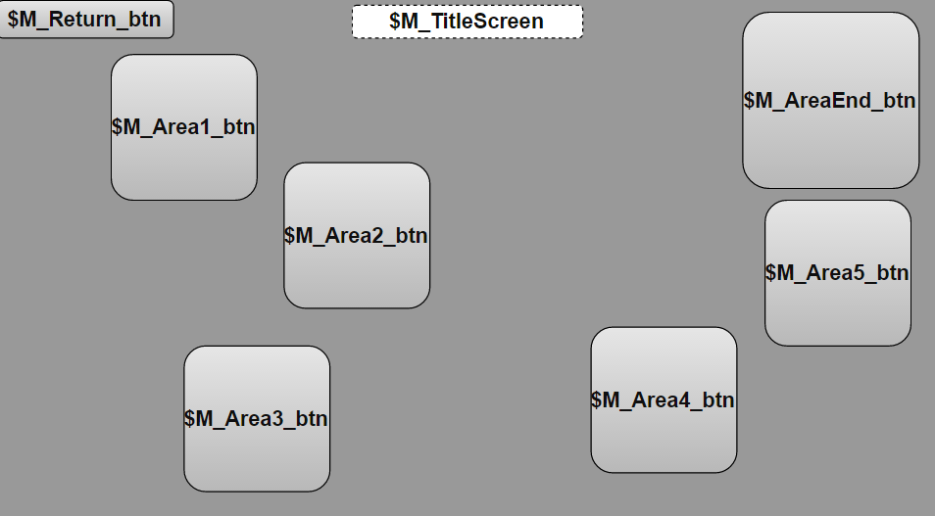

Screen Access

* From the Hub.
* From Fight Screen.

Visual Elements

|  |  |
| --- | --- |
| Background image | Image of the world map. |
| $M_TitleScreen | The name of the screen. |
| $M_Area1_btn | Icon of a Forest. |
| $M_Area2_btn | Icon of a Graveyard. |
| $M_Area3_btn | Icon of a Desert. |
| $M_Area4_btn | Icon of a Frozen Mountain. |
| $M_Area5_btn | Icon of a Burning Land. |
| $M_AreaEnd_btn | Icon of a Hell Coliseum. |
| Buttons | Area1, Area2, Area3, Area4, Area5, AreaEnd, Return. |

Interactivity and navigation

|  |  |
| --- | --- |
| $M_Area1_btn | Brings up the Fight Selection **pop-up**. |
| $M_Area2_btn | Brings up the Fight Selection **pop-up** if all previous dungeons are cleared and team is lvl 10+. |
| $M_Area3_btn | Brings up the Fight Selection **pop-up** if all previous dungeons are cleared and team is lvl 20+. |
| $M_Area4_btn | Brings up the Fight Selection **pop-up** if all previous dungeons are cleared and team is lvl 30+. |
| $M_Area5_btn | Brings up the Fight Selection **pop-up** if all previous dungeons are cleared and team is lvl 40+. |
| $M_AreaEnd_btn | Brings up the Fight Selection **pop-up** if all previous dungeons are cleared and team is lvl 50. |
| $M_Return_btn | Return at the Hub **screen**. |

|  |
| --- |
| Production Considerations  Doing a pop-up telling why the player can’t access an area would be user friendly. |

## Fight Selection

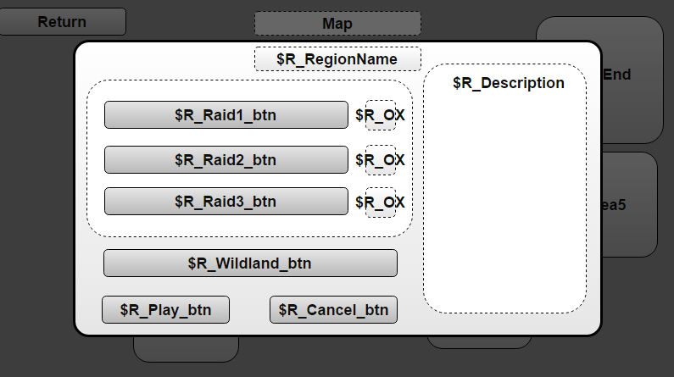

Screen Access

* From the Map.

Visual Elements

|  |  |
| --- | --- |
| Background screen | Blurred and non-interactable. |
| Background image | Simple visual. |
| Section Background image | Simple visual. |
| $M_RegionName | The name of the selected region. |
| $R_OX | Checkmark to display if a raid as already ben completed. Display green “✔” if already ben completed, else it display a red “✘”. |
| $R_Description | The description of a Raid or Wildland the mouse clicked. |
| Buttons | Raid1, Raid2, Raid3, Wildland, Play, Cancel. |

Interactivity and navigation

|  |  |
| --- | --- |
| $R_Raid1_btn | Unpress the other btn and get the $R_Play_btn clickable and show description in $R_Description. |
| $R_Raid2_btn | Unpress the other btn and get the $R_Play_btn clickable and show description in $R_Description. |
| $R_Raid3_btn | Unpress the other btn and get the $R_Play_btn clickable and show description in $R_Description. |
| $R_Wildland_btn | Unpress the other btn and get the $R_Play_btn clickable and show description in $R_Description. |
| $R_Play_btn | Brings up the Fight **screen** whit the selected fight option. |
| $R_Cancel_btn | Close the **pop-up**. |

## Fight Screen

Screen Access

* From the Fight Selection pop-up (Map).
* From the Fight Result pop-up (This screen).

Visual Elements

|  |  |
| --- | --- |
| Background image | - |
| Buttons | - |

Interactivity and navigation

|  |  |
| --- | --- |
| - | - |
| - | - |

|  |
| --- |
| Production Considerations  - |

## Fight Result

Screen Access

* From the Fight screen.

Visual Elements

|  |  |
| --- | --- |
| Background image | - |
| Buttons | - |

Interactivity and navigation

|  |  |
| --- | --- |
| - | - |
| - | - |

|  |
| --- |
| Production Considerations  - |

## Teams List

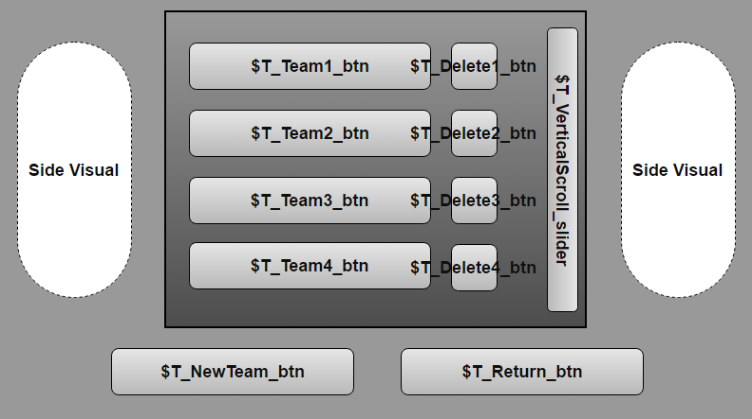

Screen Access

* From the Hub.
* Back from the Selected Team.

Visual Elements

|  |  |
| --- | --- |
| Background image | Simple visual. |
| Section Background image | Simple visual. If no registered team, display a message. |
| Side Visual | Visual catching the essence of team. (ex: shadow silhouette) |
| $T_Team#_btn | The selected team is highlighted whit VFX. |
| Buttons | Team#, Delete#, NewTeam, Return. |

Interactivity and navigation

|  |  |
| --- | --- |
| $T_Team#_btn | Brings up the Selected Team **screen** and display the name of the team. |
| $T_Delete#_btn | Brings up a confirmation **pop-up** to delete the team displayed on the left of the button and remove both button. |
| $T_VerticalScroll_slider | Allow to scroll vertically the $T_Team#_btn and $T_Delete#_btn visuals. |
| $T_NewTeam_btn | Brings up the New Team **pop-up.** |
| $T_Return_btn | Return at the Hub **screen**. |

## New Team Creation

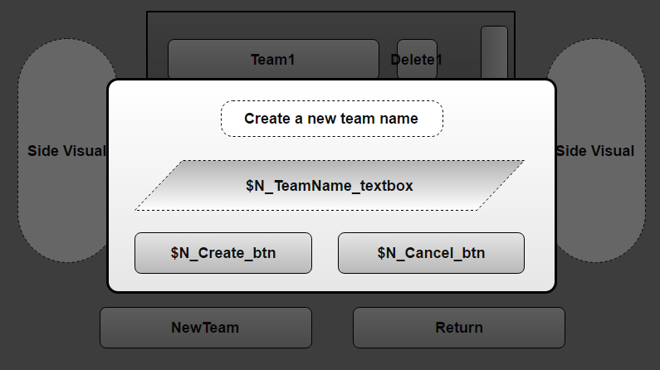

Screen Access

* From the Team List.

Visual Elements

|  |  |
| --- | --- |
| Background screen | Blurred and non-interactable. |
| Background image | Simple visual. |
| Create a new team name | Name of the pop-up |
| $N_TeamName_textbox | A blanc textbox to allow the player to choose his new team name. |
| Buttons | Create, Cancel. |

Interactivity and navigation

|  |  |
| --- | --- |
| $N_TeamName_textbox | Allow player to type his new team name. Can’t be left blanc or whit the same name as an existing team name. Also need a maximum and minimum character. |
| $N_Create _btn | Save the team information and close the **pop-up.** Anerror pop-up show up if the player left the textbox blanc, whit an already existing team name, is too short or too long. |
| $N_Cancel_btn | Close the **pop-up**. |

## Selected Team

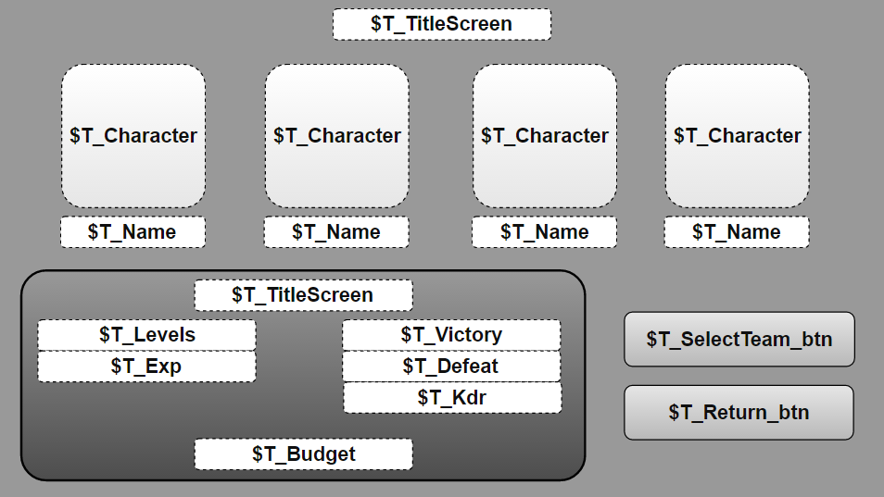

Screen Access

* From the Team List.
* Back from the New Character Creation.
* Back from the Alone Character List.
* Back from the Character Customisation.

Visual Elements

|  |  |
| --- | --- |
| Background image | Simple visual. |
| Section Background image | Simple visual. |
| $T_TitleScreen | Display the name of the team. |
| $T_Character | Display the character image if existing, else display an icon to suggest to add a new one. |
| $T_Name | Display the character name if existing, else display a “-”. |
| $T_Levels | Display the levels of the team. |
| $T_Exp | Display the exp in % until the next level. |
| $T_Victory | Display the amount of victory the team has. |
| $T_Defeat | Display the amount of defeat the team has, forfeit included. |
| $T_Kdr | Display the victory/defeat ratio. |
| $T_Budget | Display the team cost and its limit. If over 1/1 ration, display in red, else in green. |
| Buttons | Character, SelectTeam, Return. |

Interactivity and navigation

|  |  |
| --- | --- |
| $T_Character | If a character exists, bring up a Used Slot **pop-up** (Modifies, Remove, Cancel).  Else bring up an Unused Slot **pop-up** (Create, Choose, Cancel). |
| $T_SelectTeam_btn | Select the team to be able to play whit it. The button only work if the budget is not over the 1/1 ratio. Show up an error pop-up if can’t be selected. |
| $T_Return_btn | Return at the Team List **screen**. |

|  |
| --- |
| Production Considerations  Unselect the team if the condition to select a team are broken. (ex: The 1/1 budget ratio while the team is selected) |

## Character Creation

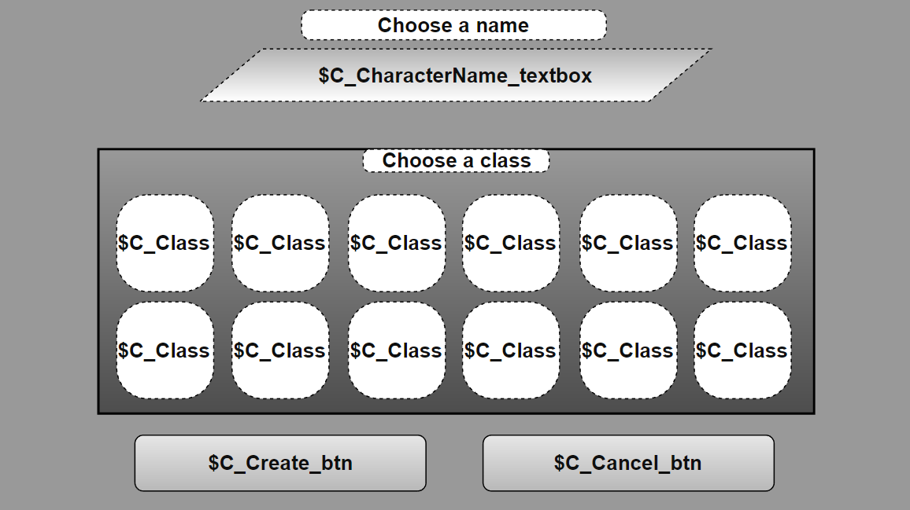

Screen Access

* From the Selected Team.

Visual Elements

|  |  |
| --- | --- |
| Background image | Simple visual. |
| Section Background image | Simple visual. |
| Choose a name | Title of the $C_CharacterName_textbox. |
| $C_CharacterName_textbox | A blanc textbox to allow the player to choose his new character name. |
| Choose a class | Title of the $C_Class section. |
| $C_Class | Each of them hold an image of a specific class. |
| Buttons | $C_Class, $C_Create_btn, $C_Cancel_btn. |

Interactivity and navigation

|  |  |
| --- | --- |
| $C_CharacterName_textbox | Allow player to type his new character name. Can’t be left blanc or whit the same name as an existing character name. Also need a maximum and minimum character. |
| $C_Class | Bring up a **pop-up** (Select, Info, Cancel). |
| $C_Create_btn | Save the character and go back at the Selected Team **screen**. |
| $C_Cancel_btn | Cancel the creation and go back at the Selected Team **screen**. |

|  |
| --- |
| Production Considerations  The $C_Class image could be an icon related to the class but not necessary the image of the playable character.  Should focus on 1-4 class maximum during the production, to release new class progressively after. |

## Class Info

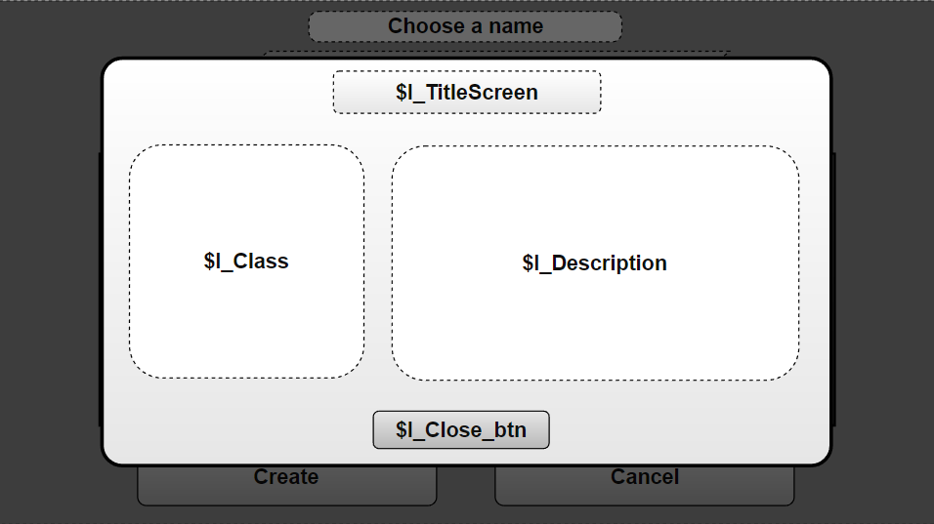

Screen Access

* From the Character Creation.

Visual Elements

|  |  |
| --- | --- |
| Background screen | Blurred and non-interactable. |
| Background image | Simple visual. |
| $I_TitleScreen | The name of the screen. |
| $I_Class | Display the image of the class. |
| $I_Description | Description of the class. |
| Buttons | Close. |

Interactivity and navigation

|  |  |
| --- | --- |
| $I_Close_btn | Close the **pop-up**. |

## Character Reserve

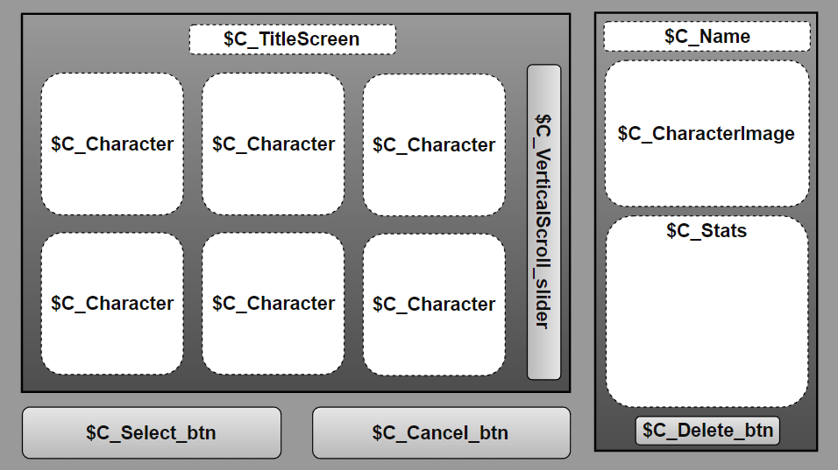

Screen Access

* From the Selected Team.

Visual Elements

|  |  |
| --- | --- |
| Background image | Simple visual. |
| Section Background image | Simple visual. |
| $C_TitleScreen | The name of the screen. |
| $C_Character | Image of an existing character not part of any existing team. |
| $C_Name | The name of an $C_Character the mouse clicked. |
| $C_CharacterImage | The image of an $C_Character the mouse clicked. |
| $C_Stats | The stats of an $C_Character the mouse clicked. |
| Buttons | Select, Cancel, Delete. |

Interactivity and navigation

|  |  |
| --- | --- |
| $C_Character | When clicked, show the stats of the character in the right section. |
| $C_VerticalScroll_slider | Allow to scroll vertically the $D_Item visuals |
| $C_Select_btn | Can get clicked when the player selected an $C_Character. Add the character to the right team and return at the right Selected Team **screen**. |
| $C_Cancel_btn | Return at the right Selected Team **Screen**. |
| $C_Delete_btn | Remove the $C_Character from the Character Reserve (Delete the data). A confirmation **pop-up** should appear to confirm whit a warning message. |

|  |
| --- |
| Production Considerations  The screen might need to be heavily modified for mobile platform whit a pop-up for the information if the information is too small for mobile screen OR Clicking on the info bring a pop-up to zoom in the region. |

## Sélection de niveaux

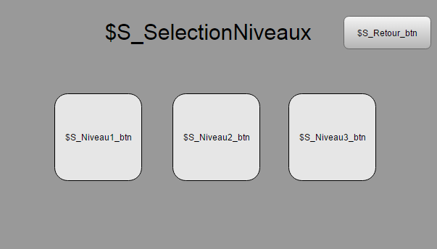

Accès à l’écran

* À partir de l’écran titre

Éléments visuels

|  |  |
| --- | --- |
| $S_SelectionNiveaux | Titre de l’écran. |
| Image de fond | Visuel vendeur représentant l’essence du jeu |
| Boutons | Niveau1, Niveau2, Niveau3 et Retour. |

Interactivité et navigation

|  |  |
| --- | --- |
| $S_Niveau1_btn | Fait apparaitre l’écran de jeu au niveau 1. |
| $S_Niveau2_btn | Fait apparaitre l’écran de jeu au niveau 2, si le niveau 1 a été compléter. |
| $S_Niveau3_btn | Fait apparaitre l’écran de jeu au niveau 3, si le niveau 1 et 2 ont été compléter. |
| $S_Retour_btn | Retourne à l’écran titre. |

## Écran de jeu

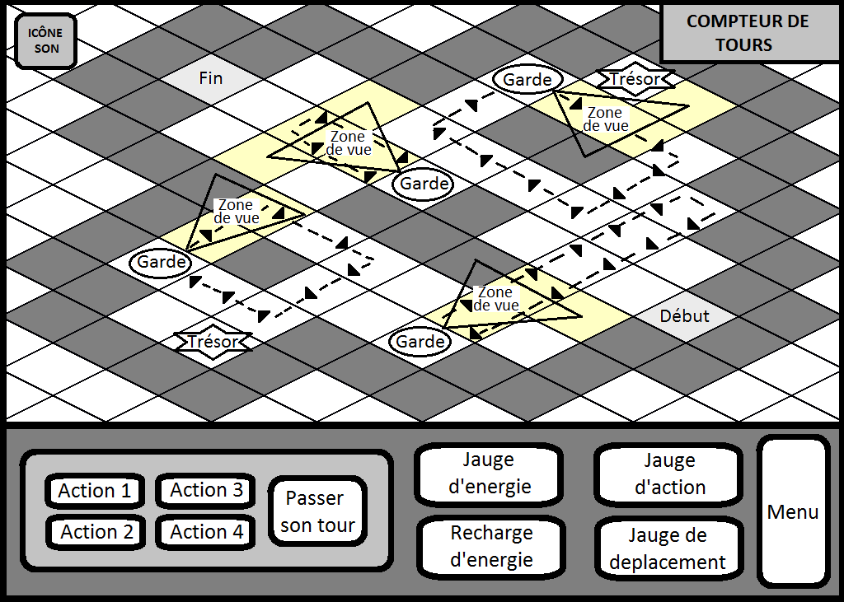

Accès à l’écran

* À partir de l’écran de sélection de niveaux.

Éléments visuels

|  |  |
| --- | --- |
| Éléments | HUD |
| Bouton | Son. |

Interactivité et navigation

|  |  |
| --- | --- |
| Icône Son | Change le statut du son à actif ou inactif. |
| Condition défaite ou victoire remplies | Fait apparaitre l’écran de fin de jeu (après un court délai). |
| Bouton Menu | Fait apparaitre la boite de menu. |

## HUD

Zone action

4 boutons correspondent aux 4 actions du joueur (voir Actions).

**Actions :** clic gauche de souris sur l’icône, puis sur un élément du jeu (varie en fonction de l’action)

Chaque bouton a 4 états :

* **Illuminé :** L’icône brille pour indiquer que l’action peut être utilisée.
* **Grisé :** L’icône est grisée pour indiquer que le joueur n’a pas suffisamment de point d’action ou d’énergie.
* **En recharge :** L’icône indique un chiffre qui indique le nombre de tours de recharge avant qu’il soit de nouveau utilisable.
* **Non Identifié :** L’icône indique ‘ ? ’ pour une action qui n’a pas encore été débloquée par le joueur.

Les jauges

La jauge d’action et de déplacement revient à leur maximum à chaque début de tour du joueur.

La jauge d’énergie revient à son maximum que si le bouton recharge d’énergie est utilisé.

**Compteur de tours**

Rétroaction : chaque fois que le joueur commence un tour, le compteur augmente de 1.

**Menu contextuel**

Ce menu de survol apparaît en contexte d’un élément survolé :

|  |  |
| --- | --- |
| Les 4 actions et le bouton de recharge d’énergie | Affiche les coûts, temps de relance et condition d’utilisation de l’action ou de la recharge d’énergie.  Survoler une action permet aussi d’afficher en surbrillance les éléments du décor qui lui sont liés. |

## MENU

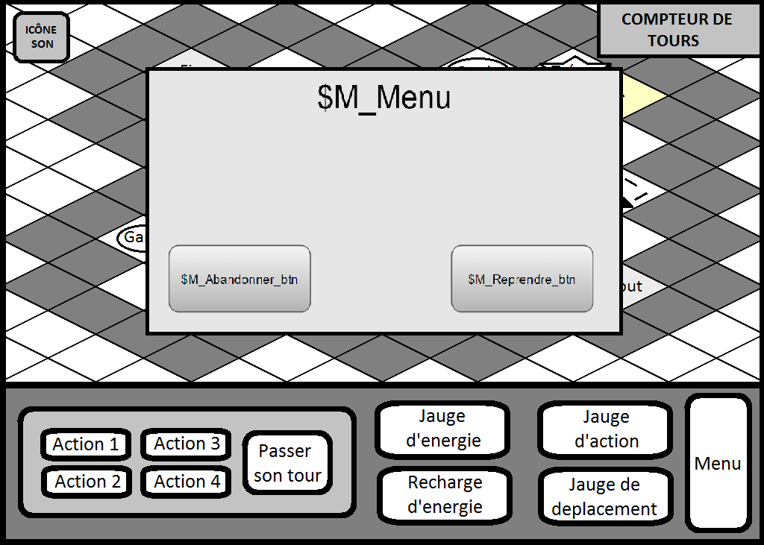

Accès à l’écran

* À partir de l’écran de jeu

Éléments visuels

|  |  |
| --- | --- |
| $M_Menu | Titre de l’écran. |
| Boutons | Reprendre et Abandonner. |

Interactivité et navigation

|  |  |
| --- | --- |
| $M_Abandonner_btn | Ferme la fenêtre et fais apparaître l’écran de fin de jeu. |
| $M_Reprendre_btn | Ferme la fenêtre et remet le jeu en marche. |

## Écran de fin de jeu

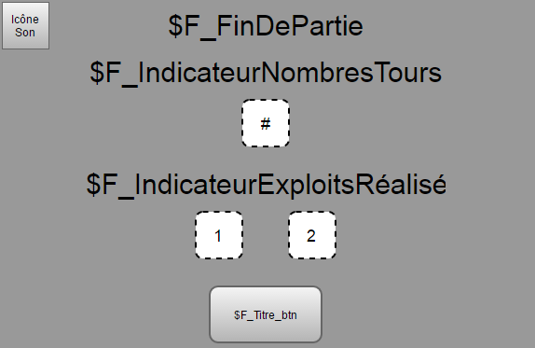

Accès à l’écran

* À partir du menu
* À la fin d’une partie

Éléments visuels

|  |  |
| --- | --- |
| $F_FinDePartie | Change selon si le joueur a gagné ou a perdu. |
| $F_IndicateurNombresTours | N’apparait que si le joueur provient d’une partie gagnée. |
| $F_IndicateurExploitsRéalisé | N’apparait que si le joueur provient d’une partie gagnée. |
| Boutons | Son, Retour à l’écran titre. |
| Élément 1 | Image de l’exploit 1 du niveau. Grisé si non compléter, brillant si réussi. |
| Élément 2 | Image de l’exploit 2 du niveau. Grisé si non compléter, brillant si réussi. |

Interactivité et navigation

|  |  |
| --- | --- |
| $F_Titre_btn | Retourne à l’écran titre. |
| Icône Son | Change le statut du son à actif ou inactif. |