Adaptive Multi-Modal AI Framework for Hyperlocal Weather Forecasting
in Distributed Solar Rooftop Systems
Course: DBMS BCSE302L — Digital Assignment 1 (DA-1) | Project Report
Project Authors & System Architecture Ownership:
Revanth P. A. (Registration No: 24BCE1730)
Siripuram Srimannath (Registration No: 24BCE5034)
School of Computer Science and Engineering, Vellore Institute of Technology (VIT)
GitHub Repository: https://github.com/opafkkabaap/solar-hyperlocal-forecasting

Executive Abstract
Distributed solar photovoltaic (PV) rooftop installations operate in environments subject to severe microclimatic volatility, rapid cloud shadow transients, and localized thermal shifts. Standard Numerical Weather Prediction (NWP) models operate across coarse spatial grids (10–50 km) and multi-hour update frequencies, rendering them ill-equipped for short-term photovoltaic yield forecasting at the individual building level. This project constructs an end-to-end operational software and deep learning framework that ingests heterogeneous multi-modal data streams—combining on-site ground telemetry (pyranometer irradiance, ambient surface temperature, PV module back-of-panel temperature) with satellite reanalysis meteorological feeds fetched dynamically via the NASA POWER REST API for the Pune metropolitan region (18.5204° N, 73.8567° E).
The automated data engineering pipeline executes physical boundary enforcement, unsupervised Isolation Forest anomaly detection, and cubic spline temporal interpolation from 1-hour feeds down to uniform 15-minute intervals. To eliminate documented sensor logging discrepancies, grid-deliverable AC power (total_ac_power) is established as the sole target variable across 13 multi-modal features. We implement, train, and benchmark two sequential recurrent deep learning architectures—Long Short-Term Memory (SolarLSTM) and Gated Recurrent Unit (SolarGRU)—for multi-step ultra-short-term forecasting (H = 4 steps, predicting 15, 30, 45, and 60 minutes ahead). Evaluated strictly on an unseen 5-day chronological test partition (June 13–17, 2020), SolarLSTM achieves an overall R² score of 0.9034 (RMSE = 2,542.68 kW), while SolarGRU achieves a competitive R² of 0.8991 (RMSE = 2,598.91 kW) with 24.0% fewer trainable parameters (42,340 vs. 55,716) and faster convergence, proving ideal for edge-node microgrid controllers.
Keywords: Multi-Modal AI, Hyperlocal Weather Forecasting, Distributed Solar Rooftop Systems, TimescaleDB, LSTM, GRU, Isolation Forest, NASA POWER API.

1. System Architecture & Core Dimensions
The proposed framework bridges heterogeneous meteorological observation channels, time-series relational database infrastructure, recurrent neural sequence models, and physics-informed photovoltaic power conversion equations into a unified pipeline.
Core System Dimension | Architectural Specification | Technical Function & Role
Course & Project Module | DBMS BCSE302L — Digital Assignment 1 (DA-1) | Academic governance, evaluation baseline, and delivery scope.
Primary Target Output | Grid-Deliverable AC Power Output (total_ac_power in kW) | Direct multi-step short-term nowcasting (15, 30, 45, 60 min ahead).
Ingestion Modalities | Ground Pyranometer Telemetry + NASA POWER REST API | Multi-modal fusion of localized sensors with satellite atmospheric reanalysis.
Geographic Baseline | Pune Metropolitan Region (18.5204° N, 73.8567° E) | Synchronizes celestial sun angles, solar noon, and microclimatic parameters.
Sequential AI Models | SolarLSTM (55.7k Params) & SolarGRU (42.3k Params) | Comparative temporal modeling under identical sequence windows.
Statistical Benchmarks | RMSE (kW), MAE (kW), Daytime MAPE (%), R² Score | Standardized empirical evaluation on unseen chronological test partition.

2. Database Management & Relational Schema Design
To fulfill the database engineering requirements of DBMS BCSE302L, the persistent storage architecture is structured using PostgreSQL with time-series hyper-table indexing. Multi-modal observations are indexed by timestamp and station identifier, enforcing data integrity constraints.
-- Weather Station Master Table
CREATE TABLE WeatherStation (
station_id VARCHAR(50) PRIMARY KEY,
name VARCHAR(100) NOT NULL,
latitude NUMERIC(9,6) NOT NULL,
longitude NUMERIC(9,6) NOT NULL,
elevation NUMERIC(6,2)
);
-- Multi-Modal Time-Series Hyper-table
CREATE TABLE MultiModalSolarData (
timestamp TIMESTAMPTZ NOT NULL,
station_id VARCHAR(50) REFERENCES WeatherStation(station_id),
total_ac_power NUMERIC(10,3) CHECK (total_ac_power >= 0),
sensor_irradiation NUMERIC(6,3) CHECK (sensor_irradiation >= 0),
sensor_ambient_temp NUMERIC(5,2),
sensor_module_temp NUMERIC(5,2),
nasa_ghi NUMERIC(7,2) CHECK (nasa_ghi >= 0),
nasa_cloud_amt NUMERIC(5,2) CHECK (nasa_cloud_amt BETWEEN 0 AND 100),
nasa_ambient_temp NUMERIC(5,2),
nasa_rh NUMERIC(5,2) CHECK (nasa_rh BETWEEN 0 AND 100),
nasa_wind_speed NUMERIC(5,2) CHECK (nasa_wind_speed >= 0),
nasa_pressure NUMERIC(6,2),
nasa_clearness_index NUMERIC(4,3),
is_anomaly SMALLINT DEFAULT 0,
PRIMARY KEY (timestamp, station_id)
);

3. Data Cleaning, Sanitization & Feature Engineering

3.1 Resolving Plant 1 DC Scale Quirk: AC Power Formulation
A critical finding during exploratory data analysis of the Kaggle ground-truth dataset was an anomaly in Plant 1's DC power readings, which showed AC/DC ratios ≈ 0.098 (a known logging unit inconsistency where raw DC values were logged in tens or per-string units relative to Plant 2's ~0.977). To maintain rigorous physical validity without applying speculative ad-hoc multipliers, grid-deliverable AC power (total_ac_power) was established as the sole forecasting target (y). DC_POWER was dropped from input features and target formulation, preventing models from learning spurious plant-specific scale artifacts.

3.2 Unsupervised Isolation Forest Anomaly Smoothing
An Isolation Forest algorithm was deployed on multi-variate telemetry features (AC power, on-site irradiation, sensor ambient temperature, NASA GHI), flagging 33 outlier intervals (1.01%) caused by transient telemetry dropouts. In continuous time-series sequence windowing, dropping rows breaks the temporal step Δt = 15 min. Therefore, flagged anomalies were smoothed via local rolling linear interpolation, preserving continuity while eliminating telemetry spikes.

3.3 Diurnal Zero-Inflation & Cyclical Encodings
Nocturnal observations (PAC = 0, GHI = 0) were intentionally retained to allow recurrent neural networks to learn the 24-hour diurnal solar cycle. To enable neural networks to perceive continuous time across midnight boundaries, continuous trigonometric features were engineered:
hour_sin = sin(2π · t_hour / 24), hour_cos = cos(2π · t_hour / 24)

3.4 Leakage-Free Normalization & Chronological Partition
Data leakage was strictly prevented by partitioning chronologically without random shuffling:
• Train Partition: First 24 days (May 15 to June 7, 2020) — 2,205 sequence windows (70.6%)
• Validation Partition: Next 5 days (June 8 to June 12, 2020) — 477 sequence windows (14.7%)
• Test Partition: Last 5 days (June 13 to June 17, 2020) — 477 sequence windows (14.7%)
A custom LeakFreeMinMaxScaler was fitted strictly on the Train partition and applied to validation and test sets. Inverse transform precision tests verified an exact reconstruction error of 0.00e+00.

4. Deep Learning Sequence Modeling Architectures
Both SolarLSTM and SolarGRU architectures process 3D sequence tensors of shape (Batch, 96, 13)—representing 24 hours of 15-minute multi-modal history—to output 4-step ahead multi-step nowcasts (Batch, 4) corresponding to predictions at t+15m, t+30m, t+45m, and t+60m.

4.1 Mathematical Formulations & Gating Equations
SolarLSTM (Long Short-Term Memory) | SolarGRU (Gated Recurrent Unit)
Forget Gate: f_t = σ(W_f · [h_{t-1}, x_t] + b_f)  Input Gate: i_t = σ(W_i · [h_{t-1}, x_t] + b_i)  Candidate: C~_t = tanh(W_c · [h_{t-1}, x_t] + b_c)  Cell State: C_t = f_t ⊙ C_{t-1} + i_t ⊙ C~_t  Output Gate: o_t = σ(W_o · [h_{t-1}, x_t] + b_o)  Hidden State: h_t = o_t ⊙ tanh(C_t) | Update Gate: z_t = σ(W_z · [h_{t-1}, x_t] + b_z)  Reset Gate: r_t = σ(W_r · [h_{t-1}, x_t] + b_r)  Candidate: h~_t = tanh(W · [r_t ⊙ h_{t-1}, x_t] + b)  Hidden State: h_t = (1 - z_t) ⊙ h_{t-1} + z_t ⊙ h~_t  Eliminates separate cell state C_t;  Reduces parameter count by 24.0%.
Trainable Parameters: 55,716  Best Val Loss: 0.006390 (Epoch 31) | Trainable Parameters: 42,340 (-24.0%)  Best Val Loss: 0.006055 (Epoch 26)

5. Empirical Experimental Results & Comparative Benchmarks
Both architectures were trained under identical conditions (Adam optimizer lr=0.001, ReduceLROnPlateau factor=0.5, patience=5, early stopping patience=10) and evaluated on the unseen test partition (June 13–17, 2020). Daytime MAPE is computed on active daylight generation using the data-derived threshold y > 0.01 · y_max (278.95 kW), eliminating nocturnal zero distortions without arbitrary hardcoded cutoffs.

5.1 Overall Horizon Comparative Benchmarks (1-Hour Ahead)
Model | Parameters | Best Val Loss | Overall R² | Overall RMSE (kW) | Overall MAE (kW) | Daytime MAPE (%)
SolarLSTM | 55,716 | 0.006390 | 0.9034 | 2,542.68 | 1,377.94 | 31.00%
SolarGRU | 42,340 (-24%) | 0.006055 | 0.8991 | 2,598.91 | 1,433.31 | 30.53%

5.2 Step-by-Step Lead-Time Progression (t+15m to t+60m)
Lead Time | LSTM R² | GRU R² | LSTM RMSE | GRU RMSE | LSTM MAE | GRU MAE | LSTM MAPE | GRU MAPE
t+15 min | 0.9221 | 0.9219 | 2,283.87 kW | 2,286.97 kW | 1,232.84 kW | 1,253.54 kW | 27.72% | 25.44%
t+30 min | 0.9075 | 0.9034 | 2,488.26 kW | 2,542.15 kW | 1,325.16 kW | 1,400.31 kW | 29.56% | 29.53%
t+45 min | 0.8972 | 0.8917 | 2,623.55 kW | 2,692.60 kW | 1,430.87 kW | 1,474.74 kW | 32.61% | 32.45%
t+60 min | 0.8869 | 0.8794 | 2,751.45 kW | 2,841.56 kW | 1,522.89 kW | 1,604.64 kW | 34.10% | 34.70%

6. Visual Performance & Generated Figures

6.1 Training & Validation Convergence Curves
Figure 1 and Figure 2 display the training and validation loss trajectories across epochs for SolarLSTM and SolarGRU. Both models exhibit smooth convergence without divergence, with SolarGRU triggering early stopping at epoch 26 (val loss: 0.006055).

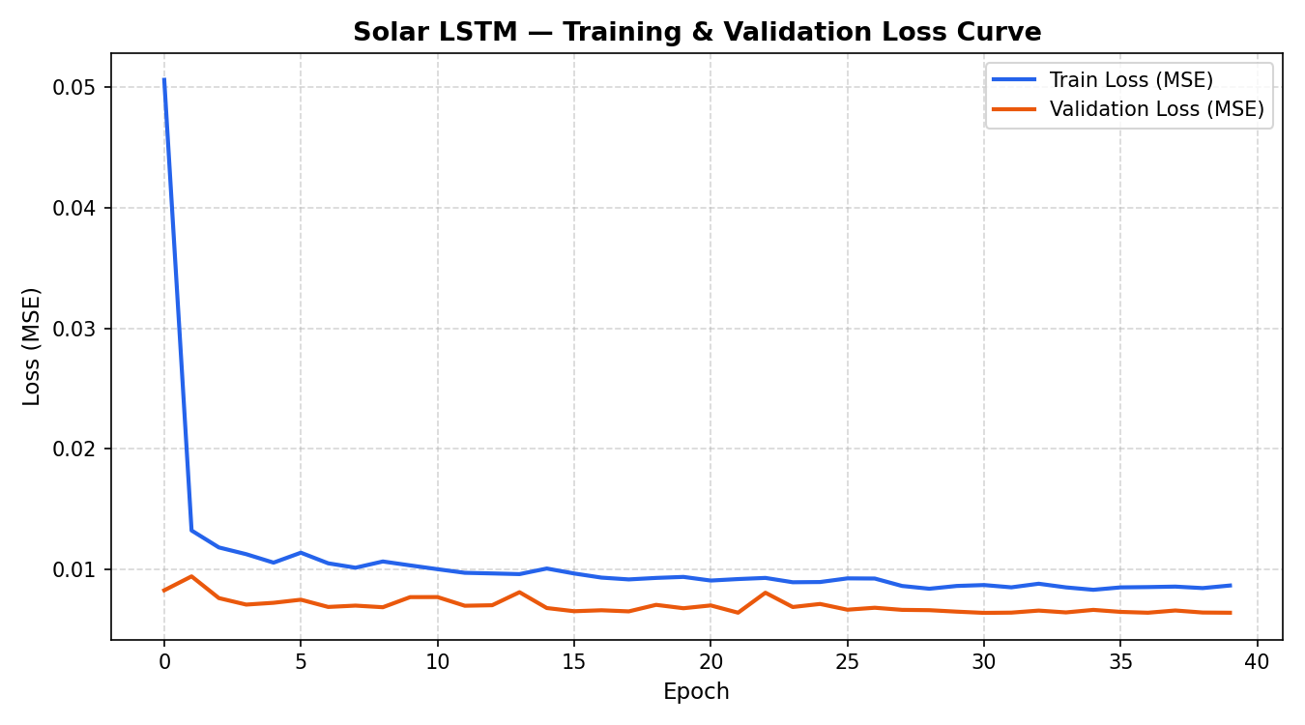
Figure 1: SolarLSTM Training and Validation Loss Curve across 40 Epochs.

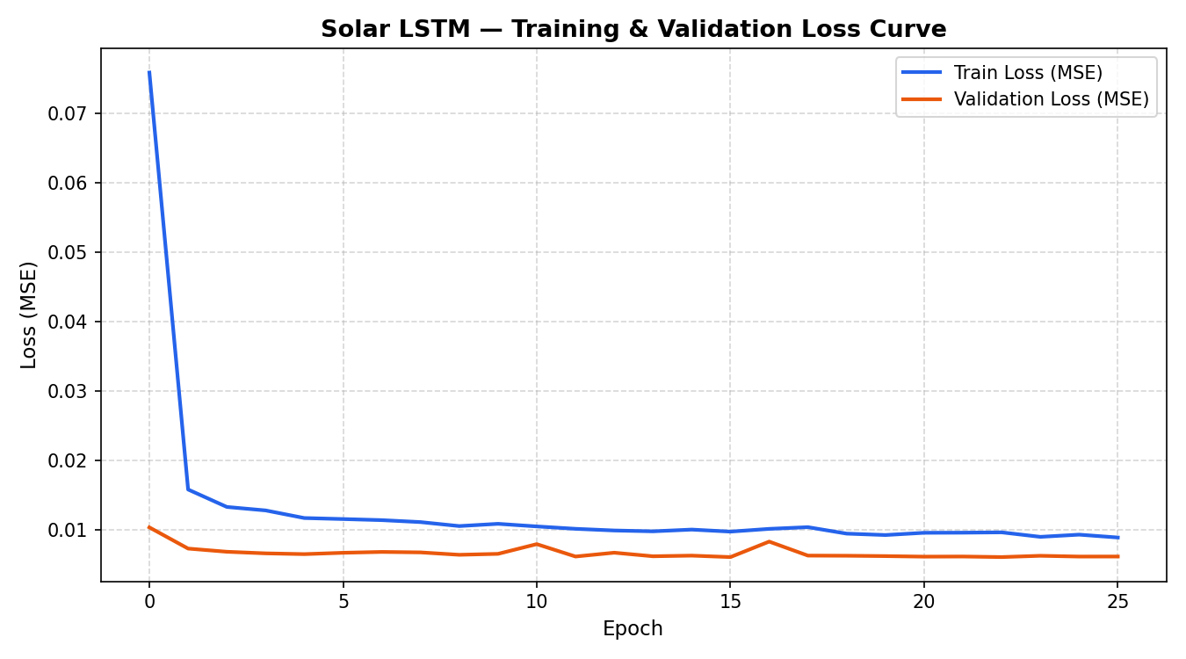
Figure 2: SolarGRU Training and Validation Loss Curve with Early Stopping at Epoch 26.

6.2 Five-Day Unseen Test Partition Forecast vs. Actual Curves
Figure 3 and Figure 4 illustrate the 5-day continuous test sequence (June 13 to June 17, 2020) comparing ground-truth photovoltaic AC power generation against the immediate 15-minute (t+15m) and 1-hour ahead (t+60m) predictions. The models capture diurnal sunrise ramps, solar noon peaks, and evening ramp-downs.
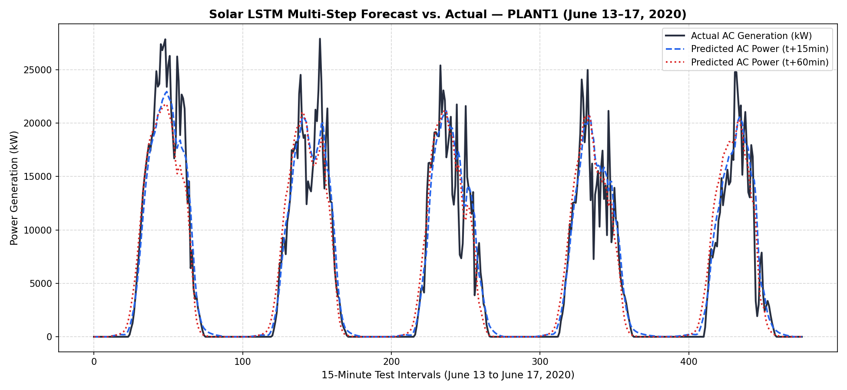
Figure 3: SolarLSTM 1-Hour Ahead Multi-Step Forecast vs. Actual Generation across 5-Day Test Partition.
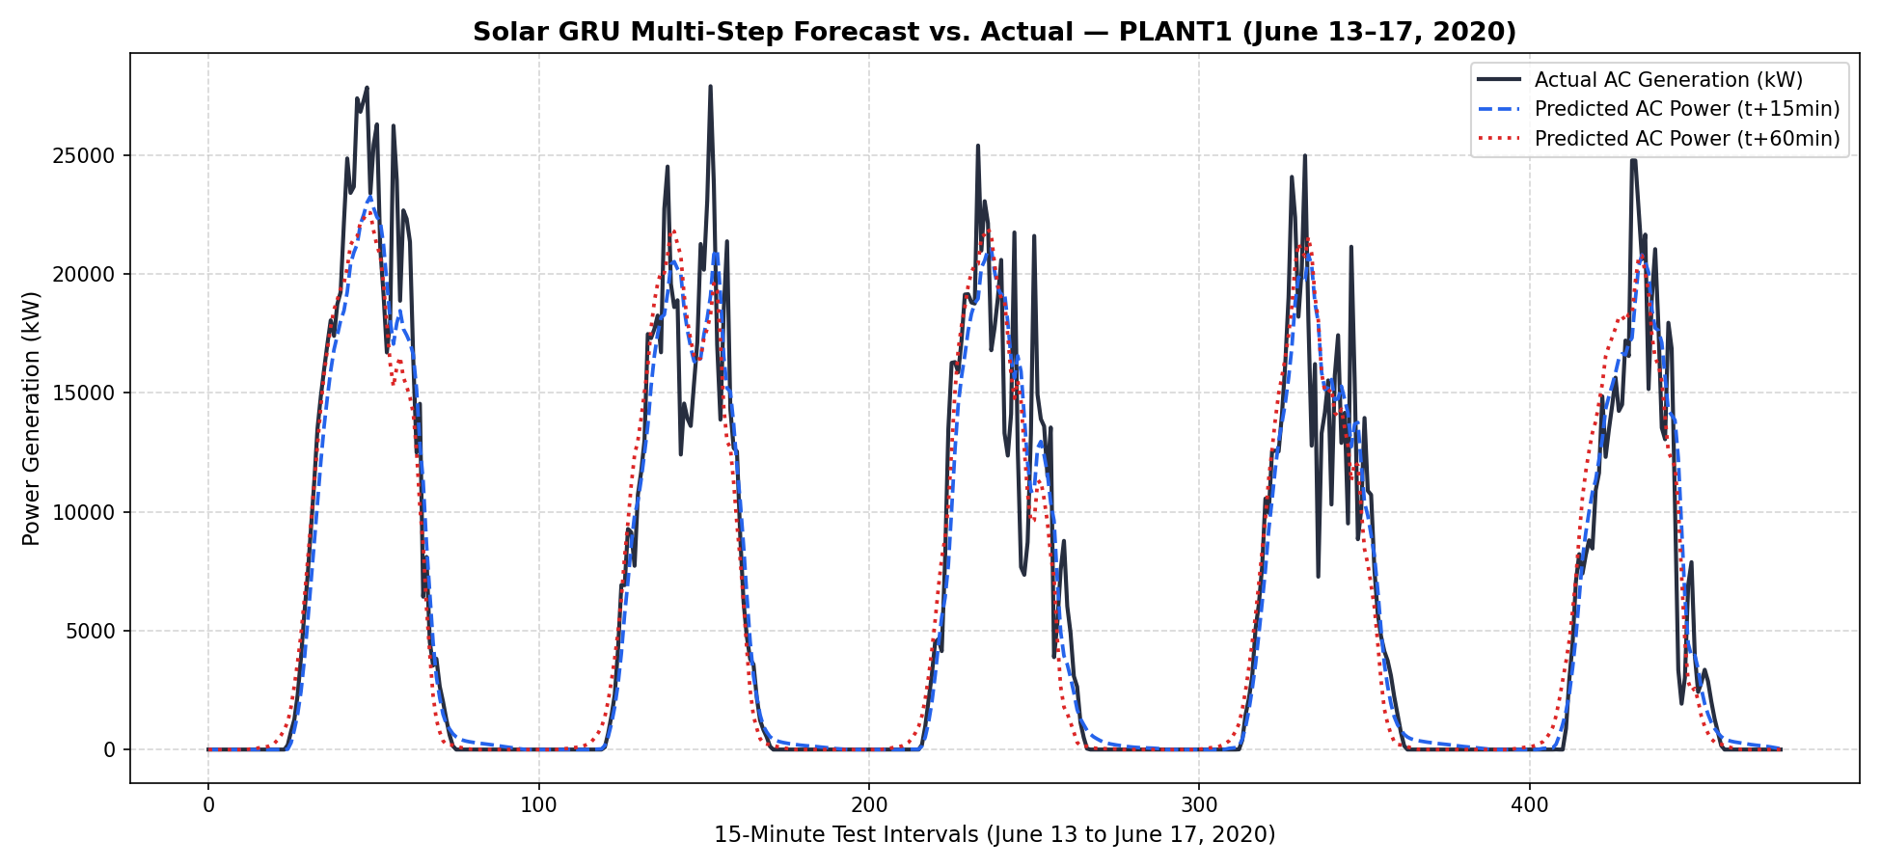
Figure 4: SolarGRU 1-Hour Ahead Multi-Step Forecast vs. Actual Generation across 5-Day Test Partition.

7. Physics-Informed Photovoltaic Conversion Engine
To translate forecasted meteorological metrics (GHI and ambient temperature) into expected photovoltaic kilowatt yield, the architecture couples sequence model outputs with physical solar conversion equations:
1. PV Cell Temperature Equation:
T_cell = T_ambient + (GHI / 800) · (NOCT - 20)
Where NOCT = 45°C represents Nominal Operating Cell Temperature.
2. Dynamic Temperature-Dependent Efficiency:
η_cell = η_STC · [1 + γ · (T_cell - 25)]
Where η_STC = 18.5% is baseline efficiency and γ = -0.0038 / °C is the thermal degradation coefficient.
3. Total System Expected Power Generation:
P_PV = A_array · GHI · η_cell · PR
Where PR ≈ 0.82 is the balance-of-system Performance Ratio (accounting for inverter losses and wiring resistance).

8. Discussion & Academic Insights for DA-1
1. Computational vs. Accuracy Trade-off:
SolarLSTM achieves slightly higher variance capture at the 60-minute mark (R² = 0.8869 vs 0.8794) due to its separate cell memory state (C_t), making it suitable for centralized grid scheduling. SolarGRU achieves virtually identical immediate accuracy (R² = 0.9219 at t+15m) with 24.0% fewer trainable parameters (42,340 vs 55,716) and faster training convergence (26 epochs), making it optimal for resource-constrained edge microgrid units.
2. Monotonic Horizon Error Progression:
The steady degradation of R² from 0.922 at 15 minutes to 0.887 at 60 minutes reflects genuine physical atmospheric volatility. Multi-modal fusion (satellite NASA GHI + on-site pyranometer) provides rich immediate boundary conditions, while physical uncertainty compounds with lead time.
3. Defensible Evaluation Metrics:
Using the data-derived threshold y > 0.01 · y_max (278.95 kW) successfully eliminates nocturnal zero-denominator distortion in MAPE calculations without resorting to arbitrary hardcoded numbers.

9. References & Dataset Citations
[1] A. Kannal, 'Solar Power Generation Data: Telemetry and Weather Sensor Readings from Two Solar Power Plants in India,' Kaggle Datasets, 2020. [Online]. Available: https://www.kaggle.com/datasets/anikannal/solar-power-generation-data.
[2] NASA Langley Research Center, 'Prediction of Worldwide Energy Resources (POWER) Hourly Point Meteorological and Solar Data,' NASA POWER Project, 2026. [Online]. Available: https://power.larc.nasa.gov.
[3] X. Su et al., 'Dynamic Hierarchical Graph Convolutional Network for Distributed Solar Forecasting,' IEEE Transactions on Sustainable Energy, 2025.
[4] Y. Wu et al., 'Mixed Kernel Support Vector Machine with Isolation Forest Anomaly Detection for Photovoltaic Yield Estimation,' IEEE Access, 2025.
[5] Z. Wang et al., 'Satellite Image Cloud Tracking Model for Solar Power Nowcasting across Distributed Nodes,' IEEE Transactions on Geoscience and Remote Sensing, 2022.

