Problem 1 Commenting website 3 items that have bad design

For my website is [www.lingscars.com](http://www.lingscars.com). This website is about car leasing.

* Colors: A lot of colors with contrast from text, picture, gif and background that kind of (soooo much) colorful. Make us feel lost.
* The font: I didn’t scroll the from my first visit this website. Frankly, I saw more than 3 fonts stuck on this page. That make the website are not going to the same direction. With regards, it feels untidy.
* In the Price list, the page is too long. I can scroll it for a while till the end of the page. With a little size of detail make us hard the compare them.
* The button: In somehow, I don’t know the figure want to click are button or not cause the images and the text look outstanding like the button should be. Also some text are linked to other page too.

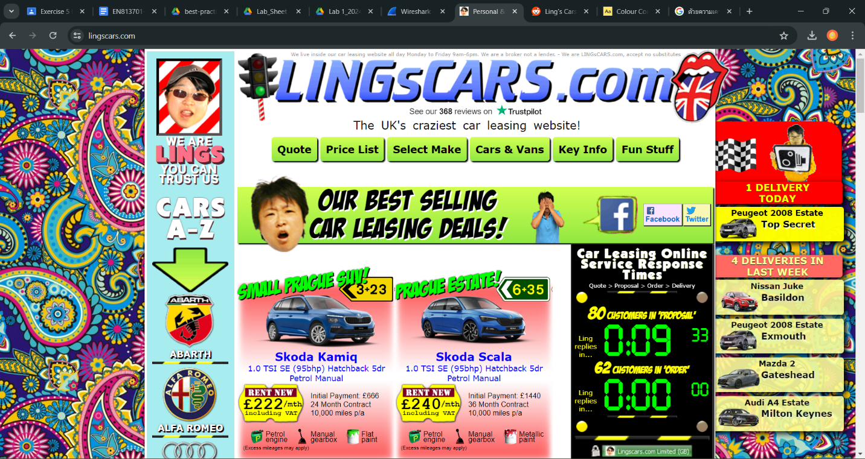This capture of website can show how the color and font are blending with other components.



about the button problem. In the red circle I did can linked to another page too.