Java Academy 2016 - How to commit academy exercises solutions

1. - Read and follow instructions to install GIT here https://git-scm.com/book/en/v2/Getting-Started-Installing-Git. If you would like to know a little bit of GIT background you can start here https://git-scm.com/book/en/v2/Getting-Started-About-Version-Control. If already have GIT installed skip this step.

2. - Create a GitHub account at https://github.com/ and log in.

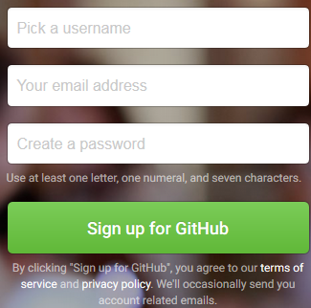

3. - Go to https://github.com/mdc-java/java-academy-2016 and click on fork button.

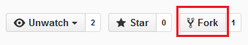

This will create a repository copy in your profile.

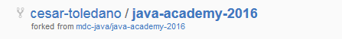

4. - Click on “Clone or download” and copy HTTPS url to clone repository locally. If you already know how to configure SSH keys select “Use SSH” and copy SSH URL.

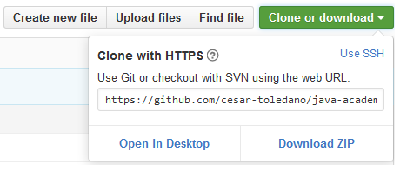

5. - Open a GIT bash prompt. This can be accomplished with a right mouse click on any directory.

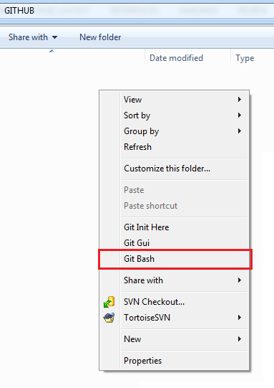

6. – Clone repository by using “git clone” command and copied URL

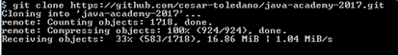

You’ll get this directory structure

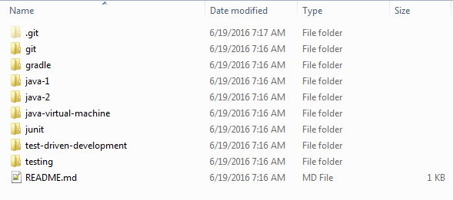
7. – In each of the directories create another with “solution” as name and add your exercises or tests solutions

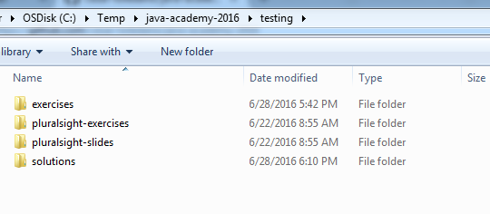

8. – Open a new GIT bash prompt and type the next commands (press enter after each)
- “git add --a” so files can be marked as added
- “git commit –m “my solutions”” to commit your changes
- “git pull” to get latest revision
- “git push origin master” to push your changes into GitHub, this will require you to provide GitHub username and password

