МИНОБРНАУКИ РОССИИ
Санкт-Петербургский государственный
электротехнический университет
«ЛЭТИ» им. В.И. Ульянова (Ленина)

отчет
по лабораторной работе № 6
по дисциплине «Веб-программирование»
Тема: АУТЕНТИФИКАЦИЯ И АВТОРИЗАЦИЯ ПОЛЬЗОВАТЕЛЕЙ WEB-ПРИЛОЖЕНИЯ

Студент гр. 4314 |  | Опаш А.Б.
Преподаватель |  | Павловский М.Г.

Санкт-Петербург
2026

Цель работы
Знакомство с настройкой базовой аутентификации и авторизации пользователей web-приложения, а также с использованием протокола HTTPS в Apache Tomcat.

Описание приложения
Создано JSP-приложение с каталогом книг. Стартовая страница принимает имя читателя и фильтр списка. Ресурс BookList.jsp защищён базовой HTTP-аутентификацией. При обращении к нему Tomcat проверяет учётные данные и роль пользователя. После успешного входа страница выводит имя пользователя, схему аутентификации BASIC и таблицу книг.
В конфигурации Tomcat определены роль catalog-user и учебная учётная запись student. Для защищённого соединения создан самоподписанный сертификат localhost-rsa.jks и включён HTTPS-коннектор на порту 8443.

Создание хранилища сертификата
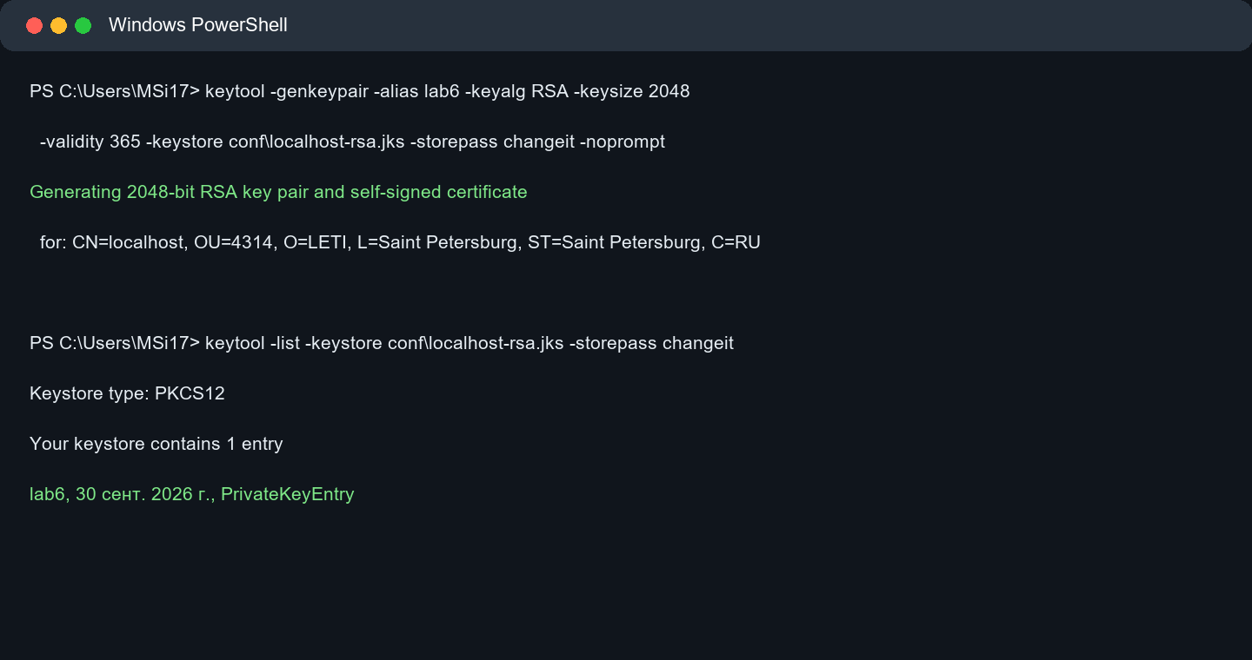
Рисунок 1 — создание и проверка хранилища сертификата
Сертификат создан утилитой keytool с алгоритмом RSA и сроком действия 365 дней. Команда keytool -list подтвердила, что в хранилище присутствует запись lab6.

Работа приложения после аутентификации
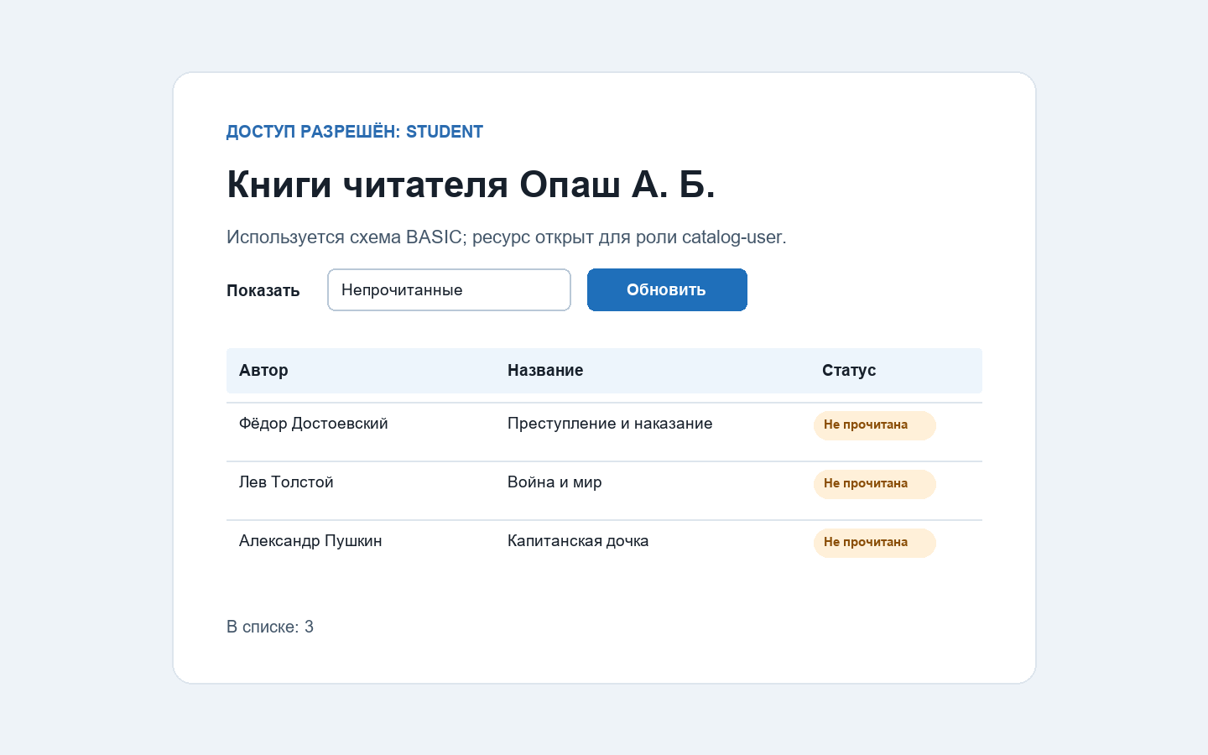
Рисунок 2 — защищённая страница каталога после входа пользователя
Запрос без учётных данных возвращает HTTP 401. После передачи учебных данных student / web2026 сервер разрешает доступ к BookList.jsp. На рисунке показан фильтр непрочитанных книг: в результате выведены три записи.

Проверка
Скрипт check_app.py проверил стартовую страницу, ответ 401 без учётных данных, аутентификацию BASIC по HTTP, фильтрацию непрочитанных книг и тот же защищённый ресурс по HTTPS. Все проверки завершились успешно.

Вывод
В ходе работы настроены аутентификация и авторизация в Apache Tomcat. Защищённый JSP-ресурс доступен только пользователю с ролью catalog-user. Для передачи данных по защищённому каналу создан сертификат и включён HTTPS-коннектор.

Приложение А. Файл tomcat-users.xml
conf/tomcat-users.xml
<?xml version="1.0" encoding="UTF-8"?>
<!--
Licensed to the Apache Software Foundation (ASF) under one or more
contributor license agreements. See the NOTICE file distributed with
this work for additional information regarding copyright ownership.
The ASF licenses this file to You under the Apache License, Version 2.0
(the "License"); you may not use this file except in compliance with
the License. You may obtain a copy of the License at
http://www.apache.org/licenses/LICENSE-2.0
Unless required by applicable law or agreed to in writing, software
distributed under the License is distributed on an "AS IS" BASIS,
WITHOUT WARRANTIES OR CONDITIONS OF ANY KIND, either express or implied.
See the License for the specific language governing permissions and
limitations under the License.
--><tomcat-users version="1.0" xmlns="http://tomcat.apache.org/xml" xmlns:xsi="http://www.w3.org/2001/XMLSchema-instance" xsi:schemaLocation="http://tomcat.apache.org/xml tomcat-users.xsd">
<!--
By default, no user is included in the "manager-gui" role required
to operate the "/manager/html" web application. If you wish to use this app,
you must define such a user - the username and password are arbitrary.
Built-in Tomcat manager roles:
- manager-gui - allows access to the HTML GUI and the status pages
- manager-script - allows access to the HTTP API and the status pages
- manager-jmx - allows access to the JMX proxy and the status pages
- manager-status - allows access to the status pages only
The users below are wrapped in a comment and are therefore ignored. If you
wish to configure one or more of these users for use with the manager web
application, do not forget to remove the <!.. ..> that surrounds them. You
will also need to set the passwords to something appropriate.
-->
<!--

Приложение А. Файл tomcat-users.xml (продолжение)
conf/tomcat-users.xml
<user username="admin" password="<must-be-changed>" roles="manager-gui"/>
<user username="robot" password="<must-be-changed>" roles="manager-script"/>
-->
<!--
The sample user and role entries below are intended for use with the
examples web application. They are wrapped in a comment and thus are ignored
when reading this file. If you wish to configure these users for use with the
examples web application, do not forget to remove the <!.. ..> that surrounds
them. You will also need to set the passwords to something appropriate.
-->
<!--
<role rolename="tomcat"/>
<role rolename="role1"/>
<user username="tomcat" password="<must-be-changed>" roles="tomcat"/>
<user username="both" password="<must-be-changed>" roles="tomcat,role1"/>
<user username="role1" password="<must-be-changed>" roles="role1"/>
-->
<role rolename="catalog-user"/>
<user username="student" password="web2026" roles="catalog-user"/>
</tomcat-users>

Приложение Б. Файл web.xml
src/main/webapp/WEB-INF/web.xml
<?xml version="1.0" encoding="UTF-8"?>
<web-app xmlns="http://xmlns.jcp.org/xml/ns/javaee"
xmlns:xsi="http://www.w3.org/2001/XMLSchema-instance"
xsi:schemaLocation="http://xmlns.jcp.org/xml/ns/javaee http://xmlns.jcp.org/xml/ns/javaee/web-app_4_0.xsd"
version="4.0">
<display-name>Защищённый каталог книг</display-name>
<welcome-file-list>
<welcome-file>index.jsp</welcome-file>
</welcome-file-list>
<security-constraint>
<web-resource-collection>
<web-resource-name>Каталог книг</web-resource-name>
<url-pattern>/BookList.jsp</url-pattern>
<http-method>GET</http-method>
<http-method>POST</http-method>
</web-resource-collection>
<auth-constraint>
<role-name>catalog-user</role-name>
</auth-constraint>
</security-constraint>
<login-config>
<auth-method>BASIC</auth-method>
<realm-name>Каталог книг ЛР 6</realm-name>
</login-config>
<security-role>
<role-name>catalog-user</role-name>
</security-role>
</web-app>

Приложение В. Файл server.xml
conf/server.xml
<?xml version="1.0" encoding="UTF-8"?>
<!--
Licensed to the Apache Software Foundation (ASF) under one or more
contributor license agreements. See the NOTICE file distributed with
this work for additional information regarding copyright ownership.
The ASF licenses this file to You under the Apache License, Version 2.0
(the "License"); you may not use this file except in compliance with
the License. You may obtain a copy of the License at
http://www.apache.org/licenses/LICENSE-2.0
Unless required by applicable law or agreed to in writing, software
distributed under the License is distributed on an "AS IS" BASIS,
WITHOUT WARRANTIES OR CONDITIONS OF ANY KIND, either express or implied.
See the License for the specific language governing permissions and
limitations under the License.
--><!-- Note: A "Server" is not itself a "Container", so you may not
define subcomponents such as "Valves" at this level.
Documentation at /docs/config/server.html
--><Server port="8005" shutdown="SHUTDOWN">
<Listener className="org.apache.catalina.startup.VersionLoggerListener"/>
<!-- Security listener. Documentation at /docs/config/listeners.html
<Listener className="org.apache.catalina.security.SecurityListener" />
-->
<!-- APR connector and OpenSSL support using Tomcat Native -->
<Listener className="org.apache.catalina.core.AprLifecycleListener"/>
<!-- OpenSSL support using FFM API from Java 22 -->
<!-- <Listener className="org.apache.catalina.core.OpenSSLLifecycleListener" /> -->
<!-- Prevent memory leaks due to use of particular java/javax APIs-->
<Listener className="org.apache.catalina.core.JreMemoryLeakPreventionListener"/>
<Listener className="org.apache.catalina.mbeans.GlobalResourcesLifecycleListener"/>
<Listener className="org.apache.catalina.core.ThreadLocalLeakPreventionListener"/>
<!-- Global JNDI resources

Приложение В. Файл server.xml (продолжение)
conf/server.xml
Documentation at /docs/jndi-resources-howto.html
-->
<GlobalNamingResources>
<!-- Editable user database that can also be used by
UserDatabaseRealm to authenticate users
-->
<Resource auth="Container" description="User database that can be updated and saved" factory="org.apache.catalina.users.MemoryUserDatabaseFactory" name="UserDatabase" pathname="conf/tomcat-users.xml" type="org.apache.catalina.UserDatabase"/>
</GlobalNamingResources>
<!-- A "Service" is a collection of one or more "Connectors" that share
a single "Container" Note: A "Service" is not itself a "Container",
so you may not define subcomponents such as "Valves" at this level.
Documentation at /docs/config/service.html
-->
<Service name="Catalina">
<!--The connectors can use a shared executor, you can define one or more named thread pools-->
<!--
<Executor name="tomcatThreadPool" namePrefix="catalina-exec-"
maxThreads="150" minSpareThreads="4"/>
-->
<!-- A "Connector" represents an endpoint by which requests are received
and responses are returned. Documentation at :
Java HTTP Connector: /docs/config/http.html
Java AJP Connector: /docs/config/ajp.html
APR (HTTP/AJP) Connector: /docs/apr.html
Define a non-SSL/TLS HTTP/1.1 Connector on port 8080
-->
<Connector URIEncoding="UTF-8" address="127.0.0.1" connectionTimeout="20000" maxParameterCount="1000" port="8081" protocol="HTTP/1.1" redirectPort="8443" useBodyEncodingForURI="true"/>
<!-- A "Connector" using the shared thread pool-->
<!--
<Connector executor="tomcatThreadPool"

Приложение В. Файл server.xml (продолжение)
conf/server.xml
port="8080" protocol="HTTP/1.1"
connectionTimeout="20000"
redirectPort="8443"
maxParameterCount="1000"
/>
-->
<!-- Define an SSL/TLS HTTP/1.1 Connector on port 8443
This connector uses the NIO implementation. The default
SSLImplementation will depend on the presence of the APR/native
library and the useOpenSSL attribute of the AprLifecycleListener.
Either JSSE or OpenSSL style configuration may be used regardless of
the SSLImplementation selected. JSSE style configuration is used below.
-->
<Connector port="8443" protocol="org.apache.coyote.http11.Http11NioProtocol"
maxThreads="150" SSLEnabled="true"
maxParameterCount="1000"
>
<SSLHostConfig>
<Certificate certificateKeystoreFile="conf/localhost-rsa.jks"
certificateKeystorePassword="changeit" type="RSA" />
</SSLHostConfig>
</Connector>
<!-- Define an SSL/TLS HTTP/1.1 Connector on port 8443 with HTTP/2
This connector uses the APR/native implementation which always uses
OpenSSL for TLS.
Either JSSE or OpenSSL style configuration may be used. OpenSSL style
configuration is used below.
-->
<!--
<Connector port="8443" protocol="org.apache.coyote.http11.Http11AprProtocol"
maxThreads="150" SSLEnabled="true"
maxParameterCount="1000"
>
<UpgradeProtocol className="org.apache.coyote.http2.Http2Protocol" />

Приложение В. Файл server.xml (продолжение)
conf/server.xml
<SSLHostConfig>
<Certificate certificateKeyFile="conf/localhost-rsa-key.pem"
certificateFile="conf/localhost-rsa-cert.pem"
certificateChainFile="conf/localhost-rsa-chain.pem"
type="RSA" />
</SSLHostConfig>
</Connector>
-->
<!-- Define an AJP 1.3 Connector on port 8009 -->
<!--
<Connector protocol="AJP/1.3"
address="::1"
port="8009"
redirectPort="8443"
maxParameterCount="1000"
/>
-->
<!-- An Engine represents the entry point (within Catalina) that processes
every request. The Engine implementation for Tomcat stand alone
analyzes the HTTP headers included with the request, and passes them
on to the appropriate Host (virtual host).
Documentation at /docs/config/engine.html -->
<!-- You should set jvmRoute to support load-balancing via AJP ie :
<Engine name="Catalina" defaultHost="localhost" jvmRoute="jvm1">
-->
<Engine defaultHost="localhost" name="Catalina">
<!--For clustering, please take a look at documentation at:
/docs/cluster-howto.html (simple how to)
/docs/config/cluster.html (reference documentation) -->
<!--

Приложение В. Файл server.xml (продолжение)
conf/server.xml
<Cluster className="org.apache.catalina.ha.tcp.SimpleTcpCluster"/>
-->
<!-- Use the LockOutRealm to prevent attempts to guess user passwords
via a brute-force attack -->
<Realm className="org.apache.catalina.realm.LockOutRealm">
<!-- This Realm uses the UserDatabase configured in the global JNDI
resources under the key "UserDatabase". Any edits
that are performed against this UserDatabase are immediately
available for use by the Realm. -->
<Realm className="org.apache.catalina.realm.UserDatabaseRealm" resourceName="UserDatabase"/>
</Realm>
<Host appBase="webapps" autoDeploy="true" name="localhost" unpackWARs="true">
<!-- SingleSignOn valve, share authentication between web applications
Documentation at: /docs/config/valve.html -->
<!--
<Valve className="org.apache.catalina.authenticator.SingleSignOn" />
-->
<!-- Access log processes all example.
Documentation at: /docs/config/valve.html
Note: The pattern used is equivalent to using pattern="common" -->
<Valve className="org.apache.catalina.valves.AccessLogValve" directory="logs" pattern="%h %l %u %t &quot;%r&quot; %s %b" prefix="localhost_access_log" suffix=".txt"/>
</Host>
</Engine>
</Service>
</Server>

Приложение Г. JSP-страница BookList.jsp
src/main/webapp/BookList.jsp
<%@ page language="java" contentType="text/html; charset=UTF-8" pageEncoding="UTF-8" %>
<%@ page import="ru.opash.web.Book, java.util.ArrayList, java.util.List, javax.servlet.http.HttpServletResponse" %>
<%!
private static String selected(String actual, String expected) {
return expected.equals(actual) ? "selected" : "";
}
%>
<%
request.setCharacterEncoding("UTF-8");
String name = request.getParameter("name");
if (name == null || name.trim().isEmpty()) {
response.sendError(HttpServletResponse.SC_BAD_REQUEST, "Не задано имя читателя.");
return;
}
name = name.trim();
String filter = request.getParameter("filter");
if (!"read".equals(filter) && !"unread".equals(filter)) filter = "all";
List<Book> catalog = new ArrayList<>();
catalog.add(new Book("Михаил Булгаков", "Мастер и Маргарита", true));
catalog.add(new Book("Фёдор Достоевский", "Преступление и наказание", false));
catalog.add(new Book("Лев Толстой", "Война и мир", false));
catalog.add(new Book("Антон Чехов", "Рассказы", true));
catalog.add(new Book("Александр Пушкин", "Капитанская дочка", false));
List<Book> books = new ArrayList<>();
for (Book book : catalog) {
if ("all".equals(filter) || ("read".equals(filter) && book.isRead())
|| ("unread".equals(filter) && !book.isRead())) books.add(book);
}
String readerName = Book.escapeHtml(name);
String userName = Book.escapeHtml(request.getRemoteUser());
%>
<!DOCTYPE html>
<html lang="ru">
<head>
<meta charset="UTF-8">
<meta name="viewport" content="width=device-width, initial-scale=1">
<title>Книги читателя</title>
<link rel="stylesheet" href="style.css">
</head>
<body>

Продолжение приложения Г
src/main/webapp/BookList.jsp
<main class="card wide">
<a class="back" href="index.jsp">← К форме</a>
<p class="eyebrow">Доступ разрешён: <strong><%= userName %></strong></p>
<h1>Книги читателя <%= readerName %></h1>
<p class="intro">Используется схема <code><%= request.getAuthType() %></code>; ресурс открыт для роли <code>catalog-user</code>.</p>
<form class="inline-form" action="BookList.jsp" method="post" accept-charset="UTF-8">
<input type="hidden" name="name" value="<%= readerName %>">
<label for="filter">Показать</label>
<select id="filter" name="filter">
<option value="all" <%= selected(filter, "all") %>>Все книги</option>
<option value="unread" <%= selected(filter, "unread") %>>Непрочитанные</option>
<option value="read" <%= selected(filter, "read") %>>Прочитанные</option>
</select>
<button type="submit">Обновить</button>
</form>
<table>
<thead><tr><th>Автор</th><th>Название</th><th>Статус</th></tr></thead>
<tbody>
<% for (Book book : books) { %>
<tr>
<td><%= Book.escapeHtml(book.getAuthor()) %></td>
<td><%= Book.escapeHtml(book.getTitle()) %></td>
<td><span class="status <%= book.isRead() ? "done" : "todo" %>"><%= book.isRead() ? "Прочитана" : "Не прочитана" %></span></td>
</tr>
<% } %>
</tbody>
</table>
<p class="note">В списке: <strong><%= books.size() %></strong></p>
</main>
</body>
</html>

