DCIT 208 – SOFTWARE ENGINEERING
Assignment Number: IA2
Assignment Title: Client Interview Evidence and Requirement Transformation Memo
Full Name: Patience Owusu
Student ID: 22398703
Team Name: TEAM NYLA
Project Title: Nyla Digital Banking Solution
Team Repository URL: https://github.com/Dept-of-Comp-Sci-University-of-Ghana/dcit208-client-project-2026-team-engineering-repository-seg26-53-teamnyla.git
Individual Portfolio Repository URL: https://github.com/opashay/DCIT208-Individual-Portfolio.git
Date: Friday, 3 July 2026
AI Disclosure Statement
I used AI assistance (ChatGPT) to help organise the structure, improve the wording, and review my work. All project-specific information was verified and adapted by me. I understand that I am responsible for explaining and defending every part of this submission.

A. Personal Client/User Discovery Questions
The following questions were prepared to better understand the client's current operations, challenges, and expectations for the Nyla Digital Banking Solution.
- How do customers currently access banking services, and what steps are involved in the existing process?
- How do bank staff currently manage customer accounts, service requests, and transaction records?
- What are the biggest challenges customers face when using the current banking services?
- Which manual processes consume the most time for bank staff, and why?
- What customer information should the system collect during account registration?
- What transaction or account information should customers be able to view within the system?
- What features would make the digital banking solution successful from the customer's perspective?
- How will the bank determine whether the new system has improved service delivery and customer satisfaction?
- What security measures should be implemented to protect customer accounts and sensitive financial information?
- If the system experiences downtime or a transaction fails, how should the system respond, and how should customers be informed?

B. Interview / Observation Evidence

Date: 2 July 2026
Time: 11:55 PM – 12:05 AM
Medium: WhatsApp Chat
Participant Role: Client Representative
Evidence Type: Screenshot of WhatsApp conversation
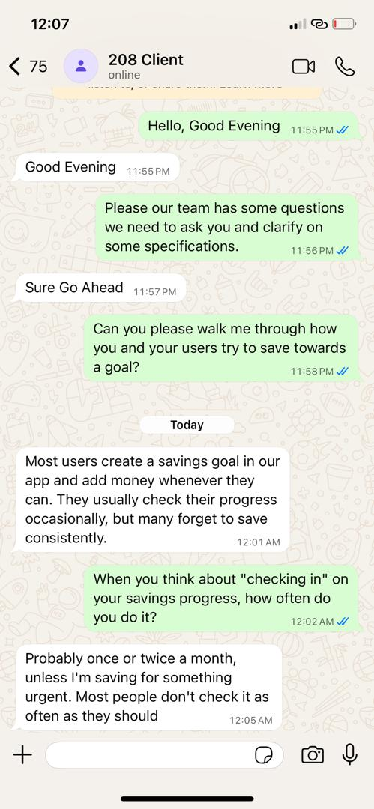

Summary of the Conversation

A WhatsApp conversation was conducted with the client representative to better understand the current savings process and user behaviour within the Nyla Digital Banking Solution.
The client explained that users typically create a savings goal within the application and add money whenever they are able. However, many users do not save consistently and often forget to monitor their savings progress.
When asked how frequently users check their savings progress, the client indicated that most users check once or twice each month, unless they are saving for an urgent purpose.
The discussion highlighted the importance of providing features that encourage consistent saving and improve user engagement through regular reminders and progress tracking.

C. Requirement Transformation
Raw Client Statement
“Most users create a savings goal in our app and add money whenever they can. They usually check their progress occasionally, but many forget to save consistently."
Functional Requirement
The system shall allow registered customers to securely log in, view their account information, submit service requests, and receive notifications from the bank.
Non-Functional Requirement
The system shall use secure authentication and encrypted communication to protect customer data and maintain user privacy.
User Story
As a bank customer, I want to securely access my account and communicate with the bank online so that I can manage my banking activities conveniently without visiting the bank.
Acceptance Criteria
- Given a registered customer with valid login credentials, when they log in, they shall be granted access to their account dashboard.
- Given a logged-in customer, when they submit a service request, the request shall be recorded successfully and a confirmation message displayed.
- Given a successful transaction or service update, when the event occurs, the customer shall receive a notification.
- Given invalid login credentials, when the customer attempts to log in, then access shall be denied and an appropriate error message displayed.
API / Interface Implication
The system should integrate with an email or SMS notification service to send alerts and confirmations to customers.
Data Implication
The system will store customer details, account information, service requests, transaction records, and notification history.
Test Idea
Verify that a registered customer can successfully log in, submit a service request, and receive a notification while unauthorised users are denied access.
Open Question
Should customers receive notifications through email, SMS, or both?

D. Reflection

Speaking with the client representative improved my understanding of how users currently manage their savings goals. Before the conversation, I assumed that customers regularly monitored their savings progress because they had already created savings goals within the application. However, the discussion showed that many users only check their progress occasionally and sometimes forget to save consistently.
This changed my understanding of the client's problem. I realised that developing a digital banking solution is not only about enabling users to set savings goals but also about encouraging ongoing engagement with those goals. Features such as reminders, notifications, and progress updates can help users develop consistent saving habits.
Another lesson I learned is the importance of asking clear and focused questions during requirements gathering. Although the client's responses were brief, they provided useful insights into user behaviour and helped identify additional system requirements not apparent from the initial problem statement.
The conversation also showed that requirements gathering is an ongoing process. Initial assumptions may change after interacting with stakeholders, making it necessary to validate requirements before system design and implementation.
Overall, this activity helped me appreciate the importance of client communication in software engineering. Even a short conversation can reveal valuable information that improves system requirements and helps developers design solutions that better meet user needs.

AI Disclosure
Date | AI Tool | Prompt Summary | Output Used | Output Rejected | Verification
3 July 2026 | ChatGPT | Helped organise the IA2 report, improve grammar, and structure the interview questions, requirement transformation, and reflection. | Used the report structure, improved wording, and formatting suggestions. | Rejected any content that was not supported by the client's WhatsApp conversation or the project documents. | Verified all information against the client's WhatsApp messages and the official project brief before including it in the final report.

