



# Registration

1.1 Visit *“https//:netpie.io/sign_up”* and fill in the registration form. After you finish filling your information, click *“Sign up”* button on the bottom of the form.

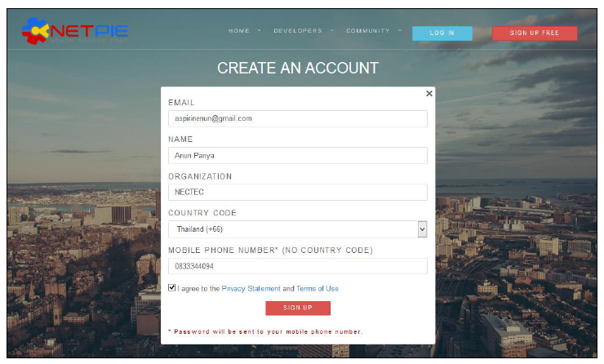

**Figure 1.1 NETPIE registration window**

1.2 Verification message will be sent to your Email address.

1.3 After you received your one-time password, click the *“LOG IN”* button on the top right-hand corner of the screen. Enter your Username or email address and the password that you received from your phone.

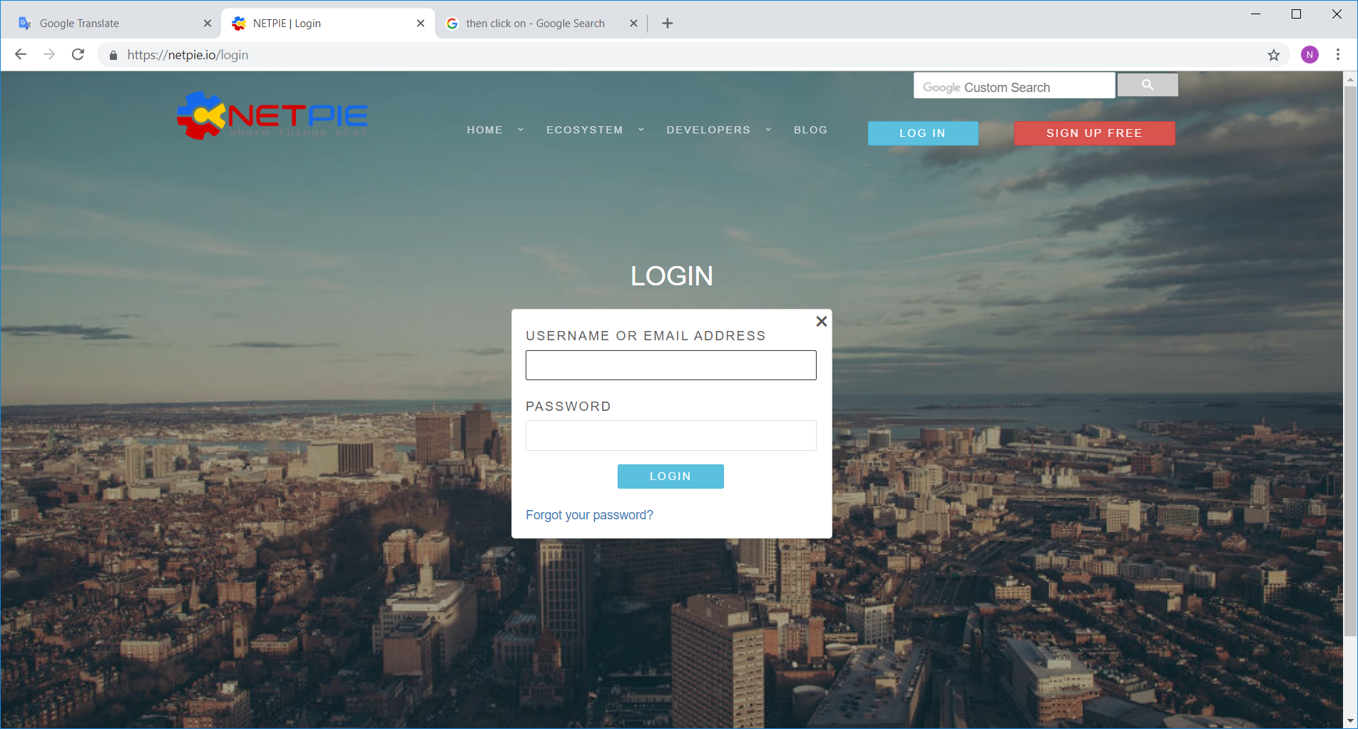

**Figure 1.2 NETPIE login window.**

1.4 Once you have finished the log in process, a new form will appear that requires

you to reset your password. Fill in the new password and press reset button.

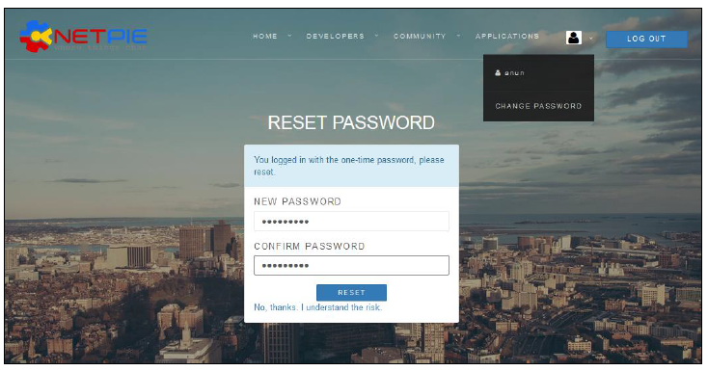

**Figure 1.3 NETPIE reset new password window**

1.5 You can always change your password on your account menu.

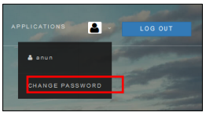

**Figure 1.4 change NETPIE password menu**

# Installing Arduino IDE and ESP32 core

2.1 Download *“Arduino IDE”* from [*https://www.arduino.cc/en/Main/Software*](https://www.arduino.cc/en/Main/Software). and choose your desired platform such as; Windows, Mac OS X, Linux.

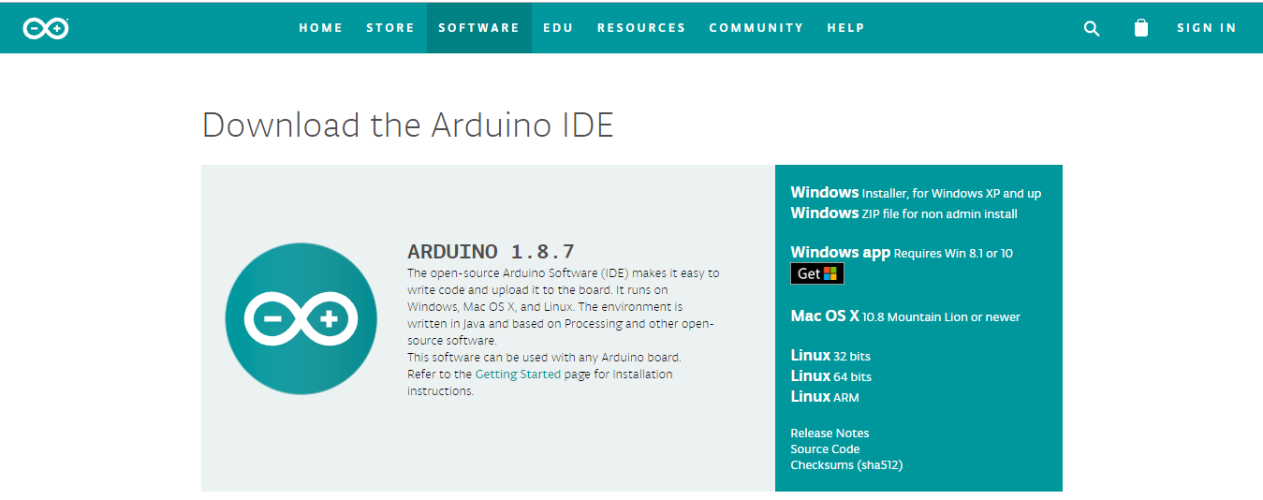

**Figure 2.1 Arduino IDE page for downloading.**

2.2 Start Arduino IDE and open Preferences menu from File >> Preferences.

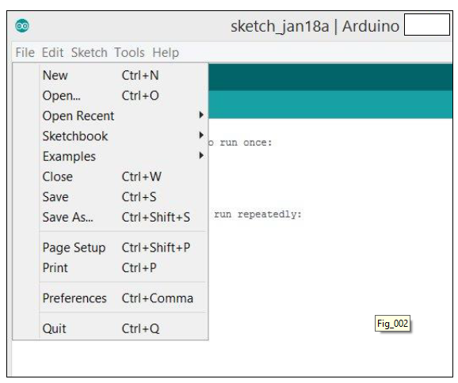

**Figure 2.2 Choosing Preferences in Arduino IDE.**

2.3 Enter *“https://dl.espressif.com/dl/package_esp32_index.json”* into Additional Board Manager URLs field.

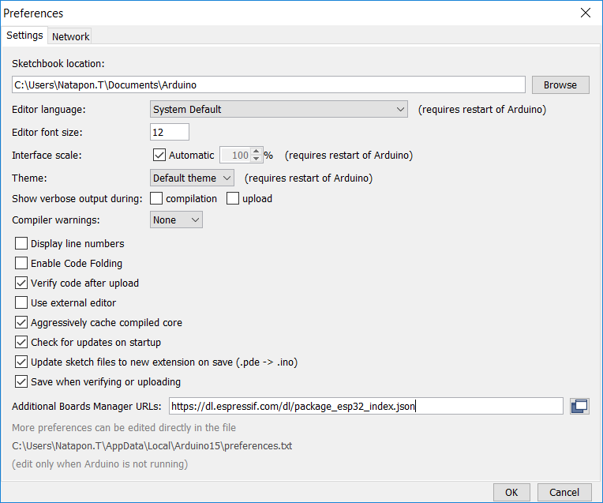

**Figure 2.3 Entering URLs link into ESP32 Arduino Core**

2.4 Open Boards Manager from Tools >> Board menu >> Boards Manager.

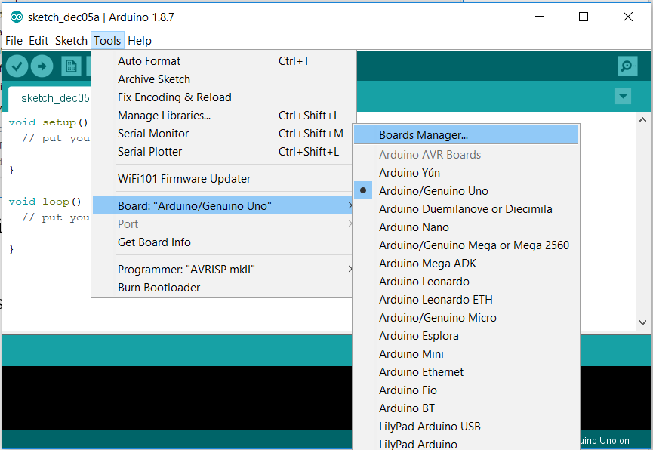

**Figure 2.4 Choosing ESP32 to install**

2.5 Search for ESP32 and press install button for the *“ESP32 by Espressif Systems”*.

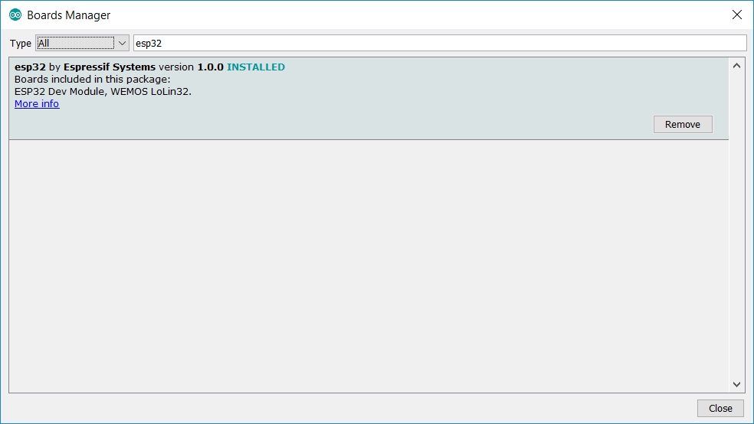

**Figure 2.5 Installing ESP32 Arduino Core**

2.6 Select your Board in Tools >> Board menu, new type of ESP32 board will appear. Select the one that matches the board you’re using. (In this workshop select *“ESP32 Dev Module”*)

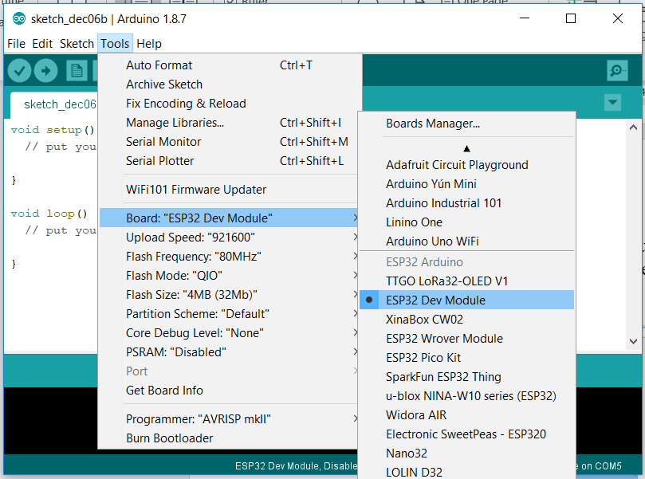

**Figure 2.6 Choose type of ESP32 board**

# NETPIE Microgear Library for ESP32

Download Microgear for ESP32 from [*https://github.com/lamloei/ESP32_Microgear*](https://github.com/lamloei/ESP32_Microgear), click on Sketch >> Include Library >> Add .ZIP Library… and choose the Zip File that you downloaded from github, Then go to Sketch >> Include Library and ESP32 Microgear will appear on the list.

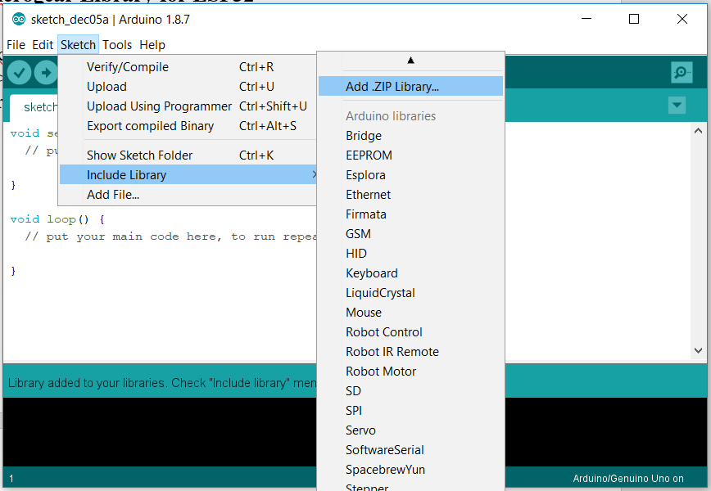

**Figure 3.1 Installing Microgear Library from Zip File**

**DHT Library**

Include DHT Library onto Arduino IDE by Choose Sketch >> Include Library >> Manage Libraries... search for the keyword “dht” and choose to install “DHT Sensor library by Adafruit Version 1.3.0” (Note: this is not the latest version available by default)

**Adafruit Unified Sensor**

Include Adafruit Unified Sensor Library onto Arduino IDE by Choose Sketch >> Include Library >> Manage Libraries... search for the keyword “Adafruit Unified Sensor” and choose to install “Adafruit Unified Sensor by Adafruit Version 1.0.2” (Note: this is not the latest version available by default)

**Adafruit LED Backpack Library**

Include Adafruit LED Backpack Library onto Arduino IDE by Choose Sketch >> Include Library >> Manage Libraries... search for the keyword “Adafruit LED Backpack Library” and choose to install “Adafruit LED Backpack Library by Adafruit version 1.1.6” (Note: this is not the latest version available by default)

**Adafruit GFX library**

Include Adafruit GFX Library onto Arduino IDE by Choose Sketch >> Include Library >> Manage Libraries... search for the keyword “Adafruit GFX Library” and choose to install “Adafruit GFX Library by Adafruit version 1.3.4” (Note: this is not the latest version available by default)

# Web Browser

It is recommended that user use Google Chrome or Firefox

Download link below:

**Chrome** *https://www.google.com/chrome/browser/index.html*

**Firefox** *https://www.mozilla.org/en-US/firefox/new/*

# Download Arduino code and presentations

https://github.com/opastrith/NETPIE-KidBright