

Skillset Vision Diagram + Market Strategy
A premium international learning marketplace connecting courses, communities, trust, payments, certificates, AI, and teacher growth tools.
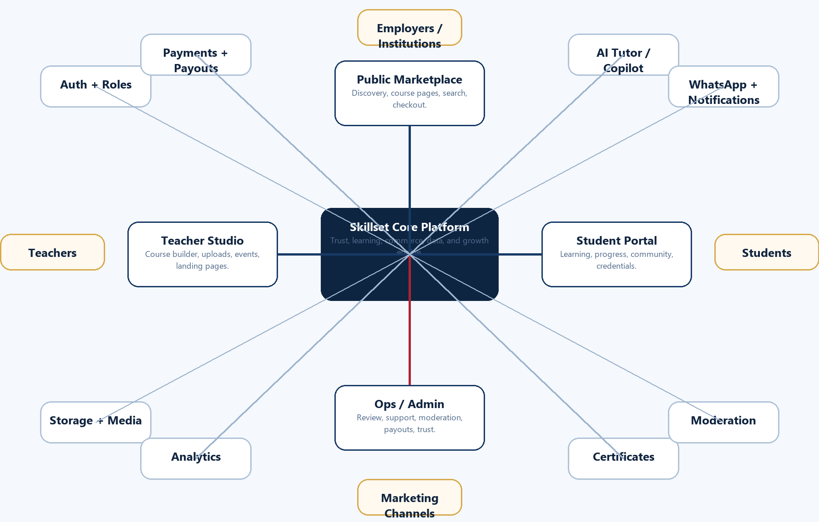



What Skillset Already Has vs. What Comes Next
The current product foundation is live enough to explain the platform, while the roadmap shows where the business can become larger than a simple course website.
Already live / started | Next expansion
Firebase Hosting, Auth, Firestore, Storage | Search, analytics, richer data model, international scaling
Teacher Studio, course builder, uploads | Landing pages, AI course assistant, marketing toolkit
Student portal, progress, communities | Gamification, assessments, networking, WhatsApp nudges
Stripe Checkout/Connect, payouts path | Revenue dashboards, coupons, bundles, subscriptions
Ops review, moderation, certificates | AI-assisted review, public verification, institutional credentials



Competitor Landscape
Skool validates community-first learning; Hotmart validates creator commerce; Kajabi validates marketing engines; Thinkific/Teachable validate course-platform demand.
Skool
Community, courses, events, and monetization in a simple creator platform.

Hotmart
Creator commerce, members area, customization, communities, certificates, and AI tutor concepts.

Kajabi
Marketing, funnels, websites, emails, offers, community, and business suite positioning.

Thinkific / Teachable
Course creation demand, but users report customization, cost, discoverability, and missing-feature gaps.



Market Gaps and Skillset Differentiators
The opportunity is not to clone one platform. The opportunity is to connect the strongest parts of several platforms and solve what users still complain about.
Market gap | Skillset response
Tools are fragmented | Course, community, payments, certificates, support, WhatsApp, and AI in one coherent operating system.
Learning accountability is weak | Progress, assessments, proofs of evolution, and gamification based on real learning activity.
Teacher marketing is hard | Landing pages, free preview lessons, checkout links, analytics, and campaign support.
Trust is shallow | Course review, moderation, verified certificates, and public verification links.
Support and complexity frustrate creators | Guided teacher studio, approval checklist, templates, and clear operations workflows.



Global Platform Ecosystem Diagram
Skillset should operate as a connected system of public discovery, teacher production, student outcomes, and trust operations.




Core Product Loop and User Journeys
The strongest product loop turns teacher expertise into trusted learning products, then uses community, assessment, and credentialing to improve outcomes.
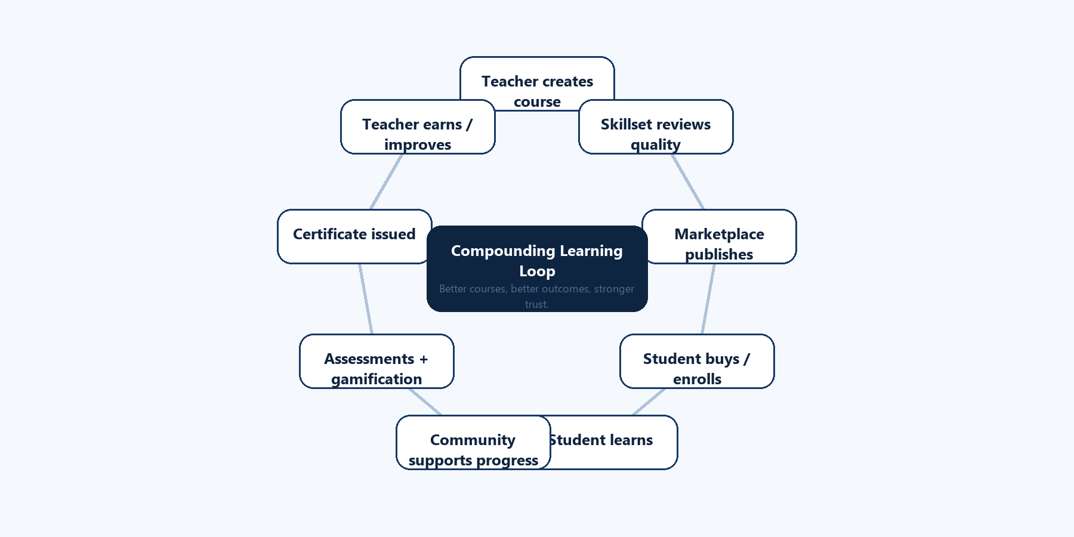



Roadmap and Milestones
Build in specific phases so the platform grows without losing quality, trust, or clarity.
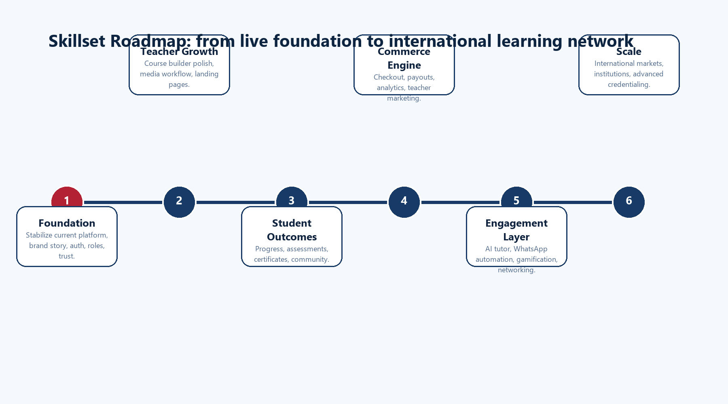



Final Objective
Skillset becomes an international professional learning network where teachers can sell serious education products and students can prove progress, not just watch videos.
For students
A place to learn, interact, track growth, attend live sessions, and prove progress through Skillset Verified credentials.

For teachers
A professional studio to package expertise, publish courses, build communities, sell through trusted checkout, and grow with analytics.

For Skillset
A differentiated platform that combines marketplace, creator commerce, community, trust, AI, WhatsApp engagement, and international professional learning.

Reference links are preserved in docs/vision/reference-links.md.

