Sieve of Eratostenes

Opruta David 936

# Definition

Sieve of Eratosthenes algorithm calculates all the prime numbers less than a given number.

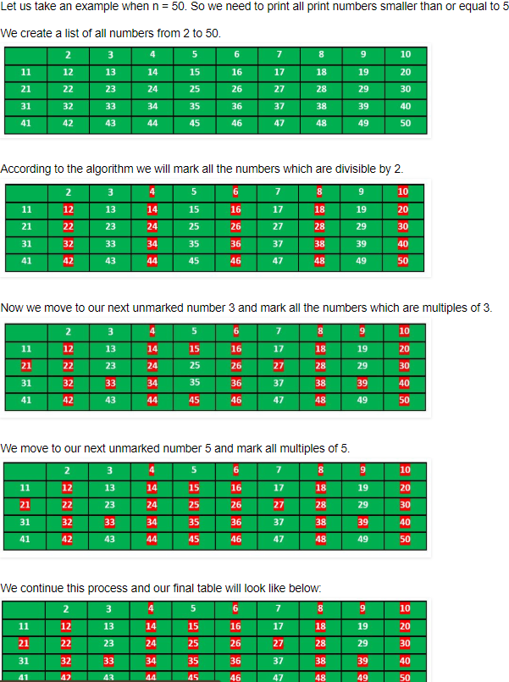

# My application

The application consists in the initialization of a vector of boolean of n+1 dimension with true, where n is the given number. While parsing the numbers we start from 2 and change the values to false of the multipliers of that number to the corresponding index from the boolean vector. At last we print all the numbers whose values are true from the boolean vector.