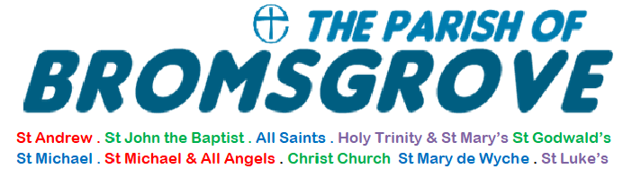

SAFEGUARDING CHILDREN AND VULNERABLE ADULTS POLICY

2024-2025

Version 10

Version 1 agreed on 13.10.2014and reviewed and updated 19.10.2015, 19.11.2016, 13.11.2017, 12.11.2018, 27.11.2019, 22.11.2021, 9.11.2022 and 8.11.23, 13.11.24 .

TABLE OF CONTENTS

Table of contents | Page 2
Introduction and contact details for parish safeguarding officers | Page 3
Legislation and Guidance | Page 4-5
Social Media | Page 5
Reporting of safeguarding concerns | Page 5
Information sharing | Page 5-6
Record keeping, data protection and confidentiality | Page 6
Supporting the vulnerable | Page 6
Safer recruitment | Page 6
Supervision and monitoring of ex-offenders | Page 6-7
Ongoing support, review and training | Page 7
Review of policies and Insurance | Page 7
Display | Page 7
Parish of Bromsgrove: Activities | Page 9
Church activities and non-church activities: St John’s and St Andrew’s, Bromsgrove. | Page 9-10
Church activities and non-church activities: All Saints, Bromsgrove. | Page 10-11
Church activities and non-church activities : St Godwald’s, Finstall, Bromsgrove. | Page 11-12
Church activities and non-church activities: Christ Church, Catshill | Page 12
Church activities and non-church activities: St Michael & All Angels, Stoke Prior, St Mary de Wyche, Wychbold & St Michael’s, Upton Warren | Page 12
Church activities: Holy Trinity and St. Mary, Dodford | Page 12
Appendix A. Flow chart: Responding promptly to every safeguarding concern or allegation | Page 13
Appendix B. Policy statement on the recruitment of ex-offenders | Page 14-15

Parish of Bromsgrove in the Diocese of Worcester

Churches of St. John’s, St. Andrew’s, All Saints, St. Godwald’s, Christ Church, Holy Trinity and St. Mary’s Dodford, St. Michael and All Angels, Stoke Prior, St. Michael’s, Upton Warren, St. Mary de Wyche, Wychbold.

Safeguarding Children, Young People and Adult Policy Statement
We are committed to adopt the House of Bishops Policy –
-Promoting a Safer Church 2017

- INTRODUCTION
All churches within the Parish of Bromsgrove are committed, to ensuring the health, safety and welfare of everyone who uses the church buildings, the churchyard and any other building they are responsible for, and deem the health and safety of all to be an intrinsic part of safeguarding. The Health and Safety Policy, is dealt with in a separate document set.
In relation to safeguarding, the following policy has been agreed and implemented by the Parish Church Council (PCC). We are committed to the safeguarding and the respectful pastoral care and nurturing of the children, young people and adults within our church community. We commit ourselves to promoting the inclusion and empowerment of children, young people and adults.
Nominated Parish Safeguarding Officers, and their contact details are:
St John’s and St. Andrew’s: Roger Savidge
rogersavidge61@gmail.com; 07858 983228
All Saints: Gill Gould
gillgould6@btinternet.com; 07824 368584
St. Godwald’s: Catherine Maund
cmaund1@sky.com: 07788 418045
Christ Church and St. Luke’s: Eleanor Newbold
eleanor.newbold21@gmail.com; 07837 351203
Holy Trinity and St. Mary, Dodford: Susan Goode
s.goode522@btinternet.com; 07985 770223

2. LEGISLATION and GUIDANCE
2.1 We are committed to adopt and follow the Church of England’s House of Bishops’ Policies and the relevant legislation and guidance Working Together to safeguard children(2018) https://assets.publishing.service.gov.uk/government/uploads/system/uploads/attachment_data/file/942454/Working_together_to_safeguard_children_inter_agency_guidance.pdf , thus ensuring that the welfare of children and young people is paramount.
We are aware of, and will implement the following documents that sit alongside the House of Bishops’ Policies:
• Promoting a Safer Church: House of Bishops’ statement policy (2017)
https://www.churchofengland.org/sites/default/files/2017-11/cofe-policy-statement.pdf
• Protecting all God’s Children (safeguarding policy for children and young people, 4th edition) 2010)
http://www.churchofengland.org/sites/default/files/2017-11/Protecting%20All%20God%27s%20Children%204th%20edition.pdf
• Promoting a Safe Church (safeguarding policy for adults) 2016
https://www.churchofengland.org/sites/default/files/2017-11/promotingasafechurch.pdf
• Diocese of Worcester Domestic Abuse Policy Statement 2017https://d3hgrlq6yacptf.cloudfront.net/5f2144e1c592d/content/pages/documents/15861749601626388540.pdf
• Central Council of Church Bell ringers General Statement on safeguarding children in towers https://cccbr.org.uk/wp-content/uploads/2016/03/statement-of-cofe-requirements-for-safeguarding.pdf
- Safer Environment and Activities 2019 https://www.churchofengland.org/sites/default/files/2019-11/Safer%20Environment%20and%20Activities%20Oct19_0.pdf
  - We will also adhere to the practice guidance set out below as recommended by the House of Bishops and any further guidance issued by the Diocese of Worcester:
- Responding to, assessing and managing safeguarding concerns or allegations against church officers (2017) https://www.churchofengland.org/sites/default/files/2017-11/responding-to-assessing-and-managing-concerns-or-allegations-against-church-officers.pdf
- Responding well to Domestic Abuse: Policy and Practice Guidance 2017 Responding well to Domestic Abuse: Policy and Practice Guidance 2017
- Responding well to those who have been sexually abused (2011) https://www.churchofengland.org/sites/default/files/2017-11/Responding%20Well%20to%20those%20who%20have%20been%20sexually%20abused_0.pdf
- Training and Development (2017) https://www.churchofengland.org/safeguarding/safeguarding-e-manual/safeguarding-learning-and-development-framework
- Safer Recruitment and People Management Guidance (2021) Safer Recruitment and People Management Guidance (2021)
- Safeguarding in Religious Communities (2015) Safeguarding in Religious Communities (2015)
- Parish Safeguarding Handbook (2018) Parish Safeguarding Handbook (2018)
  - We will work towards full compliance with the five National Safeguarding Standards set down by the national church
- National Safeguarding Standards | The Church of England
3. SOCIAL MEDIA
In relation to the use of Social Media, we will ensure that a church officer or named individual or individuals are accountable for all parish social media use. The Social Media policy is covered in a separate document set.

4. REPORTING of SAFEGUARDING CONCERNS
We are committed to report, without delay, every complaint of neglect or abuse; for example, physical, emotional, sexual, financial or spiritual abuse that we discover or suspect through the Parish Safeguarding Officers or clergy and onward to other appropriate authorities (See Appendix A).

5. INFORMATION SHARING and INTER AGENCY WORKING
We will fully cooperate with statutory agencies during any investigations into allegations concerning a member of the church community. We will inform the statutory agency of any suspected criminal offences or concerns that we are made aware of in respect of our contact with children, young people and adults.

6. RECORD KEEPING, DATA PROTECTION and CONFIDENTIALITY
Regarding the recording of information, we will ensure that a case file is opened on discovery of any safeguarding concern or allegation. Any, and all safeguarding case files, either electronic or paper, will be stored securely by the incumbent and the PSO, in line with the current General Data Protection Regulations (GDPR) 2018 and files will clearly identify who should have access to them. Secure storage is located in the locked filing cabinet in the Parish Office accessed by the PSOs who are the sole key holders. All case files should be retained in perpetuity, and if the incumbent or another member of the clergy team moves, any safeguarding case files, and any pertinent information should be shared with the new incumbent.

7. SUPPORTING the VULNERABLE
We recognize that everyone has different levels of vulnerability and everyone may be regarded as vulnerable at some time in their lives. We will offer informed pastoral care to any child, young person or adult who feels vulnerable or who has suffered abuse, and will provide them with details of local and national support agencies.

8. SAFER RECRUITMENT
We will ensure that lay ministers, volunteers and paid workers who work with children and vulnerable adults are carefully selected using the safer recruitment process and Disclosure and Barring Service to check the background of each person as outlined in the diocesan procedures. The Diocese will do likewise in respect of the ordained.

9. SUPERVISION AND MONITORING OF EX-OFFENDERS
We will supervise any member of our church community known to have offended against a child or vulnerable adult and ensure they are effectively managed and monitored in consultation with the Diocesan Safeguarding Adviser (DSA). The DSA will determine the appropriate action to be taken to best safeguard the parish and its congregation, based on the particular circumstances and facts of the case. The DSA will undertake a risk assessment and formulate a risk management plan or Safeguarding Agreement (See Appendix B).

10. ONGOING SUPPORT, REVIEW and TRAINING
The churches within the Parish are committed to supporting, resourcing, training and regular reviewing those who undertake work with children and adults.

11. REVIEW OF POLICIES and INSURANCE
11.1 We will review this policy annually and, as part of this, check that all our procedures and activities involving children, young people and vulnerable adults, including the DBS process and checks, are up to date.
11.2 We will review our insurance policy for those working with children and vulnerable adults ensuring we adopt the advice in the House of Bishops Policy and promoting a Safer Church.
11.3 The PCC has nominated people on each DCC who will represent the concerns and views of people at DCC meetings and to outside bodies.

12. DISPLAY
A current copy of this Safeguarding Policy will be displayed on the Parish notice board of each of the above named churches along with information about how to contact the DSA, PSO and how to get help with child and adult safeguarding issues from statutory agencies. Please note you can contact Childline anytime for free 0800 1111 or Age UK on 08003196789. Safeguarding arrangements are clearly accessible on the Parish website.

This Policy was discussed and initially agreed at the PCC meeting on Monday 13th October 2014 and reviewed and updated on 19th October 2015, 19th November 2016, 13th November 2017 and 12th November 2018, 27th November 2019, 22nd November 2021, 9th November 2022 8th November 2023 and 13th November 2024. We, the PCC agree to review and update this policy annually.
Signed & dated, 13th November 2024, by

PCC Chair or representative
Churchwardens of
St John’s & St Andrew’s, Bromsgrove

All Saints, Bromsgrove

St Godwald’s, Finstall, Bromsgrove

Christ Church, Catshill

Holy Trinity and St. Mary, Dodford

St. Michael and All Angels, Stoke Prior
St. Michael’s, Upton Warren
St Mary de Wyche, Wychbold
Parish Safeguarding Officers
Roger Savidge Gill Gould

Catherine Maund Susan Goode

Eleanor Newbold

Incumbent

The District Church Council of each church has identified the following activities involving children, young people and vulnerable adults to which the House of Bishops Policy and Promoting a Safe Church applies. Details of the activities, frequency, location, and person/s responsible are included applicable from November 2024.

Parish of Bromsgrove: Activities
- All Church services.
- Listening Service: Term time, in person; Norman Hewer.

Church activities: St John’s and St Andrew’s (PSO Adrienne Hall)
- Choir: Fridays and Sundays. Church and Choir Vestry, St. John’s; Steve Cowperthwaite.
- Bell Ringing. Thursdays and Sundays. Church Ringing Tower, St John’s; Sarah Marshall.
3. Home Communion & Pastoral Visiting: As and when required; Caroline Khan, Janet Hatton.
4. Baptismal Visiting Team. As & when required; Hilda Roxborough.

5. Stay and Play. Thursdays at St Andrew’s; Caroline Khan.

Non church activities: St. John’s and St. Andrew’s
St. John’s Church Hall
- 1st Bromsgrove Brownies

St Andrew's

- Pilates weekly on Mondays afternoons

- Tai Chi weekly on Monday evenings

- Rainbows Tuesday evenings

- Narcotics Anonymous Tuesday evenings (Main Hall)

- Gracechurch Mental Health Support. Friday mornings. Steve Vincent.

- Karate Saturday mornings

- Youth Group (YMCA) Thursday evening

- Grace Church. Sunday afternoons.

- Bromsgrove & Redditch Welcomes Refugees. English conversation class. Tuesday afternoons

Church activities: All Saints (PSO Gill Gould)
- Pastoral. All Saints when required; Tessa Carrick.
- Home Communion. As & when required; Barbara Murphy, Rosemary Sumner.
- Chattery. Wednesday afternoons in Church Hall; Tessa Carrick, Suzanne Thompson.
- Mothers Union. Monthly, Thursday afternoons; Rev Sue Humphries.
- Service for members of Exmoor Drive. Monthly, Pam Rosewarne.
- Choir. In church; Thursdays, 5.30-7pm, Ollie Neal

Non church activities: All Saints (in the Church Hall)
- Chloe May’s Dance Academy. Mondays, Wednesdays, Thursdays & Saturdays
- Fitness. Monday
- All Saints Art Club. Monday
- Pilates Tuesday
- Rock Choir Tuesday
- Altogether Vocal Thursday
- MF Martial Arts Thursday
- Bromsgrove Flower Club. Third Thursday of the month.
- Slimming World Friday
- Repair Café – First Saturday of the month
- Busy Boots Line Dancing – First Saturday of the month
- St Joseph’s Church – Church & Hall on the 1st & 3rd Sundays of the month

Church activities: St Godwald’s (PSO Catherine Maund)
- Totwalds Monday mornings, 9.30-10.00 in Church; Sue Bryant.
- Messy Church. Church Hall; Kerstin McDonald.
- Home Communion As and where required; Janet Hewer.
- Ramblers’ Group – 2nd & 4th Tuesdays in the month. Judith Rowe
- Community Café. Alternate Fridays, Ruth Heald Room; Judith Rowe.
- Pizza Church. Last Saturday of the month in St Godwald’s Hall; Kerstin McDonald.

Non church activities: St Godwald’s
- National Autistic Society Companion Support. Mondays in Church Hall.
- Showtime Academy. Monday & Friday in Church Hall
- Kitsune Martial Arts Tuesdays in Church Hall
- U3A Ukulele & Singing for Pleasure 2nd & 4th Tuesdays in the month. Church Hall & Ruth Heald Room
- Soupermovers. Wednesdays in the Church Hall
- Railway Club. 2nd Wednesday of the month in the Church Hall
- U3A Recorder Group. 1st & 3rd Thursdays of the month in the Ruth Heald Room.
- Bromsgrove Recorder Consort. 1st Thursday of month in the Ruth Heald Room.
- Yin Yoga. Thursdays in the Church Hall.
- Tiny Talk. Fridays in the Church Hall.
- U3A History Group . 1st Thursday of THE month in the Ruth Heald Room.

Church activities: Christ Church, Catshill (PSO Eleanor Newbold)
- Craft Group: Once a month. Contact Vicky Lawton for location of meeting.
- Open Church: Every Tuesday 10.00-12.00; Pat Hackett.
- Catshill Connect: First and third Tuesday of each Month, 2-3.30pm: Nan Adie.

Non church activities: Christ Church, Catshill
- Pre-school playgroup. St. Luke’s Church Centre, Marlbrook; each weekday 9.00-3.00 in term time.

Church activities: St. Michael and All Angels, Stoke Prior, St Mary de Wyche, Wychbold and St Michael’s, Upton Warren (PSO Vacancy)
- Coffee and cake: Second Saturday, monthly, 10-12.30: Alan Brown, Richard Edgington.
- Home visits: As required:

Non Church activities: St. Michael and All Angels, Stoke Prior, St Mary de Wyche, Wychbold and St Michael’s, Upton Warren
- Heritage Friends. Monthly: contact Julie Hill for location of meeting.

Church activities: Holy Trinity and St. Mary, Dodford (PSO Susan Goode)
- Easter workshop: Church: Contact Dorothy Woodhouse for times.
- Christmas workshop: Church: Contact Dorothy Woodhouse for times.
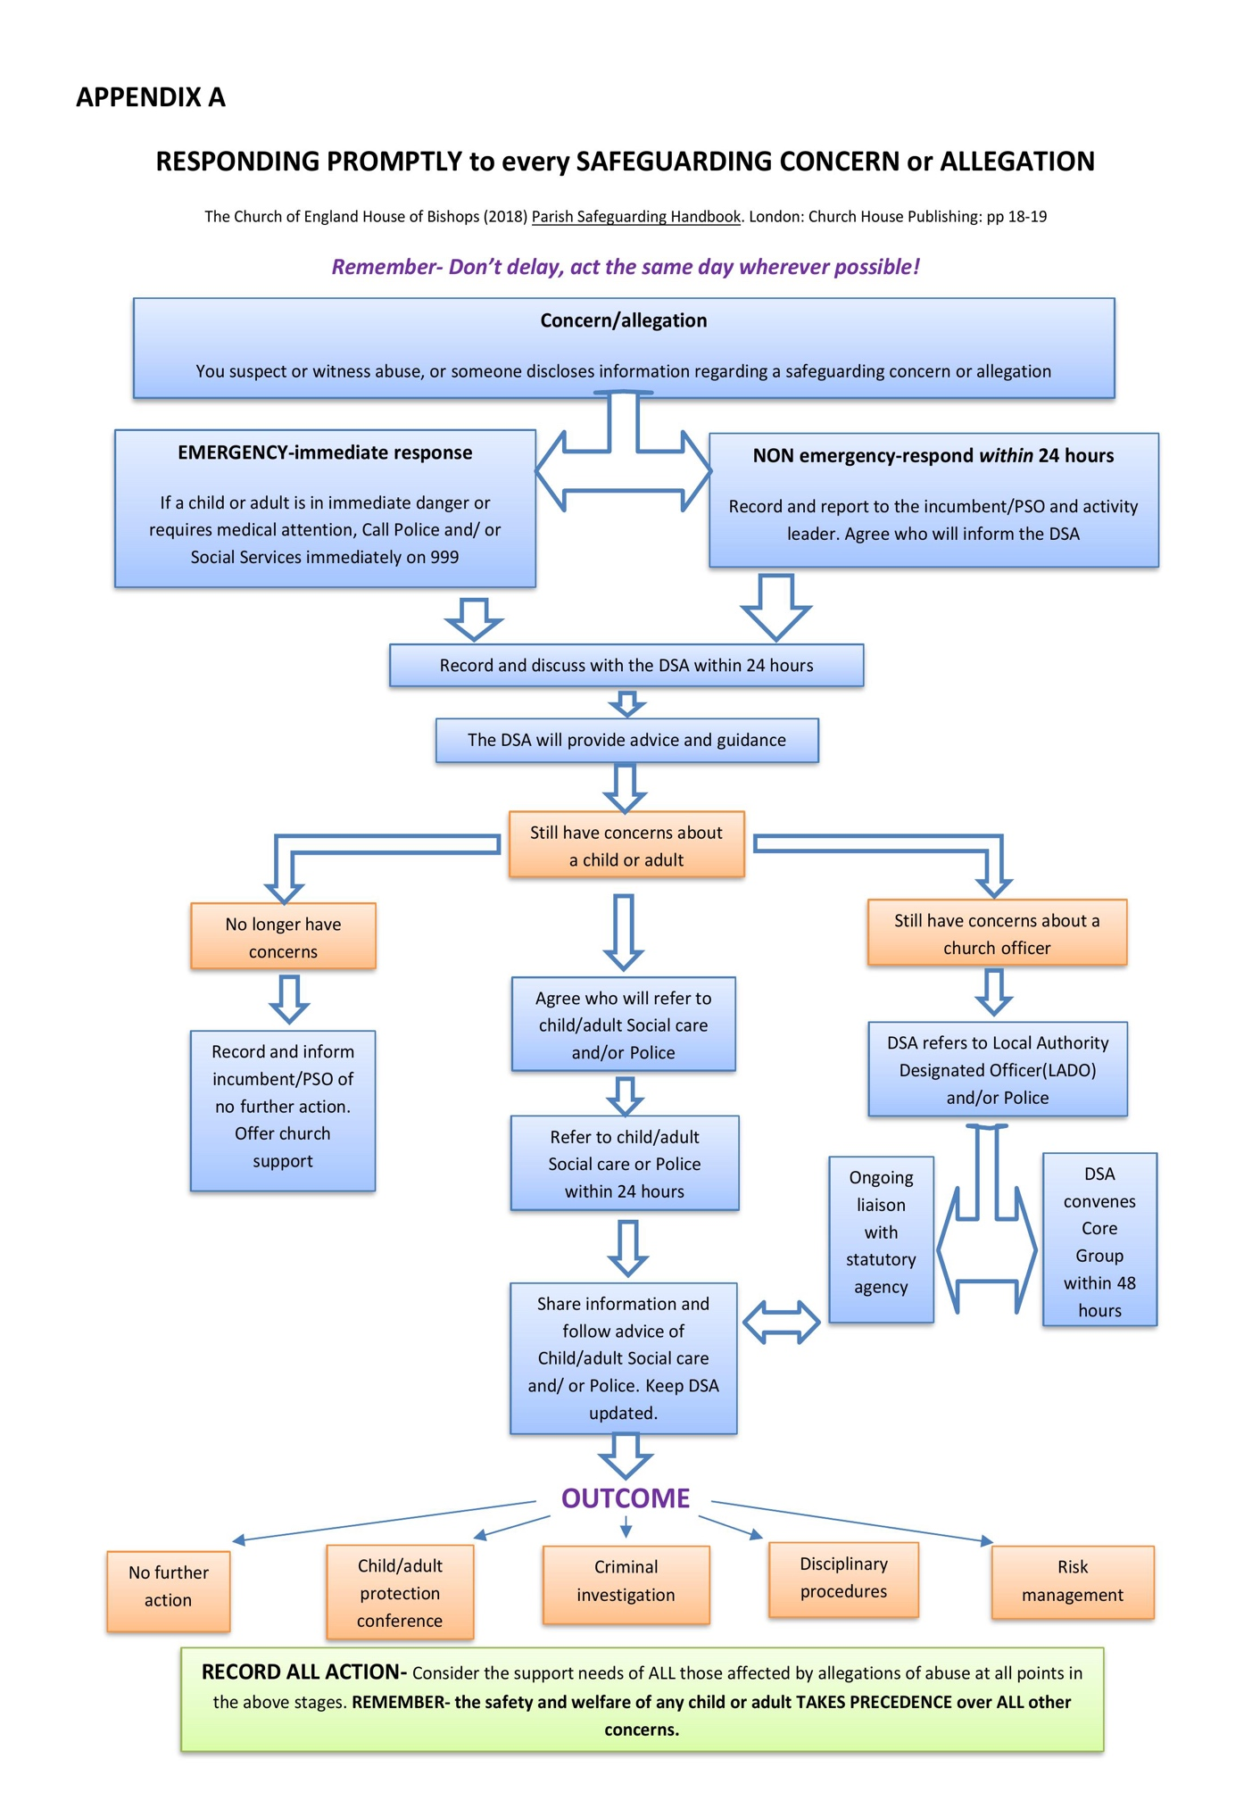

APPENDIX B
THE PARISH OF BROMSGROVE

Policy Statement for the Recruitment on Ex-Offenders

- As an organisation assessing applicants’ suitability for positions which are included in the Rehabilitation of Offenders Act 1974 (Exceptions) Order using criminal record checks processed through the Disclosure and Barring Service (DBS), The Parish of Bromsgrove complies fully with the Code of Practice and undertakes to treat all applicants for positions fairly
- The Parish of Bromsgrove undertakes not to discriminate unfairly against any subject of a criminal record check on the basis of a conviction or other information revealed
- The Parish of Bromsgrove can only ask an individual to provide details of convictions and cautions that the Parish are legally entitled to know about. Where a DBS certificate at either standard or enhanced level can legally be requested (where the position is one that is included in the Rehabilitation of Offenders Act 1974 (Exceptions) Order 1975 as amended, and where appropriate Police Act Regulations as amended)
- The Parish of Bromsgrove can only ask an individual about convictions and cautions that are not protected
- The Parish of Bromsgrove is committed to the fair treatment of its staff, potential staff or users of its services, regardless of race, gender, religion, sexual orientation, responsibilities for dependants, age, physical/mental disability or offending background
- The Parish of Bromsgrove has a written policy on the recruitment of ex-offenders, which is made available to all DBS applicants at the start of the recruitment process
- The Parish of Bromsgrove actively promotes equality of opportunity for all with the right mix of talent, skills and potential and welcome applications from a wide range of candidates, including those with criminal records
- The Parish of Bromsgrove select all candidates for interview based on their skills, qualifications and experience
- An application for a criminal record check is only submitted to DBS after a thorough risk assessment has indicated that one is both proportionate and relevant to the position concerned. For those positions where a criminal record check is identified as necessary, all application forms, job adverts and recruitment briefs will contain a statement that an application for a DBS certificate will be submitted in the event of the individual being offered the position
- The Parish of Bromsgrove ensures that all those in the Parish who are involved in the recruitment process have been suitably trained to identify and assess the relevance and circumstances of offences
- The Parish of Bromsgrove also ensures that they have received appropriate guidance and training in the relevant legislation relating to the employment of ex-offenders, e.g. the Rehabilitation of Offenders Act 1974
- At interview, or in a separate discussion, the Parish of Bromsgrove ensures that an open and measured discussion takes place on the subject of any offences or other matter that might be relevant to the position. Failure to reveal information that is directly relevant to the position sought could lead to withdrawal of an offer of employment
- The Parish of Bromsgrove makes every subject of a criminal record check submitted to DBS aware of the existence of the Code of Practice and makes a copy available on request
- The Parish of Bromsgrove undertakes to discuss any matter revealed on a DBS certificate with the individual seeking the position before withdrawing a conditional offer of employment.

