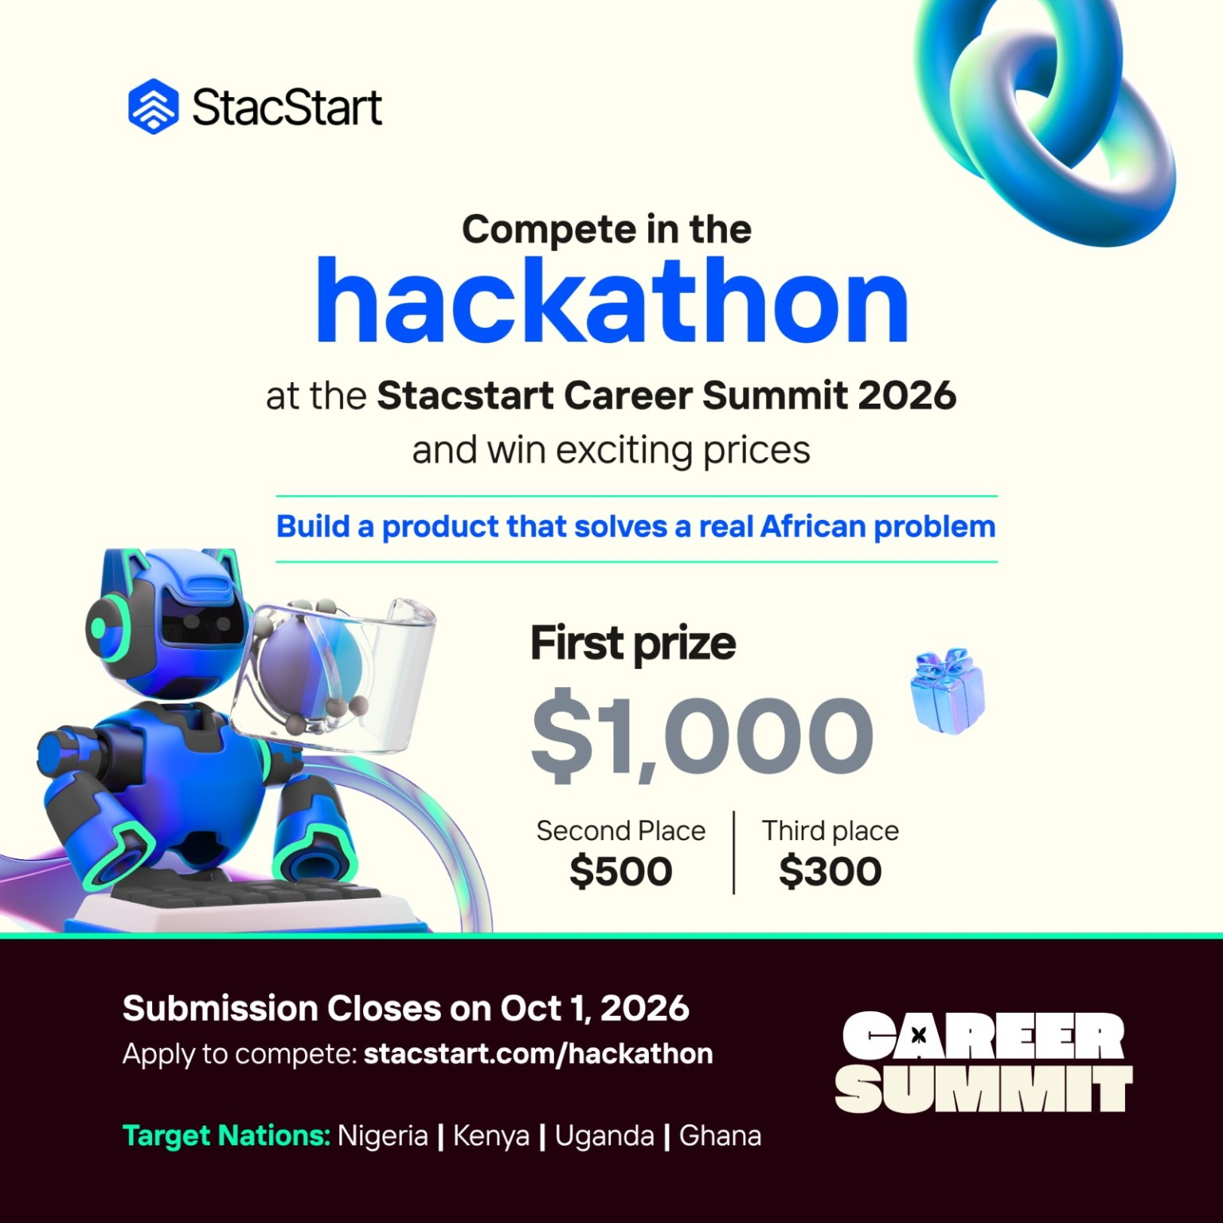
NEXT Africa
A Personal Execution Copilot for Work & Life
You tell me what matters. I help make sure it happens.
Hackathon concept • Nigeria • Kenya • Uganda • Ghana • 2026

1. Executive Summary
NEXT is a mobile-first, AI-powered personal execution copilot. Instead of asking users to classify everything as a task, note, reminder, calendar event or document, users simply tell NEXT what is happening. The copilot interprets the context, extracts commitments, creates the right actions, connects related files and deadlines, and proactively helps the user complete the next step.
The product philosophy is deliberately category-free: the user should not have to decide whether something is a task, note, reminder, calendar event, document or goal. They simply describe what is happening. NEXT interprets the situation and creates the structure needed to move it forward.
The core relationship is: “You tell me what matters. I help make sure it happens.” The copilot is highly proactive by default, but the user controls its level of intervention.

2. The Problem: Africa Has a Fragmented Execution Layer
Across African markets, people increasingly manage work, school, freelance clients, family responsibilities, applications, small businesses and personal commitments through fragmented tools: WhatsApp messages, screenshots, spreadsheets, email, calendars, notes and memory. The problem is not a lack of task-management apps. The problem is the gap between information and execution.
This is not a claim that Africans lack productivity tools. It is a design opportunity created by the way real work is communicated and completed: through chat, voice, screenshots, PDFs, spreadsheets, calls and informal instructions.
- Information arrives in unstructured form.
- Commitments get buried inside conversations.
- Deadlines live in different places.
- People switch between school, work, clients, applications and family responsibilities.
- Freelancers and small operators often need business coordination without enterprise software.
- Existing AI tools can answer questions but often stop before the real-world execution step.

3. Why Nigeria, Kenya, Uganda and Ghana?
The four target countries are different markets, but they provide a useful shared test bed: all have large youth populations, growing digital ecosystems, mobile-first behaviour and strong demand for productive work. Their differences also make the product more robust if it works across all four.
Country | What the evidence points to | Product opportunity
Nigeria | Large and growing labour force; difficulty absorbing new entrants into quality employment; digital economy opportunity. | Execution support for students, employees, freelancers, founders and job seekers; low-bandwidth/WhatsApp-first workflows.
Kenya | Strong digital ecosystem, but job creation remains heavily informal and digital-skills gaps persist. | Turn fragmented informal work into trackable client jobs, deliverables, invoices, follow-ups and learning plans.
Uganda | Very young population; agriculture remains a major employer; job creation is not keeping pace with the working-age population. | Voice/mobile workflows, simple project tracking, skills-to-opportunity guidance and support for small operators.
Ghana | Services/agriculture are important; digital entrepreneurship and digital public-service infrastructure are developing. | AI support for SMEs, applications, documents, customer follow-up and day-to-day execution.

4. What These Markets Have in Common
- Mobile-first behaviour and growing digital adoption, alongside affordability and usage gaps.
- Large youth populations and pressure to convert education and skills into productive work.
- A large informal/small-business economy where work is often managed through chat, calls, paper and spreadsheets.
- Fragmented workflows: opportunities arrive through messages, files, screenshots and conversations rather than structured systems.
- Need for locally relevant AI that understands African contexts, constraints, accents, currencies, dates and work patterns.
- Connectivity and device constraints mean the product must be lightweight, resilient and useful even when bandwidth is limited.
The strongest shared opportunity is not to build four separate country products. It is to build one execution engine with a regional access and context layer that can adapt to each market.

5. Product Philosophy

One person. One copilot. Whatever their life requires.
- Student → assignments, research, project milestones and deadlines.
- Employee → reports, meetings, follow-ups and recurring work.
- Freelancer → briefs, revisions, deliverables, invoices and client approvals.
- Founder → ideas, product work, hiring, pitch materials and business tasks.
- Parent → household responsibilities, appointments, shopping and family commitments.
The product adapts to the individual rather than forcing the individual into a category. Modes can exist as optional experiences, but the underlying memory and copilot remain one system.

6. The Core User Experience
Example:
User: “My meeting with John is next Thursday at 2, and I need to send him the proposal beforehand.”
NEXT: “Got it. I created the meeting for Thursday at 2 PM, linked the proposal as a prerequisite, and added a reminder to send it beforehand. Do you want me to suggest a send time?”
The system should infer relationships rather than merely create four separate records. Meeting, deadline, task and document context become one connected piece of work.

7. The AI Layer — Not AI for Decoration
AI should be integrated at every point where unstructured human information needs to become useful action.
1. Natural-language capture — User says or types what is happening. NEXT turns it into structured work without forcing the user to choose an app category.
2. Multimodal understanding — Read screenshots, PDFs, spreadsheets, photos, emails and voice notes; extract deadlines, names, amounts, deliverables and required actions.
3. Project memory — Remember projects, commitments, files, decisions and open loops so the user can ask 'what is left?' instead of reconstructing context.
4. Copilot Mode — Create a temporary focused workspace for a session, e.g. 'Stay with me for the next hour while I finish this report.'
5. Proactive execution — Surface useful interventions: approaching deadlines, unanswered follow-ups, conflicting commitments and stalled tasks.
6. User-controlled proactivity — A simple control from Quiet → Balanced → Active. The user can snooze, dismiss, or turn off interventions.
7. African-first access layer — WhatsApp-style chat, voice input, lightweight web/mobile experience, low-data design and graceful offline/poor-network behaviour.
8. Career & opportunity layer — Track applications, assessments, interviews, scholarships, freelance leads and client opportunities from the moment they arrive.
9. Work & document layer — Generate reports, meeting minutes, proposals, spreadsheets, checklists and summaries from source material.
10. Local context — Support local currencies, time zones, date formats, common communication patterns and eventually regional/local-language voice experiences.
The key differentiation is the loop: Understand → Decide next action → Execute → Record result → Continue.

8. Proactivity: C, With a Control Dial
Recommended personality: highly proactive, but user-controlled. The copilot should notice important things, while never silently taking consequential actions.
- Quiet: respond when asked; no proactive nudges except critical reminders.
- Balanced: surface useful deadlines, follow-ups and conflicts.
- Active: actively protect focus time, identify stalled work and propose schedule changes.
Consequential actions — sending messages, deleting files, submitting applications, making payments or changing important commitments — should require explicit confirmation unless the user has deliberately granted permission.

9. The African-First Product Layer
- Mobile-first and lightweight rather than desktop-first.
- Voice as a first-class input, not an afterthought.
- Chat-style interaction because many users already understand conversational workflows.
- Low-data design, compressed uploads and asynchronous processing where feasible.
- Local currencies, time zones, date formats and regional work patterns.
- Strong handling of screenshots and forwarded messages because real instructions often arrive visually.
- Future support for African accents and selected local-language voice experiences.
- Human-readable explanations of AI decisions and easy correction.
The design should acknowledge the digital divide rather than assuming every user has fast broadband, a premium device or constant access.

10. A Typical User Journey
Stage | Experience
Capture | “Client needs a flyer by Friday.”
Understand | AI extracts client, deliverable, deadline and likely project.
Connect | User uploads the brief; NEXT links it to the same project.
Plan | NEXT proposes: review brief → draft → internal check → send.
Execute | Copilot Mode helps produce the first draft/checklist.
Follow up | NEXT tracks whether the client responded and surfaces the next action.

11. MVP for the Hackathon
Do not build the entire productivity universe. Build the smallest convincing demonstration of the execution loop.
- Chat + voice input
- Screenshot/file upload and AI extraction
- Tasks, deadlines and projects generated automatically
- Project memory and 'What's next?' view
- One focused Copilot Mode
- Proactive deadline/follow-up alerts
- Quiet/Balanced/Active proactivity control
- Simple dashboard showing Today / Waiting For / Projects
- Demo integrations: calendar + document generation
A strong MVP should prove one thing: a messy real-world instruction can become an actionable, remembered workflow in seconds.

12. Five-Minute Demo Script
Time | Moment | What judges see
00:00–00:30 | Open with the problem | Show a WhatsApp-style message: 'Client needs this by Friday.'
00:30–01:15 | AI understands | NEXT identifies client, deliverable, project and deadline automatically.
01:15–02:00 | Add evidence | Upload a brief or screenshot. NEXT links it to the same project.
02:00–02:45 | Copilot plans | It proposes the next 3 actions and asks for confirmation where needed.
02:45–03:30 | Work alongside the user | Enter Copilot Mode; generate a checklist/report/first draft.
03:30–04:00 | Proactive moment | Simulate: 'The deadline is tomorrow and the draft is still incomplete. Want me to move this to your 6pm focus block?'
04:00–05:00 | Show impact | One timeline: Capture → Understand → Plan → Execute → Follow up.

13. Technical Architecture
Layer | Role | Example
Input | Capture text, voice, screenshots, files and messages | Voice note: 'Client needs the flyer Friday'
AI understanding | Extract entities, intent, deadline, project and relationships | Client=Rekoda; deliverable=flyer; due=Friday
Memory / knowledge | Store project context, commitments and decisions with permissions | Rekoda Branding project
Planning engine | Convert context into next actions and schedules | Draft → review → send
Execution tools | Create files, reminders, calendar items and structured outputs | Proposal.docx + reminder
Proactive engine | Detect risk and decide when to surface an intervention | Deadline in 24h; task not started
Trust layer | Permissions, confirmation, audit trail and user controls | Ask before sending or deleting anything
Suggested hackathon stack: mobile/web frontend; API/backend; PostgreSQL or equivalent for structured data; object storage for files; vector/semantic retrieval for project memory; an LLM with tool/function calling; speech-to-text for voice; document/spreadsheet parsers; calendar/document integrations. The exact vendors can change.

14. Impact
Area | Potential contribution
Productivity | Reduce time lost reconstructing context across chats, files, notes and calendars.
Youth & careers | Help users keep applications, assessments, interviews and learning commitments from falling through the cracks.
Informal work | Give freelancers and micro-businesses a lightweight operating layer for clients, jobs, deadlines and follow-ups.
SMEs | Turn unstructured messages and documents into repeatable workflows without enterprise software complexity.
Digital inclusion | Design for mobile-first, low-data, voice and simple interaction patterns.
AI inclusion | Make useful AI available as an action-oriented layer rather than only a question-answering chatbot.

15. Business Model
- Freemium: core personal copilot free; paid tier for higher limits, advanced file processing and deeper automation.
- Professional: features for freelancers, consultants, creators and knowledge workers.
- Team/SME: shared projects, roles, approvals and business workflows.
- Institutional: universities, accelerators, training programmes and workforce initiatives can provide structured versions.
- Future ecosystem: integrations with calendars, messaging, payments, cloud storage, job platforms and business tools.

16. Risks and How We Design Around Them
Risk | Why it matters | Mitigation
Privacy | Sensitive work and personal data | Granular permissions, encryption, data minimisation, deletion/export controls and clear audit logs.
AI mistakes | Wrong deadline, wrong interpretation or fabricated output | Show source evidence, require confirmation for consequential actions, preserve audit trail.
Over-notification | User ignores the copilot | User-controlled proactivity, quiet hours, relevance thresholds and learning from dismissals.
Connectivity | Poor network or expensive data | Lightweight client, compressed uploads, local caching and asynchronous sync where feasible.
AI cost | Heavy multimodal processing can be expensive | Route simple tasks to smaller models; use larger models only when needed.
Scope creep | Trying to become every productivity app | MVP stays focused on one promise: turn messy input into the next useful action and help execute it.

17. Roadmap
Phase | Build | Success signal
Hackathon MVP | Capture → understand → project → next action → proactive reminder | A judge can see value in under 5 minutes.
V1 | Files, calendar, richer project memory, voice, better integrations | Users return because NEXT remembers context.
V2 | WhatsApp channel, SME workflows, career pipeline, stronger local context | Users manage real work through NEXT.
V3 | Cross-border ecosystem, local-language voice, deeper automation and partner integrations | NEXT becomes an execution layer across multiple African markets.

18. The Pitch in One Paragraph
NEXT Africa is a personal execution copilot built for the way people actually live and work. Instead of forcing users to organise their lives across separate task lists, calendars, notes and document apps, NEXT lets them simply describe what is happening. AI turns messages, voice notes, screenshots and files into connected commitments, projects and next actions. It remembers context, works alongside the user and proactively helps prevent important work from falling through the cracks — with user-controlled proactivity and an African-first, mobile-first design.

19. Tagline & Positioning Options
- NEXT — Your personal execution copilot.
- You tell me what matters. I help make sure it happens.
- From “I need to do this” to “It’s done.”
- Don't organise your life. Move it forward.
- One person. One copilot. Whatever life requires.

20. Evidence Base / Research Notes
The country and digital-context sections above are grounded in the following public sources. Figures are time-bound and should be refreshed before a final pitch deck if the organisers require the latest available statistics.
- GSMA, Mobile Economy Africa 2026: https://www.gsma.com/solutions-and-impact/connectivity-for-good/mobile-economy/africa/
- ITU, Measuring digital development: Africa 2025: https://www.itu.int/itu-d/reports/statistics/wp-content/uploads/sites/5/2025/04/2500037E_SDDT_2025_Africa_FINAL.pdf
- World Bank, Nigeria Overview: https://www.worldbank.org/en/country/nigeria/overview.print
- World Bank, Kenya: https://www.worldbank.org/ext/en/country/kenya
- World Bank, Uganda Overview: https://www.worldbank.org/en/country/uganda/overview.print
- World Bank, Ghana Overview: https://www.worldbank.org/en/country/ghana/overview.print
- World Bank, Nigeria Digital Economy Diagnostic: https://www.worldbank.org/en/country/nigeria/publication/nigeria-digital-economy-diagnostic-a-plan-for-building-nigerias-inclusive-digital-future

Prepared as a hackathon concept document • September 2026

