Supplementary information - Exploring alternative Bayesian estimates of low- and no-effect concentration thresholds

29 October, 2021

**Authors:**

R. Fisher1,2, D.R. Fox3,4, A. Negri1, J. van Damn1, F. Flores1

**Affiliations:**

1 Australian Institute of Marine Science, Crawley, Australia  
2 University of Western Australia, Crawley, Australia  
3 Environmetrics Australia Pty Ltd, Beaumaris, Vic 3193, Australia  
4 University of Melbourne, Parkville 3010, Australia

**Corresponding author:** Rebecca Fisher

**Email:** [r.fisher@AIMS.gov.au](mailto:r.fisher@AIMS.gov.au)

# jagsNEC model formulations

Where possible jagsNEC has aimed for consistency in the interpretable meaning of the individual parameters across models, and include:

$τ,$ usually interpretable as either the y-intercept or the upper plateau representing the mean concentration of the response at zero concentration;

$η=\text{NEC}$, the No-Effect-Concentration value (the x concentration value where the breakpoint in the regression is estimated at;

$β=\text{beta}$, generally the exponential decay rate of response, either from 0 concentration or from the estimated $η$ value;

$δ=\text{bottom}$, representing the lower plateau for the response at infinite concentration;

$ω$ = $\text{EC50}$ notionally the 50% effect concentration but may be influenced by scaling and should therefore not be strictly interpreted, and

In addition to the model parameters, all **NEC**-containing models have a step function used to define the breakpoint in the regression, which can be defined as

$$f(x_{i},η)=\left\{\begin{matrix}0, & x_{i}-η<0 \\ 1, & x_{i}-η≥0\end{matrix}\right.$$

## *ECx* models

The **ECxExp** model is a basic exponential decay model, given by the equation:

$$y_{i}=τe^{-βx_{i}} (1)$$

The **ECxSigmoidal** model is a simple sigmoidal decay model, given by the equation:

$$y_{i}=τe^{-βx_{i}^{e^{ϵ}}} (2)$$

The **ECx4param** model is a 4-parameter sigmoidal decay model, given by the equation:

$$y_{i}=\frac{τ+(δ-τ)}{1+e^{β(ω-x_{i})}} (3)$$

The **ECxWeibull1** model is a 4-parameter sigmoidal decay model which is a slight reformulation of the Weibull1 model of Ritz et al. (2016), given by the equation:

$$y_{i}=δ+(τ-δ)e^{-e^{β(x_{i}-ω)}} (4)$$

The **ECxWeibull2** model is a 4-parameter sigmoidal decay model which is a slight reformulation of the Weibull2 model of Ritz et al. (2016), given by the equation:

$$y_{i}=δ+(τ-δ)(1-e^{-e^{β(x_{i}-ω)}}) (5)$$

## *NEC* models

The **NEC3param** model is a basic exponential decay model equivalent to **ECxexp** with the addition of the “NEC” step function. This is the original model of Fox (2010) given by the equation:

$$y_{i}=τe^{-β\left(x_{i}-η\right)f(x_{i},η)} (6)$$

The **NEC4param** model is a 3-parameter decay model with the addition of the “NEC” step function, given by the equation:

$$y_{i}=δ+(τ-δ)e^{-β\left(x_{i}-η\right)f(x_{i},η)} (7)$$

# Alternative sigmoidal NEC model

We explored the utility of an expanded NEC model that allows a sigmoidal curve following the NEC-step point:

$$y_{i}=τe^{-β\left(x_{i}^{ϵ}-η\right)f(x_{i},η)} (8)$$

which has the same parameters as the NEC 3 parameter model (equation (6)), but with an additional parameter $ϵ$. With the exception of *A. millepora*, NEC estimates using this sigmoidal NEC model were highly unresolved, despite the model yielding a relatively good fit to the data (Fig. S1).

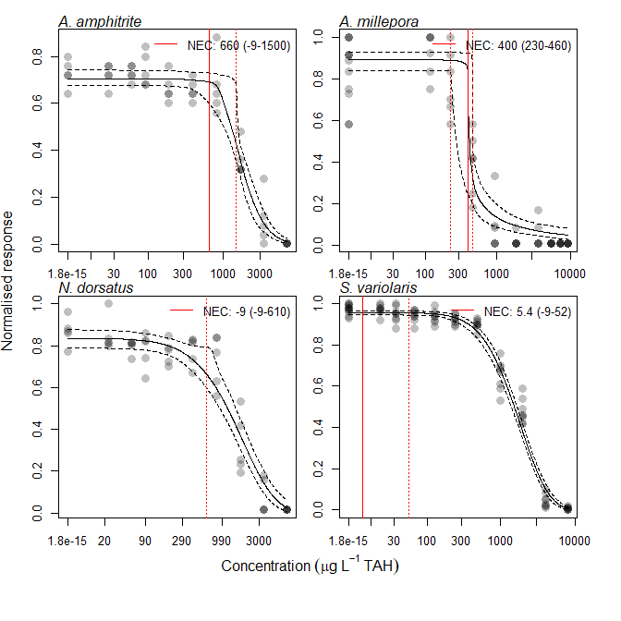

Figure S1: Concentration response relationships for the effects of 40% weathered Ichthys condensate WAF on four tropical marine species. Measured time-weighted average concentrations are expressed as µg/L Total Aromatic Hydrocarbons (TAH) on a log scale. Solid black lines are Bayesian NEC-sigmoidal beta model fits with 95% credible intervals indicated by dashed black lines. The fit is for the . Binomial response data are the proportion of successes (A. millepora, and S. variolaris); growth rate response data taking values >1 are normalised relative to the maximum value (N. dorsatus); and growth rate response data taking values <1 are modelled on the original scale (A. amphitrite). The vertical red lines indicate the estimated NEC with 95% confidence intervals (dashed lines based on posterior predictions).

# References

Fisher, R., Ricardo, G., Fox, D., 2020. Bayesian concentration-response modelling using jagsNEC. <https://doi.org/10.5281/ZENODO.3966864>

Fox, D.R., 2010. A Bayesian approach for determining the no effect concentration and hazardous concentration in ecotoxicology. Ecotoxicology and environmental safety 73, 123–131.

Ritz, C., Baty, F., Streibig, J.C., Gerhard, D., 2016. Dose-response analysis using r. PLoS ONE 10, e0146021. <https://doi.org/10.1371/journal.pone.0146021>