OpenSesame Tutorial
Creating a Gaze Cuing Experiment

Last Updated, Dec 15 2011

Sebastiaan Mathôt
Lotje van der Linden
Elke Godefroid

Dept. of Cognitive Psychology
Vrije Universiteit, Amsterdam
s.mathot@vu.nl

In this tutorial you will learn how to create a simple, but complete psychological experiment using OpenSesame (Mathôt, Schreij, & Theeuwes, in press). You will only use the OpenSesame graphical interface (i.e., no Python inline coding), although you will make small modifications to the OpenSesame script.
This document provides a highly detailed 'click-by-click' walk-through. Screenshots are provided, as well as downloadable 'snapshots' of the experiment as it should be after each step of the tutorial.
This tutorial will take approximately 2 hours to complete.

About OpenSesame
OpenSesame is a cross-platform graphical experiment builder. It provides an exceedingly simple way to create psychological experiments using a point-and-click graphical interface. For very advanced tasks, you can use Python inline scripting (not covered in this tutorial).
OpenSesame is freely available under the General Public License v3.

Resources
- Download — This tutorial assumes that you are running OpenSesame version 0.25 or newer. To check which version you are running, see the bottom right of the 'General properties' tab. You can download the most recent version of OpenSesame here:
  - http://wwww.cogsci.nl/opensesame
- Documentation — There is a dedicated website with documentation for OpenSesame:
  - http://osdoc.cogsci.nl/
- Forum — If you have any questions or comments, please visit the forum:
  - http://forum.cogsci.nl/

The experiment
The experiment that you will create is a gaze-cuing paradigm, as introduced by Friesen and Kingstone (1998). A face is presented in the center of the screen (Figure 1). This face looks either to the right or to the left. A target stimulus (a letter) is presented on the left or the right side of the face. A distractor stimulus (the letter 'X') is presented on the other side of the face. The task is to indicate as fast as possible whether the target letter is an 'F' or an 'H'. In the congruent condition, the face looks at the target. In the incongruent condition, the face looks at the distractor. As you may have guessed, the typical finding is that you are faster in the congruent condition, compared to to the incongruent condition, even though the direction of gaze is not predictive of the target location. This shows that our attention is automatically guided by other people's gaze, even in situation where this doesn't serve any purpose (and even when the face is just a smiley!). Of course, following other people's gaze is generally not useless at all, so this is actually a good strategy.
The experiment will consist of a practice and an experimental phase. We will present visual feedback after every block of trials and play a sound after every incorrect response.
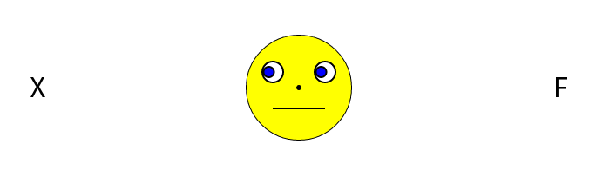Figure 1. The gaze cuing paradigm.

Step 1: Create the main sequence
When you start OpenSesame, the 'New experiment' dialog will appear (Figure 2). On the left side of this dialog, there is a list of available templates, which provide convenient starting points for creating an experiment. On the right, there is a list of recently opened experiments (which is empty if you start OpenSesame for the first time).
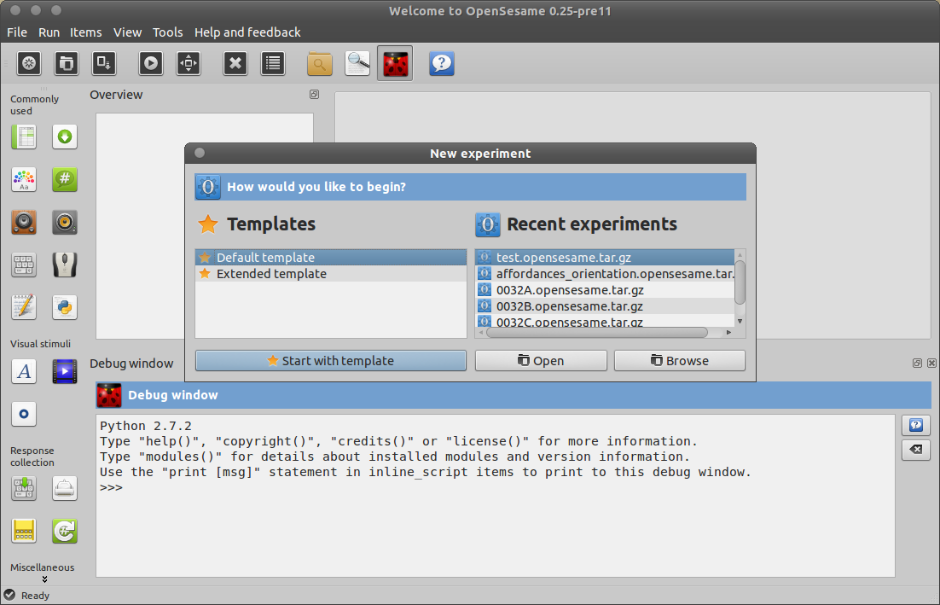Figure 2. The 'New experiment' dialog on OpenSesame start-up.
Double-click on 'Default template', to start with a minimal experimental template. Save the experiment right away as 'Gaze_cuing'.
- Tip — The 'Extended template' is a good starting point for many experiments. Here we choose the 'Default template', because for the purpose of the tutorial we want to create an experiment from scratch.
- Tip — Figure 4 schematically shows the structure of the experiment that you will create. If you get confused during the tutorial, you can refer to Figure 4 to see where you are.
- Tip — You can click on the blue '?' icons to get context sensitive help.
- Tip — Save (Control+S or the 'Save' button from the main tool bar) your experiment often! In the unfortunate (and unlikely) event of data loss, you will often be able to recover your work from the back-ups that are created automatically, by default, every 10 minutes (Menu → Tools → Open backup folder).
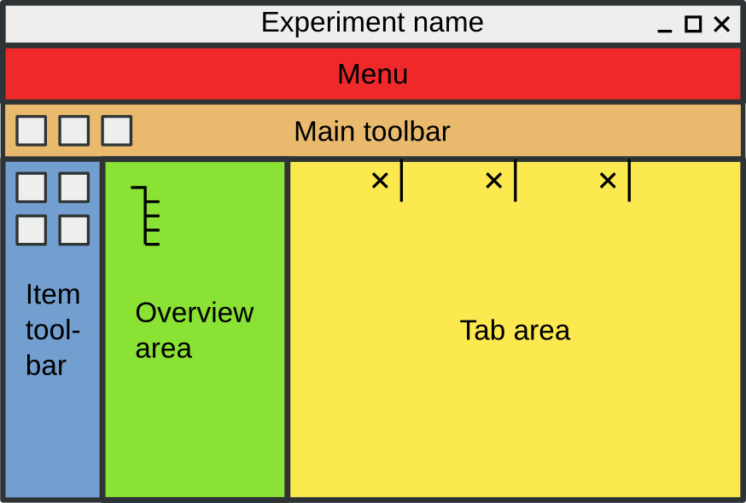Figure 3. The default layout of the OpenSesame interface.
By default there is a main sequence, simply called 'experiment'. Click on 'experiment' in the overview area (by default on the left side, see Figure 3) to open its tab in the tab area. The 'experiment' sequence consists of two items: a notepad called 'getting started' and a sketchpad called 'welcome'.
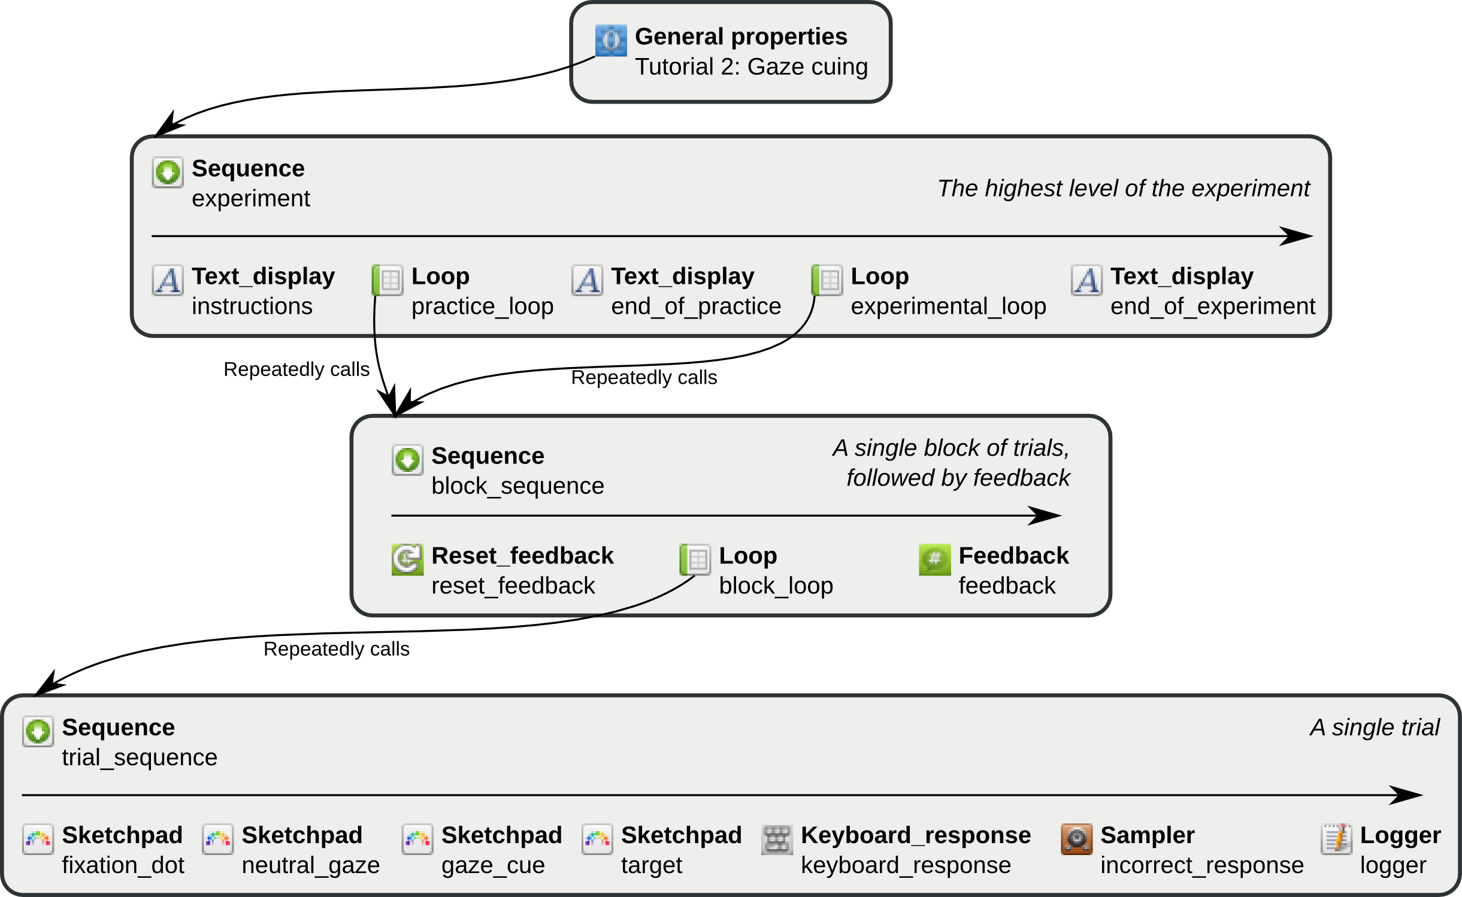Figure 4. A schematic representation of the 'Gaze cuing' experiment structure. (The item types are in bold face, item names in regular face.)
We don't need these two items. Remove 'getting_started' by right-clicking on it in the overview area and selecting 'delete'. Remove 'welcome' in the same way. The 'experiment' sequence is now empty.
- Tip — Deleted items are still available in the 'Unused items' bin, until you select 'Permanently delete unused items' in the 'Unused items' tab. You can re-add deleted items to a sequence using the 'Append existing item' button (Figure 5).
Append a text_display item for the instruction display — As the name suggests, text_display items show text. We are going to use a text_display to give instructions to the participant at the beginning of the experiment.
Click on 'experiment' in the overview area to open its controls in the tab area. You will see an empty sequence. Select 'text_display' in the combo-box labeled 'Append new item', and click on the '+' button (Figure 5). (We will get back to this in step 13.)
- Tip — Another way to add items to a sequence is by dragging them from the item toolbar onto the overview area.
- Tip — A text_display only shows text. If you require images etc., you can use a sketchpad item. We will meet the sketchpad in step 5.
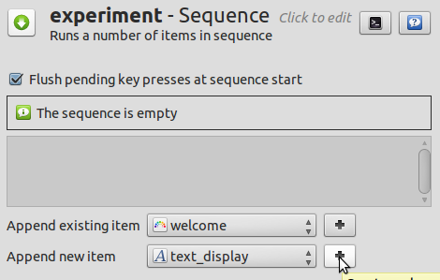Figure 5. Adding a 'text_display' to the sequence.
Append a loop item, containing a new sequence item, for the practice phase — We need to append a loop item to the main sequence. We will use this loop for the practice phase of the experiment. Click on the 'experiment' sequence to open its controls in the tab area.
Select 'loop' in the combo-box labeled 'Append new item' and click on the '+' button. You will be asked to fill the new loop item with another item. This is because a loop by itself does nothing. A loop always needs another item to run. Choose a 'sequence' item in the menu under 'Create new item to use' and click on the 'Create' button. (We will get back to this in step 2.)
- What is a loop item? — A loop is an item that adds structure to your experiment. It repeatedly runs another item, typically a sequence. A loop is also the place where you will usually define your independent variables (experimental factors).
- What is a sequence item? — A sequence item also adds structure to your experiment. A sequence runs multiple other items in sequence.
- The loop-sequence structure — You will often want to repeat a sequence of events. To do this, you will need a loop item which contains a sequence item. By itself, a sequence does not repeat itself. It simply starts with the first item from the sequence and ends with the last item. By 'wrapping' a loop item around the sequence, you can repeat the sequence multiple times. For example, a single trial will usually be a single 'trial' sequence. A 'block' loop around this 'trial' sequence would then constitute a single block of trials. Similarly, but at another level of the experiment, a 'block' sequence may contain a single block of trials, followed by a participant feedback display. A 'practice_phase' loop around this 'block' sequence would then constitute the practice phase of the experiment. This may seem a bit abstract right now, but as you follow this tutorial, you will become familiar with the use of loops and sequences.
- URL — For more information about loops and sequences, see:
  - http://osdoc.cogsci.nl/usage/about-sequences-and-loops
Append a new text_display item for the end-of-practice message — After the practice phase, we want to inform the participant that the real experiment will begin. For this we need another text_display. Go back to the sequence 'experiment' and select 'text_display' in the combo-box marked 'Append new item'. Click on the '+' button. (We will get back to this in step 13.)
Append a new loop item, containing the previously created sequence, for the experimental phase — We need a 'loop' item for the experimental phase, just like for the practice phase. Therefore, select 'loop' from the 'Append new item' menu and click on the '+' button. However, because the trials of the practice phase and the experimental phase are identical, they can use the same sequence. Therefore, in the dialog that appears after you have created a new loop item, select the previously created sequence (simply called 'sequence', because we didn't rename it yet) from the menu below 'Select existing item to use' and click on the 'Select' button.
Append a new text_display item, for the goodbye message — When the experiment is finished, we should inform the participant. For this we need another text_display item. Select 'text_display' in the 'Append new item' combo-box and click on the '+' button. (We will get back to this in step 13.)
Give the new items sensible names — By default, new items have names like 'sequence' and '_text_display'. It is good practice to give items sensible names. This makes it much easier to understand the structure of the experiment. If you want, you can also add a description to each item. Renaming items is very easy. Item names must consist of alphanumeric characters and/or underscores.
- Right-click on 'text_display' in the overview area and select 'Rename'. Rename the item to 'instructions'.
- Richt-click on 'loop' in the overview and rename it to 'practice_loop'.
- Richt-click on 'sequence' (under 'practice_loop') in the overview and rename it to 'block_sequence'. Note that, because you use this sequence as well in the 'experimental_loop', the name automatically changes there as well. This illustrates why it is efficient to re-use existing items whenever this is possible.
- Rename '_text_display' to 'end_of_practice'.
- Rename '_loop' to 'experimental_loop'.
- Rename '__text_display' to 'end_of_experiment'.
Give the whole experiment a sensible name. The experiment in its entirety also has a name (a title, in this context) and a description. Click on 'New experiment' in the overview area. You can rename the experiment by clicking on the title (in the tab area), which is currently 'New experiment'. Rename the experiment to 'Tutorial: Gaze cuing'. Note that, unlike item names, the experiment title may contain spaces etc.
- Tip — If you don't like having many tabs open, you can close all tabs except the currently opened one by clicking on the 'Close other tabs' button in the main toolbar or by pressing Control+T.
The overview area of your experiment now looks like Figure 6. This would be a good time to save your experiment (Control+S). You can download the experiment up to this point here:
- tutorial_step1.opensesame
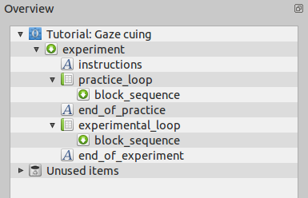Figure 6. The overview area at the end of step 1.

Step 2: Create the block sequence
Click on 'block_sequence' in the overview. At the moment the sequence is empty. We want the block sequence to consist of a block of trials, followed by a participant feedback display. For this we need to do the following:
Append a reset_feedback item to reset the feedback variables — We don't want our feedback to be confounded by key presses that participants have made during the instruction phase (or during previous blocks of trials). Therefore, we start each block of trials by resetting the feedback variables. To do this we need a 'reset_feedback' item. Select 'reset_feedback' in the 'Append new item' combo-box and click on the '+' button.
Append a new loop, containing a new sequence, for a block of trials — For a single trial we need a sequence. For a block of trials, we need to repeat this sequence multiple times. Therefore, for a block of trials we need to wrap a loop around a sequence. Select 'loop' in the 'Append new item' combo-box and click on the '+' button. In the dialog that appears, select 'sequence' under 'Create new item to use' and click on the 'Create' button. (We will get back to this in step 3.)
Append a feedback item — After every block of trials we want to give feedback to the participant, so that the participant knows how well he/ she is doing. For this we need a feedback item. Select 'feedback' in the 'Append new item' combo-box and click on the '+' button. (We will get back to this in step 10.)
Give the new items sensible names — Rename 'loop' to 'block_loop' and 'sequence' to 'trial_sequence'. (See step 1 if you don't remember how to do this.) The names 'reset_feedback' and 'feedback' are fine.
The overview of your experiment now looks like Figure 7. Remember to save your experiment regularly. You can download the experiment up to this point here:
- tutorial_step2.opensesame
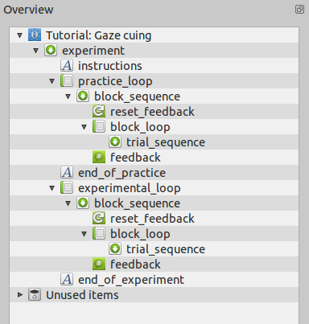Figure 7. The overview area at the end of Step 2.

Step 3: Fill the block loop with independent variables
As the name suggests, 'block_loop' corresponds to a single block of trials. In the previous step we created the 'block_loop', but we still need to 'fill' it with independent variables, which will be varied within the block. Our experiment has three independent variables:
- gaze_cue can be 'left' or 'right'.
- target_pos (the position of the target) can be '-300' or '300'. These values reflect the X-coordinate of the target in pixels (0 = center). Using the coordinates directly, rather than 'left' and 'right', will be convenient when we create the target displays (see step 5).
- target_letter (the target letter) can be 'F' or 'H'.
Our experiment has 2 x 2 x 2 = 8 levels. Although 8 levels is not that many (most experiments will have more), we don't need to type in all the possible combinations of variables by hand. Click on 'block_loop' in the overview to open its tab. Now click on the 'Variable wizard' button. In the variable wizard, you simply define all variables by typing the name in the first row and the levels in the rows below the name (see Figure 8). If you select 'Ok', you will see that the block loop has been filled with all 8 possible combinations. That's convenient!
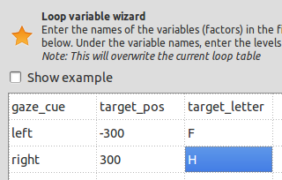Figure 8. The loop variable wizard in Step 2.
However, we are not done yet. There are two more variables that we need to add: the location of the distractor and the correct response.
- dist_pos Click on 'Add variable' and type 'dist_pos 300' in the dialog that appears. This will create a variable called 'dist_pos', with the value '300'. Change the value of 'dist_pos' to '-300' in every row where 'target_pos' is '300'. By doing this, we make sure that the distractor is always presented opposite from the target.
- correct_response Click on 'Add variable' and type 'correct_response z' in the dialog that appears. Change 'correct_response' to 'm' where 'target_letter' is 'H'. This means that the participant should press the 'z' key if he/ she sees an 'F' and the 'm' key if he/ she sees an 'H'.
There is one last thing to be done. 'Repeat' is currently set to '1.00'. This means that each level will be executed once. So the block now consists of 8 trials, which is a bit short. A reasonable length for a block of trials is 24, so set 'Repeat' to 3.00 (3 repeats x 8 levels = 24 trials). You don't need to change 'Order', because 'random' is exactly what we want.
- Tip — You can prepare your variable list in your favorite spreadsheet program and copy-paste it into the loop variable table.
- Tip — 'Cycles' refers to the number of distinct trials. 'Repeat' refers to the number of times that every trial occurs. Therefore, a block consists of 'Cycles' x 'Repeat' trials.
- Tip — You can set 'Repeat' to a non-integer number. For example, by setting 'Repeat' to '0.5', only half the trials (randomly selected) are executed.
The block_loop now looks like Figure 9. Remember to save your experiment regularly. You can download the experiment up to this point here:
- tutorial_step3.opensesame
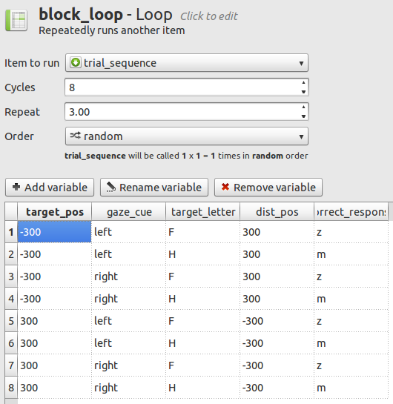Figure 9. The 'block_loop' at the end of Step 3.

Step 4: Add images and sound files to the file pool
We will not actually draw the stimuli in this experiment, but use images from file. In addition, we will play a sound if participants make an error. For this we need a sound file. You can download the required files here:
- http://files.cogsci.nl/software/opensesame/tutorial2/resources/
Direct links:
- gaze_neutral.png
- gaze_left.png
- gaze_right.png
- incorrect.ogg
After you have downloaded these files (to your desktop, say), click on the 'Show file pool' button in the main toolbar (or: Menu →View → Show file pool). This will show the file pool, by default on the right side of the window. The easiest way to add the four files to the file pool is to drag them from the desktop (or wherever you have downloaded the files to) into the file pool. Alternatively, you can click on the '+' button in the file pool and add files using the file select dialog that appears. The file pool will be automatically saved with your experiment if you save your experiment in the .opensesame.tar.gz format (which is the default format).
Your file pool now looks like Figure 10. Remember to save your experiment regularly. You can download the experiment up to this point here:
- tutorial_step4.opensesame.tar.gz
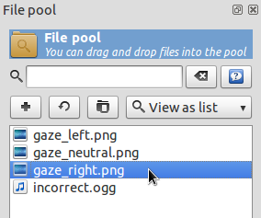Figure 10. The file pool at the end of Step 4.

Step 5: Fill the trial sequence with items
A trial in our experiment is fairly straightforward:
- Fixation dot — 750 ms, sketchpad item
- Neutral gaze — 750ms, sketchpad item
- Gaze cue — 500ms, sketchpad item
- Target — 0ms, sketchpad item
- Response collection —keyboard_response item
- Play a sound if response was incorrect — sampler item
- Log response to file — logger item
Click on 'trial_sequence' in the overview to open the trial_sequence tab. Select 'sketchpad' in the 'Append new item' menu and click four times on the '+' button. Similarly, select and append a keyboard_response item, a sampler item, and a logger item.
- What is a sketchpad item? — As the name suggests, a sketchpad is used to present visual stimuli. This includes text, geometric shapes, fixation dots, Gabor patches, etc. You can draw on the sketchpad using the built-in drawing tools.
- What is a keyboard_response item? — As the name suggests, a keyboard_response item collects a participant's response from the keyboard.
- What is a sampler item? — A sampler item plays a sound from a sound file.
- What is a logger item? — A logger item writes data to the log file. This is very important, because if you forget to include a logger item, no data will be logged during the experiment!
Again, we will rename the new items, to make sure that the trial_sequence is easy to understand. Rename 'sketchpad' to 'fixation_dot', '_sketchpad' to 'neutral_gaze', '__sketchpad' to 'gaze_cue', '___sketchpad' to 'target', and 'sampler' to 'incorrect_sound'. (See step 1 if you don't remember how to do this.)
The incorrect_sound item should only be executed if an error was made. To do this, we need to change the conditional statement (in the 'Run if …' field) to '[correct] = 0' (with spaces around the '=') in the trial_sequence tab. This works, because the keyboard_response item automatically creates a 'correct' variable, which is set to '1' (correct), '0' (incorrect) or 'undefined' (if no correct_response variable was defined, see step 3). The square brackets indicate that 'correct' should be interpreted as the name of a variable and not as text.
- URL — For more information about variables and conditional “if” statements, see:
  - http://osdoc.cogsci.nl/usage/variables-and-conditional-qifq-statements
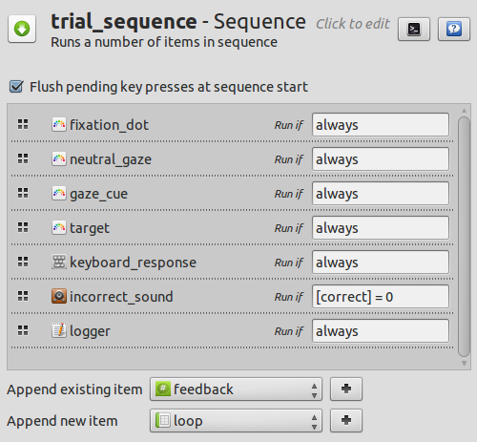Figure 11. The 'trial_sequence' at the end of Step 5.
The trial_sequence now looks like Figure 11. You can download the experiment up to this point here:
- tutorial_step5.opensesame.tar.gz

Step 6: Draw the sketchpad items
The sketchpad items that we have created in step 5 are still blank. It's time to do some drawing!
Set the background color to white — Click on 'fixation_dot' in the overview area to open its tab. You can see that the sketchpad is black, while the images that we have downloaded have a white background. Oops, we forgot to set the background color of the experiment to white (it is black by default)! Click on 'Tutorial: Gaze cuing' in the overview area to open the 'General properties' tab. Change 'Foreground color' to 'black' and 'Background color' to 'white'.
- Tip — For more fine-grained control over colors, you can also use the hexadecimal RGB notation (e.g., #FF000 for red).
  - http://www.w3schools.com/html/html_colors.asp
Draw the fixation dot — Go back to the fixation_dot by clicking on 'fixation_dot' in the overview. You can draw on the sketchpad right away, but (unless your screen is really large) it looks a bit cramped. Therefore, click on 'Open editor in new window' to open the sketchpad editor in a separate window. Now select the fixation dot tool by clicking on the button with the small black dot. If you move your cursor over the sketchpad, you can see the screen coordinates in the top-right. Set the (foreground) color to 'black'. Click on the center of the screen (0, 0) to draw a central fixation dot. Click on 'Close' to close the editor. Finally, change the 'Duration' from 'keypress' to '750', since we want the fixation dot to be presented for 750 ms.
- Tip — Make sure that the (foreground) color is set to black. Otherwise you will draw white on white and won't see anything!
- Tip — The duration of a sketchpad can be a value in milliseconds, but you can also enter 'keypress' or 'mouseclick' to collect a keyboard press or mouse click respectively. In this case a sketchpad will work much the same as a keyboard_response item (but with fewer options), including the setting of response variables.
Draw the neutral gaze — Open the neutral_gaze sketchpad and, again, open the sketchpad editor in a new window. Now select the image tool by clicking on the button with the aquarium-like icon. Click on the center of the screen (0, 0). The 'Select file from pool' dialog will appear. Select 'gaze_neutral.png' and click on the 'Select' button. The neutral gaze image will now stare at you from the center of the screen! Click on 'Close' to close the editor. Finally, like before, change the 'Duration' from 'keypress' to '750'.
Draw the gaze cue — Open the gaze_cue sketchpad, open the sketchpad editor in a new window, and select the image tool. Click on the center of the screen (0, 0) and select 'gaze_left.png'. Click on 'Close' to close the editor.
Obviously, we are not done yet, because the gaze cue should not always be 'left', but should depend on the variable 'gaze_cue', which we have defined in step 3. However, by drawing the 'gaze_left.png' image to the sketchpad, we have generated a script that needs only a tiny modification to make sure that the proper image is shown. Click on the 'Edit script' button at the top-right of the gaze_cue tab (if you have opened the sketchpad editor in a new window, you will first need to close the editor window). You will see the script that corresponds to the sketchpad that we have just created:
set duration "keypress"
set description "Displays stimuli"
set start_response_interval "no"
draw image 0 0 "gaze_left.png" scale=1.0 center=1 show_if="always"
The only thing that we have to do is replace 'gaze_left.png' with 'gaze_[gaze_cue].png'. This means that OpenSesame uses the variable 'gaze_cue' (which has the values 'left' and 'right') to determine which image should be shown.
- Tip — If you use a variable in OpenSesame script, you need to know the exact name of the variable. If you don't remember the exact name of a certain variable (e.g. if you don't remember whether you used a capital or not), you can click the 'Variable inspector' button in the main toolbar (or press Control+I). The Variable inspector provides a list of all variables used in your experiment (see Figure 12).
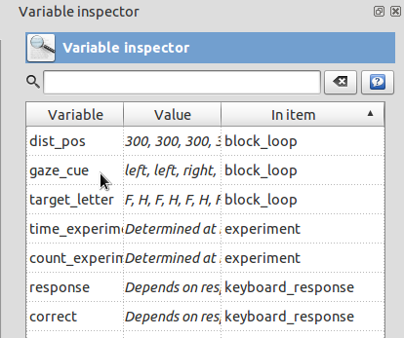Figure 12. The variable inspector.
While we are at it, we might as well change the duration to '500'.The script now looks like this:
set duration "500"
set description "Displays stimuli"
set start_response_interval "no"
draw image 0 0 "gaze_[gaze_cue].png" scale=1.0 center=1 show_if="always"
Click the 'Apply and close' button at the bottom right to apply your changes to the script and return to the regular item controls. You will see a message saying that one object is not shown, because it is defined using variables. Don't worry, it will be shown during the experiment!
- Tip — The red exclamation mark to the left of the 'Apply' button warns you when there are script changes that haven't been applied yet.
- URL — For more information about OpenSesame script, see:
  - http://osdoc.cogsci.nl/usage/opensesame-scripts
Draw the target — We want three objects to be part of the target display: the target letter, the distractor letter, and the gaze cue (see Figure 1). Like before, we will start by creating a static display using the sketchpad editor. After this, we will only need to make minor changes to the script so that the exact display depends on the variables.
Click on 'target' in the overview to open the target tab and open the editor in a new window. Like before, draw the 'gaze_left.png' image at the center of the screen. Now select the draw text tool by clicking on the button with the red 'Ab' icon. The default font size is 18pt, which is a bit small for our purpose, so change the font size to 32pt. Now click on (-320, 0) in the sketchpad (the X-coordinate does not need to be exactly 300, since we will change this to a variable anyway). Enter '[target_letter]' in the dialog that appears, to draw the target letter (when drawing text, you can use variables directly). Similarly, click on (320, 0) and draw an 'X' (the distractor is always an 'X'). Click on the 'Close' button.
- Tip — Make sure that the (foreground) color is set to black. Otherwise you will draw white on white and won't see anything!
Now open the script editor by clicking on the 'Edit script' button at the top-right of the tab. The script looks like this:
set duration "keypress"
set description "Displays stimuli"
set start_response_interval "no"
draw image 0 0 "gaze_left.png" scale=1.0 center=1 show_if="always"
draw textline -320 0 "[target_letter]" center=1 color=black font_family=mono font_size=32 show_if="always"
draw textline 320 0 "X" center=1 color=black font_family=mono font_size=32 show_if="always"
Like before, change 'gaze_left.png' to 'gaze_[gaze_cue].png'. We also need to make the position of the target and the distractor depend on 'target_pos' and 'dist_pos' respectively. To do this, simply change '-320.0' to '[target_pos]' and '320.0' to '[dist_pos]'. Make sure that you leave the '0.0', which is the Y-coordinate. The script now looks like this:
set duration "keypress"
set description "Displays stimuli"
set start_response_interval "no"
draw image 0 0 "gaze_[gaze_cue].png" scale=1.0 center=1 show_if="always"
draw textline [target_pos] 0 "[target_letter]" center=1 color=black font_family=mono font_size=32 show_if="always"
draw textline [dist_pos] 0 "X" center=1 color=black font_family=mono font_size=32 show_if="always"
Click on the “Apply and close” button to apply the script and go back to the regular item controls. We still need to change two final things.
First, set 'Duration' to '0'. This does not mean that the target is presented for only 0ms, but that the experiment will advance to the next item (the keyboard_response) right away. Since the keyboard_response waits for a response, but doesn't change the screen, the target will remain visible until a response has been given.
Second, tick the box marked 'start_response_interval'. This will make the keyboard_response use the onset of the target item as the start of the response interval when determining the response_time. If you don't set the start of the response interval, the onset time of the response item will be used. In this case, this boils down to the same thing, but it is good practice to always explicitly specify the start of the response interval.
- Tip — Each element of a sketchpad has a 'show if' option, which specifies when the element should be shown. You can use this to hide/ show elements from a sketchpad depending on certain variables. (We could have used the 'show if' method here as well.)
Remember to save your experiment regularly. You can download the experiment up to this point here:
- tutorial_step6.opensesame.tar.gz

Step 7: Configure the keyboard response item
Click on 'keyboard_response' in the overview to open its tab. You will see three options: correct response, allowed responses, and timeout.
We have already set the 'correct_response' variable in step 3, so we don't need to set it here. If we do, we will simply override the previously set correct response, which is definitely not what we want.
- Tip — By default, the keyboard response will use the 'correct_response' variable to determine whether a response was correct. But you can use a different variable as well. To do this, enter a variable name between square brackets ('[my_variable']) in the correct response field.
We do need to set the allowed responses. Enter 'z;m' in the allowed responses field. The semicolon is used to separate responses. So the keyboard_response now only accepts 'z' and 'm' keys. All other key presses are ignored, with the exception of 'escape', which aborts the experiment.
- Tip — To use special keys, such as '/' or the up-arrow key, you can use key names (e.g., 'up' and 'space') or associated characters (e.g., '/' and ']'). The 'List available keys' button provides an overview of all valid key names.
We also want to set a timeout, which is the maximum interval that the keyboard_response waits before deciding that the response was incorrect and setting the 'response' variable to 'timeout'. '2000' (ms) is a good value.
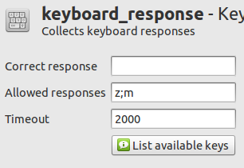Figure 13. The keyboard_response at the end of Step 7.
The keyboard_response now looks like Figure 13. You can download the experiment up to this point here:
- tutorial_step7.opensesame.tar.gz

Step 8: Configure the incorrect (sampler) item
The incorrect_sound item doesn't need much work. Essentially we only need to select the sound that should be played. Click on 'incorrect_sound' in the overview to open its tab. Click on the 'Browse' button and select 'incorrect.ogg' from the file pool.
- Tip — You can use variables to specify which sound should be played by using a variable name between square brackets as (part of) the file name. For example, '[a_word].ogg'.
- Tip — The sampler handles files in .ogg and .wav format. If you have sound files in a different format, Audacity is a great free tool to convert sound files (and much more):
  - http://audacity.sourceforge.net/
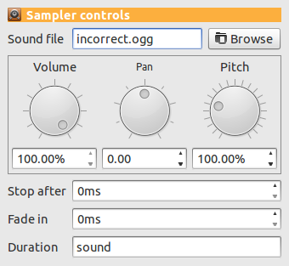Figure 14. The 'incorrect_sound' sampler at the end of Step 8.
The sampler now looks like Figure 14. You can download the experiment up to this point here:
- tutorial_step8.opensesame.tar.gz

Step 9: Configure the variable logger
Actually, we don't need to configure the variable logger, but let's take a look at it anyway. Click on 'logger' in the overview to open its tab. You will see that the option 'Automatically detect and log all variables' is selected. This means that OpenSesame logs everything, which is fine.
- Tip — If you like your log-files clean, you can disable the 'auto-select' option and manually select variables to log or use the 'Smart select' button. 'Smart select' will select 1) all variables that are defined in the loops, 2) all variables offered by the response items, and 3) the count_[item name] variables of all sequence items, which keep track of how often a particular sequence has been executed (essentially these are trial and block counters).
- Tip — Always triple-check whether all the necessary variables are logged in your experiment!

Step 10: Draw the feedback item
After every block of trials, we want to present feedback to the participant to let him/ her know how well he/ she is doing. Therefore, in step 2, we have added a feedback item, simply named 'feedback' to the end of block_sequence.
Click on 'feedback' in the overview to open its tab and open the editor in a new window. Select the draw text tool and click at (0, -128). Enter 'Your average response time was [avg_rt]ms'. Similarly, draw 'Your accuracy was [acc]%' at (0, -64) and 'Press any key to continue …' at (0, 64). Because we want the feedback item to remain visible as long as the participant wants (i.e. until he/ she presses a key), we leave 'Duration' set to 'keypress'. Click on the 'Close' button to close the editor.
- What is a feedback item? — A feedback item is almost the same as a sketchpad item. The only difference is that a feedback item is not prepared in advance. This means that you can use it to present feedback, which requires up-to-date information about a participant's response. You should not use feedback items to present time critical displays, since the fact that it is prepared 'at runtime' means that its timing properties are not as good as that of the sketchpad item.
- Feedback and variables — Response items automatically keep track of the accuracy and average response time of the participant in the variables 'acc' (synonym: 'accuracy') and 'avg_rt' (synonym: 'average_response_time') respectively.
- Tip — Make sure that the (foreground) color is set to black. Otherwise you will draw white on white and won't see anything!
- URL — For more information about feedback, see:
  - http://osdoc.cogsci.nl/usage/giving-feedback-to-participants
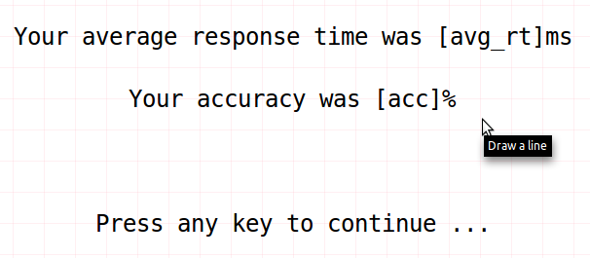Figure 15. The feedback item at the end of step 10.
The feedback item now looks like Figure 15 You can download the experiment up to this point here:
- tutorial_step10.opensesame.tar.gz

Step 11: Set the length of the practice phase and experimental phase
We have previously created the practice_loop and the experiment_loop items, which both call the block_sequence (i.e., a block of trials). However, right now they call the block_sequence only once, which means that both the practice and the experimental phase consist of only a single block of trials.
Click on 'practice_loop' to open its tab and set 'Repeat' to '2.00'. This means that the practice phase consists of two blocks.
Click on 'experimental_loop' to open its tab and set 'Repeat' to '8.00'. This means that the experimental phase consists of eight blocks.
- Tip — You can create a variable 'practice' in both the practice_loop and experimental_loop and set it respectively to 'yes' and 'no'. This is an easy way of keeping track of which trials were part of the practice phase.
You can download the experiment up to this point here:
- tutorial_step11.opensesame.tar.gz

Step 12: Draw the instructions, end_of_practice and end_of_experiment text_displays
I think you can handle this step your own! Simply open the appropriate tabs and add some text to present instructions, an end-of-practice message and an end-of-experiment message.
- Tip — Make sure that the foreground color is set to black, and the background color to white.
- Tip — Just like for the feedback items, we want the text items to remain visible as long as the participant wants (i.e. until he/ she presses a key). Therefore, we leave 'Duration' set to 'keypress'.
You can download the experiment up to this point here:
- tutorial_step12.opensesame.tar.gz

Step 13: Run the experiment!
You're done! Click on the 'Run in window' or 'Run fullscreen' buttons in the toolbar to run your experiment.
- Tip — If you want to give your experiment a test run without having to press any keys, you can activate the auto response option (Menu → Run → Enable auto response). In this mode, OpenSesame will simulate the participant's responses.
You can download the finished experiment here:
- tutorial.opensesame.tar.gz

Finally: Some general considerations regarding timing and back-end selection
In the 'General properties' tab of the experiment, you can select a back-end. The back-end is the layer of software that controls the display, input devices, sound, etc. Most experiments will work with all back-ends, but there are reasons to prefer one back-end over the other. Currently there are three back-ends (depending on your system, not all three may be available):
- legacy — a 'safe' back-end, based on PyGame. It provides reliable performance on most platforms, but, due to a lack of hardware acceleration, its timing properties are not as good as those of the other back-ends.
- opengl — a hardware accelerated back-end, based on PyOpenGL.
- psycho — a hardware accelerated back-end, based on PsychoPy (Peirce, 2007).
The current default back-end is 'legacy'. For most purposes this is a good choice, because of its stability, but it should be noted that its timing properties are not as good as those of the other back-ends. Specifically, in our test set-ups, the average combined error of display presentation and response collection was 3 to 16ms, depending on the system (Mathôt et al., in press).
If you require a higher degree of temporal accuracy, you should switch to one of the hardware accelerated back-ends. In our test set-ups, the average combined error of display presentation and response collection was 2 to 3ms for the 'psycho' back-end.
A detailed discussion and the full benchmark experiment can be found in Mathôt et al. (in press). See also Damian (2010), Brand and Bradley (2011), and Ulrich and Giray (1989) for some general considerations about when to worry, and when not to worry about timing.
- URL — For more information about back-ends, see:
  - http://osdoc.cogsci.nl/back-ends/about-back-ends

References
Brand, A., & Bradley, M. T. (2011). Assessing the effects of technical variance on the statistical outcomes of web experiments measuring response times. Social Science Computer Review. doi:10.1177/0894439311415604
Damian, M. F. (2010). Does variability in human performance outweigh imprecision in response devices such as computer keyboards? Behavior Research Methods, 42, 205-211. doi:10.3758/BRM.42.1.205
Friesen, C. K., & Kingstone, A. (1998). The eyes have it! Reflexive orienting is triggered by nonpredictive gaze. Psychonomic Bulletin & Review, 5, 490–495.
Mathôt, S., Schreij, D., & Theeuwes, J. (in press). OpenSesame: An open-source, graphical experiment builder for the social sciences. Behavior Research Methods.
Peirce, J. W. (2007). PsychoPy: Psychophysics software in Python. Journal of Neuroscience Methods, 162(1-2), 8-13. doi:10.1016/j.jneumeth.2006.11.017
Ulrich, R., & Giray, M. (1989). Time resolution of clocks: Effects on reaction time measurement—Good news for bad clocks. British Journal of Mathematical and Statistical Psychology, 42(1), 1-12. doi:10.1111/j.2044-8317.1989.tb01111.x

