OpenSesame crash course
Creating a lexical decision task

Last Updated, Nov 8 2011

Sebastiaan Mathôt

Dept. of Cognitive Psychology
Vrije Universiteit, Amsterdam
s.mathot@vu.nl

About this crash course
In this crash course you will learn how to create a simple psychological experiment using OpenSesame (Mathôt, Schreij, & Theeuwes, in press). You will only use the OpenSesame graphical interface (i.e., no Python inline coding).
This crash course is intended to help you get started quickly. It does not provide any detail. If you are looking for an in-depth tutorial, or if you find that this crash course is a bit too confusing, please refer to the Creating a gaze-cuing experiment tutorial. This can be found on the OpenSesame website, and provides you with a detailed click-by-click walk-through.
This crash-course will take approximately 15 minutes to complete.

About OpenSesame
OpenSesame is a cross-platform graphical experiment builder. It provides an exceedingly simple way to create psychological experiments using a point-and-click graphical interface. For very advanced tasks, you can use Python inline scripting (not covered in this crash course).
OpenSesame is freely available under the General Public License v3.

Getting OpenSesame
This crash-course assumes that you are running OpenSesame version 0.25 or newer. To check which version you are running, see the bottom right of the 'General properties' tab. You can download the most recent version of OpenSesame here:
  - http://wwww.cogsci.nl/opensesame

The experiment
The experiment that you will create is a lexical decision task. In this task, the participant first sees a task-irrelevant word, called a prime. Next, the participant sees a target word. The participant's task is to indicate as quickly as possible whether the target refers to a man-made or a natural object, by pressing respectively the 'z'-key and 'slash'-key. The typical finding is that participants are faster to respond if the prime, despite being task-irrelevant, is semantically related to the target.

The user interface
The default layout of the OpenSesame interface is depicted schematically in Figure 1.
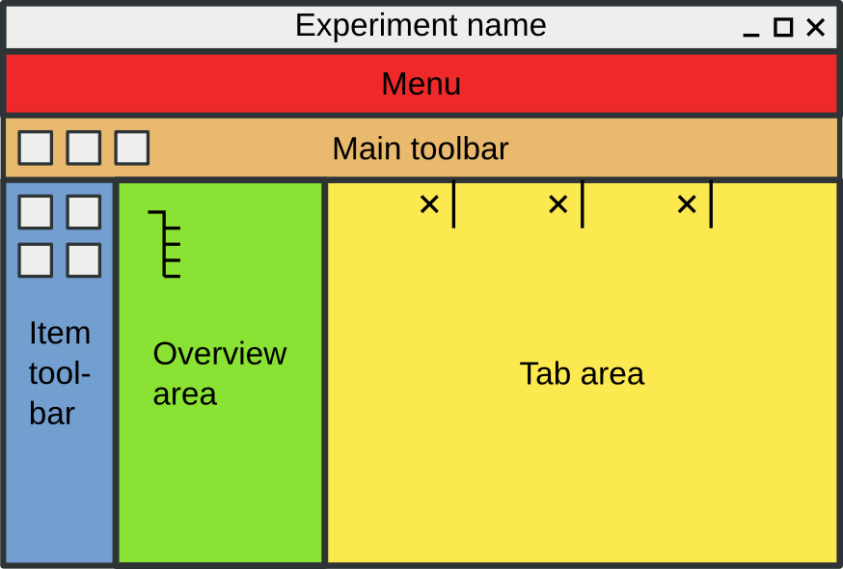Figure 1. The default layout of the OpenSesame interface.

Step 1: Open the Extended template
When you start OpenSesame, the 'New experiment' dialog will appear. Double-click on Extended template. This will open a template that provides the structure of a typical psychological experiment. This can be a real time-saver.

Step 2: Define independent variables
Independent variables are typically defined in loop items. In this case, the variables that are varied within a block (i.e., all variables in this experiment) are defined in the 'block_loop'.
Click on 'block_loop' in the overview area to open the 'block_loop' tab. Click on the Variable wizard button. This will open a dialog that allows you to quickly generate a table with all your independent variables.
Names of the variables should be entered in the first row. Possible values should be entered in the rows underneath.
Enter the variable 'prime' with the following values: 'computer', 'internet', 'facebook', 'fruit', 'apple', and 'banana'. Enter the variable 'target' with the following values: 'pear', 'strawberry', and 'vegetable' (Figure 2). Press 'Enter' to generate the loop table.
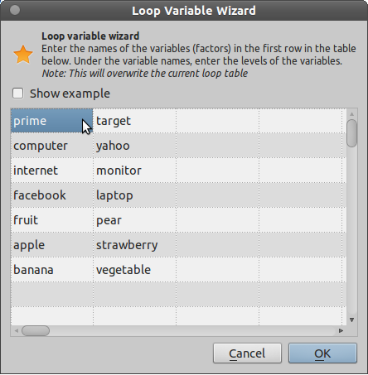Figure 2. Defining independent variables

Step 3: Define the trial sequence
A trial in our experiment looks as follow:
- Central fixation dot (500ms)
- Prime (500ms)
- Another central fixation dot (500ms)
- Target (until response)
Click on 'trial_sequence' in the overview area to open the 'trial_sequence' tab. Right now, the trial sequence consists of a sketchpad (with a fixation dot) followed by a keyboard response (which collects the participant's key press) and a logger (which writes all data to a log file).
Right-click on 'sketchpad' an select rename in the context menu that appears. Rename the sketchpad to 'fixation_dot'.
We want to show the same fixation dot twice, once at the start of the trial and oce after the prime. Therefore. select 'fixation_dot' in the menu labeled 'Append existing item', at the bottom of the tab, and click on the '+' button. A second 'fixation_dot' now appears at the end of the trial sequence. Drag the second 'fixation_dot' to the top of the sequence by clicking, holding, and dragging the 'fixation_dot' grip (the four, small black squares on the left of the item).
For the prime and the target displays, drag two sketchpads (the rainbow icon) from the item toolbar onto the 'fixation_dot' grip in the trial sequence. Right click on the new items and rename them to 'prime' and 'target'.
Drag the items to put in the proper order, as shown in Figure 3.
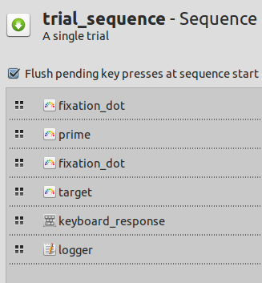Figure 3. The trial sequence at the end of Step 3.

Step 4: Create the sketchpads
Click on 'fixation_dot' in the overview area to open the 'fixation_dot' tab. It already has a central fixation dot, as part of the template, but the duration should be changed. Change the duration to '500'.
Click on 'probe' in the overview area to open the 'probe' tab. First, change the duration to '500'. Next, we need to insert a single word at the center of the sketchpad. Select the text tool by clicking on the red 'Ab' icon. Move the mouse to the center of the sketchpad. You can see the position of the cursor on the sketchpad in the top-right of the tab (next to 'Show grid'). The center of the sketchpad is indicated by (0, 0). Click on the center and enter the text '[probe]' (Figure 4). The square brackets around 'probe' indicate that 'probe' is the name of a variable, rather than a literal string of text.
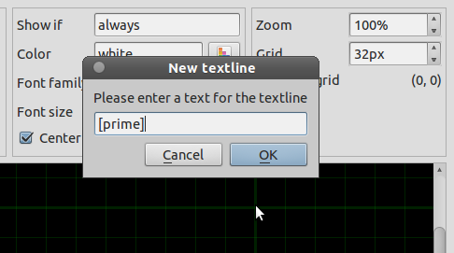Figure 4. Adding text to a sketchpad.
Click on 'target' in the overview area to open the 'target' tab. First, change duration to '0'. This means that the experiment advances right away to the next item, which is the keyboard response item. Next, add the text '[target]' to the center of the sketchpad.

You're (sort of) done!
You can now run the experiment by clicking on the Run button (or the Run in window button) in the main toolbar.
Of course, there's lots more to be done. For example. you can define the correct response for each trial, so that OpenSesame provides accurate feedback after each block. You can add a timeout to the keyboard response. And, importantly, you can add instructions to the experiment. This, and much more, is described in the full tutorial Creating a gaze-cuing experiment.
I hope that you now have some idea of what you can do with OpenSesame. And how incredibly easy it can be to create an experiment!

References
Mathôt, S., Schreij, D., & Theeuwes, J. (in press). OpenSesame: An open-source, graphical experiment builder for the social sciences. Behavior Research Methods.

