2013-CZ-05-EN Rotation tool
0 medium | I: easy | II: ---- | III: ---- | IV: ----

Answer Type: Multiple Choice Graphics are: self made and colorblind proof

Body
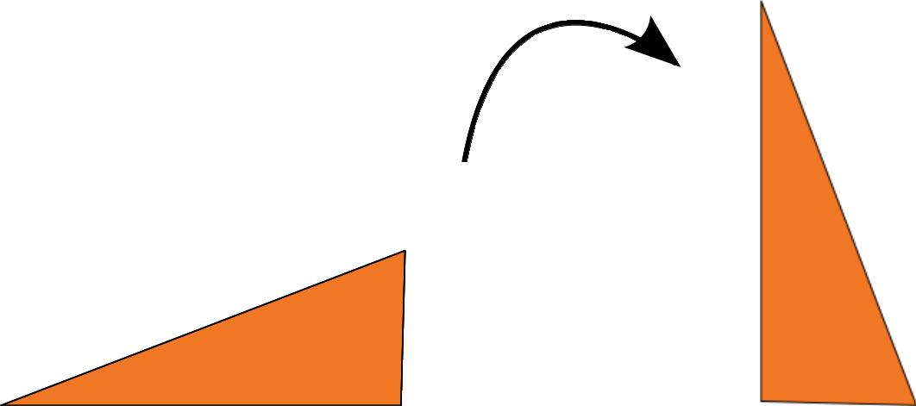

There is a rotate tool on the computer.
If you select a picture and use this tool, the picture will turn clockwise (see picture). You can use it several times on the same picture.

Question

Which of puzzle pieces A, B, C, D is impossible to get from the puzzle piece X with the rotate tool?

X)

Answer





A) B) C) D)

Explanation

Correct answer is B.
A is one rotation anticlockwise.
C is one rotation clockwise.
D is two rotations (anti-) clockwise.
B is mirror-inverted, so you can't get it with rotations.

It's informatics

To know how to work with computer means not only to use its tools but to understand how they work and what they are able to do.
The good way how to decide which solution is impossible is to compare all images and search for distinguishing feature.

Keywords

rotate tool, transformation

Websites

Internal Use

Wording

Françoise Tort 2013-06-29: During discussions in the group someone proposed to turn “to right angle” into “ to 90°”. But it is not appropriate for levels 0 and I. Finally we decided to erase it. We just write “rotation”, the “90°” is now implicit (see the figures), but it doesn't matter for the resolution of the problem.

Comments

Jin-Young Choi & Michael Weigend 2013-06-28: The images including could be more attractive to young people. Check the copyright of the images. It should be clear what the photo depicts. Instead of a toothbrush one could show something more meaningful for young people.
Françoise Tort 2013-06-29: see Wording above + new pictures: the toothbrush is replaced by a puzzle piece, because it makes sense to rotate it.

Files

All additional files for this task (graphics, scripts, etc.)
2013-CZ-05-EN.odt (this file)
2013-CZ-05-puzzle_A.png (answer)
2013-CZ-05-puzzle_B.png (answer)
2013-CZ-05-puzzle_C.png (answer)
2013-CZ-05-puzzle_D.png (answer)
2013-CZ-05.png (piece that should be rotated)
2013-CZ-05-example.svg (example rotating)

Authorship

Jiří Vaníček, vanicek@pf.jcu.cz, Czechia
Françoise Tort, francoise.tort@ens-cachan.fr, France
Barbara Müllner, b_muellner@gmx.at, Austria

License

Copyright © Bebras – International Contest on Informatics and Computer Fluency.
This work is licensed under a Creative Commons Attribution-ShareAlike 3.0 Unported License. Visit: http://creativecommons.org/licenses/by-sa/3.0/

