2013-DE-02 Random Pictures
0 ---- | I: ---- | II: ---- | III: hard | IV: medium

Answer Type: Multiple Choice Graphics are: self made and colorblind proof

Body

The beavers have a factory producing individual designs for greeting cards and wrapping paper. The designs are created according to these instructions (creating an object means that it is created in the computer memory, not painted on the screen):

Create a circle of random color and call it C.
Repeat the following sequence of instructions a random number of times:
Create a square of random size and random color and call it S.
Set the size of C to one of these sizes: Large or small.
Print C at a random position on the image.
Print S at a random position on the image.

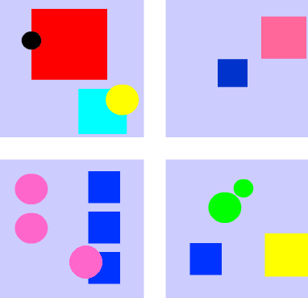

Question

Which of the images has not been created by this factory?

Answer

This image cannot be created by the factory.

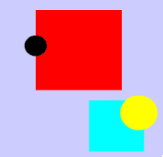

Explanation

This image contains two different circles with two different colors. In the algorithm, the circle is chosen once at the beginning. Just the size is changed later.
The other images are possible outcomes of the algorithm, although they do not look like it at first sight.
Since the program prints a square for each circle, the number of circles has to be the same as the number of squares. But a square might cover a circle and hide it. You must also consider that a square or a circle might have the same color as the background.
The positions of the circles and squares are chosen randomly. But it is possible (although highly improbable) that regular and symmetric structures arise.

It's informatics

Movies like “Avatar” (directed by James Cameron, USA 2009) have a lot of visual content that has been created automatically by computers. Basically, the designer just defines a set of rules. All the tiny details of a complex artificial structure are created by the computer in a non-deterministic way but still according to the given rules.

Keywords

Computer graphics, nondeterminism, programming, variables

Websites

Internal Use

Wording

Comments

Group 1 Comments:
2013-06-29 – The correct answer is the only where the circles visibly overlap the rectangles, so we plan to modify the "regular" answer so that one circle overlaps a rectangle
2013-06-29 – Add IV:medium
Make a comment about abstractness of the "create" operation
2013-06-29 Bartosz Bieganowski (PL, Group 1): changed the picture and the answer, added IV:medium and maked a comment about abstracness.

Files

2013-DE-02_squarescircles.png
2013-DE-02_impossible.png
2013-DE-02_squarescircles_another.png
2013-DE-02.odt (this file)

Authorship

Michael Weigend, mw@creative-informatics.de, Germany

License

Copyright 2013 Bebras - International Contest on Informatics and Computer Fluency.
This work is licensed under Creative Commons
Attribution-NonCommercial-ShareAlike 3.0 Unported (CC BY-NC-SA 3.0).
Visit: http://creativecommons.org/licenses/by-nc-sa/3.0/

