2013-RU-05-EN Balls trigger
0 hard | I: medium | II: easy | III: easy | IV: ----

Answer Type: Click to choose! Graphics are: not used in this task

Body

A trigger is a device that can be in one of two states. The state changes every time a signal comes.
A smart beaver has a trigger that works in the following way:
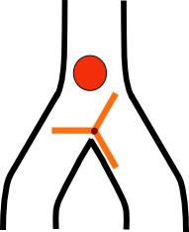
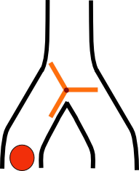
The ball falls from the top, goes to some direction, to the left or to the right. It also rotates a trigger in such a way that the next ball will fall to the other direction.
The smart beaver constructed a device out of such triggers that looks like this:
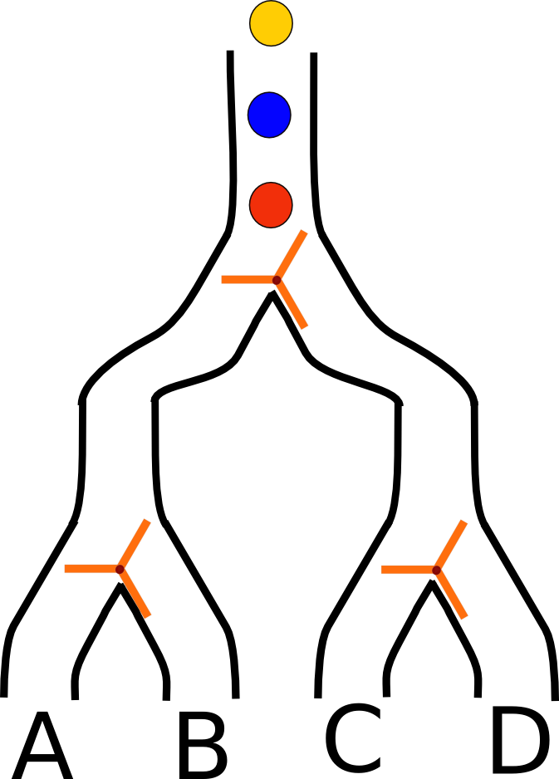

Question

Out of which pipe will the third (yellow) ball fall?

Answer

From the pipe A
From the pipe B
From the pipe C
From the pipe D

Explanation

The first ball will go to the leftmost pipe and set both triggers to the right. The second ball will therefore go somewhere right and set the first trigger back to the left. We are not interested in the rest of its journey. The last ball goes left on the first trigger, and then right on the second trigger (it is still set by the first ball), falling out from the pipe B.

It's informatics

Our computers are literally built of pieces similar to such triggers. There are probably several dozens of millions of such microscopic parts in your computer. Combining them in a clever way, you can have little devices to do logic operations (and, or, not...), then calculations, such as adding, subtracting etc. Combining these more complicated pieces into more and more complex components, you get a full-scale computer. Inside, everything is based on two states of each element, just as the trigger is.

Keywords

Trigger
Logical gate

Websites

https://www.youtube.com/watch?v=GcDshWmhF4A – wooden marble adding machine, based exactly on the same principle

Internal Use

Wording

List of word used to name important things in the task body (concepts, definitions, objects, names, etc.) This is to ensure the consequent use of terms in the task body and facilitates translation.

Comments

Author, Date (YYYY-MM-DD), Comment.
Sergey Pozdniakov, 2013-06-26, this task needs to be changed for older participants, they should have 5 balls instead of 3 (Answer is A). Seniors should even have 100 balls (the answer is D).
Ilya Posov, 2013-06-26, An animated GIF with the ball falling through the trigger would be great.

Files

All additional files for this task (graphics, scripts, etc.)
2013-RU-05-EN.odt (this file)
2013-RU-05-EN-t1.svg (the trigger in the first state, inkscape)
2013-RU-05-EN-t2.svg (the trigger in the second state, inkscape)
2013-RU-05-EN-device.svg (the device, inkscape)
2013-RU-05-EN-t1.png (export of the corresponding image from inkscape)
2013-RU-05-EN-t2.png (export of the corresponding image from inkscape)
2013-RU-05-EN-device.png (export of the corresponding image from inkscape)

Authorship

List all authors who have contributed to this Document, with e-mail and country.
Sergey Pozdniakov, pozdnkov@gmail.com, Russia

License

Copyright © Bebras – International Contest on Informatics and Computer Fluency.
This work is licensed under a Creative Commons Attribution-ShareAlike 3.0 Unported License. Visit: http://creativecommons.org/licenses/by-sa/3.0/

