2013-SE-02-EN.odt Cheapest computer network
0 ---- | I: ---- hard | II: ---- medium | III: ---- easy | IV: ---- easy

Answer Type: Click to choose! Graphics are: not used in this task
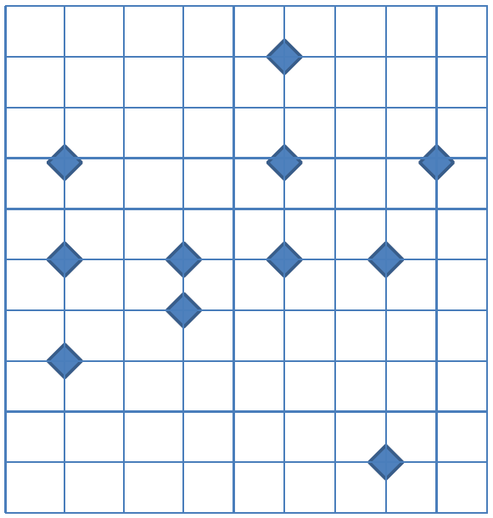

Body

All the beavers in the beaver collective have recently bought their own computers. After playing a few games and chatting with a local chat bot they really felt the need to talk to other beavers. They therefore decided to build their own local network connecting all the computers. To prepare the connections, they have created a map of where all the beavers live.

Question

What is the minimum length of cables needed to connect all the beaver computers into a single network? Cables can only be drawn vertically or horizontally between two computers. Each square is 100x100 meters.
- 2000 meters
- 2100 meters
- 2200 meters
- 2300 meters

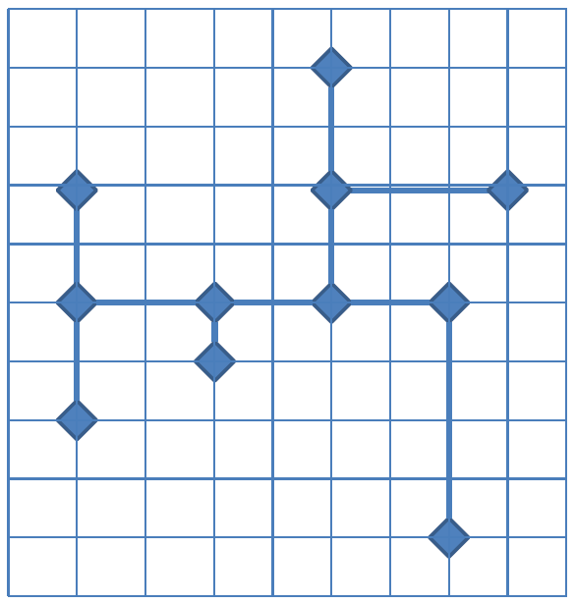

Answer

2200 meter

Explanation

Instead of the cost (length) you give each distance a weight between the nodes. Add the different weight to reach a minimum value.

It's informatics

This is a problem where you need to find the minimum spanning tree in a graph. This can be done with either Kruskal's or Prim's algorithm. Kruskal's algorithm creates a minimum spanning tree by sorting all the edges by ascending weight and greedily adding the minimum weight edge which connects two disconnected components in the graph.

Keywords

Spanning trees and graph theory.

Websites

Learn about Prim’s algorithm on youtube, http://www.youtube.com/watch?feature=fvwp&v=DqpmZiC3ito&NR=1

Internal Use

Wording

Graph, connected, minimum length

Comments

Fredrik Heintz (2013-06-09). Initial version.

Files

2013-SE-02-EN.odt (this file)
2013-SE-02-EN.png
2013-SE-02-EN-solution.png

Authorship

Fredrik Heintz, Linköping University, Sweden, fredrik.heintz@liu.se
Modifications:

Eugenio Bravo , eugenio.bravo@ehu.es, Spain.

License

Copyright © Bebras – International Contest on Informatics and Computer Fluency.
This work is licensed under a Creative Commons Attribution-ShareAlike 3.0 Unported License. Visit: http://creativecommons.org/licenses/by-sa/3.0/

