2013-SK-05 The Necklace Machine
0 easy | I: easy | II: ---- | III: ---- | IV: ----

Answer Type: Interactive Move Graphics are: self made and colorblind proof

Body

Jane wants a new necklace like this one:
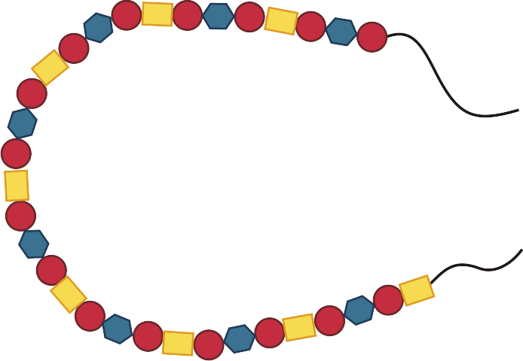
She has a machine that needs to be set up with a pattern of beads to produce the necklace.

Question

Build the sequence of beads she should enter if she wants a necklace like the one above:

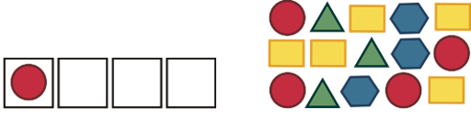

Answer



Explanation

We need to find the correct sequence of four beads which the machine will place one after another on the string. The first bead is already set – red round one. According to this we know that the machine began to string the beads from the top end. If the red round bead was the first the second is the blue hexagon, then again a red round one and a yellow rectangle. Thus we have found all four beads. We can check if the pattern is right by examining rest of the necklace on the picture – our sequence repeats itself over the whole necklace.

It's informatics

In this task we create a sequence of beads – this pattern when repeated will form a necklace. In informatics and in programming it is often important o find such sequence. If we find one we can write better program for a computer or a machine. One of the first programmable machines were looms that made colorful fabric according to such programs.

Keywords

algorithm, programming, sequence, repeat, pattern

Websites

Internal Use

Wording

Comments

The file 2013-SK-05.swf shows a possible implementation of the interactive task that is visually somewhat different because it puts the question in the middle of the necklace and it also does not use the extra triangle bead.
2013-06-28 Goup 1: This task is interesting also for countries without interactive options and therefor should be make additional version this tasks.

Files

All additional files for this task (graphics, scripts, etc.)
2013-SK-05-beads.svg
2013-SK-05-task.png
2013-SK-05-bead1.png
2013-SK-05-bead2.png
2013-SK-05-bead3.png
2013-SK-05-bead4.png
2013-SK-05.swf - sample implementation (slightly different, see comments)
2013-SK-05.odt (this file)

Authorship

author: Martina Kabatová, kabatova@fmph.uniba.sk
graphics: Martina Kabatová, kabatova@fmph.uniba.sk
interactive task implementation: Monika Tomcsányiová and Peter Tomcsányi, tomcsanyiova@fmph.uniba.sk, tomcsanyi@fmph.uniba.sk

License

Copyright ©2013 Bebras - International Contest on Informatics and Computer Fluency.
This work is licensed under Creative Commons Attribution-NonCommercial-ShareAlike 3.0 Unported (CC BY-NC-SA 3.0).
Visit: http://creativecommons.org/licenses/by-nc-sa/3.0/

