Firewall Configuration
A common problem blocking new users is a default firewall connection on individual computers. This appendix shows an example adjustment that allows proper network execution of software.
To get to the Windows Firewall Configuration right click the network icon on the Windows taskbar (Figure 77).
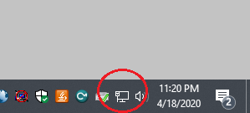
- Network Icon in Windows Taskbar
It shows a dialog were “Open Network & Internet settings” must be selected (Figure 78).
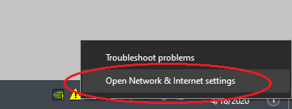
- Network Settings Dialog
Selecting “Open Network & Internet settings” displays a window with the network status and a link to the Windows Firewall settings (Figure 79).
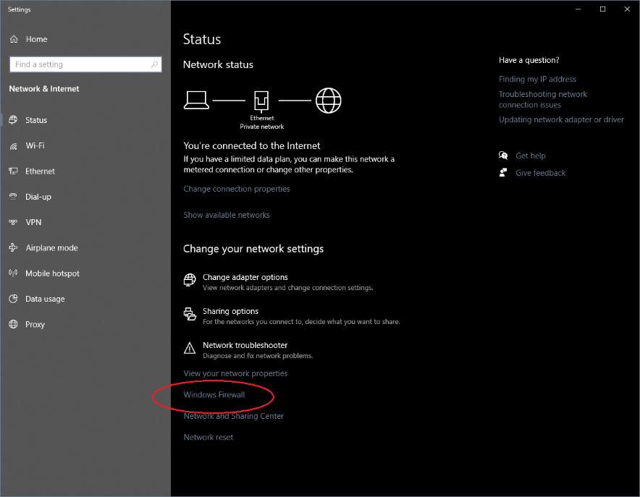
- Network Status window
Selecting “Windows Firewall” displays a window with the status for “Firewall & network protection” (Figure 80).
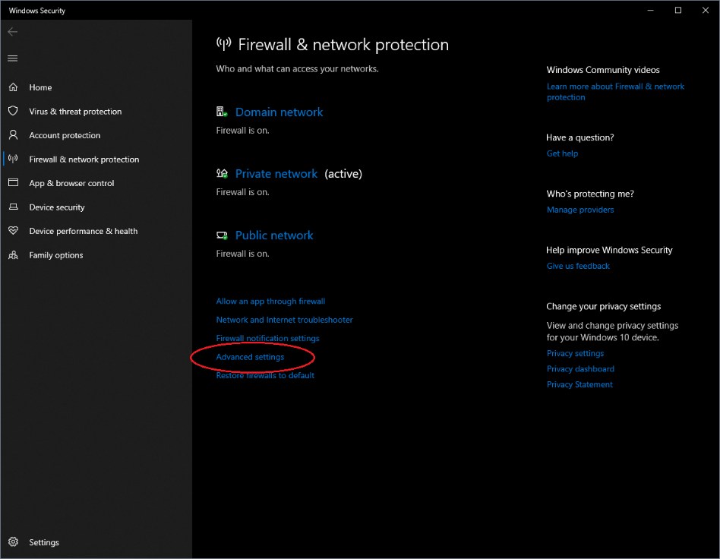
- Firewall & Network protection window
After selecting “Advanced settings” the final dialog of changes that must be made is displayed (Figure 81).
To access the inbound rules the menu item “Inbound rules” must be chosen (Figure 81). In Figure 82 all inbound rules are displayed.
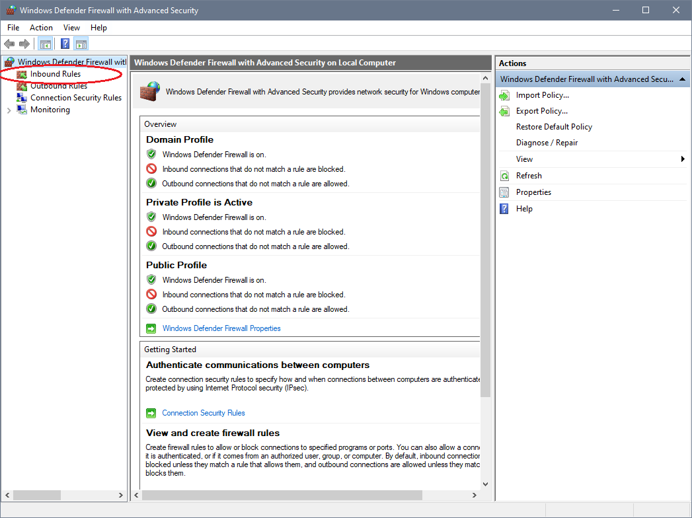
- Windows 10 Defender Firewall window
In the Actions box on the right side of Figure 82, the action “New Rule…” must be selected to bring up the “New Inbound Rule Wizard” (Figure 83).
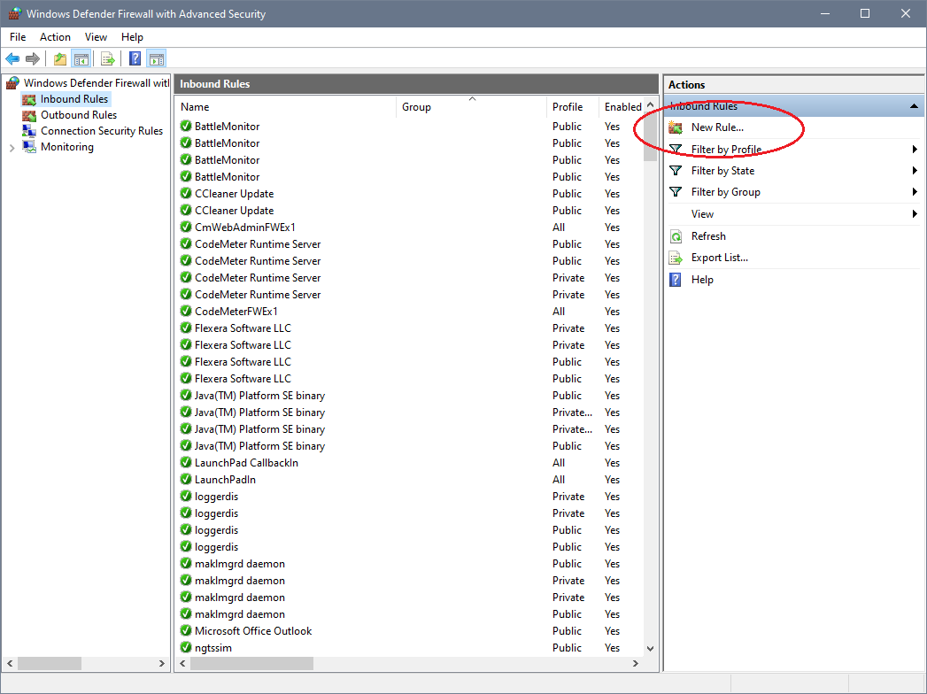
- Windows Defender Firewall Inbound Rules view
A single Port 3000 must be opened, so the radio button for “Port” must be selected (Figure 83).
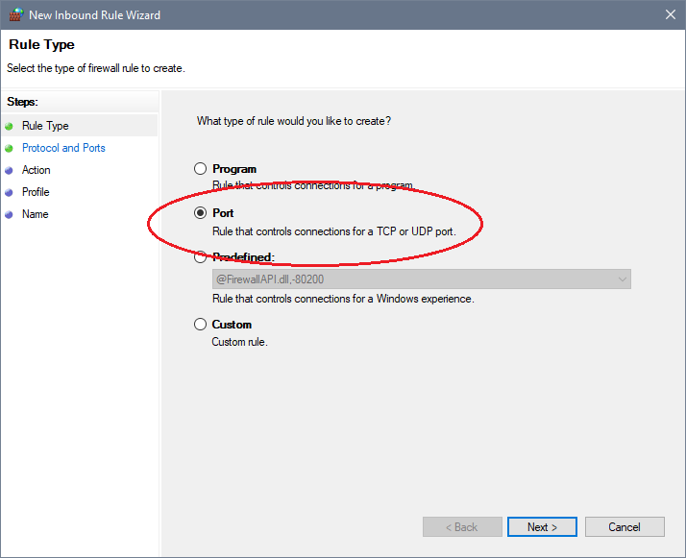
- Windows Defender Firewall New Inbound Rule Wizard Type Selection
In Figure 84 UDP must be selected and the port number 3000 must be added to the text field.
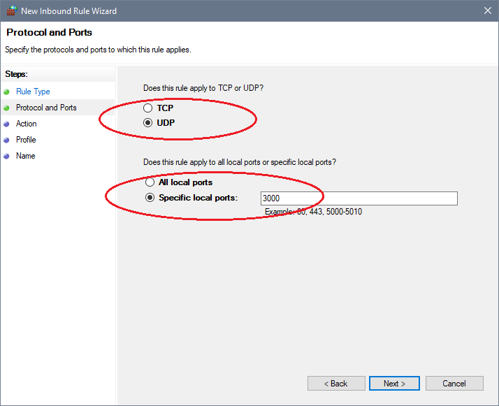
- Windows Defender Firewall New Inbound Rule Wizard Port Selection
In Figure 85 the default must not be changed.
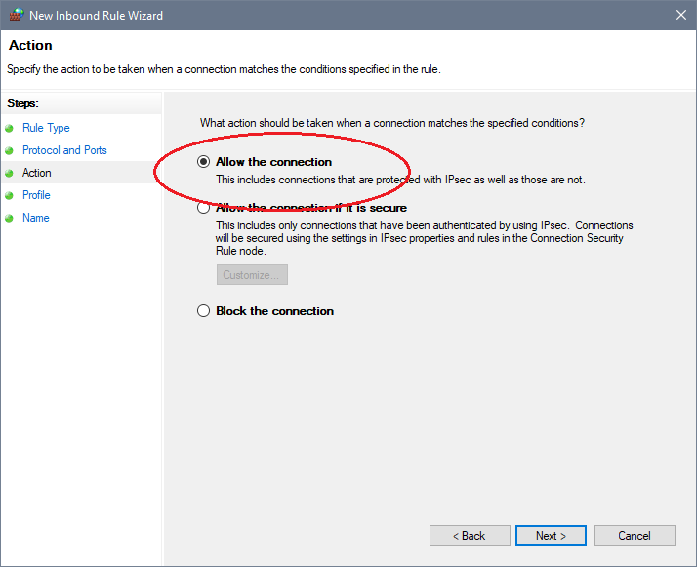
- Windows Defender Firewall New Inbound Rule Wizard Allow/​Block Dialog
In Figure 86 the rule can be specified for different type of networks. The default can be left unchanged.
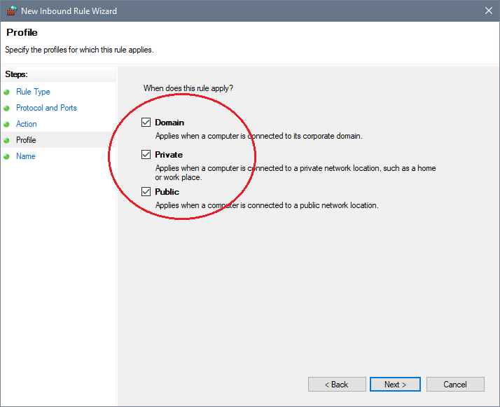
- Windows Defender Firewall New Inbound Rule Wizard Network Selection
In the last window of the New Inbound Rule Wizard (Figure 87) a name for the new rule must be provided. It is a best practice to use a descriptive name. After closing the wizard by clicking “Finish” the new rule is displayed within the Windows Defender Firewall Inbound Rules view (Figure 88).
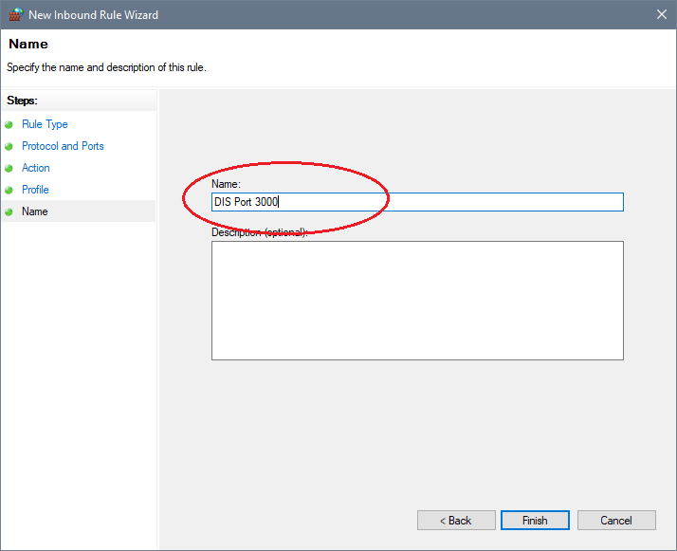
- Windows Defender Firewall New Inbound Rule Wizard Name Dialog
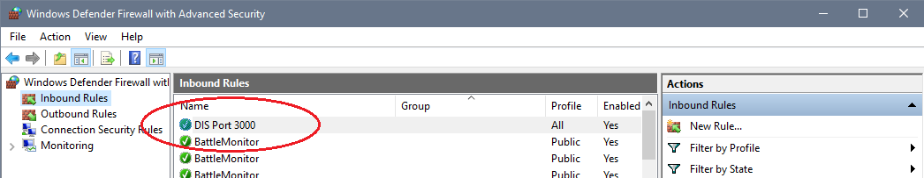
- Windows Defender Firewall Inbound Rules view with new DIS Port 3000 rule

