# Using Simkit in Eclipse and Netbeans

This short note should provide enough information to get started using Simkit in either Eclipse or Netbeans, two of the most popular open source IDEs for Java. It is oriented towards using the computers on-campus (e.g. Gl-203 lab). It is assumed that you know the basics of your IDE.

In all cases, create a Project called OA3302W09[1] and a package called oa3302 (**Note**: *all* Java packages should be in lower case).  This will guide you through creating the first Simkit class.

The following IDEs are specifically covered:[2]

* Eclipse 3.4
* Netbeans 6.5

## Eclipse

### Create the Project

Create a new Java Project (File | New | Java Project):

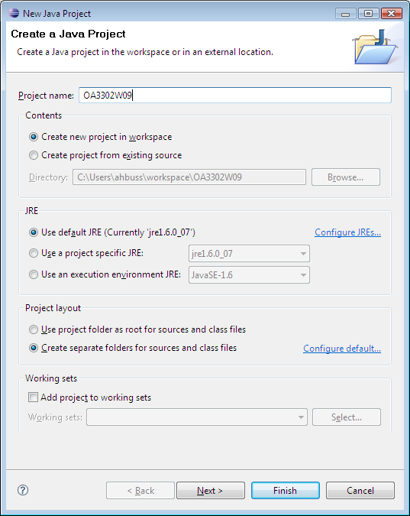

Click Finish and the Project will appear

### Create the Simkit User Library

Right-click on the project in the Navigator window on the left and select Properties.  Then choose Java Build Path from the tree in the left pane. Click the Libraries tab and then the “Add Library” button on the right. On the popup dialogue select “User Library” and click “Next.”

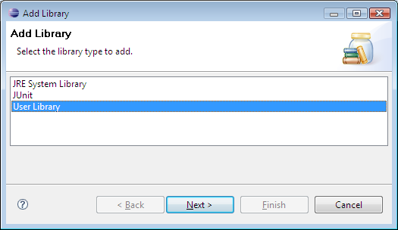

This brings up the User Libraries dialogue:

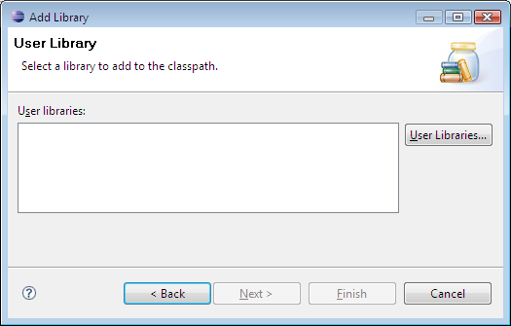  
Click the “User Libraries” button on the right and then “New” on the next dialogue. Enter “Simkit” as the name of the library and click OK:

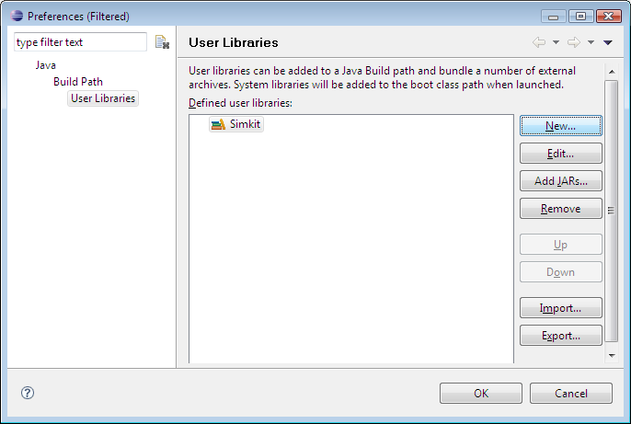

Now click the “Add Jars” button on the right and navigate to where Simkit is installed. In the lab it will be in R:\Simkit; on your computer it will be C:\Program Files\Simkit (or C:\Program Files (x86)\Simkit on Vista). The Simkit.jar file is located in a subdirectory called “lib” – select Simkit.jar and click “Open.”

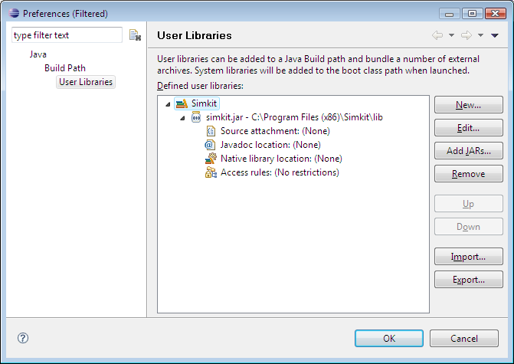

To finish the user library, point to the source and javadoc files – they are located in the Simkit directory itself. Select “Source attachment” and click the “Edit” button. Click “External File” and select “simkit-src.zip” (in the directory above where Simkit.jar is) and click Open. Then select “Javadoc location” and click Edit, then the “Javadoc in Archive” radio button. Click “Browse” next to “Archive Path” and select “simkit-doc.zip” and “Open.”

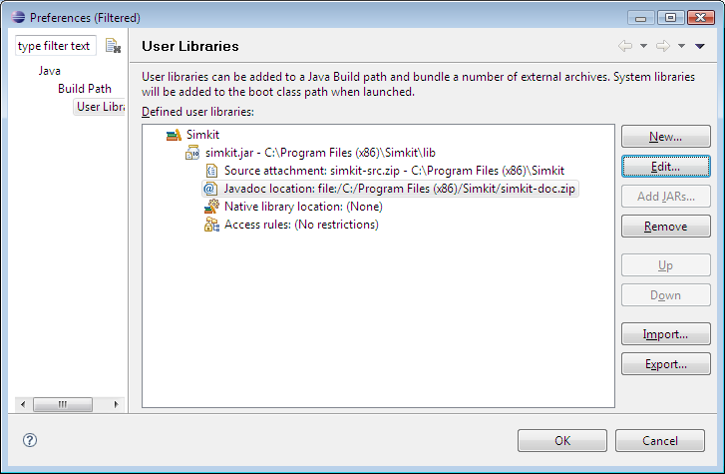

Click OK to complete the definition of the Simkit user library. You can now select it to be on the project classpath:

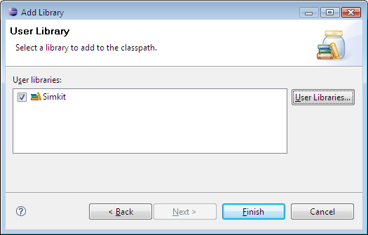

Click “Finish” – you can now use the Simkit classes in your project.

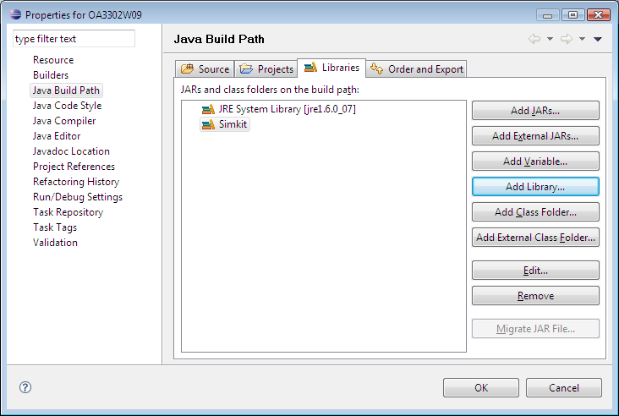

### Create the Package

Right-click the src node and select New | Package.  Name the package oa3302:

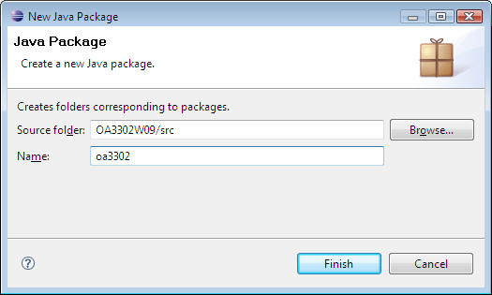

Click “Finish.”

**Important**: be sure to name your package “oa3302” *not* OA3302 – although Java will let you use upper-case letters for a package name, it is considered bad Java style to do so.

### Create the Class File

Right-click the oa3302 item in the Navigator (expand the tree if necessary) and select New | Class.  You can choose the superclass (SimEntityBase) in the dialog (uncheck the box to create a main method):

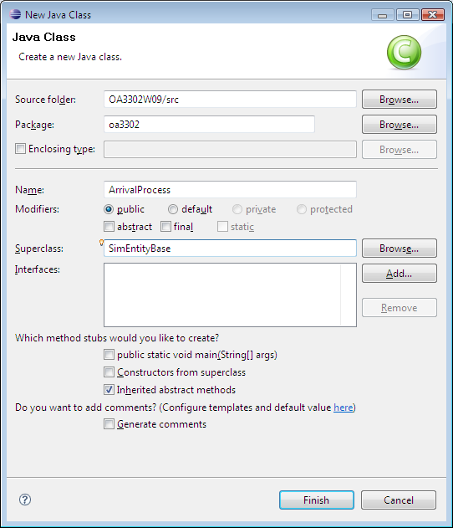

Click “Finish.” Eclipse will now complain that it can’t find SimEntityBase:

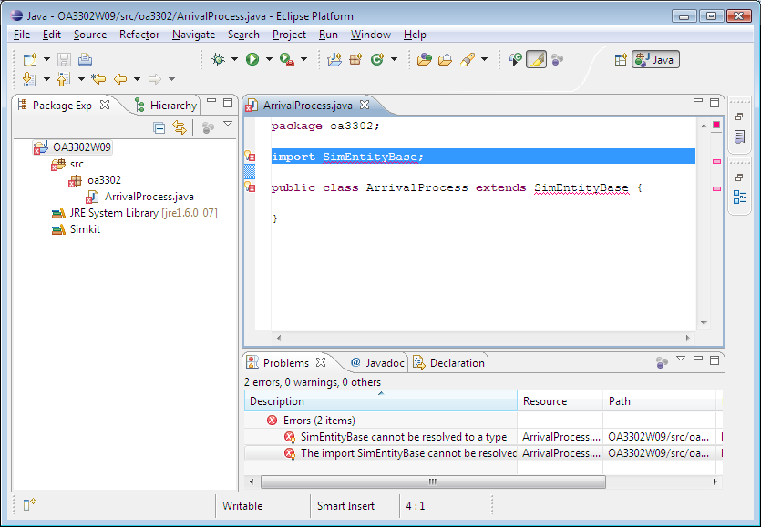

Right-click in the code panel and select Source | Organize Imports, and Eclipse will find it:

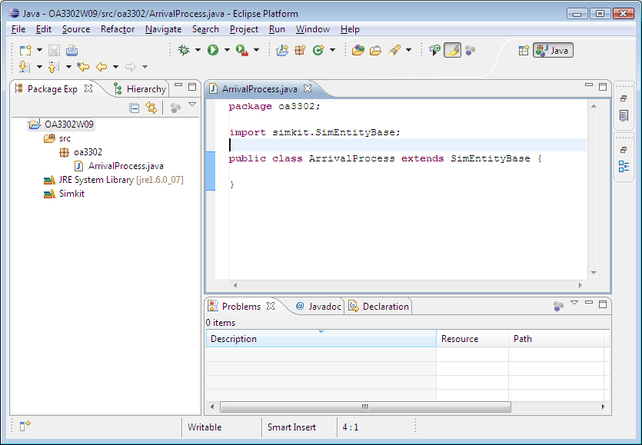

The error messages in the bottom panel will go away after you save the file.

## Netbeans

### Create the Project

Click File | New Project and select General | Java Class Library (since there will be many "main" classes in the project):

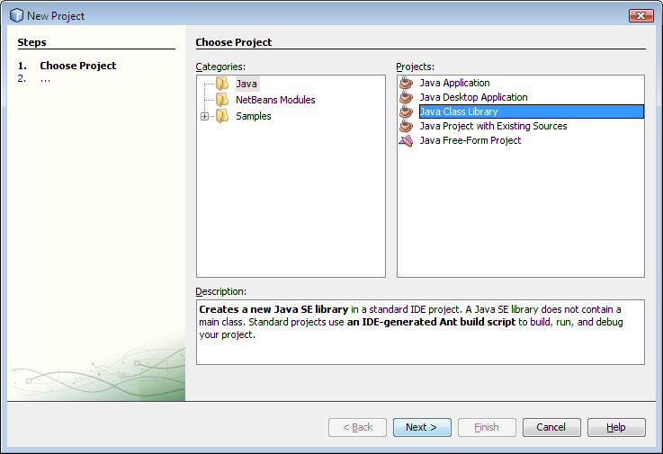

Change the Project Location by clicking the Browse button and name your project OA3302W09.  **Note**: In the computer lab, your project location will have to be on the H: drive

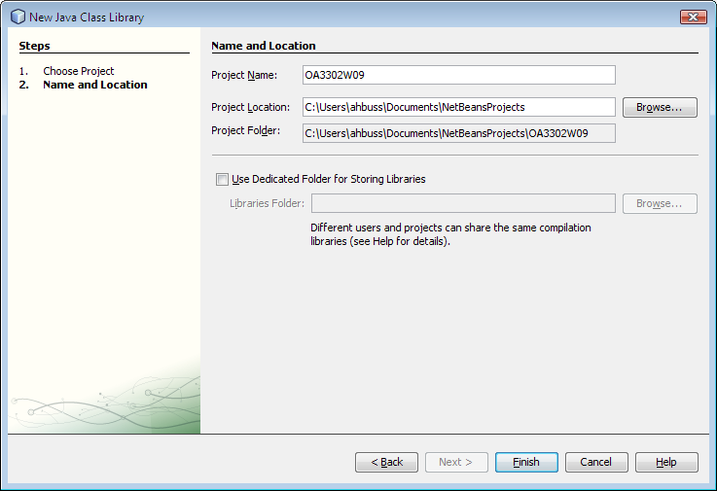

The project will appear in the Projects pane:

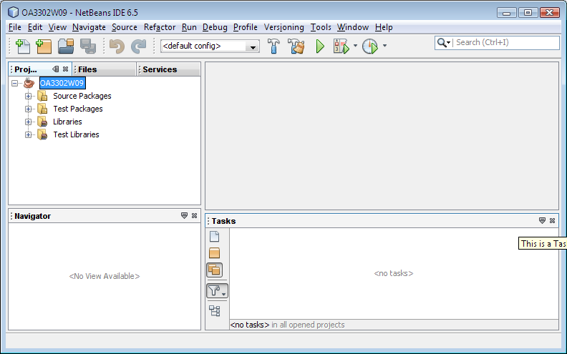

### Create the Simkit Library

On the menu bar, click Tools | Libraries, then “New Library” in the bottom left of the popup dialogue; enter Simkit as the name of the Library and click OK:

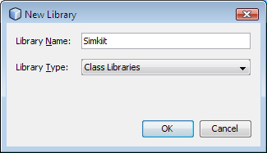

Navigate to the Simkit\lib folder and select Simkit.jar and click “Add Jar/Folder”:

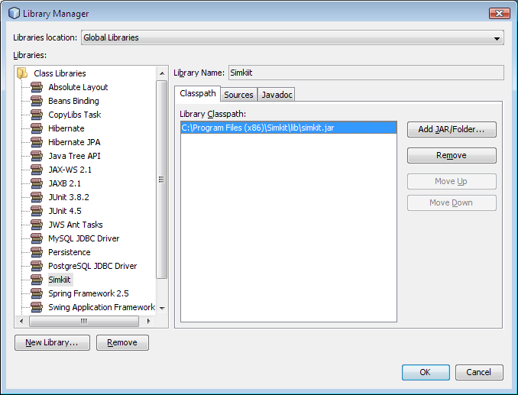

Click the Sources tab, then the “Add Jar/Folder” button on the right; then select simkit-src.zip in the directory just above “lib,” then click “Add Jar/Folder.” Select the Javadoc tab and click the “Add Zip/Folder” button on the right. Select the simkit-doc.zip file and click “Add Zip/Folder.” Finally click “OK” in the Library Manager dialogue to complete the Simkit user library.

To add the Simkit library to your project, right-click OA3302W09 in the Project folder and select Properties.  On the left side of the window that appears, select "Libraries."  Click the "Add Library" on the right, select “Simkit” in the popup dialogue and click “Add Library.”

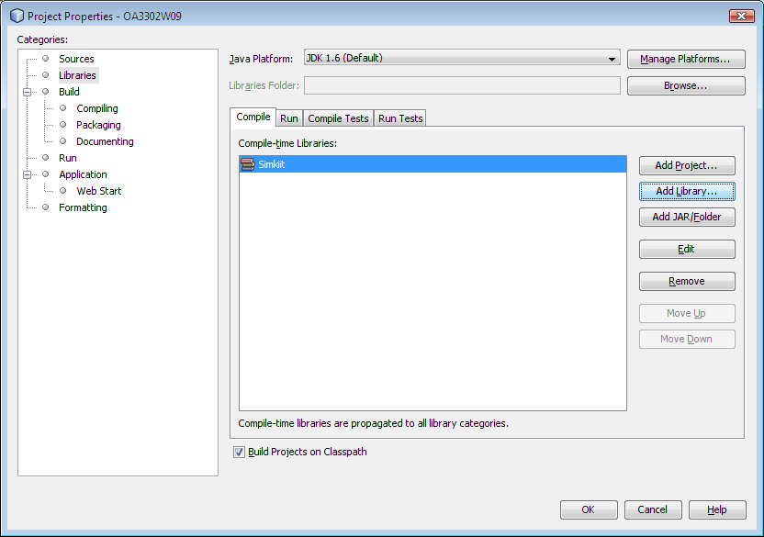

Click “OK” to add Simkit to the project classpath.

### Create the Package

Right-click on “Source Packages” and select “New | Java Package.” Enter oa3302 as the package name (**Important**: Do not name the package OA3302!) and click “Finish”:

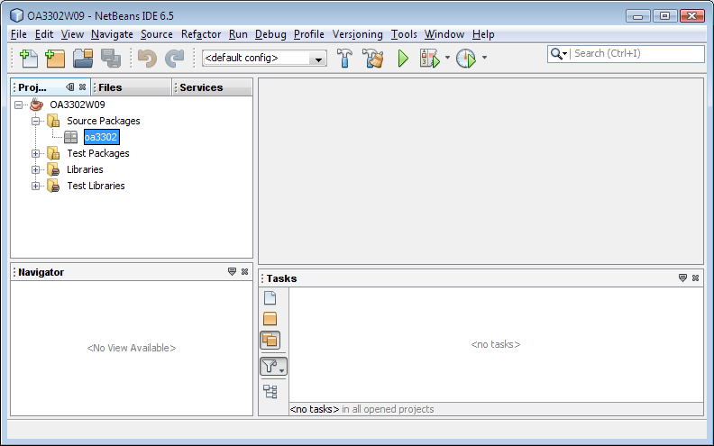

### Create the Class File

Right-click on the oa3302 package and select New | Java Class. Name it ArrivalProcess and click “Finish.”

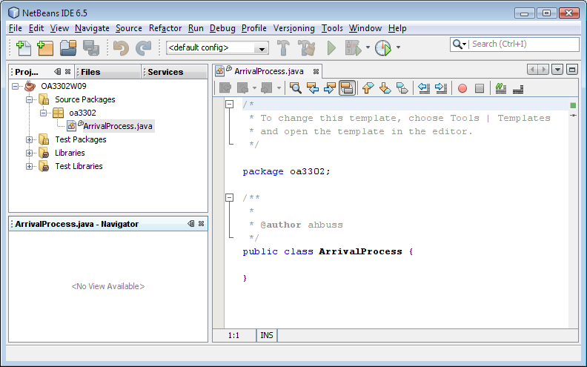

The ArrivalProcess class should extend SimEntityBase. Netbeans indicates it doesn’t “know” about SimEntityBase:

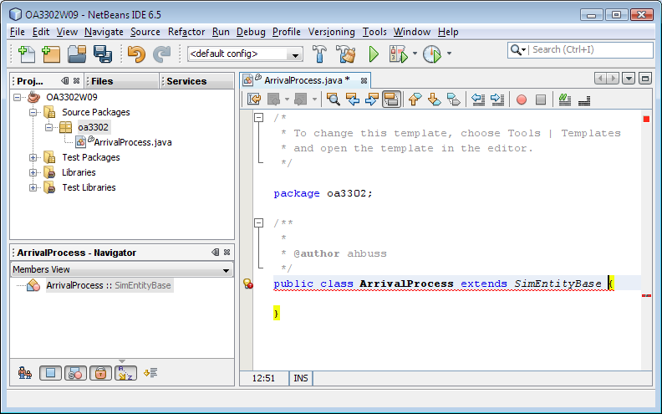

See the light bulb to the left of the class declaration, just behind a red x? Click once on the light bulb and select “Add import for simkit.SimEntityBase”; Netbeans is happy now:

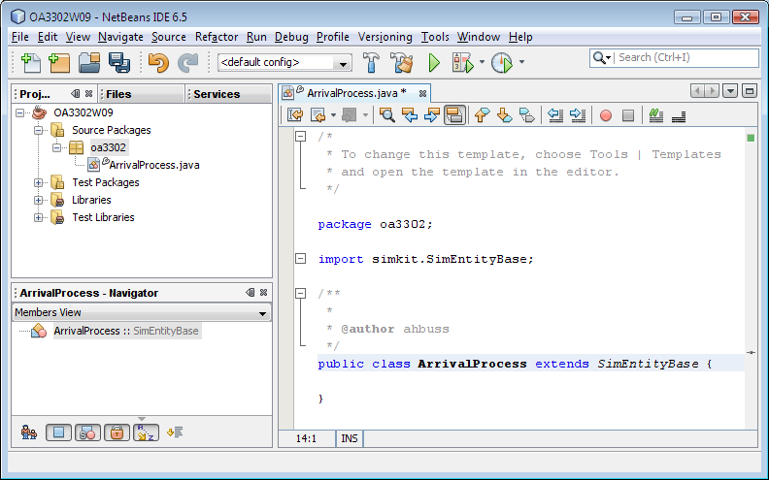

You are now ready to begin creating the class.

1. Replace the last three letters with the appropriate quarter and year.
2. The procedures for different versions should be roughly the same.