Intel Smart Tolling – System Documentation
Project Type: Internal Engineering / Demo
Deployment Model: Single-System (All components on one machine)
Project Maturity: Demo / Advanced Proof-of-Concept

Index
- Project Overview
- Use Cases
- System Architecture
- Hardware & Software Environment
- System Components
- End-to-End Data Flow
- Use Case Details
- Installation & Setup (edge-ai-suites)
- Intel Scenescape Configuration
- Node-RED Configuration & Logic
- InfluxDB Configuration
- Grafana Dashboards
- Security Considerations
- Operational Notes & Startup Guide
- JSON files

1. Project Overview
Intel Smart Tolling is a real-time, AI-driven toll analytics application that leverages existing camera infrastructure to automatically identify vehicles, detect license plates, estimate axle counts, and compute toll classifications.
Unlike traditional frame-based or sensor-heavy toll systems, this solution uses:
- Multi-camera fusion
- Scene-level intelligence
- Edge AI analytics
All components run on a single system, enabling low latency, simplified deployment, and cost efficiency.
The application demonstrates how Intel DL Streamer, Intel Scenescape, and open-source analytics tools can be combined to build a smart, software-defined tolling solution.

2. Use Cases

2.1 Vehicle Axle Detection
Objective:
Determine vehicle class based on axle and wheel count.
Camera Type:
- Side-view camera
Output:
- Axle count
- Wheel count
- Vehicle color
- Vehicle type (light / medium / heavy)
Usage:
Used for toll classification and revenue calculation.
How it works:
uses vehicle type detection model on the entire camera frame
uses vehicle color classification model on vehicle detected bounding box
uses axle detection model on each vehicle detected bounding box
# camera frame > vehicle type model > vehicle bounding box > color model+axle model

2.2 License Plate Detection (ANPR)
Objective:
Identify vehicles uniquely using license plates.
Camera Types:
- Front-view camera
- Rear-view camera
Region of Interest:
- One region covering one lane
- Vehicles moving in the same direction
Output:
- License plate text
- License plate image (stored locally)
How it works:
uses vehicle detection model on the entire camera frame
uses license plate detection model on each vehicle detected bounding box
uses ocr reading classification model on each license plate detected bounding box
# camera frame > vehicle model > vehicle bounding box > license plate model > license plate bounding box > OCR reading model

2.3 Visualization & Analytics (Dashboards)
Objective:
Provide real-time and historical insights for toll operators.
Insights Provided:
- Total vehicles
- Vehicle trends
- Axle-based classification
- Speed & dwell time
- Toll class and fee
- Vehicle history by license plate

3. System Architecture

3.1 High-Level Architecture
Video Loop Inputs (3 Cameras)
↓
DL Streamer (AI Inference)
↓
MQTT Broker (TLS)
↓
Intel Scenescape
↓
Publish to MQTT Broker (TLS)
↓
Node-RED
↓
InfluxDB
↓
Grafana Dashboards

4. Hardware & Software Environment

4.1 Hardware
Component | Details
CPU | Intel® Core™ Ultra 9 285H @ 2.50 GHz
RAM | 32 GB (DDR5 – 16 GB x 2)
GPU | CPU Integrated Graphics
System Type | Board

4.2 Operating System
- Ubuntu 24.04 LTS

5. System Components

5.1 DL Streamer
- Runs AI inference pipelines
- Processes video loop inputs
- Publishes metadata to MQTT

5.2 Intel Scenescape
- Scene creation and calibration
- Camera registration
- Region definition
- Emits region-based object events

5.3 MQTT Broker
- Secure metadata transport (TLS)
- Topic-based event streaming

5.4 Node-RED
- Subscribes to Scenescape events
- Filters exit events
- Transforms data
- Stores ANPR images
- Writes data to InfluxDB

5.5 InfluxDB
- Time-series storage
- Stores vehicle, axle, speed, dwell, and toll data

5.6 Grafana
- Visualization and dashboards
- Analytics and vehicle drill-down

6. End-to-End Data Flow

6.1 Video & AI Processing
- RTSP camera streams are configured in DL Streamer.
- DL Streamer runs trained AI models for:
  - Vehicle detection
  - Axle detection
  - License Plate detection
  - OCR detection
- AI metadata is published to the MQTT Broker.

6.2 Scenescape Processing
- Scenescape subscribes to MQTT metadata.
- Cameras are added and calibrated against a scene map.
- Regions of Interest (ROIs) are drawn on the intersection map:
  - Vehicle lane
- Each region has a unique MQTT topic.
- When objects interact with regions:
  - Events are emitted to MQTT topics
  - Metadata includes:
    - Object type
    - Size
    - Speed
    - Latitude / Longitude
    - Scene ID
    - Region ID
    - Timestamp
    - Heading
    - Vehicle Type
    - License Plate Text
    - Axle Count
    - License Plate b64
    - Touching/Not touching the ground
    - Scene name

6.3 Event Frequency & Filtering
- Camera FPS: 20 FPS (for instance)
- Raw events: ~20 frames/second
- Vehicle Events:
  - Only exit events are captured
  - Exit array contains finalized vehicle metadata

6.4 Data Analytics Flow

- Node-RED MQTT IN Node subscribes to region topics.
- Function Node transforms JSON into InfluxDB format:
  - Measurements
  - Tags
  - Fields
- InfluxDB OUT Node writes data to InfluxDB
6.5 Data Visuaization

- InfluxDB acts as a single source of truth.
- Grafana connects to InfluxDB as a datasource.
- Dashboards provide:
  - Real-time monitoring
  - Historical analysis

Synopsis of Data Flow
- Video loops are fed into DL Streamer
- AI models detect vehicles and license plates
- Metadata is published to MQTT
- Scenescape maps detections to scene regions
- Exit events are generated when vehicles leave the region
- Node-RED processes only finalized exit events
- Data is written to InfluxDB
- Grafana visualizes metrics and vehicle details

7. Installation & Setup (edge-ai-suites)

7.1 Repository
https://github.com/open-edge-platform/edge-ai-suites

7.2 Recipe Used
metro-ai-suite/
└── metro-vision-ai-app-recipe/
└── smart-intersection (keeping similar file structure in smart-tolling)

7.3 Startup
cd edge-ai-suites/metro-ai-suite/metro-vision-ai-app-recipe
docker compose up -d
This starts:
- DL Streamer
- MQTT Broker
- Intel Scenescape
- Node-RED
- InfluxDB
- Grafana

8. Intel Scenescape Configuration
Access:
https://localhost
Username: admin
Password: stored in supass file inside edge-ai-suites

8.1 Scene Setup

Steps:
- Create a new scene
- Upload satellite image of intersection
- Configure pixel-per-meter scale
- Add 3 cameras (toll_front, toll_side, toll_rear)
- Calibrate cameras using reference points
- Save camera configuration
- Draw regions (lane)
- Click on live-view to check object trails

8.2 Camera Roles
- Camera 1: Side view (axle detection)
- Camera 2: Front view (ANPR)
- Camera 3: Rear view (ANPR)

8.3 Region Events
- Only exit events are used
- Ensures stable, final metadata

9. MQTT Explorer Setup
Used for debugging and verification.
- Download MQTT Explorer (.deb)
- Install and configure:
  - Broker host
  - TLS settings
- Verify Scenescape region topics and metadata

10. Node-RED Configuration & Logic

10.1 Access
https://localhost/nodered/

10.2 Flow Overview
MQTT IN → Function → InfluxDB OUT

10.3 Responsibilities
- Filter exit events
- Compute speed
- Extract axle & vehicle metadata
- Store license plate images
- Assign toll class and fee
- Write to InfluxDB
The full Node-RED flow JSON provided by you is used as-is.

11. InfluxDB Configuration

11.1 Access
http://localhost:8086
Credentials:
- Username: admin
- Password: stored in secrets directory

11.2 Bucket
- Name: tolling-bucket
- Retention: default (no explicit policy)

11.3 Measurement
- scenescape_exit_events

11.4 Stored Data
- License plate text
- Axle count
- Speed
- Dwell time
- Toll class
- Toll fee
- Image URL

12. Grafana Dashboards

12.1 Access
https://localhost/grafana

12.2 Dashboards

A. Smart Toll – Overview
- Total vehicles
- Vehicles (last hour)
- License plates
- Average speed
- Average dwell
- Heavy vehicle count
- Speed violations
- Traffic trend

B. Smart Toll – Vehicle Events & Axle Analysis
- Vehicle events table
- Drill-down by license plate
- Vehicle history
- Axle distribution
- Toll revenue by axle class
- License plate image viewer

13. Security Considerations
- MQTT communication over TLS
- No external exposure of services
- InfluxDB secured using API tokens
- Local-only image storage
- Internal network communication
- Credentials managed via Docker secrets

14. Operational Notes & Startup Guide

14.1 Setup
14.1.1 DL Streamer
Run the commands in terminal:
git clone –filter=blob:none –sparse –branch main https://github.com/open-edge-platform/edge-ai-suites.git
cd edge-ai-suites/
git sparse-checkout set metro-ai-suite
cd metro-ai-suite/metro-vision-ai-app-recipe/
./install.sh smart-intersection

before performing “docker compose up”, enter thsi command first:
export SUPASS=$(cat ./smart-intersection/src/secrets/supass)

Go to this folder path
“/smart-intersection/src/dlstreamer-pipeline-server/config.json”
Inside the file, you must setup the Camera_ID, DL Streamer pipeline flow and the parameters.
In scenescape, the Camera ID should be set as the same as name attribute in the json file, and in the json file set the auto_start value to true for those camera you want running.
In the pipeline setting, make sure you insert the file paths for the input video/rtsp, trained models, source code.
And at the end, in the docker_compose.yml file, make sure you give the volume paths for all the models you use in the pipeline so Scenescape gets access to those models.

14.1.2 MQTT Explorer
visit this site “https://mqtt-explorer.com” and download the deb version and install it,open mqtt explorer from applications and enter the following details as shown in the image to connect the mqtt server(scenescape):
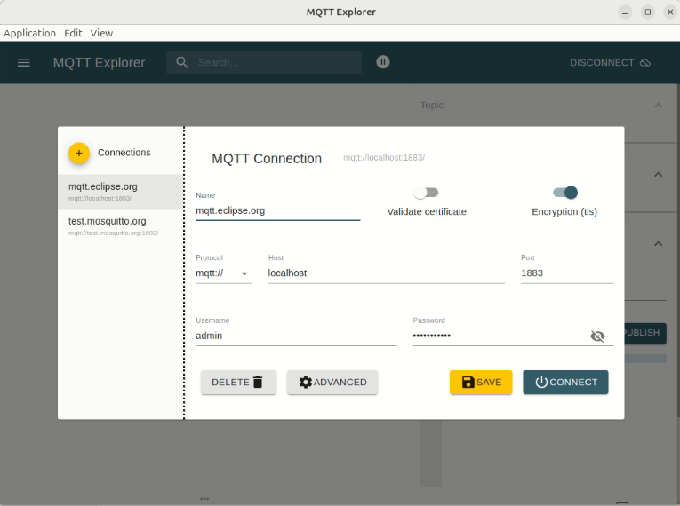

14.1.3 Scenescape
go to the repository(for ex - cd Documents) in the terminal which contains the docker-compose.yml file, then run “docker compose up” to start the services in yml file which includes DL Streamer, Scenescape,Node-Red, InfluxDB,Grafana
search this on chrome “https://localhost”, there you will see a login page
enter these credentials:
- username : admin
- password : locate through the file path “smart-intersection/src/secrets/supass”
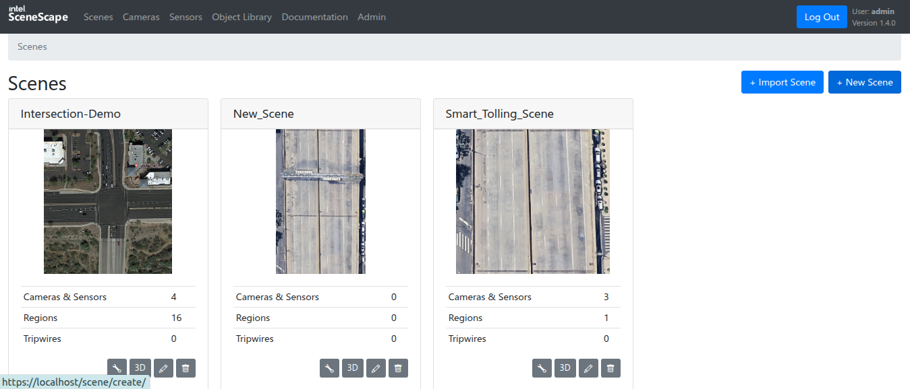
after logging in, you will see a list or scenes (or maybe empty), go inside the scene if it already exists, but if its empty create a new scene by clicking new scene

Option 1: Take a screenshot of a satellite view image from google earth, not down the coordinate points(decimal format) and altitude for the 4 corners of the area covered in the screenshot starting from bottom left counterclockwise, insert the screenshot, give the pixel per metre value(ppm) and save the scene.
Option 2: Upload a .glb file for a scene directly and save the scene.
Option 3: Import a scene (zip file).
Debug: In case, you are uploading a scene glb file and the file size of the .glb file is too big and Scenescape is not accepting it, go to files under this path “smart-intersection/src/nginx” and open “nginx.conf”
Inside the file, at around line 7, inside http function, insert this line just below “http { “ , so the block looks something like this:
http {
client_max_body_size 1024M;
upstream dlstreamer{ ......
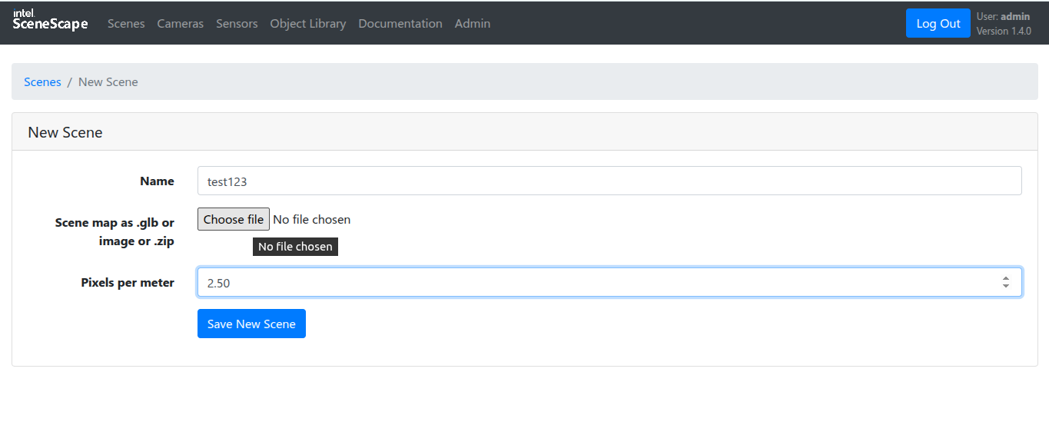
After that click the option for editing the scene, where you will add the coordinate and altitude values, check the format as shown (latitude, longitude, altitude).
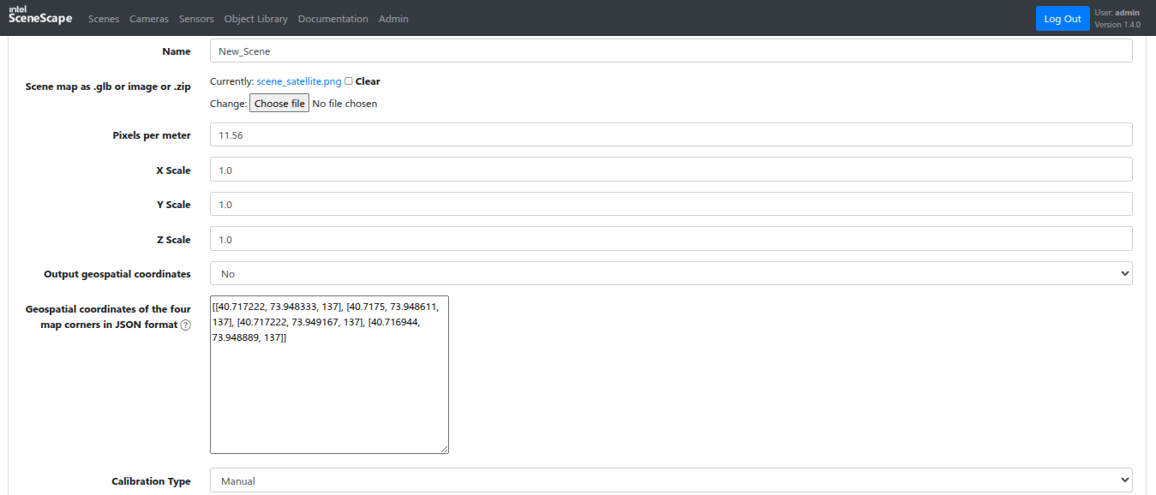
Once you have done that enter the scene to start setting cameras. Click on ‘New Camera’ button and then go to this folder path
“/smart-intersection/src/dlstreamer-pipeline-server/config.json”
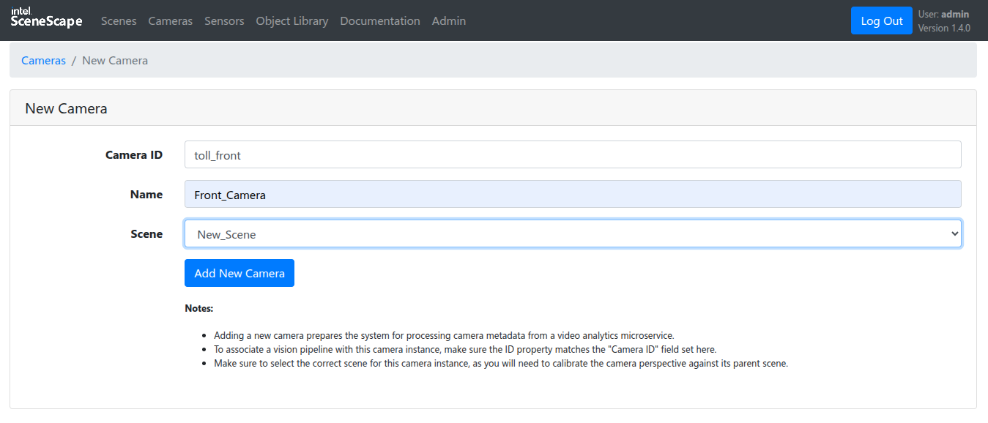
Next step is caliberating cameras, where you have to set up points on the satellite image and the camera frame in order to sync the location of the camera on the scene. Click on one of the cameras where you will see the following image below. Set minimum 4 points so that you get a view of the camera frame(left) on the scene(right). Adjust the points accordingly such that they sync with the exact location.
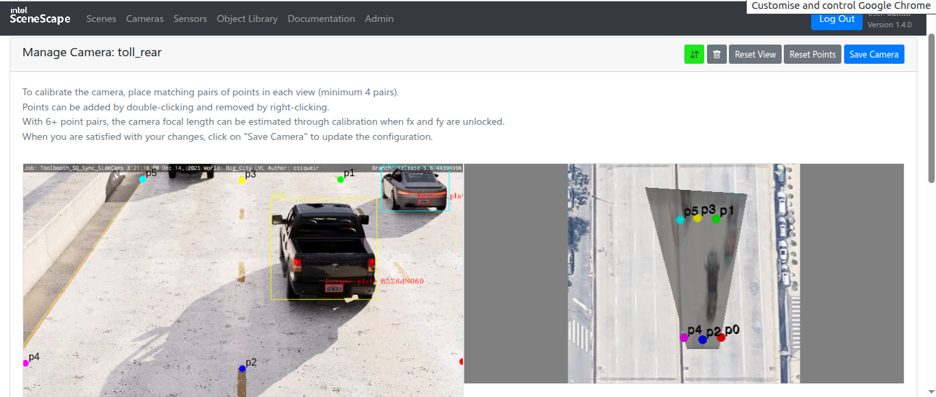

Next step is setting up the region. Click on the “Regions” tab where you can add regions, add minimum 4 points on the scene and close the figure to give it a shape, that shape is you region of interest. You can add as many ROIs as needed.

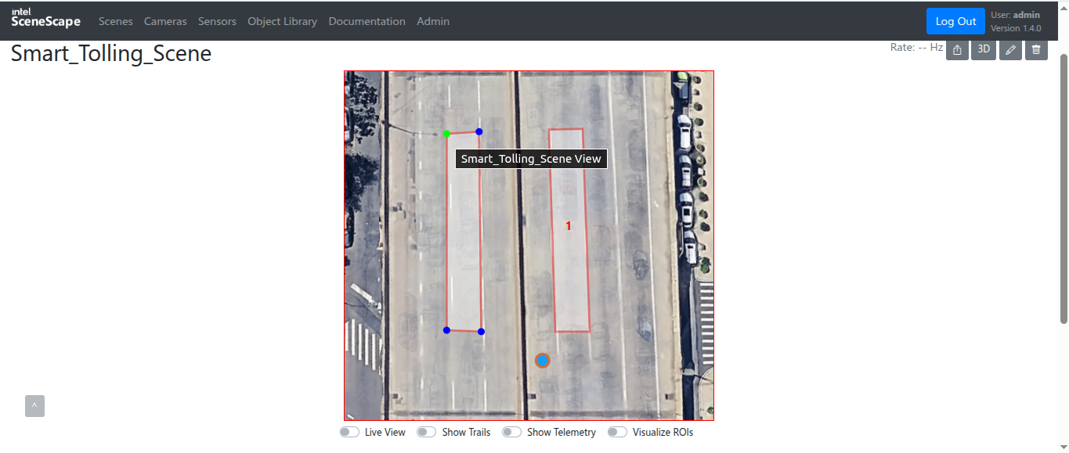

Finally, toggle live view to verify where the points are moving according to the objects detected in the camera frame on the exact location.

14.1.4 Node Red
enter this URL “https://localhost/nodered/”
You will see a drop zone where you can add(drag and drop) nodes in the area from the node list
Here are the nodes that we have to use for transporting the metadata to InfluxDB:
- MQTT in node
- InfluxDB out node
- Function node (used for converting MQTT JSON format data into InfluxDB format)
- Debug node
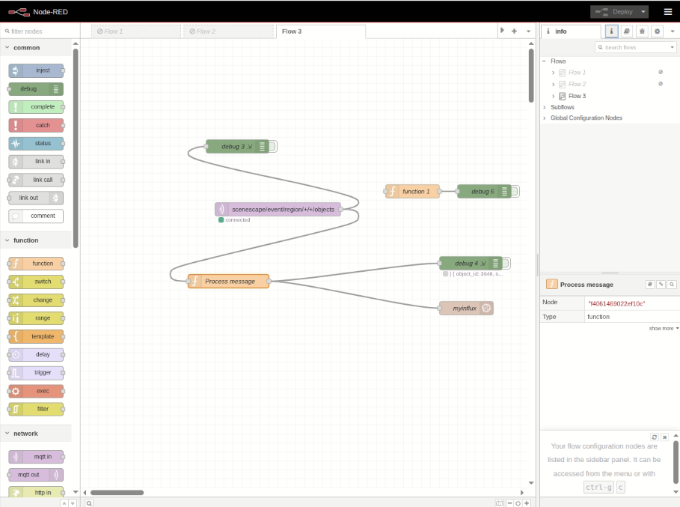
Following are some configurations that you have to do within each node in order to connect each other.
In Influx DB out node, you are also supposed to enter a token for te bucket you will use inside Influx DB(click on the pencil icon in Server section).
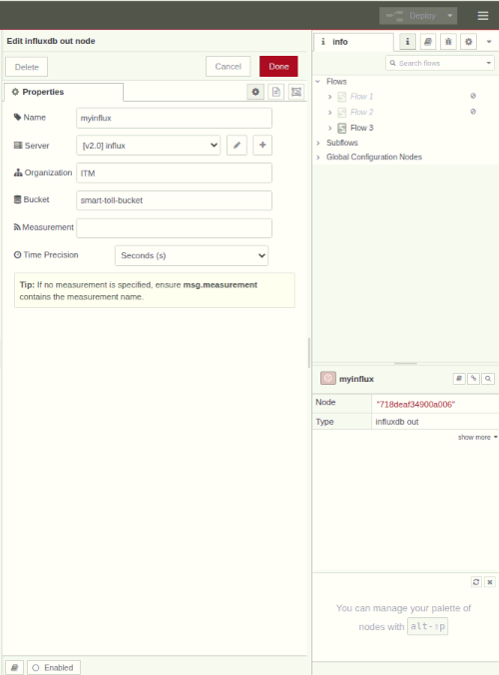
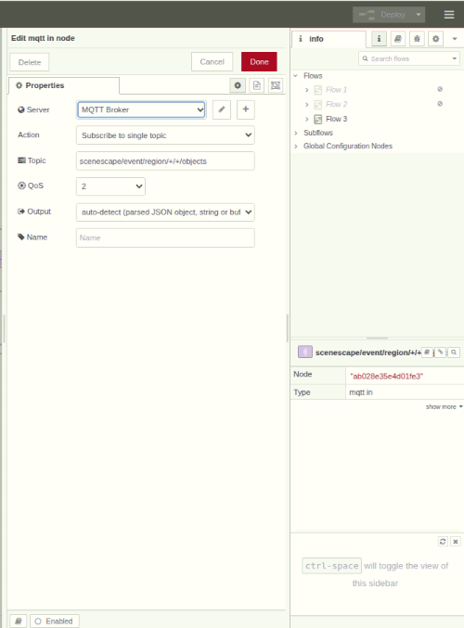

14.1.5 Influx DB
enter this URL “localhost:8086” , you will see a login page
Username : admin
Password : look in this file “smart-intersection/src/secrets/influxdb2/influxdb2-admin-password”
After loggin in you will see this UI from where you can add buckets(storage containers), you can create new buckets, add new data in them or add more data in existing buckets

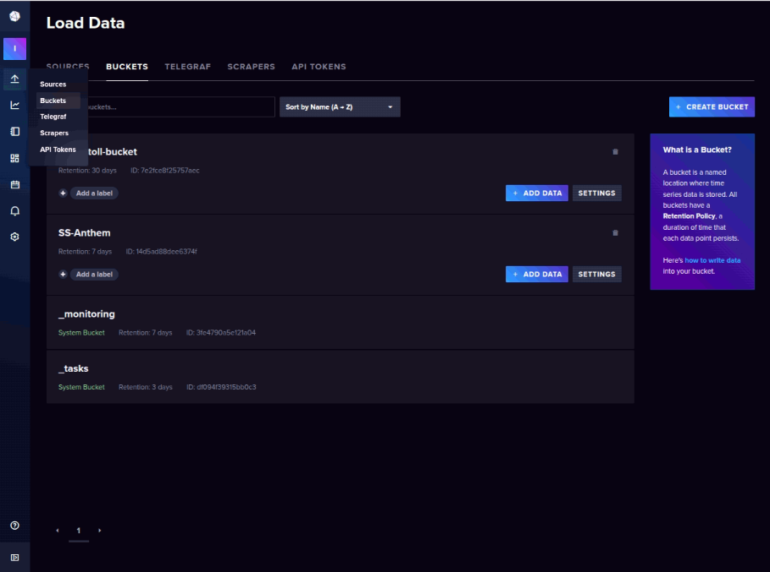

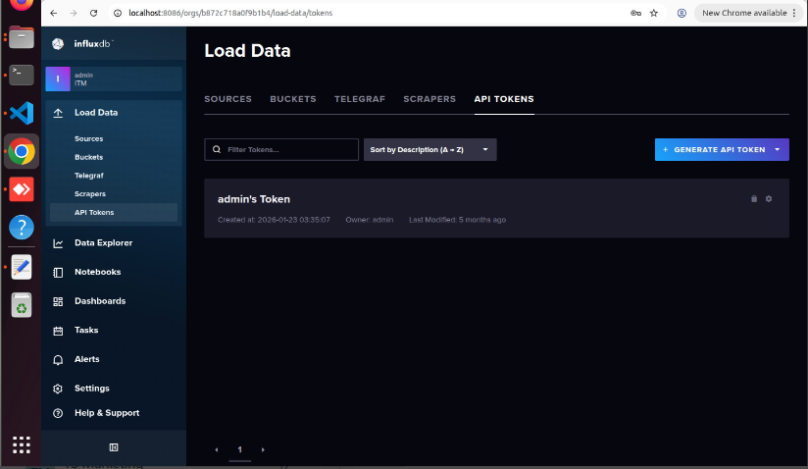
Now, to generate the API token in order to connect to the Influx DB Out Node in the Node-RED, do the following (Refer the image below):

Go to Load Data > API Tokens > Custom API Token > Choose Bucket (Only One) > Select both Read and Write > Generate

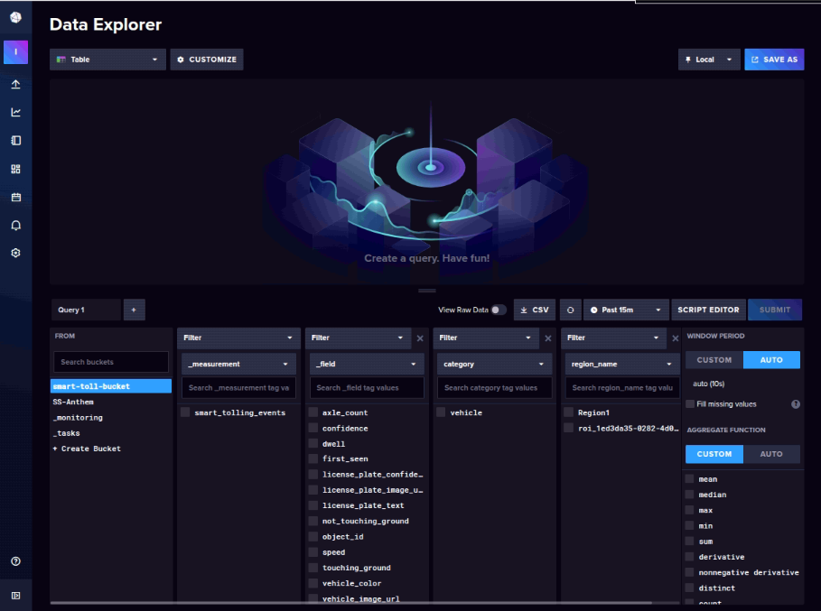
After the bucket is connected to the node, the data will start being exported to the bucket and you can see the data by selecting various attributes as shown in the image, and you can choose however you want to see it as (Graphs, Tables, etc).

14.1.6 Grafana
enter this URL “localhost/grafana”

username : admin
password : admin
(you will get prompted to choose and confirm password after your first login)
To change your password again, use this command, in the same directory you performed the docker compose command:
docker exec it <container id> grafana-cli admin reset-admin-password "<enter-password>"

14.2 Start All Services
docker compose up -d
docker ps (for verification)

14.3 Common URLs
- Scenescape UI: https://localhost
- Node-RED: https://localhost/nodered/
- InfluxDB: http://localhost:8086
- Grafana: https://localhost/grafana
- Check Pipeline Status : https://localhost/api/pipelines/status

Node Red : flows.json
[
{
"id": "64691cf15582719d",
"type": "tab",
"label": "Flow 3",
"disabled": false,
"info": "",
"env": []
},
{
"id": "ab028e35e4d01fe3",
"type": "mqtt in",
"z": "64691cf15582719d",
"name": "",
"topic": "scenescape/event/region/+/+/objects",
"qos": "2",
"datatype": "auto-detect",
"broker": "8cd7a0bff00dfccc",
"nl": false,
"rap": false,
"inputs": 0,
"x": 440,
"y": 380,
"wires": [
[
"f4061469022ef10c",
"a4ebffa3e37083f6",
"84630f62d8d05252"
]
]
},
{
"id": "f4061469022ef10c",
"type": "function",
"z": "64691cf15582719d",
"name": "Process message",
"func": "var msg_payload = msg.payload;\n\n// ---------- BASIC VALIDATION ----------\nif (!msg_payload || !Array.isArray(msg_payload.exited) || msg_payload.exited.length === 0) {\n return null;\n}\n\n// ---------- ROOT METADATA ----------\nvar timestamp = msg_payload.timestamp;\nvar scene_name = msg_payload.scene_name || \"unknown_scene\";\nvar region_name = msg_payload.region_name || \"unknown_region\";\n\nvar ts = new Date(timestamp);\nvar dateStr = ts.toISOString().split(\"T\")[0];\nvar timeStr = ts.toTimeString().split(\" \")[0].replace(/:/g, \"\");\n\n// ---------- PROCESS EXITED VEHICLES ----------\nmsg_payload.exited.forEach(function (exitItem) {\n\n var obj = exitItem.object;\n if (!obj || obj.category !== \"vehicle\") return;\n\n // ---------- SPEED ----------\n var velocity = obj.velocity || [0, 0, 0];\n var vx = velocity[0] || 0;\n var vy = velocity[1] || 0;\n var speed = Math.sqrt(vx * vx + vy * vy) * 3.6;\n\n // ---------- BASE FIELDS ----------\n var fields = {\n object_id: obj.object_id ?? null,\n speed: parseFloat(speed.toFixed(2)),\n dwell: exitItem.dwell ? parseFloat(exitItem.dwell.toFixed(2)) : null,\n first_seen: obj.first_seen ?? null,\n confidence: obj.confidence ?? null\n };\n\n // ---------- TAGS ----------\n var tags = {\n scene_name: scene_name,\n region_name: region_name,\n category: obj.category,\n type: obj.type\n };\n\n // ---------- IMAGE DIRECTORY ----------\n var baseDir = `/images_data/vehicle-events/${dateStr}/${scene_name}`;\n fs.mkdirSync(baseDir, { recursive: true });\n\n // =====================================================\n // FRONT / REAR CAMERA (ANPR DATA)\n // =====================================================\n if (obj.vehicle_image_b64) {\n\n var vehicleImgName = `vehicle_${obj.object_id}_${timeStr}.jpg`;\n var vehicleImgPath = `${baseDir}/${vehicleImgName}`;\n\n fs.writeFileSync(\n vehicleImgPath,\n Buffer.from(obj.vehicle_image_b64, \"base64\")\n );\n\n fields.vehicle_image_url =\n `http://localhost:8081/vehicle-events/${dateStr}/${scene_name}/${vehicleImgName}`;\n }\n\n if (obj.license_plate && obj.license_plate.text) {\n\n var plateText = obj.license_plate.text;\n\n // basic sanity check\n if (plateText.length >= 6) {\n fields.license_plate_text = plateText;\n fields.license_plate_confidence = obj.license_plate.confidence ?? null;\n\n if (obj.license_plate.image_b64) {\n\n var plateImgName = `plate_${plateText}_${timeStr}.jpg`;\n var plateImgPath = `${baseDir}/${plateImgName}`;\n\n fs.writeFileSync(\n plateImgPath,\n Buffer.from(obj.license_plate.image_b64, \"base64\")\n );\n\n fields.license_plate_image_url =\n `http://localhost:8081/vehicle-events/${dateStr}/${scene_name}/${plateImgName}`;\n }\n }\n }\n\n // =====================================================\n // SIDE VIEW CAMERA (AXLE DATA)\n // =====================================================\n if (obj.vehicle_color !== undefined) {\n fields.vehicle_color = obj.vehicle_color ?? null;\n fields.axle_count = obj.axle_count ?? null;\n fields.wheel_count = obj.wheel_count ?? null;\n fields.touching_ground = obj.touching_ground ?? null;\n fields.not_touching_ground = obj.not_touching_ground ?? null;\n }\n\n if (obj.vehicle_side_view_b64) {\n\n var sideImgName = `side_${obj.object_id}_${timeStr}.jpg`;\n var sideImgPath = `${baseDir}/${sideImgName}`;\n\n fs.writeFileSync(\n sideImgPath,\n Buffer.from(obj.vehicle_side_view_b64, \"base64\")\n );\n\n fields.vehicle_side_view_url =\n `http://localhost:8081/vehicle-events/${dateStr}/${scene_name}/${sideImgName}`;\n }\n\n // ---------- SEND TO INFLUX ----------\n node.send({\n measurement: \"smart_tolling_events\",\n payload: [fields, tags],\n timestamp: timestamp\n });\n});\n\nreturn null;\n\n\n// var msg_payload = msg.payload;\n\n// // ---- BASIC VALIDATION ----\n// if (!msg_payload || !Array.isArray(msg_payload.exited) || msg_payload.exited.length === 0) {\n// return null;\n// }\n\n// // ---- ROOT DATA ----\n// var timestamp = msg_payload.timestamp;\n// var scene_name = msg_payload.scene_name || \"unknown_scene\";\n// var region_name = msg_payload.region_name || \"unknown_region\";\n\n// var ts = new Date(timestamp);\n// var dateStr = ts.toISOString().split(\"T\")[0];\n// var timeStr = ts.toTimeString().split(\" \")[0].replace(/:/g, \"\");\n\n// // ---- LOOP THROUGH EXITED OBJECTS ----\n// msg_payload.exited.forEach(function (exitItem) {\n\n// if (!exitItem.object) return;\n\n// var obj = exitItem.object;\n\n// // ---- SPEED CALCULATION (COMMON) ----\n// var velocity = obj.velocity || [0, 0, 0];\n// var vx = velocity[0] || 0;\n// var vy = velocity[1] || 0;\n// var speed = Math.sqrt(vx * vx + vy * vy) * 3.6;\n\n// // ---- COMMON FIELDS ----\n// var fields = {\n// object_id: obj.object_id ?? null,\n// speed: parseFloat(speed.toFixed(2)),\n// dwell: parseFloat(exitItem.dwell.toFixed(2)),\n// first_seen: obj.first_seen\n// };\n\n// // ---- COMMON TAGS ----\n// var tags = {\n// scene_name: scene_name,\n// region_name: region_name,\n// category: obj.category,\n// type: obj.type\n// };\n\n// // =====================================================\n// // LICENSE PLATE CATEGORY\n// // =====================================================\n// if (obj.category === \"license_plate\") {\n\n// var plate = obj.license_plate_text || \"\";\n\n// // Skip junk / short plates\n// if (plate.length < 6) return;\n\n// fields.license_plate_text = plate;\n\n// // ---- IMAGE HANDLING ----\n// if (obj.plate_image_b64) {\n\n// var dirPath = `/data/anpr-images/${dateStr}/${scene_name}`;\n// fs.mkdirSync(dirPath, { recursive: true });\n\n// var fileName = `${plate}_${timeStr}.jpg`;\n// var filePath = `${dirPath}/${fileName}`;\n\n// var buffer = Buffer.from(obj.plate_image_b64, \"base64\");\n// fs.writeFileSync(filePath, buffer);\n\n// fields.image_url =\n// `http://localhost:8081/anpr-images/${dateStr}/${scene_name}/${fileName}`;\n// }\n// }\n\n// // =====================================================\n// // VEHICLE CATEGORY\n// // =====================================================\n// if (obj.category === \"vehicle\") {\n\n// fields.vehicle_type = obj.vehicle_type ?? null;\n// fields.vehicle_color = obj.vehicle_color ?? null;\n// fields.axle_count = obj.axle_count ?? null;\n// fields.wheel_count = obj.wheel_count ?? null;\n// fields.touching_ground = obj.touching_ground ?? null;\n// fields.not_touching_ground = obj.not_touching_ground ?? null;\n// }\n\n// // ---- SEND TO INFLUXDB ----\n// node.send({\n// measurement: \"scenescape_exit_events\",\n// payload: [\n// fields,\n// tags\n// ],\n// timestamp: timestamp\n// });\n// });\n\n// return null;\n",
"outputs": 1,
"timeout": 0,
"noerr": 0,
"initialize": "",
"finalize": "",
"libs": [
{
"var": "fs",
"module": "fs"
},
{
"var": "path",
"module": "path"
}
],
"x": 390,
"y": 540,
"wires": [
[
"3a7c707595275e79",
"718deaf34900a006"
]
]
},
{
"id": "a4ebffa3e37083f6",
"type": "debug",
"z": "64691cf15582719d",
"name": "debug 3",
"active": true,
"tosidebar": true,
"console": true,
"tostatus": false,
"complete": "payload",
"targetType": "msg",
"statusVal": "",
"statusType": "auto",
"x": 350,
"y": 240,
"wires": []
},
{
"id": "3a7c707595275e79",
"type": "debug",
"z": "64691cf15582719d",
"name": "debug 4",
"active": true,
"tosidebar": true,
"console": true,
"tostatus": true,
"complete": "payload",
"targetType": "msg",
"statusVal": "payload",
"statusType": "auto",
"x": 870,
"y": 500,
"wires": []
},
{
"id": "718deaf34900a006",
"type": "influxdb out",
"z": "64691cf15582719d",
"influxdb": "eb84a11cbb71c428",
"name": "myinflux",
"measurement": "",
"precision": "",
"retentionPolicy": "",
"database": "database",
"precisionV18FluxV20": "s",
"retentionPolicyV18Flux": "",
"org": "ITM",
"bucket": "smart-toll-bucket",
"x": 860,
"y": 600,
"wires": []
},
{
"id": "84630f62d8d05252",
"type": "function",
"z": "64691cf15582719d",
"name": "function 1",
"func": "// Check if exited exists and has at least one element\nif (msg.payload && Array.isArray(msg.payload.exited) && msg.payload.exited.length > 0) {\n // Send only exited array to debug\n msg.payload = msg.payload;\n return msg;\n}\n\n// If no exited data, do nothing\nreturn null;\n",
"outputs": 1,
"timeout": 0,
"noerr": 0,
"initialize": "",
"finalize": "",
"libs": [],
"x": 740,
"y": 340,
"wires": [
[
"20434e4b6ecafe72"
]
]
},
{
"id": "20434e4b6ecafe72",
"type": "debug",
"z": "64691cf15582719d",
"name": "debug 6",
"active": false,
"tosidebar": true,
"console": false,
"tostatus": false,
"complete": "payload",
"targetType": "msg",
"statusVal": "",
"statusType": "auto",
"x": 900,
"y": 340,
"wires": []
},
{
"id": "8cd7a0bff00dfccc",
"type": "mqtt-broker",
"name": "MQTT Broker",
"broker": "broker.scenescape.intel.com",
"port": "1883",
"tls": "9c1dd4dad8b11701",
"clientid": "",
"autoConnect": true,
"usetls": true,
"compatmode": false,
"protocolVersion": 4,
"keepalive": "60",
"cleansession": true,
"autoUnsubscribe": true,
"birthTopic": "",
"birthQos": "0",
"birthPayload": "",
"birthMsg": {},
"closeTopic": "",
"closePayload": "",
"closeMsg": {},
"willTopic": "",
"willQos": "0",
"willPayload": "",
"willMsg": {},
"userProps": "",
"sessionExpiry": ""
},
{
"id": "eb84a11cbb71c428",
"type": "influxdb",
"hostname": "127.0.0.1",
"port": 8086,
"protocol": "http",
"database": "database",
"name": "influx",
"usetls": false,
"tls": "",
"influxdbVersion": "2.0",
"url": "http://influxdb2:8086",
"timeout": 10,
"rejectUnauthorized": false
},
{
"id": "9c1dd4dad8b11701",
"type": "tls-config",
"name": "Broker TLS",
"cert": "/run/secrets/broker-cert",
"key": "/run/secrets/broker-key",
"ca": "/run/secrets/root-cert",
"certname": "",
"keyname": "",
"caname": "",
"servername": "",
"verifyservercert": false,
"alpnprotocol": ""
}
]

