**Procedure to reserve intel network IP using ddi tool**

1. **Logon to to ddi tool using** [**https://ddi.intel.com/menandmice/Login.htm?SSO=1**](https://ddi.intel.com/menandmice/Login.htm?SSO=1) **url**

Please click on cancel button and click on New DDI Request button as shown below.

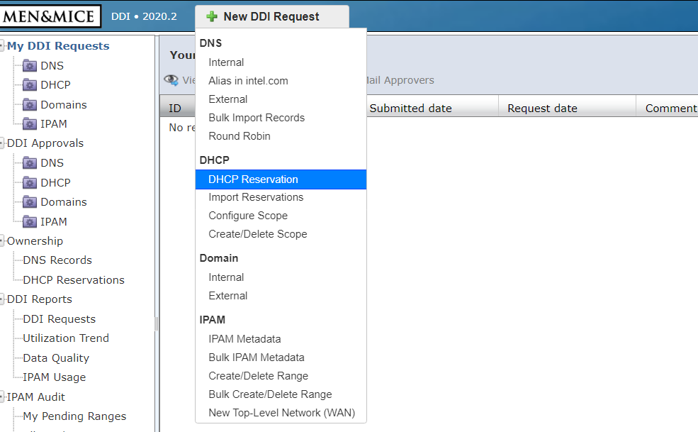

1. **Enter the MAC address of the SUT which you want to provision as shown below. Click on Next**

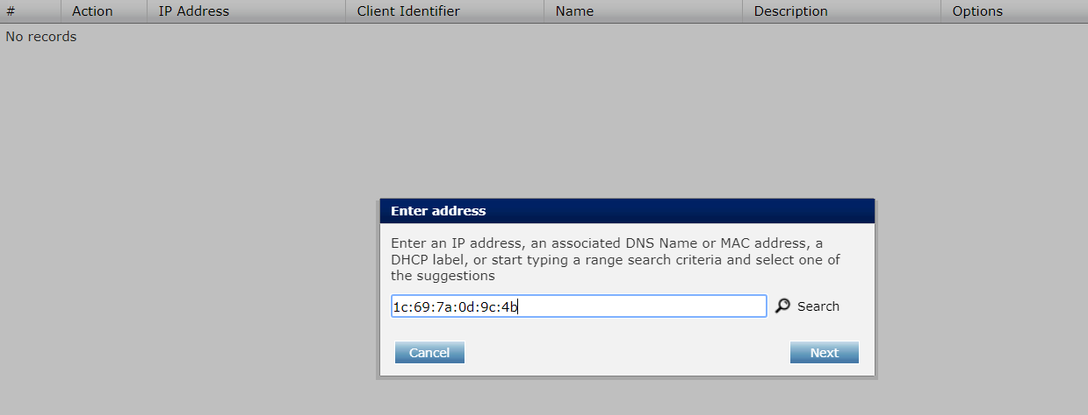

1. **Now you will see the IP address corresponding to your mac, click on OK.**

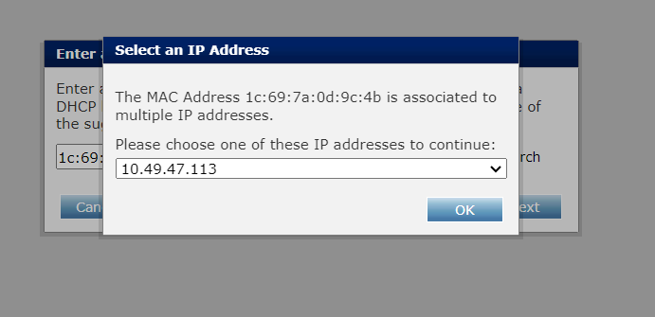

1. **Click on Options tab and provide the details for 66 && 67 as shown below.**

**66-> your load balancer ip address**

**67->ipxe.efi as shown below**

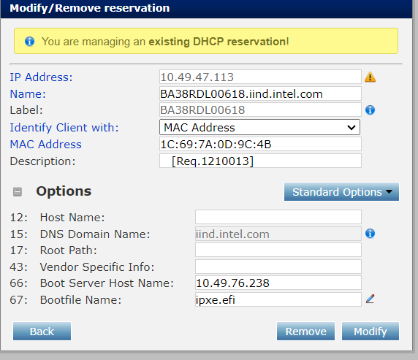

1. **Click on Modify tab and Finally Submit the Request**

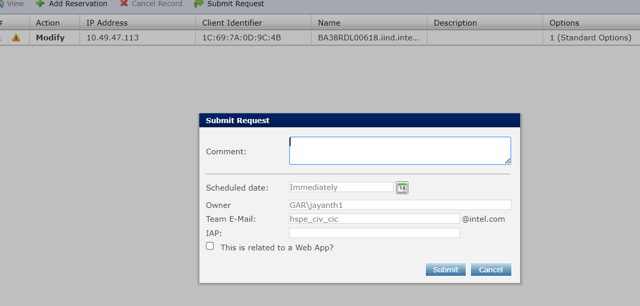

1. **Again, we need to repeat the same procedure from step1 to step 3.**

**After step 3 client ok you will see below window**

**First click on standard portion ->user class ->Tinkerbell -> select this as standard option**

**Second click on options tab and provide the details for 66 && 67 as below.**

**66: your load balancer ip**

**67:** <http://10.49.76.238/auto.ipxe>

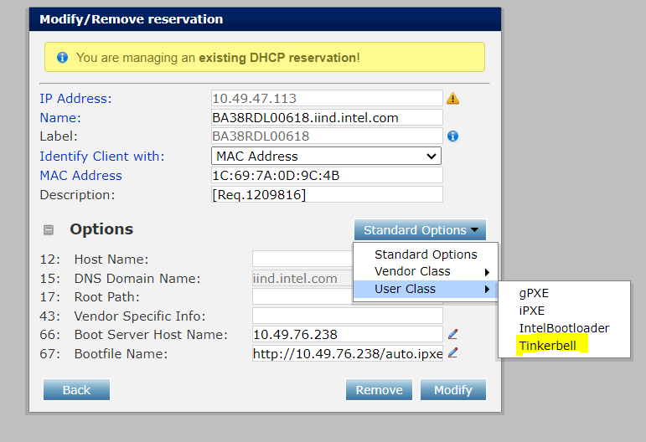

**Click on Modify tab**

1. **Finally submit the request as show below**

