E-Enterprise Community Information Platform

Administration Guide & Long-Term Maintenance Plan

Last Updated August 28, 2018

Table of Contents

1 Administration Overview 3

2 Community Manager Administration Tasks 4

2.1 Agency master list maintenance 4

2.1.1 Create a new agency (optional) 4

2.1.2 Creating a new agency email rule (optional) 5

2.2 User Account Maintenance 6

2.2.1 Deactivating a User Account 6

2.2.2 Reactivating a User Account 6

2.2.3 Assign Administrator Rights to an EECIP User 7

2.2.4 Assign Read-Only (aka Contractor) Rights to an EECIP User 7

2.2.5 Creating a User Account for Someone 8

2.3 Moderating Discussion Forum 9

2.3.1 Creating or Modifying Forum Categories 9

2.3.2 Editing Existing Posts 11

2.4 Reference Data Updates 12

2.5 Setting Application Announcements or Terms & Conditions 14

2.6 Data Import 15

2.7 Azure Search Logic & Configuration 18

2.7.1 Updating Azure Search Synonyms 18

2.7.2 Resyncing Azure Search Indexed Data 19

2.8 Google Analytics 20

3 IT Administration Tasks 21

3.1 Application Component Installation and Maintenance 21

3.2 Patch Deployment 22

3.3 Editing Global Application Settings 24

3.4 EECIP Source Code Maintenance 25

# Administration Overview

Several tasks are required for the ongoing maintenance and administration of the E-Enterprise Community Information Platform (EECIP). Some are one-time tasks while others will be on-going responsibilities. Responsibility for these tasks has not yet been assigned, but the following table outlines a possible division of labor for EECIP Administration. Depending on the resources available, these roles could be combined or modified.

This guide outlines these administrative tasks and provides instructions on how to complete those tasks.

|  |  |  |
| --- | --- | --- |
| **Community Manager Tasks** |  | **IT Administrator Tasks** |
| 1. **Agency Master List moderation:** Periodic review, addition, and occasional correction of agency profiles and email rules. **(See Section 2.1)** |  | 1. **Maintain/monitor cloud services** (Azure Virtual Machine, Search, Google Analytics service, Azure Backup, SQL Server, Chaperone service) **(See Section 3.1)** |
| 1. **User Account and Role management:** Although users can self-register and recover lost passwords without administrative help, Community Manager may need to occasionally perform:  * Account deactivation **(See Section 2.2.1)** * Account reactivation **(See Section 2.2.2)** * Assign Admin role to people **(See Section 2.2.3)** * Assign ReadOnly role to people. **(See Section 2.2.4)** |  | 1. **Patch Deployment:** Deploy any new EECIP patches on Virtual Machine. Includes running of database scripts on EECIP database **(See Section 3.2)** |
| 1. **Moderating discussion forum:** reviewing, moderating, and organizing forum questions and threads **(See Section 2.3)** |  | 1. **Global Application Settings:** Rare tasks such as modifying global application settings, or reinitializing the Azure Search data **(See Section 3.3)** |
| 1. **Reference data updates:** update pick list values or Tag options available to users **(See Section 2.4)** |  | 1. **Source Code Maintenance:** Managing source code repository at GitHub **(See Section 3.4)** |
| 1. **Setting Application Announcements or Terms & Conditions:** Administrators can make announcements in the application, and tweak the language of the Terms and Conditions page. **(See Section 2.5)** |  |  |
| 1. **Data Import:** Bulk importing of externally sourced data may occasionally be performed. **(See Section 2.6)** |
| 1. **Azure Search Configuration:** Administrators can define synonyms to improve search accuracy, and resynch the search data. **(See Section 2.7)** |
| 1. **Google Analytics:** EECIP includes Google Analytics, which can be reviewed for insights into application usage **(See Section 2.8)** |

# Community Manager Administration Tasks

## Agency master list maintenance

Possible Tasks include:

1. **Create a new agency (optional)** Section 2.1.1)
2. **Create a new agency email rule (optional)** (Section 2.1.2)

### Create a new agency (optional)

An Administrator can create a new agency, so when people register new EECIP accounts, the agency will be already available to them. For people registering with .gov or .us emails, this is an **optional** step (because EECIP does allow people with .gov and .us emails to self-register and self-create their agencies). But creating an agency will be a mandatory task for administrators to allow agencies that do not utilize .gov or .us emails (which is common for Tribal organizations and NGO/Governance type organizations).

To create a new agency, navigate to the Administration 🡪 Reference Data 🡪 Agencies page, which will list all agencies currently in EECIP, as shown below:

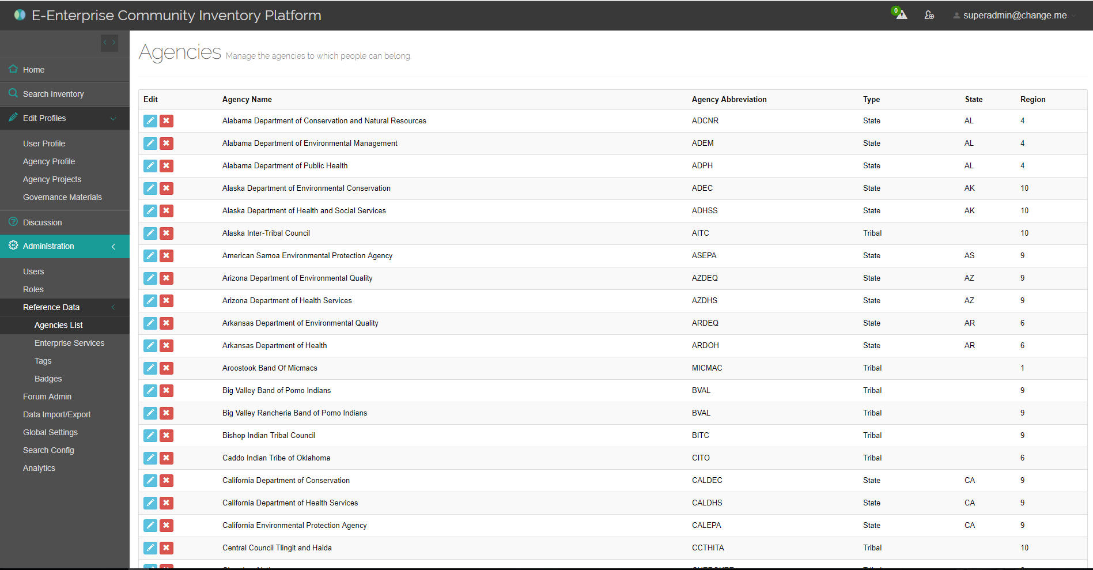

Figure 1: Master Agency List

Scroll to the bottom of the page and click the button. When creating an agency, keep these tips in mind:

* When creating Tribal agencies, leave State blank
* EECIP only supports 3 agency types: State, Tribal, and Governance
* Supplying Region will allow the agency to be searched by Region. Some organizations span multiple regions (or are not geographically tied): region can be left blank for these agencies.

### Creating a new agency email rule (optional)

* ***Why?*** *Agency email rules are used during EECIP registration to automatically associate a user with the agency to which they belong. This adds a layer of security (by restricting users using unknown emails) and registration convenience (by automatically handling the user-to-agency association). The security works because the system sends an email with a verification code to the user when they register, so users cannot use the system with a bogus email.*

**Multiple agencies using the same email rules:** There are situations where multiple EECIP agencies use the emails. For example, all agencies in Massachusetts may use (state.ma.us). So in EECIP both Mass DEP and Mass DOH use the same email rule. This is OK: when people register from Massachusetts, EECIP will detect that multiple agencies match their email rule, so it will prompt them to select the correct agency from the short list.

**One agency using multiple email rules:** There are also situations where one agency employs multiple email rules. For example MassDEP may have employees that are [johndoe@state.ma.us](mailto:johndoe@state.ma.us) as well as [johndoe@massmail.state.ma.us](mailto:johndoe@massmail.state.ma.us). This is OK: an administrator can add multiple email rules for an agency.

To create a new email rule for an agency, navigate to the Administration 🡪 Reference Data 🡪 Agencies page, then click the  button to edit an existing agency. When at the agency edit page, click the  button to add the new agency email rule.

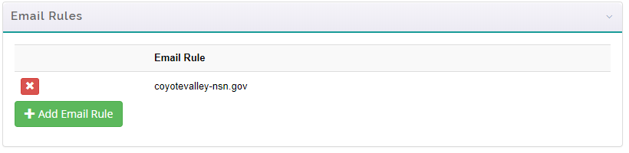

Figure 2: Agency email rules

When creating agency email rules, follow these tips:

* When creating an email rule, do NOT include the ampersand, but include the string that follows the ampersand. So for example, to match rules such as [john.doe@utah.gov](mailto:john.doe@utah.gov), enter utah.gov
* The system supports partial string email rules. So for example, if an agency has users with [john.doe@dep1.utah.gov](mailto:john.doe@dep1.utah.gov) and [jane.smith@dep2.utah.gov](mailto:jane.smith@dep2.utah.gov), you can just use the partial string utah.gov to match all cases.

## User Account Maintenance

Possible tasks include:

1. Deactivating a User Account (Section 2.2.1)
2. Reactivating a User Account (Section 2.2.2)
3. Making a User an EECIP Site Administrator (Section 2.2.3)
4. Creating a User Account for Someone (Optional) (Section 2.2.5)

### Deactivating a User Account

* ***Why?*** *If a user leaves an agency, the agency may contact the Administrator to deactivate the user account to prevent ex-employees from accessing agency data.*

To Deactivate a User Account, navigate to the Administration 🡪 Security Config 🡪 Users screen. Find the user you wish to deactivate, and then click the  icon.

If the user has not made any forum posts, the system will simply remove the user from the database. However, if the user has made forum posts, then instead of deleting the user, the system will make the user account inactive and you will see the following message:

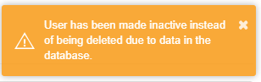

This will others to still see old posts made by the inactive user. The deactivated user will no longer be able to log into the system.

### Reactivating a User Account

* ***Why?*** *As part of the system security, if a user has 5 consecutive failed login attempts, the system will automatically inactivate their account. This is to prevent brute force login attacks. As a result, there may be times when an administrator needs to reactivate a user account.*

To do this, navigate to the Administration 🡪 Security Config 🡪 Users screen. Find the user you wish to deactivate, and then click the  icon.

Then on the User Edit screen, click the following checkbox:



Then click the save button.

### Assign Administrator Rights to an EECIP User

An EECIP administrator can assign other users with the EECIP Administrator Role. To do this, navigate to the Administration 🡪 Security Config 🡪 Roles page, as shown here:

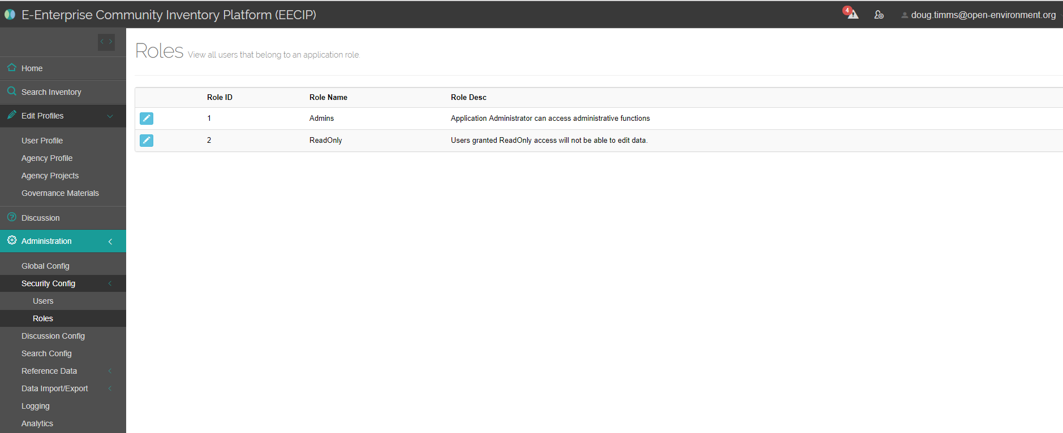

Then click the button to edit the “Admins” role.

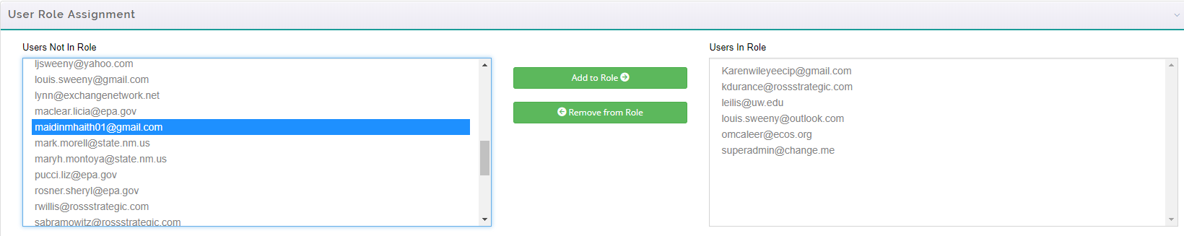

Highlight the email address corresponding to the user account you wish to grant the Admin role to, then click the  button.

* **Note:** any user who has had their role changed will need to log out and log back in for the changes to be effective.

### Assign Read-Only (aka Contractor) Rights to an EECIP User

* ***Why?*** *Some users who are not government employees may want access to the system. These users will not be able to self-register and thus the Community Manager will need to create the account for them. However, the Community Manager may wish to limit the access of these users to ReadOnly access. This will prevent the user from being able to edit projects, discussions, or agency profile information.*

Navigate to the Administration 🡪 Security Config 🡪 Roles page, as shown here:



Then click the button to edit the “ReadOnly” role.



Highlight the email address corresponding to the user account you wish to have only Read Only access, then click the  button.

* **Note:** any user who has had their role changed will need to log out and log back in for the changes to be effective.

### Creating a User Account for Someone

* ***Why?*** *Some users who are not government employees may want access to the system. These users will not be able to self-register and thus the Community Manager will need to create the account for them.*

EECIP Administrators can create a user account for someone. This is done by navigating to the Administration 🡪 Security Config 🡪 Users page, and clicking the  button. The Administrator will be prompted to enter in the user’s first name, last name, and email address. An email will then be automatically delivered to the user, which will contain a link they must click to verify their email address, at which point they can set their permanent password.

## Moderating Discussion Forum

Possible tasks include:

1. Creating or Modifying Forum Categories
2. Editing Existing Posts

### Creating or Modifying Forum Categories

* ***Why?*** *The Discussion Forum can be grouped into a hierarchy of different discussion categories. The Administrator can define or reshape this hierarchy of categories to improve how users organize their discussion topics and navigate to relevant information.*

To modify the Forum categories click on the Administration 🡪 Discussion Config screen. Here you will see the current listing of forum categories:

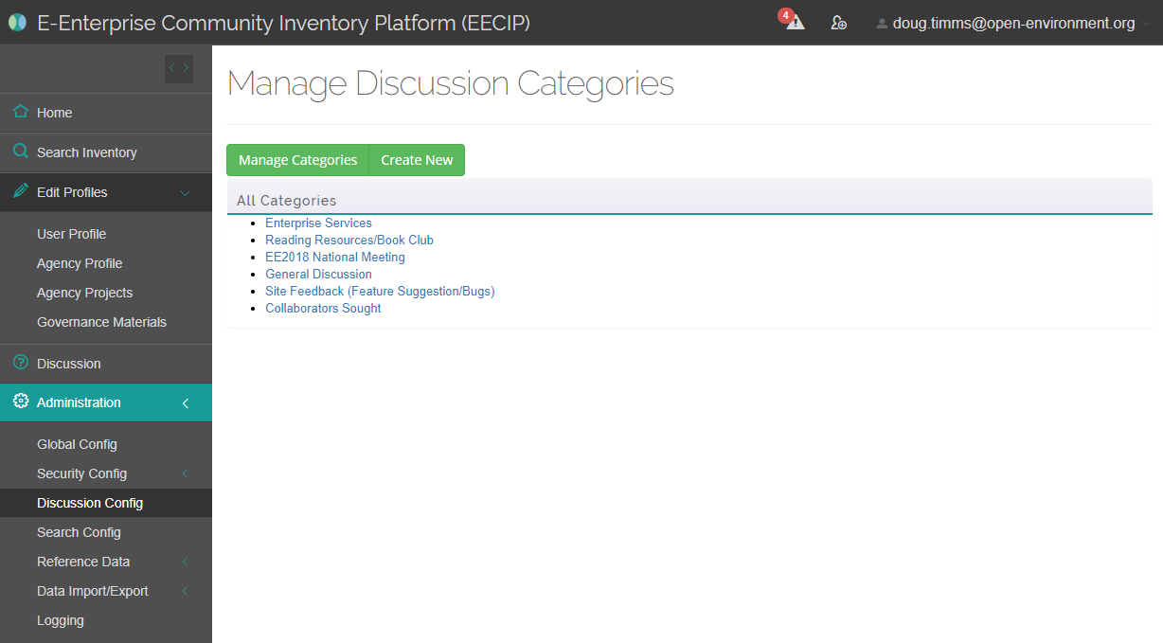

**Modify An Existing Category:** To modify an existing category, click on the  button, and then click on the link for that category. The Edit Category page will display, allowing you to modify the category name, description, sort order, and parent category, as shown here:

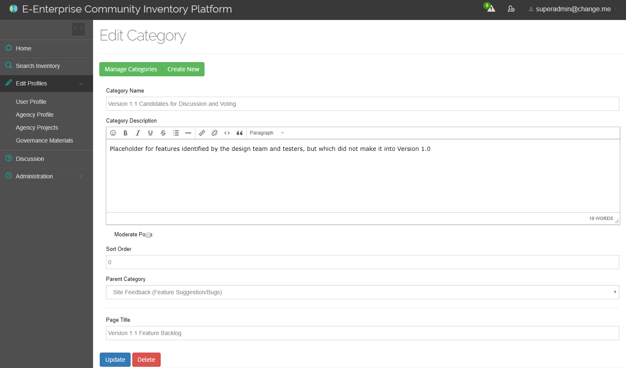

When you are finished editing the category, click on the  button to save your changes.

**Creating a New Category:** To create a new category, click the  button, and then fill out the category name, description, sort order, and parent category.

**Note:** leave Parent Category blank to create a top-level forum category.

### Editing Existing Posts

* ***Why?*** *There may be times when an Administrator needs to clean up a discussion topic or post. This could include the following scenarios: (1) correcting erroneous information, (2) deleting topics that are unhelpful or contain now out-of-date information, (3) changing a topic category to be more relevant, (4) adding tags to a discussion topic so it will be searched more easily. (5) Locking a Topic so that no one can reply.*

To modify a discussion topic or post, navigate to the post the Discussion Forum. If you belong to the “Admins” role, you will see the following buttons.

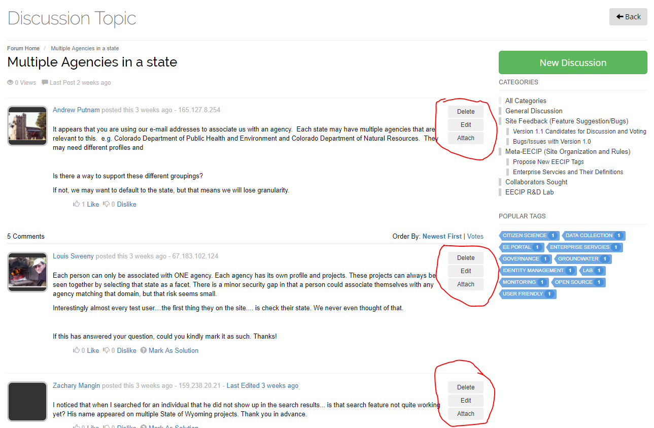

These buttons will allow you to edit or delete a post, even if you are not the creator of the post.

**Note:** If editing the first post in a discussion thread, you will have additional options. These include:

* Edit the topic Category
* Edit the topic Tags
* Lock the Topic
* Pin the Topic to the top of the discussion forum

This option is only available when editing the first post in a thread.

## Reference Data Updates

Administrators can modify the following Reference Data pick lists that users see. The following table lists the different types of reference data lists that can be maintained by an Administrator, where the list can be edited, and where in the application the list is used by application users.

| **Type of Reference Data** | **Where Does the Admin Update** | **Where Reflected** |
| --- | --- | --- |
| Enterprise Services | Admin 🡪 Reference Data 🡪 Enterprise Services | The list of possible enterprise services that users can fill out when editing their agency profile. |
| Tags | Admin 🡪 Reference Data 🡪 Tags 🡪 “Tags” | The consolidated list users can pick from when filling out 3 different places:   * User Profile 🡪 Expertise/Interest * Agency Projects 🡪 Tags * Discussion Forum 🡪 Tag |
| API | Admin 🡪 Reference Data 🡪 Tags 🡪 “API” | Agency Profile 🡪 “Do you have internal/external APIs and/or an agency strategy for APIs?” |
| Application Framework | Admin 🡪 Reference Data 🡪 Tags 🡪 “App Framework” | Agency Profile 🡪 “Application Development Framework” |
| Cloud Interest | Admin 🡪 Reference Data 🡪 Tags 🡪 “Cloud” | Agency Profile 🡪 “Are you using/considering cloud applications” |
| COTS | Admin 🡪 Reference Data 🡪 Tags 🡪 “COTS” | Agency Projects 🡪 “Commercial Off the Shelf/In House?” |
| Database Platforms | Admin 🡪 Reference Data 🡪 Tags 🡪 “Database” | Agency Profile 🡪 “Primary database platform” |
| Program Areas | Admin 🡪 Reference Data 🡪 Tags 🡪 “Program Area” | Agency Projects 🡪 “Program Areas” |
| Project Media | Admin 🡪 Reference Data 🡪 Tags 🡪 “Project Media” | Agency Projects 🡪 “Media” |
| Project Statuses | Admin 🡪 Reference Data 🡪 Tags 🡪 “Project Status” | Agency Projects 🡪 “Current Implementation Status” |
| Use Amount | Admin 🡪 Reference Data 🡪 Tags 🡪 “Use Amount” | Agency Projects 🡪 the dropdowns for:   * “Was business process modernization a part of this project?” * “Is there a mobile component?” * “Does this involve advanced monitoring?” |
| Badges | Admin 🡪 Reference Data 🡪 Badges | The various badges that can be awarded to uses, and the number of points a user earns when they earn a badge. |

## Setting Application Announcements or Terms & Conditions

* ***Why?*** *Administrators may wish to convey announcements to EECIP application users. Users will see these announcements when they log into the application and hit the home page. This is a convenient way to spread a message related to EECIP to various EECIP users.*

**Announcements:**

To set an announcement, navigate to the Administration 🡪 Global Config page, then click on the  header. Announcements can either be plain text or in html format. One example of html formatting is shown here:

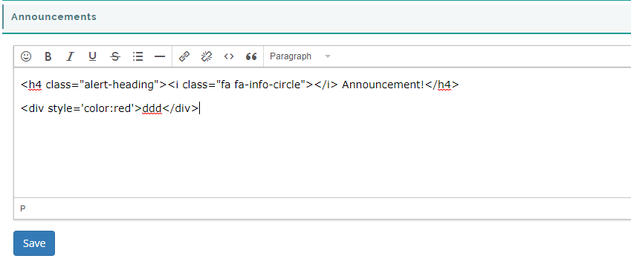

The announcements section supports Bootstrap 3 framework and Font Awesome styling classes, or inline styling. All three types are demonstrated in the example image above.

**Terms and Conditions:**

Similarly, the administrator can set the text used when someone registers for the system and views the application Terms and Conditions. (Terms and Conditions is also accessible by clicking the link in the application footer. <https://www.eecip.net/Home/TermsAndConditions>

## Data Import

* ***Why?*** *Administrators can bulk import new projects into EECIP. This is helpful when a new external data source of projects has been found.*

**Data Import Template:** Data must be imported according to the structure provided in the Project Import Template, which is found here: <https://www.eecip.net/App_Docs/ProjectImportTemplate.xlsx>

To import data, navigate to the Administration 🡪 Data Import/Export screen.

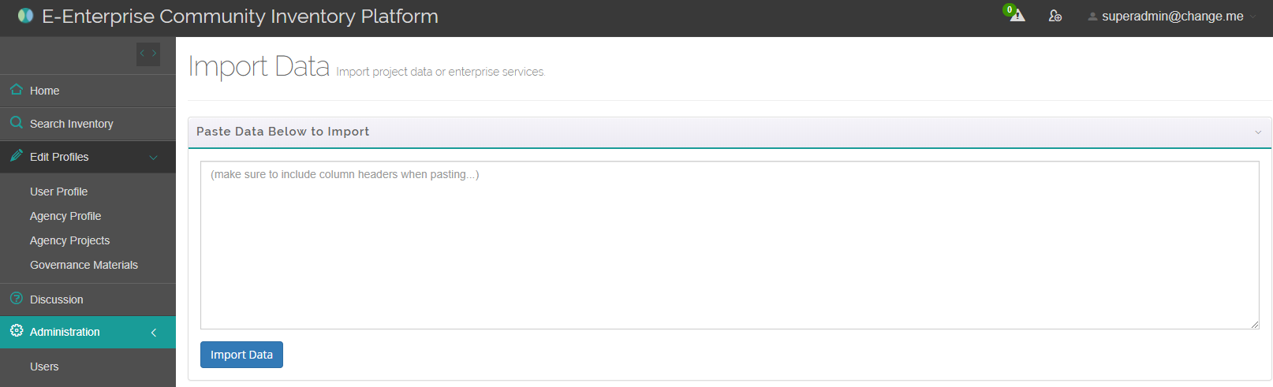

To import data follow these steps:

1. **Fill out the Data Import Template in Excel.**Follow these rules when filling out the template:
   1. Not all columns need to be filled out
   2. DO NOT change the text in the column headers (EECIP uses the column header text to know what information is in each column)
   3. You CAN remove columns you don’t use.
   4. You CAN change the order of columns in the template
   5. You CAN add additional columns that you may need to make managing the data in the spreadsheet easier, but keep in mind that EECIP will ignore those columns when importing data.
   6. **Required Fields:** The only minimum required fields are:
      1. Agency Name
      2. Record Source
      3. Project Name
   7. **Agency Name:** The agency supplied in the “Agency Name” column must exactly match the full name of the agency in EECIP (for example “Alaska Department of Environmental Conservation”). Any deviation will result in that record not importing properly.
   8. **Data update/insert logic:** By default, all projects imported using bulk import will be inserted as new project records. There are, however, 2 options available for treating imported project records as data updates to existing data rather than data inserts of new records:
      1. **EECIP Project ID:** If you knowthe unique ID generated by EECIP for a project record, then you can supply this value. When importing data, if EECIP sees that an EECIP Project ID is supplied, and it actually matches an existing EECIP project record, then the existing record will be updated. Note: the EECIP Project ID for a particular project can be found by navigating to the project’s page in EECIP, and noting the ID in the URL. (For example, if the URL is <https://www.eecip.net/Dashboard/ProjectDetails/f5ccf36c-ac8f-4e5b-9b0e-2e1d49724e6f>, then the EECIP Project ID is f5ccf36c-ac8f-4e5b-9b0e-2e1d49724e6f.)
      2. **Import ID:** Another option for updating data is to supply an Import ID. This is any unique identifier that you specify for an imported record. You must supply this Import ID when you initially import the record. Then any subsequent times you import the same record, if you use the same “Import ID” the system will treat this as a data update.
2. **Copy the data from the Data Import Template.**When copying data, make sure you include the column headers.
3. **Paste the data into the large textbox.**Remembering to include the column headers. It will look similar to the following:

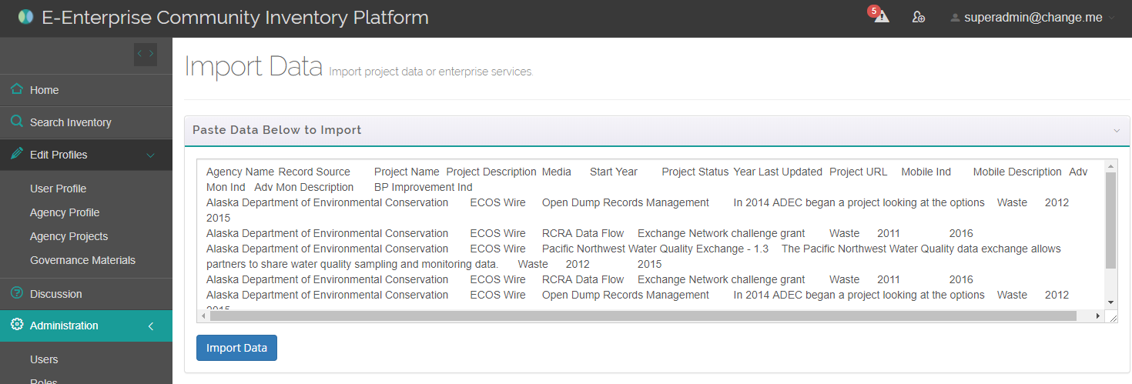

1. **Click the “Import Data” button.**The system will proceed to validate the records.
   1. **If there are ANY data import errors:** a table will be displayed, showing the data validation status of each record. Projects that pass validation will be shown in green and projects that fail validation will be shown in red. The first column will display a message indicating why the project failed data import validation.  
      **Note:** If any validation errors are found, no records will be imported (even those passing validation). You will need to correct the errors and reimport the entire dataset.

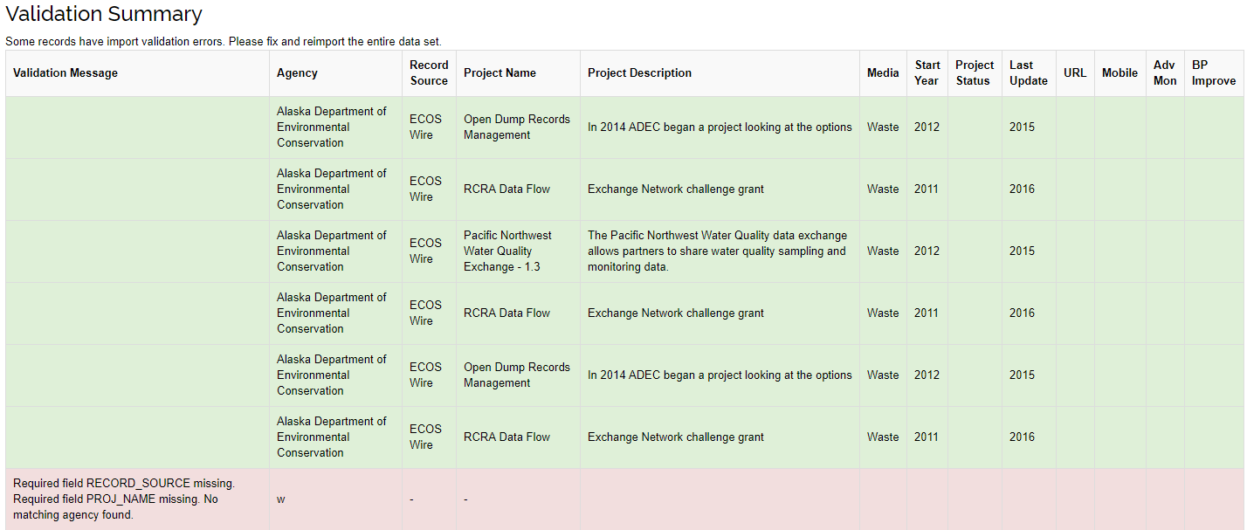

* 1. If there are NO data import errors: A message stating “Data imported successfully” will be displayed as shown here:   
       
     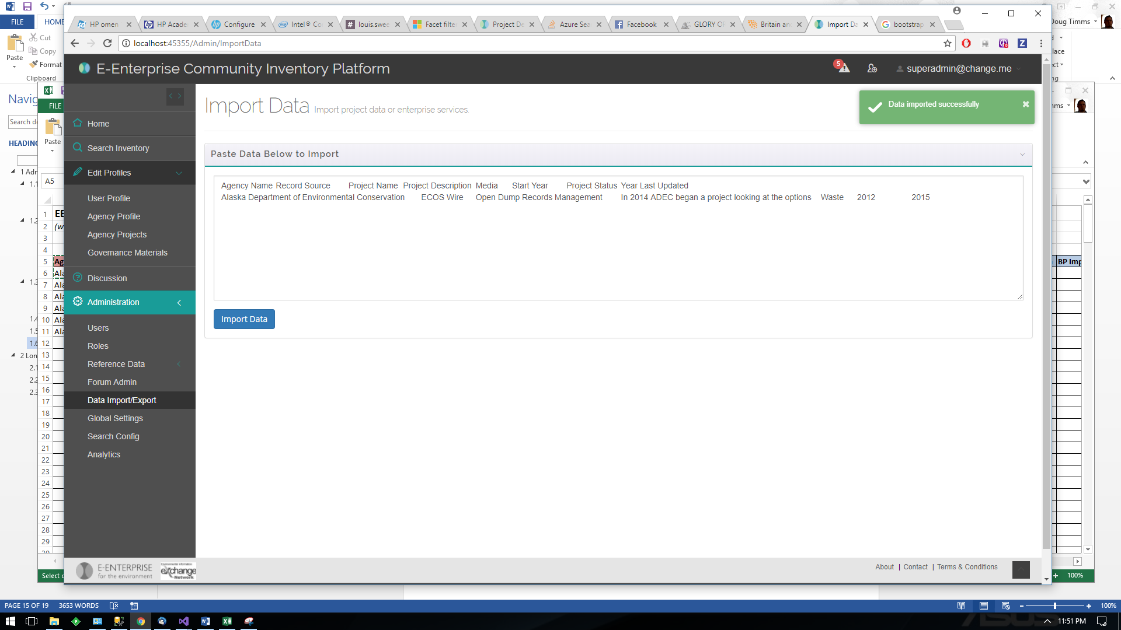

## Azure Search Logic & Configuration

* ***Why?*** *EECIP uses a powerful Azure Search service to index much of the data in the system. This enables advanced searching capabilities such as*
  + ***Full text search:*** *providing the ability to search multiple fields (e.g. Project Name, Agency Name, Program Area, etc) with a single text search with built-in logical operators*
  + ***Faceted navigation:*** *allowing people to drill-down on search results by seeing how many results match different categories of data.*
  + ***Search ranking:*** *the ability to control the ranking of search results based on a variety of criteria. For example, you might want newer projects to appear higher in the search results.*
  + ***Search suggestions:*** *for type-ahead queries in a search bar. Actual documents in the index are suggested as users enter partial search input.*
  + ***Synonym and Fuzzy Search:*** *greater flexibility in search by applying automatic fuzzy search and augmenting search with synonym management (e.g. 303D = ATTAINS) for common related environmental terms*

*The Administrator can improve search by updating the list of synonyms (e.g. mapping the term “UST” with “Underground Storage Tanks” or “NPDES” with “Wastewater”.   
In addition, there may be times when the indexed Azure search data becomes out-of-sync with the data stored in the EECIP database. This would not be a normal situation, but in the rare case when this happens, the Administrator can resync the entire EECIP database with the Azure search index.*

### Updating Azure Search Synonyms

To update Azure Search Synonyms, navigate to Administration 🡪 Search Config, and edit the Synonyms section:

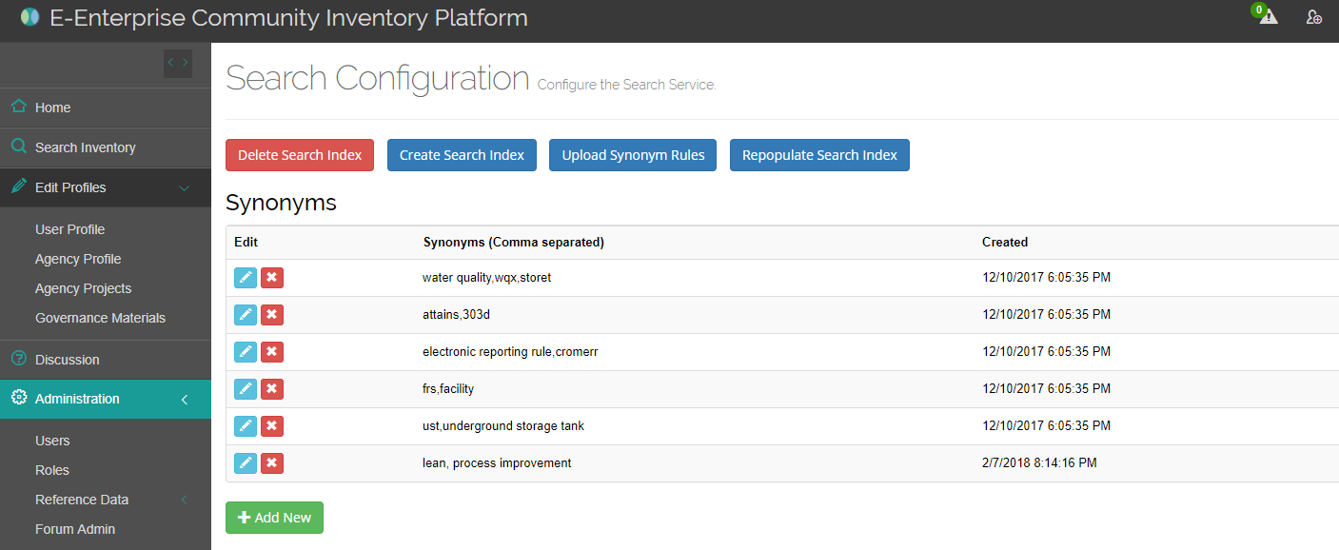

For each synonym set, you can define multiple terms that the Azure Search service should equate, separating each with a comma (for example “water quality, wqx, storet”). Once this synonym is in place, anyone searching “WQX” will get results returned that use the terms “Storet” or “Water quality”.

After synonym changes are made, click the button to refresh the synonyms in Azure.

### Resyncing Azure Search Indexed Data

* ***Why?*** *As long as the EECIP system is working as intended, this step* ***should never be needed****. EECIP automatically synchs changes made to the Azure Search index as soon as changes are saved to the database. However, there may be cases where the EECIP database becomes out of sync with the Azure Search Index. This would happen, for example, if someone went directly to the SQL Server database to make data changes, bypassing the EECIP web page interface.*

To completely resync the Azure Search Index, navigate to the Administration 🡪 Search Config screen, and then click the 4 buttons ( ) in sequence, each time waiting for a confirmation message from EECIP that the step has completed.

## Google Analytics

* ***Why?*** *EECIP includes Google Analytics to allow Administrators to monitor site usage trends. Insights gained from Google Analytics can inform future application modifications or content additions.*

To access Google Analytics, navigate to the Administration 🡪 Analytics menu. Here you will see the Google Analytics Dashboard, as shown here.

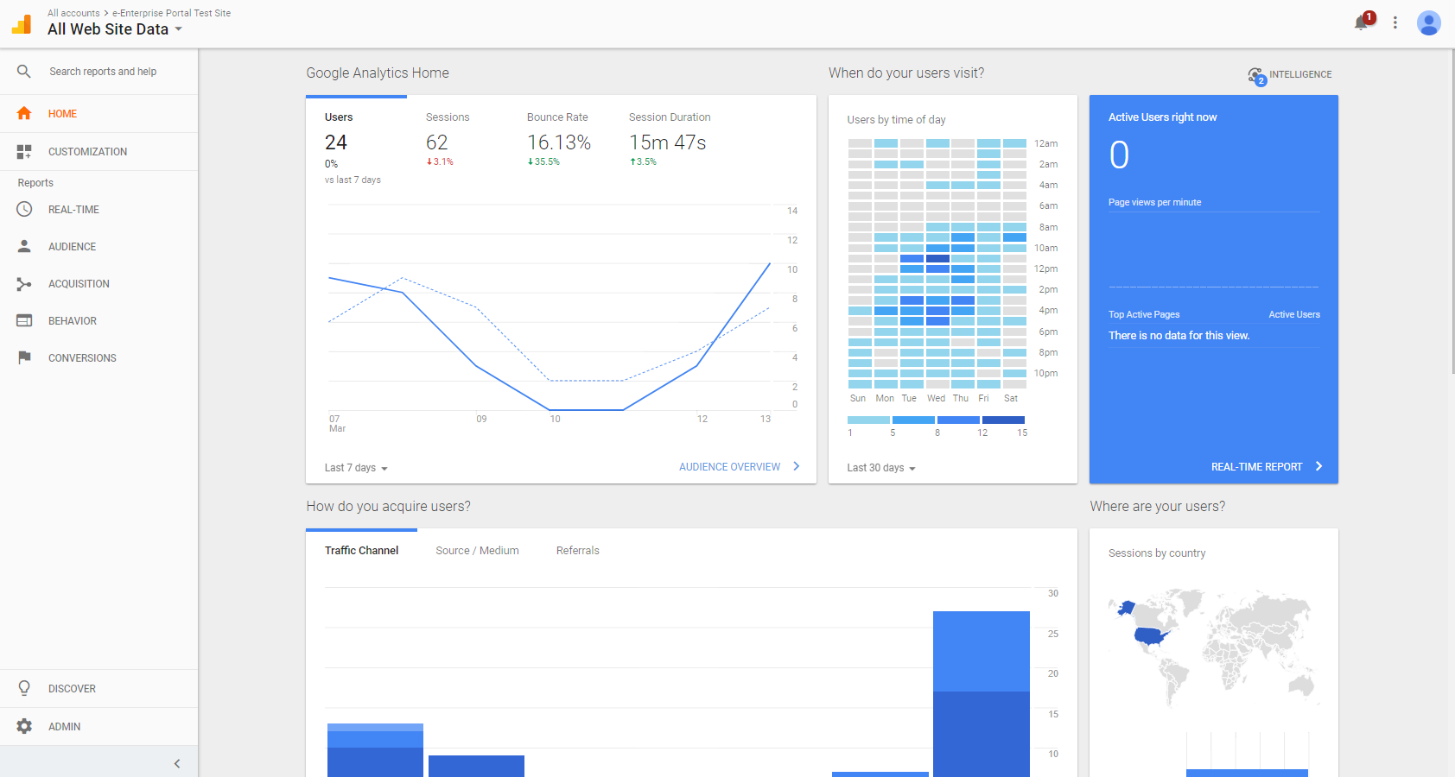

If you do not have access to the dashboard, you will need to be granted rights by the contractor.

# IT Administration Tasks

This section outlines the tasks to be performed by an IT Administrator.

## Application Component Installation and Maintenance

EECIP consists of a variety of application components, as detailed here:

|  |  |  |  |
| --- | --- | --- | --- |
| **Hosting Component** | **Description/ Purpose** | **Size & Config Details** | **How/Where Managed?** |
| Azure Virtual Machine * | Provides publicly accessible server on which to host EECIP web application, database, and SSL certificate | D1 v2 (3.5GB RAM, 10GB Temporary Storage)  Windows Server 2012R2  Public IP: 13.82.106.55 | Azure Portal |
| SQL Server Database | Data storage for EECIP data | SQL Server Express installed on Virtual Machine | Directly on Azure VM |
| Azure Search Service | Adds robust search capabilities to EECIP | Basic Tier (supports up to 3 indexes, 1 million records)  Name: | Azure Portal |
| Azure Backup | Provides nightly backup service for the virtual machine to allow for disaster recovery | Utilizes ~50GB nightly backup; scheduled to run at 12:30AM each night. | Azure Portal |
| SendGrid | Provides cloud-based email delivery service. No need to integrate with local SMTP server | Azure free plan (up to 25,000 emails / month) | Azure Portal |
| Domain Name | Provides a meaningful URL name for EECIP | Eecip.net, eecip.com, eecip.org all registered. Eecip.org and eecip.com redirect to eecip.net. Domains currently expire 1/9/2019 | Namecheap.com |
| SSL Certificate | Protect information in-transit | Positivessl, currently expires 1/24/2020 | Namecheap.com |
| Chaperone | Provides guided tours in the EECIP application. |  | Getchaperone.com (managed via Chrome plug-in) |
| Google Analytics | Provides insight to application usage |  |  |

## Patch Deployment

Patches will likely be deployed by the IT Administrator. Patches will contain the following:

* Application Files
* Database scripts

**Application File Deployment:**

The EECIP application files will be deployed using Remote Desktop Protocol to the EECIP Virtual Machine. Updated application files will be copied to the C:\Inetpub\wwwroot\EECIP directory, as shown here:

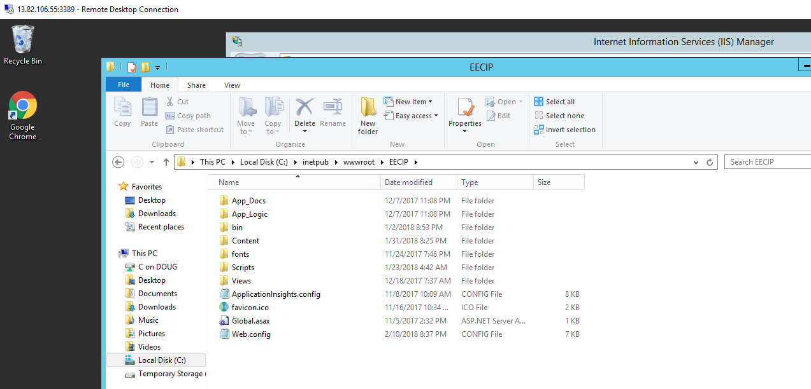

**Database Script Deployment:**

Database scripts will also be run by first accessing the EECIP Virtual Machine via Remote Desktop Protocol, and then running SQL Server Management Studio, which is installed directly on the Virtual Machine, as shown here:

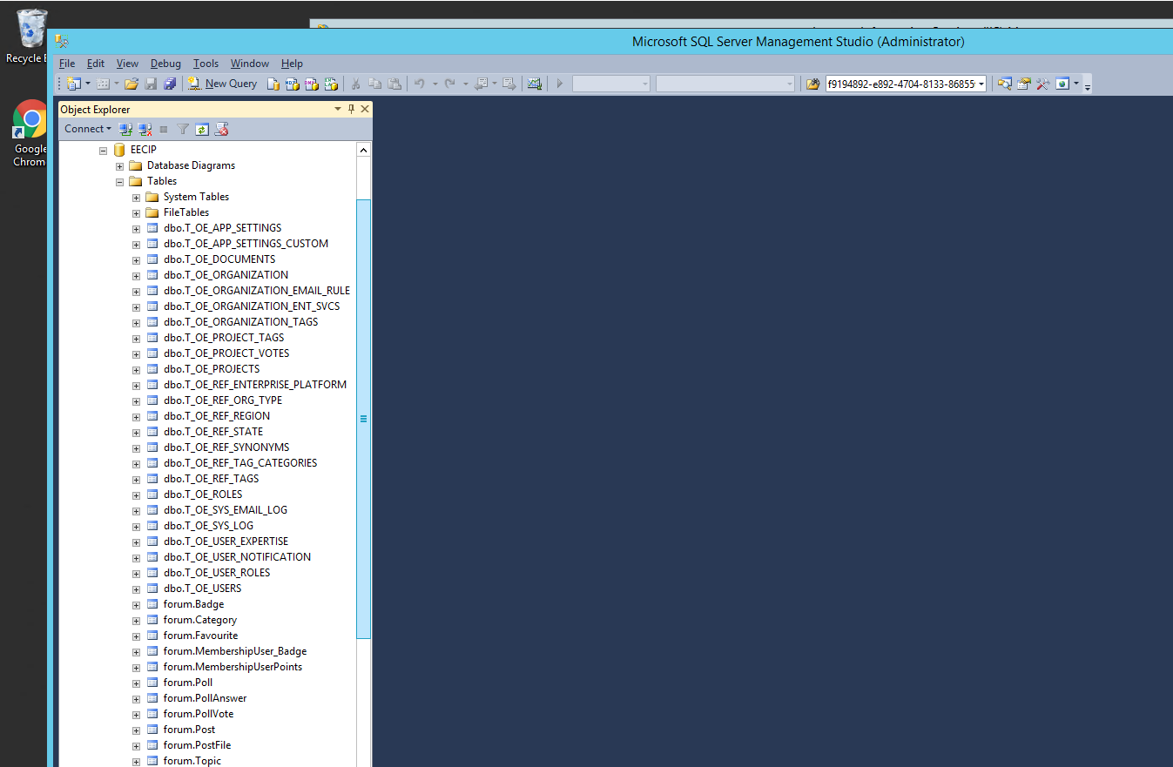

Script (SQL) files can then be run from the query command prompt.

## Editing Global Application Settings

EECIP has several configurable settings that will most likely be maintained by the IT Administrator. These settings can be managed by navigating to the Administration 🡪 Global Config page, as shown here:

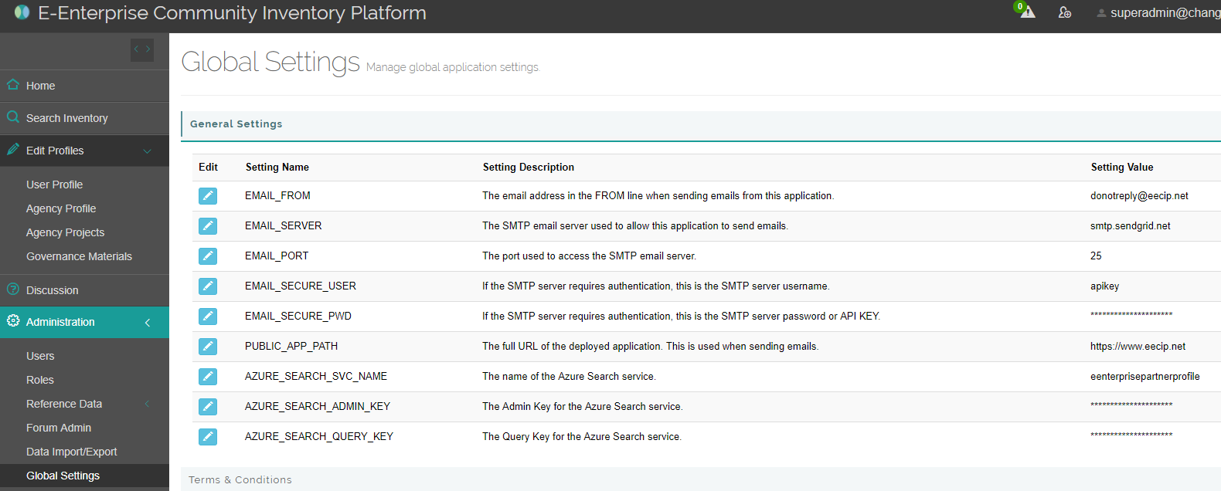

The meaning of these settings is further described here:

* **EMAIL_FROM:** EECIP sends out emails for a variety of purposes (new account registration, notification of new badge awarded, notification of discussion topic updated). When users receive these emails from EECIP, the EMAIL_FROM setting will be the email address that it appears the email is being sent from.
* **EMAIL_SERVER, EMAIL_PORT, EMAIL_SECCURE_USER, EMAIL_SECURE_PWD:** As mentioned in a previous section, EECIP utilizes the SendGrid service to distribute emails. This is a secure service that requires a master account. These settings are provided to properly connect with and utilize the external SendGrid email distribution service.
* **PUBLIC_APP_PATH:** When EECIP sends out emails, it sometimes includes a link for the user to click to return to the application. This setting provides the correct URL of the application.
* **AZURE_SEACH_SVC_NAME, AZURE_SEARCH_ADMIN_KEY, AZURE_SEARCH_QUERY_KEY:** A mentioned in a previous section, EECIP utilizes the Azure Search service for advanced search capabilities. These settings are provided to properly connect with and utilize the external Azure search service.

## EECIP Source Code Maintenance

EECIP is an open source application, so all source code for the application is maintained in a publicly viewable location. EECIP source code is maintained through GitHub at the following location:

* https://github.com/open-environment/EECIP

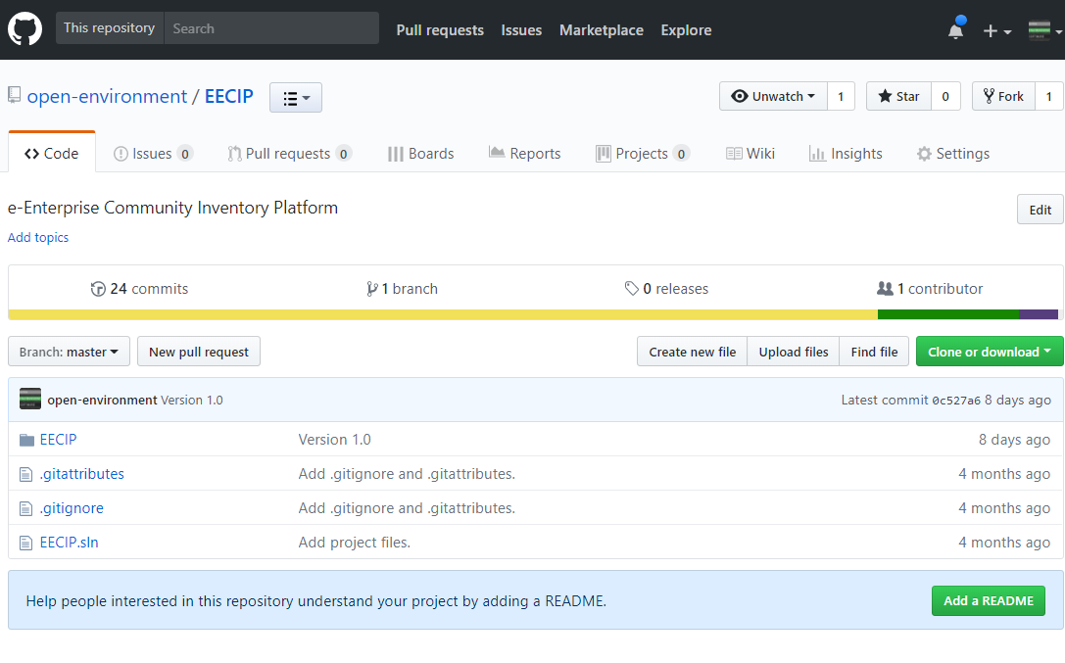

After patches are made to the application, the latest source code revisions will be merged into this repository.