Roteiro para Converter dados do TrackSource para Shapefile

Michel Metran da Silva
Dia 7 de Março de 2012

Objetivos:
Montar uma base cartográfica, em SAD 69, com o material provindo do TrackSource, ou seja, uma base cartográfica de Estradas, Ruas e Rodovias

Pré-Requisitos:
- TrackSource instalado no PC

Sofwares necessários:
- GPSMapEdit
- GlobalMapper
- ArcGIS (ArcCatalog)

1. Copiar todos os mapas .img (formato do TrackSource) da pasta aonde foi instalado o TrackSource para ..\Etapa_1\Maps
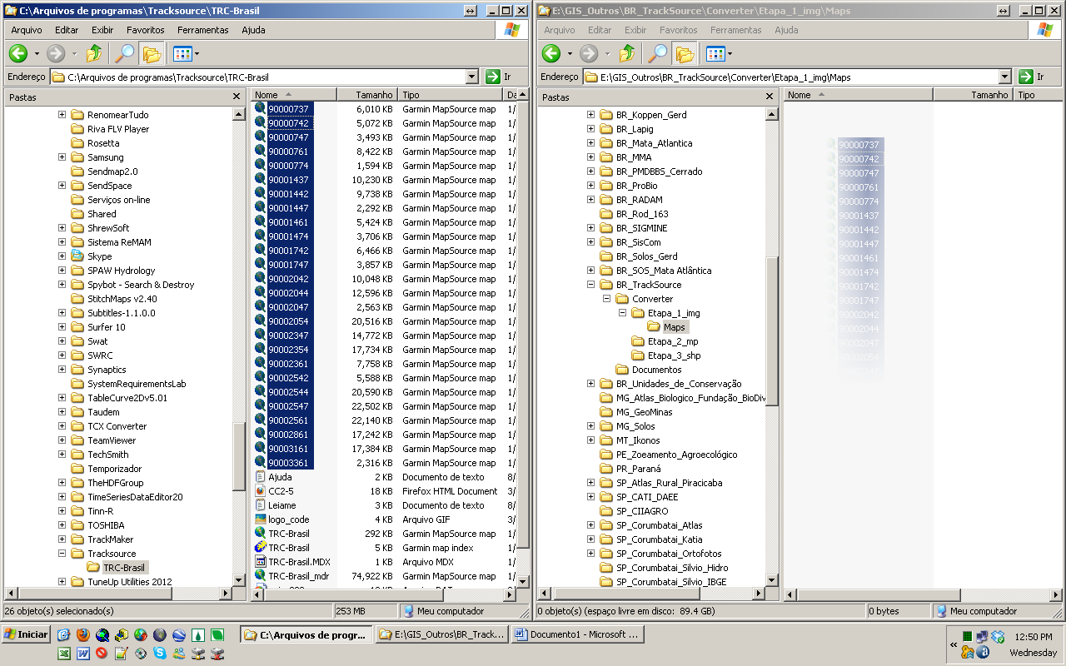

2. Aplicar a macro ConvertToNTM.vbs...que se encontra dentro de E:\GIS_Outros\BR_TrackSource\Converter\Etapa_1_img
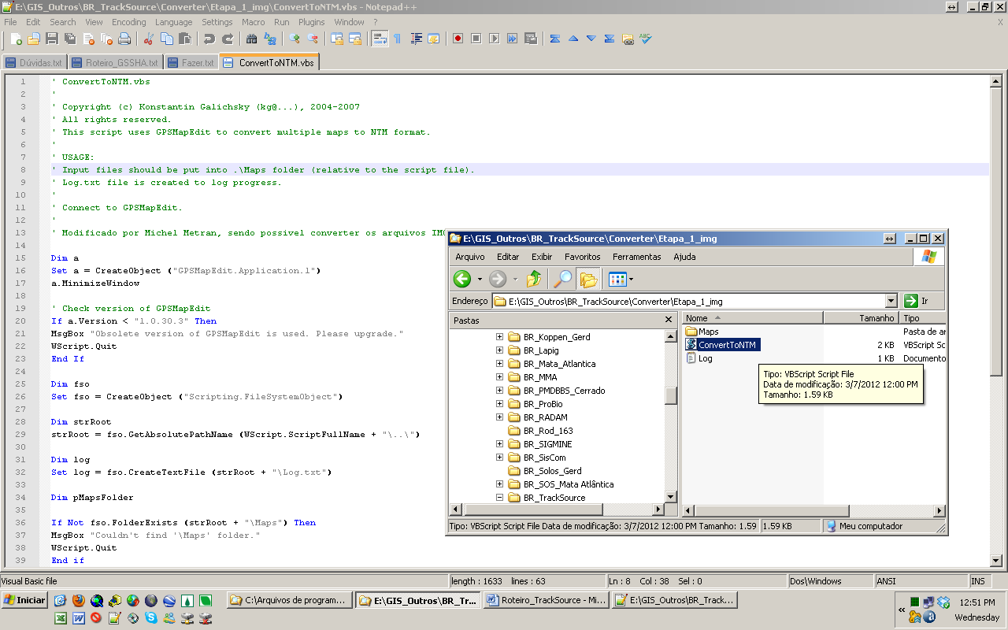

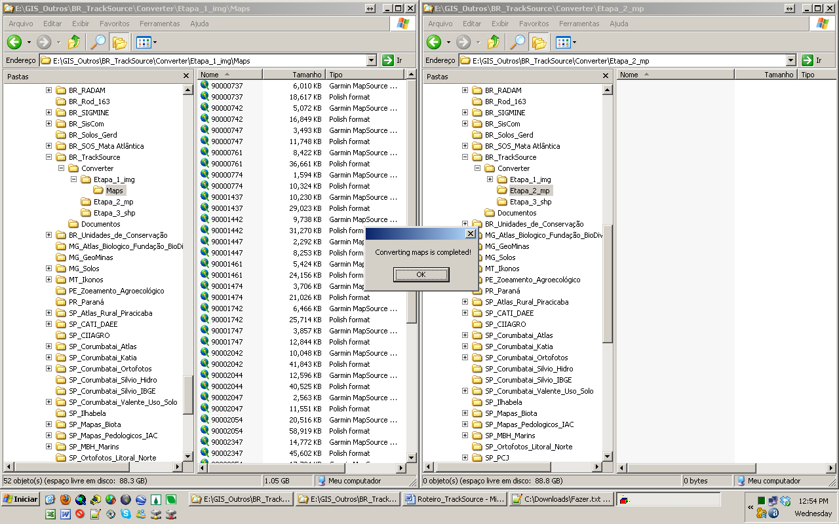

3. Colocar os arquivos em formato .mp na pasta ..\Etapa_2
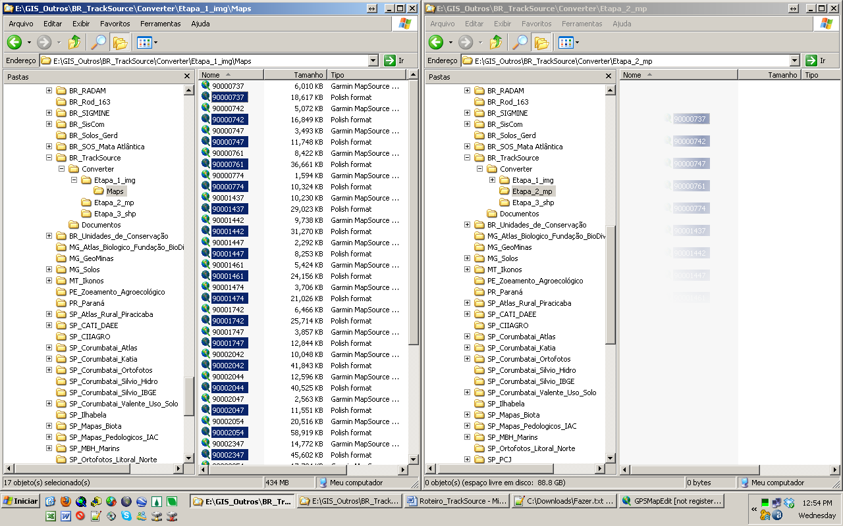

4. Deletar os mapas .img

5. Usando a ferramenta Batch, interna, do Global Mapper, reprojetar os arquivos .mp para shapefile...
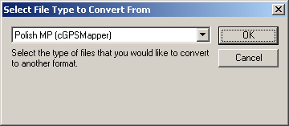
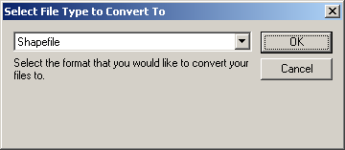
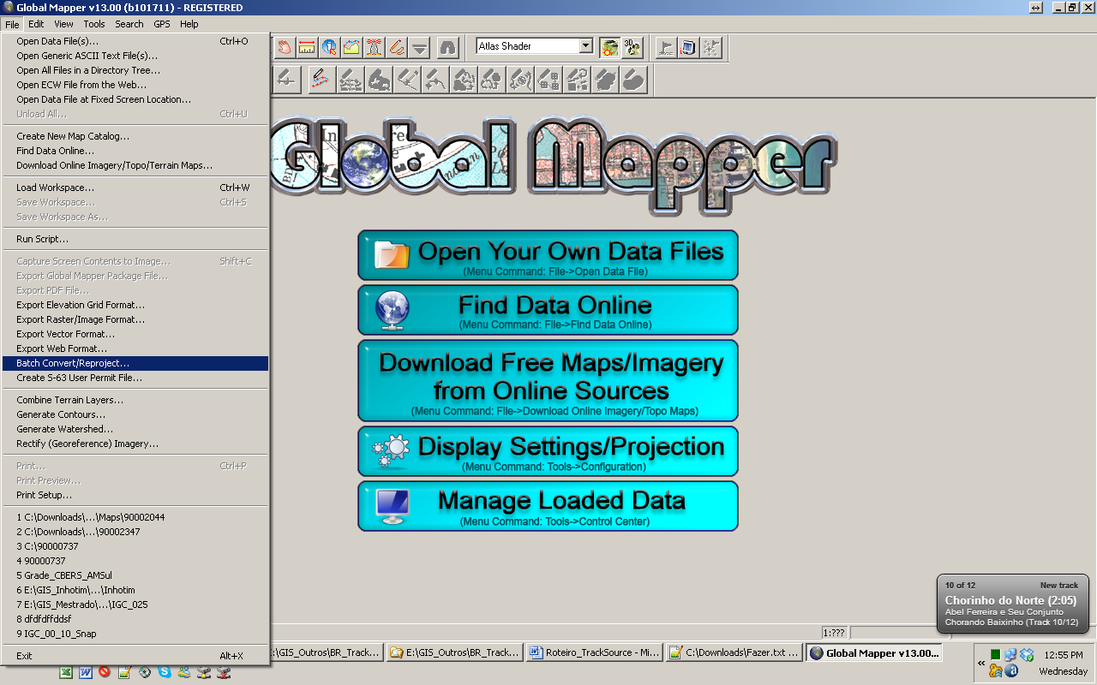

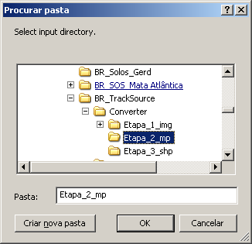
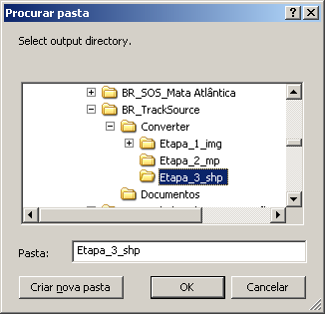
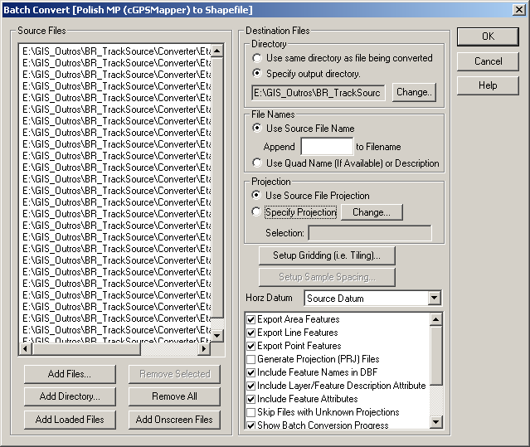

6. Processo feito, deletar arquivos .mp
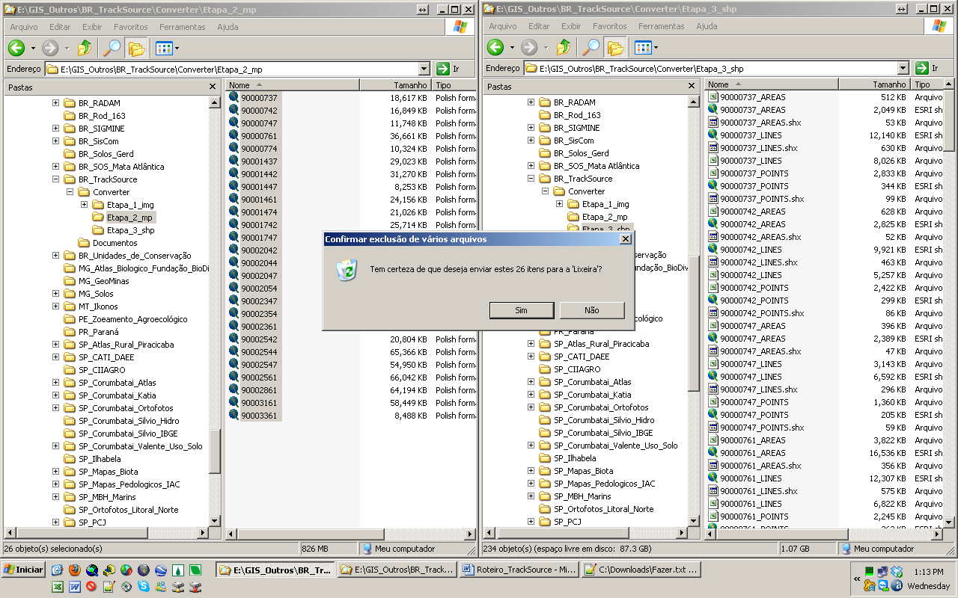

7. No ArcCatalog, aplicar o Script:
Ajustar os paths do workspace

## Code ArcGIS

workspace E:\GIS_Outros\BR_TrackSource\Converter\Etapa_3_shp
CreateFolder_management %workspace% Pass_1_Select
CreateFolder_management %workspace% Pass_2_Project
CreateFolder_management %workspace% Pass_3_Final
Select * %workspace%\Pass_1_Select\_%input% '"DataLevel" = 0'

workspace E:\GIS_Outros\BR_TrackSource\Converter\Etapa_3_shp\Pass_1_Select

## Definindo Projeções
DefineProjection_management * GEOGCS['GCS_WGS_1984',DATUM['D_WGS_1984',SPHEROID['WGS_1984',6378137.0,298.257223563]],PRIMEM['Greenwich',0.0],UNIT['Degree',0.0174532925199433]]

## Projetando Arquivos
Project_management * ..\Pass_2_Project\shp%input% GEOGCS['GCS_South_American_1969',DATUM['D_South_American_1969',SPHEROID['GRS_1967_Truncated',6378160.0,298.25]],PRIMEM['Greenwich',0.0],UNIT['Degree',0.0174532925199433]] SAD_1969_To_WGS_1984_14 GEOGCS['GCS_WGS_1984',DATUM['D_WGS_1984',SPHEROID['WGS_1984',6378137.0,298.257223563]],PRIMEM['Greenwich',0.0],UNIT['Degree',0.0174532925199433]]

## Criando Geodatabase
CreatePersonalGDB_management ..\Pass_3_Final\ Geo_TrackSource
CreateFeatureDataset_management ..\Pass_3_Final\Geo_TrackSource.mdb Individuais GEOGCS['GCS_South_American_1969',DATUM['D_South_American_1969',SPHEROID['GRS_1967_Truncated',6378160.0,298.25]],PRIMEM['Greenwich',0.0],UNIT['Degree',0.0174532925199433]];IsHighPrecision
CreateFeatureDataset_management ..\Pass_3_Final\Geo_TrackSource.mdb TrackSource GEOGCS['GCS_South_American_1969',DATUM['D_South_American_1969',SPHEROID['GRS_1967_Truncated',6378160.0,298.25]],PRIMEM['Greenwich',0.0],UNIT['Degree',0.0174532925199433]];IsHighPrecision

workspace E:\GIS_Outros\BR_TrackSource\Converter\Etapa_3_shp\Pass_2_Project
CopyFeatures_management * ..\Pass_3_Final\Geo_TrackSource.mdb\Individuais\%input% # 0 0 0

## Merge
## Deletar o que não presta, manualmente.

workspace

8. ArcCatalog
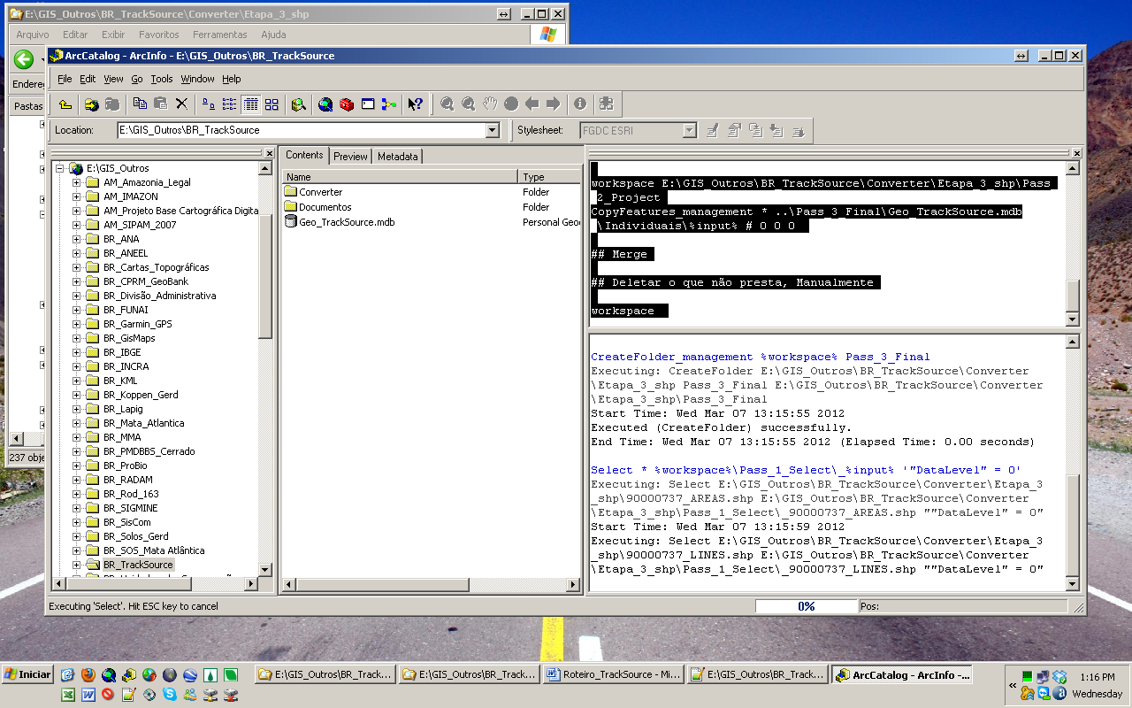

9. Deletar lixos
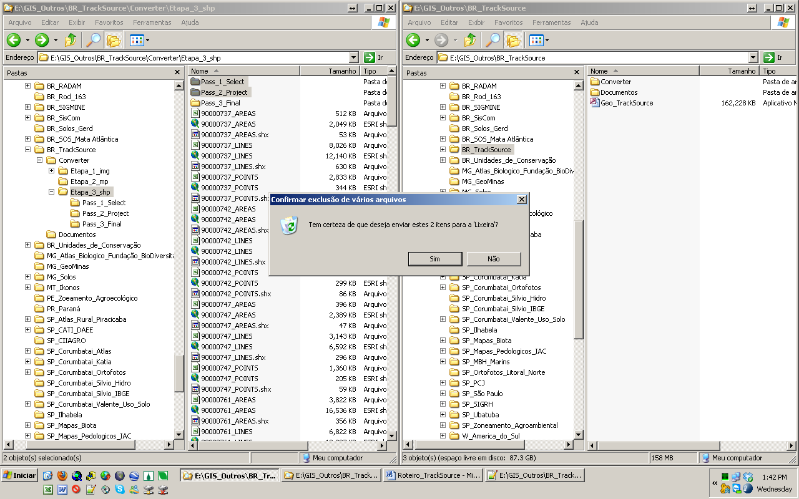

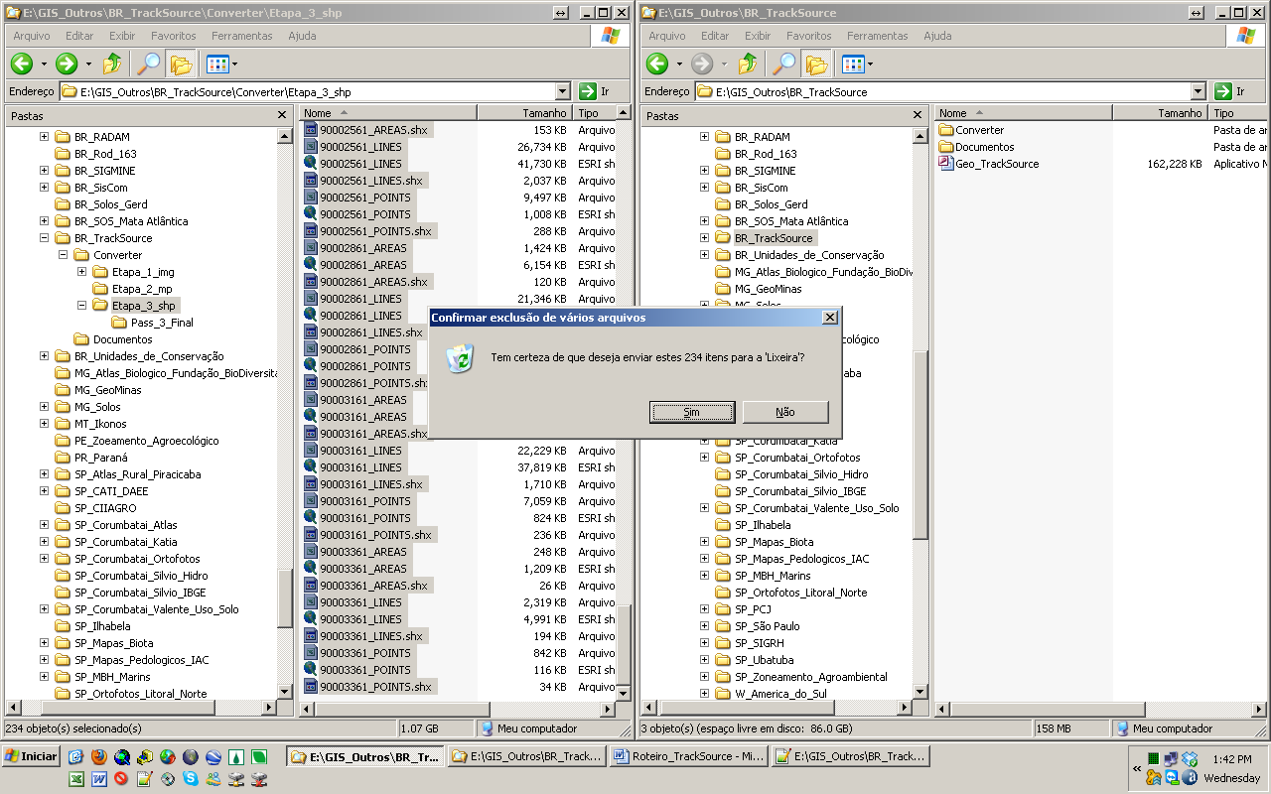

10. Mover o que interessa
