mbFXWords Version 1.4 Manual 20.11.2018

Content
1 General 1
2 Installation 1
3 Quick Guide 2
4 Windows 2
4.1 Main 2
4.2 Main table of main window 3
4.3 Word Count 3
4.4 Sentence Display 4
4.5 Settings 5
4.6 Credits 6

General
Analyze the content of a text. Diagonal reading with subject, predicate and object. Search for similar pdf or plain text content using Bing search.
Supports English, French and German text and pdf files.
Portable application. Runs under Windows and Linux. JavaFX application.
Open source: Apache License Version 2.0
Part of speech tagging builds upon Apache OpenNLP.
NLP (Natural Language Processing) extensions:
- Divide sentences in sub clauses: segmentation.
- Divide plain text: subject, predicate, object.
- Count words: stemming.
- Search for similar content: pdf's.
Download Wiki Javadoc GitHub
Brought to you by
open-hopin
Buelow Sensalgo

Installation
Unzip to destination folder. Open mbFXWords.exe for Windows or mbFXWords.sh for Linux.
Make sure JRE 1.8 or higher is installed on your machine. (Java Runtime Environment)
Command line optionally accepts file to be analyzed with relative or absolute path.
Example files to be analyzed can be found in sub directory “resources”.
mbFXWords can be used for pdf displayed in an Internet browser. For Firefox integration install mbFXWords to Firefox installation directory. Firefox must be able to display pdf on a tab. Then download and open with mbFXWords from there.

Quick Guide
For a first impression simply click Analyze (text “resources/default.txt”). Choose a different file by button Choose. A selection of content clauses (subject, predicate and object) you find in the middle of main window, a content’s abstract at the top and most common words at the bottom.

Windows

Main
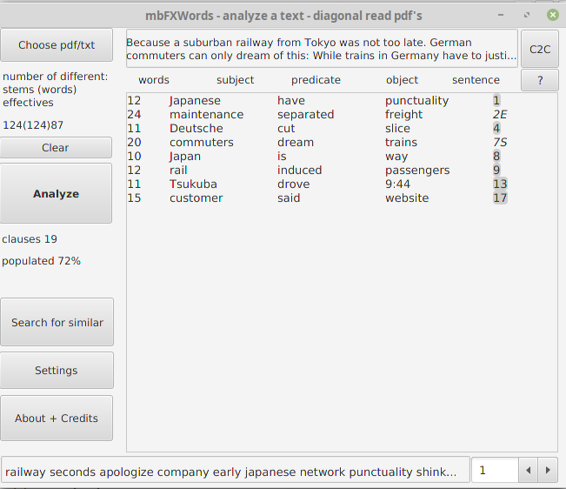
turn pages of
main table
main table
abstract
action
open different
file
Bing search in browser
total number of clauses in the text
part of subjects, predicates and objects known by program
manual
most common words in respective order
copy abstract
to clipboard
see explanation under ‚word count‘

Main table of main window
Division of complete text in sub clauses.
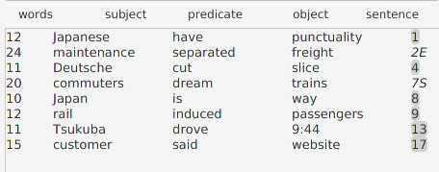
sub clause no. 4,
consecutive numbering,
link to complete sentence
predicate,
link to word count
12 words form the first clause

Word Count
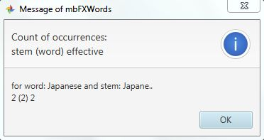
The word “Japanese” in this inflected form occurs two times in complete text. This is the number in braces.
The stem is the word with last two letters substituted by points, so words that differ in last two letters have the same stem. In complete text stem occurs 2 times. This is the first number.
If words can differ in length by two letters and it does not matter wich letter a point in the stem stands for, we have the number of occurrences of such words as indicated by last number.

Sentence Display
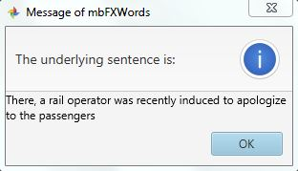

Settings
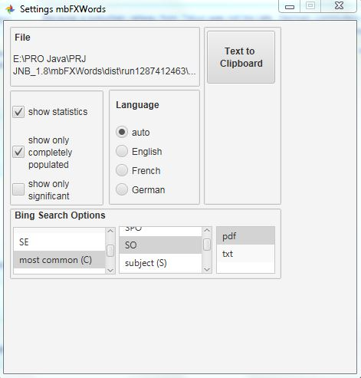
language auto detection
or preselect to save
execution time
current file‘s location
copy file‘s complete
plain text to clipboard
in main
window
in main table
of main window
(subject, predicate,
object),
deselect both to show
all clauses.
Search in browser for pdf or txt (select on the right) file with similar content to loaded file according to following options:

(select on the left) (select in the middle)

CSE – common, significant and extraordinary SPO – search for subject, predicate and object
CS – common and significant SO – search for subject and object
SE – significant and extraordinary subject (S) – only this
most common (C) – only this predicate (P) – only this
significant (S) – only this object (O) – only this
extraordinary (E) – only this

All columns form a combined search string, for example for the predicate that is most common in a pdf file.

Credits
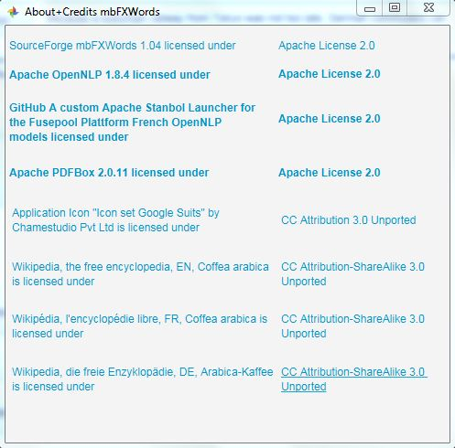
Used modules are part of main application and its source libs. No extra installation necessary.

