INTERNATIONAL TELECOMMUNICATION UNION

ITU-T | M.3108.1
TELECOMMUNICATION  STANDARDIZATION SECTOR  OF ITU | (03/99)

SERIES M: TMN AND NETWORK MAINTENANCE: INTERNATIONAL TRANSMISSION SYSTEMS, TELEPHONE CIRCUITS, TELEGRAPHY, FACSIMILE AND LEASED CIRCUITS
Telecommunications management network

Information model for management of leased circuit and reconfigurable services

ITU-T Recommendation M.3108.1
(Previously CCITT Recommendation)

ITU-T M-SERIES RECOMMENDATIONS
TMN AND NETWORK MAINTENANCE: INTERNATIONAL TRANSMISSION SYSTEMS, TELEPHONE CIRCUITS, TELEGRAPHY, FACSIMILE AND LEASED CIRCUITS
For further details, please refer to ITU-T List of Recommendations.
Introduction and general principles of maintenance and maintenance organization | M.10–M.299
International transmission systems | M.300–M.559
International telephone circuits | M.560–M.759
Common channel signalling systems | M.760–M.799
International telegraph systems and phototelegraph transmission | M.800–M.899
International leased group and supergroup links | M.900–M.999
International leased circuits | M.1000–M.1099
Mobile telecommunication systems and services | M.1100–M.1199
International public telephone network | M.1200–M.1299
International data transmission systems | M.1300–M.1399
Designations and information exchange | M.1400–M.1999
International transport network | M.2000–M.2999
Telecommunications management network | M.3000–M.3599
Integrated services digital networks | M.3600–M.3999
Common channel signalling systems | M.4000–M.4999
ITU-T RECOMMENDATION M.3108.1

INFORMATION MODEL FOR MANAGEMENT OF LEASED CIRCUIT
AND RECONFIGURABLE SERVICES

Summary
This Recommendation provides a GDMO-based information model to support the management of the leased circuit service as outlined in Recommendation M.3208.1. Appendix I provides a protocol-independent version of this information model in "structured" English. Appendix II provides a mapping from the management functions in Recommendation M.3208.1 to the Managed Objects defined in this Recommendation. Appendix III provides a Unified Modelling Language (UML) view of the same information model.

Source
ITU-T Recommendation M.3108.1 was prepared by ITU-T Study Group 4 (1997-2000) and was approved under the WTSC Resolution No. 1 procedure on the 26th of March 1999.

FOREWORD
ITU (International Telecommunication Union) is the United Nations Specialized Agency in the field of telecommunications. The ITU Telecommunication Standardization Sector (ITU-T) is a permanent organ of the ITU. The ITU-T is responsible for studying technical, operating and tariff questions and issuing Recommendations on them with a view to standardizing telecommunications on a worldwide basis.
The World Telecommunication Standardization Conference (WTSC), which meets every four years, establishes the topics for study by the ITU-T Study Groups which, in their turn, produce Recommendations on these topics.
The approval of Recommendations by the Members of the ITU-T is covered by the procedure laid down in WTSC Resolution No. 1.
In some areas of information technology which fall within ITU-T’s purview, the necessary standards are prepared on a collaborative basis with ISO and IEC.

NOTE
In this Recommendation the term recognized operating agency (ROA) includes any individual, company, corporation or governmental organization that operates a public correspondence service. The terms Administration, ROA and public correspondence are defined in the Constitution of the ITU (Geneva, 1992).

INTELLECTUAL PROPERTY RIGHTS
The ITU draws attention to the possibility that the practice or implementation of this Recommendation may involve the use of a claimed Intellectual Property Right. The ITU takes no position concerning the evidence, validity or applicability of claimed Intellectual Property Rights, whether asserted by ITU members or others outside of the Recommendation development process.
As of the date of approval of this Recommendation, the ITU had not received notice of intellectual property, protected by patents, which may be required to implement this Recommendation. However, implementors are cautioned that this may not represent the latest information and are therefore strongly urged to consult the TSB patent database.

© ITU 1999
All rights reserved. No part of this publication may be reproduced or utilized in any form or by any means, electronic or mechanical, including photocopying and microfilm, without permission in writing from the ITU.
CONTENTS
Page
1 Scope, purpose and application 1
1.1 Scope 1
1.2 Purpose 1
1.3 Application 1
2 References 1
3 Definitions 2
4 Abbreviations 2
5 Overview 3
5.1 Generic service request fragment 5
5.2 LCS service request fragment 5
5.3 Link connection service request fragment 5
5.4 Transport service fragment 6
5.5 Resource fragment 6
6 Information model 8
6.1 Managed objects for generic service request fragment 8
6.1.1 currentServiceRequest 8
6.1.2 serviceRequestHistoryRecord 10
6.1.3 serviceModifyRequest 10
6.2 Managed objects for LCS request fragment 11
6.2.1 currentLcsRequest 11
6.2.2 lcsRequestHistoryRecord 11
6.2.3 lcsModifyRequest 12
6.3 Managed objects for link connection service request fragment 12
6.3.1 currentLinkConnectionServiceRequest 12
6.3.2 linkConnectionServiceRequestHistoryRecord 13
6.3.3 linkConnectionServiceModifyRequest 13
6.4 Managed objects for service fragment 13
6.4.1 Transport service 13
6.4.2 lcs 14
6.4.3 linkConnectionService 15
6.4.4 Service Access Domain 15
6.4.5 Service Access Group 16
6.5 Managed objects for resource fragment 16
6.5.1 Service Access Equipment 16
Page
6.6 Packages 17
6.6.1 aliasNameInfoPackage 17
6.6.2 aliasNamePackage 17
6.6.3 bandwidthInfoPackage 17
6.6.4 bandwidthPackage 17
6.6.5 customerRequestNumberPackage 17
6.6.6 dateOfInstallationPackage 17
6.6.7 dailySchedulingInfoPackage 18
6.6.8 dailySchedulingCurrentPackage 18
6.6.9 diversityInfoPackage 18
6.6.10 diversityPackage 18
6.6.11 equipmentManufacturerPackage 18
6.6.12 equipmentTypePackage 18
6.6.13 expectedDateOfInstallationInfoPackage 18
6.6.14 expectedDateOfInstallationPackage 19
6.6.15 externalSchedulerCurrentPackage 19
6.6.16 externalSchedulerInfoPackage 19
6.6.17 initialServiceAdministrativeStateInfoPackage 19
6.6.18 initialServiceAdministrativeStatePackage 19
6.6.19 modelTypePackage 19
6.6.20 originatingLocationCPEInfoPackage 19
6.6.21 originatingLocationCPEModifyPackage 19
6.6.22 originatingLocationCPEPackage 20
6.6.23 originatingLocationCPInfoPackage 20
6.6.24 originatingLocationInfoPackage 20
6.6.25 originatingLocationSapInfoPackage 20
6.6.26 originatingLocationSapPackage 20
6.6.27 procedurePackage 20
6.6.28 quantityInfoPackage 20
6.6.29 quantityPackage 20
6.6.30 reflectiveOperationalStatePackage 21
6.6.31 reflectiveAdministrativeStatePackage 21
6.6.32 routeInfoPackage 21
6.6.33 routePackage 21
6.6.34 serviceAdministrativeStatePackage 21
6.6.35 serviceAvailabilityDateInfoPackage 21
6.6.36 serviceAvailabilityDatePackage 21
6.6.37 serviceCustomerContactPackage 22
6.6.38 serviceDescriptionInfoPackage 22
Page
6.6.39 serviceDescriptionPackage 22
6.6.40 serviceProviderContactPackage 22
6.6.41 serviceTerminationDateInfoPackage 22
6.6.42 serviceTerminationDatePackage 22
6.6.43 serviceTypeInfoPackage 22
6.6.44 terminatingLocationCPEInfoPackage 23
6.6.45 terminatingLocationCPEModifyPackage 23
6.6.46 terminatingLocationCPEPackage 23
6.6.47 terminatingLocationCPInfoPackage 23
6.6.48 terminatingLocationInfoPackage 23
6.6.49 terminatingLocationSapInfoPackage 23
6.6.50 terminatingLocationSapPackage 23
6.6.51 weeklySchedulingInfoPackage 23
6.6.52 weeklySchedulingCurrentPackage 24
6.7 Attributes 24
6.7.1 aliasName 24
6.7.2 bandwidth 24
6.7.3 cp 24
6.7.4 customerRequestNumber 24
6.7.5 dateOfInstallation 25
6.7.6 diversity 25
6.7.7 equipmentManufacturer 25
6.7.8 equipmentType 25
6.7.9 expectedDateOfInstallation 25
6.7.10 listOfSags 25
6.7.11 listOfSaps 26
6.7.12 modelType 26
6.7.13 numberOfUnspecifiedSaps 26
6.7.14 originatingLocation 26
6.7.15 originatingLocationCP 26
6.7.16 originatingLocationCPE 26
6.7.17 originatingLocationSap 27
6.7.18 procedure 27
6.7.19 providerRequestNumber 27
6.7.20 quantity 27
6.7.21 requestedInitialServiceAdministrativeState 27
6.7.22 requestReceptionTime 28
6.7.23 requestSequenceNumber 28
6.7.24 route 28
Page
6.7.25 sadId 28
6.7.26 sagId 28
6.7.27 sagLocation 29
6.7.28 serviceAvailabilityDate 29
6.7.29 serviceCustomerContact 29
6.7.30 serviceInstance 29
6.7.31 serviceProviderContact 29
6.7.32 serviceRequestState 29
6.7.33 serviceTerminationDate 30
6.7.34 terminatingLocation 30
6.7.35 terminatingLocationCP 30
6.7.36 terminatingLocationCPE 30
6.7.37 terminatingLocationSap 30
6.8 Error messages 31
6.8.1 addToSagError 31
6.8.2 bandwidthUnavailable 31
6.8.3 CreateLCSError 31
6.8.4 createLinkConnectionError 31
6.8.5 createSadError 31
6.8.6 createSagError 31
6.8.7 deleteLCSError 32
6.8.8 deleteLinkConnectionError 32
6.8.9 deleteSadError 32
6.8.10 deleteSagError 32
6.8.11 modifyLCSError 32
6.8.12 removeFromSagError 32
6.8.13 resourcesUnavailable 33
6.9 Notifications 33
6.9.1 lcsModifyProgressProblemReport 33
6.9.2 lcsRequestProgressProblemReport 33
6.9.3 linkConnectionModifyProgressProblemReport 33
6.9.4 linkConnectionRequestProgressProblemReport 33
6.10 Actions 34
6.10.1 updateServiceRequest 34
6.10.2 AddSapsToSag 34
6.11 Name bindings 34
6.11.1 currentLcsRequest-account 34
6.11.2 lcsRequestHistoryRecord-currentLCSRequest 34
Page
6.11.3 lcsModifyRequest-lcs 35
6.11.4 currentLinkConnectionServiceRequest-account 35
6.11.5 linkConnectionServiceRequestHistoryRecord-currentLinkConnectionServiceRequest 35
6.11.6 linkConnectionServiceModifyRequest-linkConnectionService 35
6.11.7 serviceAccessEquipmentView-account 35
6.11.8 linkConnectionService-account 36
6.11.9 lcs-account 36
6.11.10 serviceAccessDomain-account 36
6.11.11 serviceAccessGroup-serviceAccessDomain 36
6.12 ASN.1 syntax 37
6.12.1 Rules of extensibility 37
6.12.2 ASN.1 module 37
7 Functional units 44
7.1 Basic transport service functional unit 45
7.2 Transport service order functional unit 45
7.3 Transport service order history functional unit 45
7.4 Transport service modify functional unit 45
7.5 Transport resource visibility functional unit 45
7.6 Negotiation of functional units 45
8 Conformance 46
8.1 Static conformance 46
8.2 Dynamic conformance 46
8.3 Conformance to managed object definitions 46
Appendix I – Protocol-independent object description 47
I.1 Generic service request fragment 48
I.1.1 currentServiceRequest 48
I.1.2 serviceRequestHistoryRecord 50
I.1.3 serviceModifyRequest 52
I.2 LCS request fragment 53
I.2.1 currentLcsRequest 53
I.2.2 lcsRequestHistoryRecord 55
I.2.3 lcsModifyRequestRecord 55
Page
I.3 Link connection service request fragment 56
I.3.1 currentLinkConnectionServiceRequest 56
I.3.2 linkConnectionServiceRequestHistoryRecord 58
I.3.3 linkConnectionServiceModifyRequest 58
I.4 Service fragment 59
I.4.1 transportService 59
I.4.2 lcs 60
I.4.3 linkConnectionService 61
I.5 Reconfigurable service fragment 62
I.5.1 serviceAccessDomain 62
I.5.2 serviceAccessGroup 63
I.6 Resource fragment 64
I.6.1 serviceAccessEquipment 64
Appendix II – Mapping of M.3208.1 functions into M.3108.1 MOs 65
Appendix III – UML diagrams for leased circuit service object model 68
III.1 Introduction 68
III.2 UML class diagrams for inheritance of M.3208.1 object classes 68
III.3 UML class diagrams for modelling relationships 70
III.4 UML class diagrams for modelling agent functionality 72
III.5 UML sequence diagrams to illustrate scenarios of object usage 73
Recommendation M.3108.1
INFORMATION MODEL FOR MANAGEMENT OF LEASED CIRCUIT
AND RECONFIGURABLE SERVICES
(Geneva, 1999)

1 Scope, purpose and application

1.1 Scope
This Recommendation provides a GDMO-based information model to support the management of the leased circuit service as outlined in Recommendation M.3208.1. Appendix I provides a protocol-independent version of this information model in "structured" English. Appendix II provides a mapping from the management functions in Recommendation M.3208.1 to the managed objects defined in this Recommendation. Appendix III provides a Unified Modelling Language (UML) view of the same information model.

1.2 Purpose
The purpose of this Recommendation is to support standard interfaces, across the X interface, among service customers, service providers and network providers for the purposes of managing leased circuit services in the service management layer of the TMN. It specifically intended to support the requirements provided in Recommendation M.3208.1.

1.3 Application
This Recommendation is applicable to interfaces between systems that participate in the ordering and management of leased circuit services.

2 References
The following ITU-T Recommendations and other references contain provisions which, through reference in this text, constitute provisions of this Recommendation. At the time of publication, the editions indicated were valid. All Recommendations and other references are subject to revision; all users of this Recommendation are therefore encouraged to investigate the possibility of applying the most recent edition of the Recommendations and other references listed below. A list of the currently valid ITU-T Recommendations is regularly published.
– ITU-T Recommendation G.805 (1995), Generic functional architecture of transport networks.
– ITU-T Recommendation M.3010 (1996), Principles for a telecommunications management network.
– ITU-T Recommendation M.3100 (1995), Generic network information model.
– ITU-T Recommendation M.3200 (1997), TMN management services and telecommunications managed areas: Overview.
– ITU-T Recommendation M.3208.1 (1997), TMN management services for dedicated and reconfigurable circuits network: Leased circuit services.
– ITU-T Recommendation M.3400 (1997), TMN management functions.
– ITU-T Recommendation Q.821 (1993), Stage 2 and stage 3 description for the Q3 interface – Alarm surveillance.
– CCITT Recommendation X.721 (1992) | ISO/IEC 10165-2:1992, Information technology – Open Systems Interconnection – Structure of management information: Definition of management information.
– CCITT Recommendation X.734 (1992) | ISO/IEC 10164-5:1993, Information technology – Open Systems Interconnection – Systems management: Event report management function.
– CCITT Recommendation X.735 (1992) | ISO/IEC 10164-6:1993, Information technology – Open Systems Interconnection – Systems management: Log control function.
– ITU-T Recommendation X.746 (1995) | ISO/IEC 10164-15:1995, Information technology – Open Systems Interconnection – Systems management: Scheduling function.
– ITU-T Recommendation X.790 (1995), Trouble management function for ITU-T applications.

3 Definitions
This Recommendation uses the definitions provided in Recommendation M.3208.1.

4 Abbreviations
This Recommendation uses the following abbreviations:
AP Access Point
ATM Asynchronous Transfer Mode
CP Connection Point
CPE Customer Premises Equipment
GDMS Guidelines for the Definition of TMN Management Services
LC Link Connection
LCS Leased Circuit Service
MS Management Services
NML Network level Management Layer
PDH Plesiochronous Digital Hierarchy
SAD Service Access Domain
SAG Service Access Group
SC Service Customer
SDH Synchronous Digital Hierarchy
SML Service level Management Layer
SN Service Node
SNC Sub-Network Connection
SP Service Provider
TCP Termination Connection Point
TMN Telecommunications Management Network
UML Unified Modelling Language

5 Overview
This clause provides an overview of the information model and its use in the management of LCS. Clause 6 provides the formal definition of the GDMO-based information model.
The information model consists of five fragments:
• Generic service request – contains generic MOs to be used for subclassing MOs in support of specific services.
• LCS service request – supports the service request process for LCS.
• Link connection service request – supports the service request process for link connection service.
• Transport service – represents transport services, supports SC's management of provisioned services.
• Resources – represents resources used for the provisioning of LCS and link connection service.
The first four are defined in this Recommendation. The fifth also includes information elements defined in other Recommendations, such as Recommendations M.3100 and G.855.1.
The management of a LCS or a link connection service starts when a Service Customer (SC) requests the service. This can be achieved by the SC creating an instance of a subclass of transportService MO, or the SC creates an instance of a subclass of currentServiceRequest MO. More specifically, the created object is an instance of one of the following MO classes:
• lcs;
• linkConnectionService;
• currentLcsRequest;
• currentLinkConnectionService.
The first two bullets above correspond to instant service provisioning, without going through the service request process. The last two bullets above correspond to the case where the SC's request goes through the service request process.
The request must satisfy the terms of the Service Level Agreement (SLA) between the SC and the SP.
The following scenario applies when the request proceeds through the service request process. The Service Provider (SP), assuming the Agent role, creates an instance of a (subclass of) currentServiceRequest MO. Upon creation of this MO instance the SP fills in the values of some of the attributes, as specified in Recommendation M.3208.1 (e.g. the actual due date for the service). The SP then sends a create reply regarding that creation to the SC, assuming the Manager role. The create reply includes the values of the attributes that must be communicated by the SP to the SC in response to the service request, as per Recommendation M.3208.1. If the SC has created an instance of a (subclass of) currentServiceRequest MO, then the SC can update the request through the updateServiceRequest action, e.g. the SC may request a change to the date when the service is desired, or a different route. The SC may also cancel the initial request by deleting the currentServiceRequest. The (subclasses of) currentServiceRequest represent the current view of the service request. In order to keep track of the modifications issued by the SC, the SP may create (subject to SLA) instances of (a subclass of) serviceRequestHistoryRecord that represent the values
of the attributes requested to be modified by specific updateServiceRequest action. The first instance of serviceRequestHistoryRecord created for a specific service request represents the values of the attributes of the initial service request. The values of the currentServiceRequest may be different from the values requested by the SC due to changes made by the SP (and reported to the SC).
After the requested LCS or link connection service has been implemented by the SP, the SP instantiates an instance of the lcs or linkConnectionService MO. Both are subclasses of the transportService MO. More specifically, the SP creates an instance of one of the following MO classes:
• linkConnectionService;
• lcs.
The SP then informs the SC of the availability of the requested service through a notification of the creation of an instance of a MO representing that service.
In some cases the SP may provide the requested service instantaneously, even though formally it goes through the service request process. In this case the SP will send the SC three consecutive notifications: for the creation of a service create request record, for the deletion of the just created service create request record, and for the creation of the requested service. In this case the service create request record is purely transient and the SC does not interact with it. This scenario applies when the SC initiates the request through the service request process. If the SP represents to provide requested LCS or link connection service instantaneously, then another scenario is also possible: the SC skips the service request process and requests the service by issuing a "create an instance of" (a subclass of) transportService.
After the SC has been notified about the creation of that MO (a subclass of transportService), the SC can modify the service through management operations for some attributes. For other attributes the modification is done by creating an instance of the modifyRequestRecord MO class, referring to the lcs or linkConnectionService MO instance. The SP may choose to require that an instance of serviceModifyRequest MO be created every time the SC wishes to make changes to any attributes of the service.
An instance of a (subclass of) transportService MO class may refer to instances of serviceAccessEquipmentView MO classes (representing CPE) and/or instances of MO classes corresponding to topological elements such as link, connection point and subnetwork.
An instance of the networkR1 MO is used for naming. All entries in that MO instance can be changed only by the SP, though the SC can read (GET) such information.
An instance of the account MO class (imported from Recommendation X.790) contains information regarding the SC, such as the SC's contact information. In general, only the SC can set information in the account MO. The account MO is contained in the network MO (imported from Recommendation M.3100).
The SC can create an instance of a serviceAccessDomain MO class. A serviceAccessDomain contains zero or more serviceAccessGroups, though a serviceAccessDomain containing less than two serviceAccessGroups is not very useful. The SC can create instances of serviceAccessGroup MO class. A serviceAccessGroup MO contains zero or more SAPs. A serviceAccessGroup is created without any SAPs. After creation of a serviceAccessGroup, the SC can add or remove SAPs from the serviceAccessGroup. The SC can identify some or all of the SAPs desired in a serviceAccessGroup. If the SC adds to a serviceAccessGroup more SAPs than are explicitly identified, then the SP assigns additional SAPs, from the same service location to the serviceAccessGroup, and informs the SC about the identity of those SAPs. The SC can add or remove SAPs from a serviceAccessGroup through management operations. If the two SAPs corresponding to a LCS belong to
serviceAccessGroups that are members of the same serviceAccessDomain, then the LCS is a reconfigurable LCS. This is usually also reflected in the service name and service type of the LCS.

5.1 Generic service request fragment
The (generic) service request MOs are not instantiable. They are used as superclasses for service-specific, instantiable MOs. As such the generic MOs can be reused to define instantiable MOs for other services. The LCS and link connection service requests instantiable MOs are derived from the generic ones.
The generic service request fragment consists of MOs that support the request of a service as well as updates to service requests and modifications to existing services. It defines three generic, non-instantiable, classes:
• currentServiceRequest;
• serviceRequestHistoryRecord;
• serviceModifyRequest.
The currentServiceRequest represents the up-to-date values of the attributes describing the requested service. Those values may be different from those in the initial service request due to subsequent changes requested by the SC or introduced by the SP. Indeed, the SP may replace the values of some attributes (e.g. if the available bandwidth does not match the bandwidth requested by the SC). The SLA may specify that the service request history is kept through (subclasses of) serviceRequestHistoryRecord. Several instances of serviceRequestHistoryRecord may be created. The first instance of serviceRequestHistoryRecord represents the SC initial request for service. Subsequently created instances represent changes to the request submitted by the SC.
If there is a large number of updates, it may not be clear what the SC really wants. To this end the SP may create an instance of a currentServiceRequest MO class. This is a generic, non-instantiable class that represents the current information about what the SC wants. It is derived from serviceCreateRequestRecord, though the values of its attributes are updated (by the SP) whenever a new serviceUpdateRequestRecord is received. When this happens it sends an attribute value change notification to the SC, thus keeping the SC updated. The SC can inquire about the current information in the request by retrieving values of attributes of the currentServiceRequest.
After the requested service has been created, the SC can modify that service through management operations or by creating instances of (a subclass of) serviceModifyRequest MO class. As in the case of service request, the SC may issue management operations against the MO representing the service instead of creating new instances of serviceModifyRequest. In that case the SP may keep a log of the management operations issued by the SC to update attributes in the MO representing the service. (The mechanism for such storage is outside the scope of this Recommendation.)
Instantiable, service-specific MO classes are derived from the MOs in this fragment.

5.2 LCS service request fragment
The MO classes in this fragment consist of LCS-specific subclasses of the MO classes in the generic service request fragment.

5.3 Link connection service request fragment
The MO classes in this fragment consist of link connection service-specific subclasses of the MO classes in the generic service request fragment.

5.4 Transport service fragment
The transport service fragment contains a generic, non-instantiable MO transportService from which two instantiable MOs are derived: lcs and linkConnectionService.
This fragment further contains two objects representing serviceAccessGroup and serviceAccessDomain. Those instantiable objects allow the SC to manage the existing services through management operations directed at the corresponding objects. This is a plausible alternative to the management of existing services through the creation of serviceModifyRequestRecord MOs.

5.5 Resource fragment
The resource fragment contains two MOs that represent physical resources and which are needed in some aspects of LCS management: network, as defined in Recommendation M.3100, and serviceAccessEquipment, which is defined in this Recommendation. It further includes MOs that would be defined in support of elements in Recommendation G.805 corresponding to topological entities (link, connectionPoint, subNetwork). Those MOs allow the SP to offer the SC a more detailed view of how the service is provisioned.
Figures 5-1 and 5-2 represent the inheritance and containment relationships of the MOs respectively. Inheritance and containment are not shown for all the MOs that are imported from other Recommendations. Figure 5-2 does not show the containment of the M.3100 network MO in directory objects as specified in Recommendation M.3100.
This Recommendation defines six Functional Units (FUs):
• Service order;
• Service modify;
• Leased circuit service;
• Link connection service;
• Reconfigurable circuit service;
• Resource visibility.
These FUs cover the management functions defined in Recommendation M.3208.1. This Recommendation provides a mapping of the M.3208.1 functions into the FUs and specifies the MOs required for each of the FUs.
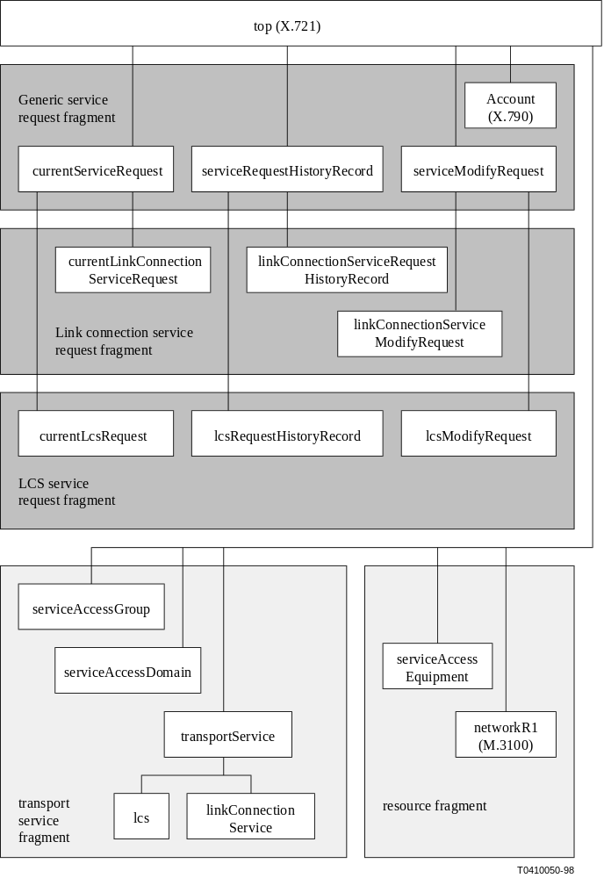
Figure 5-1/M.3108.1 – Inheritance
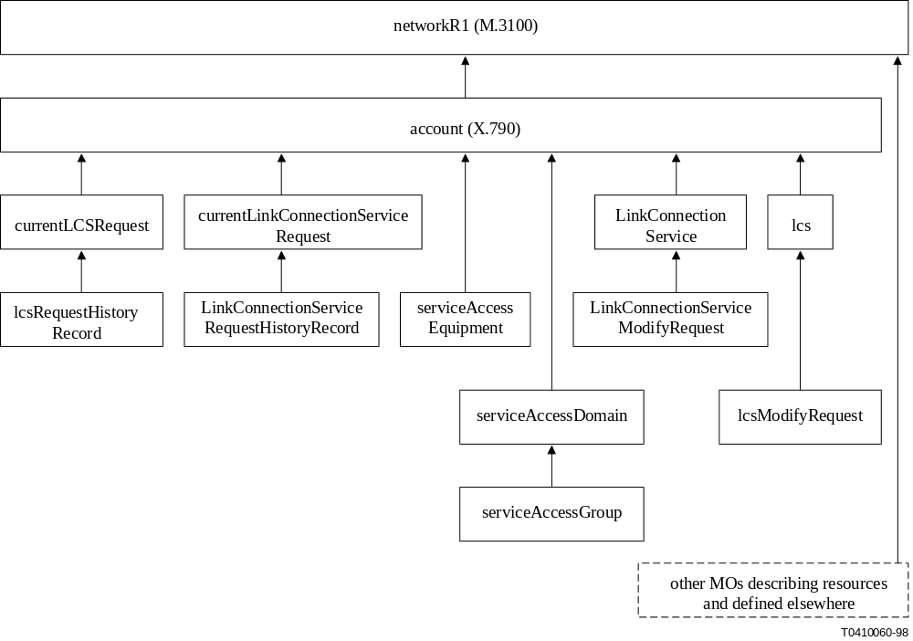
Figure 5-2/M.3108.1 – Containment

6 Information model
This clause provides the information model for the management of LCS using GDMO.
The objects are grouped by fragment.

6.1 Managed objects for generic service request fragment

6.1.1 currentServiceRequest

currentServiceRequest MANAGED OBJECT CLASS
DERIVED FROM "Rec. X.721|ISO/IEC 10165-2:1992":top;
CHARACTERIZED BY
serviceRequestPackage PACKAGE
BEHAVIOUR
currentServiceRequestBehaviour BEHAVIOUR
DEFINED AS
"The currentServiceRequest MO class represents information elements that are common to all service requests and captures the current value of a service request. It is a superclass from which service-specific subclasses can be defined.
This MO represents the current view of the values of the service request that the SP will process on behalf of the SC. They may be different from the values requested by the SC due to the availability or lack thereof of SP's resources.
The updateServiceRequest action can be used by the service customer to modify the service request following creation of this object class (or subclasses). The following attributes specified in this object class can be modified by the updateServiceRequest action:
– serviceCustomer contact;
– serviceAvailabilityDate;
– serviceTerminationDate;
– initialServiceAdministrativeState;
– aliasName;
– intervalsOfDay;
– weekMask.
Subclasses of this object class can specify additional attributes that can be modified by the updateServiceRequest action.
It is the responsibility of the SC to check the values of the attributes in the create notification and attribute value change notification emitted by this MO. If the values of any attributes in the notifications are different from those supplied by the SC, and if they are unacceptable to the SC, then the SC may cancel the service request by deleting this object.
If the history of the requested values is to be kept by the SP, then a serviceRequestHistoryRecord is created when the service customer issues an updateServiceRequest action towards a currentServiceRequest (and subclasses); the serviceRequestHistoryRecord contains a record of the attribute values specified in the request. The SP also creates a serviceRequestHistoryRecord of the initial service request values (when the SC creates the currentServiceRequest).";;
ATTRIBUTES
providerRequestNumber GET, -- used as naming attribute
requestSequenceNumber GET,
requestReceptionTime GET,
"Rec. X.790":serviceType GET SET-BY-CREATE,
serviceProviderContact GET,
serviceCustomerContact GET SET-BY-CREATE,
serviceAvailabilityDate GET SET-BY-CREATE,
serviceTerminationDate GET SET-BY-CREATE,
serviceRequestState GET;
-- this attribute represents the service request state
-- defined in Rec. M.3208.1 and behaves according to the
-- state model
ACTIONS
updateServiceRequest;
NOTIFICATIONS
"Rec.X.721 | ISO/IEC 10165-2:1992": attributeValueChange,
"Rec.X.721 | ISO/IEC 10165-2:1992": objectDeletion;;;
CONDITIONAL PACKAGES
initialServiceAdministrativeStatePackage PRESENT IF "SLA supports it",
serviceDescriptionPackage PRESENT IF "SLA supports it",
-- represents the service class in Rec. M.3208.1
customerRequestNumberPackage PRESENT IF "SC provides it",
aliasNamePackage PRESENT IF "SLA supports it",
"Rec. X.721":availabilityStatus PRESENT IF "Any scheduling (daily, weekly, external) is present",
dailySchedulingCurrentPackage
PRESENT IF "both the weekly scheduling current package and external scheduler current packages are not present and daily scheduling is supported for the requested service",
weeklySchedulingCurrentPackage
PRESENT IF "both the daily scheduling current package and external scheduler current packages are not present and weekly scheduling is supported for the requested service",
externalSchedulerCurrentPackage
PRESENT IF "both the daily scheduling current package and weekly scheduling current packages are not present and external scheduling is supported for the requested service";
REGISTERED AS {m3108Part1ObjectClass 1};

6.1.2 serviceRequestHistoryRecord

serviceRequestHistoryRecord MANAGED OBJECT CLASS
DERIVED FROM "Rec. X.721 | ISO/IEC 10165-2:1992":top;
CHARACTERIZED BY
serviceRequestHistoryRecordPackage PACKAGE
BEHAVIOUR
serviceRequestRecordBehaviour BEHAVIOUR
DEFINED AS
"This MO represents a history record of the content of a service (update) request by the SC to a service request. The serviceRequestHistoryRecord is created when the service customer issues an updateServiceRequest action towards a currentServiceRequest (and subclasses) and contains a record of the attribute values specified in the request. The service provider also creates a serviceRequestHistoryRecord of the initial service request values (when the SC creates the currentServiceRequest).";;
ATTRIBUTES
requestSequenceNumber GET, -- used as naming attribute
requestReceptionTime GET;
NOTIFICATIONS
"Rec.X.721 | ISO/IEC 10165-2:1992": objectCreation,
"Rec.X.721 | ISO/IEC 10165-2:1992": objectDeletion;;;

CONDITIONAL PACKAGES
aliasNameInfoPackage PRESENT IF "part of the service (update) request",
dailySchedulingInfoPackage PRESENT IF "part of the service (update) request",
externalSchedulerInfoPackage PRESENT IF "part of the service (update) request",
initialServiceAdministrativeStateInfoPackage
PRESENT IF "part of the service (update) request",
serviceAvailabilityDateInfoPackage PRESENT IF "part of the service (update) request",
serviceCustomerContactPackage PRESENT IF "part of the service (update) request",
serviceDescriptionInfoPackage PRESENT IF "part of the service (update) request",
serviceTypeInfoPackage PRESENT IF "part of the service (update) request",
serviceTerminationDateInfoPackage PRESENT IF "part of the service (update) request",
weeklySchedulingInfoPackage PRESENT IF "part of the service (update) request";
REGISTERED AS {m3108Part1ObjectClass 2};

6.1.3 serviceModifyRequest

serviceModifyRequest MANAGED OBJECT CLASS
DERIVED FROM "Rec. X.721 | ISO/IEC 10165-2:1992":top;
CHARACTERIZED BY
serviceModifyRequestPackage PACKAGE
BEHAVIOUR
serviceModifyRequestBehaviour BEHAVIOUR
DEFINED AS "This MO represents SC's request to modify an existing service. It is a superclass from which service-specific subclasses are derived. When changes to the service occur as a result of such a modification request, or for any other reason, the MO representing the affected service (e.g. lcs or link connection service) will issue the appropriate attribute value change notifications. After all the modifications requested by the SC through this MO have been resolved, this MO instance will be deleted and a notification of its deletion shall be sent to the SC.";;
ATTRIBUTES
providerRequestNumber GET, -- used as naming attribute
serviceRequestState GET,
serviceInstance GET SET-BY-CREATE,
requestReceptionTime GET;
NOTIFICATIONS
"Rec.X.721 | ISO/IEC 10165-2:1992": objectDeletion,
"Rec.X.721 | ISO/IEC 10165-2:1992": objectCreation;;;
CONDITIONAL PACKAGES
aliasNamePackage
PRESENT IF "SLA supports it",
"Rec. X.721":availabilityStatus PRESENT IF "Any scheduling (daily, weekly, external) is present",
dailySchedulingCurrentPackage
PRESENT IF "both the weekly scheduling current package and external scheduler current packages are not present and daily scheduling is supported for the requested service",
externalSchedulerCurrentPackage
PRESENT IF "both the daily scheduling current package and weekly scheduling current packages are not present and external scheduling is supported for the requested service",
serviceCustomerContactPackage
PRESENT IF "SLA supports it",
weeklySchedulingCurrentPackage
PRESENT IF "both the daily scheduling current package and external scheduler current packages are not present and weekly scheduling is supported for the requested service";
REGISTERED AS {m3108Part1ObjectClass 3};

6.2 Managed objects for LCS request fragment

6.2.1 currentLcsRequest

currentLcsRequest MANAGED OBJECT CLASS
DERIVED FROM currentServiceRequest;
CHARACTERIZED BY
currentLcsRequestPackage PACKAGE
BEHAVIOUR
currentLcsRequestBehaviour BEHAVIOUR
DEFINED AS "This MO represents the LCS the SC currently wants, as per the SC's create service request and subsequent updates related to that create service request.";;
ATTRIBUTES
originatingLocation GET SET-BY-CREATE,
terminatingLocation GET SET-BY-CREATE;
ACTIONS
updateServiceRequest
bandwidthUnavailable
modifyLCSError
resourcesUnavailable;
NOTIFICATIONS
lcsRequestProgressProblemReport;;;
-- used to report problems in progressing the request.
-- changes in the value of the serviceRequestState are
-- reported using the attribute value change notification.
CONDITIONAL PACKAGES
quantityPackage PRESENT IF "SLA supports it",
bandwidthPackage PRESENT IF "SLA supports it",
diversityPackage PRESENT IF "SLA supports it",
routePackage PRESENT IF "SLA supports it",
originatingLocationCPEPackage PRESENT IF "SLA supports it",
terminatingLocationCPEPackage PRESENT IF "SLA supports it",
originatingLocationSapPackage PRESENT IF "SLA supports it",
terminatingLocationSapPackage PRESENT IF "SLA supports it";
REGISTERED AS {m3108Part1ObjectClass 4};

6.2.2 lcsRequestHistoryRecord

lcsRequestHistoryRecord MANAGED OBJECT CLASS
DERIVED FROM serviceRequestHistoryRecord;
CHARACTERIZED BY
lcsRequestHistoryRecordPackage PACKAGE
BEHAVIOUR
lcsRequestHistoryRecordBehaviour BEHAVIOUR
DEFINED AS "This MO represents a record of the attributes of a create or update request of a LCS.";;;;
CONDITIONAL PACKAGES
originatingLocationInfoPackage PRESENT IF "part of the service (update) request",
terminatingLocationInfoPackage PRESENT IF "part of the service (update) request",
quantityInfoPackage PRESENT IF "part of the service (update) request",
bandwidthInfoPackage PRESENT IF "part of the service (update) request",
diversityInfoPackage PRESENT IF "part of the service (update) request",
routeInfoPackage PRESENT IF "part of the service (update) request",
originatingLocationCPEInfoPackage PRESENT IF "part of the service (update) request",
terminatingLocationCPEInfoPackage PRESENT IF "part of the service (update) request",
originatingLocationSapInfoPackage PRESENT IF "part of the service (update) request",
terminatingLocationSapInfoPackage PRESENT IF "part of the service (update) request";
REGISTERED AS {m3108Part1ObjectClass 5};

6.2.3 lcsModifyRequest

lcsModifyRequest MANAGED OBJECT CLASS
DERIVED FROM serviceModifyRequest;
CHARACTERIZED BY
lcsModifyRequestPackage PACKAGE
BEHAVIOUR
lcsModifyRequestBehaviour BEHAVIOUR
DEFINED AS "This MO represents a request to modify an existing LCS service or a previuous modify against an LCS.";;
NOTIFICATIONS
lcsModifyProgressProblemReport;;;
-- used to report problems in progressing the request.
-- changes in the value of the serviceRequestState are
-- reported using the attribute value change notification.
CONDITIONAL PACKAGES
bandwidthPackage PRESENT IF "SLA supports it",
diversityPackage PRESENT IF "SLA supports it",
routePackage PRESENT IF "SLA supports it",
originatingLocationCPEPackage PRESENT IF "SLA supports it",
terminatingLocationCPEPackage PRESENT IF "SLA supports it";
REGISTERED AS {m3108Part1ObjectClass 6};

6.3 Managed objects for link connection service request fragment

6.3.1 currentLinkConnectionServiceRequest

currentLinkConnectionServiceRequest MANAGED OBJECT CLASS
DERIVED FROM currentServiceRequest;
CHARACTERIZED BY
currentLinkConnectionServiceRequestPackage PACKAGE
BEHAVIOUR
currentLinkConnectionServiceRequestBehaviour BEHAVIOUR
DEFINED AS "This instantiable MO represents a SC's request for a link connection service.
The following attributes specified by this object class (in addition to those inherited from currentServiceRequest) can be modified by the service customer using the updateServiceRequest action:
– bandwidth
– originatingLocationCP
– terminationLocationCP
The SC must provide either the Originating or Terminating Location Connection Point or both. If one of the points is at the customer premises, that point must be provided by the SC. If one of the points is in a network of a service provider other than the one receiving create request, it must be provided by the SC.";;
ATTRIBUTES
originatingLocationCP GET SET-BY-CREATE,
terminatingLocationCP GET SET-BY-CREATE;
ACTIONS
updateServiceRequest
bandwidthUnavailable -- specific action reply parameter values
resourcesUnavailable;
NOTIFICATIONS
linkConnectionRequestProgressProblemReport;;;
-- used to report problems in progressing the request.
-- changes in the value of the serviceRequestState are
-- reported using the attribute value change notification.
CONDITIONAL PACKAGES
bandwidthPackage PRESENT IF "SLA supports it";
REGISTERED AS {m3108Part1ObjectClass 7};

6.3.2 linkConnectionServiceRequestHistoryRecord

linkConnectionServiceRequestHistoryRecord MANAGED OBJECT CLASS
DERIVED FROM serviceRequestHistoryRecord;
CHARACTERIZED BY
linkConnectionServiceRequestHistoryRecordPackage PACKAGE
BEHAVIOUR
linkConnectionServiceRequestHistoryRecordBehaviour
BEHAVIOUR DEFINED AS "This MO represents a request to update either a previously issued request to create a link connection service, or a previous update against that link connection service request.";;;;
CONDITIONAL PACKAGES
bandwidthInfoPackage PRESENT IF "part of the service (update) request",
originatingLocationCPInfoPackage PRESENT IF "part of the service (update) request",
terminatingLocationCPInfoPackage PRESENT IF "part of the service (update) request";
REGISTERED AS {m3108Part1ObjectClass 8};

6.3.3 linkConnectionServiceModifyRequest

linkConnectionServiceModifyRequest MANAGED OBJECT CLASS
DERIVED FROM serviceModifyRequest;
CHARACTERIZED BY
linkConnectionServiceModifyRequestPackage PACKAGE
BEHAVIOUR
linkConnectionServiceModifyRequestBehaviour BEHAVIOUR
DEFINED AS "This MO represents a request to modify an existing link connection service or a previous modify against a link.";;
NOTIFICATIONS
linkConnectionModifyProgressProblemReport;;;
CONDITIONAL PACKAGES
bandwidthPackage PRESENT IF "SLA supports it";
REGISTERED AS {m3108Part1ObjectClass 9};

6.4 Managed objects for service fragment

6.4.1 Transport service

transportService MANAGED OBJECT CLASS
DERIVED FROM "Rec. X.721 | ISO/IEC 10165-2:1992":top;
CHARACTERIZED BY
"Rec. M.3100:1995":administrativeOperationalStatesPackage,
"Rec. M.3100:1995":stateChangeNotificationPackage,
"Rec. M.3100:1995":createDeleteNotificationsPackage,
"Rec. M.3100:1995":attributeValueChangeNotificationPackage,
transportServicePackage PACKAGE
BEHAVIOUR
transportServiceBehaviour BEHAVIOUR
DEFINED AS "This MO represents a transport service. This MO class cannot be instantiated; service-specific subclasses of this class can be instantiated. Values of attributes of subclasses of this MO class can be set through management operations or through the creation of an instance of a service-specific subclass of the serviceModifyRequest MO class. If an attribute is supported by the SLA, and it can be set by the SC, and the SC has not specified its value in the service request, then it shall have its default value when this MO is instantiated.";;
ATTRIBUTES
"Rec. X.790":serviceID GET SET-BY-CREATE,
-- represents the circuit ID or link connection ID specified in Rec. M.3208.1
-- the serviceID is used for naming
serviceTerminationDate GET-REPLACE,
bandwidth GET-REPLACE,
serviceProviderContact GET,
-- the value of this attribute is set at creation by the SP
-- this attribute points to an instance of X.790 contact MO
-- or it contains X.790 PersonReach information.
serviceCustomerContact GET-REPLACE;
-- this attribute points to an instance of X.790 contact MO
-- or it contains X.790 PersonReach information.
NOTIFICATIONS
"Rec. X.721 | ISO/IEC 10165-2": qualityOfServiceAlarm;;;
CONDITIONAL PACKAGES
aliasNamePackage PRESENT IF "SLA supports it",
serviceDescriptionPackage PRESENT IF "present in the service request",
-- represents the service class in Rec. M.3208.1
"Rec. X.721":availabilityStatus PRESENT IF "Any scheduling (daily, weekly, external) is present",
"Rec. X.721 | ISO/IEC 10165-2":dailyScheduling
PRESENT IF "present in the service request.",
"Rec. X.721 | ISO/IEC 10165-2":weeklyScheduling
PRESENT IF " present in the service request ",
"Rec. X.721 | ISO/IEC 10165-2":externalScheduler
PRESENT IF " present in the service request ";
REGISTERED AS {m3108Part1ObjectClass 10};

6.4.2 lcs

lcs MANAGED OBJECT CLASS
DERIVED FROM transportService;
CHARACTERIZED BY
lcsPackage PACKAGE
BEHAVIOUR
lcsBehaviour BEHAVIOUR
DEFINED AS "This instantiable MO represents a LCS. If the SLA allows the SC to specify the route and the SC did not specify the route in the service request, then the route attribute shall be present as an empty SEQUENCE. The route cannot be changed through a management operation on this MO. The route can be changed by the SC by creating an instance of the lcsModifyRequest MO class.";;
ATTRIBUTES
originatingLocationSap GET SET-BY-CREATE,
"Rec. X.790":serviceType GET SET-BY-CREATE,
-- represents the service name in Rec. M.3208.1
"Rec. X.790":serviceLocationList GET SET-BY-CREATE,
-- represents the originating and terminating
-- locations in Rec. M.3208.1
serviceAvailabilityDate GET SET-BY-CREATE,
terminatingLocationSap GET SET-BY-CREATE;;;
CONDITIONAL PACKAGES
diversityPackage PRESENT IF "present in the service request",
routePackage PRESENT IF "route was present in the service request",
originatingLocationCPEModifyPackage PRESENT IF "originatingLocationCPE was present in the service request",
terminatingLocationCPEModifyPackage PRESENT IF "terminatingLocationCPE was present in the service request";
REGISTERED AS {m3108Part1ObjectClass 11};

6.4.3 linkConnectionService

linkConnectionService MANAGED OBJECT CLASS
DERIVED FROM transportService;
CHARACTERIZED BY
linkConnectionServicePackage PACKAGE
BEHAVIOUR
linkConnectionServiceBehaviour BEHAVIOUR
DEFINED AS "This instantiable MO represents a link connection service.";;
ATTRIBUTES
originatingLocationCP GET SET-BY-CREATE,
"Rec. X.790":serviceType GET SET-BY-CREATE,
-- represents the service name in Rec. M.3208.1
"Rec. X.790":serviceLocationList GET SET-BY-CREATE,
-- represents the originating and terminating
-- locations in Rec. M.3208.1
serviceAvailabilityDate GET SET-BY-CREATE,
terminatingLocationCP GET SET-BY-CREATE;;;
REGISTERED AS {m3108Part1ObjectClass 12};

6.4.4 Service Access Domain

serviceAccessDomain MANAGED OBJECT CLASS
DERIVED FROM "Rec. X.721 | ISO/IEC 10165-2:1992":top;
CHARACTERIZED BY
serviceAccessDomainPackage PACKAGE
BEHAVIOUR
serviceAccessDomainBehaviour BEHAVIOUR
DEFINED AS "This MO represents a Service Access Domain consisting of Service Access Groups having similar characteristics (e.g. supporting the same bandwidths). Although Rec. M.3208.1 specifies that a provider request number be provided by the SP, it is not included in this MO since this MO is created directly by the SC.";;
ATTRIBUTES
providerRequestNumber GET,
serviceCustomerContact GET-REPLACE,
sadId GET SET-BY-CREATE,
-- sadId can be provided by the SC, otherwise it is set by the SP; used as naming attribute
listOfSags GET-REPLACE ADD-REMOVE,
"Rec. X.790":serviceType GET SET-BY-CREATE,
serviceProviderContact GET;
NOTIFICATIONS
"Rec.X.721 | ISO/IEC 10165-2:1992":objectDeletion,
"Rec.X.721 | ISO/IEC 10165-2:1992":objectCreation;;;
CONDITIONAL PACKAGES
aliasNamePackage PRESENT IF "aliasName was present in the service request",
serviceDescriptionPackage PRESENT IF "serviceDescription was present in the service request";
REGISTERED AS {m3108Part1ObjectClass 13};

6.4.5 Service Access Group

serviceAccessGroup MANAGED OBJECT CLASS
DERIVED FROM "Rec. X.721 | ISO/IEC 10165-2:1992":top;
CHARACTERIZED BY
serviceAccessGroupPackage PACKAGE
BEHAVIOUR
serviceAccessGroupBehaviour BEHAVIOUR
DEFINED AS "This MO represents a Service Access Group consisting of Service Access Points having similar characteristics (e.g. supporting the same bandwidths). If the administrative state is locked, then all the SAPs in the SAG are locked";;
ATTRIBUTES
sagId GET SET-BY-CREATE,
listOfSaps GET-REPLACE ADD-REMOVE
addToSagError
removeFromSagError,
sagLocation GET SET-BY-CREATE;
ACTIONS
addSapsToSag;
NOTIFICATIONS
"Rec.X.721 | ISO/IEC 10165-2:1992":objectDeletion,
"Rec.X.721 | ISO/IEC 10165-2:1992":objectCreation;;;
CONDITIONAL PACKAGES
aliasNamePackage PRESENT IF "aliasName was present in the service request",
"Rec. X.721 | ISO/IEC 10165-2:1992":administrativeStatePackage
PRESENT IF "SLA supports it",
REGISTERED AS {m3108Part1ObjectClass 14};

6.5 Managed objects for resource fragment

6.5.1 Service Access Equipment

serviceAccessEquipmentView MANAGED OBJECT CLASS
DERIVED FROM "Rec. X.721 | ISO/IEC 10165-2:1992":top;
CHARACTERIZED BY
serviceAccessEquipmentViewPackage PACKAGE
BEHAVIOUR
serviceAccessEquipmentViewBehaviour BEHAVIOUR
DEFINED AS "The serviceAccessEquipment MO class represents customer-owned equipment that terminates LCS(s). The SC updates information in this MO to correctly reflect the actual state of the service access equipment in the SC's premises.";;
ATTRIBUTES
"Rec. M3100:1995": equipmentId GET SET-BY-CREATE,
listOfSaps GET-REPLACE ADD-REMOVE,
"Rec. X.790:1995": locationAddress GET SET-BY-CREATE;
NOTIFICATIONS
"Rec.X.721 | ISO/IEC 10165-2:1992": objectDeletion,
"Rec.X.721 | ISO/IEC 10165-2:1992": objectCreation;;;
CONDITIONAL PACKAGES
reflectiveAdministrativeStatePackage
PRESENT IF "SLA supports it",
reflectiveOperationalStatePackage
PRESENT IF "SLA supports it",
equipmentTypePackage
PRESENT IF "SLA supports it",
equipmentManufacturerPackage
PRESENT IF "SLA supports it",
modelTypePackage
PRESENT IF "SLA supports it",
dateOfInstallationPackage
PRESENT IF "SLA supports it",
expectedDateOfInstallationPackage
PRESENT IF "SLA supports it",
procedurePackage
PRESENT IF "SLA supports it";
REGISTERED AS {m3108Part1ObjectClass 15};

6.6 Packages

6.6.1 aliasNameInfoPackage

aliasNameInfoPackage PACKAGE
ATTRIBUTES
aliasName GET;
REGISTERED AS {m3108Part1Package 1};

6.6.2 aliasNamePackage

aliasNamePackage PACKAGE
ATTRIBUTES
aliasName GET SET-BY-CREATE;
REGISTERED AS {m3108Part1Package 2};

6.6.3 bandwidthInfoPackage

bandwidthInfoPackage PACKAGE
ATTRIBUTES
bandwidth GET;
REGISTERED AS {m3108Part1Package 3};

6.6.4 bandwidthPackage

bandwidthPackage PACKAGE
BEHAVIOUR
bandwidthPackageBehaviour BEHAVIOUR
DEFINED AS "If the requested bandwidth cannot be provided by the SP, the SP shall return the value together with a reason code indicating that the bandwidth is not available.";;
ATTRIBUTES
bandwidth GET SET-BY-CREATE;
REGISTERED AS {m3108Part1Package 4};

6.6.5 customerRequestNumberPackage

customerRequestNumberPackage PACKAGE
ATTRIBUTES
customerRequestNumber GET SET-BY-CREATE;
REGISTERED AS {m3108Part1Package 7};

6.6.6 dateOfInstallationPackage

dateOfInstallationPackage PACKAGE
ATTRIBUTES
dateOfInstallation GET;
REGISTERED AS {m3108Part1Package 8};

6.6.7 dailySchedulingInfoPackage

dailySchedulingInfoPackage PACKAGE
ATTRIBUTES
"Rec. X.721 | ISO/IEC 10165-2":intervalsOfDay GET;
REGISTERED AS {m3108Part1Package 9};

6.6.8 dailySchedulingCurrentPackage

dailySchedulingCurrentPackage PACKAGE
BEHAVIOUR
dailySchedulingCurrentPackageBehaviour BEHAVIOUR
DEFINED AS "If the SC specifies a value and the SP is not able to accommodate the requested schedule, the SP must return a error with a reason code indicating that the schedule can not be met.";;
ATTRIBUTES
"Rec. X.721 | ISO/IEC 10165-2":intervalsOfDay
GET SET-BY-CREATE;
REGISTERED AS {m3108Part1Package 10};

6.6.9 diversityInfoPackage

diversityInfoPackage PACKAGE
ATTRIBUTES
diversity GET;
REGISTERED AS {m3108Part1Package 11};

6.6.10 diversityPackage

diversityPackage PACKAGE
BEHAVIOUR
diversityPackageBehaviour BEHAVIOUR
DEFINED AS "In the case of partial success, the SP may indicate the common (i.e. non-diverse) components of the circuits (new and/or old) as a set of topological entities.";;
ATTRIBUTES
diversity GET SET-BY-CREATE;
REGISTERED AS {m3108Part1Package 12};

6.6.11 equipmentManufacturerPackage

equipmentManufacturerPackage PACKAGE
ATTRIBUTES
equipmentManufacturer GET-REPLACE;
REGISTERED AS {m3108Part1Package 14};

6.6.12 equipmentTypePackage

equipmentTypePackage PACKAGE
ATTRIBUTES
equipmentType GET-REPLACE;
REGISTERED AS {m3108Part1Package 16};

6.6.13 expectedDateOfInstallationInfoPackage

expectedDateOfInstallationInfoPackage PACKAGE
ATTRIBUTES
expectedDateOfInstallation GET;
REGISTERED AS {m3108Part1Package 17};

6.6.14 expectedDateOfInstallationPackage

expectedDateOfInstallationPackage PACKAGE
ATTRIBUTES
expectedDateOfInstallation GET-REPLACE;
REGISTERED AS {m3108Part1Package 18};

6.6.15 externalSchedulerCurrentPackage

externalSchedulerCurrentPackage PACKAGE
ATTRIBUTES
"Rec. X.721 | ISO/IEC 10165-2":schedulerName GET-REPLACE;
REGISTERED AS {m3108Part1Package 19};

6.6.16 externalSchedulerInfoPackage

externalSchedulerInfoPackage PACKAGE
ATTRIBUTES
"Rec. X.721 | ISO/IEC 10165-2":schedulerName GET;
REGISTERED AS {m3108Part1Package 20};

6.6.17 initialServiceAdministrativeStateInfoPackage

initialServiceAdministrativeStateInfoPackage PACKAGE
ATTRIBUTES
requestedInitialServiceAdministrativeState GET;
REGISTERED AS {m3108Part1Package 21};

6.6.18 initialServiceAdministrativeStatePackage

initialServiceAdministrativeStatePackage PACKAGE
BEHAVIOUR
initialServiceAdministrativeStateBehaviour BEHAVIOUR
DEFINED AS "If this package is not present then the value of the service, when created, is subject to the SLA.";;
ATTRIBUTES
requestedInitialServiceAdministrativeState
GET SET-BY-CREATE;
REGISTERED AS {m3108Part1Package 22};

6.6.19 modelTypePackage

modelTypePackage PACKAGE
ATTRIBUTES
modelType GET-REPLACE;
REGISTERED AS {m3108Part1Package 23};

6.6.20 originatingLocationCPEInfoPackage

originatingLocationCPEInfoPackage PACKAGE
ATTRIBUTES
originatingLocationCPE GET;
REGISTERED AS {m3108Part1Package 25};

6.6.21 originatingLocationCPEModifyPackage

originatingLocationCPEModifyPackage PACKAGE
ATTRIBUTES
originatingLocationCPE GET-REPLACE;
REGISTERED AS {m3108Part1Package 26};

6.6.22 originatingLocationCPEPackage

originatingLocationCPEPackage PACKAGE
ATTRIBUTES
originatingLocationCPE GET SET-BY-CREATE;
REGISTERED AS {m3108Part1Package 27};

6.6.23 originatingLocationCPInfoPackage

originatingLocationCPInfoPackage PACKAGE
ATTRIBUTES
originatingLocationCP GET;
REGISTERED AS {m3108Part1Package 28};

6.6.24 originatingLocationInfoPackage

originatingLocationInfoPackage PACKAGE
ATTRIBUTES
originatingLocation GET;
REGISTERED AS {m3108Part1Package 30};

6.6.25 originatingLocationSapInfoPackage

originatingLocationSapInfoPackage PACKAGE
ATTRIBUTES
originatingLocationSap GET;
REGISTERED AS {m3108Part1Package 31};

6.6.26 originatingLocationSapPackage

originatingLocationSapPackage PACKAGE
ATTRIBUTES
originatingLocationSap GET SET-BY-CREATE;
REGISTERED AS {m3108Part1Package 32};

6.6.27 procedurePackage

procedurePackage PACKAGE
ATTRIBUTES
procedure GET-REPLACE;
REGISTERED AS {m3108Part1Package 33};

6.6.28 quantityInfoPackage

quantityInfoPackage PACKAGE
ATTRIBUTES
quantity GET;
REGISTERED AS {m3108Part1Package 35};

6.6.29 quantityPackage

quantityPackage PACKAGE
ATTRIBUTES
quantity GET SET-BY-CREATE;
REGISTERED AS {m3108Part1Package 36};

6.6.30 reflectiveOperationalStatePackage

reflectiveOperationalStatePackage PACKAGE
ATTRIBUTES
"Rec.X.721 | ISO/IEC 10165-2:1992":operationalState GET-REPLACE;
REGISTERED AS { m3108Part1Package 37};

6.6.31 reflectiveAdministrativeStatePackage

reflectiveAdministrativeStatePackage PACKAGE
ATTRIBUTES
"Rec.X.721 | ISO/IEC 10165-2:1992":administrativeState GET-REPLACE;
REGISTERED AS { m3108Part1Package 38};

6.6.32 routeInfoPackage

routeInfoPackage PACKAGE
ATTRIBUTES
route GET;
REGISTERED AS {m3108Part1Package 39};

6.6.33 routePackage

routePackage PACKAGE
BEHAVIOUR
routePackageBehaviour BEHAVIOUR
DEFINED AS "The SP may reject the requested route with returning the reason code or may return alternate route when the requested route is not available."::
ATTRIBUTES
route GET SET-BY-CREATE;
REGISTERED AS {m3108Part1Package 40};

6.6.34 serviceAdministrativeStatePackage

serviceAdministrativeStatePackage PACKAGE
ATTRIBUTES
"Rec. X.721 | ISO/IEC 10164-2":administrativeState GET-REPLACE;
REGISTERED AS {m3108Part1Package 41};

6.6.35 serviceAvailabilityDateInfoPackage

serviceAvailabilityDateInfoPackage PACKAGE
ATTRIBUTES
serviceAvailabilityDate GET;
REGISTERED AS {m3108Part1Package 42};

6.6.36 serviceAvailabilityDatePackage

serviceAvailabilityDatePackage PACKAGE
BEHAVIOUR
serviceAvailabilityDatePackageBehaviour BEHAVIOUR
DEFINED AS "The Service Availability Date can be modified only if the service has not been established.";;
ATTRIBUTES
serviceAvailabilityDate GET SET-BY-CREATE;
REGISTERED AS {m3108Part1Package 43};

6.6.37 serviceCustomerContactPackage

serviceCustomerContactPackage PACKAGE
ATTRIBUTES
serviceCustomerContact GET SET-BY-CREATE;
REGISTERED AS {m3108Part1Package 45};

6.6.38 serviceDescriptionInfoPackage

serviceDescriptionInfoPackage PACKAGE
ATTRIBUTES
"Rec. X.790":serviceDescription GET;
REGISTERED AS {m3108Part1Package 46};

6.6.39 serviceDescriptionPackage

serviceDescriptionPackage PACKAGE
BEHAVIOUR
serviceDescriptionPackageBehaviour BEHAVIOUR
DEFINED AS "If the requested service class is not equal to the class of service provided by the SP, then the SP must supply the value, else it is optional.";;
ATTRIBUTES
"Rec. X.790":serviceDescription GET SET-BY-CREATE;
REGISTERED AS {m3108Part1Package 47};

6.6.40 serviceProviderContactPackage

serviceProviderContactPackage PACKAGE
ATTRIBUTES
serviceProviderContact GET;
REGISTERED AS {m3108Part1Package 48};

6.6.41 serviceTerminationDateInfoPackage

serviceTerminationDateInfoPackage PACKAGE
ATTRIBUTES
serviceTerminationDate GET;
REGISTERED AS {m3108Part1Package 49};

6.6.42 serviceTerminationDatePackage

serviceTerminationDatePackage PACKAGE
BEHAVIOUR
serviceTerminationDatePackageBehaviour BEHAVIOUR
DEFINED AS "If the SP cannot accept the date, an alternate date is provided.";;
ATTRIBUTES
serviceTerminationDate GET SET-BY-CREATE;
REGISTERED AS {m3108Part1Package 50};

6.6.43 serviceTypeInfoPackage

serviceTypeInfoPackage PACKAGE
ATTRIBUTES
"Rec. X.790":serviceType GET;
REGISTERED AS {m3108Part1Package 51};

6.6.44 terminatingLocationCPEInfoPackage

terminatingLocationCPEInfoPackage PACKAGE
ATTRIBUTES
terminatingLocationCPE GET;
REGISTERED AS {m3108Part1Package 52};

6.6.45 terminatingLocationCPEModifyPackage

terminatingLocationCPEModifyPackage PACKAGE
ATTRIBUTES
terminatingLocationCPE GET-REPLACE;
REGISTERED AS {m3108Part1Package 53};

6.6.46 terminatingLocationCPEPackage

terminatingLocationCPEPackage PACKAGE
ATTRIBUTES
terminatingLocationCPE GET SET-BY-CREATE;
REGISTERED AS {m3108Part1Package 54};

6.6.47 terminatingLocationCPInfoPackage

terminatingLocationCPInfoPackage PACKAGE
ATTRIBUTES
terminatingLocationCP GET;
REGISTERED AS {m3108Part1Package 55};

6.6.48 terminatingLocationInfoPackage

terminatingLocationInfoPackage PACKAGE
ATTRIBUTES
terminatingLocation GET;
REGISTERED AS {m3108Part1Package 57};

6.6.49 terminatingLocationSapInfoPackage

terminatingLocationSapInfoPackage PACKAGE
ATTRIBUTES
terminatingLocationSap GET;
REGISTERED AS {m3108Part1Package 58};

6.6.50 terminatingLocationSapPackage

terminatingLocationSapPackage PACKAGE
ATTRIBUTES
terminatingLocationSap GET-REPLACE;
REGISTERED AS {m3108Part1Package 59};

6.6.51 weeklySchedulingInfoPackage

weeklySchedulingInfoPackage PACKAGE
ATTRIBUTES
"Rec. X.721 | ISO/IEC 10165-2": weekMask GET;
REGISTERED AS {m3108Part1Package 60};

6.6.52 weeklySchedulingCurrentPackage

weeklySchedulingCurrentPackage PACKAGE
BEHAVIOUR
weeklySchedulingCurrentPackageBehaviour BEHAVIOUR
DEFINED AS "If the SC specifies a value and the SP is not able to accommodate the requested schedule, the SP must return an error with a reason code indicating that the schedule can not be met.";;
ATTRIBUTES
"Rec. X.721 | ISO/IEC 10165-2":weekMask
GET SET-BY-CREATE;
REGISTERED AS {m3108Part1Package 61};

6.7 Attributes

6.7.1 aliasName

aliasName ATTRIBUTE
WITH ATTRIBUTE SYNTAX M3108Part1ASN1Module.AliasName;
MATCHES FOR EQUALITY, SUBSTRINGS;
REGISTERED AS {m3108Part1Attribute 1};
-- represents information in the M.3208.1 "Information flow" [3.3.3.1.1.2], [3.3.3.1.3.2], [3.3.3.2.1.2],
-- [3.3.3.2.6.2], [3.3.3.2.9.2], [3.3.3.3.1.2], [3.3.3.3.3.2], [3.3.3.4.1.2], [3.3.3.4.3.2], [3.3.3.4.4.2],
-- [3.3.3.4.6.2], [3.3.3.4.9.2], [3.3.3.7.1.2], [3.3.3.7.2.2]

6.7.2 bandwidth

bandwidth ATTRIBUTE
WITH ATTRIBUTE SYNTAX M3108Part1ASN1Module.Bandwidth;
MATCHES FOR EQUALITY, ORDERING;
REGISTERED AS {m3108Part1Attribute 2};
-- represents Bandwidth, Link Connection Bandwidth information in the M.3208.1 "Information flow"
-- [3.3.3.1.1.2], [3.3.3.1.3.2], [3.3.3.2.1.2], [3.3.3.2.3.2], [3.3.3.2.4.2], [3.3.3.2.6.2], [3.3.3.2.9.2],
-- [3.3.3.3.1.2], [3.3.3.4.1.2], [3.3.3.3.3.2], [3.3.3.4.3.2], [3.3.3.4.4.2], [3,3.3.4.6.2], [3.3.3.4.9.2]

6.7.3 cp

cp ATTRIBUTE
WITH ATTRIBUTE SYNTAX M3108Part1ASN1Module.Cp;
MATCHES FOR EQUALITY, SUBSTRINGS;
BEHAVIOUR
cpBehaviour BEHAVIOUR
DEFINED AS "This attribute identifies the connection point or the service node specified in Rec. M.3208.1";;
REGISTERED AS {m3108Part1Attribute 3};
-- represents information in the M.3208.1 "Information flow" [3.3.3.3.1.2], [3.3.3.3.3.2], [3.3.3.4.1.2],
-- [3.3.3.4.3.2], [3.3.3.4.4.2], [3.3.3.4.6.2], [3.3.3.4.9.2]

6.7.4 customerRequestNumber

customerRequestNumber ATTRIBUTE
WITH ATTRIBUTE SYNTAX M3108Part1ASN1Module.RequestNumber;
MATCHES FOR EQUALITY, ORDERING;
REGISTERED AS {m3108Part1Attribute 4};
-- represents information in the M.3208.1 "Information flow" [3.3.3.9.1.2], [3.3.3.9.2.2]

6.7.5 dateOfInstallation

dateOfInstallation ATTRIBUTE
WITH ATTRIBUTE SYNTAX M3108Part1ASN1Module.Time;
MATCHES FOR EQUALITY, ORDERING;
BEHAVIOUR "Rec. X.721 | ISO/IEC 10165-2:1992":timeOrdering;
REGISTERED AS {m3108Part1Attribute 5};
-- represents information in the M.3208.1 "Information flow" [3.3.3.9.1.2], [3.3.3.9.2.2]

6.7.6 diversity

diversity ATTRIBUTE
WITH ATTRIBUTE SYNTAX M3108Part1ASN1Module.Diversity;
MATCHES FOR EQUALITY;
BEHAVIOUR
diversityBehaviour BEHAVIOUR
DEFINED AS "This attribute identifies the topological entities from which the circuit should be diverse, or the other circuits from which the circuit should be diverse, or the number of the circuits in the diverse group and the topological entities from which the circuits in the group should be diverse.";;
REGISTERED AS {m3108Part1Attribute 6};
-- represents information in the M.3208.1 "Information flow" [3.3.3.1.1.2], [3.3.3.2.1.2], [3.3.3.2.4.2]

6.7.7 equipmentManufacturer

equipmentManufacturer ATTRIBUTE
WITH ATTRIBUTE SYNTAX M3108Part1ASN1Module.EquipmentManufacturer;
MATCHES FOR EQUALITY, SUBSTRINGS;
REGISTERED AS {m3108Part1Attribute 7};
-- represents information in the M.3208.1 "Information flow" [3.3.3.9.1.2], [3.3.3.9.2.2]

6.7.8 equipmentType

equipmentType ATTRIBUTE
WITH ATTRIBUTE SYNTAX M3108Part1ASN1Module.EquipmentType;
MATCHES FOR EQUALITY, SUBSTRINGS;
REGISTERED AS {m3108Part1Attribute 8};
-- represents information in the M.3208.1 "Information flow" [3.3.3.9.1.2], [3.3.3.9.2.2]

6.7.9 expectedDateOfInstallation

expectedDateOfInstallation ATTRIBUTE
WITH ATTRIBUTE SYNTAX M3108Part1ASN1Module.Time;
MATCHES FOR EQUALITY, ORDERING;
REGISTERED AS {m3108Part1Attribute 9};
-- represents information in the M.3208.1 "Information flow" [3.3.3.9.1.2], [3.3.3.9.2.2]

6.7.10 listOfSags

listOfSags ATTRIBUTE
WITH ATTRIBUTE SYNTAX M3108Part1ASN1Module.ListOfSags;
MATCHES FOR EQUALITY, SET-INTERSECTION, SET-COMPARISON;
REGISTERED AS {m3108Part1Attribute 10};
-- represents information in the M.3208.1 "Information flow" [3.3.3.7.1.2]

6.7.11 listOfSaps

listOfSaps ATTRIBUTE
WITH ATTRIBUTE SYNTAX M3108Part1ASN1Module.ListOfSaps;
MATCHES FOR EQUALITY, SET-INTERSECTION, SET-COMPARISON;
REGISTERED AS {m3108Part1Attribute 11};
-- represents Service Access Point Ids, Service Access Point
-- information in the M.3208.1 "Information flow" [3.3.3.7.4.2], [3.3.3.7.5.2], [3.3.3.9.1.2], [3.3.3.9.2.2]

6.7.12 modelType

modelType ATTRIBUTE
WITH ATTRIBUTE SYNTAX M3108Part1ASN1Module.ModelType;
MATCHES FOR EQUALITY, SUBSTRINGS;
REGISTERED AS {m3108Part1Attribute 12};
-- represents information in the M.3208.1 "Information flow" [3.3.3.9.1.2], [3.3.3.9.2.2]

6.7.13 numberOfUnspecifiedSaps

numberOfUnspecifiedSaps ATTRIBUTE
WITH ATTRIBUTE SYNTAX M3108Part1ASN1Module.NumberOfUnspecifiedSaps;
MATCHES FOR EQUALITY, ORDERING;
REGISTERED AS {m3108Part1Attribute 13};
-- represents information in the M.3208.1 "Information flow" [ 3.3.3.7.4.2]

6.7.14 originatingLocation

originatingLocation ATTRIBUTE
WITH ATTRIBUTE SYNTAX M3108Part1ASN1Module.OriginatingLocation;
MATCHES FOR EQUALITY;
REGISTERED AS {m3108Part1Attribute 14};
-- represents information in the M.3208.1 "Information flow" [ 3.3.3.1.1.2], [3.3.3.2.1.2]

6.7.15 originatingLocationCP

originatingLocationCP ATTRIBUTE
WITH ATTRIBUTE SYNTAX M3108Part1ASN1Module.Cp;
MATCHES FOR EQUALITY, SUBSTRINGS;
REGISTERED AS {m3108Part1Attribute 15};
-- represents information in the M.3208.1 "Information flow" [3.3.3.3.1.2], [3.3.3.3.3.2], [3.3.3.4.1.2],
-- [3.3.3.4.3.2], [3.3.3.4.4.2], [3.3.3.4.6.2], [3.3.3.4.9.2]

6.7.16 originatingLocationCPE

originatingLocationCPE ATTRIBUTE
WITH ATTRIBUTE SYNTAX M3108Part1ASN1Module.Cpe;
MATCHES FOR EQUALITY;
BEHAVIOUR
originatingLocationCPEBehaviour BEHAVIOUR
DEFINED AS "This attribute describes the type and make of the CPE that the LCS is connected to at the originating point of the circuit.";;
REGISTERED AS {m3108Part1Attribute 16};
-- represents Originating Location CPE Type information in the M.3208.1 "Information flow"
-- [3.3.3.1.1.2], [3.3.3.1.3.2], [3.3.3.2.1.2], [3.3.3.2.3.2], [3.3.3.2.6.2], [3.3.3.2.9.2]

6.7.17 originatingLocationSap

originatingLocationSap ATTRIBUTE
WITH ATTRIBUTE SYNTAX M3108Part1ASN1Module.Sap;
MATCHES FOR EQUALITY;
BEHAVIOUR
originatingLocationSAPBehaviour BEHAVIOUR
DEFINED AS "This attribute identifies access point where the Leased Circuit Service originates.";;
REGISTERED AS {m3108Part1Attribute 17};
-- represents information in the M.3208.1 "Information flow" [3.3.3.1.1.2], [3.3.3.1.3.2], [3.3.3.2.1.2],
-- [3.3.3.2.4.2], [3.3.3.2.6.2], [3.3.3.2.9.2]

6.7.18 procedure

procedure ATTRIBUTE
WITH ATTRIBUTE SYNTAX M3108Part1ASN1Module.Procedure;
MATCHES FOR EQUALITY;
BEHAVIOUR
procedureBehaviour BEHAVIOUR
DEFINED AS "This attribute describes the changes of the (test) procedure.";;
REGISTERED AS {m3108Part1Attribute 18};
-- represents Changes In Procedure information in the M.3208.1 "Information flow" [3.3.3.9.2.2]

6.7.19 providerRequestNumber

providerRequestNumber ATTRIBUTE
WITH ATTRIBUTE SYNTAX M3108Part1ASN1Module.RequestNumber;
MATCHES FOR EQUALITY, ORDERING;
BEHAVIOUR
providerRequestNumberBehaviour BEHAVIOUR
DEFINED AS "This attribute is a unique identifier provided by the SP to identify the request. The providerRequestNumber attribute is an attribute type whose distinguished value can be used as a RDN when naming an instance of the current service request and service modify request object class";;
REGISTERED AS {m3108Part1Attribute 19 };
-- represents information in the M.3208.1 "Information flow" [ 3.3.3.1.1.2], [3.3.3.1.2.2], [3.3.3.1.3.2],
-- [3.3.3.1.4.2], [3.3.3.2.1.2], [3.3.3.2.4.2], [3.3.3.2.7.2], [3.3.3.2.8.2], [3.3.3.2.9.2], [3.3.3.3.1.2],
-- [3.3.3.3.2.2], [3.3.3.3.3.2], [3.3.3.3.4.2], [3.3.3.4.1.2], [3.3.3.4.4.2], [3.3.3.4.7.2], [3.3.3.4.8.2],
-- [3.3.3.4.9.2], [3.3.3.7.1.2]

6.7.20 quantity

quantity ATTRIBUTE
WITH ATTRIBUTE SYNTAX M3108Part1ASN1Module.Number;
MATCHES FOR EQUALITY, ORDERING;
REGISTERED AS {m3108Part1Attribute 21 };
-- represents information in the M.3208.1 "Information flow" [3.3.3.1.1.2], [3.3.3.2.1.2], [3.3.3.2.4.2]

6.7.21 requestedInitialServiceAdministrativeState

requestedInitialServiceAdministrativeState ATTRIBUTE
WITH ATTRIBUTE SYNTAX M3108Part1ASN1Module.RequestedInitialServiceAdministrativeState;
MATCHES FOR EQUALITY;
REGISTERED AS {m3108Part1Attribute 22};
-- represents Service Administrative State, Link Connection Service Administrative State
-- information in the M.3208.1 "Information flow" [3.3.3.1.1.2], [3.3.3.3.1.2]

6.7.22 requestReceptionTime

requestReceptionTime ATTRIBUTE
WITH ATTRIBUTE SYNTAX M3108Part1ASN1Module.Time;
MATCHES FOR EQUALITY, ORDERING;
BEHAVIOUR "Rec. X.721 | ISO/IEC 10165-2:1992":timeOrdering;
REGISTERED AS {m3108Part1Attribute 23};

6.7.23 requestSequenceNumber

requestSequenceNumber ATTRIBUTE
WITH ATTRIBUTE SYNTAX M3108Part1ASN1Module.RequestNumber;
MATCHES FOR EQUALITY;
BEHAVIOUR
requestSequenceNumberBehaviour BEHAVIOUR
DEFINED AS "The requestSequenceNumber attribute is an attribute type whose distinguished value can be used as a RDN when naming an instance of the service request history record object class";;
REGISTERED AS {m3108Part1Attribute 24};
-- represents information in the M.3208.1 "Information flow" [3.3.3.1.3.2], [3.3.3.1.4.2], [3.3.3.2.4.2],
-- [3.3.3.3.3.2], [3.3.3.3.4.2]

6.7.24 route

route ATTRIBUTE
WITH ATTRIBUTE SYNTAX M3108Part1ASN1Module.Route;
MATCHES FOR EQUALITY;
REGISTERED AS {m3108Part1Attribute 25};
-- represents information in the M.3208.1 "Information flow" [3.3.3.1.1.2], [3.3.3.1.3.2], [3.3.3.2.1.2],
-- [3.3.3.2.3.2], [3.3.3.2.4.2], [3.3.3.2.6.2], [3.3.3.2.9.2]

6.7.25 sadId

sadId ATTRIBUTE
WITH ATTRIBUTE SYNTAX M3108Part1ASN1Module.SadId;
MATCHES FOR EQUALITY;
BEHAVIOUR
sadIDBehaviour BEHAVIOUR
DEFINED AS "The sadID attribute is an attribute type whose distinguished value can be used as a RDN when naming an instance of the service access domain object class";;
REGISTERED AS {m3108Part1Attribute 26};
-- represents information in the M.3208.1 "Information flow" [3.3.3.7.1.2], [3.3.3.7.2.2], [3.3.3.7.3.2]

6.7.26 sagId

sagId ATTRIBUTE
WITH ATTRIBUTE SYNTAX M3108Part1ASN1Module.SagId;
MATCHES FOR EQUALITY;
BEHAVIOUR
sagIDBehaviour BEHAVIOUR
DEFINED AS "The sagID attribute is an attribute type whose distinguished value can be used as a RDN when naming an instance of the service access group object class";;
REGISTERED AS {m3108Part1Attribute 27};
-- represents information in the M.3208.1 "Information flow" [3.3.3.7.2.2], [3.3.3.7.3.2], [3.3.3.7.4.2], [3.3.3.7.5.2]

6.7.27 sagLocation

sagLocation ATTRIBUTE
WITH ATTRIBUTE SYNTAX M3108Part1ASN1Module.SagLocation;
MATCHES FOR EQUALITY;
REGISTERED AS {m3108Part1Attribute 28};
-- represents information in the M.3208.1 "Information flow" [3.3.3.7.2.2]

6.7.28 serviceAvailabilityDate

serviceAvailabilityDate ATTRIBUTE
WITH ATTRIBUTE SYNTAX M3108Part1ASN1Module.Time;
MATCHES FOR EQUALITY, ORDERING;
BEHAVIOUR "Rec. X.721 | ISO/IEC 10165-2:1992":timeOrdering;
REGISTERED AS {m3108Part1Attribute 29};
-- represents Service Availability Date, Link Connection Availability Date information in the
-- M.3208.1 "Information flow" [3.3.3.1.1.2], [3.3.3.1.3.2], [3.3.3.2.1.2], [3.3.3.2.4.2], [3.3.3.2.6.2],
-- [3.3.3.2.9.2], [3.3.3.3.1.2], [3.3.3.3.3.2.], [3.3.3.4.1.2], [3.3.3.4.6.2], [3.3.3.4.9.2]

6.7.29 serviceCustomerContact

serviceCustomerContact ATTRIBUTE
WITH ATTRIBUTE SYNTAX M3108Part1ASN1Module.Contact;
MATCHES FOR EQUALITY;
REGISTERED AS {m3108Part1Attribute 30};
-- represents Customer Contact information in the M.3208.1 "Information flow" [3.3.3.1.1.2],
-- [3.3.3.1.3.2], [3.3.3.2.1.2], [3.3.3.2.3.2], [3.3.3.2.6.2], [3.3.3.2.9.2], [3.3.3.3.1.2], [3.3.3.3.3.2],
-- [3.3.3.4.6.2], [3.3.3.4.9.2], [3.3.3.7.1.2]

6.7.30 serviceInstance

serviceInstance ATTRIBUTE
WITH ATTRIBUTE SYNTAX M3108Part1ASN1Module.ObjectInstance;
MATCHES FOR EQUALITY;
REGISTERED AS {m3108Part1Attribute 31};
-- represents Circuit Number, Link Connection Identifier information in the M.3208.1 "Information
-- flow" [3.3.3.1.1.2], [3.3.3.1.2.2], [3.3.3.1.3.2], [3.3.3.2.1.2], [3.3.3.2.2.2], [3.3.3.2.3.2], [3.3.3.2.4.2],
-- [3.3.3.2.5.2], [3.3.3.2.6.2], [3.3.3.3.1.2], [3.3.3.3.2.2], [3.3.3.3.3.2], [3.3.3.4.1.2], [3.3.3.4.2.2],
-- [3.3.3.4.3.2], [3.3.3.4.5.2], [3.3.3.4.6.2], [3.3.3.4.9.2]

6.7.31 serviceProviderContact

serviceProviderContact ATTRIBUTE
WITH ATTRIBUTE SYNTAX M3108Part1ASN1Module.Contact;
MATCHES FOR EQUALITY;
REGISTERED AS {m3108Part1Attribute 32};
-- represents information in the M.3208.1 "Information flow" [3.3.3.1.1.2], [3.3.3.1.2.2], [3.3.3.2.1.2],
-- [3.3.3.2.2.2], [3.3.3.2.4.2], [3.3.3.3.1.2], [3.3.3.3.2.2], [3.3.3.4.1.2], [3.3.3.4.2.2], [3.3.3.4.3.2],
-- [3.3.3.4.4.2], [3.3.3.7.1.2]

6.7.32 serviceRequestState

serviceRequestState ATTRIBUTE
WITH ATTRIBUTE SYNTAX M3108Part1ASN1Module.ServiceRequestState;
MATCHES FOR EQUALITY;
BEHAVIOUR
serviceRequestStateBehaviour BEHAVIOUR
DEFINED AS "This attribute represents the service request state specified in Rec. M.3208.1.";;
REGISTERED AS {m3108Part1Attribute 33};
-- represents Service Request State, Link Connection Request State information in the M.3208.1
-- "Information flow" [3.3.3.1.1.2], [3.3.3.1.2.2], [3.3.3.1.3.2], [3.3.3.2.7.2], [3.3.3.2.8.2], [3.3.3.3.1.2],
-- [3.3.3.3.3.2], [3.3.3.4.7.2], [3.3.3.4.8.2], [3.3.3.4.9.2]

6.7.33 serviceTerminationDate

serviceTerminationDate ATTRIBUTE
WITH ATTRIBUTE SYNTAX M3108Part1ASN1Module. ServiceTerminationDate;
MATCHES FOR EQUALITY, ORDERING;
BEHAVIOUR "Rec. X.721 | ISO/IEC 10165-2:1992":timeOrdering;
REGISTERED AS {m3108Part1Attribute 34};
-- represents Service Termination Date, Link Connection Termination Date, Link Termination Date
-- information in the M.3208.1 "Information flow" [3.3.3.1.1.2], [3.3.3.1.2.2], [3.3.3.1.3.2],
-- [3.3.3.2.1.2], [3.3.3.2.2.2], [3.3.3.2.3.2], [3.3.3.2.6.2], [3.3.3.3.1.2], [3.3.3.3.2.2], [3.3.3.3.3.2],
-- [3.3.3.4.1.2], [3.3.3.4.2.2], [3.3.3.4.3.2], [3.3.3.4.4.2], [3.3.3.4.6.2], [3.3.3.4.9.2]

6.7.34 terminatingLocation

terminatingLocation ATTRIBUTE
WITH ATTRIBUTE SYNTAX M3108Part1ASN1Module.TerminatingLocation;
MATCHES FOR EQUALITY;
REGISTERED AS {m3108Part1Attribute 36};
-- represents information in the M.3208.1 "Information flow" [ 3.3.3.1.1.2], [3.3.3.2.1.2]

6.7.35 terminatingLocationCP

terminatingLocationCP ATTRIBUTE
WITH ATTRIBUTE SYNTAX M3108Part1ASN1Module.Cp;
MATCHES FOR EQUALITY, SUBSTRINGS;
REGISTERED AS {m3108Part1Attribute 37};
-- represents information in the M.3208.1 "Information flow" [3.3.3.3.1.2], [3.3.3.3.3.2], [3.3.3.4.1.2],
-- [3.3.3.4.3.2], [3.3.3.4.4.2], [3.3.3.4.6.2], [3.3.3.4.9.2]

6.7.36 terminatingLocationCPE

terminatingLocationCPE ATTRIBUTE
WITH ATTRIBUTE SYNTAX M3108Part1ASN1Module.Cpe;
MATCHES FOR EQUALITY;
BEHAVIOUR
terminatingLocationCPEBehaviour BEHAVIOUR
DEFINED AS "This attribute describes the type and make of the CPE that the LCS is connected to at the terminating point of the circuit.";;
REGISTERED AS {m3108Part1Attribute 38};
-- represents Originating Location CPE Type information in the M.3208.1 "Information flow"
-- [3.3.3.1.1.2], [3.3.3.1.3.2], [3.3.3.2.1.2], [3.3.3.2.3.2], [3.3.3.2.6.2], [3.3.3.2.9.2]

6.7.37 terminatingLocationSap

terminatingLocationSap ATTRIBUTE
WITH ATTRIBUTE SYNTAX M3108Part1ASN1Module.Sap;
MATCHES FOR EQUALITY;
BEHAVIOUR
terminatingLocationSAPBehaviour BEHAVIOUR
DEFINED AS "This attribute identifies access point where the Leased Circuit Service terminates.";;
REGISTERED AS {m3108Part1Attribute 39};
-- represents information in the M.3208.1 "Information flow" [3.3.3.1.1.2], [3.3.3.1.3.2], [3.3.3.2.1.2],
-- [3.3.3.2.4.2], [3.3.3.2.6.2], [3.3.3.2.9.2]

6.8 Error messages

6.8.1 addToSagError

addToSagError PARAMETER
CONTEXT SPECIFIC-ERROR;
WITH SYNTAX M3108Part1ASN1Module.AddToSagError;
BEHAVIOUR addToSagErrorBehaviour BEHAVIOUR
DEFINED AS "This error is issued if the request add a SAP to a SAG is invalid or if the SP cannot comply with the request.";;
REGISTERED AS {m3108Part1Parameter 1};

6.8.2 bandwidthUnavailable

bandwidthUnavailable PARAMETER
CONTEXT SPECIFIC-ERROR;
WITH SYNTAX M3108Part1ASN1Module.Null;
BEHAVIOUR bandwidthUnavailableBehaviour BEHAVIOUR
DEFINED AS "This error is issued if the SP does not have the bandwidth to comply with the request.";;
REGISTERED AS {m3108Part1Parameter 2};

6.8.3 CreateLCSError

createLCSError PARAMETER
CONTEXT SPECIFIC-ERROR;
WITH SYNTAX M3108Part1ASN1Module.CreateLCSError;
BEHAVIOUR createLCSErrorBehaviour BEHAVIOUR
DEFINED AS "This error is issued if the request for LCS is invalid or if the SP cannot provide the requested service.";;
REGISTERED AS {m3108Part1Parameter 3};

6.8.4 createLinkConnectionError

createLinkConnectionError PARAMETER
CONTEXT SPECIFIC-ERROR;
WITH SYNTAX M3108Part1ASN1Module.CreateLinkConnectionError;
BEHAVIOUR createLinkConnectionErrorBehaviour BEHAVIOUR
DEFINED AS "This error is issued if the request for link connection service is invalid or if the SP cannot provide the requested service.";;
REGISTERED AS {m3108Part1Parameter 4};

6.8.5 createSadError

createSadError PARAMETER
CONTEXT SPECIFIC-ERROR;
WITH SYNTAX M3108Part1ASN1Module.CreateSadError;
BEHAVIOUR createSadErrorBehaviour BEHAVIOUR
DEFINED AS "This error is issued if the request for a SAD is invalid or if the SP cannot provide the requested SAD.";;
REGISTERED AS {m3108Part1Parameter 5};

6.8.6 createSagError

createSagError PARAMETER
CONTEXT SPECIFIC-ERROR;
WITH SYNTAX M3108Part1ASN1Module.CreateSagError;
BEHAVIOUR createSagErrorBehaviour BEHAVIOUR
DEFINED AS "This error is issued if the request for a SAG is invalid or if the SP cannot provide the requested SAG.";;
REGISTERED AS {m3108Part1Parameter 6};

6.8.7 deleteLCSError

deleteLCSError PARAMETER
CONTEXT SPECIFIC-ERROR;
WITH SYNTAX M3108Part1ASN1Module.DeleteLCSError;
BEHAVIOUR deleteLCSErrorBehaviour BEHAVIOUR
DEFINED AS "This error is issued if the request to delete a LCS is incorrect.";;
REGISTERED AS {m3108Part1Parameter 7};

6.8.8 deleteLinkConnectionError

deleteLinkConnectionError PARAMETER
CONTEXT SPECIFIC-ERROR;
WITH SYNTAX M3108Part1ASN1Module.DeleteLinkConnectionError;
BEHAVIOUR deleteLinkConnectionErrorBehaviour BEHAVIOUR
DEFINED AS "This error is issued if the request to delete a link connection service is incorrect.";;
REGISTERED AS {m3108Part1Parameter 8};

6.8.9 deleteSadError

deleteSadError PARAMETER
CONTEXT SPECIFIC-ERROR;
WITH SYNTAX M3108Part1ASN1Module.DeleteSadError;
BEHAVIOUR deleteSadErrorBehaviour BEHAVIOUR
DEFINED AS "This error is issued if the request to delete a SAD is incorrect, in particular, if the SAD contains SAG(s).";;
REGISTERED AS {m3108Part1Parameter 9};

6.8.10 deleteSagError

deleteSagError PARAMETER
CONTEXT SPECIFIC-ERROR;
WITH SYNTAX M3108Part1ASN1Module.DeleteSagError;
BEHAVIOUR deleteSagErrorBehaviour BEHAVIOUR
DEFINED AS "This error is issued if the request to delete a SAG is incorrect.";;
REGISTERED AS {m3108Part1Parameter 10};

6.8.11 modifyLCSError

modifyLCSError PARAMETER
CONTEXT SPECIFIC-ERROR;
WITH SYNTAX M3108Part1ASN1Module.ModifyLCSError;
BEHAVIOUR modifyLcsErrorBehaviour BEHAVIOUR
DEFINED AS "This error is issued if the SP cannot comply with the request.";;
REGISTERED AS {m3108Part1Parameter 11};

6.8.12 removeFromSagError

removeFromSagError PARAMETER
CONTEXT SPECIFIC-ERROR;
WITH SYNTAX M3108Part1ASN1Module.RemoveFromSagError;
BEHAVIOUR removeFromSagErrorBehaviour BEHAVIOUR
DEFINED AS "This error is issued if the request remove a SAP from a SAG is invalid or if the SP cannot comply with the request.";;
REGISTERED AS {m3108Part1Parameter 12};

6.8.13 resourcesUnavailable

resourcesUnavailable PARAMETER
CONTEXT SPECIFIC-ERROR;
WITH SYNTAX M3108Part1ASN1Module.Null;
BEHAVIOUR resourcesUnavailableBehaviour BEHAVIOUR
DEFINED AS "This error is issued if the SP does not have the resources to comply with the request.";;
REGISTERED AS {m3108Part1Parameter 13};

6.9 Notifications

6.9.1 lcsModifyProgressProblemReport

lcsModifyProgressProblemReport NOTIFICATION
BEHAVIOUR lcsModifyProgressProblemReportBehaviour;
WITH INFORMATION SYNTAX M3108Part1ASN1Module.LcsModifyProgressProblemReport;
REGISTERED AS {m3108Part1Notification 1};

lcsModifyProgressProblemReportBehaviour
BEHAVIOUR
DEFINED AS "This notification is used to report problems with a LCS modification request.";

6.9.2 lcsRequestProgressProblemReport

lcsRequestProgressProblemReport NOTIFICATION
BEHAVIOUR lcsRequestProgressProblemReportBehaviour;
WITH INFORMATION SYNTAX M3108Part1ASN1Module.LcsRequestProgressProblemReport;
REGISTERED AS {m3108Part1Notification 2};

lcsRequestProgressProblemReportBehaviour
BEHAVIOUR
DEFINED AS " This notification is used to report problems with a LCS request.";

6.9.3 linkConnectionModifyProgressProblemReport

linkConnectionModifyProgressProblemReport NOTIFICATION
BEHAVIOUR linkConnectionModifyProgressProblemReportBehaviour;
WITH INFORMATION SYNTAX M3108Part1ASN1Module.LinkConnectionModifyProgressProblemReport;
REGISTERED AS {m3108Part1Notification 3};

linkConnectionModifyProgressProblemReportBehaviour
BEHAVIOUR
DEFINED AS "This notification is used to report problems with a link connection service modification request.";

6.9.4 linkConnectionRequestProgressProblemReport

linkConnectionRequestProgressProblemReport NOTIFICATION
BEHAVIOUR linkConnectionRequestProgressProblemReportBehaviour;
WITH INFORMATION SYNTAX M3108Part1ASN1Module.LinkConnectionRequestProgressProblemReport;
REGISTERED AS {m3108Part1Notification 4};

linkConnectionRequestProgressProblemReportBehaviour
BEHAVIOUR
DEFINED AS "This notification is used to report problems with a link connection service request.";

6.10 Actions

6.10.1 updateServiceRequest

updateServiceRequest ACTION
BEHAVIOUR updateServiceRequestBehaviour;
WITH INFORMATION SYNTAX M3108Part1ASN1Module.UpdateServiceRequest;
WITH REPLY SYNTAX M3108Part1ASN1Module.UpdateServiceReply;
REGISTERED AS {m3108Part1Action 1};

updateServiceRequestBehaviour BEHAVIOUR
DEFINED AS "The updateServiceRequest action is used by the service customer to modify a non-completed service request. The attributes that can be modified are identified by the service request object class. If the values provided by the SP are different from the values requested by the SC, then the values of those attributes must be returned by the SP to the SC. If as result of the action some other attribues have changed (e.g. the SC requests a different bandwidth, the request is implemented, but the route has changed, then the values of those changed attributes must be included in the response from the SP to the SC.";

6.10.2 AddSapsToSag

AddSapsToSag ACTION
BEHAVIOUR AddSapsToSagBehaviour;
WITH INFORMATION SYNTAX M3108Part1ASN1Module. AddSapsToSagInformation;
WITH REPLY SYNTAX M3108Part1ASN1Module. AddSapsToSagResult;
REGISTERED AS {m3108Part1Action 2};

AddSapsToSagBehaviour BEHAVIOUR
DEFINED AS "This action is used to arrange service access points into SAGs. Contained service access points IDs are added; if the service access points IDs are empty and the number of access service access points is provided, the SP adds as many SAPs as specified in the number of SAPs; the SP further provides their IDs. If the number of SAPs is not provided and no SAP IDs are specified, then the SP adds a single SAP to the SAG and provides its Id. If both the number of SAPs and SAP IDs are present, then the SP adds the identified SAPs to the SAG, the SP further adds as many SAPs as specified by the number of SAPs and provides their IDs. The SAP IDs must be present in case of an erroror if the SAP IDs are provided by the SP to the SC in the reply value.";

6.11 Name bindings

6.11.1 currentLcsRequest-account

currentLcsRequest-account NAME BINDING
SUBORDINATE OBJECT CLASS currentLcsRequest AND SUBCLASSES;
NAMED BY SUPERIOR OBJECT CLASS "Rec. X.790":account AND SUBCLASSES;
WITH ATTRIBUTE providerRequestNumber;
CREATE
WITH-AUTOMATIC-INSTANCE-NAMING
createLCSError;
DELETE DELETES-CONTAINED-OBJECTS
deleteLCSError;
REGISTERED AS {m3108Part1NameBinding 1};

6.11.2 lcsRequestHistoryRecord-currentLCSRequest

lcsRequestHistoryRecord-currentLCSRequest NAME BINDING
SUBORDINATE OBJECT CLASS lcsRequestHistoryRecord;
NAMED BY SUPERIOR OBJECT CLASS currentLcsRequest AND SUBCLASSES;
WITH ATTRIBUTE requestSequenceNumber;
REGISTERED AS {m3108Part1NameBinding 2};

6.11.3 lcsModifyRequest-lcs

lcsModifyRequest-lcs NAME BINDING
SUBORDINATE OBJECT CLASS lcsModifyRequest AND SUBCLASSES;
NAMED BY SUPERIOR OBJECT CLASS lcs AND SUBCLASSES;
WITH ATTRIBUTE providerRequestNumber;
CREATE
WITH-AUTOMATIC-INSTANCE-NAMING;
DELETE;
REGISTERED AS {m3108Part1NameBinding 3};

6.11.4 currentLinkConnectionServiceRequest-account

currentLinkConnectionServiceRequest-account NAME BINDING
SUBORDINATE OBJECT CLASS currentLinkConnectionServiceRequest
AND SUBCLASSES;
NAMED BY SUPERIOR OBJECT CLASS "Rec. X.790":account AND SUBCLASSES;
WITH ATTRIBUTE providerRequestNumber;
CREATE
WITH-AUTOMATIC-INSTANCE-NAMING
createLinkConnectionError;
DELETE DELETES-CONTAINED-OBJECTS
deleteLinkConnectionError;
REGISTERED AS {m3108Part1NameBinding 4};

6.11.5 linkConnectionServiceRequestHistoryRecord-currentLinkConnectionServiceRequest

linkConnectionServiceRequestHistoryRecord-currentLinkConnectionServiceRequest NAME BINDING
SUBORDINATE OBJECT CLASS linkConnectionServiceRequestHistoryRecord;
NAMED BY SUPERIOR OBJECT CLASS currentLinkConnectionServiceRequest
AND SUBCLASSES;
WITH ATTRIBUTE requestSequenceNumber;
BEHAVIOUR
historyBindingBehaviour BEHAVIOUR
DEFINED AS "The service provider creates a serviceRequestHistoryRecord of the initial service request (currentServiceRequest) values. The serviceRequestHistoryRecord is also created when the service customer issues an updateServiceRequest action towards a currentServiceRequest (and subclasses) and contains a record of the attribute values specified in the request.";;
REGISTERED AS {m3108Part1NameBinding 5};

6.11.6 linkConnectionServiceModifyRequest-linkConnectionService

linkConnectionServiceModifyRequest-linkConnectionService NAME BINDING
SUBORDINATE OBJECT CLASS linkConnectionServiceModifyRequest;
NAMED BY SUPERIOR OBJECT CLASS linkConnectionService
AND SUBCLASSES;
WITH ATTRIBUTE providerRequestNumber;
CREATE
WITH-AUTOMATIC-INSTANCE-NAMING;
DELETE;
REGISTERED AS {m3108Part1NameBinding 6};

6.11.7 serviceAccessEquipmentView-account

serviceAccessEquipmentView-account NAME BINDING
SUBORDINATE OBJECT CLASS serviceAccessEquipmentView AND SUBCLASSES;
NAMED BY SUPERIOR OBJECT CLASS "Rec. X.790":account AND SUBCLASSES;
WITH ATTRIBUTE "Rec. M3100:1995":equipmentId;
CREATE
WITH-AUTOMATIC-INSTANCE-NAMING;
DELETE;
REGISTERED AS {m3108Part1NameBinding 7};

6.11.8 linkConnectionService-account

linkConnectionService-account NAME BINDING
SUBORDINATE OBJECT CLASS linkConnectionService AND SUBCLASSES;
NAMED BY SUPERIOR OBJECT CLASS "Rec. X.790":account AND SUBCLASSES;
WITH ATTRIBUTE "Rec. X.790:1995": serviceID;
CREATE
WITH-AUTOMATIC-INSTANCE-NAMING;
DELETE DELETES-CONTAINED-OBJECTS;
REGISTERED AS {m3108Part1NameBinding 8};

6.11.9 lcs-account

lcs-account NAME BINDING
SUBORDINATE OBJECT CLASS lcs AND SUBCLASSES;
NAMED BY SUPERIOR OBJECT CLASS "Rec. X.790":account AND SUBCLASSES;
WITH ATTRIBUTE "Rec. X.790:1995": serviceID;
CREATE
WITH-AUTOMATIC-INSTANCE-NAMING;
DELETE DELETES-CONTAINED-OBJECTS;
REGISTERED AS {m3108Part1NameBinding 9};

6.11.10 serviceAccessDomain-account

serviceAccessDomain-account NAME BINDING
SUBORDINATE OBJECT CLASS serviceAccessDomain AND SUBCLASSES;
NAMED BY SUPERIOR OBJECT CLASS "Rec. X.790":account AND SUBCLASSES;
WITH ATTRIBUTE sadId;
BEHAVIOUR
serviceAccessDomainBindingBehaviour BEHAVIOUR
DEFINED AS "An instance of this MO class can be created by the SC. An instance of this MO class can be deleted by the SC.";;
CREATE
WITH-AUTOMATIC-INSTANCE-NAMING
createSadError;
DELETE
deleteSadError;
REGISTERED AS {m3108Part1NameBinding 10};

6.11.11 serviceAccessGroup-serviceAccessDomain

serviceAccessGroup-serviceAccessDomain NAME BINDING
SUBORDINATE OBJECT CLASS serviceAccessGroup;
NAMED BY SUPERIOR OBJECT CLASS serviceAccessDomain AND SUBCLASSES;
WITH ATTRIBUTE sagId;
BEHAVIOUR
serviceAccessGroupBindingBehaviour BEHAVIOUR
DEFINED AS "An instance of this MO class can be created by the SC. An instance of this MO class can be deleted by the SC.";;
CREATE
WITH-AUTOMATIC-INSTANCE-NAMING
createSagError;
DELETE
deleteSagError;
REGISTERED AS {m3108Part1NameBinding 11};

6.12 ASN.1 syntax

6.12.1 Rules of extensibility
The following types will be indicated as being extensible:
– ENUMERATED;
– named INTEGER;
– named BIT STRING;
– tagged SET;
– tagged SEQUENCE;
– tagged CHOICE.
Under the rules of extensibility new enumerations (for ENUMERATED types), new bit name assignments (for named BIT STRING types), new named numbers (for named INTEGER types), and new tagged elements (for tagged SET, SEQUENCE, and CHOICE types) may be added in future versions of this Recommendation.
When processing information in a System Management Application Protocol (SMAP) PDU, the accepting SMAP-machine shall ignore:
– enumerations not recognized;
– unrecognized named numbers;
– unrecognized named bits;
– unrecognized tagged elements of sets, sequences, and choices.

6.12.2 ASN.1 module

M3108Part1ASN1Module {ccitt recommendation m lcs(3108) serviceManagement(1) informationModel(0) asn1Modules(2) asn1DefinedTypesModule(0)}

DEFINITIONS IMPLICIT TAGS ::=
BEGIN
-- EXPORTS everything
IMPORTS
NameType
FROM ASN1DefinedTypesModule {ccitt recommendation m gnm(100) informationModel(0) asn1Modules(2) asn1DefinedTypesModule(0)}
AdditionalInformation, AdditionalText, AdministrativeState, AttributeList, AvailabilityStatus,
NotificationIdentifier, SourceIndicator
FROM Attribute-ASN1Module {joint-iso-ccitt ms(9) smi(3) part2(2) asn1Module (2) 1}
ObjectInstance
FROM CMIP-1 {joint-iso-ccitt ms(9) cmip(1) modules(0) protocol(3)}
LocationAddress, PersonReach
FROM X790ASN1Module {itu-t(0) recommendation(0) x(24) x790(790) informationModel(0) asn1module(2)}
;

m3108Part1InformationModel OBJECT IDENTIFIER ::= {ccitt recommendation m lcs(3108) serviceManagement(1) informationModel(0) }
m3108Part1ObjectClass OBJECT IDENTIFIER ::= {m3108Part1InformationModel managedObjectClass(1)}
m3108Part1Package OBJECT IDENTIFIER ::= {m3108Part1InformationModel package(2)}
m3108Part1Attribute OBJECT IDENTIFIER ::= {m3108Part1InformationModel attribute(3)}
m3108Part1NameBinding OBJECT IDENTIFIER ::= {m3108Part1InformationModel nameBinding(4)}
m3108Part1Notification OBJECT IDENTIFIER ::= {m3108Part1InformationModel notification(5)}
m3108Part1Parameter OBJECT IDENTIFIER ::= {m3108Part1InformationModel parameter(6)}
m3108Part1Action OBJECT IDENTIFIER ::= {m3108Part1InformationModel action(7)}

AddSapsToSagInformation ::= SEQUENCE {
listOfSaps ListOfSaps OPTIONAL,
numberOfServiceAccessPoints INTEGER OPTIONAL
}

AddSapsToSagResult ::= CHOICE {
listOfSaps ListOfSaps,
addToSagError AddToSagError
}

AddToSagError ::= ENUMERATED {
invalidSapId (0),
invalidSagId (1),
sapNotInAppropriateUsageState (2),
resourcesNotAvailable (3),
...
}

AliasName ::= PrintableString

Bandwidth ::= CHOICE {
bitsPerSecond [0] Number,
kiloBitsPerSecond [1] Number,
megaBitsPerSecond [2] Number,
gigaBitsPerSecond [3] Number,
teraBitsPerSecond [4] Number
-- , …
}

CircuitId ::= NameType

CircuitNumber ::= Number

Contact ::= CHOICE{
person PersonReach,
contactObject ObjectInstance
-- the ObjectInstance points to an instance of a X.790 Contact object.
}

Cp ::= TopologicalEntity

Cpe ::= CHOICE { name PrintableString,
object ObjectInstance
}

CreateSadError ::= ENUMERATED {
invalidLocation (0),
invalidServiceType (1),
invalidServiceDescription (2),
...
}

CreateSagError ::= ENUMERATED {
invalidLocation (0),
invalidSagId (1),
invalidSadId (2),
...
}

CreateLCSError ::= ENUMERATED {
unknownServiceDescription (0),
unknownServiceType (1),
resourcesUnavailable (2),
requestedBandwidthNotAvailable (3),
quantitySpecifiedOutOfRange (4),
contractViolation (5),
invalidValue (6),
requiredParameterNotAvailable (7),
serviceCannotBeCompleted (8),
invalidServiceTerminationDate (9),
invalidSchedule (10),
invalidServiceAvailabilityDate (11),
requestAlreadyClosed (12),
invalidAddress (13),
nonExistentSAP (14),
...
}
CreateLinkConnectionError ::= ENUMERATED {
unknownServiceDescription (0),
unknownServiceType (1),
resourcesUnavailable (2),
requestedLinkConnectionBandwidthNotAvailable (3),
contractViolation (4),
invalidValue (5),
requiredParameterNotAvailable (6),
linkConnectionRequestCannotBeCompleted (7),
invalidLinkConnectionTerminationDate (8),
invalidLinkConnectionAvailabilityDate (9),
nonExistentLinkConnectionPoint (10),
...
}

DeleteLCSError ::= ENUMERATED {
alreadyDeleted (0),
invalidCircuitNumber (1),
invalidServiceTerminationDate (2),
notBeingInAppropriateServiceAdministrativeState (3),
contractViolation (4),
...
}

DeleteLinkConnectionError ::= ENUMERATED {
alreadyDeleted (0),
invalidLinkConnectionIdentifier (1),
invalidLinkConnectionTerminationDate (2),
notBeingInAppropriateLinkConnectionAdministrativeState (3),
contractViolation (4),
...
}

DeleteSadError ::= ENUMERATED {
invalidSadId (0),
sadContainsSags (1),
...
}

DeleteSagError ::= ENUMERATED {
invalidSagId (0),
invalidSadId (1),
...
}

Diversity ::= CHOICE {
topologicalElements [1] SET OF TopologicalEntity,
-- the topological entities from which the circuit should be diverse --
otherCircuits [2] SET OF CircuitId,
-- other circuits from which the circuit should be diverse --
severalGroups [3] SET OF SEQUENCE {
numberOfCircuits INTEGER,
-- the number of circuits in the diverse group --
topologicalElements SET OF TopologicalEntity
-- the topological entities from which the circuits in the group should be diverse --

}
}

EquipmentManufacturer ::= PrintableString

EquipmentType::= PrintableString

LcsModifyProgressProblemReport ::= SEQUENCE {
sourceIndicator [1] SourceIndicator OPTIONAL,
lcsModifyProgressProblemReportInfo [2] LcsModifyProgressProblemReportInfo,
notificationIdentifier [3] NotificationIdentifier OPTIONAL,
additionalText [4] AdditionalText OPTIONAL,
additionalInformation [5] AdditionalInformation OPTIONAL
}

LcsModifyProgressProblemReportInfo ::= ENUMERATED {
resourcesUnavailable (0),
requestedBandwidthNotAvailable (1),
...
}

LcsRequestProgressProblemReport ::= SEQUENCE {
sourceIndicator [1] SourceIndicator OPTIONAL,
lcsRequestProgressProblemReportInfo [2] LcsRequestProgressProblemReportInfo,
notificationIdentifier [3] NotificationIdentifier OPTIONAL,
additionalText [4] AdditionalText OPTIONAL,
additionalInformation [5] AdditionalInformation OPTIONAL
}

LcsRequestProgressProblemReportInfo ::= ENUMERATED {
resourcesUnavailable (0),
requestedBandwidthNotAvailable (1),
serviceCannotBeCompleted (2),
invalidServiceAvailabilityDate (3),
invalidAddress (4),
nonExistentSap (5),
...
}

LinkConnectionModifyProgressProblemReport ::= SEQUENCE {
sourceIndicator [1] SourceIndicator OPTIONAL,
linkConnectionModifyProgressProblemReportInfo [2]
LinkConnectionModifyProgressProblemReportInfo,
notificationIdentifier [3] NotificationIdentifier OPTIONAL,
additionalText [4] AdditionalText OPTIONAL,
additionalInformation [5] AdditionalInformation OPTIONAL
}

LinkConnectionModifyProgressProblemReportInfo ::= ENUMERATED {
resourcesUnavailable (0),
requestedBandwidthNotAvailable (1),
...
}

LinkConnectionRequestProgressProblemReport ::= SEQUENCE {
sourceIndicator [1] SourceIndicator OPTIONAL,
linkConnectionRequestProgressProblemReportInfo [2]
LinkConnectionRequestProgressProblemReportInfo,
notificationIdentifier [3] NotificationIdentifier OPTIONAL,
additionalText [4] AdditionalText OPTIONAL,
additionalInformation [5] AdditionalInformation OPTIONAL
}

LinkConnectionRequestProgressProblemReportInfo ::= ENUMERATED {
resourcesUnavailable (0),
requestedLinkConnectionBandwidthNotAvailable (1),
linkConnectionRequestCannotBeCompleted (2),
nonExistentLinkConnectionPoint (3),
...
}

ListOfSags ::= SET OF SagId

ListOfSaps ::= SET OF Sap

M3108FunctionalUnits ::= BIT STRING {
basicTransportService (0),
transportServiceOrder (1),
transportServiceOrderHistory (2),
transportServiceModify (3),
transportResourceVisibility (4)
}
ModelType::= PrintableString

ModifyLCSError ::= UpdateLCSError

ModifyLinkConnectionError ::= ENUMERATED {
requiredBandwidthNotAvailable (0),
resourcesUnavailable (1),
unknownRoute (2),
serviceAdministrativeStateUnlocked (3),
...
}

NumberOfUnspecifiedSaps ::= INTEGER (1..MAX)

Name ::= PrintableString

Number ::= INTEGER (0..MAX)

Null ::= NULL

OriginatingLocation ::= LocationAddress

Procedure ::= CHOICE {
name PrintableString,
number INTEGER
}

RemoveFromSagError ::= SEQUENCE {
sourceIndicator [1] SourceIndicator OPTIONAL,
removeFromSagErrorInfo [2] RemoveFromSagErrorInfo,
notificationIdentifier [3] NotificationIdentifier OPTIONAL,
additionalText [4] AdditionalText OPTIONAL,
additionalInformation [5] AdditionalInformation OPTIONAL
}

RemoveFromSagErrorInfo ::= ENUMERATED {
invalidSapId (0),
invalidSagId (1),
sapNotInAppropriateUsageState (2),
...
}

RequestedInitialServiceAdministrativeState ::= AdministrativeState

RequestNumber ::= INTEGER (0..MAX)

Route ::= SEQUENCE OF TopologicalEntity

SadId ::= NameType

SagId ::= NameType

SagLocation ::= LocationAddress

Sap ::= PrintableString

ServiceRequestState ::= ENUMERATED {
pre-processing (0),
open-active (1),
pending (2),
closed (3)
}

ServiceTerminationDate ::= CHOICE { time Time,
continous NULL}
-- continous means that no termination date has been specified, this is the default value
-- for ServiceTerminationDate

Time ::= GeneralizedTime
-- without fractions of seconds, with time zone indication. --

TerminatingLocation ::= LocationAddress

TopologicalEntity ::= CHOICE { name PrintableString,
object ObjectInstance
}

UpdateLCSError ::= ENUMERATED {
invalidCpeType (0),
invalidSAP (1),
resourcesUnavailable (2),
requiredBandwidthNotAvailable (3),
unknownRoute (4),
contractViolation (5),
serviceAdminstrativeStateUnlocked (6),
invalidCircuitNumber (7),
invalidServiceTerminationDate (8),
invalidSchedule (9),
invalidServiceAvailableState (10),
invalidProviderRequestNumber (11),
invalidAliasName (12),
...
}

UpdateLinkConnectionError ::= ENUMERATED {
invalidLinkConnectionPoint (0),
resourcesUnavailable (1),
requiredBandwidthNotAvailable (2),
contractViolation (3),
linkConnectionAdminstrativeStateUnlocked (4),
invalidLinkConnectionIdentifier (5),
invalidLinkConnectionTerminationState (6),
invalidLinkConnectionAvailableState (7),
invalidProviderRequestNumber (8),
invalidLinkConnectionAliasName (9),
invalidSchedule (10),
...
}

UpdateServiceRequest ::= AttributeList

UpdateServiceReply ::= SEQUENCE {
requestIdentifier SEQUENCE {
initialRequest RequestNumber OPTIONAL,
newRequest RequestNumber
} OPTIONAL,
alternateValues AttributeList OPTIONAL
}

OriginatingLocationCP ::= TopologicalEntity

OriginatingLocationSap ::= TopologicalEntity

TerminatingLocationCP ::= TopologicalEntity

TerminatingLocationSap ::= TopologicalEntity

END

7 Functional units
The services defined to support the functions specified in Recommendation M.3208.1 have been grouped into several functional units to allow negotiation of their use on an association (during association establishment), and to allow referencing by other Recommendations. Functional unit negotiation shall be performed as described in Recommendation X.701. The bit string defined in 6.12.2 shall be used to represent functional units. No TMN-specific user information is supplied during association release or aborts. Table 7-1 lists these functional units and their corresponding managed object classes and functions from Recommendation M.3208.1.
Table 7-1/M.3108.1 – Functional units, object classes, and functions
Functional unit | Object class(es) | Function(s) (M.3208.1)
Basic transport service | networkR1 account  (subclass of) transportService, lcs, linkConnectionService, serviceAccessGroup, serviceAccessDomain | Create LCS (3.3.3.1.1)  Delete LCS (3.3.3.1.2)  Report creation of LCS (3.3.3.2.1)  Report deletion of LCS (3.3.3.2.2)  Report LCS configuration change (3.3.3.2.3)  Control LCS administrative state (3.3.3.2.5)  Link connection configuration (3.3.3.3)  Create link connection service (3.3.3.3.1)  Delete link connection service (3.3.3.3.2)  Report creation of link connection service (3.3.3.4.1)  Report deletion of link connection service (3.3.3.4.2)  Report link connection service configuration change (3.3.3.4.3)  Control link connection service administrative state (3.3.3.4.5)  Reconfigurable leased circuit service configuration (3.3.3.5, 3.3.3.6)  Service access domain configuration set (3.3.3.7)  Create SAD (3.3.3.7.1)  Create SAG (3.3.3.7.2)  Delete SAG (3.3.3.7.3)  Add SAPs to SAG (3.3.3.7.4)  Remove SAPs from SAG (3.3.3.7.5)
Transport service order | networkR1 account  (subclass of) currentServiceRequest | Create service request (3.3.3.1.1, 3.3.3.3.1)  Cancel service request (3.3.3.1.4, 3.3.3.3.4)  Report change of service request parameters (3.3.3.2.4, 3.3.3.4.4)  Monitor progress of service request (3.3.3.2.7)  Report progress of service request (3.3.3.2.8)  Retrieve service request parameters (3.3.3.2.9, 3.3.3.4.9)
Table 7-1/M.3108.1 – Functional units, object classes, and functions (concluded)
Functional unit | Object class(es) | Function(s) (M.3208.1)
Transport service order history | networkR1 account  (subclass of) serviceRequestHistoryRecord  linkConnectionServiceRequestHistory  Record, lcsRequestHistoryRecord | Modify service request (3.3.3.1.3)
Transport service modify | networkR1 account  (subclass of) serviceModifyRecord, linkConnectionServiceModifyRequest, lcsModifyRequest | Modify LCS (3.3.3.1.3)  Modify link connection service (3.3.3.3.3)
Transport resource visibility | networkR1 account  serviceAccessEquipmentView  (additional resource subject to SLA) | Access equipment status (3.3.3.9)  Access equipment status update (3.3.3.9.1)  Access equipment status inquiry (3.3.3.9.2)

7.1 Basic transport service functional unit
The basic transport service functional unit supports services (subject to service level agreement) on provisioned transport services with the exception of modification of the service characteristics. The service customer can modify parameters that are not affecting service, e.g. service customer contact.

7.2 Transport service order functional unit
The transport service order functional unit permits the service customer to issue requests for transport services and it makes visible the service order process. The service customer can provide missing parameters or change previously supplied parameters while the service order is in the pending or open/active states, i.e. not yet completed.

7.3 Transport service order history functional unit
The transport service order history functional unit allows the service provider to keep a history of all requests for modifications of the service order as issued by the service customer.

7.4 Transport service modify functional unit
The transport service modify functional unit allows the service customer to modify parameters of existing transport services.

7.5 Transport resource visibility functional unit
The transport service visibility functional unit provides visibility of transport resources. The set of transport resources made visible to the customer is not specified in this Recommendation and is in general subject to SLA.

7.6 Negotiation of functional units
This Recommendation assigns the following object identifier values:

{itu-t (0) recommendation(0) m(31) m3108(3108) part1(1) protocolSupport(1) functionalUnitPackage(1)}
as a value of the ASN.1 type FunctionalUnitPackageId defined in Recommendation X.701 to use for negotiating the following functional units:
0 basic transport service
1 transport service order
2 transport service order history
3 transport service modify
4 transport resource visibility
where the number identifies the bit positions in the BIT STRING assigned to the functional units, and the names referencing the functional units as defined in clause 7.
Within the systems management application context, the mechanism for negotiating the functional units is described in Recommendation X.701.
NOTE – The requirement to negotiate functional units is specified by the application context.

8 Conformance

8.1 Static conformance
A system claiming conformance to this Recommendation shall:
a) support the role of manager or agent or both, with respect to the FUs defined or referenced in this Recommendation;
b) support the transfer syntax derived from the encoding rules specified in Recommendation X.209 and named {joint-iso-ccitt asn(1) basicEncoding(1)}, for the purpose of generating and/or interpreting the MAPDUs defined by the abstract data types defined in this Recommendation for the role supported in a) above;
c) support at least one of the FUs defined in Table 7-1;
d) support the conformance requirements specified in Q.812 CMIP profile.

8.2 Dynamic conformance
The system shall, for the role for which conformance is claimed, support the elements of procedure defined in:
• Recommendation X.730 for the PT-GET, PT-CREATE, PT-DELETE, PT-SET services;
• Recommendation X.730 for the object creation reporting and object deletion reporting, if the create delete notifications are specified in the objects supported;
• Recommendation X.730 for the attribute value change reporting if the attribute value change notification is specified in the objects supported;
• Recommendation X.731 for the state change reporting service if the state change reporting notification is specified in the objects supported.

8.3 Conformance to managed object definitions
The managed objects supported by the open system for service provisioning shall comply with the syntax and semantics of the information model specified for the FUs to which conformance is claimed.
appendix i
Protocol-independent object description
This appendix provides a protocol-independent description of the objects in the information model.
The protocol-independent description of the objects is based on the following template:
1) Unique name (within a uniquely identified module).
2) Description: general description of the object.
3) Business purpose description: provides traceability to specific business needs in Recommendation M.3208.1; traceability is provided though the title of the appropriate clause in Recommendation M.3208.1 and/or the number of the appropriate clause in Recommendation M.3208.1 enclosed in square brackets. In general, different combinations of MOs can support the same generic business need. The selection of the specific MOs in support of a management function is a local matter that may depend on local business practices. Therefore, the traceability provided here is not complete; it points only to one or two functions in Recommendation M.3208.1 that may be supported by the MO. Appendix II provides a more complete listing of the MOs that may support each of the management functions in Recommendation M.3208.1.
4) Primary identifier: the primary IDs for the modelling object.
5) Attributes
Attribute name: for ease of reading, the attribute name is given in plain English, e.g. Alias name rather than aliasName; if the object definition includes any packages that consist only of attributes and/or behaviours, such packages are listed as entries under this appendix, and the attributes within the package are listed in parenthesis after the package name.
Access modes (R = read; W = write, update; S = set to default)
Optional or Mandatory
Description of the attribute.
6) Behaviour description
Creation When is the object created.
Read When is the object read.
Update When is the object updated.
Action What actions are allowed on the object and when.
Deletion When is the object deleted.
Notifications Notifications emitted from the object.
7) Notes/Comment
For an object class that is a subclass of another object class, the inherited properties are not repeated. Only differences from the superclass are shown in the descriptions below.

I.1 Generic service request fragment

I.1.1 currentServiceRequest
1) Unique name: currentServiceRequest.
2) Description: Represents information elements that are common to all service requests and updates to service requests. It is used as a superclass for defining service-specific, instantiable managed objects representing requests for specific services.
3) Business purpose description: Every information element (attribute, notification) in this object is listed in the "Create dedicated leased circuit service function" [3.3.3.1.1] in Recommendation M.3208.1; in particular, the attributes are listed under "Information Flow" [3.3.3.1.1.2]. However, since the currentServiceRequest object is designed a super class for service-specific objects, it does not contain all the information exchange listed in Recommendation M.3208.1 for "Create dedicated leased circuit service function".
4) Primary identifier: providerRequestNumber.
5) Attributes

Attribute name | Access mode | Optional/  Mandatory | Description
Provider request number | R | M | Unique identifier provided by the SP to identify the request.
Request reception time | R | M | The time when the service request was received by the service provider. Used to establish an order among requests, and changes to requests. Such ordering may be needed since, in case of conflicting changes to a request, the most recent change request is effective.
Initial service administrative state | R, W | O | The SC may specify the service administrative state when the service is created. Valid values are:  Unlocked – Indicating that the LCS is available for use (provides service) by the SC.  Locked – Indicating that the LCS is currently not providing service. The SC may use this value for pre-provisioning LCS(s).  See Figure 5/M.3208.1 for an explanation of the Service Administrative State Model.
Customer request number | R | O | Unique identifier provided by the SC to identify the request.
Service termination date | R, W | O | The date at which the LCS will be made inactive.  If the SC provides a termination date and the SP does not return a date, the requested date is accepted. In case the SP cannot accept the date, an alternate date is provided.
Alias name | R, W | O | Allows the customer to assign a "user-friendly" name to the service; this information has no meaning to the service provider.

Attribute name | Access mode | Optional/  Mandatory | Description
Daily scheduling (intervals of day) | R, W | O | Allows the customer to specify during which periods of the day the service shall be available.
Weekly scheduling (week mask) | R, W | O | Allows the customer to specify during which days of the week the service shall be available.
External scheduler (schedule name) | R, W | O | Allows the customer to point to an external scheduler which specifies when the service shall be available.
Service availability status | R | O
Request sequence number | R | M | Allows the SP to "staple" together several changes to the same service request.
Service type | R, W (at create) | M | The type of leased circuit service offered by the SP. Service names are not subject to standardization and are defined by the contract between the SC and the SP.
Service provider contact | R | M | The provider contact information for use by the SC in resolving questions or problems with the service.
Service customer contact | R, W | M | The customer contact information for use by the SP in resolving questions or problems with the service.
Service availability date | R, W | M | Date the service is due to be provisioned and placed in the requested Service Administrative State, as requested by the SC.
Service request state | R | M | This parameter indicates that the request is in progress.  Valid values are:  pre-processing – Indicates that the service request is currently being checked for validity of request parameters.  open/active – Indicates that the service request is open and is being actively processed.  Pending – Indicating that the service request is deactivated for reasons such as waiting for additional information, completion of other supporting tasks. Activation from this pending state is required before processing can be continued.  Closed – Indicates the service request is closed either as a result of successful completion or error or because the request was cancelled.  See Figure 4/M.3208.1 for allowed state transitions.

Attribute name | Access mode | Optional/  Mandatory | Description
Service description | R, W at create | O | The name of a profile of service characteristics (associated with the service type) defined and supported by the SP. Examples of the service characteristics that may be included in the profile are directionality, channelization, signalling options, protection, quality of service objectives, application, etc. Service values of this attribute are not subject to standardization and are defined by the contract.  If the requested service is not equal to the service provided by the SP, then the SP must supply the value; else, it is optional.
6) Behaviour description
Creation When the customer requests a service or changes the request.
Read When the customer wants to know what is being requested, after any number of changes by the customer.
Update When the customer decides to change (parts of) the request or as the processing of the request by the service provider proceeds and the status of the request evolves.
Action An action allows the SC to update some of the attributes. If the updates are not feasible, the SP returns error messages. If agreed upon in the SLA, the action causes the SP to create an instance of a history record in order to log the action.
Deletion When the service is made available to the customer, when the customer has requested cancellation of the service request and the request has been cancelled, when the service provider has determined that the service cannot be provided and has notified the customer thereof.
Notifications Object creation, object deletion.
7) Notes/Comment

I.1.2 serviceRequestHistoryRecord
1) Unique name: serviceRequestHistoryRecord.
2) Description: This MO represents historical record of SC initiated change to a pending service request. Values of attributes of this MO are set by the SP at the time of creation, based on an action issued by the SC against a pending request. Values of attributes in this MO cannot be changed.
3) Business purpose: This MO supports recording of generic information exchanged for the "Modify dedicated leased circuit service function" [3.3.3.1.3], in particular, the attributes in this MO correspond to information items listed in the "Information Flow" table [3.3.3.1.3.2].
4) Primary identifier: requestSequenceNumber.
5) Attributes

Attribute name | Access mode | Optional/  Mandatory | Description
Provider request number | R | M | Unique identifier provided by the SP to identify the request.
Request reception time | R | M | The time when the service request was received by the service provider. Used to establish an order among requests, and changes to requests. Such ordering may be needed since in case of conflicting changes to a request the most recent change request is effective.
Initial service administrative state | R | O | The SC may specify the service administrative state when the service is created. Valid values are:  Unlocked – Indicating that the LCS is available for use (provides service) by the SC.  Locked – Indicating that the LCS is currently not providing service. The SC may use this value for pre-provisioning LCS(s).  See Figure 5/M.3208.1 for an explanation of the Service Administrative State Model.
Service termination date | R | O | The date at which the LCS will be made inactive.  If the SC provides a termination date and the SP does not return a date, the requested date is accepted. In case the SP cannot accept the date, an alternate date is provided.
Alias name | R | O | Allows the customer to assign a "user-friendly" name to the service; this information has no meaning to the service provider.
Daily scheduling (intervals of day) | R | O | Allows the customer to specify during which periods of the day the service shall be available.
Weekly scheduling (week mask) | R | O | Allows the customer to specify during which days of the week the service shall be available.
External scheduler (schedule name) | R | O | Allows the customer to point to an external scheduler which specifies when the service shall be available.
Service customer contact | R | O | The customer contact information for use by the SP in resolving questions or problems with the service.
Service availability date | R | O | Date the service is due to be provisioned and placed in the requested Service Administrative State.
Service description | R | O
Service type | R | O
6) Behaviour description
Creation By SP when SC wants to modify a request for service.
Read When the SC wants to verify what changes in the service request were requested.
Update
Action
Deletion When the service is provided or when the SP notifies the SC that the requested service cannot be provided.
Notifications Object creation and object deletion.
7) Notes/Comment

I.1.3 serviceModifyRequest
1) Unique name: serviceModifyRequest.
2) Description: This MO represents SC's request to modify an existing service. It is a superclass from which service-specific subclasses are derived. When changes to the service occur as a result of such a modification request, or for any other reason, the MO representing the affected service (e.g. lcs or link connection service) will issue the appropriate attribute value change notifications. After all the modifications requested by the SC through this MO have been resolved, this MO instance will be deleted and a notification of its deletion shall be sent to the SC.
3) Business purpose: This MO represents generic information exchanged for the purpose of modifying an existing service, as described in "Modify dedicated leased circuit service function" [3.3.3.1.3], in particular, attributes in this MO correspond to generic information items in "Information Flow" [3.3.3.1.3.2].
4) Primary identifier: provider request number.
5) Attributes

Attribute name | Access mode | Optional/  Mandatory | Description
Provider request number | R | M | Unique identifier provided by the SP to identify the request.
Request reception time | R | M | The time when the service request was received by the service provider. Used to establish an order among requests, and changes to requests. Such ordering may be needed since in case of conflicting changes to a request the most recent change request is effective.
Service request state | R | M
Service instance | R | M
Alias name | R, W (at object creation) | O | Allows the customer to assign a "user-friendly" name to the service; this information has no meaning to the service provider.

Attribute name | Access mode | Optional/  Mandatory | Description
Daily scheduling (intervals of day) | R, W (at object creation) | O | Allows the customer to specify during which periods of the day the service shall be available.
Weekly scheduling (week mask) | R, W (at object creation) | O | Allows the customer to specify during which days of the week the service shall be available.
External scheduler (schedule name) | R, W (at object creation) | O | Allows the customer to point to an external scheduler which specifies when the service shall be available.
Service customer contact | R, W (at object creation) | O | The customer contact information for use by the SP in resolving questions or problems with the service.
Availability status | R, W (at object creation) | O
6) Behaviour description
Creation When a change to an existing service is requested.
Read When the SC wishes to verify what changes were requested or what is the status of the request.
Update
Action
Deletion When the requested changes have been performed by the SP or when the SP reports to the SC that the requested changes cannot be performed.
Notifications Object creation and object deletion.
7) Notes/Comment

I.2 LCS request fragment

I.2.1 currentLcsRequest
1) Unique name: currentLcsRequest.
2) Description: This instantiable MO represents an SC request for LCS.
3) Business purpose: Every information element (attribute, notification) in this object is listed in the "Create dedicated leased circuit service function" [3.3.3.1.1] in Recommendation M.3208.1, in particular, the attributes are listed under "Information Flow" [3.3.3.1.1.2].
4) Primary identifier: See currentServiceRequest.
5) Attributes: See currentServiceRequest, plus:

Attribute name | Access mode | Optional/  Mandatory | Description
Originating location | R, W (at create only) | M | Physical location (e.g. street address) where the LCS originates.
Terminating location | R, W (at create only) | M | Physical location (e.g. street address) where the LCS terminates.
Quantity | R, W | O | The number of LCSs to be generated by the SP.
Bandwidth | R, W | O | The bandwidth to be provided by the SP.
Diversity | R, W | O | Diversity may be specified with respect to existing leased circuit(s) by identification of leased circuit(s) from which this (these) new leased circuit(s) shall be diverse, or by identification of the set of topological entities from which this (these) new leased circuit(s) shall be diverse.  When more than one leased circuit is requested, diversity may be specified within the request. In this case, the SC specifies the number of diverse groups and the number of circuits within each group, and/or a set of topological entities.
Route | R, W | O | A sequence of topological entities over which LCS is provided (i.e. connection points, links, subnetworks). The SP may associate user-friendly names (i.e. city names) with such topological entities.
Originating location CPE | R, W | O | Describes the type and make of the CPE that the LCS is connected to at the originating point of the circuit.
Terminating location CPE | R, W | O | Describes the type and make of the CPE that the LCS is connected to at the terminating point of the circuit.
Originating location SAP | R, W | O | Access point where the leased circuit service originates.
Terminating location SAP | R, W | O | Access point where the leased circuit service terminates.
6) Behaviour description
Creation When the SC requests an LCS.
Read When the SC wants to verify the LCS request.
Update When the SC wants to change information in the LCS request or when the SP wants to update information in the LCS request.
Action When the SC wants to change information in the LCS.
Deletion When the SP provides the requested LCS to the SC or when the SP reports to the SC that the requested LCS cannot be provided.
Notifications Object creation, object deletion, attribute value change, report problems in progressing the LCS request.
7) Notes/Comment

I.2.2 lcsRequestHistoryRecord
1) Unique name: lcsRequestHistoryRecord.
2) Description: This MO provides a historical record of changes to a pending LCS request by the SC.
3) Business purpose: This MO supports the "Report change of leased circuit service request parameter function" [3.3.3.2.4], in particular, information items in "Information Flow" [3.3.3.2.4.2] and "Retrieve leased circuit service request parameters function [3.3.3.2.9], in particular, information in "Information Flow" [3.3.3.2.9.2].
4) Primary identifier: See currentLcsRequest.
5) Attributes: See currentLcsRequest, but the attribute values cannot change.
6) Behaviour description
Creation When the SC requests LCS or makes changes to a pending LCS request changes to an LCS request.
Read When the SC wishes to know the current information in the LCS request.
Update
Action
Deletion When the service is provided or when the SP notifies the SC that the requested service cannot be provided.
Notifications Object creation and object deletion.
7) Notes/Comment

I.2.3 lcsModifyRequestRecord
1) Unique name: lcsModifyRequestRecord.
2) Description: This MO represents a request to modify an existing LCS.
3) Business purpose: This MO represents information exchanged for the purpose of modifying an existing LCS, as described in "Modify dedicated leased circuit service function" [3.3.3.1.3], in particular, attributes in this MO correspond to information items in "Information Flow" [3.3.3.1.3.2].
4) Primary identifier: request sequence number.
5) Attributes: See serviceModifyRequestRecord, plus:

Attribute name | Access mode | Optional/  Mandatory | Description
Bandwidth | R, W | O | The bandwidth to be provided by the SP.
Diversity | R, W | O | Diversity may be specified with respect to existing leased circuit(s) by identification of leased circuit(s) from which this (these) new leased circuit(s) shall be diverse, or by identification of the set of topological entities from which this (these) new leased circuit(s) shall be diverse.  When more than one leased circuit is requested, diversity may be specified within the request. In this case, the SC specifies the number of diverse groups and the number of circuits within each group, and/or a set of topological entities.
Route | R, W | O | A sequence of topological entities over which LCS is provided (i.e. connection points, links, subnetworks). The SP may associate user-friendly names (i.e. city names) with such topological entities.
Originating location CPE | R, W | O | Describes the type and make of the CPE that the LCS is connected to at the originating point of the circuit.
Terminating location CPE | R, W | O | Describes the type and make of the CPE that the LCS is connected to at the terminating point of the circuit.
6) Behaviour description
Creation When the SC wants to change an existing LCS.
Read When the SC wants to verify information in a request to change an existing LCS.
Update
Action
Deletion When the requested changes have been made by the SP or when the SP reports to the SC that the requested changes cannot be performed.
Notifications Object creation, object deletion, progress problem report.
7) Notes/Comment

I.3 Link connection service request fragment

I.3.1 currentLinkConnectionServiceRequest
1) Unique name: currentLinkConnectionServiceRequest.
2) Description: This instantiable MO represents an SC request for a link connection.
3) Business purpose: This MO represents information specified in "Create link connection function" [3.3.3.3.1], in particular, attributes in this MO correspond to information items in "Information Flow" [3.3.3.3.1.2].
4) Primary identifier: provider request number.
5) Attributes: See currentServiceRequest, plus:

Attribute name | Access mode | Optional/  Mandatory | Description
Bandwidth | R, W | O | The bandwidth to be provided by the SP.
Originating location CP | R, W | M | CP or SN, where the Link Connection originates.  Must exist prior to provisioning. The SC may not know the name at the time of the request. SP must provide the name of the CP to the SC.  SP cannot provision the service unless the CP is known.  The SC must provide either the originating or terminating location connection point or both.  If one of the points is at the customer premises, that point must be provided by the SC.  If one of the points is in a network of a service provider other than the one receiving this request, it must be provided by the SC.
 |  |  | If the link connection point name is not provided by the SC in the request and the response indicates the completion of the LC and the SC did not provide it in the request, then the value of this parameter must be provided by the SP in the response.
Terminating location CP | R, W | M | CP or SN, where the link connection terminates.  Must exist prior to provisioning. The SC may not know the name at the time of the request. SP must provide the name of the CP to the SC.  SP cannot provision the service unless the CP is known.  If the link connection point name is not provided by the SC in the request and the response indicates the completion of the LC and the SC did not provide it in the request, then the value of this parameter must be provided by the SP in the response.
6) Behaviour description
Creation When the SC requests a link connection.
Read When the SC wants to verify a link connection request.
Update When the SC wants to change a link connection request or when the SP has additional information for the link connection request.
Action When the SC wants to change a link connection request.
Deletion When the requested link connection has been provided by the SP or when the SP reports to the SC that the requested link connection cannot be provided.
Notifications Object creation, object deletion, attribute value change.
7) Notes/Comment

I.3.2 linkConnectionServiceRequestHistoryRecord
1) Unique name: linkConnectionServiceRequestHistoryRecord.
2) Description: This MO represents a request to update either a previously issued request to create a link connection service, or a previous update against that link connection service request.
3) Business purpose: This MO supports information exchange specified in "Modify link connection function" [3.3.3.3.3], in particular, attributes in this MO correspond to information items in "Information Flow" [3.3.3.3.3.2].
4) Primary identifier: See serviceUpdateRequestRecord.
5) Attributes: See serviceRequestHistoryRecord, plus the additional attributes for currentLinkConnectionServiceRequest.
6) Behaviour description
Creation When the SC wants to change an existing link connection request.
Read When the SC wants to verify changes request to an existing link connection request.
Update
Action
Deletion When the requested link connection has been provided by the SP or when the SP reports to the SC that the requested link connection cannot be provided.
Notifications Object creation, object deletion.
7) Notes/Comment

I.3.3 linkConnectionServiceModifyRequest
1) Unique name: linkConnectionServiceModifyRequest.
2) Description: This MO represents a request to modify an existing link connection.
3) Business purpose: This MO supports information exchange specified in "Modify link connection function" [3.3.3.3.3], in particular, attributes in this MO correspond to information items in "Information Flow" [3.3.3.3.3.2].
4) Primary identifier: See serviceModifyRequest.
5) Attributes: See serviceModifyRequest plus:

Attribute name | Access mode | Optional/  Mandatory | Description
Bandwidth | R, W | O | The bandwidth to be provided by the SP.
6) Behaviour description
Creation When the SC wants to change an existing link connection.
Read When the SC wants to verify a request for changing an existing link connection.
Update
Action
Deletion When the requested changes have been implemented by the SP or when the SP reports to the SC that the requested changes cannot be made.
Notifications Object creation, object deletion, link connection modify progress problem report.
7) Notes/Comment

I.4 Service fragment

I.4.1 transportService
1) Unique name: transportService.
2) Description: This MO represents a transport service. This MO class cannot be instantiated; service-specific subclasses of this class can be instantiated. Values of attributes of subclasses of this MO class can be set through management operations or through the creation of an instance of a service-specific subclass of the serviceModifyRequestRecord MO class. It is expected that only one of those two methods for changing values of attributes of subclasses of this MO class will be supported on any specific interface.
3) Business purpose: This MO supports information exchange specified for "Retrieve link connection parameters by the service customer function" [3.3.3.4.6]; in particular, attributes in this MO correspond to some of the information items in "Information Flow" [3.3.3.4.6.2]. It further supports information exchange specified for "Retrieve leased circuit service parameters by the service customer function" [3.3.3.2.6]; in particular, attributes in this MO correspond to some of the information items in "Information Flow" [3.3.3.2.6.2].
4) Primary identifier: service ID.
5) Attributes

Attribute name | Access mode | Optional/  Mandatory | Description
Service ID | R | M | Circuit number or link connection identifier.
Administrative state | R, W | M | Valid values are:  Unlocked – Indicating that the LCS is available for use (provides service) by the SC.  Locked – Indicating that the LCS is currently not providing service. The SC may use this value for pre-provisioning LCS(s).  See Figure 5/M.3208.1 for an explanation of the Service Administrative State Model.
Operational state | R | M | Indicates if the service is operational. Default value if parameter is absent is enabled.
Service type | R | M | Corresponds to service name in Recommendation M.3208.1.
Service location list | R | M | Represents the originating and terminating locations in Recommendation M.3208.1.
Bandwidth | R, W | M
Service provider contact | R | M | The provider contact information for use by the SC in resolving questions or problems with the service.

Attribute name | Access mode | Optional/  Mandatory | Description
Service customer contact | R, W | M | The customer contact information for use by the SP in resolving questions or problems with the service.
Service availability date | R, W (at object creation) | M | Customer's requested start date, can be changed by the SP to the actual start date which may be different, depending on availability of SP's resources.
Service termination date | R, W | M | Date at which the SC wishes to terminate the service.
Alias name | R | O | Allows the customer to assign a "user-friendly" name to the service; this information has no meaning to the service provider.
Service description | R | O | Corresponds to service class in Recommendation M.3208.1.
Availability status | R, W | O
Daily scheduling (intervals of day) | R, W | O | Allows the customer to specify during which periods of the day the service shall be available.
Weekly scheduling (week mask) | R, W | O | Allows the customer to specify during which days of the week the service shall be available.
External scheduler (schedule name) | R, W | O | Allows the customer to point to an external scheduler which specifies when the service shall be available.
6) Behaviour description
Creation When a requested service is made available by the SP to the SC.
Read When the SC wants to verify the service parameters.
Update When the parameters of the service change as result of a SC request or SP initiative.
Action
Deletion When the service is terminated.
Notifications Object creation, object deletion, state change notification, attribute value change, quality of service alarm.
7) Notes/Comment

I.4.2 lcs
1) Unique name: lcs.
2) Description: This instantiable MO represents an LCS.
3) Business purpose: This MO supports information exchange specified for "Retrieve leased circuit service parameters by the service customer function" [3.3.3.2.6]; in particular, attributes in this MO correspond to some of the information items in "Information Flow" [3.3.3.2.6.2].
4) Primary identifier: Service ID.
5) Attributes: See transportService, plus the following attributes:

Attribute name | Access mode | Optional/  Mandatory | Description
Diversity | R, W | O | Diversity may be specified with respect to existing leased circuit(s) by identification of leased circuit(s) from which this (these) new leased circuit(s) shall be diverse, or by identification of the set of topological entities from which this (these) new leased circuit(s) shall be diverse.  When more than one leased circuit is requested, diversity may be specified within the request. In this case, the SC specifies the number of diverse groups and the number of circuits within each group, and/or a set of topological entities.
Route | R, W | O | A sequence of topological entities over which LCS is provided (i.e. connection points, links, subnetworks). The SP may associate user-friendly names (i.e. city names) with such topological entities.
Originating location CPE | R, W | O | Describes the type and make of the CPE that the LCS is connected to at the originating point of the circuit.
Terminating location CPE | R, W | O | Describes the type and make of the CPE that the LCS is connected to at the terminating point of the circuit.
Originating location SAP | R, W | M | Access point where the leased circuit service originates.
Terminating location SAP | R, W | M | Access point where the leased circuit service terminates.
6) Behaviour description
Creation When a requested LCS is provided.
Read When a SC wants to verify the parameters of an LCS.
Update When a SC wants to change some characteristics of an LCS.
Action
Deletion When the LCS is terminated.
Notifications See transportService.
7) Notes/Comment

I.4.3 linkConnectionService
1) Unique name: linkConnectionService.
2) Description: This instantiable MO represents a link connection service.
3) Business purpose: This MO supports information exchange specified for "Retrieve link connection parameters by the service customer function" [3.3.3.4.6]; in particular, attributes in this MO correspond to some of the information items in "Information Flow" [3.3.3.4.6.2].
4) Primary identifier: service ID.
5) Attributes: See transportService, plus the following attributes:

Attribute name | Access mode | Optional/  mandatory | Description
Originating location CP | R, W | M | CP or SN, where the link connection originates.
Terminating location CP | R, W | M | CP or SN, where the link connection terminates.
6) Behaviour description
Creation When a requested link connection is made available by the SP to the SC.
Read When the SC wants to verify the parameters of a link connection.
Update When the SC wants to change a link connection or when the SP changes a link connection in response to the SC's request or due to other circumstances.
Action
Deletion When the link connection is terminated.
Notifications See transportService.
7) Notes/Comment

I.5 Reconfigurable service fragment

I.5.1 serviceAccessDomain
1) Unique name: serviceAccessDomain.
2) Description: This MO represents a Service Access Domain consisting of Service Access Groups having similar characteristics (e.g. supporting the same bandwidths).
3) Business purpose: This MO represents information exchanged in "Create service access domain function" [3.3.3.7.1], in particular, its attributes correspond to information items in "Information Flow" [3.3.3.7.1.2].
4) Primary identifier: provider request number (for SAD creation request) or sadId (for existing SAD).
5) Attributes

Attribute name | Access mode | Optional/  Mandatory | Description
Provider request number | R | M | SP-specific identifier for a SAD create request.
SAD identifier | R | M | Uniquely identifies the SAD.
Service type | R | M | Corresponds to service name in Recommendation M.3208.1.
Service provider contact | R | M | The provider contact information for use by the SC in resolving questions or problems with the service.
Service customer contact | R, W | M | The customer contact information for use by the SP in resolving questions or problems with the service.
Alias name | R | O | Allows the customer to assign a "user-friendly" name to the service; this information has no meaning to the service provider.
Service description | R | O | Corresponds to service class in Recommendation M.3208.1.
List of SAGs | R, W | M | List of the SAGs making up the SAD.
6) Behaviour description
Creation When a SAD is created.
Read When the SC wants to verify the SAD's parameters.
Update When SAGs are added/removed from the SAD.
Action
Deletion When a SAD is deleted.
Notifications Notifications emitted from the object.
7) Notes/Comment

I.5.2 serviceAccessGroup
1) Unique name: serviceAccessGroup.
2) Description: This MO represents a Service Access Group consisting of Service Access Points having similar characteristics (e.g. supporting the same bandwidths).
3) Business purpose: This MO represents information exchanged in "Create service access group function" [3.3.3.7.2]; in particular, its attributes correspond to information items in "Information Flow" [3.3.3.7.2.2]; it further represents information exchanged in "Add service access points to service access group function" [3.3.3.7.4]; in particular, its attributes correspond to information items in "Information Flow" [3.3.3.7.4.2].
4) Primary identifier: SAG ID.
5) Attributes

Attribute name | Access mode | Optional/  Mandatory | Description
SAG ID | R | M | Uniquely identifies the SAG.
List of SAPs | R, W | M | Lists the SAPs that make up the SAG.
SAG location | R | M | Physical location (e.g. street address) of the SAG.
Alias name | R, W | O | User-friendly name for the SAG.
Number of unspecified SAPs | R, W | O | Number of SAPs in the SAG that are not individually identified in the list of SAPs.
Administrative state | R, W | O | Valid values are:  Unlocked – Indicating that the LCS is available for use (provides service) by the SC.  Locked – Indicating that the LCS is currently not providing service. The SC may use this value for pre-provisioning LCS(s).
6) Behaviour description
Creation When a SAG is created.
Read When the SC wants to verify the parameters of the SAG.
Update When SAPs are added/removed from the SAG or when other parameters are updated.
Action
Deletion When the SAG is terminated.
Notifications
7) Notes/Comment

I.6 Resource fragment

I.6.1 serviceAccessEquipment
1) Unique name: serviceAccessEquipment.
2) Description: The serviceAccessEquipment MO class represents customer-owned equipment that terminates the LCS.
3) Business purpose: This MO represents information exchanged in "Access equipment status update function" [3.3.3.9.1]; in particular, its attributes correspond to information items in "Information Flow" [3.3.3.9.1.2]; it further represents information exchanged in "Access equipment status inquiry function" [3.3.3.9.2]; in particular, its attributes correspond to information items in "Information Flow" [3.3.3.9.2.2].
4) Primary identifier: requipment ID.
5) Attributes

Attribute name | Access mode | Optional/  Mandatory | Description
Equipment ID | R, W | M | SC-provided unique identifier for the CPE.
SAP | R, W | M | SAP connected to the equipment.
Location address | R, W | M | Physical location of the CPE.
Administrative state | R, W | O
Operational state | R, W | O
Equipment type | R, W | O
Equipment manufacturer | R, W | O
Model type | R, W | O
Date of installation | R, W | O
Expected date of installation | R, W | O
Procedure | R, W | O
6) Behaviour description
Creation When the CPE is connected to a LCS or to a link connection.
Read When the SP wants to verify CPE parameters.
Update When the SC changes the CPE.
Action
Deletion When the CPE is not connected to any service provided by the SP.
Notifications Object creation, object deletion.
7) Notes/Comment
appendix ii
Mapping of M.3208.1 functions into M.3108.1 MOs
The mapping provided here refers to each function in Recommendation M.3208.1 by its clause number and title. Functions are grouped under the corresponding M.3208.1 function sets. For each M.3208.1 function, this mapping indicates one or more M.3108.1 MOs that may be used to support that function. In general, if more than one MO is indicated, then the decision on which MO(s) to select for that function is a local matter based on local business practices.
NOTE – Recommendation M.3208.1 does not include an explicit function specifying that the SP needs to keep a log of the SC's changes to a pending service request. However, this functionality is implicit in the request sequence number that the SP issues for every SC's modification of a pending service request. This is reflected by the inclusion of the history records in the modify services in the following:

M.3208.1 subclause | M.3208.1  Functions | M.3108.1  Managed objects
3.3.3.1 | Dedicated leased circuit service configuration function set
3.3.3.1.1 | Create dedicated leased circuit service function | currentLcsRequest
3.3.3.1.2 | Delete dedicated leased circuit service function | lcs
3.3.3.1.3 | Modify dedicated leased circuit service function | lcs  lcsModifyRequestRecord  currentLcsRequest  lcsRequestHistoryRecord
3.3.3.1.4 | Cancel dedicated leased circuit service request function | currentLcsRequest
3.3.3.2 | Dedicated leased circuit service status administration function set
3.3.3.2.1 | Report creation of leased circuit service to service customer function | lcs
3.3.3.2.2 | Report deletion of leased circuit service to service customer function | lcs
3.3.3.2.3 | Report configuration change of leased circuit service parameters to service customer function | lcs
3.3.3.2.4 | Report change of leased circuit service request parameters function | currentLcsRequest
3.3.3.2.5 | Control leased circuit service administrative state by the service customer function | lcs
3.3.3.2.6 | Retrieve leased circuit service parameters by the service customer function | lcs
3.3.3.2.7 | Monitor progress of the leased circuit service request function | currentLcsRequest
3.3.3.2.8 | Report progress of the leased circuit service request function | currentLcsRequest
3.3.3.2.9 | Retrieve leased circuit service request parameters function | currentLcsRequest
3.3.3.3 | Link connection configuration service function set | currentLinkConnectionServiceRequest
3.3.3.3.1 | Create link connection function | linkConnectionService
3.3.3.3.2 | Delete link connection function | linkConnectionService
3.3.3.3.3 | Modify link connection function | linkConnectionServiceModifyRequestRecord  currentLinkConnectionServiceRequest  linkConnectionServiceRequestHistoryRecord  linkConnectionService
3.3.3.3.4 | Cancel link connection request function | currentLinkConnectionServiceRequest

M.3208.1 subclause | M.3208.1  Functions | M.3108.1  Managed objects
3.3.3.4 | Link connection status administration function set
3.3.3.4.1 | Report creation of link connection to service customer function | linkConnectionService
3.3.3.4.2 | Report deletion of link connection to service customer function | linkConnectionService
3.3.3.4.3 | Report configuration change of link connection parameters to service customer function | linkConnectionService
3.3.3.4.4 | Report change of link connection request parameters function | currentLinkConnectionServiceRequest  linkConnectionServiceModifyRequestRecord
3.3.3.4.5 | Control link connection administrative state by the service customer function | linkConnectionService
3.3.3.4.6 | Retrieve link connection parameters by the service customer function | linkConnectionService
3.3.3.4.7 | Monitor progress of the link connection request function | currentLinkConnectionServiceRequest
3.3.3.4.8 | Report progress of the link connection request function | currentLinkConnectionServiceRequest
3.3.3.4.9 | Retrieve link connection request parameters function | currentLinkConnectionServiceRequest
3.3.3.5 | Reconfigurable leased circuit service configuration function set | serviceAccessDomain  serviceAccessGroup
3.3.3.6 | Reconfigurable leased circuit service function set | serviceAccessDomain  serviceAccessGroup
3.3.3.7 | Service access domain configuration function set | serviceAccessDomain
3.3.3.7.1 | Create service access domain function | serviceAccessDomain
3.3.3.7.2 | Create service access group function | serviceAccessGroup
3.3.3.7.3 | Delete service access group function | serviceAccessGroup
3.3.3.7.4 | Add service access points to service access group function | serviceAccessGroup
3.3.3.7.5 | Remove service access points from service access group function | serviceAccessGroup
3.3.3.8 | Reconfigurable leased circuit service administration function set | see 3.3.3.2/M.3208.1 for all functions in this set
3.3.3.9 | Access equipment status administration function set
3.3.3.9.1 | Access equipment status update function | serviceAccessEquipment
3.3.3.9.2 | Access equipment status inquiry function | serviceAccessEquipment
appendix iii
UML diagrams for leased circuit service object model

III.1 Introduction
This appendix provides UML (Unified Modelling Language) diagrams to assist in explanation of the M.3208.1 leased circuit service object model.

III.2 UML class diagrams for inheritance of M.3208.1 object classes
In these diagrams (Figures III.1 to III.5), classes are shown as boxes with three sections, including: object class name in the top section; the attribute names in the second section (not filled in for these figures for readability); and access operations in the bottom section.
The operation "get( )" is used in the class diagrams to denote that the class attributes are readable after an instance of that class is created.
The operation "set( ) is used to denote that some (at least one) of the class attributes may be modified after an instance of that class is created.
UML class diagrams use large open-headed arrows to indicate inheritance relationships. When a class is related to another by inheritance, the operations from the superclass (the one which has the large arrowhead touching it) are also supported for the inherited class, but are not repeated in the operation section of the class box.
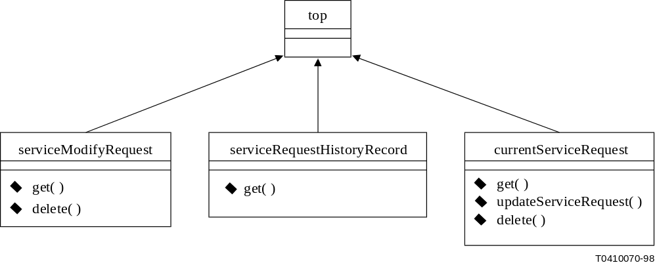
Figure III.1/M.3108.1 – Inheritance relationships for generic service request fragment
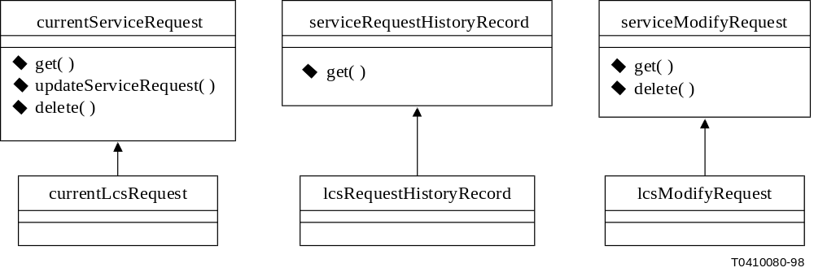
Figure III.2/M.3108.1 – Inheritance relationships for LCS request fragment
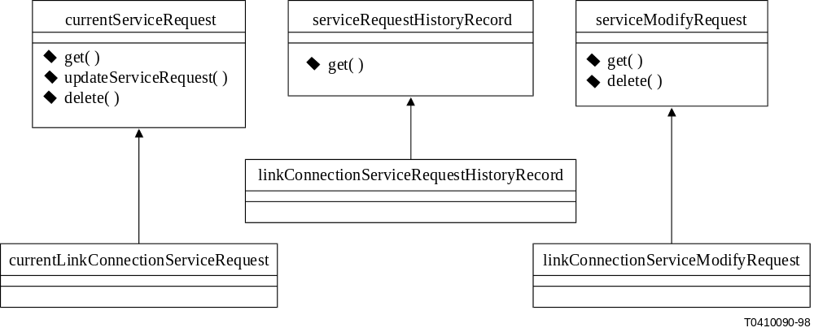
Figure III.3/M.3108.1 – Inheritance relationships for link connection
service request fragment
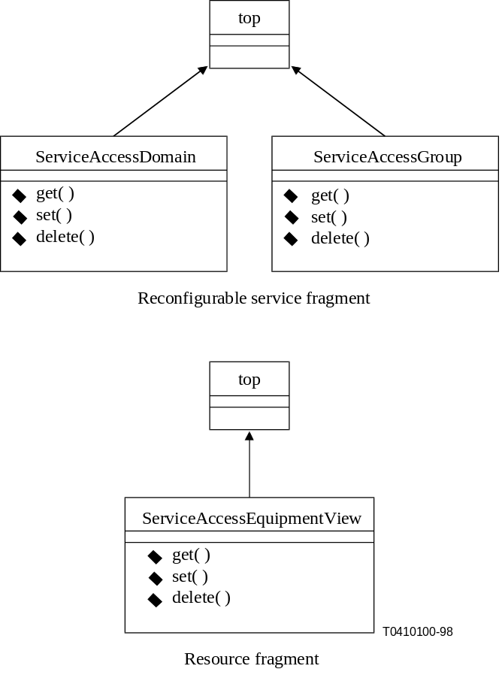
Figure III.4/M.3108.1 – Inheritance relationships for resource fragment
and reconfigurable service fragment
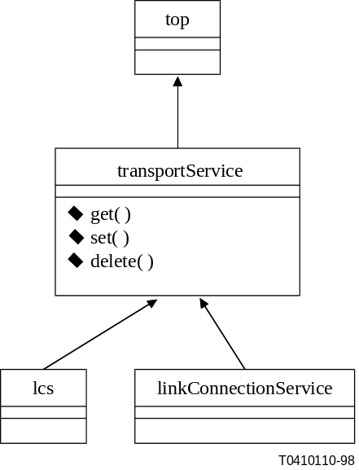
Figure III.5/M.3108.1 – Inheritance relationships for service fragment

III.3 UML class diagrams for modelling relationships
The possible relationships between instances are shown in UML class diagrams with associations (Figures III.6 and III.7). Containment relationships are denoted by a diamond headed line touching the parent (UML aggregation). Simple associations are shown with lines with roles indicates on the line ends. Relationship cardinalities are indicated by "0..*" or "1..*" tags on the end of the line representing a relationship.
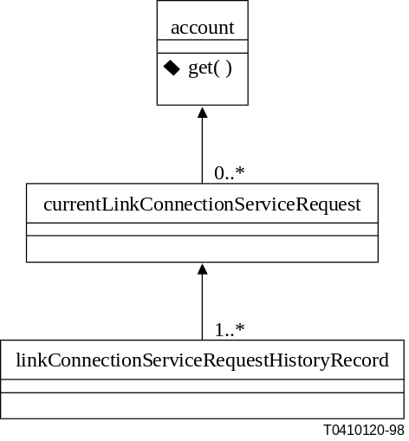
Figure III.6/M.3108.1 – Containment relationships for link connection
service request with history records
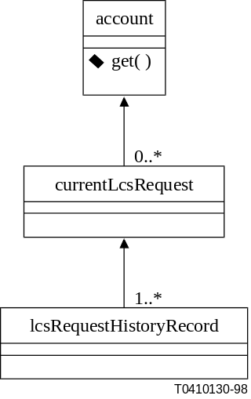
Figure III.7/M.3108.1 – Containment relationships for LCS request
with history records
In Figure III.8, associations from account to service customer and service provider are shown, even though the classes "service customer" and "service provider" are not exposed as managed objects.
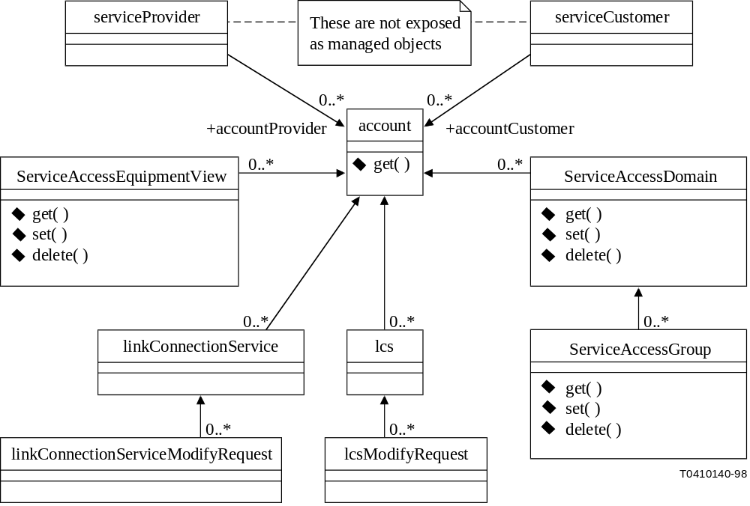
Figure III.8/M.3108.1 – UML model for relationships beyond
service creation and update

III.4 UML class diagrams for modelling agent functionality
Some UML classes are introduced (factories and notification dispatcher) to model the actions for creating objects and distributing notifications from objects (Figure III.9). Instances of these agent functionality classes appear in the sequence diagrams. When a notification operation invocation is made onto a notification dispatch object, all destinations which have registered interest will receive a copy of that notification. These final delivery flows are not shown in the sequence diagrams in III.5, since many object may be interested in receiving them.
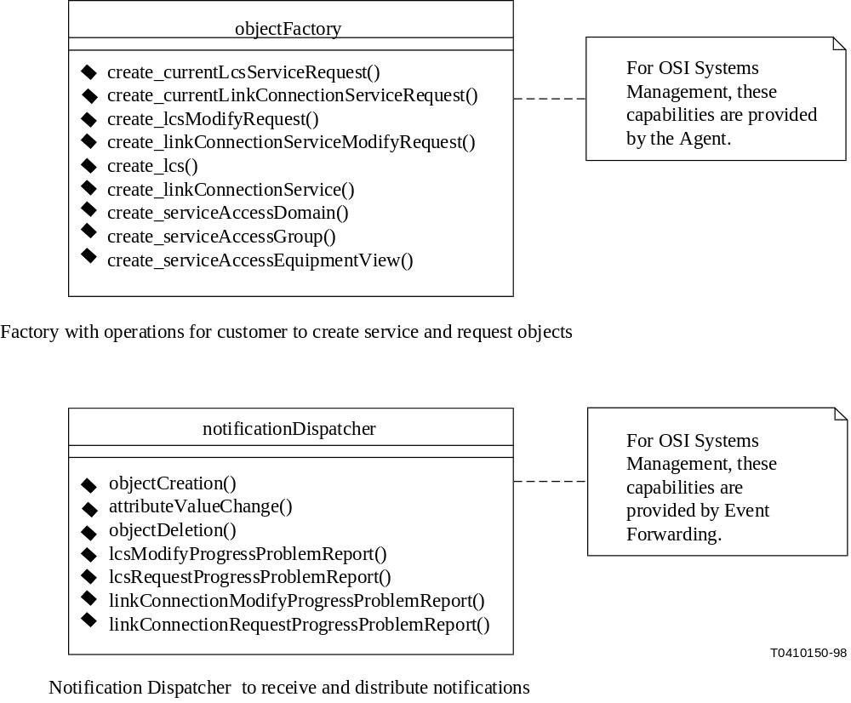
Figure III.9/M.3108.1 – UML model for agent functions
(creating objects and disseminating notifications)

III.5 UML sequence diagrams to illustrate scenarios of object usage
The sequence diagrams (Figures III.10 to III.15) in this subclause illustrate various scenarios discussed in the overview in clause 5.
The message flows from the notification dispatcher to the ultimate registered destinations are not shown in these diagrams. It would be normal for the customer (as well as other objects) to be a registered recipient for the notifications shown in these sequence diagrams).
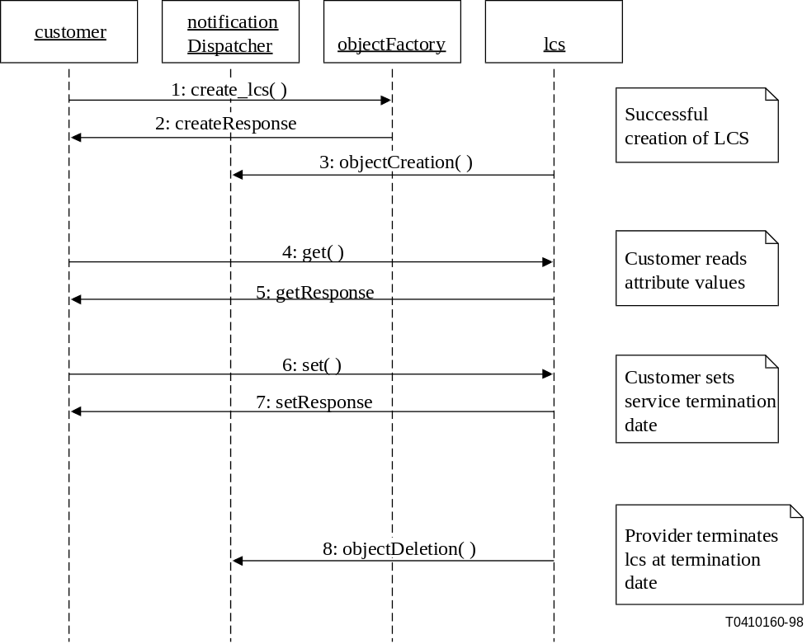
Figure III.10/M.3108.1 – Sequence diagram for explicit LCS
create and automatic termination
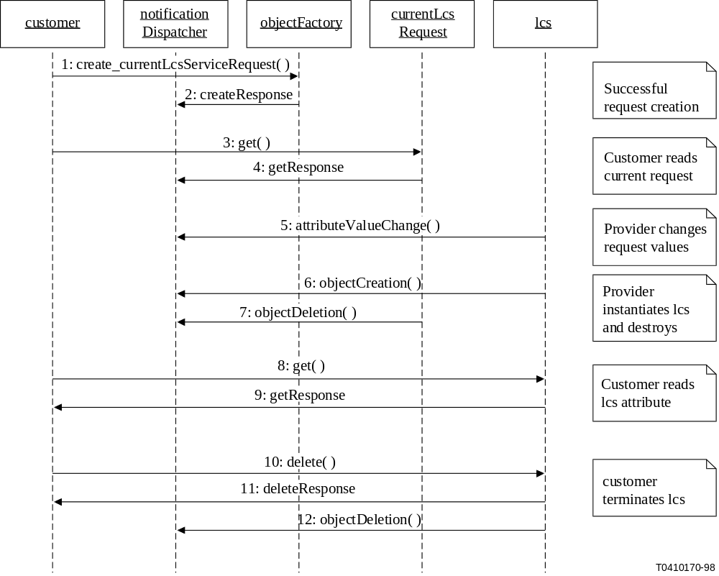
Figure III.11/M.3108.1 – Sequence diagram for instantiation of LCS
using request and explicit deletion

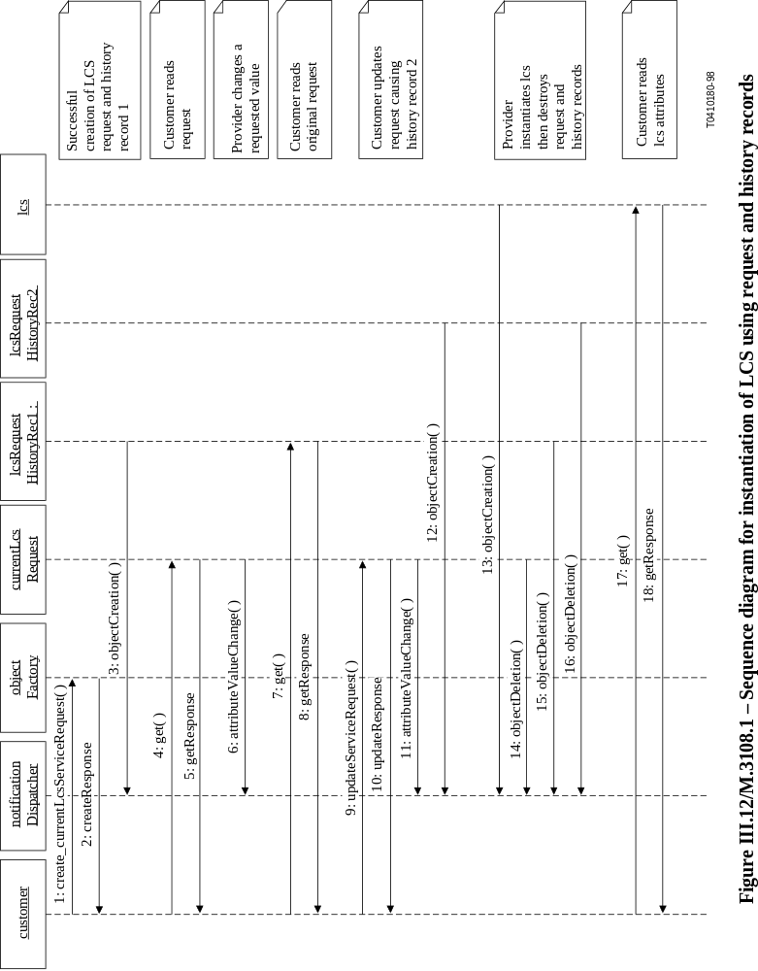
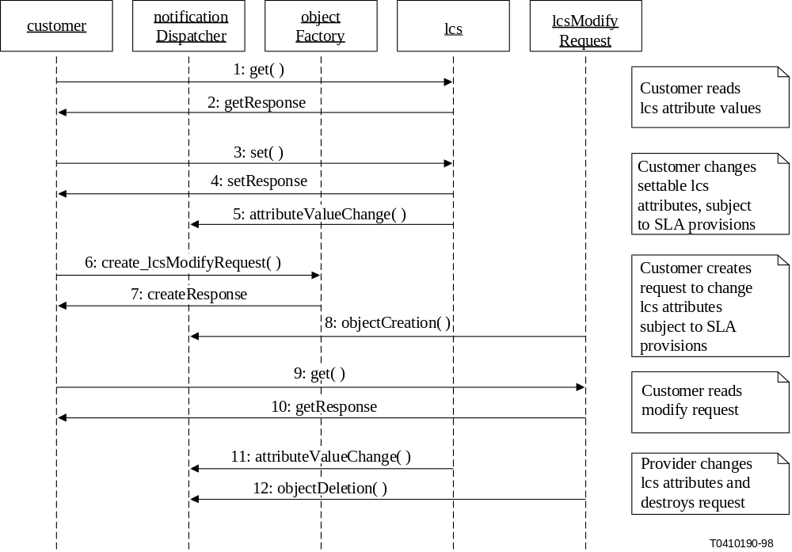
Figure III.13/M.3108.1 – Sequence diagram for modification of existing LCS
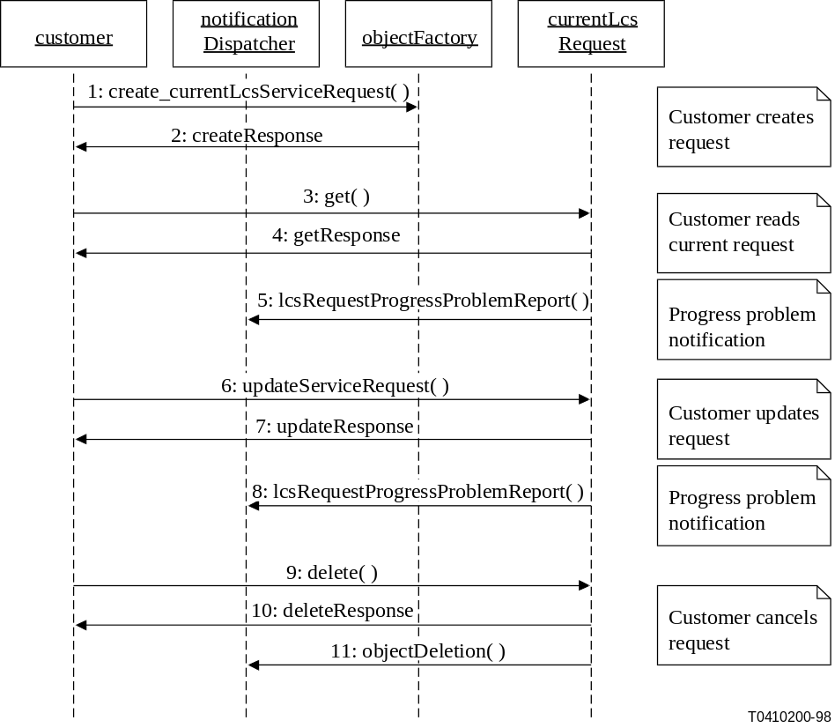
Figure III.14/M.3108.1 – Sequence diagram for unsuccessful LCS
instantiation using request without history
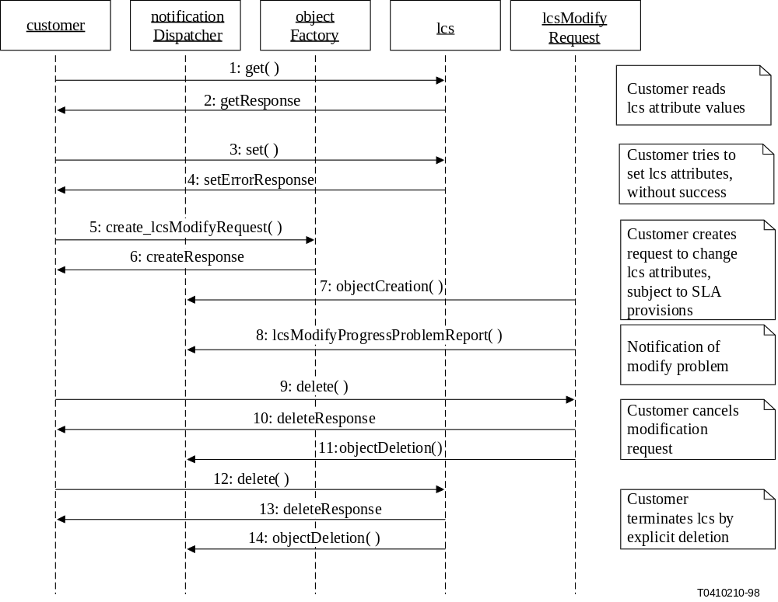
Figure III.15/M.3108.1 – Sequence diagram for unsuccessful LCS
modification followed by LCS deletion

ITU-T RECOMMENDATIONS SERIES
Series A | Organization of the work of the ITU-T
Series B | Means of expression: definitions, symbols, classification
Series C | General telecommunication statistics
Series D | General tariff principles
Series E | Overall network operation, telephone service, service operation and human factors
Series F | Non-telephone telecommunication services
Series G | Transmission systems and media, digital systems and networks
Series H | Audiovisual and multimedia systems
Series I | Integrated services digital network
Series J | Transmission of television, sound programme and other multimedia signals
Series K | Protection against interference
Series L | Construction, installation and protection of cables and other elements of outside plant
Series M | TMN and network maintenance: international transmission systems, telephone circuits, telegraphy, facsimile and leased circuits
Series N | Maintenance: international sound programme and television transmission circuits
Series O | Specifications of measuring equipment
Series P | Telephone transmission quality, telephone installations, local line networks
Series Q | Switching and signalling
Series R | Telegraph transmission
Series S | Telegraph services terminal equipment
Series T | Terminals for telematic services
Series U | Telegraph switching
Series V | Data communication over the telephone network
Series X | Data networks and open system communications
Series Y | Global information infrastructure and Internet protocol aspects
Series Z | Languages and general software aspects for telecommunication systems

