

Open Hardware 101: Fundamentals of Electronic Design

0. Basic LED Circuit (Pre-Blink)

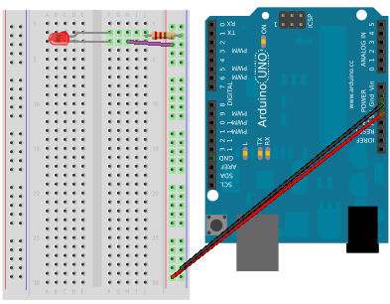

1. Blink

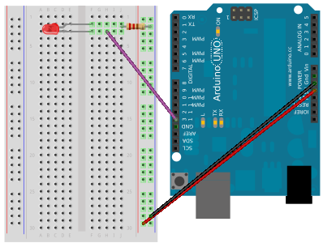

2. Button

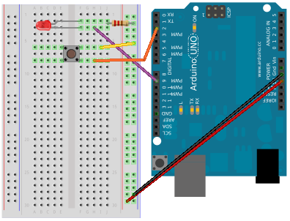

3. Light Sensor

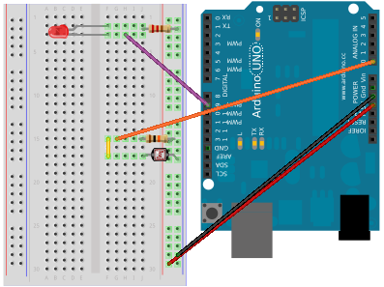

- IT-oLogy events calendar http://it-ology.org/events
- Open IT Lab http://open-it-lab.com/
- Arduino http://arduino.cc/
- SparkFun Inventor's Kit http://www.sparkfun.com/products/10173
- Arduino discussion forum http://forum.sparkfun.com/viewforum.php?f=32
- SparkFun Education http://learn.sparkfun.com/
- Intro to Arduino (book) http://introtoarduino.com/
- You can buy the Arduino and accessories from SparkFun or Radio Shack

