### **If youCall for application to join the next cohort of Open Life Science**

#### *For any further questions, please email:* [*team@openlifesci.org*](mailto:team@openlifesci.org)***.***

**Table of Content**

Step 1: Register in Open Review 1

Step 2: Template to prepare your application draft 2

Step 3: Submit your application via the Open Review form 7

## **Step 1: Register in Open Review**

*Please create your profile minimum 5 days before the application deadline so any technical problem can be addressed by either the OLS or Open Review team.*

1. Add your name and email
2. Click the confirmation link in your email
3. Set up your profile by adding the following **minimum information**
   * Personal link (Add any one link from Twitter/GitHub/Website) 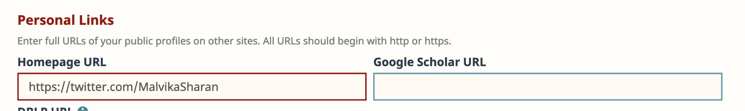
   * Add the current position, start date (skip the end date to indicate your present role), institute domain (like “openlifesci.org”) and your institution name 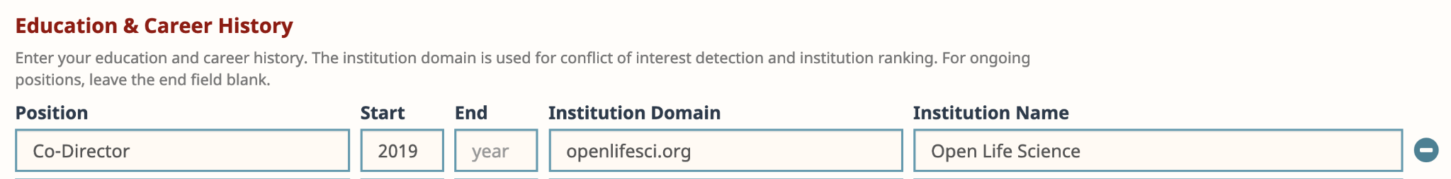
4. You can optionally add other details, but they are not necessary for your application
5. You will receive an email saying *“Your OpenReview profile has been successfully created. Please allow up to 12 hours before the profile is activated.”* (**it takes only a few hours before a profile is activated**)
6. While you wait for a confirmation, you can start drafting your application locally using the template provided below

## **Step 2: Template to prepare your application draft**

***\**** *denotes a required field*

\***Title**

*Project Name. Please note that your project doesn’t have to be technical — it can be a curriculum (open educational resource), an open data project, documentation or report, an open source software project, open publication, community building, team culture movements, or anything else that supports openness in research communities, have something to work on (a feature, module, or minimum viable product) during the program and allows and welcomes contributions by others. Whether your project is just an idea at this stage or something that’s been running for years, all applications are welcome.*

<your answer>

**TL;DR**

*"Too Long; Didn't Read": a short sentence describing your proposal*

<your answer>

**\*Authors**

*Search author profile by first, middle and last name or email address. If the profile is not found, you can add the author by completing first, middle, and last names as well as the author email address.*

<your answer>

**\*Country**

*Country of residence. Comma-separated list of countries, if different for different authors.*

<your answer>

**\*Affiliation**

*Please provide the affiliation under which your project will be developed. Comma-separated list of affiliation, if different for different authors.*

<your answer>

**Pronouns**

*Please share preferred pronouns (optional). Comma-separated list of pronouns, if different for different authors.*

<your answer>

**Keywords**

*Comma-separated list of keywords that best describe the research and interest areas of your project.*

<your answer>

**\*Project**

*Describe your project in a maximum of 200 words. You can use MarkDown formatting (see:* [*https://commonmark.org/help/*](https://commonmark.org/help/)*).*

<your answer>

**\*Problem**

*What problem(s) are you solving with this project? Please describe in a maximum of 200 words. You can use MarkDown formatting (see:* [*https://commonmark.org/help/*](https://commonmark.org/help/)*).*

<your answer>

**\*Achievements**

*What concrete achievements do you want to accomplish during the OLS program? Please describe in a maximum of 200 words. You can use MarkDown formatting (see:* [*https://commonmark.org/help/*](https://commonmark.org/help/)*).*

<your answer>

**\*Status**

*What is the current status of your project or work?* ***Choose one option***

* I have a great idea
* Working towards a first prototype
* Just launched first prototype
* Working on new release/feature on an existing prototype
* Maintaining work on an existing prototype

**\*Goal**

*Where would you like to be after the OLS program?* ***Choose one option***

* I have a great idea
* Working towards a first prototype
* Just launched first prototype
* Working on new release/feature on an existing prototype
* Maintaining work on an existing prototype

**\*Open**

*What inspires you to work openly in research? Please respond in a maximum of 200 words. You can use MarkDown formatting (see:* [*https://commonmark.org/help/*](https://commonmark.org/help/)*).*

<your answer>

**\*Challenges**

*What challenges have you faced in working in open science? Please respond in a maximum of 200 words. You can use MarkDown formatting (see:* [*https://commonmark.org/help/*](https://commonmark.org/help/)*).*

<your answer>

**\*Learning**

*What are your learning goals in the Open Life Science program? Please respond in a maximum of 200 words. You can use MarkDown formatting (see:* [*https://commonmark.org/help/*](https://commonmark.org/help/)*).*

<your answer>

**\*Mentor**

*What do you expect from a mentor? Please respond in a maximum of 200 words. You can use MarkDown formatting (see:* [*https://commonmark.org/help/*](https://commonmark.org/help/)*).*

<your answer>

**\*Other OLS applications**

*Have you applied to OLS before, or are you applying as an author on more than one project in this round of applications? If yes, please share the project name and which round(s) you applied to OLS in, e.g. "OLS, Open Science Writing Guide".*

<your answer>

**\*Accessibility**

*The OLS team aims to create as inclusive an environment as possible for everyone. To help us prepare effectively, please let us know if there is anything we can do to facilitate your participation. This might include sign interpreters for video calls, alternative format materials, or something else. We will provide real-time captioning using otter.ai and/or Google Slides by default. This information will not be shared with application reviewers, and will not affect whether or not you are accepted to the program.*

<your answer>

**\*Language**

*What spoken language do you prefer for your mentoring calls?*

<your answer>

**\*Scheme**

*Are you affiliated with any of these organisations?* ***Choose one option***

* EOSC-Life
* The Turing Way/The Alan Turing Institute
* TU Delft - Faculty of Applied Sciences
* CZI
* Not sure
* None

## **Step 3: Submit your application via the Open Review form**

1. Visit the submission page: https://openreview.net/group?id=openlifesci.org/Open_Life_Science/2023/Cohort_7
2. Click the “**Open Life Science 2021 Cohort Submission**” link
3. Transfer the content from your draft application to the Open Review form

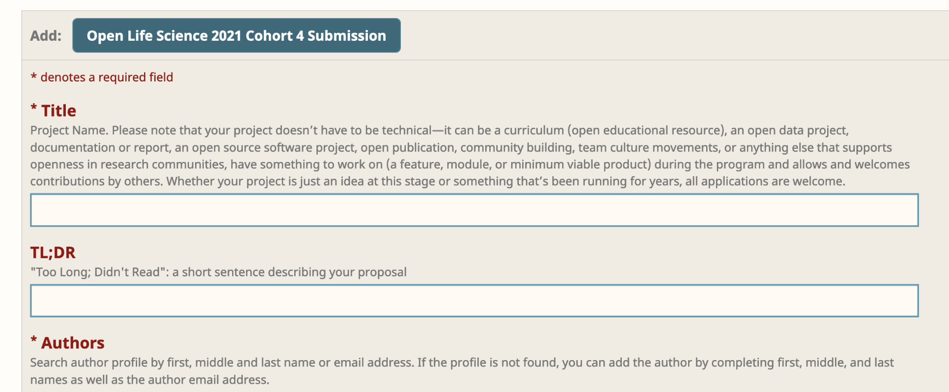

1. When you’re ready, click “**submit**”

#### 

#### **All the best from the OLS team!**

#### *License: CC BY 4.0, Open Life Science (OLS), 2023*

#### 