Call for application to join the fourth cohort of Open Life Science, OLS-4

For any further questions, please email: team@openlifesci.org.

Table of Content

Step 1: Register in Open Review 1
Step 2: Template to prepare your application draft 2
Step 3: Submit your application via the Open Review form 7

Step 1: Register in Open Review
Please create your profile minimum 5 days before the application deadline so any technical problem can be addressed by either the OLS or Open Review team.

- Add your name and email
- Click the confirmation link in your email
- Set up your profile by adding the following minimum information
  - Personal link (Add any one link from Twitter/GitHub/Website) 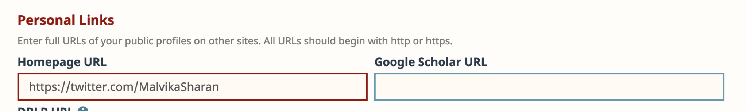
  - Add the current position, start date (skip the end date to indicate your present role), institute domain (like “openlifesci.org”) and your institution name 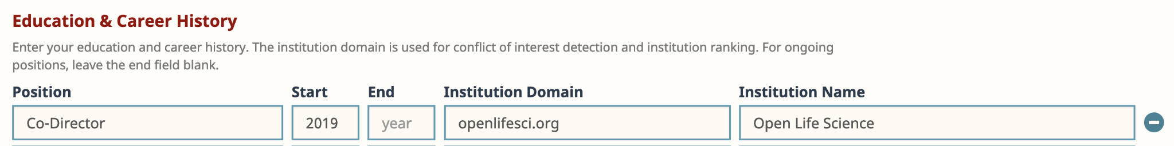
- You can optionally add other details, but they are not necessary for your application
- You will receive an email saying “Your OpenReview profile has been successfully created. Please allow up to 12 hours before the profile is activated.” (it takes only a few hours before a profile is activated)
- While you wait for a confirmation, you can start drafting your application locally using the template provided below

Step 2: Template to prepare your application draft
Submission Deadline: July 15, 2021 11:59pm AOE, * denotes a required field
*Title
Project Name. Please note that your project doesn’t have to be technical — it can be a curriculum (open educational resource), an open data project, documentation or report, an open source software project, open publication, community building, team culture movements, or anything else that supports openness in research communities, have something to work on (a feature, module, or minimum viable product) during the program and allows and welcomes contributions by others. Whether your project is just an idea at this stage or something that’s been running for years, all applications are welcome.
<your answer>

TL;DR
"Too Long; Didn't Read": a short sentence describing your proposal
<your answer>

*Authors
Search author profile by first, middle and last name or email address. If the profile is not found, you can add the author by completing first, middle, and last names as well as the author email address.
<your answer>

*Country
Country of residence. Comma-separated list of countries, if different for different authors.
<your answer>

*Affiliation
Please provide the affiliation under which your project will be developed. Comma-separated list of affiliation, if different for different authors.
<your answer>

Pronouns
Please share preferred pronouns (optional). Comma-separated list of pronouns, if different for different authors.
<your answer>

Keywords
Comma-separated list of keywords that best describe the research and interest areas of your project.
<your answer>

*Project
Describe your project in a maximum of 200 words. You can use MarkDown formatting (see: https://commonmark.org/help/).
<your answer>

*Problem
What problem(s) are you solving with this project? Please describe in a maximum of 200 words. You can use MarkDown formatting (see: https://commonmark.org/help/).
<your answer>

*Achievements
What concrete achievements do you want to accomplish during the OLS-4 program? Please describe in a maximum of 200 words. You can use MarkDown formatting (see: https://commonmark.org/help/).
<your answer>

*Status
What is the current status of your project or work? Choose one option

- I have a great idea
- Working towards a first prototype
- Just launched first prototype
- Working on new release/feature on an existing prototype
- Maintaining work on an existing prototype

*Goal
Where would you like to be after the OLS-4 program? Choose one option
- I have a great idea
- Working towards a first prototype
- Just launched first prototype
- Working on new release/feature on an existing prototype
- Maintaining work on an existing prototype

*Open
What inspires you to work openly in research? Please respond in a maximum of 200 words. You can use MarkDown formatting (see: https://commonmark.org/help/).
<your answer>

*Challenges
What challenges have you faced in working in open science? Please respond in a maximum of 200 words. You can use MarkDown formatting (see: https://commonmark.org/help/).
<your answer>

*Learning
What are your learning goals in the Open Life Science program? Please respond in a maximum of 200 words. You can use MarkDown formatting (see: https://commonmark.org/help/).
<your answer>

*Mentor
What do you expect from a mentor? Please respond in a maximum of 200 words. You can use MarkDown formatting (see: https://commonmark.org/help/).
<your answer>

*Accessibility
The OLS team aims to create as inclusive an environment as possible for everyone. To help us prepare effectively, please let us know if there is anything we can do to facilitate your participation. This might include sign interpreters for video calls, alternative format materials, or something else. We will provide real-time captioning using otter.ai and/or Google Slides by default. This information will not be shared with application reviewers, and will not affect whether or not you are accepted to the program.
<your answer>

*Language
What spoken language do you prefer for your mentoring calls?
<your answer>

*Scheme
Are you affiliated with any of these organisations? Choose one option
- EOSC-Life
- The Turing Way/The Alan Turing Institute
- TU Delft - Faculty of Applied Sciences
- Not sure
- None

Step 3: Submit your application via the Open Review form
- Visit the submission page: https://openreview.net/group?id=openlifesci.org/Open_Life_Science/2021/Cohort_4
- Click the “Open Life Science 2021 Cohort 4 Submission” link
- Transfer the content from your draft application to the Open Review form 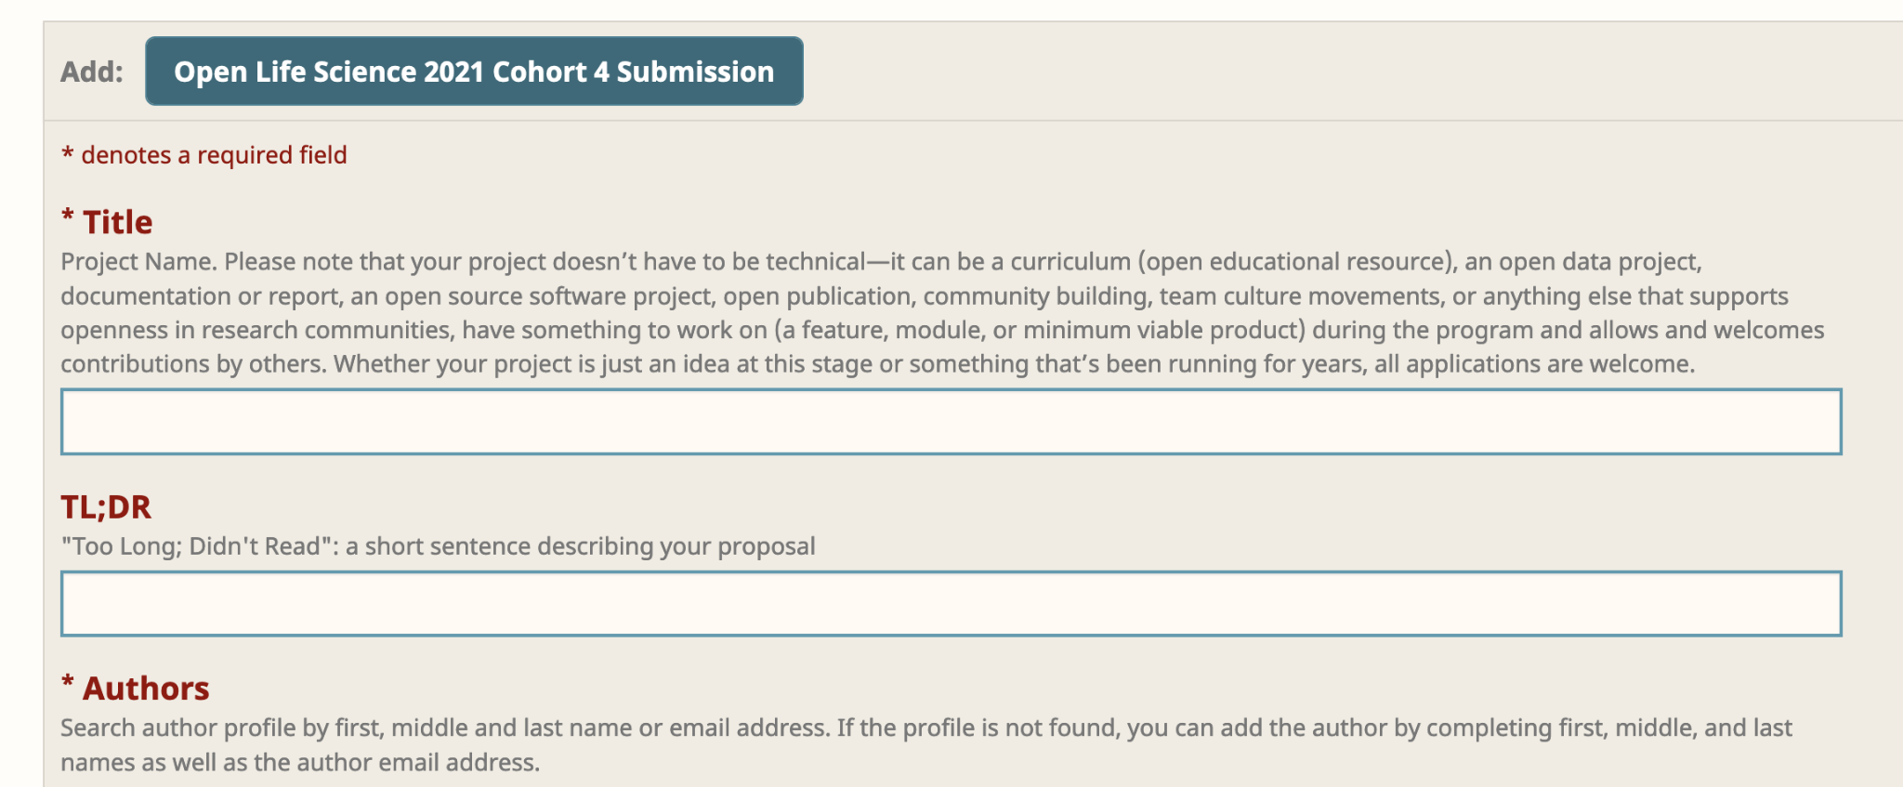
- When you’re ready, click “submit”

All the best from the OLS team!

License: CC BY 4.0, Open Life Science (OLS-4), 2021,

