

Vbench Reporter
Revision <0.3>

Table of Contents

1. About This Document 2
1.1 Audience 2
1.2 Document Scope 2
1.3 Terminology and Acronyms 2
2. Introduction 3
2.1 Identification 3
2.2 Goals and Objectives 3
2.3 Environment 3
3. Report data format 4
3.1 Description 4
3.2 File structure 4
4. Reports 6
4.1 Description 6
4.2 Categories 6
5. Report utility 9
5.1 Description 9
5.2 Command-Line Arguments 9
5.3 INI-file structure 10

Revision History

Revision | Date | Description | Author
0.1 | 22 June 2009 | Initial | Igor Ivanov
0.2 | 23 June 2009 | Modified format of the internal YAML file. New graphics. | Andrew Senin
0.3 | 17 August 2009 | Rewritten | Igor Ivanov

About This Document

Audience
The target audience includes members of Benchmarking Group and anyone interested in understanding the functionality of HPC benchmarking applications.

Document Scope
This document describes visual report representation.

Terminology and Acronyms
Table 1-1 Acronyms Description
Acronym | Description
BG | Benchmarking Group
OMA | The Voltaire Open MPI Accelerator ("OMA") is an exclusive, Voltaire-developed software enhancement to the Open MPI software stack. While Open MPI is an open-source programming implementation, OMA is offered to Voltaire customers only
Benchmark | The act of running a computer program, a set of programs, or other operations, in order to assess the relative performance of an object, normally by running a number of standard tests
Google AppEngine | http://code.google.com/appengine/docs/whatisgoogleappengine.html
MPI | The Message-Passing Interface is a standard for expressing distributed parallelism via message passing
MCA | Modular Component Architecture
YAML | YAML Ain't Markup Language. The home page for YAML is http://yaml.org/

Introduction

Identification
Benchmarks provide a method of comparing the performance of various subsystems across different architectures.

Goals and Objectives
- Report utility should select benchmarking metrics from the output and create excel file with parsed results per metric. Graph should be generated with performance metric for results that allow graphic view.
- The utility should support merging of performance results created from different executions of the same application to create single presentation.

Environment
Base for represented results is Google App Engine Datastore.

Report data format

Description
To isolate report creation procedure from interaction with datastore and not to worry about way how one or set of results got we introduce a special formatted file. This file is based on YAML standard. YAML is a generic data serialization language that is optimized for human readability and editing that completely suites our tasks. Structure of the file allows identifying product version that generated it, content of datastore and performance results. Performance results are described in manner that hides nature of data.

File structure
The full version of formatted file has following organization.
product: <mtt-gds> – product name to identify a host of this yaml-formatted file;
version: <0.1> – product version to make possible format modification;
app_id: <query> – application identifier;

modules: – datastore content section;
TestRunPhase:
propery: value
...
propery: value

TestBuildPhase:
propery: value
...
propery: value

MpiInstallPhase:
propery: value
...
propery: value

SubmitInfo:
propery: value
...
propery: value

SuiteInfo:
propery: value
...
propery: value

MpiInfo:
propery: value
...
propery: value

ClusterInfo:
propery: value
...
propery: value

CompilerInfo:
propery: value
...
propery: value
It is permitted to use short version of formatted file as.
product: <mtt-gds> – product name to identify a host of this yaml-formatted file;
version: <0.1> – product version to make possible format modification;
app_id: <query> – application identifier;

modules: – datastore content section;
TestRunPhase:
propery: value
...
propery: value

Reports

Description
All reports are generated using information from yaml-file described above and optional arguments that are set as input parameters to report utility. Reports are created as xls-file. Report consists of several sheets that can be one of three types such as information, view and data. Information sheet has detail description of single test execution or set executions defined by query from datastore or local. «View» sheet has table or table and graph representation of performance metric data or information. Few sheets are created in case execution has several performance metric results – one sheet for one performance metric result. «Data» tab forms all data related the test execution.

Categories
There are three kinds of query that are accepted for this product such as “Query a list of metric results”, “Query maximum (or minimum) metric result” and “Information queries” (see “Vbench Queries” document for more details).
All performance results generated by benchmarking applications can be divided in two groups as: array and value.
Example of performance result of array type is output of OSU_latency (pair: message size – latency):
# OSU MPI Bandwidth Test v3.1.1
# Size Bandwidth (MB/s)
1 1.78
2 3.55
4 7.11
8 14.23
16 28.21
32 48.67
64 99.35
128 178.94
256 308.49
512 482.24
1024 649.12
2048 740.73
4096 785.14
8192 879.94
16384 885.88
32768 779.55
65536 897.26
131072 943.55
262144 950.92
524288 966.06
1048576 975.71
2097152 973.58
4194304 975.77
Example of performance result of value type from HPL (value: Gflop):
============================================================================
T/V N NB P Q Time Gflops
----------------------------------------------------------------------------
WR00R2R4 8192 16 1 1 331.91 1.105e+00
--VVV--VVV--VVV--VVV--VVV--VVV--VVV--VVV--VVV--VVV--VVV--VVV--VVV--VVV--VVV-
Max aggregated wall time rfact . . . : 1.65
+ Max aggregated wall time pfact . . : 0.82
+ Max aggregated wall time mxswp . . : 0.07
Max aggregated wall time update . . : 330.05
+ Max aggregated wall time laswp . . : 4.40
Max aggregated wall time up tr sv . : 0.19
----------------------------------------------------------------------------
||Ax-b||_oo / ( eps * ||A||_1 * N ) = 0.0551503 ...... PASSED
||Ax-b||_oo / ( eps * ||A||_1 * ||x||_1 ) = 0.0232659 ...... PASSED
||Ax-b||_oo / ( eps * ||A||_oo * ||x||_oo ) = 0.0038397 ...... PASSED
============================================================================

These results can be figured in two diagrams such as line and column:

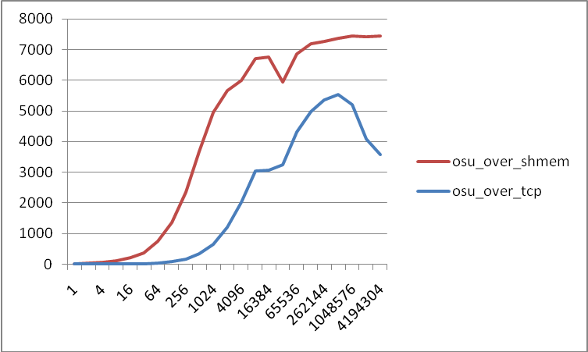
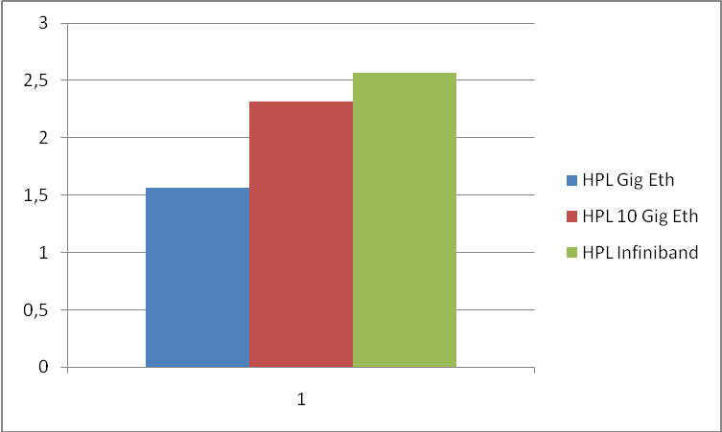

Report utility

Description
Report utility as <breport> allows to get different kinds of reports using data generated by <bquery> tool and located in file system. A result of report utility execution is xls. The utility support different forms of usage as passing parameters from command-line arguments and from special structured file.

Command-Line Arguments
The breport command takes a set of options and can be run as
breport.pl [OPTION...]
The following options are available:
--help
Show the help message and exit.
--dir=[DIR]
Path to directory with collected results.
--src=[FILE]
Source file for tool.
--dest=[FILE]
Output file name (default: report.xls).
--ini=[FILE]
Configuration file name.
--section
Section of configuration file.
--title
Title of report (default: List of objects).
--axis_x
Propery name of data that should be displaied on axis X.
--axis_y
Propery name of data that should be displaied on axis Y.
--label_x
Axis X label.
--label_y
Axis Y label.
--legend
Template to legend in format $<property1>$<property2>... (additional: $filename)
--email
Send result by e-mail address.
Example:
./breport.pl --dir=”query_imb” --dest=”query_imb/report_query_imb.xls” --axis_x=data_message_size --axis_y=data_latency_avg --axis_x=data_message_size --axis_y=data_bandwidth_avg --legend=$mpi_nproc$cached_mpiinfo_mpi_name --title=”IMB Results”

INI-file structure
Configuration file that <breport> utility accepts as input parameter represents INI-file that can be broken up into several sections, each of which describes single report document. Sections precedes with the section name in square brackets, followed by parameter names and their values. The first non-blank character of the line indicating a section must be a left bracket and the last non-blank character of a line indicating a section must be a right bracket. The characters making up the section name can be any symbols at all. However section names must be unique. Parameters are specified in each section as Name=Value. Any spaces around the equals sign will be ignored, and the value extends to the end of the line (including any whitespace at the end of the line. Parameter names are localized to the namespace of the section, but must be unique within a section.
Each section has own unique fields:
dir - Path to directory with collected results.
src - Source file for tool.
dest - Output file name (default: report.xls).
ini - Configuration file name.
section - Section of configuration file.
title - Title of report (default: List of objects).
axis_x - Propery name of data that should be displayed on axis X or “none” .
axis_y - Propery name of data that should be displayed on axis Y or “none” .
label_x - Axis X label.
label_y - Axis Y label.
legend - Template to legend in format $<property1>$<property2>...

Example:
./breport.pl --ini=”report.ini” --section=test_5
[test_5]
dest=test5.xls
dir=
title=OSU Report
axis_x=<<EOT
data_message_size
none
mpi_nproc
EOT

axis_y=<<EOT
data_latency_avg
mpi_nproc
duration
EOT

label_x=<<EOT
message size (bytes)
objects
number of processors
EOT
label_y=<<EOT
latency (sec)
number of processors
duration (sec)
EOT

