

Vbench Google Datastore setup
Revision <0.2>

Table of Contents

1. About This Document 2
1.1 Audience 2
1.2 Document Scope 2
1.3 Terminology and Acronyms 2
2. GDS Overview 3
3. Code organization 4
4. Installation 5
5. Administration Console 7
6. GQL Query 9
7. HOW TO 10

Revision History

Revision | Date | Description | Author
0.1 | 17 August 2009 | Initial | Igor Ivanov
0.2 | 21 August 2009 | Minor fixes. Formatting | Andrew Senin
0.3 | 21 August 2009 | 7 topic is added | Igor Ivanov
0.4 | 18 February 2010 | Added Google account authorization | Igor Ivanov

About This Document

Audience
The target audience includes members of Benchmarking Group and anyone interested in understanding the functionality of HPC benchmarking applications.

Document Scope
This document describes steps necessary to make to run the benchmarking backend at Google.

Terminology and Acronyms
Table 1-1 Acronyms Description
Acronym | Description
BG | Benchmarking Group
OMA | The Voltaire Open MPI Accelerator ("OMA") is an exclusive, Voltaire-developed software enhancement to the Open MPI software stack. While Open MPI is an open-source programming implementation, OMA is offered to Voltaire customers only
Benchmark | The act of running a computer program, a set of programs, or other operations, in order to assess the relative performance of an object, normally by running a number of standard tests
GDS | Google Datastore

GDS Overview
Google App Engine lets you run your web applications on Google's infrastructure. App Engine applications are easy to build, easy to maintain, and easy to scale as your traffic and data storage need to grow. With App Engine, there are no servers to maintain: you just upload your application, and it's ready to serve your users.
You can serve your app using a free name on the appspot.com domain. You can share your application with the world, or limit access to members of your organization.
App Engine provides a powerful distributed data storage service that features a query engine and transactions. Just as the distributed web server grows with your traffic, the distributed Datastore grows with your data.
The Datastore is physically based on Google’s servers. It is spread across multiple servers to provide redundancy and performance. This is one of the main benefits of developing on the App Engine; Google’s scalability is leveraged. The Datastore was developed over Google’s Big Table, which hosts many internal and external services of Google.
The Datastore is a non-relational database. This means unlike traditional databases, we don’t build normalized tables then JOIN them for results. Instead, the Datastore is optimized for reading. The JOIN command is not supported so we need to architect the database as we would for a high volume reporting database, meaning more columns and fewer tables.
Many common datatypes are supported in the Datastore, including String, Int, Float, and DateTime. In addition, there are Key (system assigned unique row id), Links (URL), phone number, and postal address types.

For more information you can go to http://code.google.com/appengine/docs/whatisgoogleappengine.html.

Code organization
Backend and frontend parts of application are located at MTT/server/gds. File structure can be changed in next version.
gds/
admin/
auth/
pager/
templates/
images/
__init__.py
app.yaml
conf.py
index.yaml
main.py
models.py

Installation
To get started, create a login with the Google App Engine, located at http://code.google.com/appengine/. Low usage accounts are free of charge.
Once a login is created with the App Engine, it will ask you to create an Account. Think of an Account as a Database. All our Tables (called Models in the Datastore), and data (Entities) will be saved inside an Application (Database).
The next step is to push our application to the Google server. Visit this place to get full information http://code.google.com/appengine/docs/python/tools/uploadinganapp.html. Open a Shell Command prompt, copy content of MTT/server/gds folder to new place, change the first line of gds/app.yaml file as “application” to your “your application name” and execute “appcfg.py update gds/” from this place. You will be prompted for your Google login. Below is the output from posting the application.
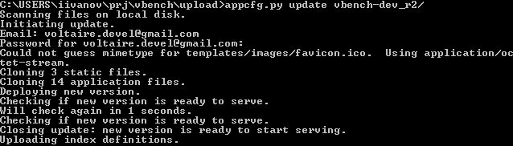
Now open a browser and go to “your application name”.appspot.com/admin/ and signed in using Datastore Account.
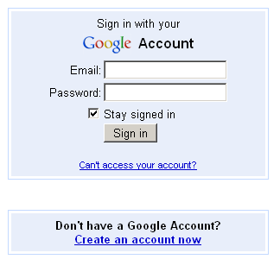
First time you setup application on Google you need to create the first user that should be a superuser (administrator) using following form as
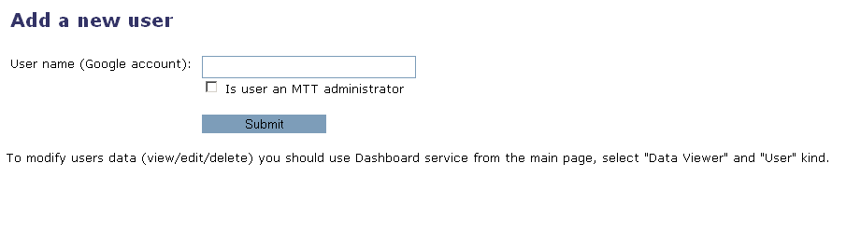
In the future you can use special client tool as bquery.pl that is located at MTT/client place to add another user. Be aware that a superuser can be created from web-form only.
To have possibility to store results generated by mtt it is required to set few parameters in standard MTT configuration file as
mttdatabase_username =
mttdatabase_password =
mttdatabase_url = http://“your application name”.appspot.com/

Administration Console
Let’s enter the Google Administration Console to view the newly inserted data. The Console can be accessed from: http://appengine.google.com/. After logging in, the first screen will list our Applications (Databases). Entering an Application will bring up the Dashboard pictured below.
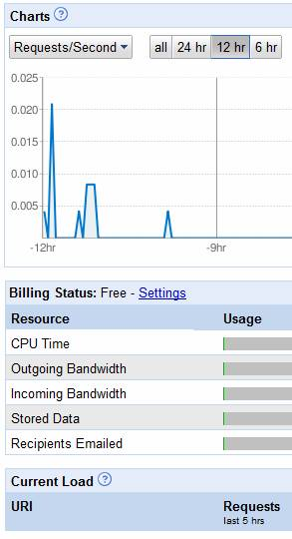
The Dashboard gives us a snapshot of our processes and resources being utilized. On the left of the chart is a link called “Data Viewer”. The Data Viewer is the web interface to our data and shows the record just entered.
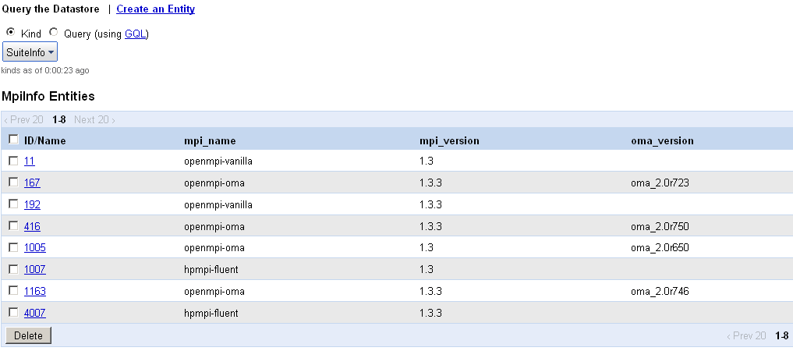
From this interface we can add, edit, and delete data as well as view. In addition, there is a window to Query. Click the “Query” radio button towards the top of the screen to open a query text area.

GQL Query
Querying data in the Datastore is done with a SQL like language called GQL. For example, this statement returns the newly created record:
SELECT * FROM SuiteInfo WHERE suite_name = 'osu'
The GQL is not a powerful language like PL/SQL or TSQL, but is adequate for presenting data to forward facing web applications. There are WHERE, ORDER BY, and LIMIT keywords. The OR command doesn’t exist for WHERE statements, but there is an IN grouping clause that can be used. The GQL reference is located at this URL: http://code.google.com/appengine/docs/python/Datastore/gqlreference.html .

HOW TO
In this topic basic how to instruction is described to help a new user of GDS.

To add a new custom field to datastore and save some value in one you need execute few steps:
- Open MTT/lib/MTT/Reporter/MTTGDS.pm;
- Set you values to $phase_form->{name of new field} with prefix “custom_” in one of functions as “_process_phase_test_run”, “_process_phase_test_build” or “_process_phase_mpi_install”;
- Run mtt

To add a new permanent field to datastore and save some value in one you need execute few steps:
- Open MTT/lib/MTT/Reporter/MTTGDS.pm;
- Set you values to $phase_form->{name of new field} with prefix “custom_” in one of functions as _process_phase_test_run, _process_phase_test_build or _process_phase_mpi_install;
- Open MTT/server/gds/modules.py
- Add you field in one of models as “MpiInstallPhase”, “TestBuildPhase” or “TestRunPhase”.
- Run mtt

